Figure S4:
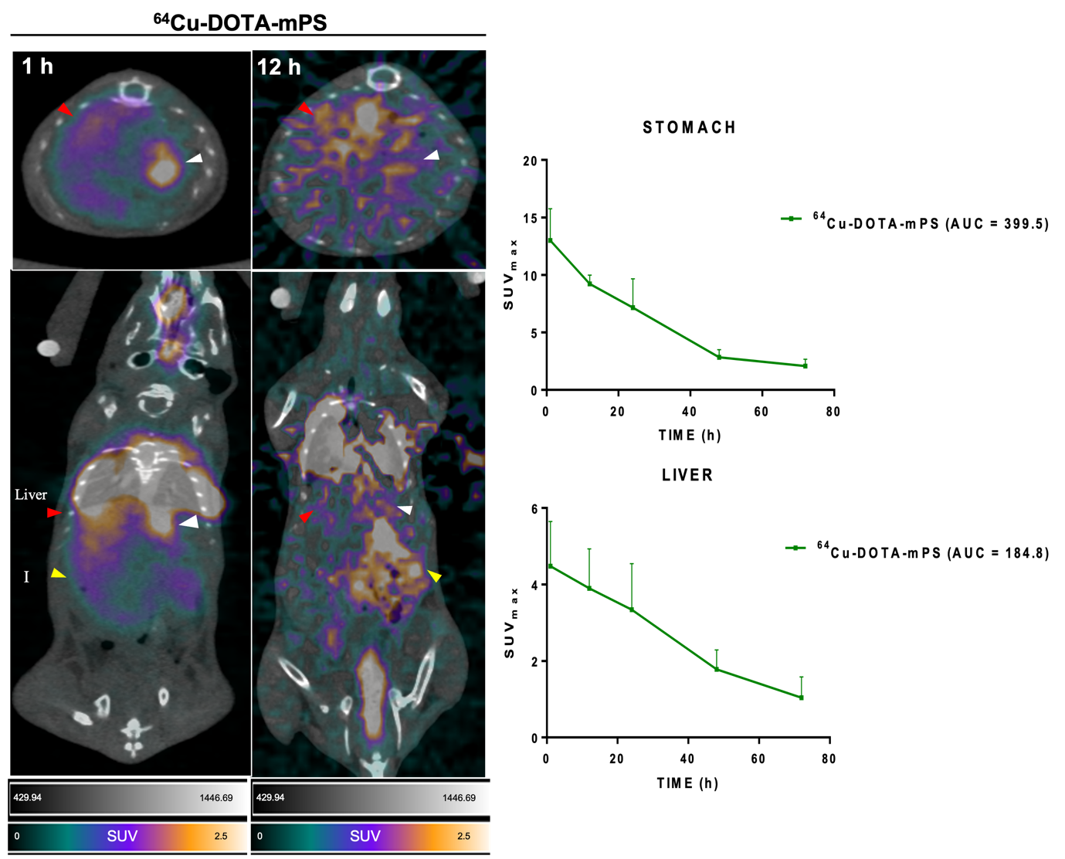

Fig. S4. The [⁶⁴Cu]Cu-DOTA-mPS PET images showing stomach and liver uptake. The 1 h and 12 h images showed increased stomach uptake (GIT translocation) and liver uptake in mPS group. The images were marked with arrows pointing to organs; red arrow-liver, white arrow-stomach, yellow arrow-intestines. SUV graph was obtained from Fig. 3.

