Figure S2:
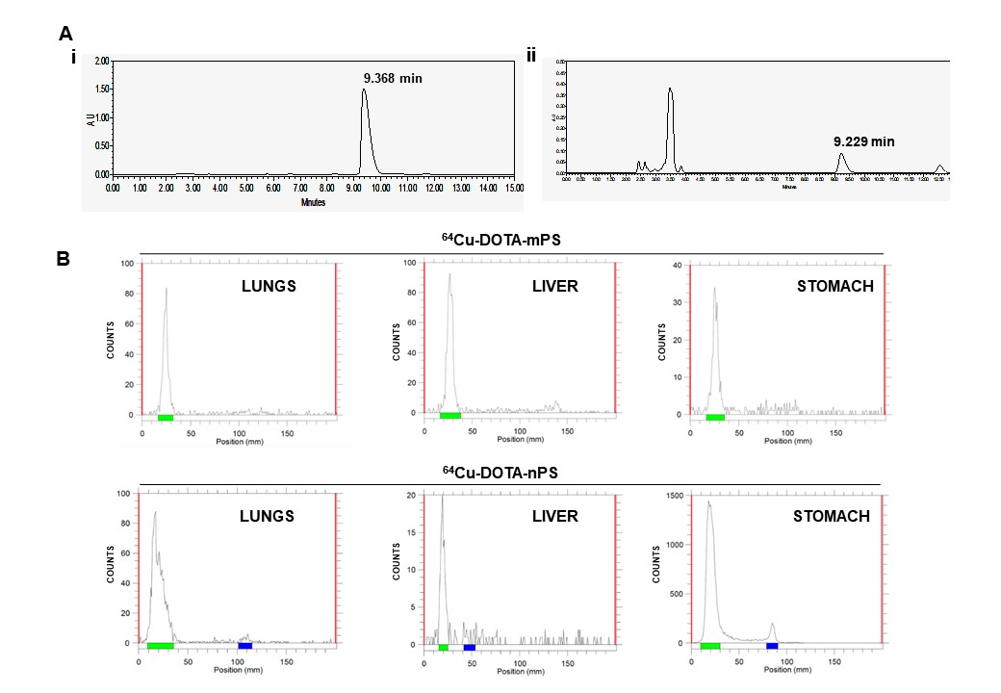
Fig. S2. (A) The number of moles of DOTA conjugates per mg of polystyrene was quantified using high performance liquid chromatography; i) HPLC peak of p-SCN-Bn-DOTA in the standard concentration of 100 μg/ 50 μl at 254 nm detected at 9.368 min and ii) detection of p-SCN-Bn-DOTA in DOTA-polystyrene conjugated product at 9.229 min. (B) Ex vivo instant thin layer chromatography results of lungs, liver and stomach at 1 h post intra-tracheal instillation of [⁶⁴Cu]Cu-DOTA-mPS (above) and [⁶⁴Cu]Cu-DOTA-nPS (below) developed from the homogenized tissue samples with 0.1 M citric acid as mobile phase (left peak denotes the [⁶⁴Cu]Cu-DOTA-polystyrene and the right peak is copper-64).

