Figure S3:
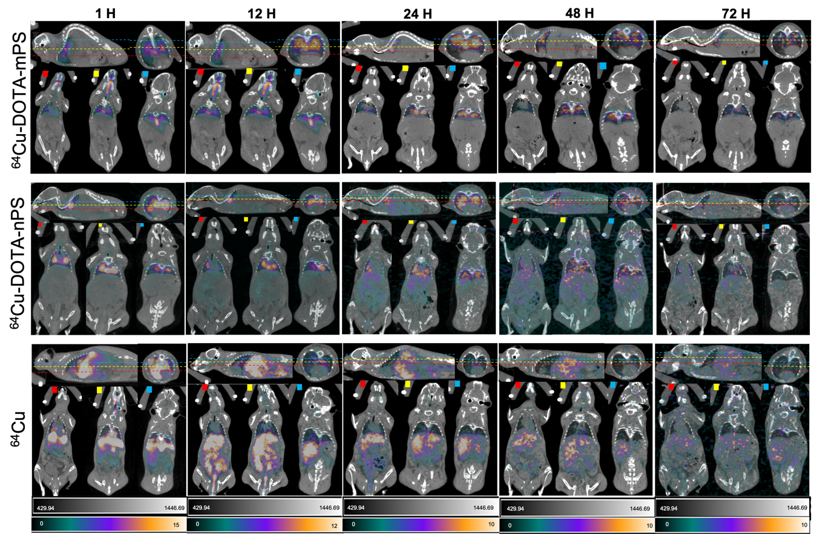
Fig. S3. The transverse, coronal and sagittal PET image slices at all time points post instillation. The red, yellow and blue lines indicate anterior, medial and posterior slices respectively and the same slices are represented at different time points.

