Table 1: Description of the developmental stages and corresponding bone age (in years and months separated by a decimal point) for the three bones (B=Boys, G=Girls)
Radius |  | Age (yr) | Age (yr) | Hamate |  | Age (yr) | Age (yr) | 3rd terminal phalanx |  | Age (yr) | Age (yr)
Stage description | Figure | B | G | Stage description | Figure | B | G | Stage description | Figure | B | G
The distal end of the diaphysis is flared. The epiphysis has not yet appeared. | 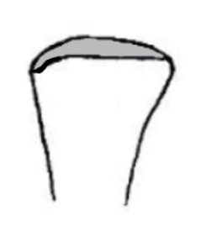 | 0 | 0 | The center for the hamate has not yet appeared. |  | 0 | 0 | The base of the diaphysis is flat. The epiphysis has not yet appeared. |  | 0 | 0
The epiphysis appears as a small dot. | 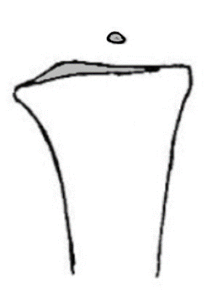 | 1.2 | 1 | The appearance of a small dot is noted. |  | 0.6 | 0.6 | The epiphysis appears as a small dot. |  | 2 | 2
The epiphysis is larger, less than half the metaphysis, like a tear drop on side view, with a pointed ulnar margin. | 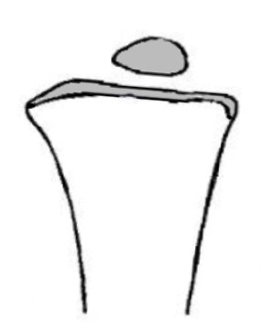 | 1.6 | 1.5 | Slight enlargement in size is noted. The hamate is smaller than the capitate, and is round and smooth in shape. | 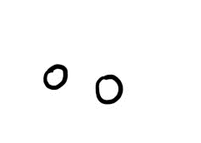 | 0.6 | 0.6 | The epiphysis appears disc- like and its longest axis is transverse. | 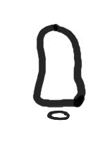 | 3 | 2.5
The epiphysis is roughly half the width of the metaphysis. A white outline of the epiphysis begins to appear, curving around the ulnar tip. | 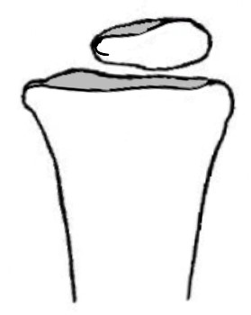 | 3 | 2 | Further enlargement, round and smooth shape is noted. | 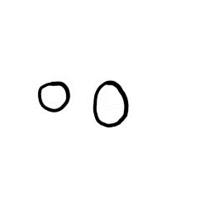 | 0.9 | 0.6 | The longest axis is transverse with further widening. | 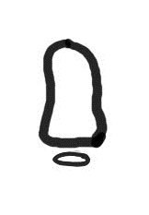 | 3.5 | 3
The epiphysis is wider than half the width of the metaphysis. The proximal white line from the ulnar tip extends beyond the center. | 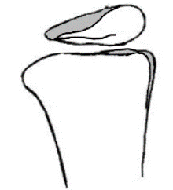 | 4 | 3 | Oval appearance of the hamate is noted. | 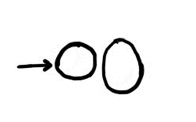 | 1 | 1 | The epiphysis is wider in the center and triangular in shape. | 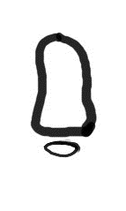 | 4 | 3.5
On the ulnar side, the distal margin of the epiphysis is flattened as the lunate and ulnar facets begin to appear. | 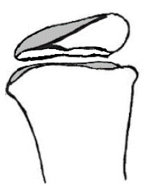 | 5 | 4 | The hamate is now slightly triangular in appearance. | 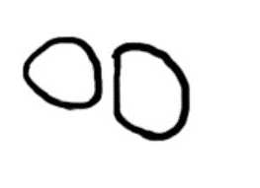 | 1.6 | 2 | The width of the epiphysis is between 1/2 and 2/3rd the width of the metaphysis. The central portion is thicker. | 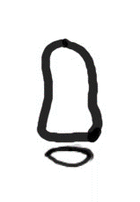 | 5 | 4
The lateral epiphysis where the styloid process develops begins to enlarge and the epiphysis is almost as wide as the metaphysis. | 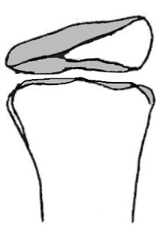 | 6 | 5 | The capitate side of the hamate becomes rounder. | 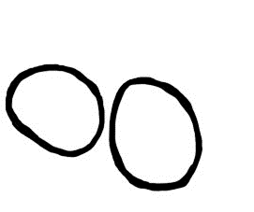 | 2 | 2 | The epiphysis is slightly thicker at the edges. | 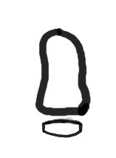 | 6 | 5
The epiphysis becomes 2/3rd or wider. Its ulnar end starts looking bulkier. | 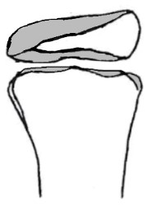 | 7 | 6 | The future triquetral surface begins to flatten from the bottom, on the ulnar side. | 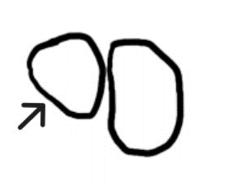 | 2 | 2.5 | Further central thickening is noted, future articular surfaces are now seen. | 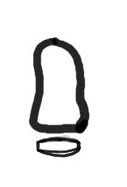 | 8 | 6
The epiphysis is wider than 2/3rd the width of the metaphysis. The proximal and distal white lines are separated at the ulnar side. | 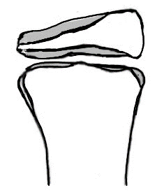 | 9 | 8 | The capitate side of the hamate becomes more convex. | 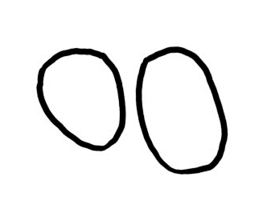 | 3 | 3 | The epiphysis is now as wide as the metaphysis. | 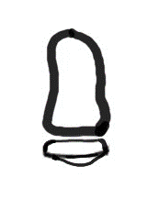 | 10 | 7
The epiphysis is almost as wide as the metaphysis. Proximal and distal white lines are further separated. | 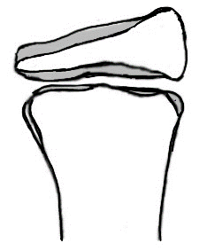 | 10 | 9 | The longest axis of the hamate is oblique and is directed towards the base of the fifth metacarpal. | 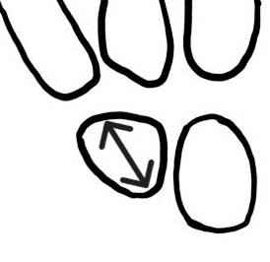 | 3 | 4 | The epiphysis is wider than the metaphysis. | 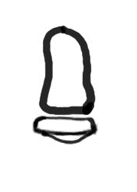 | 11 | 9
The epiphysis is as wide as the metaphysis. The proximal white line is seen extending across the whole width of the epiphysis. | 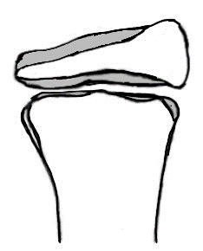 | 11 | 10 | The capitate side of the hamate becomes further convex and an articular surface appears. | 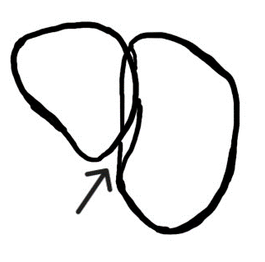 | 5 | 5 | The epiphysis wider than the metaphysis and widens further at its lateral edges. | 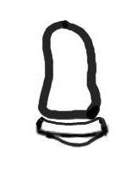 | 12 | 10
The epiphysis as wide as the metaphysis. A distinct vertical edge (white line) is seen on the ulnar margin of the epiphysis. | 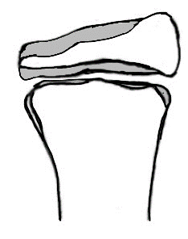 | 12 | 11 | The triquetral surface (on the ulnar side) is concave. | 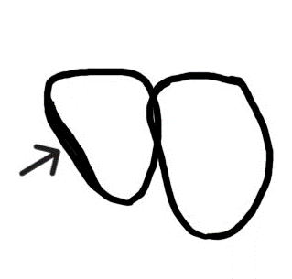 | 7 | 7 | The epiphysis starts capping the metaphysis. | 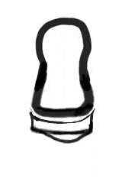 | 13 | 11
Capping has begun on the ulnar side. | 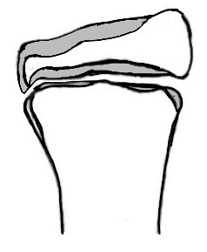 | 13 | 11 | The capitate edge of the hamate is seen as a white line. | 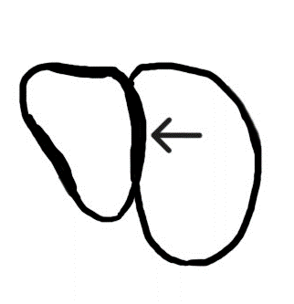 | 10 | 9 | The central portion of the epiphysis starts moving closer to the metaphysis. | 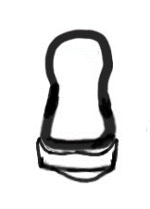 | 14 | 13
Capping is now seen on both sides. |  | 14 | 12 | The fourth metacarpal facet is seen and the beginning of hamate hook margin is noted. The proximal edge of the bone becomes constricted. | 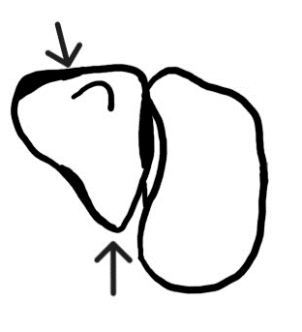 | 11 | 10 | Fusion of the epiphysis occurs. A line is still seen. | 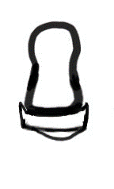 | 15 | 13.6
The gap between the epiphysis and the metaphysis is very narrow but complete. |  | 15 | 13 | A thin margin of the hook of the hamate is seen. | 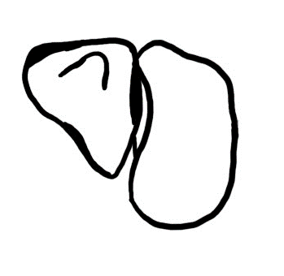 | 12 | 11 | Further fusion occurs, a very thin line is seen. | 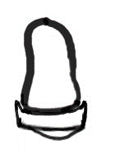 | 16 | 14
Central fusion of the epiphysis has started. |  | 16 | 14 | The hook is seen better triangular. | 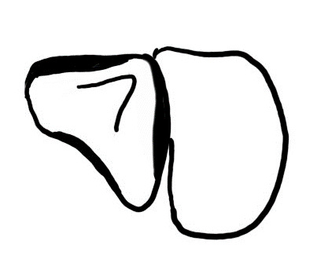 | 13 | 11 | Total fusion of the epiphysis occurs. No line is seen. | 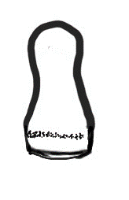 | 17 | 15
Many small areas of fusion are seen. |  | 17 | 15 | A complete outline of the hook is now seen. | 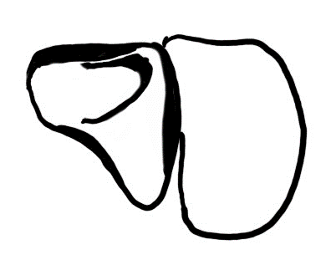 | 14 | 12 | Total fusion of the epiphysis occurs. No line is seen. | 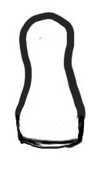 | 18 | 16
Near total fusion is noted. The gap between the epiphysis and the metaphysis has almost disappeared. |  | 18 | 17 | The hook widens further covering 2/3rd of the upper portion of the hamate. | 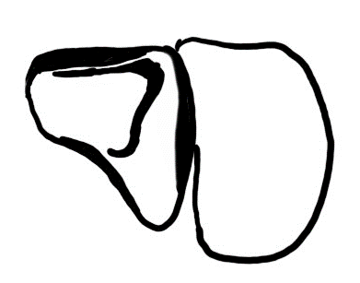 | 15 | 13
Total fusion is noted. A thin line may be seen for year. |  | 18 | 18 | The outline of the tip of the hamulus (triangular edge) is now distinct and triangular and each metacarpal articular surface has appeared. | 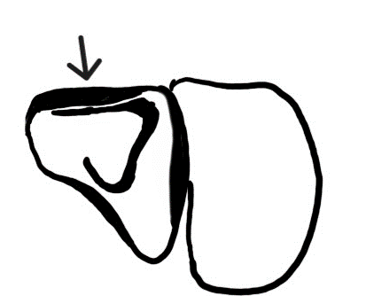 | 16 | 15
 |  |  |  | The hamate has adult triangular appearance with all margins well developed and the hook is thick and wide. | 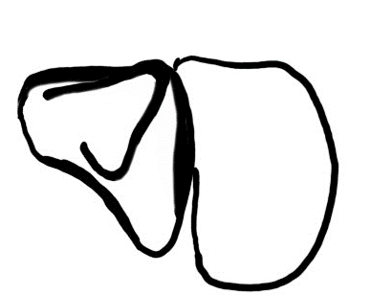 | 17 | 16
 |  |  |  | The hamate has adult triangular appearance with all margins well developed and the hamulus is thick and wide. | 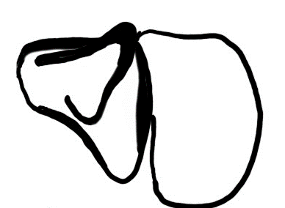 | 18 | 18

