Appendices
Table 1 Repeating earthquakes identified on the Haichenghe fault area
Serial Number | Origin Time | Longitude/°E | Latitude/°N | Depth/km | Magnitude/M_{L} | Relocation Error/m |  |  | Seismic Moment/ 10¹⁰ N·m | Rupture Radius/m | Cluster | Distribution on the fault
 |  |  |  |  |  | EW | NS | Vertical
1  2  3 | 2021-10-14T14:37:32  2021-10-15T10:46:15  2021-10-16T00:03:34 | 122.680461  122.680306  122.680648 | 40.696847  40.696920  40.696932 | 12.039  12.044  12.027 | 1.0  1.8  0.8 | 3.7  5.2  3.8 | 2.4  2.8  2.4 | 6.0  7.4  5.7 | 6.31  39.81  3.98 | 21.0  38.7  18.0 | Cluster 01 | The NW segment
4  5  6 | 2021-10-05T03:22:17  2021-10-05T03:24:34  2021-10-05T07:17:05 | 122.821916  122.821948  122.821916 | 40.664884  40.664840  40.664909 | 10.091  10.104  10.079 | 0.2  0.4  0.7 | 4.2  3.3  2.4 | 3.3  3.0  2.5 | 9.3  8.3  5.6 | 1.00  1.58  3.16 | 11.3  13.2  16.6 | Cluster 02 | The NW segment
7  8  9  10  11  12  13 | 2021-10-05T03:31:58  2021-10-05T03:46:36  2021-10-05T04:04:21  2021-10-05T06:52:19  2021-10-05T06:54:35  2021-10-05T07:50:22  2021-10-05T08:03:46 | 122.822078  122.822111  122.822070  122.822013  122.821924  122.821989  122.822030 | 40.664856  40.664840  40.664844  40.664844  40.664872  40.664884  40.664884 | 10.088  10.083  10.085  10.089  10.082  10.076  10.077 | 0.3  0.4  0.4  0.5  0.7  -0.4  -1.1 | 2.7  3.5  2.3  3.1  2.4  2.2  2.2 | 2.9  3.3  2.9  3.3  3.0  2.4  2.5 | 6.1  7.8  5.4  6.3  5.6  5.1  5.3 | 1.26  1.58  1.58  2.00  3.16  0.25  0.05 | 12.2  13.2  13.2  14.3  16.6  7.2  4.2 | Cluster 03 | The NW segment
14  15 | 2021-10-11T19:15:21  2021-10-12T03:50:00 | 122.880933  122.880965 | 40.651567  40.651632 | 12.871  12.849 | 0.9  0.8 | 12.5  12.5 | 14.4  14.4 | 26.8  26.8 | 5.01  3.98 | 19.4  18.0 | Cluster 04 | The NW segment
16  17 | 2021-10-22T12:28:41  2021-10-31T12:02:32 | 122.717489  122.717407 | 40.710173  40.709831 | 3.793  3.788 | 1.0  1.1 | 6.4  6.4 | 7.6  7.6 | 10.6  10.6 | 6.31  7.94 | 21.0  22.6 | Cluster 05 | CF
18  19 | 2021-10-24T12:15:10  2021-10-27T15:46:33 | 122.713924  122.714079 | 40.709672  40.709827 | 3.637  3.653 | 0.9  1.1 | 13.2  13.2 | 16.1  16.1 | 28.8  28.8 | 5.01  7.94 | 19.4  22.6 | Cluster 06 | CF
20  21 | 2021-10-19T09:07:42  2021-10-28T09:56:58 | 122.639201  122.639217 | 40.653410  40.653422 | 3.957  3.949 | 1.5  1.6 | 7.8  7.7 | 8.7  8.6 | 13.4  12.8 | 19.95  25.12 | 30.8  33.2 | Cluster 07 | CF
22  23  24  25 | 2021-10-05T11:33:20  2021-10-13T10:01:35  2021-10-21T09:28:00  2021-10-31T09:54:22 | 122.640226  122.640259  122.63999  122.640015 | 40.652901  40.652783  40.652751  40.652767 | 4.303  4.284  4.317  4.314 | 1.0  1.2  1.2  1.4 | 8.4  8.9  8.7  8.6 | 7.0  7.0  6.7  6.7 | 11.1  11.5  10.7  10.7 | 6.31  10.00  10.00  15.85 | 21.0  24.4  24.4  28.5 | Cluster 08 | CF
26  27 | 2021-10-10T23:05:40  2021-10-12T18:55:15 | 123.057837  123.057886 | 40.538810  40.538944 | 7.616  7.600 | 0.2  0.5 | 7.5  4.7 | 6.2  4.3 | 5.8  3.4 | 1.00  2.00 | 11.3  14.3 | Cluster 09 | The SE segment
28  29  30 | 2021-10-12T19:04:01  2021-10-13T18:40:35  2021-10-15T08:38:13 | 123.059261  123.059359  123.059245 | 40.537008  40.536991  40.536902 | 7.557  7.578  7.589 | 1.0  0.7  0.8 | 16.6  16.7  16.3 | 9.3  9.3  10.6 | 22.3  23.9  22.8 | 6.31  3.16  3.98 | 21.0  16.6  18.0 | Cluster 10 | The SE segment

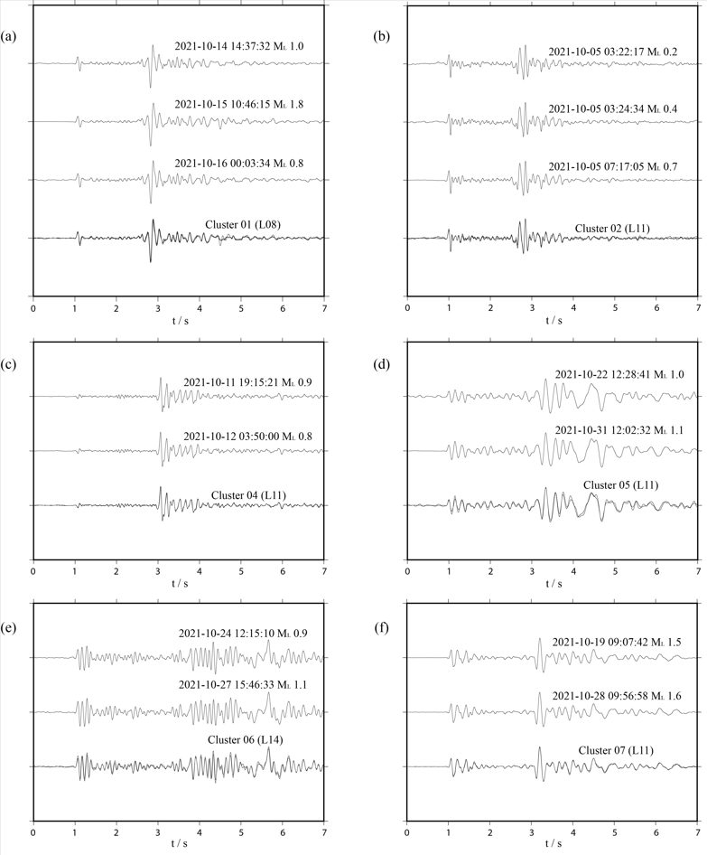
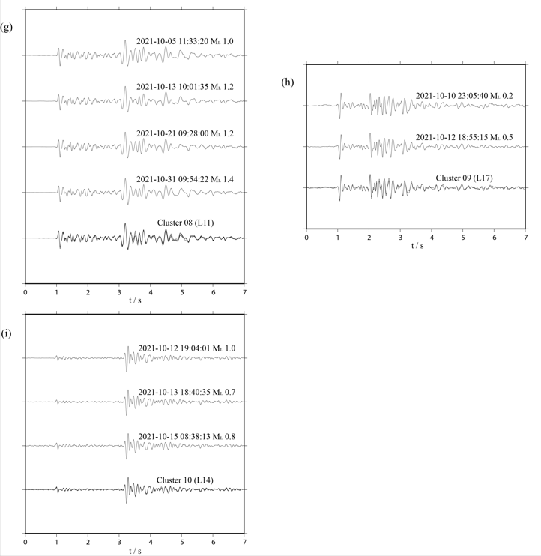
Fig. 12 Normalized seismograms of all clusters of repeating earthquakes except Cluster 03. In each subfigure, waveform of each trace is normalized seismogram of each repeater member, and the bottom trace shows the stacking waveforms of each cluster.

