Making interfacial solar evaporation of seawater faster than fresh water
Huimin Yu ^{1†}, Huanyu Jin ^{4, 5†}, Meijia Qiu ^{3†}, Peng Sun ³, Chuanqi Cheng ⁷, Pan Wu ¹, Yida Wang ¹, Xuan Wu ¹, Dewei Chu ⁶, Min Zheng ⁴, Tong Qiu⁸, Yi Lu ², Bin Zhang ⁷, Wenjie Mai ^{3*}, Xiaofei Yang ²*, Gary Owens ¹, Haolan Xu ¹*
¹Future Industries Institute, UniSA STEM, University of South Australia, Mawson Lakes Campus, Adelaide, SA 5095, Australia
²Jiangsu Co-Innovation Center of Efficient Processing and Utilization of Forest Resources, International Innovation Center for Forest Chemicals and Materials, College of Science, Nanjing Forestry University, Nanjing 210037, China
³Siyuan Laboratory, Guangzhou Key Laboratory of Vacuum Coating Technologies and New Energy Materials, Guangdong Provincial Engineering Technology Research Center of Vacuum Coating Technologies and New Energy Materials, Department of Physics, Jinan University, Guangzhou 510632, China
⁴School of Chemical Engineering and Advanced Materials, University of Adelaide, Adelaide, SA 5005, Australia
⁵Institute for Mineral and Energy Resources, University of Adelaide, Adelaide, SA 5005, Australia
⁶School of Materials Science and Engineering, University of New South Wales, Australia
⁷Department of Chemistry, School of Science, Tianjin University, Tianjin 300072, China
⁸Materials Industrialization Engineering Research Center, School of Materials Science and Engineering, Shanghai Jiao Tong University, 200240

†These authors contributed equally: Huimin Yu, Huanyu Jin, Meijia Qiu.
E-mail: xiaofei.yang@njfu.edu.cn; wenjiemai@email.jnu.edu.cn；haolan.xu@unisa.edu.au

Table S1 │ Comparison of previously reported evaporation rates of pure water and seawater/salty water. The average reduction in evaporation rate of seawater is ~8.0%.

Evaporation rate in pure water  (kg m⁻² h⁻¹) | Evaporation rate in seawater  (kg m⁻² h⁻¹) | Evaporation rate in artificial seawater  (kg m⁻² h⁻¹) | Reduction (%) | reference
1.38 | - | 1.35 (10wt% NaCl) | 2.2% | ACS Nano 2020, 14, 17419-17427.
3.29 |  | 2.86(salinity 35%) | 13.1% | ACS Nano 2021, 15, 19877-19887.
2.7 | 2.4 |  | 11.1% | J. Mater. Chem. A 2020, 8, 10742
1.25 |  | 1.24 (3.5 wt% NaCl) | 0.8% | J. Mater. Chem. A 2019, 7, 15333.
1.61 |  | 1.58 (3.5 wt% NaCl) | 1.9% | Nano Energy 2021, 81, 105682
3.87 |  | 3.65 (3.5% salty) | 5.7% | ACS Appl. Mater. Interfaces 2021, 13, 3762
2.13 | 1.99 |  | 6.6% | Adv. Funct. Mater. 2022, 2108586  DOI: doi.org/10.1002/adfm.202108586
2.23 | 2.15 |  | 3.6% | Adv. Funct. Mater. 2021, 2112159  DOI: doi.org/10.1002/adfm.202112159
4.02 | 3.96 |  | 1.5% | Adv. Mater. 2022, 34, 2107400.
2.41 | 2.30 |  | 4.6% | Chem. Eng. J. 2021, 415, 128893
2.622 | 1.77 |  | 32.5% | ACS Appl. Energy Mater. 2019, 2, 7223–7232
0.85 | 0.8 |  | 5.9% | Nanoscale 2018, 10, 2876-2886
1.67 | 1.58 |  | 5.4% | Nano Energy 2020, 70, 104538
1.58 | 1.50 |  | 5.1% | ACS Appl. Mater. Interfaces 2020, 12, 47029–47037
2.7698 | 2.338 |  | 15.6% | Sci. Total Environ. 2019, 668, 153–16
1.12 |  | 1.0 (3.5% NaCl ) | 10.7% | ACS Sustainable Chem. Eng. 2018, 6, 8192–8200
1.21 |  | 1.1 (3.5% salinity ) | 9.1% | Energy Technol. 2020, 8, 20005672000567
2.25 | 2.0 |  | 11.1% | ACS Appl. Mater. Interfaces 2020, 12, 15279–15287
1.725 | 1.717 |  | 0.46% | J. Mater. Chem. A, 2019, 7, 16696-16703
1.79 | 1.73 |  | 3.4% | J. Mater. Chem. A, 2020, 8, 22645-22656
2.01 | 1.97 |  | 2.0% | Adv.Mater.2018, 30, 1706805
1.31 |  | 1.28 (10% brine) | 2.3% | Sci. Adv. 2019; 5, eaaw7013
3.2 | 2.9 |  | 9.4% | Adv. Funct. Mater. 2021, 31, 2011114
1.31 | 1.15 |  | 12.2% | ACS Sustainable Chem. Eng. 2016, 4, 1223–1230
2.07 | 2 |  | 3.4% | Chem. Eng. J. 2012, 423, 130268
1.4 | 1.33 |  | 5.0% | Chem. Eng. J. 2021, 417, 128051
1.7 |  | 1.36 (3.5% NaCl) | 20.0% | J. Mater. Chem. A 2018, 6, 9874–9881
1.98 | 1.91 |  | 3.5% | Nano Energy 2019, 58, 322-330
6.4 |  | 5.5 (1 M KCl) | 14.1% | Adv. Funct. Mater. 2018, 28, 1704505
1.1687 | 1.1598 |  | 0.8% | Chem. Sci. 2018, 9, 623–628
6.25 | 6.22 |  | 0.5% | ACS Nano 2017, 11, 5087–5093
7.6 | 7.4 |  | 2.6% | Sol. RRL 2021,5, 2100053
2.09 |  | 1.61 (24% NaCl) | 23.0% | Nat. Commun. 2021, 12, 998
2.54 |  | 2.24 (25 % NaCl) | 11.8% | Nat. Commun. 2020, 11, 521
0.408 | 0.325 |  | 20.3% | Nat. Sustain. 2020, 3, 144–151

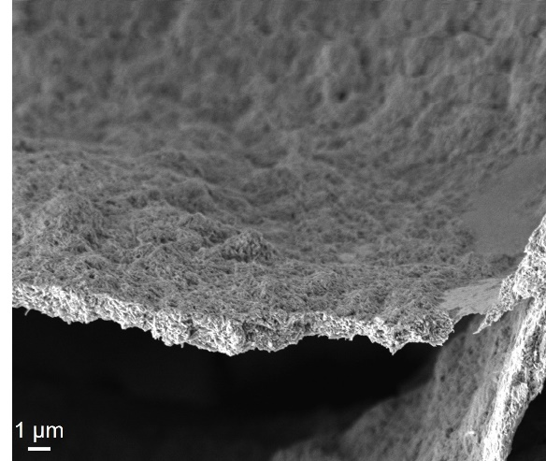
Fig. S1 │ High-resolution SEM image of the HNT-photothermal hydrogel.

Fig. S2 │ XPS survey spectrum of the HNT-photothermal hydrogel.

Note 1: To investigate the vertical water transportation of water along the hydrogel (~1.2 cm thickness), a tissue was placed on the top surface of the HNT-photothermal hydrogel, and the bottom surface was then placed into water. The tissue was fully wetted at 18 s, demonstrating efficient water transportation along the hydrogel.

Fig. S3 │ Surface wetting process of the HNT-photothermal hydrogel through vertical water transport.

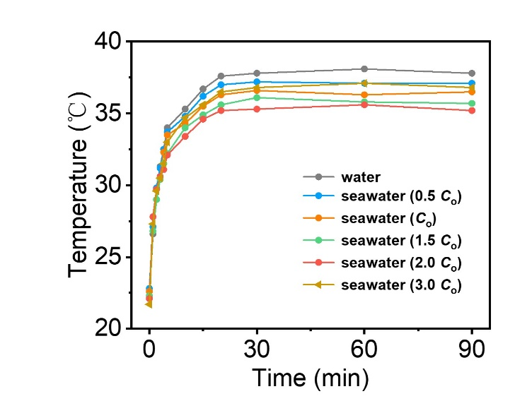
Fig. S4 │ Time-dependent evaporation surface temperature change of the HNT-photothermal hydrogel in pure water and different concentrated seawater.

Fig. S5 │ a, Mass change of the HNT-photothermal hydrogel over 10 h. b, Evaporation rate of the hydrogel over 10 h. Inset: digital photograph of the hydrogel surface before and after the continuous 10 h test.

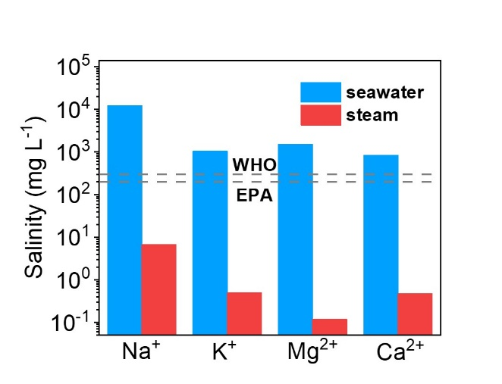
Fig. S6 │ Ion concentrations of the original seawater and condensed water.

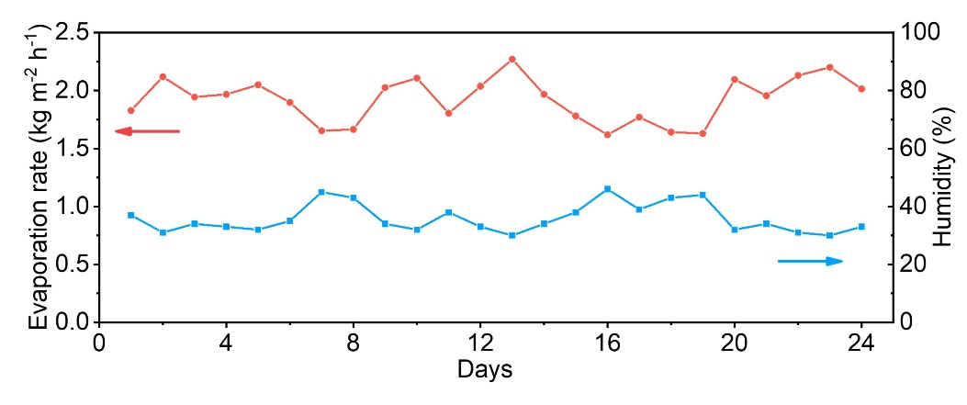
Fig. S7 │ Evaporation rates and environmental humidity during a long-term (24 days) indoor evaporation test.

Fig. S8 │ Mass change during the long-term solar evaporation test of the HNT-photothermal hydrogel.

Fig. S9 │ Morphology and structure of the HNT-photothermal hydrogel after the long-term solar evaporation test. a, SEM image. b, FTIR curve. c, XRD.

Note 2: The same surface area of bulk water, seawater and pure water in HNT-photothermal hydrogel were synchronously placed in a closed circular container together with a supersaturated magnesium chloride solution (which enabled a stable RH of 33%) at 25 ºC and ambient air pressure. The distances between the three samples, each sample and side wall of the container were the same. Mass losses were recorded after 90 mins. The equivalent evaporation enthalpy (Δ𝐻_{𝑒𝑞𝑢}) of bulk water, HNT-photothermal hydrogel with seawater and pure water were calculated by vaporizing the water with identical power input (U_{in}):
𝑈_{𝑖𝑛} = Δ𝐻₀𝑚₀ = Δ𝐻_{𝑒𝑞𝑢}𝑚_{𝑔}
where Δ𝐻₀ and 𝑚₀ are the evaporation enthalpy and mass loss of bulk water; m_{g} is the mass loss of hydrogel-water.
The evaporation enthalpy of pure water at different temperature was calculated by the following Equation:
Δ𝐻₀ = 𝐶₁ + 𝐶₂𝑇 + 𝐶₃𝑇^{1.5} + 𝐶₄𝑇^{2.5} + 𝐶₅𝑇³
where 𝐶₁ = 2500.304, 𝐶₂ = -2.2521025, 𝐶₃ = -0.021465847, 𝐶₄ = 3.1750136×10^{–4}, 𝐶₅ = -2.8607959×10^{–5} are constants, and 𝑇 is temperature (°C). Thus, the Δ𝐻₀ of pure water at 25 °C was 2442 kJ kg^{–1}. The corresponding calculated Δ𝐻_{𝑒𝑞𝑢} was shown in Fig. 4b.
Fig. S10 │ Schematic diagram of the dark evaporation experiments.
Note 3: To further prove the reduced evaporation enthalpy of seawater in HNT-photothermal hydrogel, DSC was employed to measure the vaporization energy of pure water and seawater in HNT-photothermal hydrogels. The pure water and seawater in the hydrogel (same shape and surface area) were put into open Al crucibles and measured with linear heating rate of 5 °C /min, under nitrogen flow flux (50 mL/min), in the temperature range of 20 – 180 °C. Fig. S8a showed the change of heat flow as a function of temperature. A sharp peak and a rapid decay after the signal reached a maximum were observed for pure water in the hydrogel, indicating a different evaporation behavior between pure water and seawater in the HNT-photothermal hydrogel. The seawater in hydrogel had a lower evaporation enthalpy.
Fig. S11 │ a, DSC curves of the HNT-photothermal hydrogel with seawater and pure water, separately. b, Evaporation enthalpies of pure water and seawater in HNT-photothermal hydrogel based on DSC analysis.

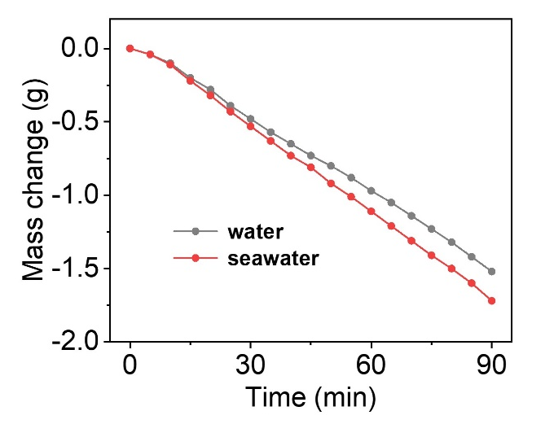
Fig. S12 │ Pure water and sweater evaporation behavior of the HNTs-CNTs film without SA hydrogel.

Note 4: The N-hydrogel was synthesized via the same method as used to prepare HNT-photothermal hydrogel but without addition of HNTs. Typically, CNT (20 mg) and SDBS (20 mg) were homogenously dispersed in 8 mL water via ultrasonication for 30 mins. Then, a CNT-SA dispersion was produced by mixing the above solution with 2 mL SA solution (25 mg/mL) under ultrasonication for 10 mins. The CNT-SA dispersion was then transferred into a PTFE mold (diameter: 3 cm) and placed on a surface of copper block under liquid nitrogen. After the dispersion was fully frozen, it was freeze-dried for 24 h to obtain the initial aerogel. The freeze-dried aerogel was then immersed into 5.0 wt% AlCl₃ solution for 48 h to form an Al³⁺ cross-linked N-hydrogel. The cross-linked N-hydrogel was washed with water to remove any residual Al³⁺.

Fig. S13 │ Evaporation behavior of the N-hydrogel without HNTs. a, mass change of the N-hydrogel in pure water and seawater. b, corresponding evaporation rates of pure water and seawater with the N-hydrogel.

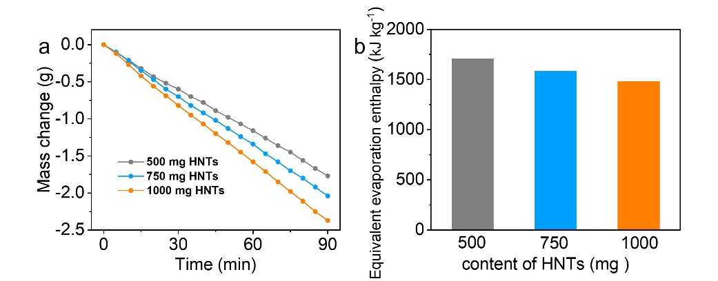
Fig. S14 │ Evaporation performance of HNT-photothermal hydrogels with different HNT contents. a, mass changes of seawater over the hydrogels with different HNT contents. b, measured equivalent evaporation enthalpies of seawater in hydrogels with different HNT contents.

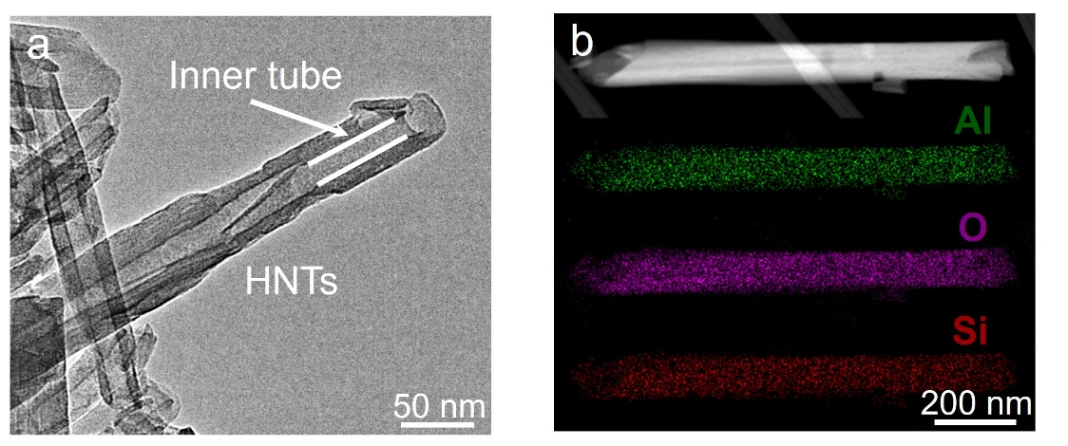
Fig. S15 │ a, TEM image of the HNTs. b, TEM−EDS elemental maps of the single HNT.
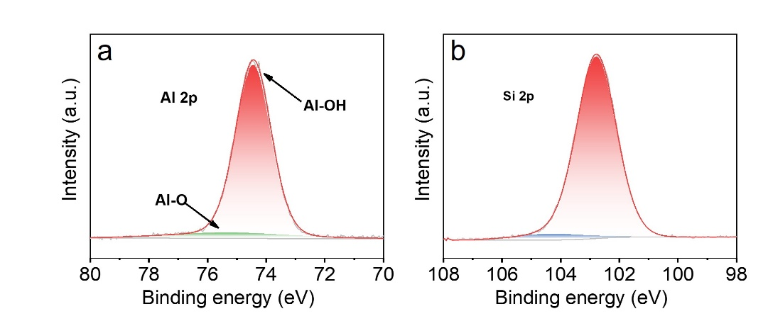
Fig. S16 │ a, XPS curve of Al 2p in HNTs. b, XPS curve of Si 2p in HNTs.
Fig. S17 │ Speciation calculations using Visual MINTEQ showing that the dissolution of HNTs increased with pH.
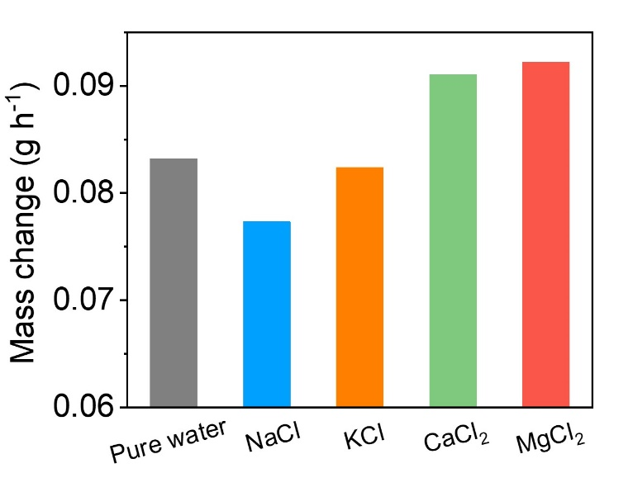
Fig. S18 │ Mass change of 0.529 M NaCl, 0.027 M KCl, 0.021 M CaCl₂, 0.064 M MgCl₂ solutions and pure water during dark evaporation.

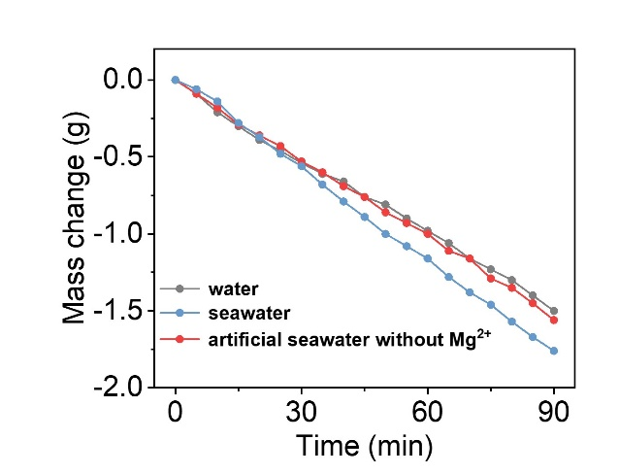
Fig. S19 │ Mass change of seawater, artificial seawater without Mg²⁺, and pure water over the HNT-photothermal hydrogel under 1 sun illumination.

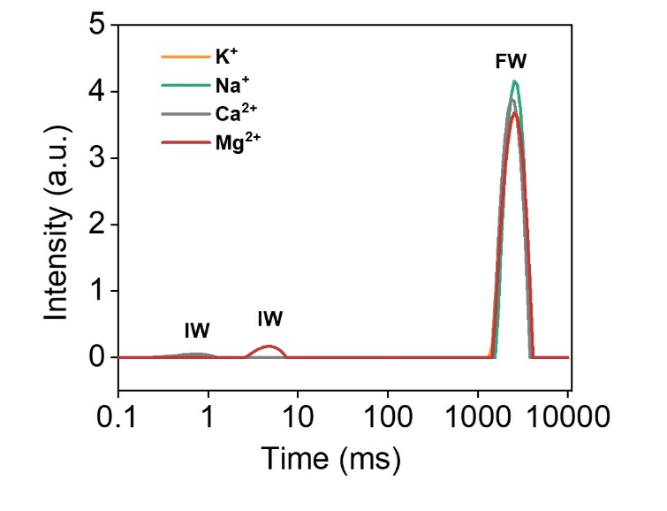
Fig. S20 │ T₂ relaxation spectra of NaCl, KCl, CaCl₂ and MgCl₂ solutions.

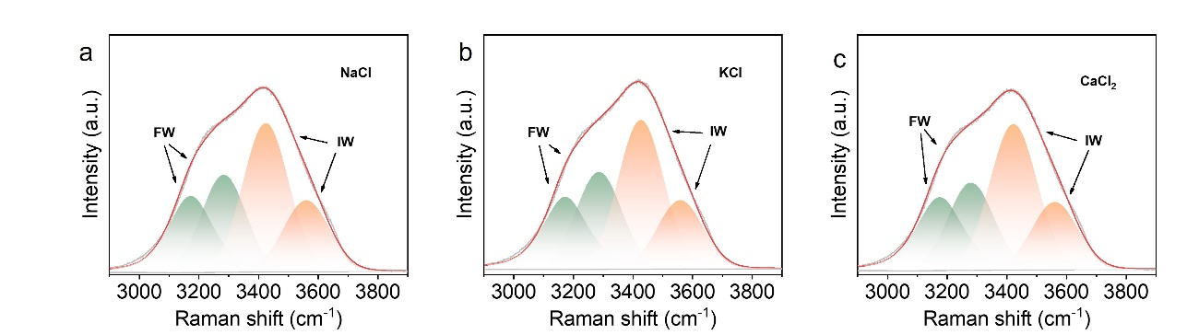

Fig. S21 │ Raman spectra showing the fitting peaks of IW and FW of a, NaCl, b, KCl, and c, CaCl₂ solutions.

Fig. S22 │ Top and side view of the atomic structure of HNT.

Fig. S23 │ Top and side view of the atomic structure of ion exchanged HNTs.

Fig. S24 │ The statistical water molecule loss of pure water over original HNTs and seawater over modified HNTs.

Fig. S25 │ Snapshots of seawater evaporation on the original HNTs surface at 0, 50, 100, and 200 ps.

Fig. S26 │ The statistical water molecule loss over evaporation time of seawater over original HNTs.

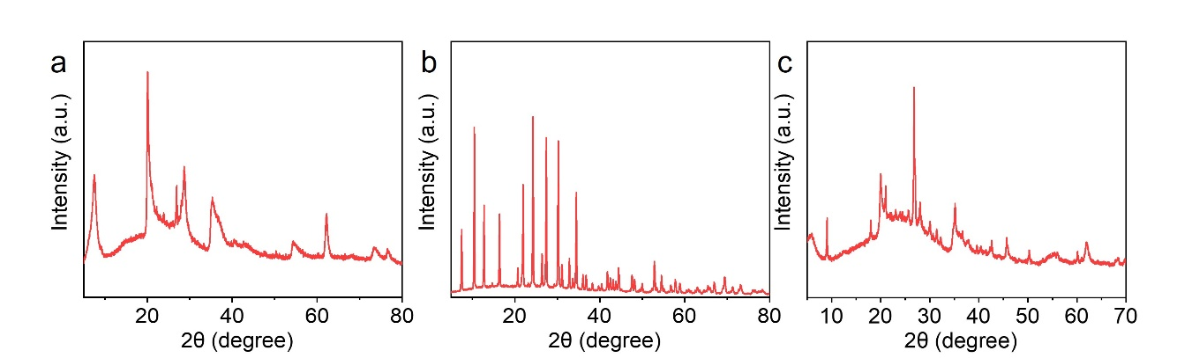
Fig. S27 │ XRD patterns of a, bentonite, b, zeolite and c, montmorillonite.

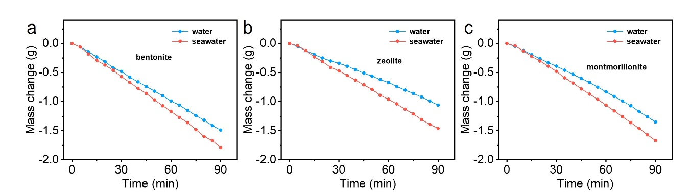
Fig. S28 │ Mass change of the a, BT, b, ZL, and c, MN-photothermal hydrogels in pure water and seawater.

Note 5: The HNT-rGO-hydrogel was synthesized via the same method as used to prepare HNT-photothermal hydrogel but replacing CNTs by rGO. Typically, rGO (20 mg) and SDBS (20 mg) were homogenously dispersed in 8 mL water via ultrasonication for 30 mins. 500 mg HNTs was added into the rGO dispersion and ultrasonicated for another 10 mins. Then, a rGO-HNT-SA dispersion was produced by mixing the above solution with 2 mL SA solution (25 mg/mL) under ultrasonication for 10 mins. The rGO-HNT-SA dispersion was then transferred into a PTFE mold (diameter: 3 cm) and placed on a surface of copper block under liquid nitrogen. After the dispersion was fully frozen, it was freeze-dried for 24 h to obtain the initial aerogel. The freeze-dried aerogel was then immersed into 5.0 wt% AlCl₃ solution for 48 h to form an Al³⁺ cross-linked rGO-hydrogel. The cross-linked HNT-rGO-hydrogel was washed with water to remove any residual Al³⁺.

Fig. S29 │ a, Photograph of the HNT-rGO-hydrogel evaporator. b, Solar evaporation rates of pure water (1.68 kg m⁻² h⁻¹) and seawater (2.05 kg m⁻² h⁻¹) with the HNT-rGO-hydrogel.

Note 6: The HNT-CNT-PVA-hydrogel was synthesized via the same method as used to prepare HNT-photothermal hydrogel but replacing SA by PVA. Typically, CNTs (20 mg) and SDBS (20 mg) were homogenously dispersed in 5 mL water via ultrasonication for 30 mins. 500 mg HNTs was added into the CNTs dispersion and ultrasonicated for another 10 mins. Then, a CNT-HNT-PVA dispersion was produced by mixing the above solution with 5 mL PVA solution (10 mg/mL) under ultrasonication for 10 mins. The CNT-HNT-PVA dispersion was then transferred into a PTFE mold (diameter: 3 cm) and placed on a surface of copper block under liquid nitrogen. After the dispersion was fully frozen, it was freeze-dried for 24 h to obtain the initial aerogel. The freeze-dried aerogel was then immersed into 50 mg/mL tannic acid (TA) solution for 48 h to form a cross-linked HNT-CNT-PVA-hydrogel. The cross-linked HNT-CNT-PVA-hydrogel was washed with water to remove any residual TA.
Fig. S30 │ a, Photograph of the HNT-PVA-hydrogel evaporator. b, Solar evaporation rates of pure water (1.67 kg m⁻² h⁻¹) and seawater (1.89 kg m⁻² h⁻¹) with the HNT-CNT-PVA-hydrogel.

Note 7: Fabrication of HNT-sponge 3D evaporator: CNTs (20 mg) and SDBS (20 mg) were homogenously dispersed in 8 mL of water via ultrasonication for 30 mins. 500 mg HNTs was added into the rGO dispersion and ultrasonicated for another 10 mins. Then, a CNT-HNT-SA dispersion was produced by mixing the above solution with 2 mL SA solution (25 mg/mL) under ultrasonication for 10 mins. The CNTs-HNTs-SA dispersion was dropped on the sponge surfaces and frozen using liquid nitrogen. Thereafter, the sponge was freeze-dried for 24 h to obtain the initial 3D HNT-sponge evaporator. The HNT-sponge was then immersed into 5.0 wt% AlCl₃ solution for 48 h to form an Al³⁺ cross-linked 3D HNT-sponge evaporator. The HNT-sponge evaporator was washed with water to remove residual Al³⁺. The dimension of the sponge evaporator was 2 (L) ×3 (W) × 3 (H) cm.
Fig. S31 │ a, Photograph of the 3D HNT-sponge evaporator. b, Mass change of the 3D HNTs-sponge evaporator with pure water and seawater.

Note 8: Typically, CNTs (20 mg) and SDBS (20 mg) were homogenously dispersed in 8 mL water via ultrasonication for 30 mins. 500 mg HNTs was added into the rGO dispersion and ultrasonicated for another 10 mins. Then, a CNT-HNT-SA dispersion was produced by mixing the above solution with 2 mL SA solution (25 mg/mL) under ultrasonication for 10 mins. The bamboo paper was immersed in the CNT-HNT-SA dispersion and frozen under liquid nitrogen. Thereafter, it was freeze-dried for 24 h to obtain the initial HNT-CNT coated bamboo paper. The HNT-CNT coated bamboo was then immersed into 5.0 wt% AlCl₃ solution for 48 h for cross-linking. The HNT-CNT coated bamboo paper was washed with water to remove residual Al³⁺.Then, the HNT-CNT coated bamboo paper was wrapped on a cotton block to produce the 3D HNT-cotton evaporator. The dimension of the 3D HNT-cotton evaporator was 3 (L) ×3 (W) ×3.5 (H) cm.
Fig. S32 │ a, Photograph of the 3D HNT-cotton evaporator. b, Mass change of the 3D HNT-cotton evaporator with pure water and seawater.

Note 9: To investigate thermal distillation performance, containers with HNT-photothermal hydrogels placed on seawater and pure water surfaces were synchronously placed in a closed oven. The oven temperature was set as 50, 60, and 70 ℃ respectively, and the mass change of water and seawater was recorded at 90 mins to calculate the thermal distillation evaporation rate.
Fig. S33 │ Thermal distillation behavior of the HNT-photothermal hydrogel in pure water and seawater.

Note 10: The HNTs used in this work were purchased from Sigma Aldrich costing AU$ 247.00 for 500 g. However, only 0.5 g of HNTs is used for one sample which means the cost increase is only AU$ 0.247. For commercial large-scale production, the wholesale price of HNTs would be much cheaper (AU$ 0.0086 per evaporator. Price sourced from Alibaba.com).

