Supplementary appendix
Appendix 1
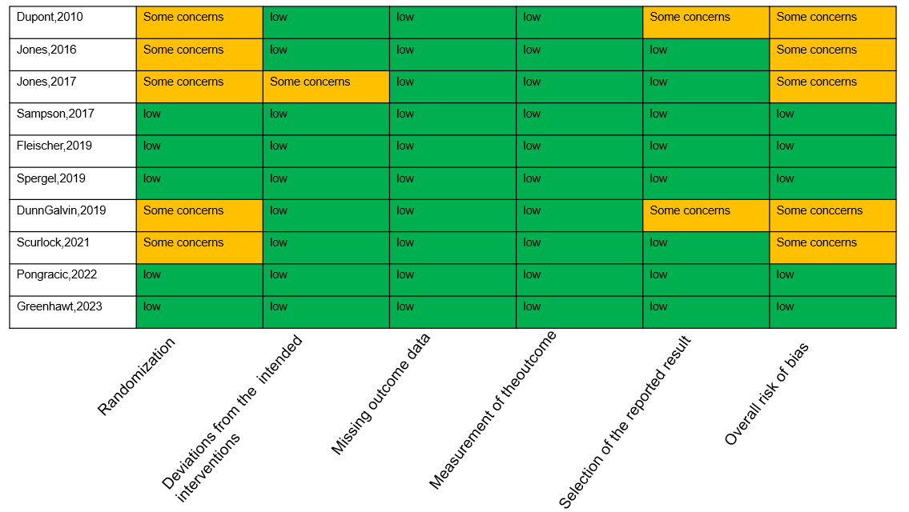
Risk-of-bias diagram of the included studies

Appendix 2
topical medication utilization Local adverse reactions
Systemic adverse reactions epinephrine utilization

Desensitization Serious adverse events
Appendix 3

