Supplementary data
Through ICA analysis, we decomposed all the data of the subject into 41 principal components (N=41, supplementary Figures S1 to S41), calculated the spatial map and time process, and then removed the components whose Power_{LF}/Power_{HF} values were < 1 from the spatial map. These components were usually composed of artifacts. We sorted the principal components with the standard visual function network template the imaging experts selected the fifth principal component as the visual function network component of the subjects, and obtained the mask image (figure 42) by conducting a single sample T-test (Table S1) on the data. This mask image was used as a template for the subsequent paired T-test of the functional connection of the visual functional network for the first and second fMRI data.
Supplementary figures
Figures S1 to S41: 41 principal components decomposed by the ICA method.
Among them, Under the advice of a radiology expert, we consider Figure S5 as ROI.
Figure S42: Mask image of visual function network obtained by single sample T-test.
Table S1. Results of single sample T-test for obtaining mask images
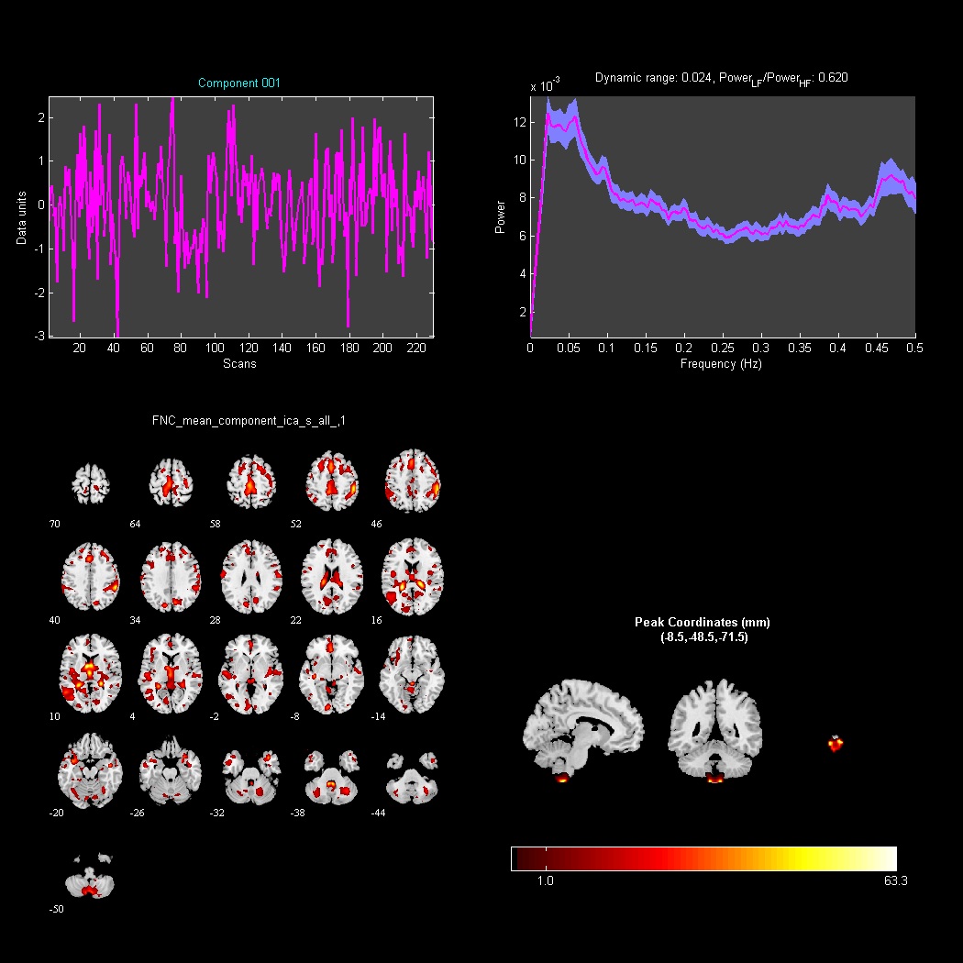
Figure S1. Principal Component 1 (Power_{LF}/Power_{HF}=0.620 ,invalid component).
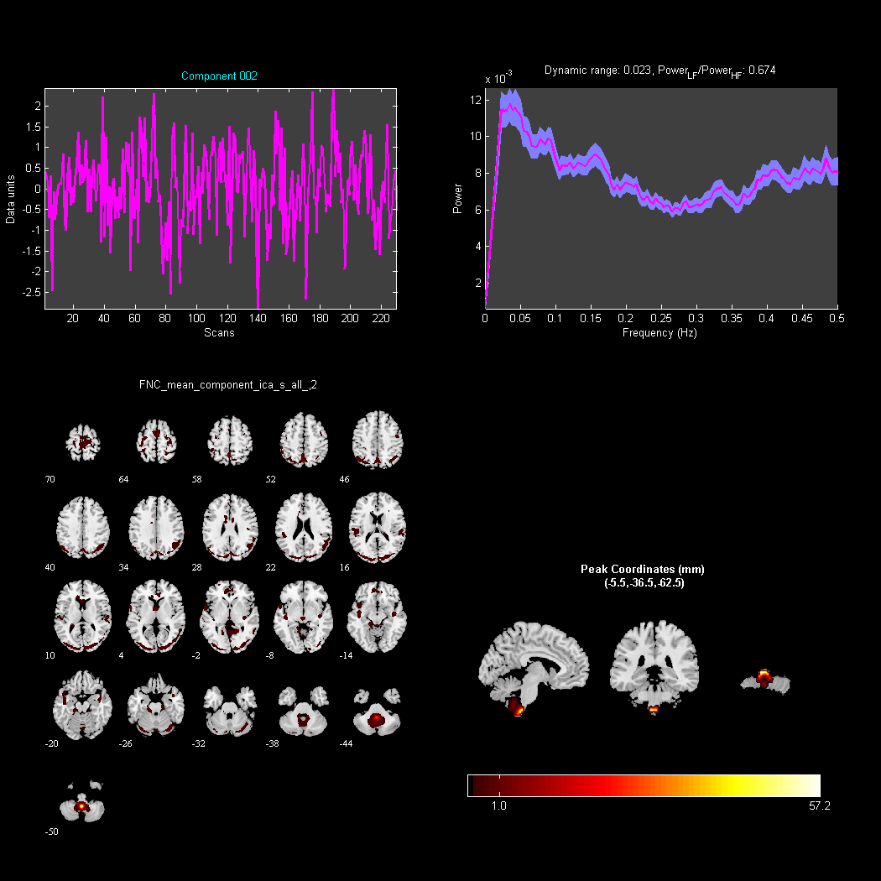
Figure S2. Principal Component 2 (Power_{LF}/Power_{HF}=0.674 ,invalid component).

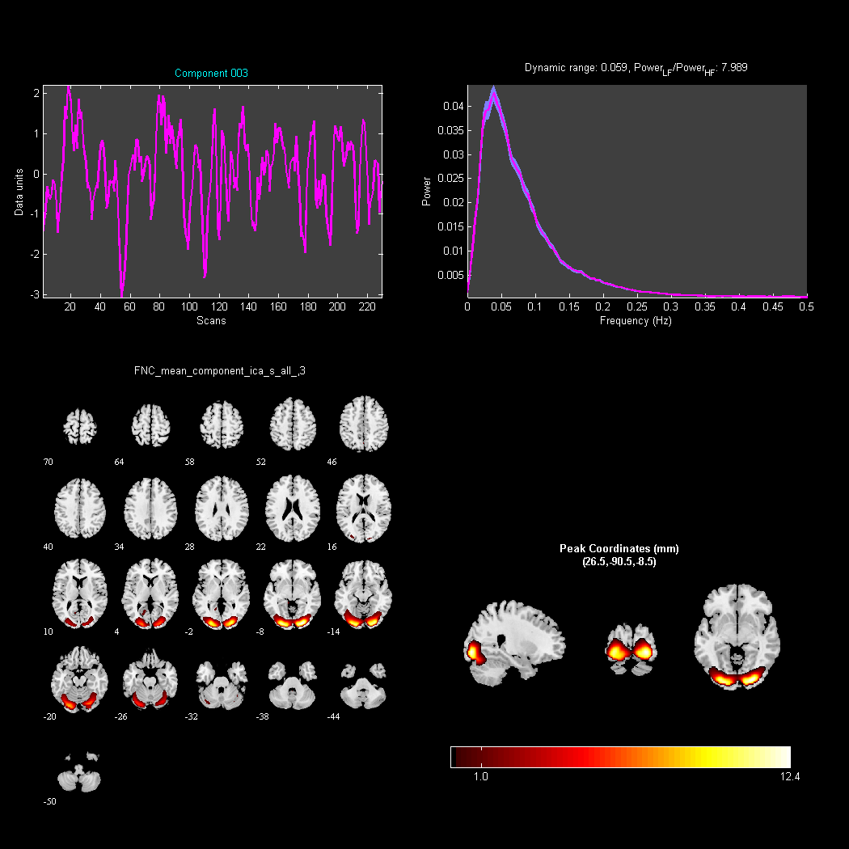
Figure S3. Principal Component 3 (Power_{LF}/Power_{HF}=7.989 ,valid component).
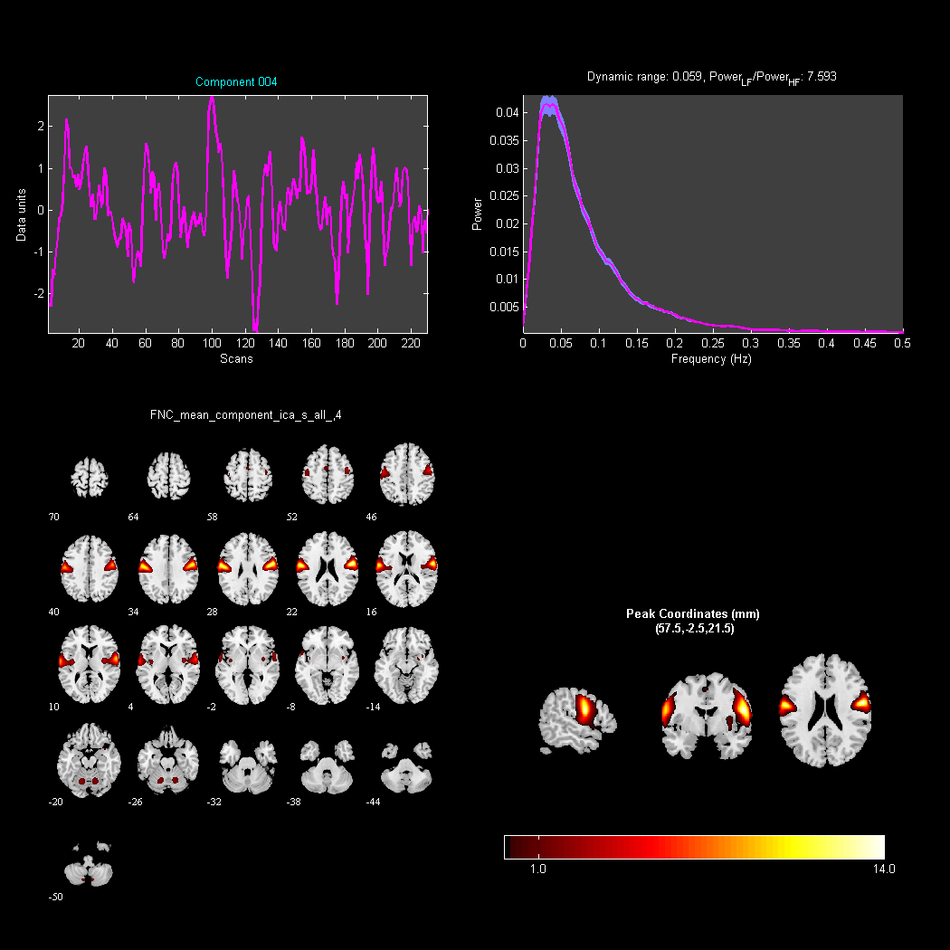
Figure S4. Principal Component 4 (Power_{LF}/Power_{HF}=7.593 ,valid component).
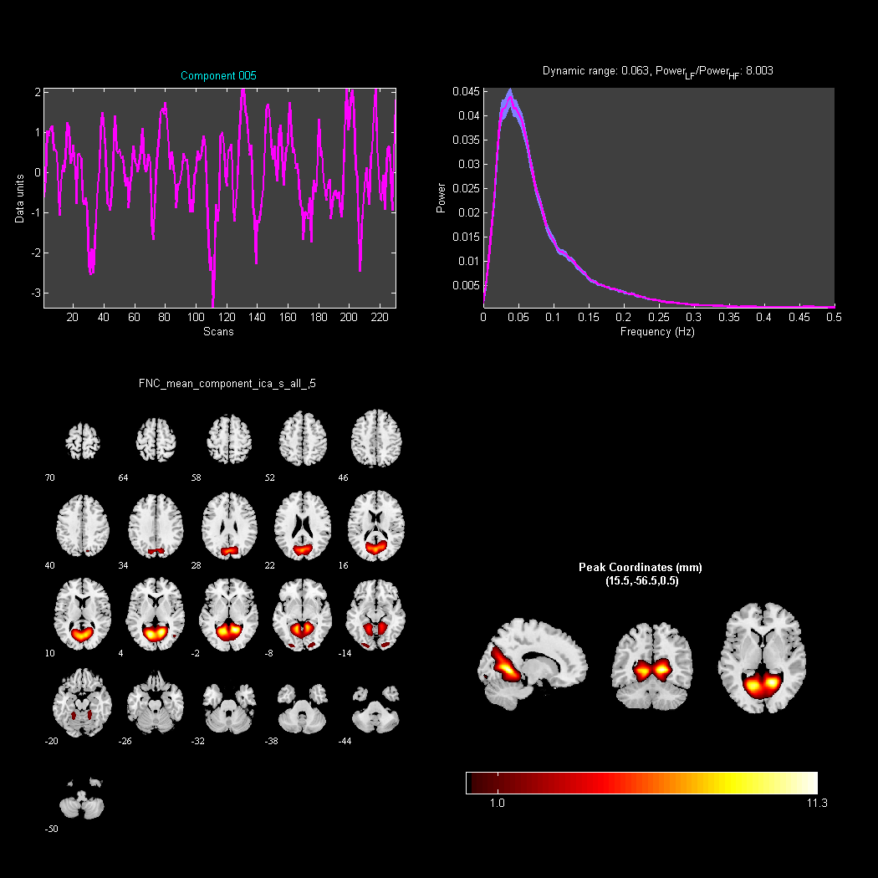
Figure S5. Principal Component 5 (Power_{LF}/Power_{HF}=8.003, valid component,as visual ROI).
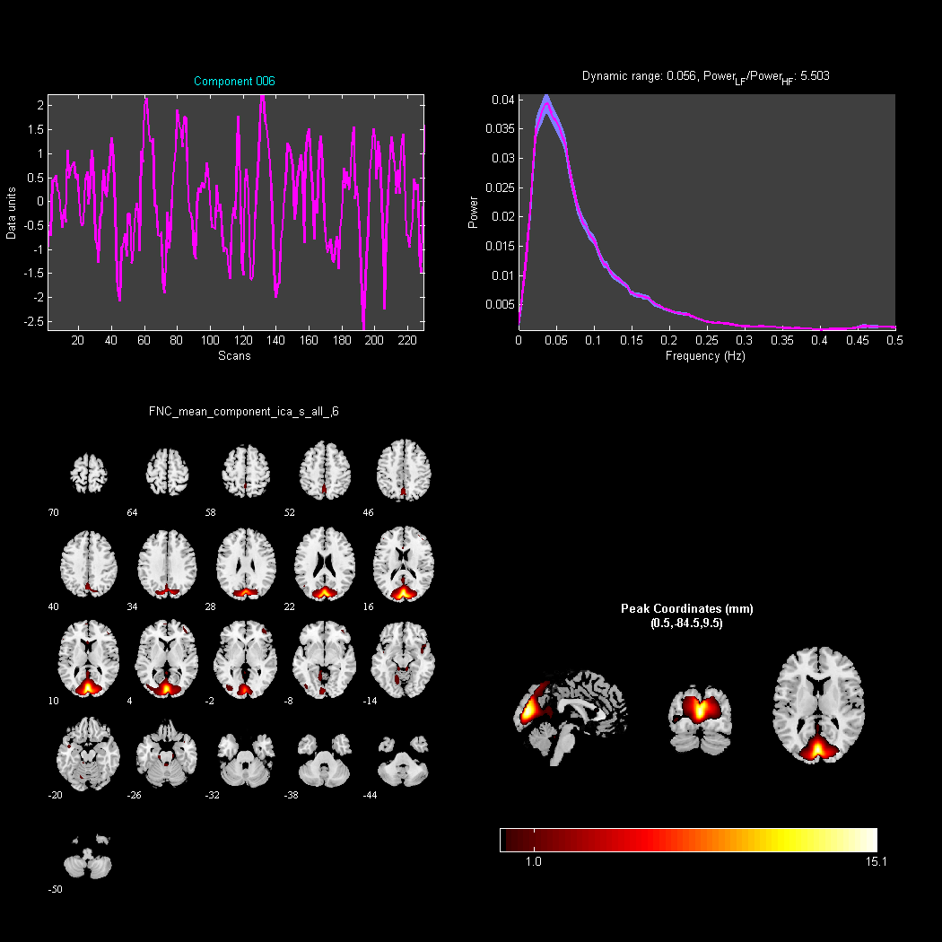
Figure S6. Principal Component 6 (Power_{LF}/Power_{HF}=5.503,valid component).
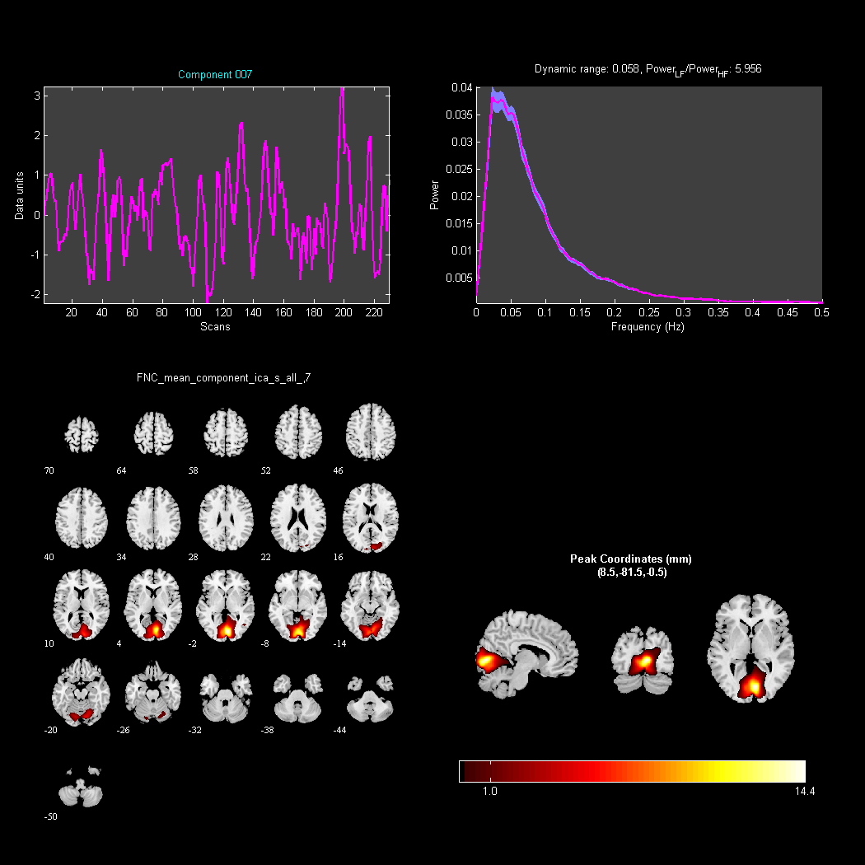
Figure S7. Principal Component 7 (Power_{LF}/Power_{HF}=5.956 ,valid component).

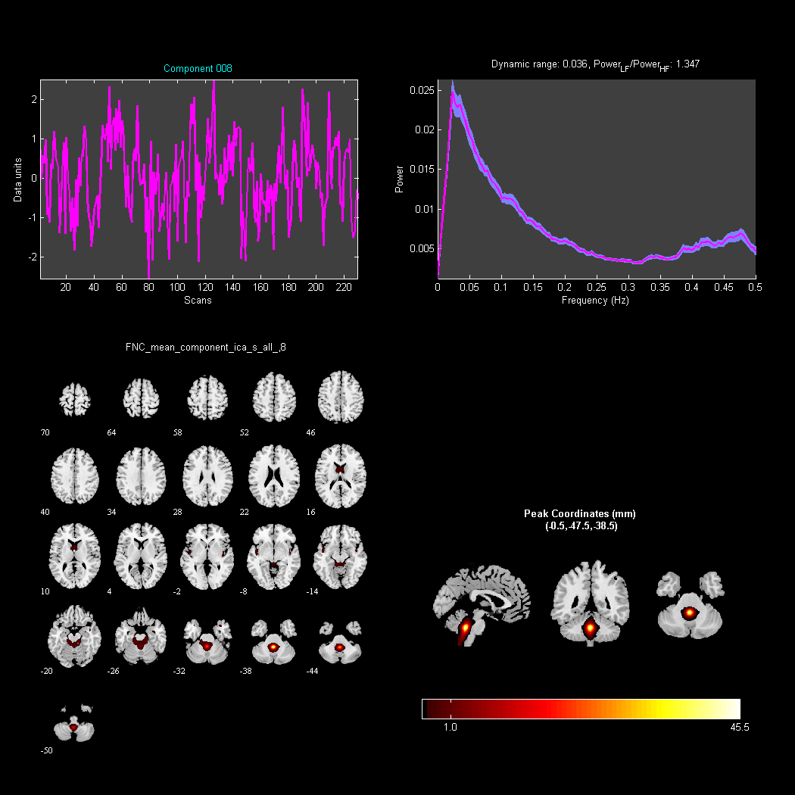
Figure S8. Principal Component 8 (Power_{LF}/Power_{HF}=1.347,valid component).

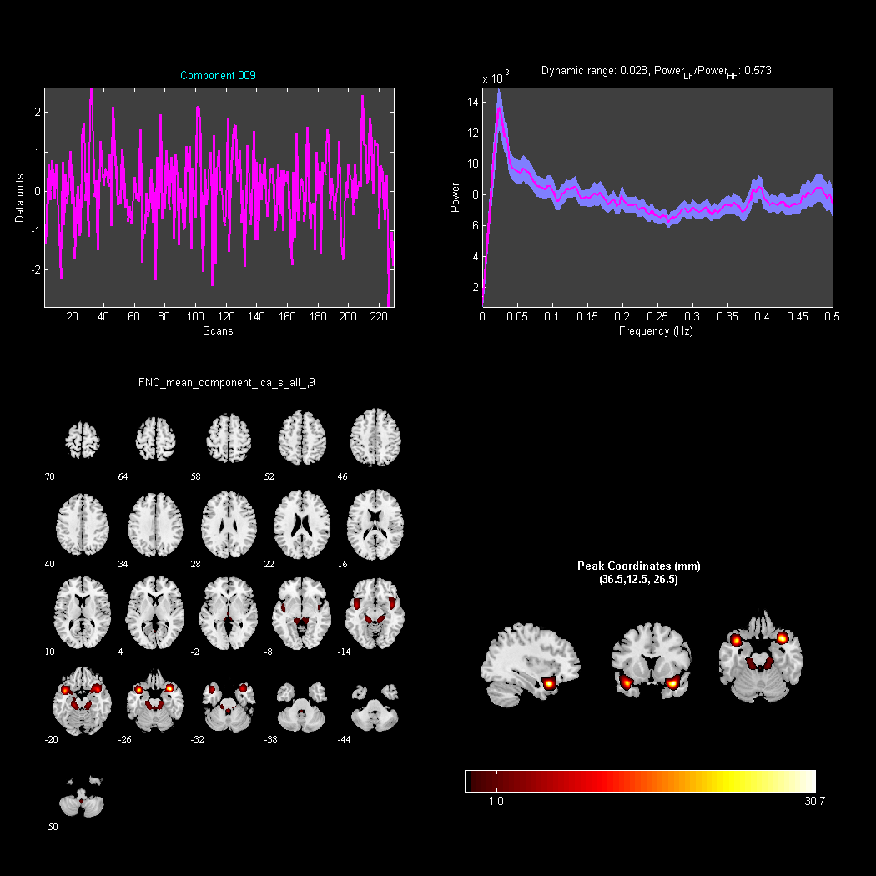
Figure S9. Principal Component 9 (Power_{LF}/Power_{HF}=0.573 ,Invalid component).

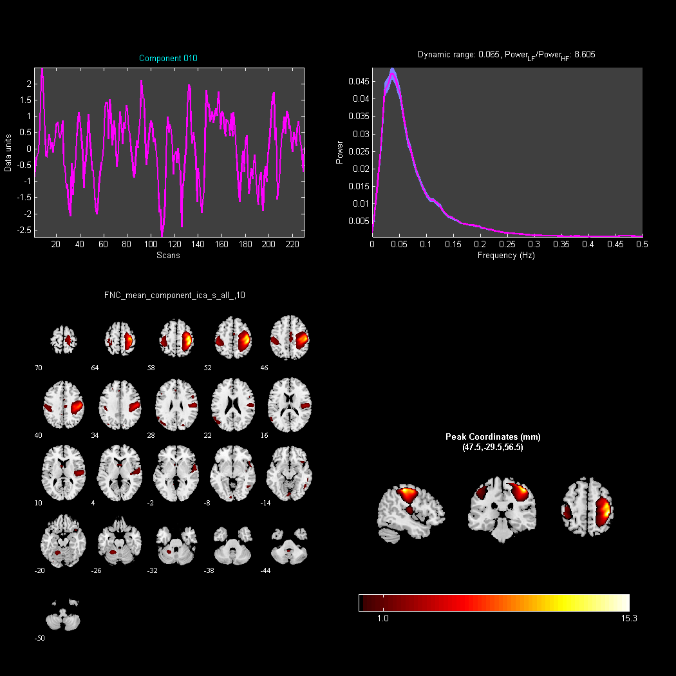
Figure S10. Principal Component 10 (Power_{LF}/Power_{HF}=8.605,valid component).

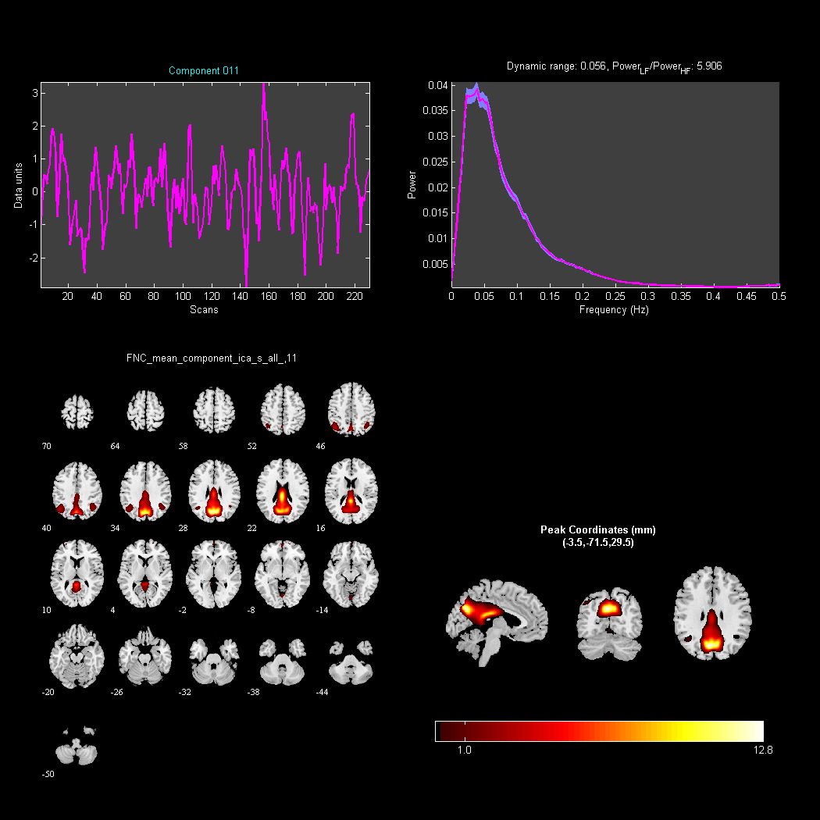
Figure S11. Principal Component 11 (Power_{LF}/Power_{HF}=5.906,valid component).

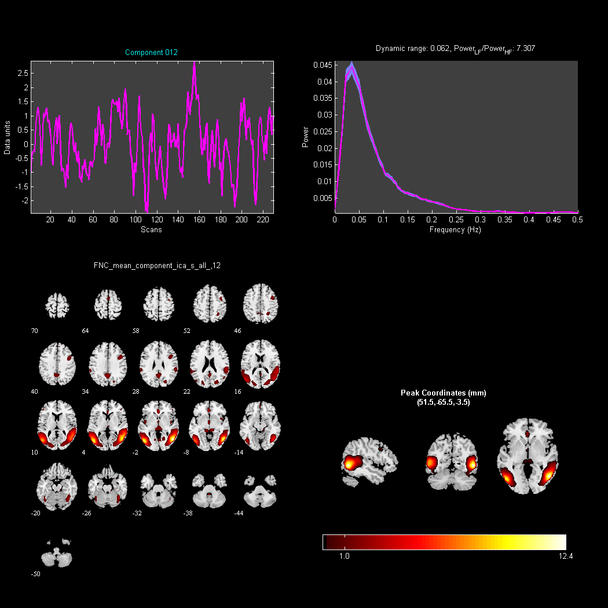
Figure S12. Principal Component 12 (Power_{LF}/Power_{HF}=7.307,valid component).

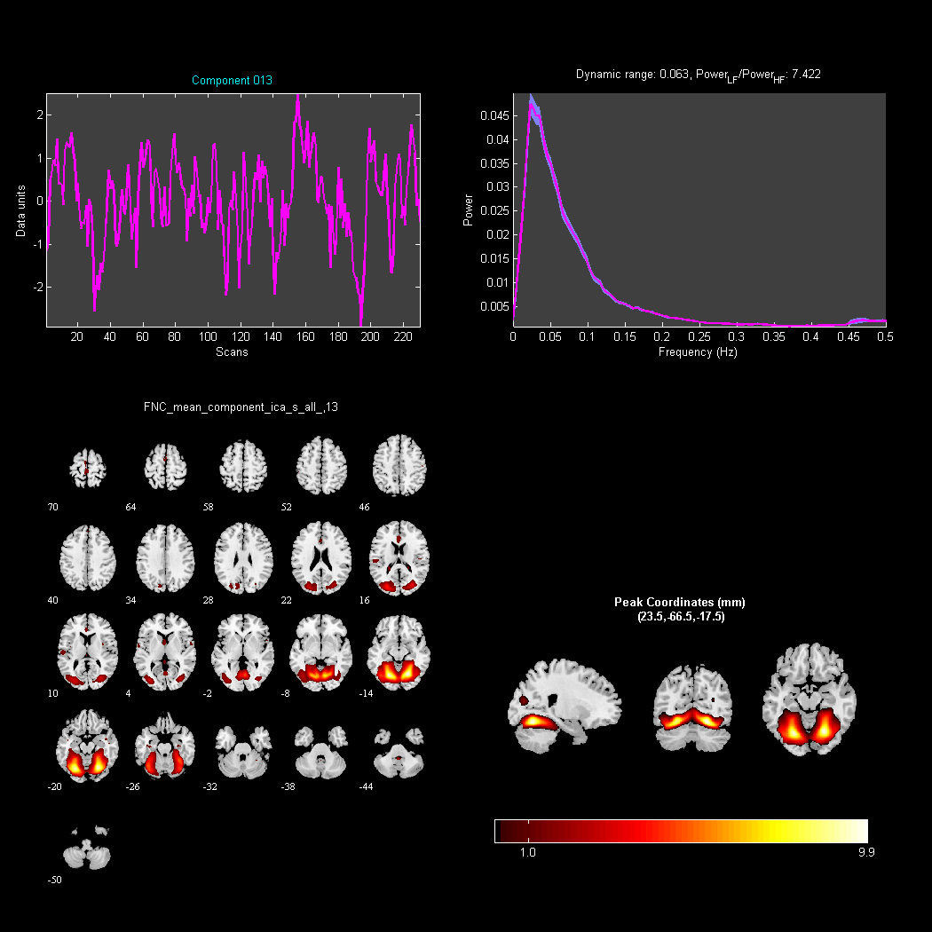
Figure S13. Principal Component 13 (Power_{LF}/Power_{HF}=7.422 ,valid component).

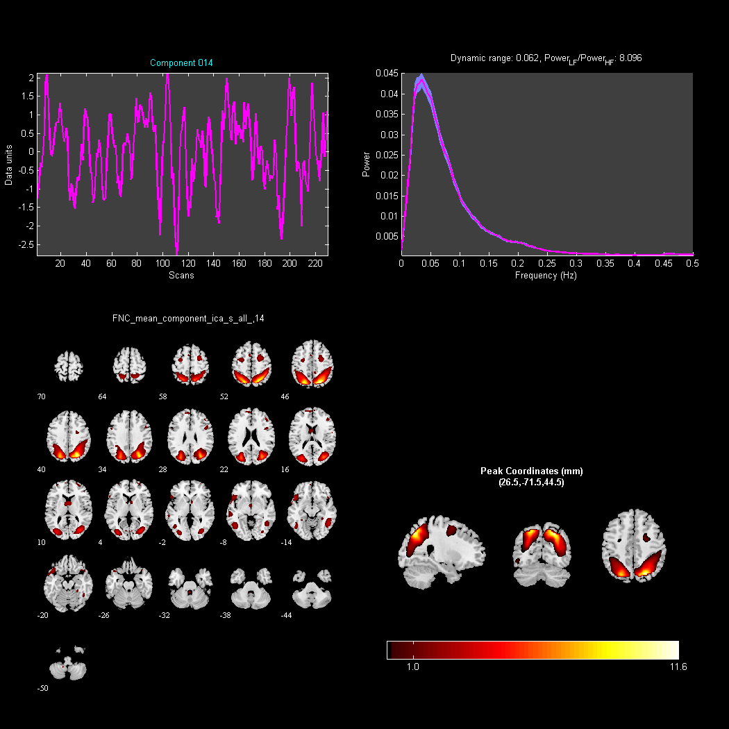
Figure S14. Principal Component 14 (Power_{LF}/Power_{HF}=8.096,valid component).

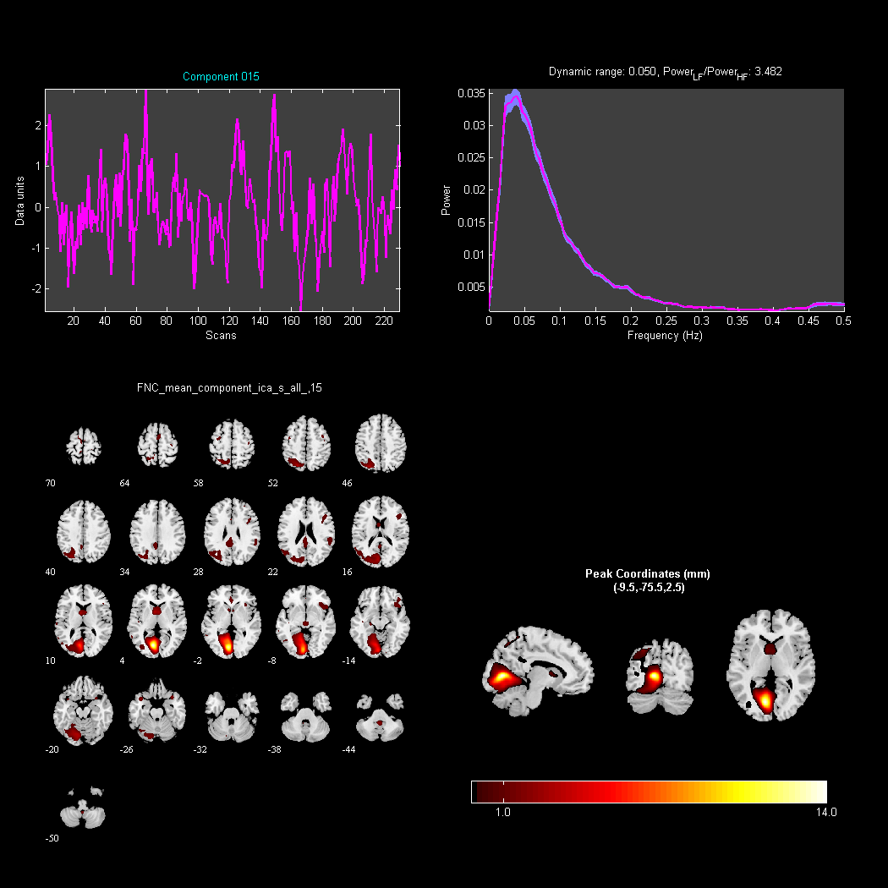
Figure S15. Principal Component 15 (Power_{LF}/Power_{HF}=3.482,valid component).

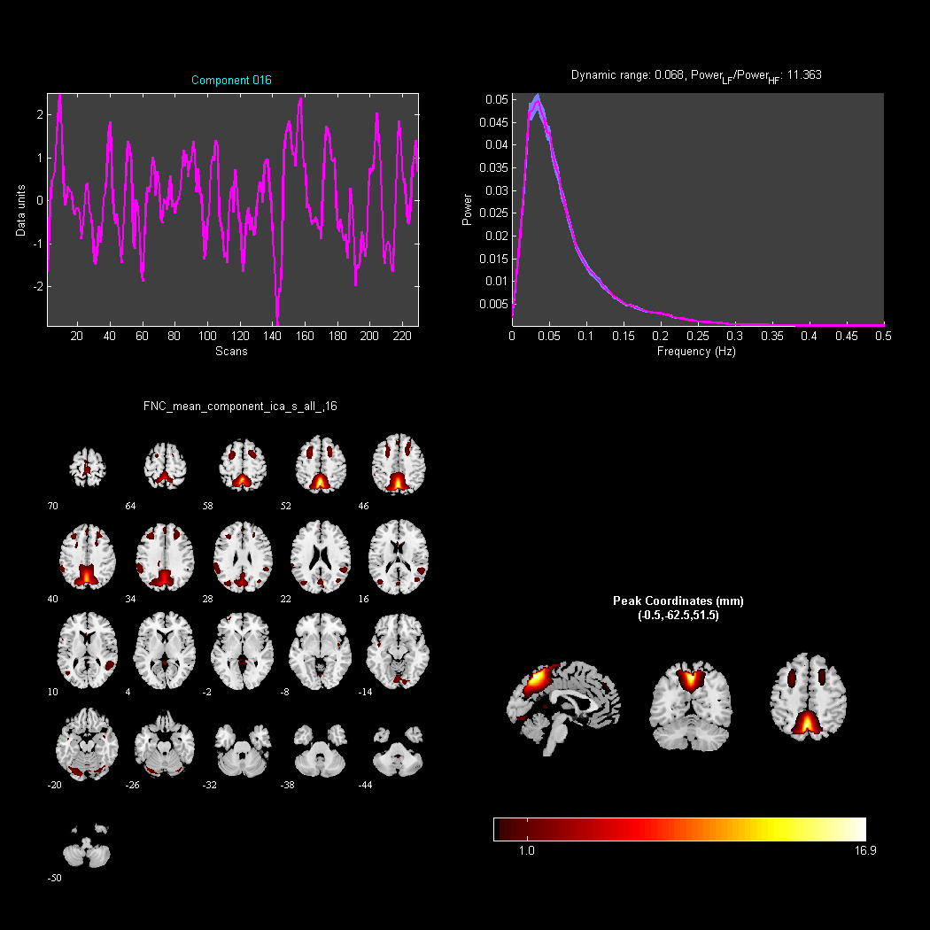
Figure S16. Principal Component 16 (Power_{LF}/Power_{HF}=11.363,valid component).

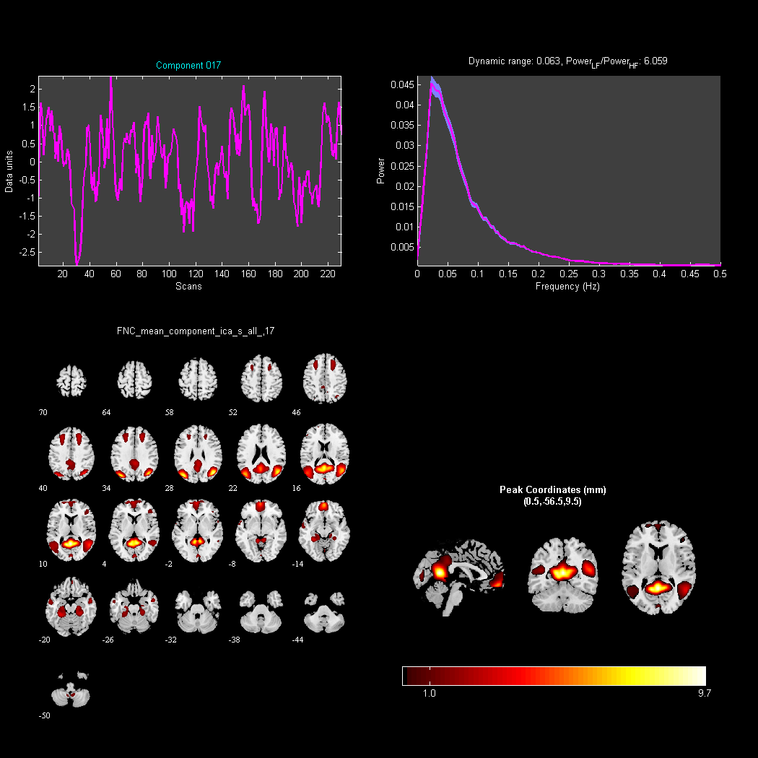
Figure S17. Principal Component 17 (Power_{LF}/Power_{HF}=6.059,valid component).

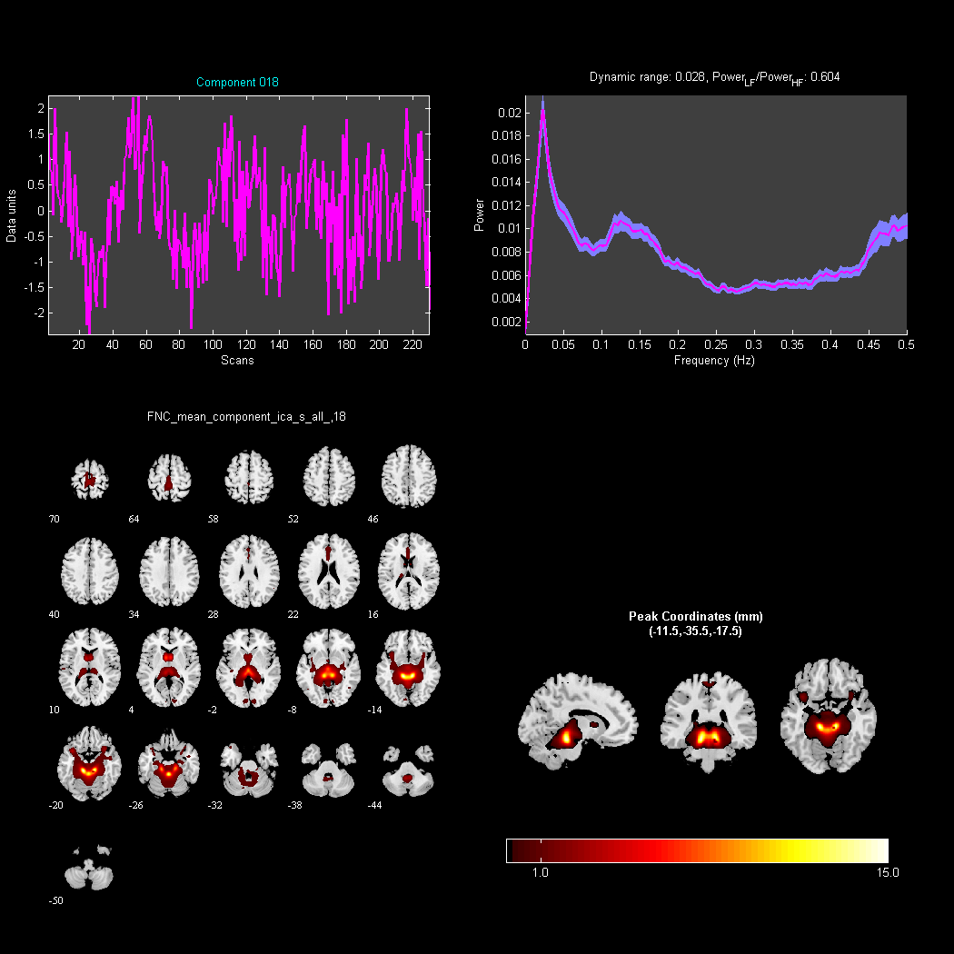
Figure S18. Principal Component 18 (Power_{LF}/Power_{HF}=0.604, Invalid component).

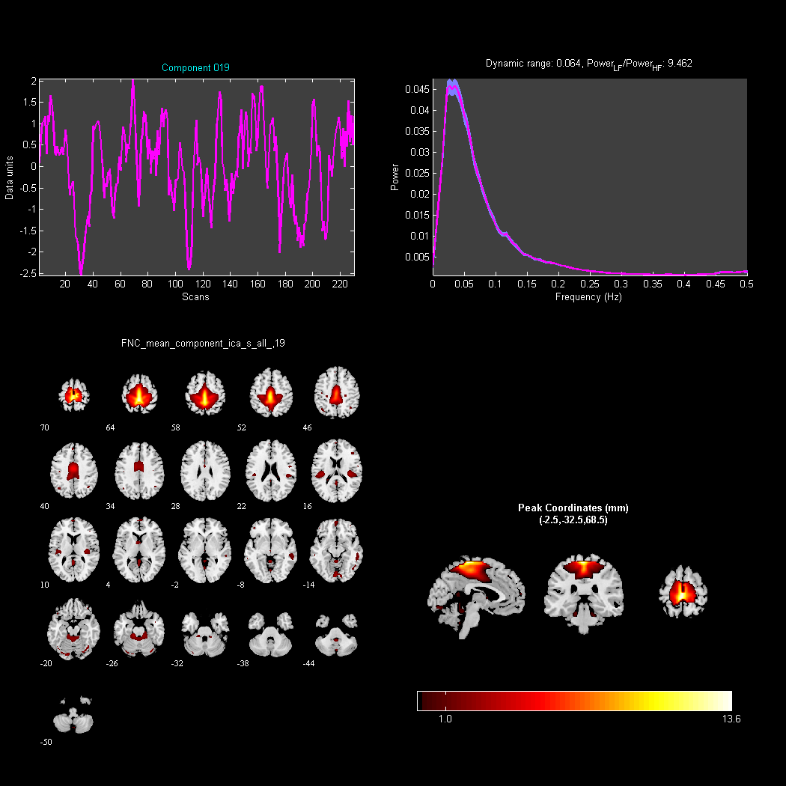
Figure S19. Principal Component 19 (Power_{LF}/Power_{HF}=9.462, valid component).

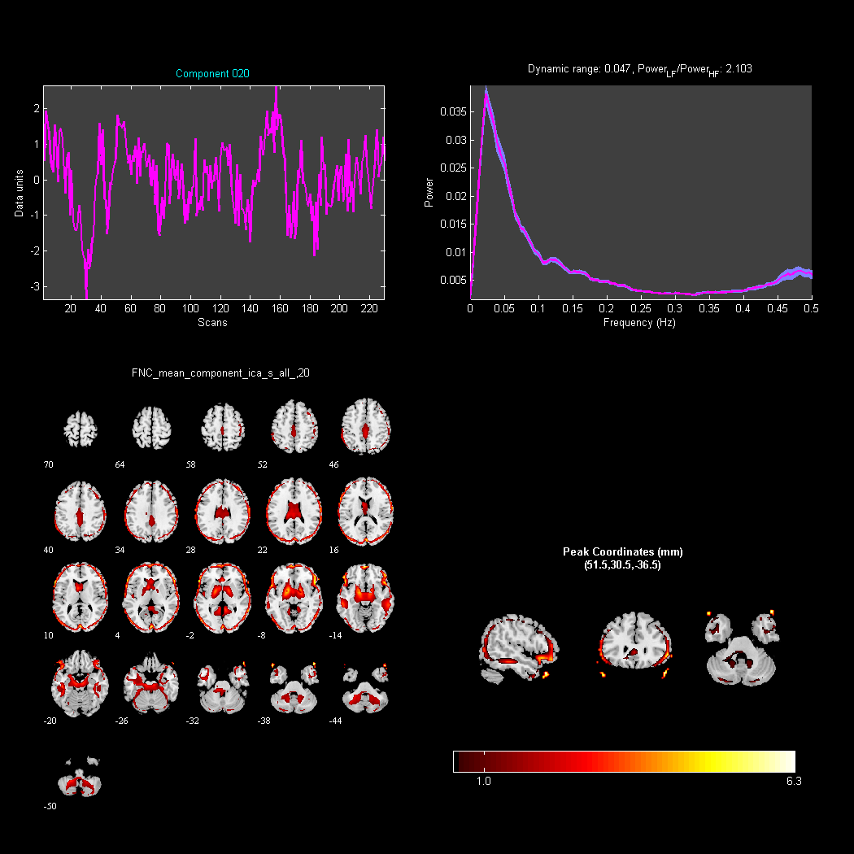
Figure S20. Principal Component 20 (Power_{LF}/Power_{HF}=2.103, valid component).

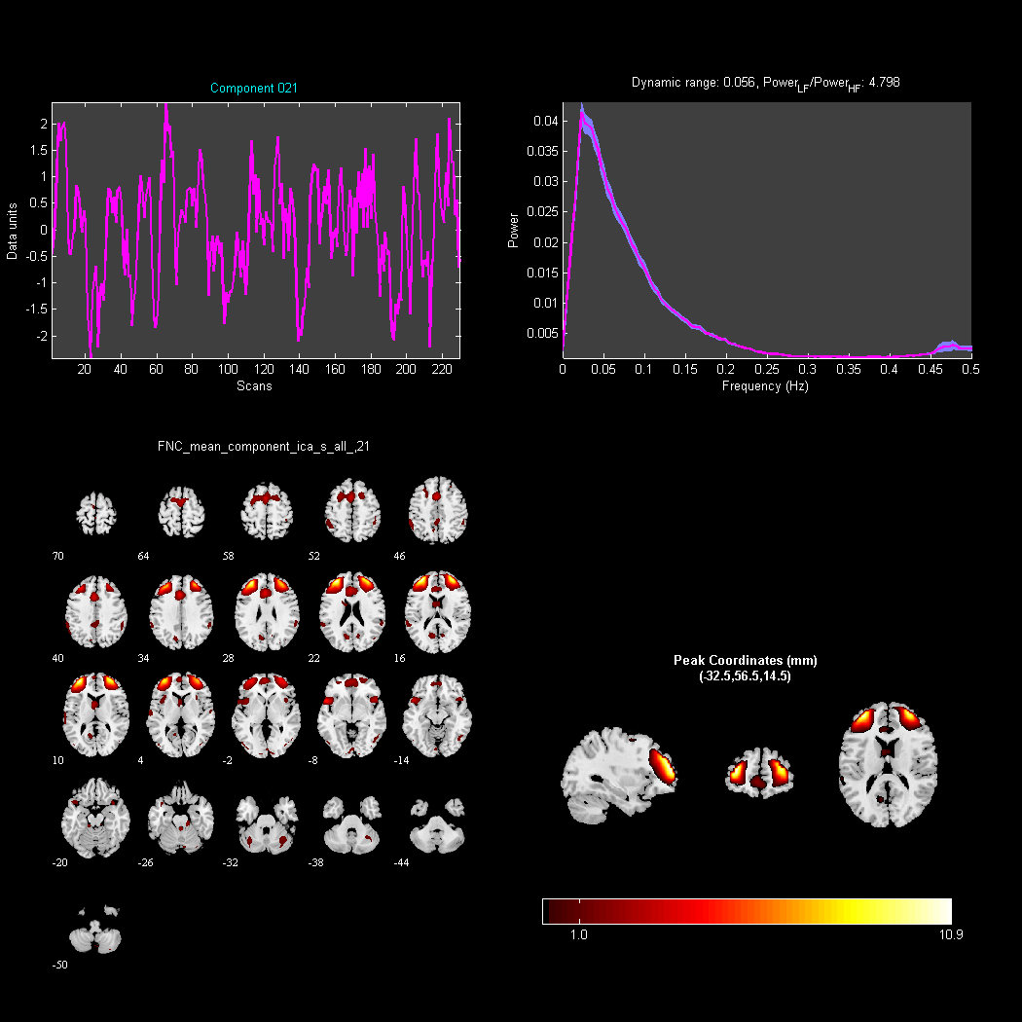
Figure S21. Principal Component 21 (Power_{LF}/Power_{HF}=4.798, valid component).

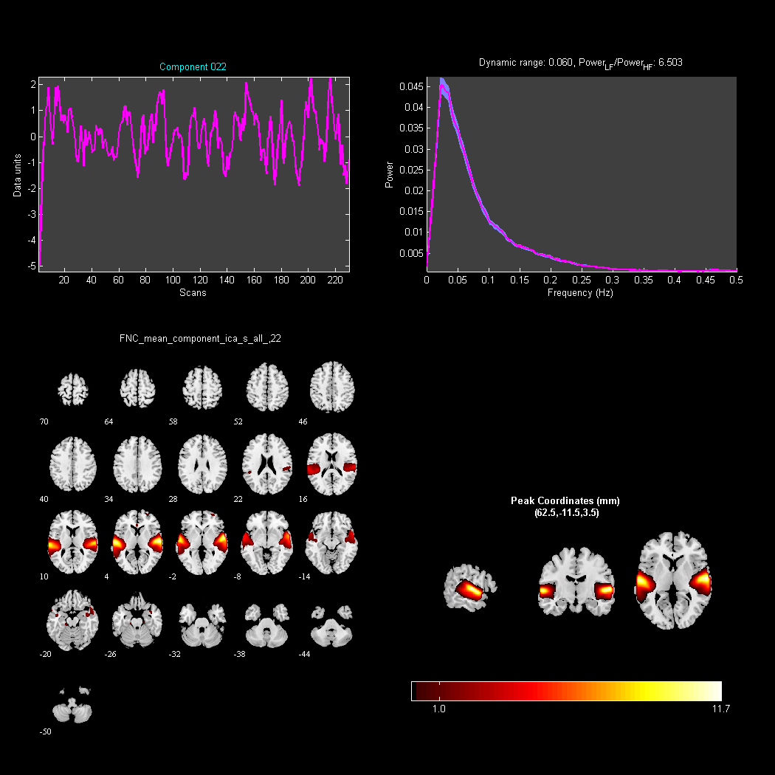
Figure S22. Principal Component 22 (Power_{LF}/Power_{HF}=6.503, valid component).

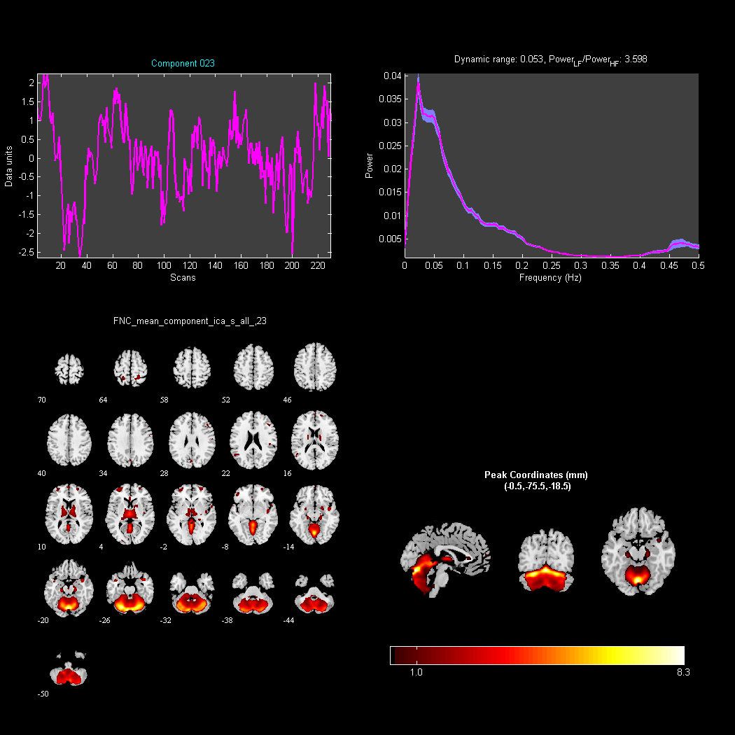
Figure S23. Principal Component 23 (Power_{LF}/Power_{HF}=3.598, valid component).

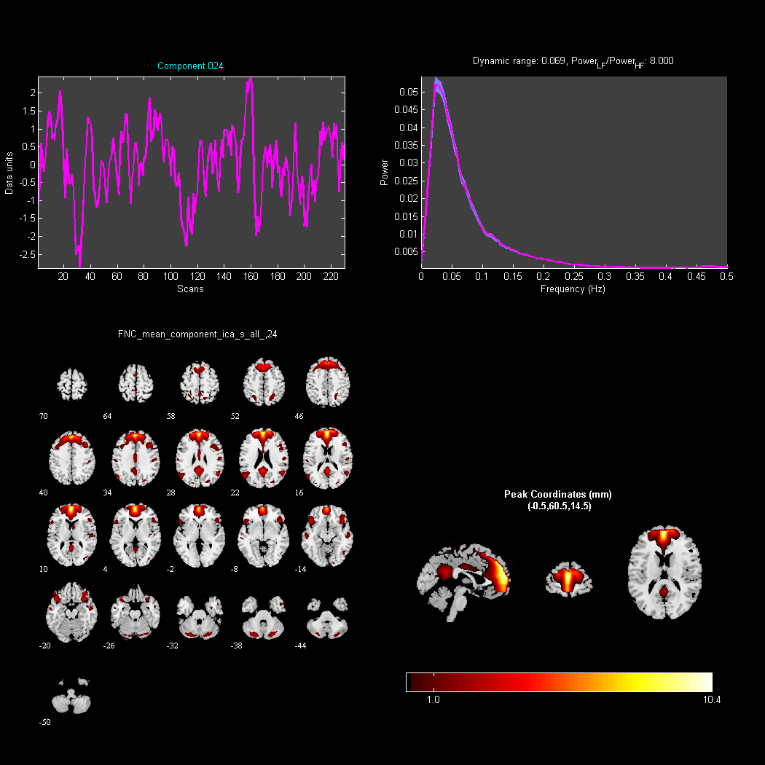
Figure S24. Principal Component 24 (Power_{LF}/Power_{HF}=8.000, valid component).

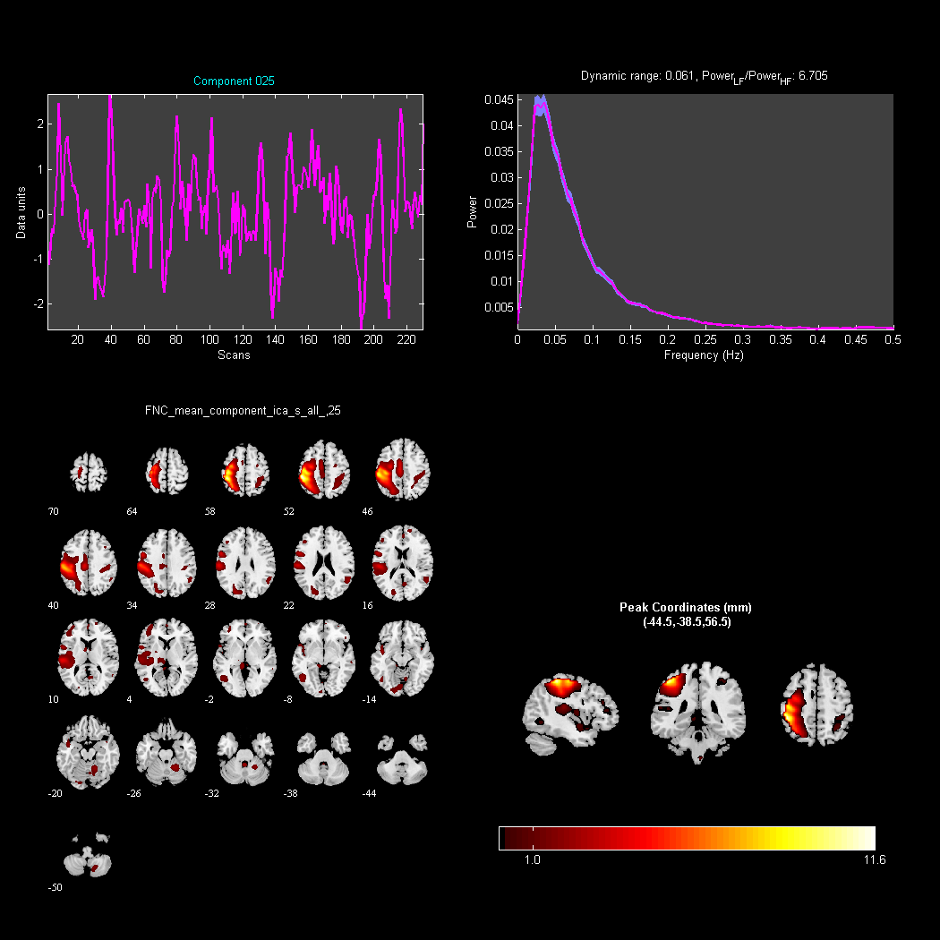
Figure S25. Principal Component 25 (Power_{LF}/Power_{HF}=6.705, valid component).

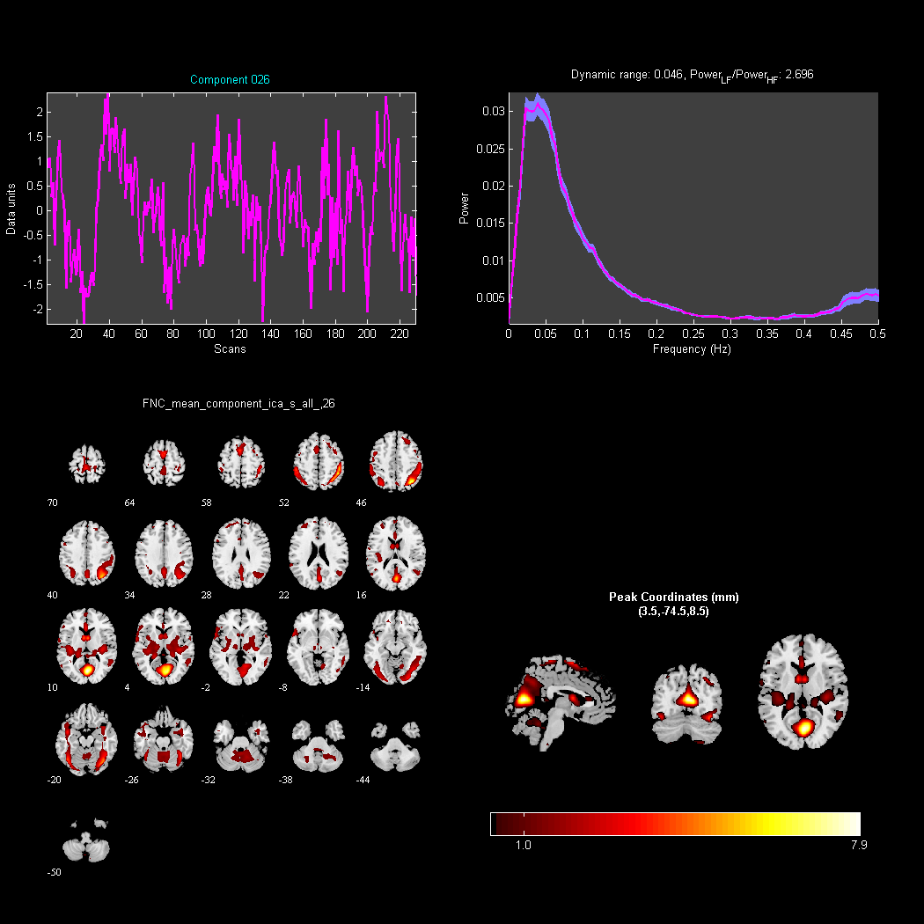
Figure S26. Principal Component 26 (Power_{LF}/Power_{HF}=2.696, valid component).

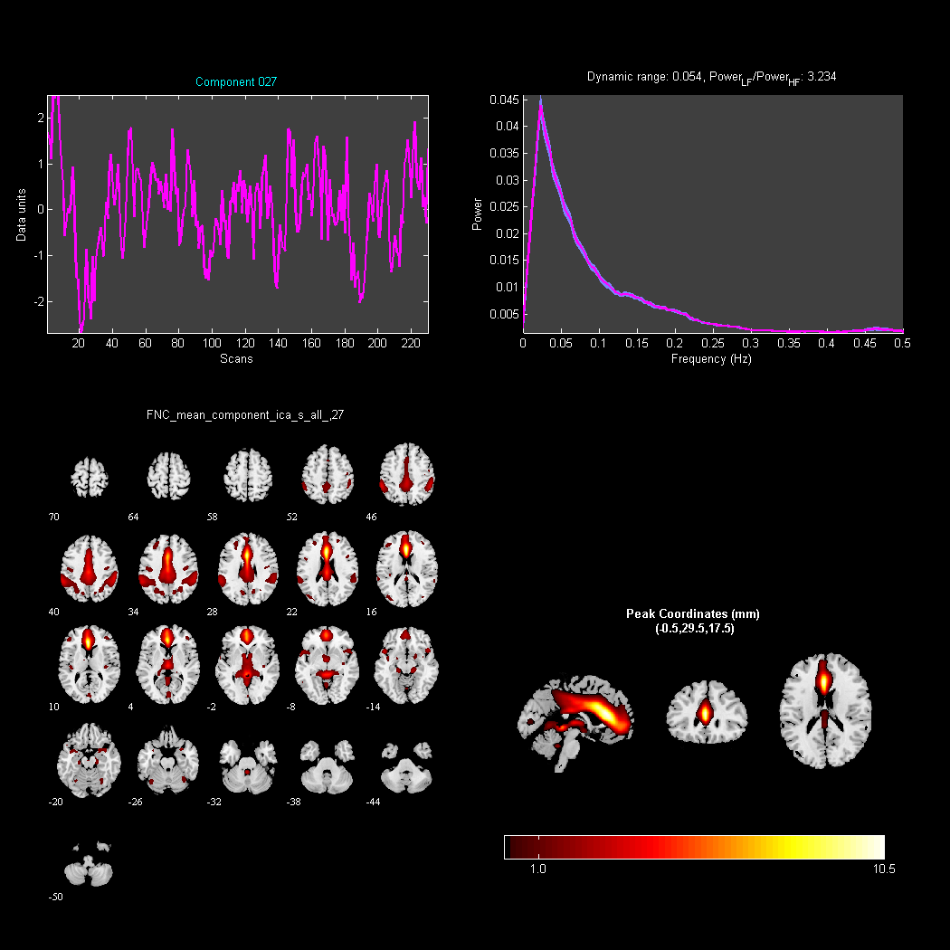
Figure S27. Principal Component 27 (Power_{LF}/Power_{HF}=3.234, valid component).

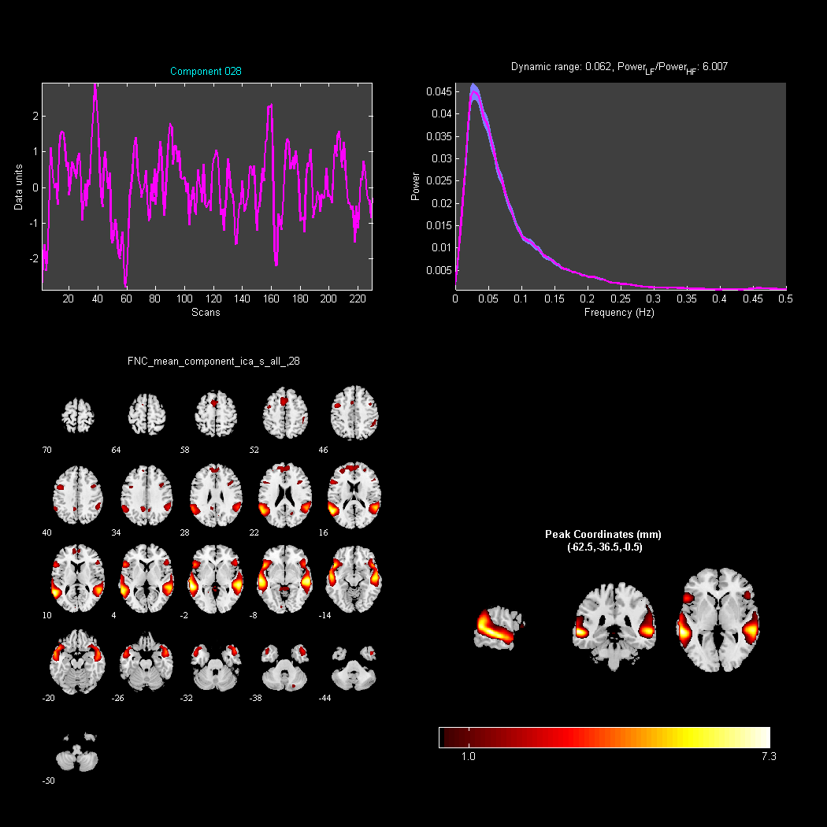
Figure S28. Principal Component 28 (Power_{LF}/Power_{HF}=6.007, valid component).

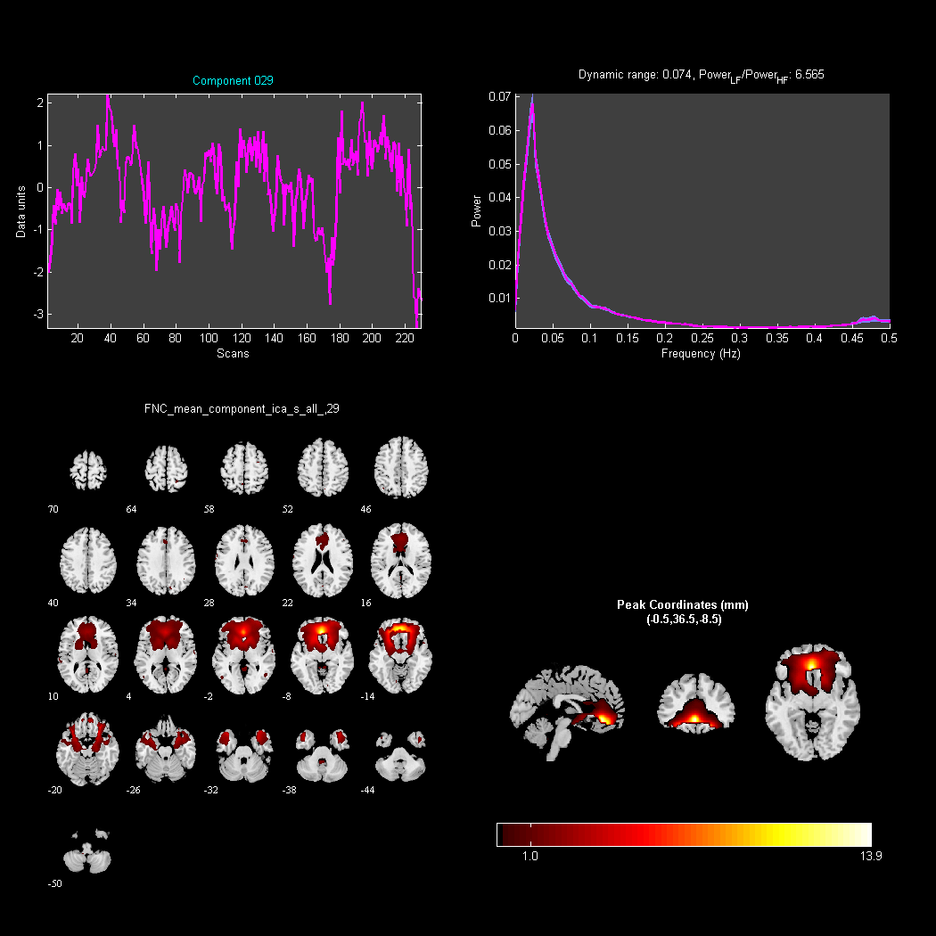
Figure S29. Principal Component 29 (Power_{LF}/Power_{HF}=6.565, valid component).

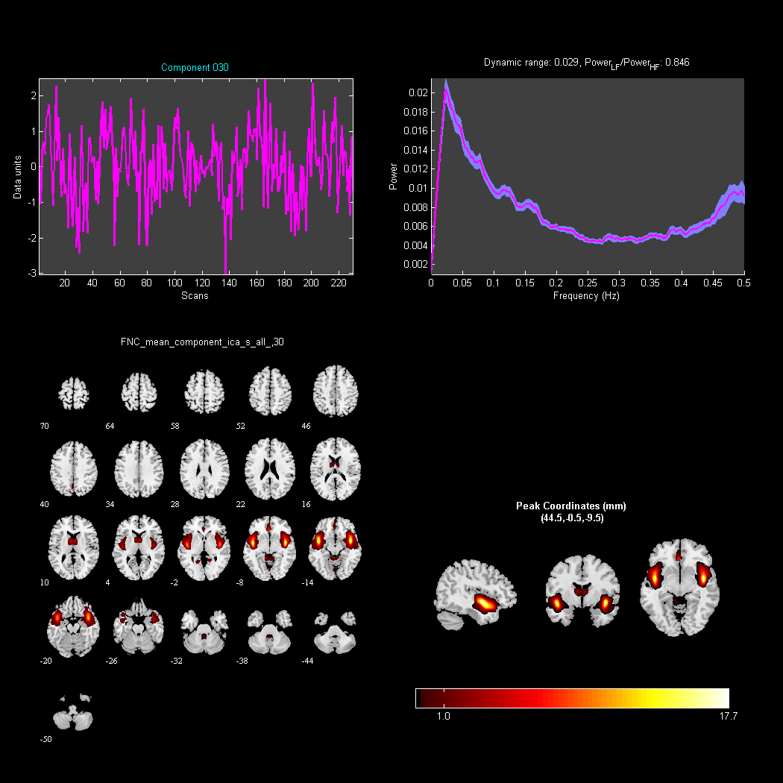
Figure S30. Principal Component 30 (Power_{LF}/Power_{HF}=0.846, invalid component).

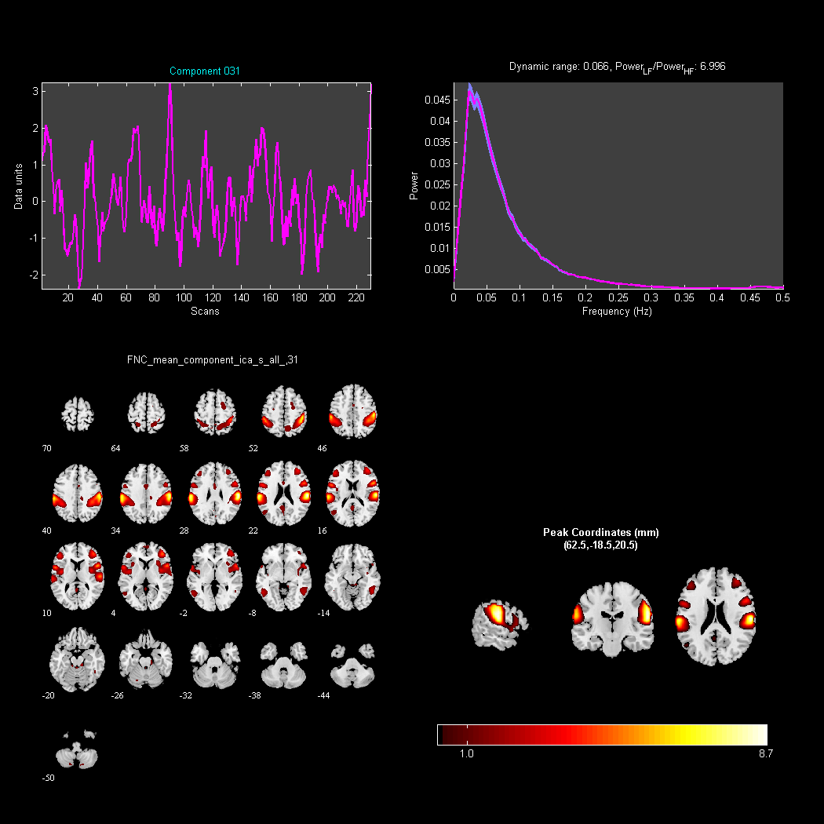
Figure S31. Principal Component 31 (Power_{LF}/Power_{HF}=6.996, valid component).

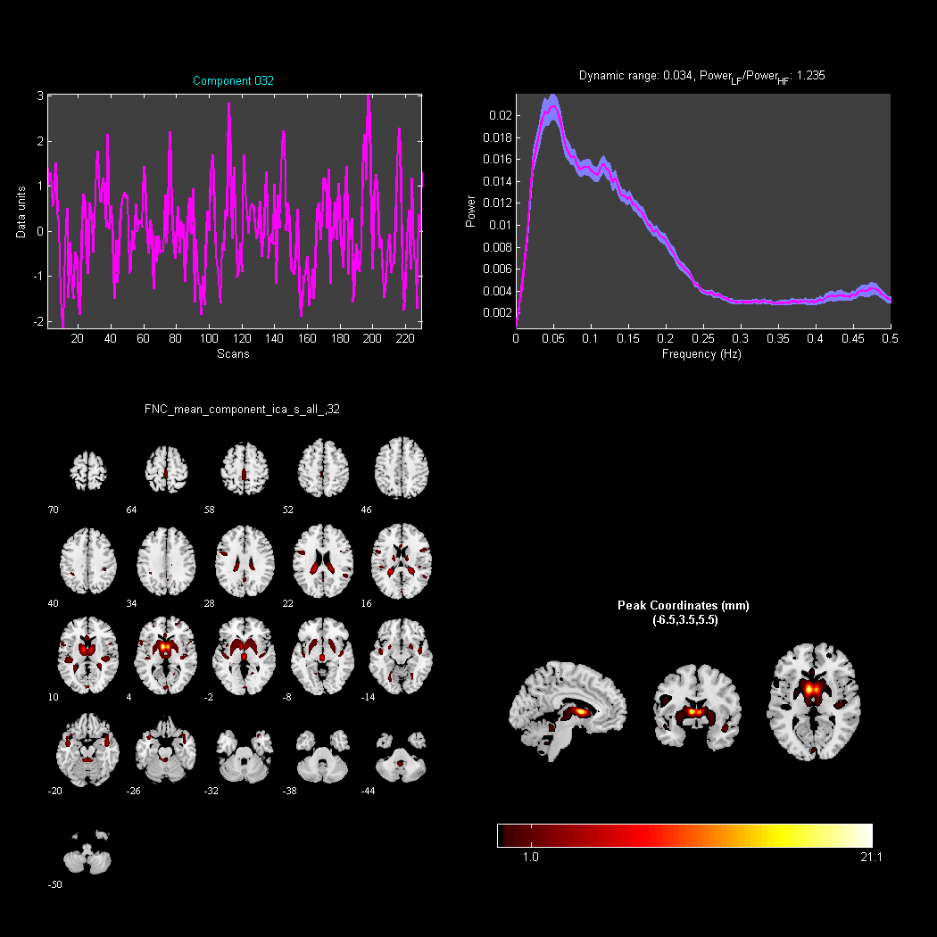
Figure S32. Principal Component 32 (Power_{LF}/Power_{HF}=1.235, valid component).

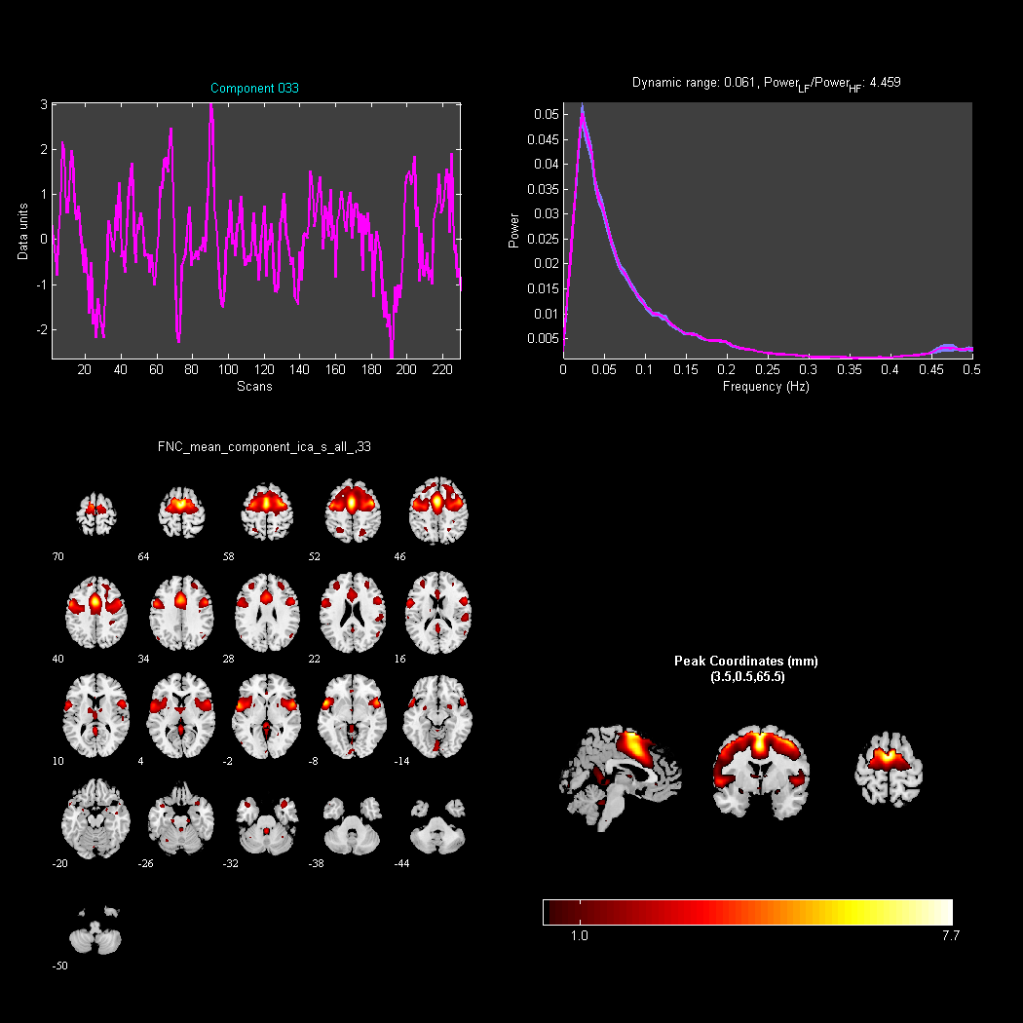
Figure S33. Principal Component 33 (Power_{LF}/Power_{HF}=4.459,valid component).

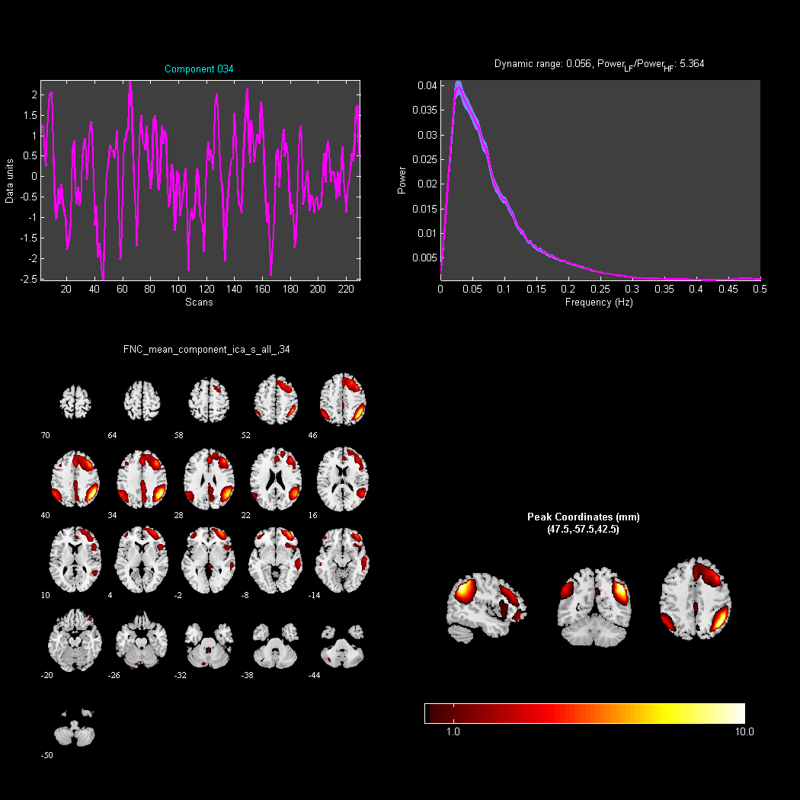
Figure S34. Principal Component 34 (Power_{LF}/Power_{HF}=5.346, valid component).

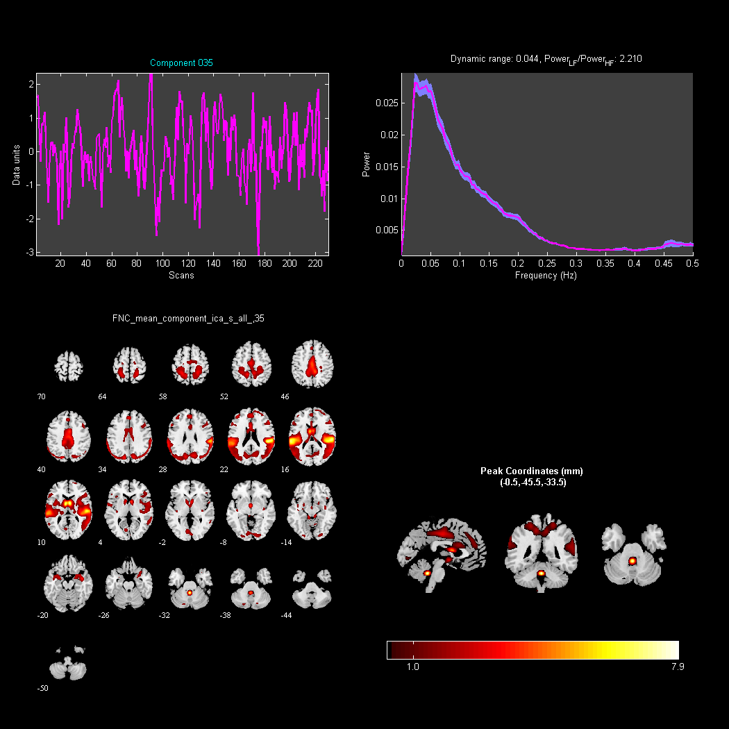
Figure S35. Principal Component 35 (Power_{LF}/Power_{HF}=2.210,valid component).
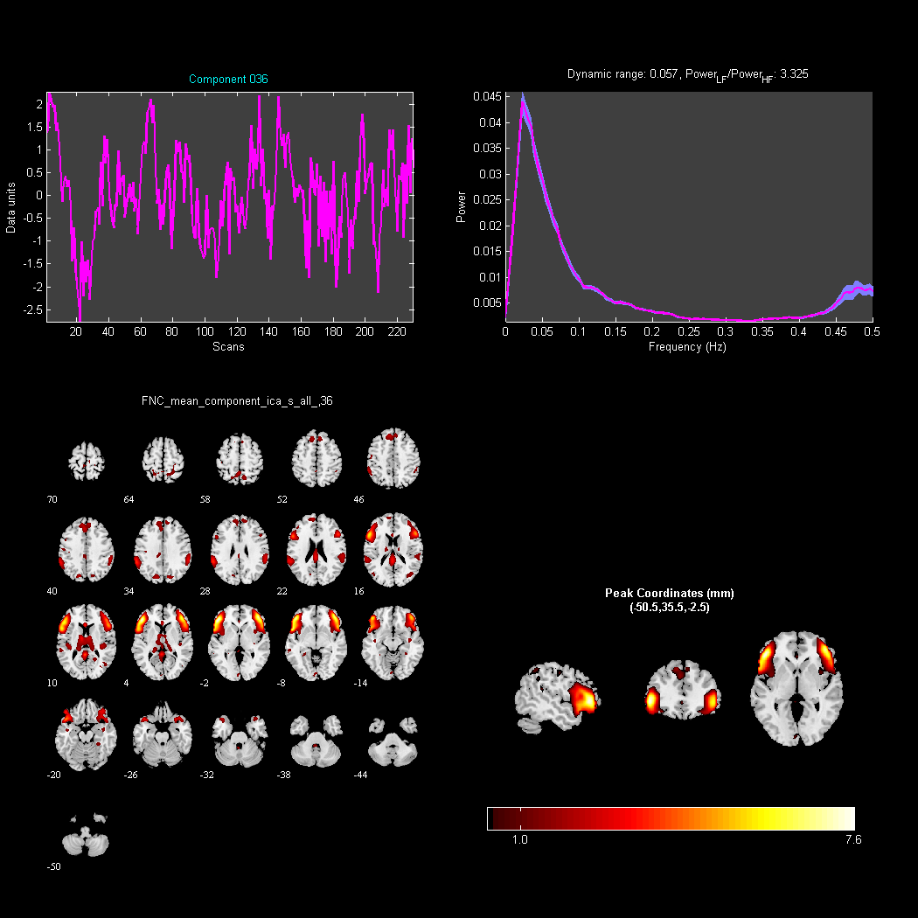
Figure S36. Principal Component 36 (Power_{LF}/Power_{HF}=3.325, valid component).

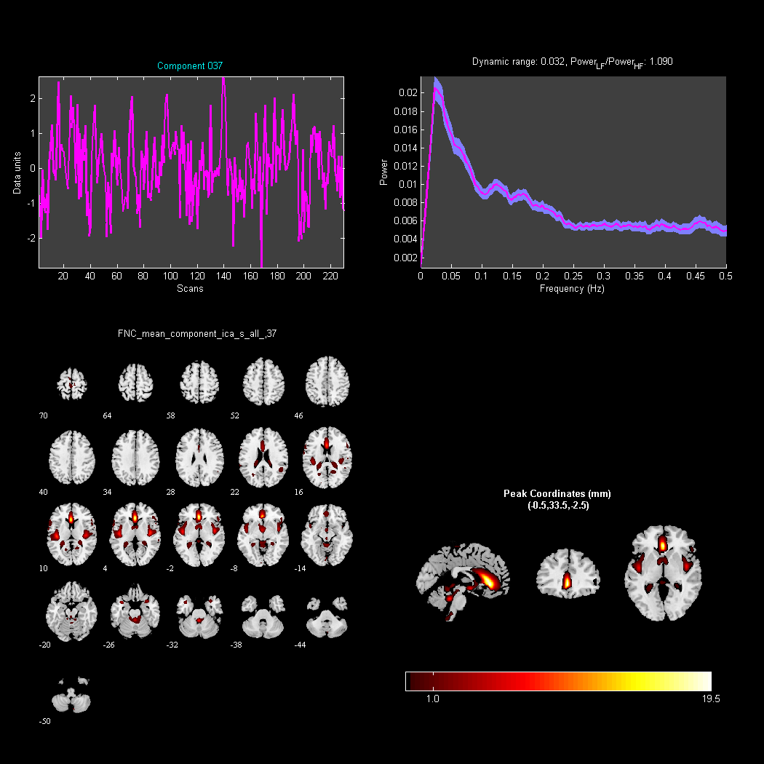
Figure S37. Principal Component 37 (Power_{LF}/Power_{HF}=1.090, valid component).

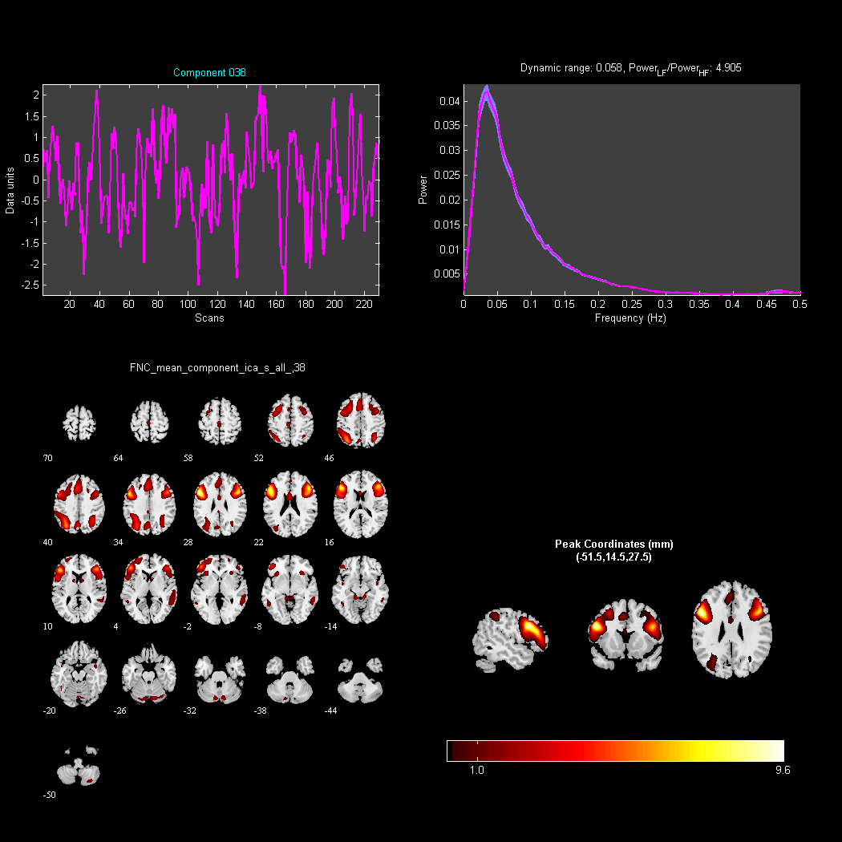
Figure S38. Principal Component 38 (Power_{LF}/Power_{HF}=4.905,valid component).

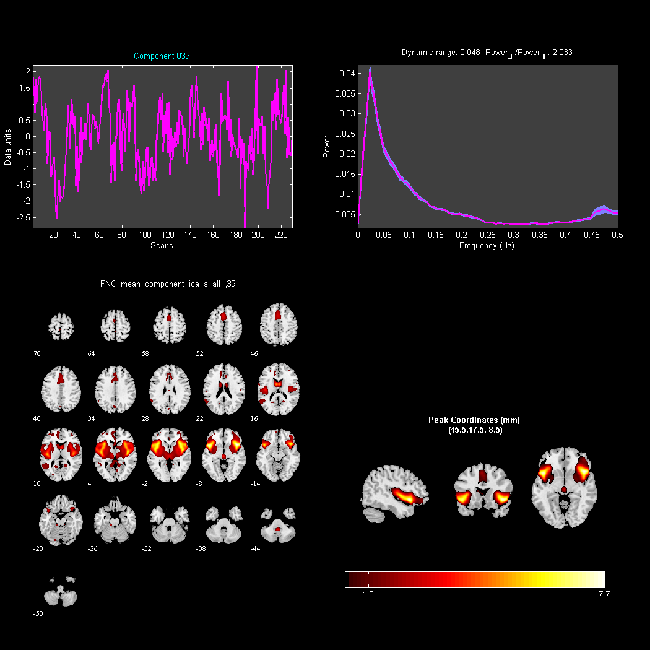
Figure S39. Principal Component 39 (Power_{LF}/Power_{HF}=2.033, valid component).

Figure S40. Principal Component 40 (Power_{LF}/Power_{HF}=2.033, valid component).

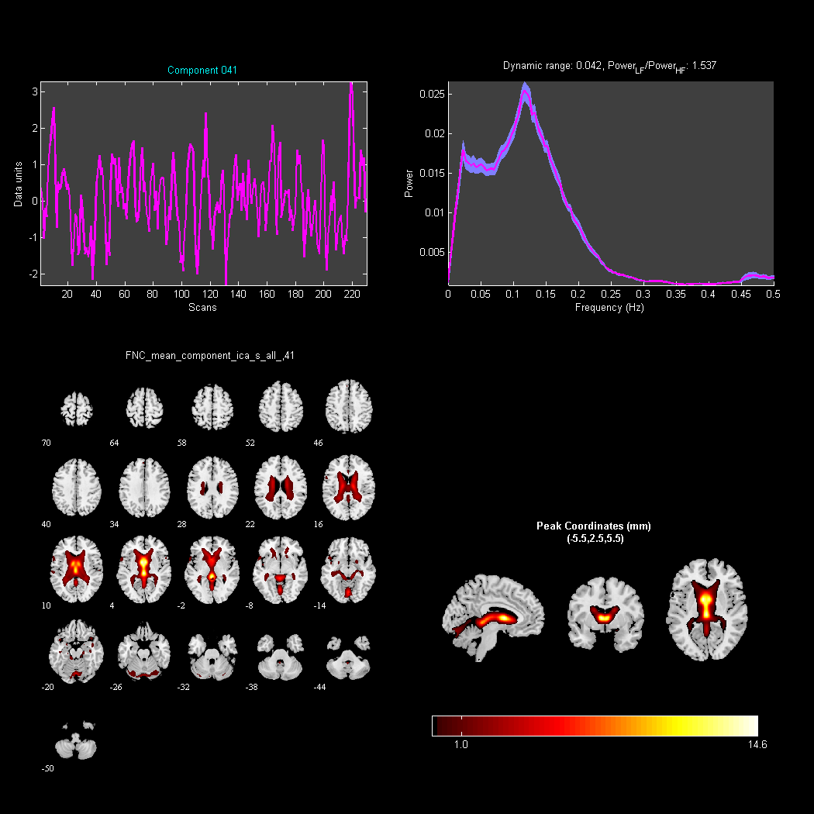
Figure S41. Principal Component 41 (Power_{LF}/Power_{HF}=1.537, valid component).

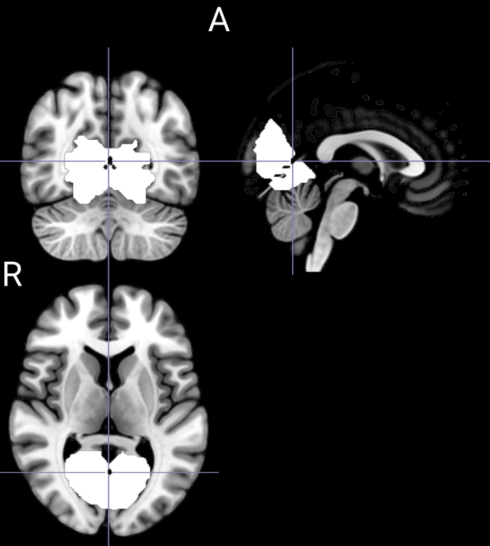
Figure S42. Single sample test result mask (White part).

Table S1. Paired T-test results of functional connectivity of visual network components
Peak Location | Cluster  Size | MNI  Coordinates |  |  | Peak  t-score | P-value  corrected  by FWE
Peak Location | Cluster  Size | X | Y | Z | Peak  t-score | P-value  corrected  by FWE
Calcarine_R | 1253 | 12 | -66 | 15 | 10.2392 | <0.0001
In PVT data, due to data distributed asymmetry, Friedman test was used. The results showed the changes of three PVT indicators are statistically significant (Table 2), showing an overall upward trend.

