SUPPORTING INFORMATION

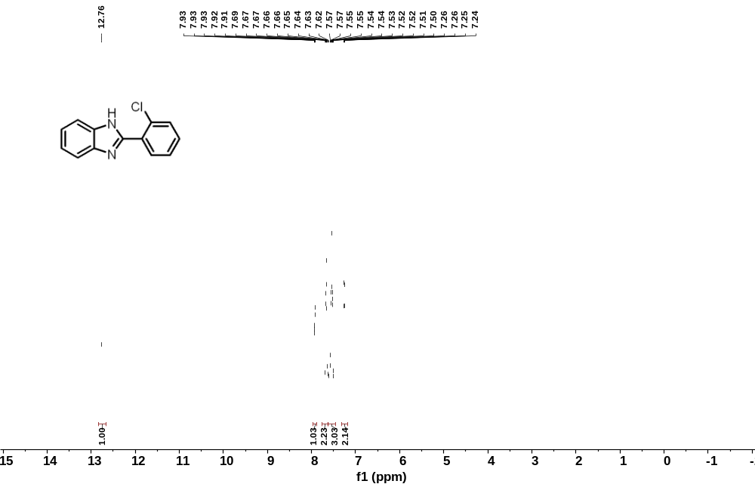
Figure-1. ¹H NMR Spectrum of chlorbenazole.
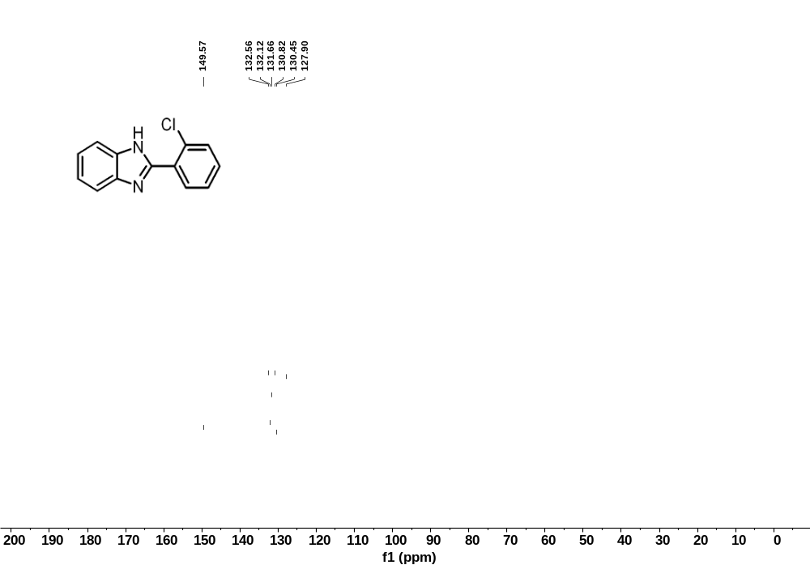
Figure-2. ¹³C NMR spectrum of chlorbenazole

