Supplementary Figure 1

A) GMFM-66 scores grouped by caregiver-reported ambulatory status (n=38)
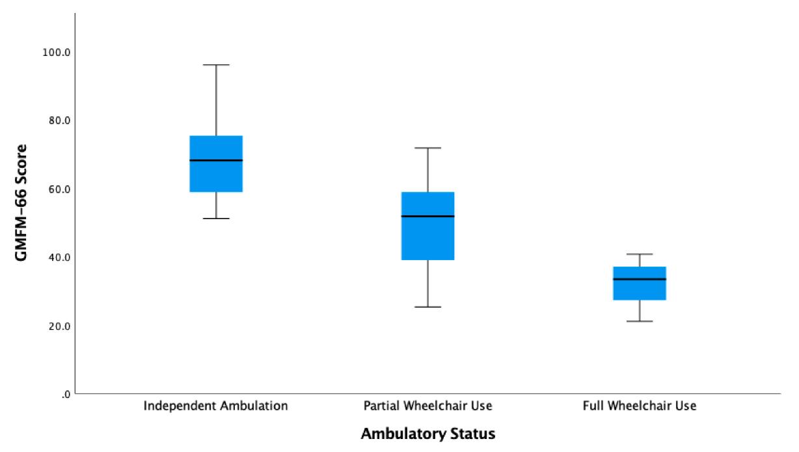

GMFM-66 = Gross Motor Function Measure – 66 items

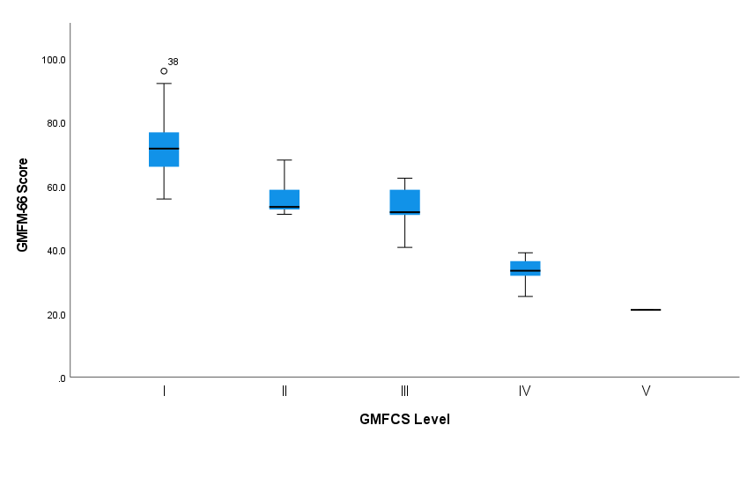
B) GMFM 66 grouped by GMFCS level

GMFM-66 = Gross Motor Function Measure – 66 items
GMFCS = Gross Motor Functional Classification System

C) GMFM-66 scores grouped by the two most common PPP22R5D variants included in this cohort (Glu198Lys and Glu200Lys)
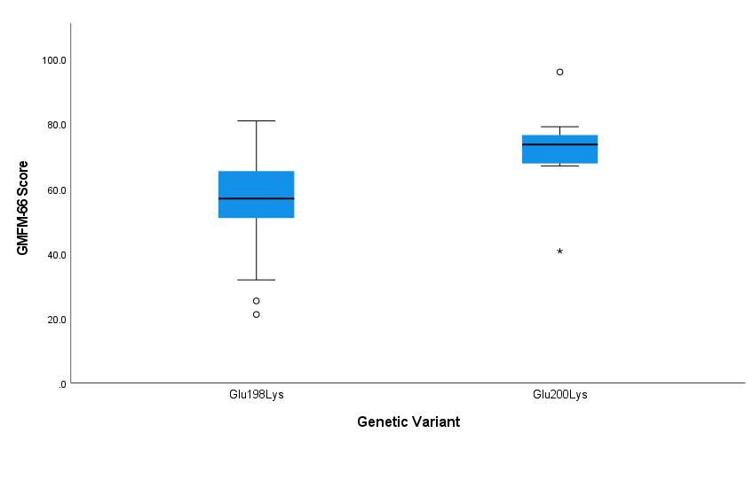

GMFM-66 = Gross Motor Function Measure – 66 items

