Supplementary Figure 1: Temporal Trend in Confirmed LF Incidents in Ondo State, 2017-2021
Supplementary Figure 2A: Wards with Significant Hotspot of LF in 2017
Supplementary Figure 2B: Wards with Significant Hotspot of LF in 2018
Supplementary Figure 2C: Wards with Significant Hotspot of LF in 2019
Supplementary Figure 2D: Wards with Significant Hotspot of LF in 2020
Supplementary Figure 2E: Wards with Significant Hotspot of LF in 2021
Supplementary Figure 2F: Wards with Significant Hotspot of LF between 2017 and 2021
Supplementary Figure 3A: MSGWR Coefficient of Human Factor
Supplementary Figure 3B: MSGWR Coefficient of Physical Factor
Supplementary Figure 3C: MSGWR Coefficient of Environmental Factor
Supplementary Figure 3D: MSGWR Coefficient of Regression Intercept
Supplementary Figure 3E: Wards with strongly positive association between LF incidence and Human and Environmental Factors

Supplementary Figure 1: Temporal Trend in Confirmed LF Incidents in Ondo State, 2017-2021

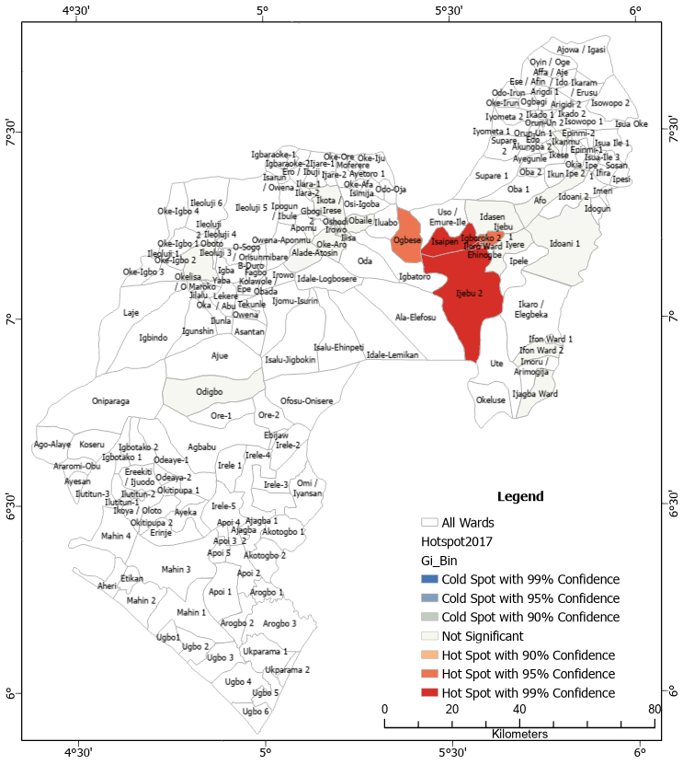 | 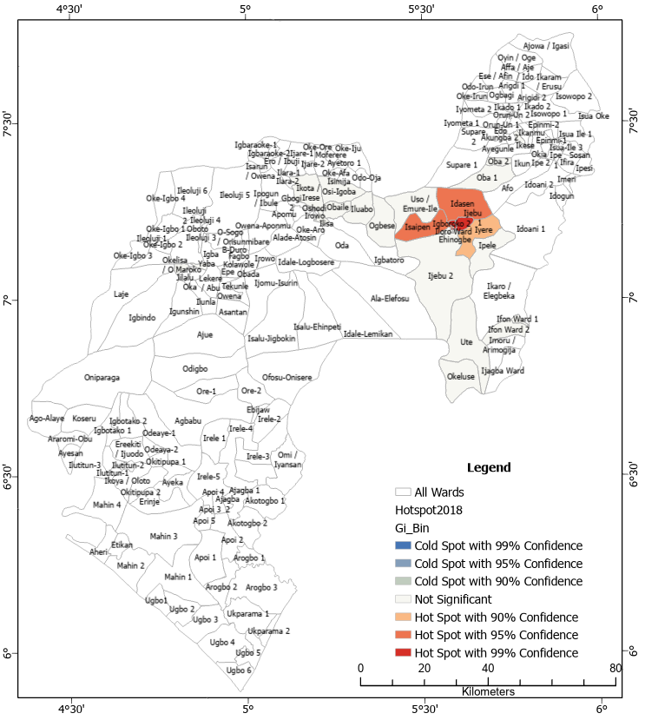
Supplementary Figure 2A: Wards with Significant Hotspot of LF in 2017 | Supplementary Figure 2B: Wards with Significant Hotspot of LF in 2018
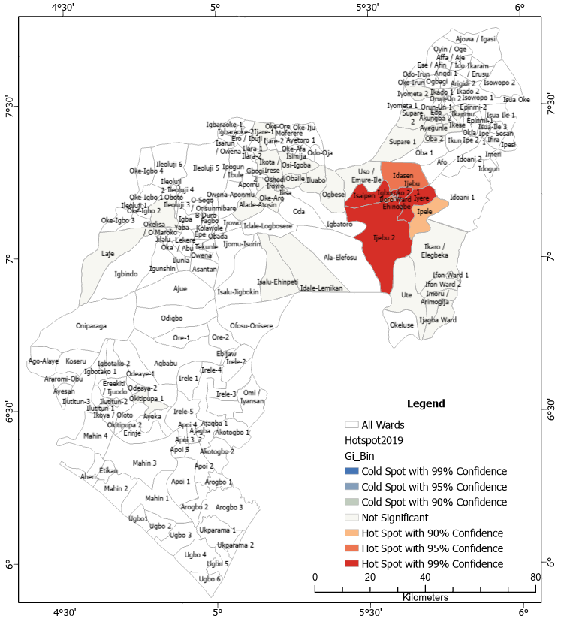 | 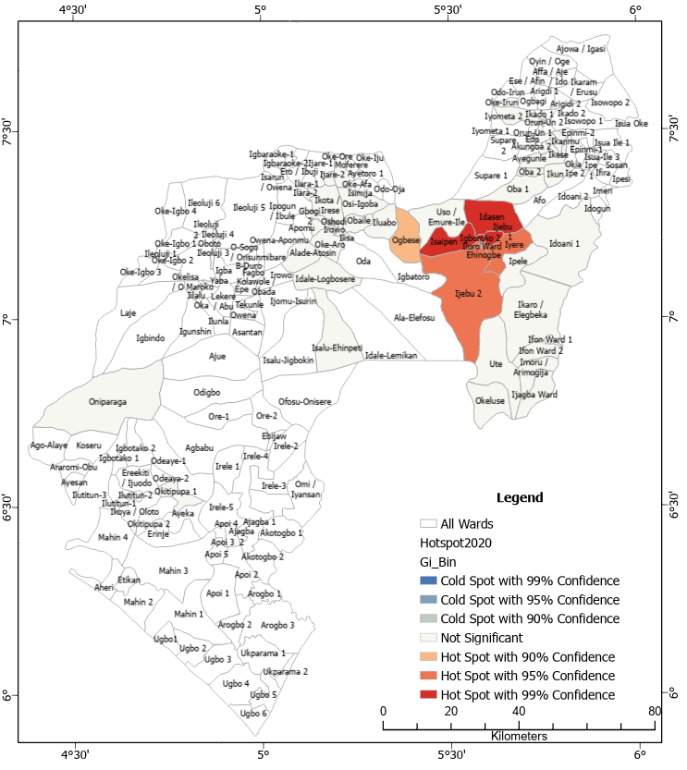
Supplementary Figure 2C: Wards with Significant Hotspot of LF in 2019 | Supplementary Figure 2D: Wards with Significant Hotspot of LF in 2020
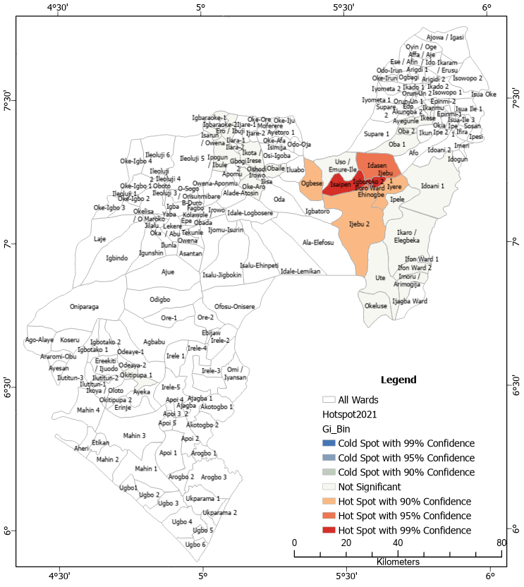 | 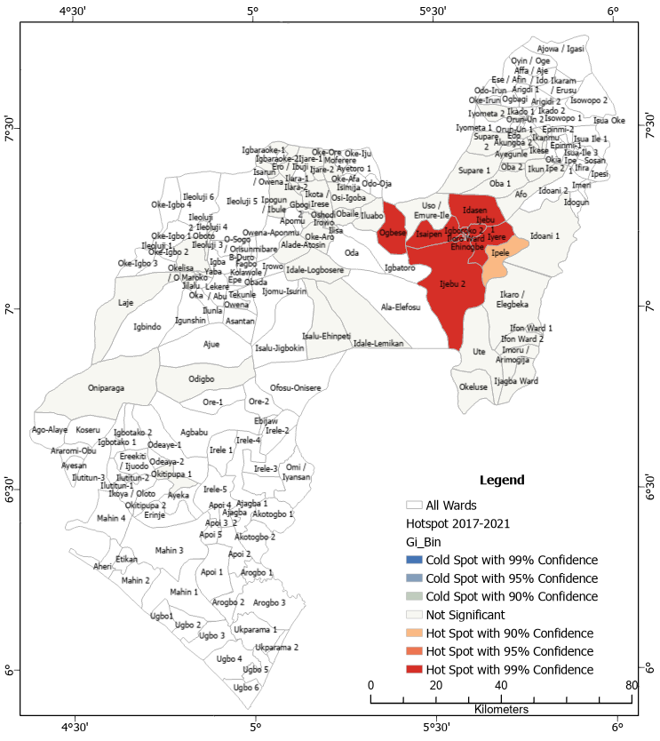
Supplementary Figure 2E: Wards with Significant Hotspot of LF in 2021 | Supplementary Figure 2F: Wards with Significant Hotspot of LF between 2017 and 2021

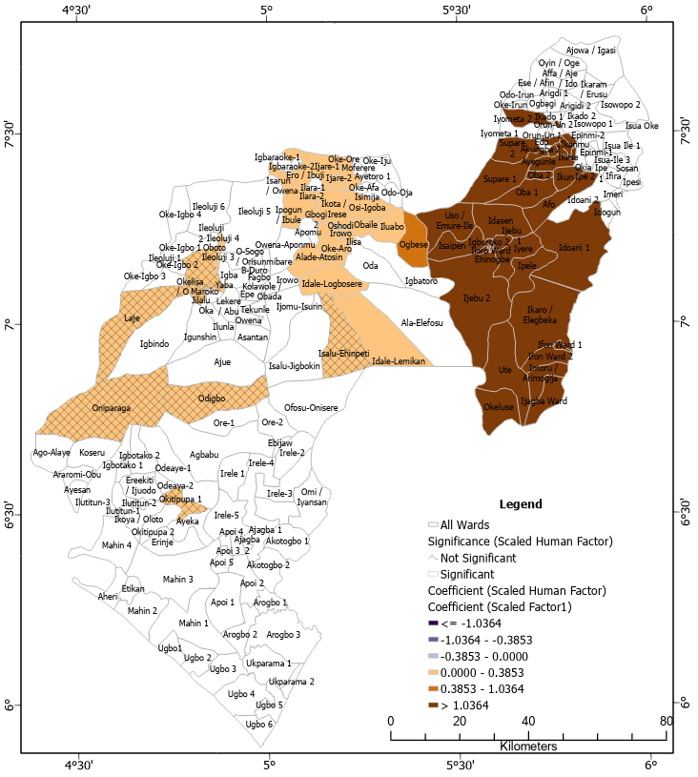 | 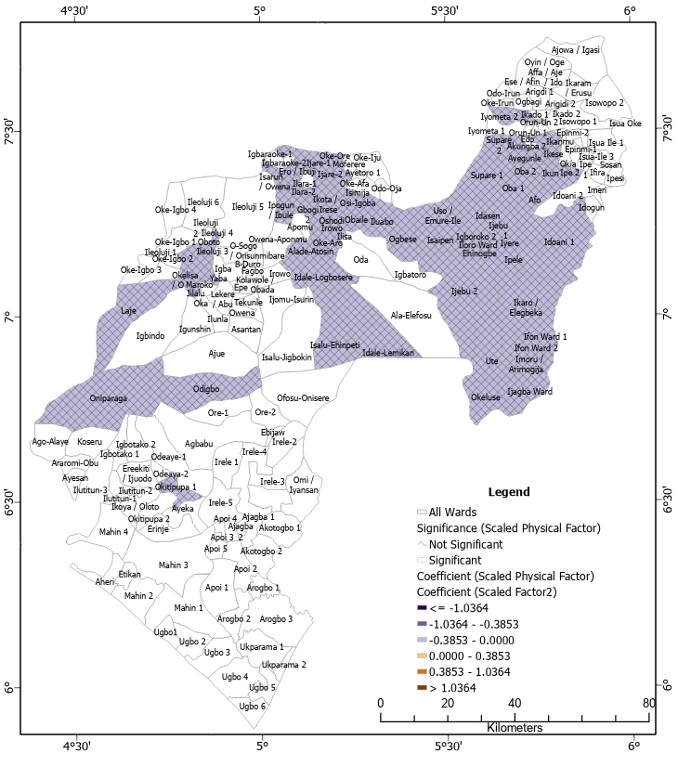
Supplementary Figure 3A: MSGWR Coefficient of Human Factor | Supplementary Figure 3B: MSGWR Coefficient of Physical Factor
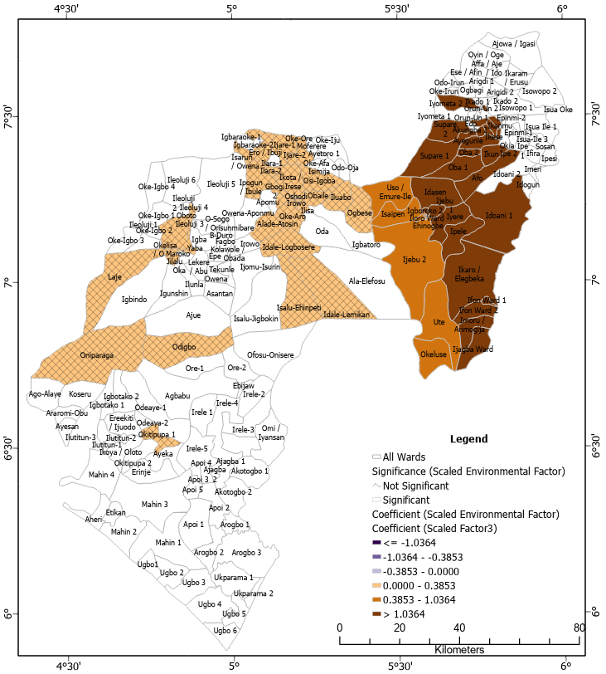 | 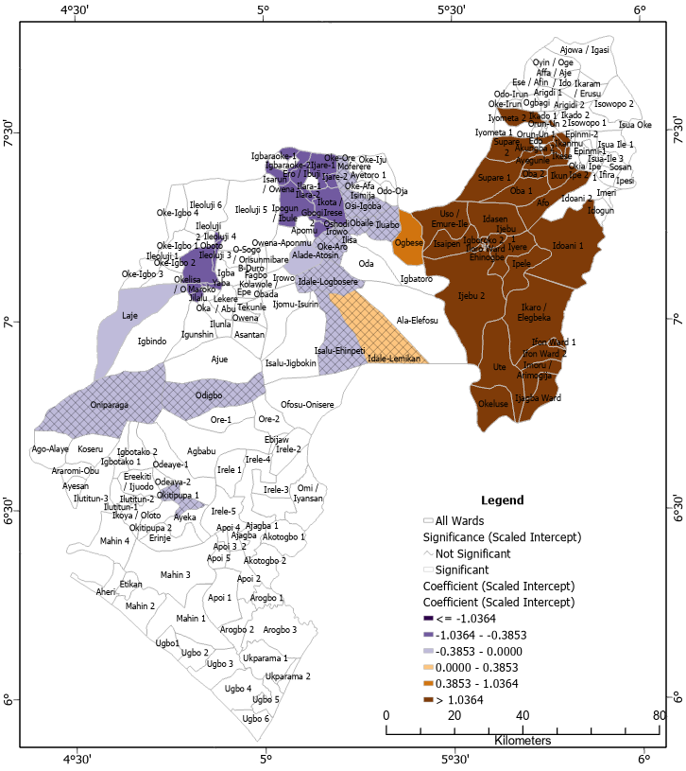
Supplementary Figure 3C: MSGWR Coefficient of Environmental Factor | Supplementary Figure 3D: MSGWR Coefficient of Regression Intercept
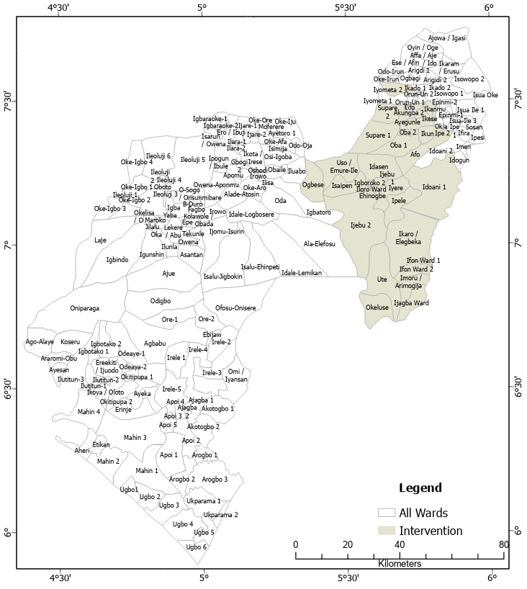
Supplementary Figure 3E: Wards with strongly positive association between LF incidence and Human and Environmental Factors.

