Supplementary Plate 1: Google Earth Image of Owo Town With confirmed LF Overlay
Supplementary Plate 2: Google Earth Image of Akure Town With confirmed LF Overlay

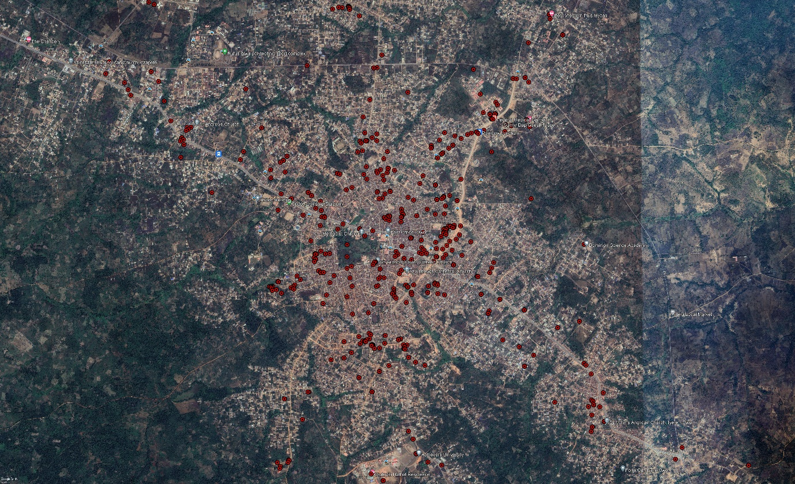
Plate 1: Google Earth Image of Owo Town With confirmed LF Overlay

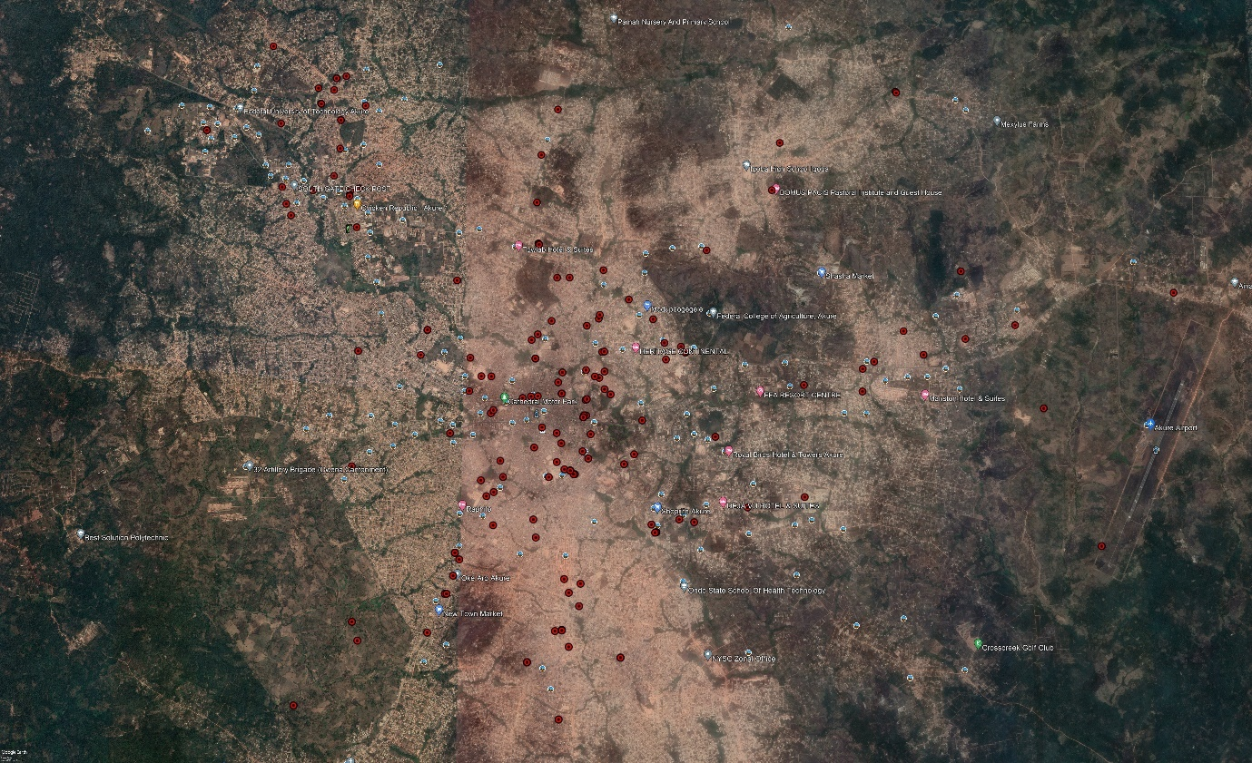
Plate 2: Google Earth Image of Akure Town With confirmed LF Overlay

