Table S1. Effects of MT on wheat yield and agronomic traits under different drought stress and rehydration

Sprayed  Solution |  | Grain Yield (kg/hm²) | 1000-grain weigh (g) | Dry Weight of Stem (g) | Dry Weight of Leaf (g) | Dry Weight of Spike (g) | Plant Height (cm)
W | CK | 2931.16±29.63 a | 50.43±1.35 a | 6.01±0.94 a | 1.31±0.35 ab | 16.75±3.14 a | 58.48±0.84 b
 | MD | 2961.84±31.02 ab | 49.23±2.22 ab | 5.65±0.87 a | 1.54±0.11 ab | 17.06±3.15 a | 53.59±0.47 d
 | HD | 2363.80±37.20 c | 44.89±3.59 c | 6.10±1.09 a | 1.189±0.17 b | 15.63±2.52 a | 56.73±0.50 bc
M | CK | 2822.30±42.07 abc | 49.63±1.54 ab | 6.14±0.64 a | 1.55±0.58 ab | 17.57±2.99 a | 62.36±1.05 a
 | MD | 2929.64±45.44 a | 46.56±2.45 bc | 5..87±0.38 a | 1.80±0.25 a | 15.83±1.90 a | 58.79±0.76 b
 | HD | 2509.56±37.14 bc | 44.60±1.92 c | 6.02±0.74 a | 1.66±0.04 ab | 14.83±2.83 a | 54.85±0.55 cd
T |  | * | ** | ns | ns | ns | ***
S |  | ns | ns | ns | ns | ns | ***
T×S |  | ns | ns | ns | * | ns | ***

Note: CK: the control with provided sufficient water; MD: Moderate drought treatment; HD:Severe drought treatment; W: Water; M: Melatonin; T: Treatment; S: Solution; ns: No Significant; Values were calculated by Mean±SD (n = 13 in grain yield; n=4 in 1000-grain weight and dry weight; n=10 in plant height ); Different lowercase letters indicate statistically significant differences (Duncan test, P < 0.05); The ANOVA was analyzed for T, S, and T×S; Asterisks (*) indicate significant differences at P < 0.05; Asterisks (**) indicate significant differences at P < 0.01;Asterisks (***) indicate significant differences at P < 0.001.

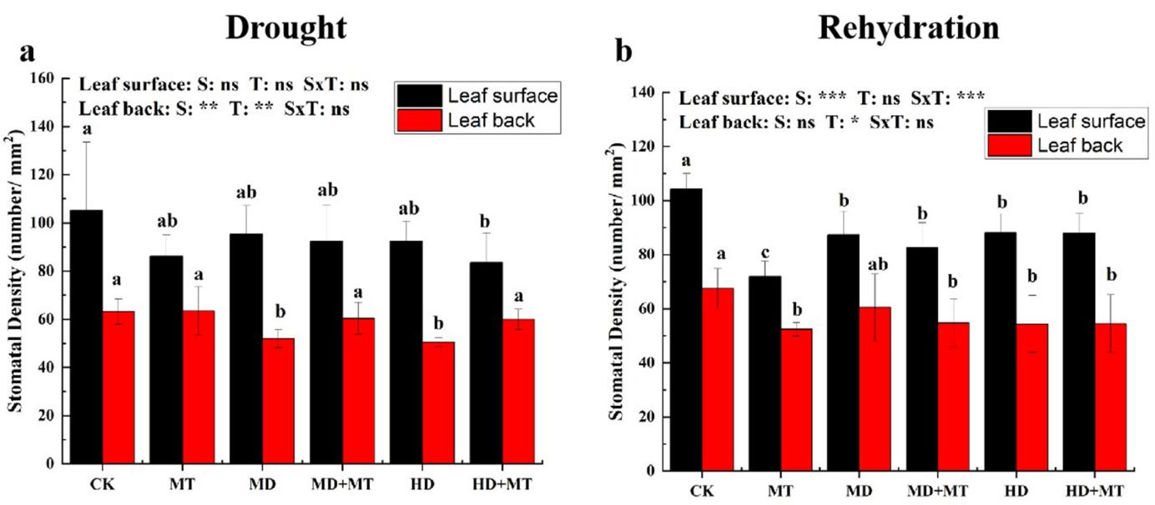
Figure S1. Effects of MT on the stomatal density of wheat under different drought stress and rehydration
a represent the stomatal density under drought stress; b represent the stomatal density under rehydration conditions; CK: the control with provided sufficient water; MT: Melatonin; MD: Moderate drought treatment; HD:Severe drought treatment; MD+MT: Moderate drought treatment with spraying melatonin; HD+MT: Severe drought treatment with spraying melatonin; T: Treatment; S: Solution; ns: No Significant; Values were calculated by Mean±SD (n = 6); Error bars represent standard deviation; Different lowercase letters indicate statistically significant differences (Duncan test, P < 0.05); The ANOVA was analyzed for T, S, and T×S; Asterisks (*) indicate significant differences at P < 0.05; Asterisks (**) indicate significant differences at P < 0.01; Asterisks (***) indicate significant differences at P < 0.001.

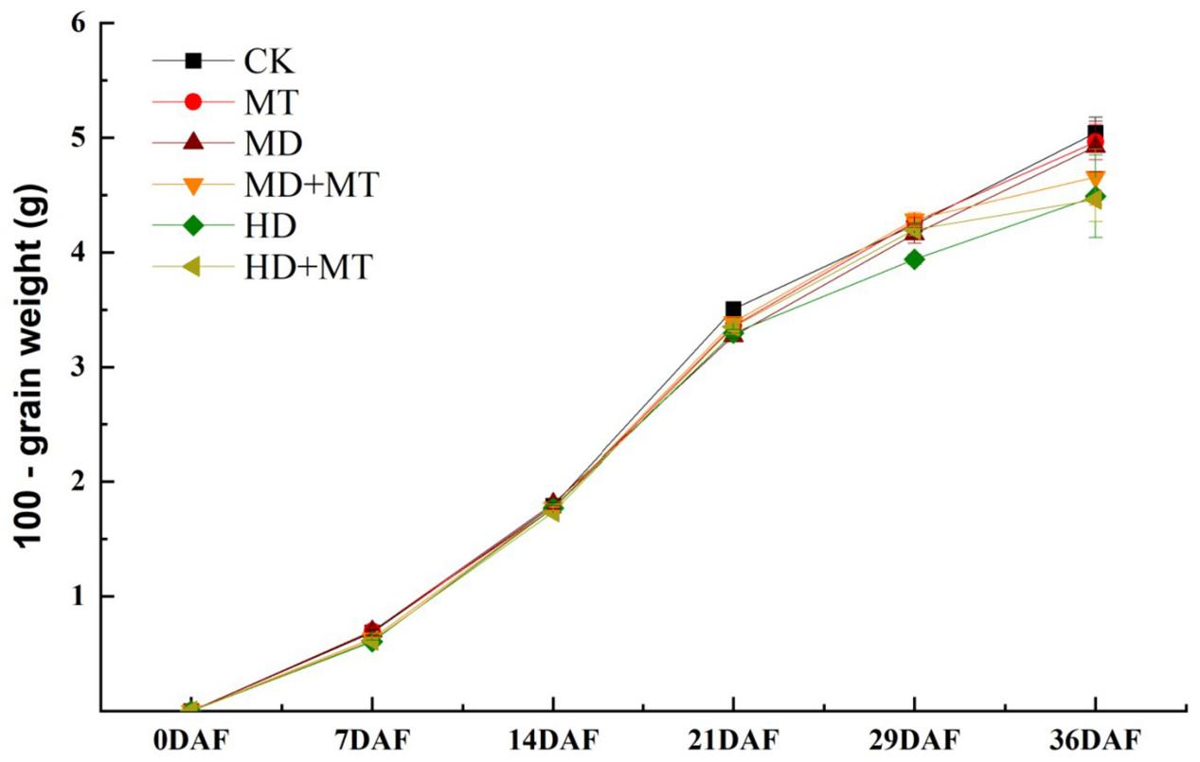
Figure S2. Effects of MT on grain filling rate of wheat under different drought stress and rehydration
CK: the control with provided sufficient water; MT: Melatonin; MD: Moderate drought treatment; HD:Severe drought treatment; MD+MT: Moderate drought treatment with spraying melatonin; HD+MT: Severe drought treatment with spraying melatonin; DAF: day after flowering;Values were calculated by Mean±SD (n = 3); Error bars represent standard deviation.

