Supplementary Table 1. Univariate and multivariate Cox regression analyses of different variables considered for OS and CSS for patients with advanced stage (III-IV) ovarian serous cystadenocarcinoma (OSC)
Characteristics | Univariate |  |  |  |  |  |  |  |  |  |  |  | Multivariate
Characteristics | OS |  |  |  | CSS |  |  |  |  |  |  |  | OS |  |  |  |  |  |  |  |  | CSS
Characteristics | HR(95%CI) | P |  |  | HR(95%CI) |  |  |  |  | P |  |  | HR(95%CI) |  |  |  |  |  | P |  |  | HR(95%CI) |  |  |  |  |  | P
Age (<50 as ref.)
50-69 | 1.309 (1.062-1.613) | 0.012 |  |  | 1.183 (0.961-1.457) |  |  |  |  | 0.112 |  |  | 1.255 (1.089-1.448) |  |  |  |  |  | 0.002 |  |  | 1.203 (1.040-1.391) |  |  |  |  |  | 0.013
70-79 | 1.754 (1.405-2.190) | <0.001 |  |  | 1.530 (1.228-1.906) |  |  |  |  | <0.001 |  |  | 1.514 (1.306-1.755) |  |  |  |  |  | <0.001 |  |  | 1.444 (1.242-1.68) |  |  |  |  |  | <0.001
>79 | 3.150 (2.222-4.464) | <0.001 |  |  | 2.238 (1.611-3.109) |  |  |  |  | <0.001 |  |  | 2.420 (1.996-2.933) |  |  |  |  |  | <0.001 |  |  | 2.226 (1.820-2.721) |  |  |  |  |  | <0.001
Race (Black as ref.)
White | 1.243 (0.962-1.606) | 0.096 |  |  | 1.117 (0.869-1.436) |  |  |  |  | 0.387 |  |  | 1.088 (0.929-1.275) |  |  |  |  |  | 0.296 |  |  | 1.058 (0.899-1.245) |  |  |  |  |  | 0.499
Other | 0.971 (0.699-1.348) | 0.859 |  |  | 0.942 (0.681-1.302) |  |  |  |  | 0.717 |  |  | 0.924 (0.747-1.143) |  |  |  |  |  | 0.466 |  |  | 0.924 (0.742-1.149) |  |  |  |  |  | 0.476
Marital status | 1.246 (1.084-1.432) | 0.002 |  |  | 1.164 (1.016-1.334) |  |  |  |  | 0.028 |  |  | 1.193 (1.096-1.298) |  |  |  |  |  | <0.001 |  |  | 1.173 (1.074-1.281) |  |  |  |  |  | <0.001
Number of situ/malignant tumors (1 as ref.)
2 | 0.891 (0.734-1.081) | 0.242 |  |  | 0.708 (0.587-0.856) |  |  |  |  | <0.001 |  |  | 0.898 (0.800-1.009) |  |  |  |  |  | 0.071 |  |  | 0.806 (0.710-0.913) |  |  |  |  |  | <0.001
3 | 1.103 (0.749-1.626) | 0.619 |  |  | 0.811 (0.553-1.188) |  |  |  |  | 0.282 |  |  | 1.104 (0.871-1.400) |  |  |  |  |  | 0.413 |  |  | 0.956 (0.735-1.245) |  |  |  |  |  | 0.740
4 | 1.208 (0.396-3.685) | 0.739 |  |  | 0.352 (0.115-1.078) |  |  |  |  | 0.068 |  |  | 1.538 (0.821-2.881) |  |  |  |  |  | 0.179 |  |  | 0.820 (0.339-1.982) |  |  |  |  |  | 0.660
≥5 | 0.448 (0.026-6.995) | 0.562 |  |  | 0.545 (0.033-8.920) |  |  |  |  | 0.671 |  |  | 0.625 (0.087-4.470) |  |  |  |  |  | 0.639 |  |  | 0.674 (0.094-4.826) |  |  |  |  |  | 0.694
Laterality (Left as ref.)
Right | 1.030 (0.825-1.286) | 0.792 |  |  | 1.045 (0.839-1.301) |  |  |  |  | 0.696 |  |  | 0.970 (0.839-1.122) |  |  |  |  |  | 0.686 |  |  | 0.980 (0.841-1.141) |  |  |  |  |  | 0.791
Bilateral | 1.497 (1.244-1.801) | <0.001 |  |  | 1.465 (1.221-1.758) |  |  |  |  | <0.001 |  |  | 1.093 (0.970-1.231) |  |  |  |  |  | 0.146 |  |  | 1.106 (0.976-1.253) |  |  |  |  |  | 0.113
side unspecified | 4.651 (0.947-22.852) | 0.058 |  |  | 5.742 (1.182-27.888) |  |  |  |  | 0.030 |  |  | 2.025 (1.103-3.720) |  |  |  |  |  | 0.023 |  |  | 2.178 (1.184-4.007) |  |  |  |  |  | 0.012
FIGO stage (IIIA as ref.)
III | 0.867 (0.392-.921) | 0.726 |  |  | 0.836 (0.381-1.836) |  |  |  |  | 0.656 |  |  | 0.794 (0.251-2.514) |  |  |  |  |  | 0.695 |  |  | 0.872 (0.245-3.098) |  |  |  |  |  | 0.832
IIIB | 0.384 (0.101-1.454) | 0.159 |  |  | 0.434 (0.110-1.715) |  |  |  |  | 0.234 |  |  | 1.241 (0.727-2.119) |  |  |  |  |  | 0.428 |  |  | 1.206 (0.692-2.104) |  |  |  |  |  | 0.508
IIIC | 1.291 (0.650-2.564) | 0.465 |  |  | 1.128 (0.573-2.220) |  |  |  |  | 0.727 |  |  | 1.745 (1.100-2.769) |  |  |  |  |  | 0.018 |  |  | 1.662 (1.033-2.673) |  |  |  |  |  | 0.036
IIINOS | 2.142 (0.983-4.665) | 0.055 |  |  | 1.721 (0.806-3.677) |  |  |  |  | 0.161 |  |  | 1.943 (1.184-3.189) |  |  |  |  |  | 0.009 |  |  | 1.846 (1.107-3.078) |  |  |  |  |  | 0.019
III-IV | 5.892 (1.127-30.795) | 0.036 |  |  | 6.402 (1.239-33.067) |  |  |  |  | 0.027 |  |  | 2.908 (1.487-5.689) |  |  |  |  |  | 0.002 |  |  | 2.956 (1.497-5.838) |  |  |  |  |  | 0.002
IV, IVA, IVB | 2.097 (1.065-4.127) | 0.090 |  |  | 1.550 (0.788-3.050) |  |  |  |  | 0.204 |  |  | 2.201 (1.386-3.493) |  |  |  |  |  | <0.001 |  |  | 2.107 (1.310-3.390) |  |  |  |  |  | 0.002
T stage (T0 as ref.)
T1 | 2.879 (0.381-21.779) | 0.306 |  |  | 5.228 (0.479-57.026) |  |  |  |  | 0.175 |  |  | 1.819 (0.421-7.856) |  |  |  |  |  | 0.423 |  |  | 3.187 (0.420-24.196) |  |  |  |  |  | 0.262
T2 | 6.035 (0.839-43.385) | 0.074 |  |  | 10.919 (1.049-113.645) |  |  |  |  | 0.045 |  |  | 3.314 (0.802-13.694) |  |  |  |  |  | 0.098 |  |  | 6.108 (0.838-44.516) |  |  |  |  |  | 0.074
T3 | 1.231 (0.150-10.128) | 0.846 |  |  | 2.262 (0.191-26.793) |  |  |  |  | 0.518 |  |  | 3.600 (0.750-17.277) |  |  |  |  |  | 0.109 |  |  | 5.351 (0.632-45.334) |  |  |  |  |  | 0.124
T3a | 8.217 (1.082-62.393) | 0.042 |  |  | 16.619 (1.527-180.836) |  |  |  |  | 0.021 |  |  | 5.780 (1.357-24.620) |  |  |  |  |  | 0.018 |  |  | 11.515 (1.545-85.830) |  |  |  |  |  | 0.017
T3b | 8.599 (1.182-62.568) | 0.034 |  |  | 14.950 (1.424-156.923) |  |  |  |  | 0.024 |  |  | 4.438 (1.072-18.377) |  |  |  |  |  | 0.040 |  |  | 8.240 (1.129-60.147) |  |  |  |  |  | 0.038
T3c | 8.786 (1.244-62.080) | 0.029 |  |  | 17.958 (1.751-184.165) |  |  |  |  | 0.015 |  |  | 4.708 (1.154-19.213) |  |  |  |  |  | 0.031 |  |  | 9.373 (1.299-67.606) |  |  |  |  |  | 0.026
T3NOS | 15.488 (2.164-110.856) | 0.006 |  |  | 28.722 (2.775-297.231) |  |  |  |  | 0.005 |  |  | 4.712 (1.152-19.274) |  |  |  |  |  | 0.031 |  |  | 9.424 (1.304-68.096) |  |  |  |  |  | 0.026
TX | 4.699 (0.646-34.174) | 0.126 |  |  | 9.190 (0.875-96.574) |  |  |  |  | 0.065 |  |  | 5.144 (1.237-21.396) |  |  |  |  |  | 0.024 |  |  | 9.648 (1.317-70.707) |  |  |  |  |  | 0.026
N stage (N0 as ref.)
N1 | 1.290 (1.070-1.556) | 0.008 |  |  | 1.319 (1.098-1.584) |  |  |  |  | 0.003 |  |  | 1.242 (1.107-1.393) |  |  |  |  |  | <0.001 |  |  | 1.268 (1.125-1.429) |  |  |  |  |  | <0.001
NX | 0.672 (0.488-0.926) | 0.015 |  |  | 0.770 (0.564-1.049) |  |  |  |  | 0.098 |  |  | 1.087 (0.903-1.308) |  |  |  |  |  | 0.379 |  |  | 1.126 (0.929-1.365) |  |  |  |  |  | 0.226
Grade(Grade I as ref.)
Grade II | 1.596 (0.874-2.913) | 0.128 |  |  | 1.776 (0.958-3.295) |  |  |  |  | 0.068 |  |  | 1.439 (0.921-2.250) |  |  |  |  |  | 0.110 |  |  | 1.591 (0.978-2.588) |  |  |  |  |  | 0.062
Grade III | 2.985 (1.705-5.226) | <0.001 |  |  | 3.044 (1.708-5.425) |  |  |  |  | <0.001 |  |  | 2.246 (1.477-3.417) |  |  |  |  |  | <0.001 |  |  | 2.466 (1.557-3.907) |  |  |  |  |  | <0.001
Grade IV | 2.399 (1.372-4.194) | 0.002 |  |  | 2.517 (1.414-4.481) |  |  |  |  | 0.002 |  |  | 2.113 (1.388-3.217) |  |  |  |  |  | <0.001 |  |  | 2.324 (1.466-3.684) |  |  |  |  |  | <0.001
Histology (Papillary cystadenocarcinoma, NOS as ref.)
Serous cystadenocarcinoma, NOS | 0.000 (0.000-) | 1.000 |  |  | 0.000 (0.000-) |  |  |  |  | 1.000 |  |  | 1.464 (0.189-11.323) |  |  |  |  |  | 0.715 |  |  | 1.087 (0.138-8.541) |  |  |  |  |  | 0.936
Papillary serous cystadenocarcinoma | 0.000 (0.000-) | 1.000 |  |  | 0.000 (0.000-) |  |  |  |  | 1.000 |  |  | 1.507 (0.195-11.665) |  |  |  |  |  | 0.695 |  |  | 1.156 (0.147-9.086) |  |  |  |  |  | 0.891
Serous surface papillary carcinoma | 0.000 (0.000-) | 1.000 |  |  | 0.000 (0.000-) |  |  |  |  | 1.000 |  |  | 1.517 (0.194-11.846) |  |  |  |  |  | 0.691 |  |  | 1.167 (0.147-9.263) |  |  |  |  |  | 0.884
CA-125 (Negative/normal as ref.)
Positive/elevated | 2.052 (1.412-2.983) | <0.001 |  |  | 1.806 (1.246-2.617) |  |  |  |  | 0.002 |  |  | 1.656 (1.261-2.175) |  |  |  |  |  | <0.001 |  |  | 1.613 (1.215-2.14) |  |  |  |  |  | <0.001
Not documented | 2.478 (1.645-3.733) | <0.001 |  |  | 2.149 (1.434-3.222) |  |  |  |  | <0.001 |  |  | 1.681 (1.259-2.244) |  |  |  |  |  | <0.001 |  |  | 1.643 (1.217-2.219) |  |  |  |  |  | <0.001
undetermined whether positive or negative | 8.923 (0.796-100.076) | 0.076 |  |  | 9.233 (0.834-102.22) |  |  |  |  | 0.070 |  |  | 4.256 (1.321-13.715) |  |  |  |  |  | 0.015 |  |  | 4.624 (1.43-14.949) |  |  |  |  |  | 0.011
Site specific surgery (No as ref.)
Debulking sur | 0.454 (0.233-0.882) | 0.020 |  |  | 0.757 (0.420-1.364) |  |  |  |  | 0.355 |  |  | 0.411 (0.306-0.554) |  |  |  |  |  | <0.001 |  |  | 0.444 (0.322-0.611) |  |  |  |  |  | <0.001
Unilateral or bilateral oophorectomy Plus Omentectomy | 0.451 (0.232-0.877) | 0.019 |  |  | 0.765 (0.425-1.377) |  |  |  |  | 0.371 |  |  | 0.368 (0.273-0.496) |  |  |  |  |  | <0.001 |  |  | 0.400 (0.290-0.551) |  |  |  |  |  | <0.001
Pelvic exenteration | 0.522 (0.227-1.199) | 0.126 |  |  | 0.846 (0.393-1.822) |  |  |  |  | 0.669 |  |  | 0.443 (0.290-0.675) |  |  |  |  |  | <0.001 |  |  | 0.471 (0.302-0.735) |  |  |  |  |  | <0.001
Unilateral or bilateral oophorectomy Plus hysterectomy | 0.304 (0.147-0.628) | <0.001 |  |  | 0.564 (0.293-1.086) |  |  |  |  | 0.087 |  |  | 0.290 (0.202-0.417) |  |  |  |  |  | <0.001 |  |  | 0.321 (0.219-0.470) |  |  |  |  |  | <0.001
Other specific surgery | 0.414 (0.198-0.865) | 0.019 |  |  | 0.552 (0.283-1.077) |  |  |  |  | 0.082 |  |  | 0.375 (0.261-0.539) |  |  |  |  |  | <0.001 |  |  | 0.364 (0.245-0.541) |  |  |  |  |  | <0.001
Chemotherapy (No as ref.) | 0.816 (0.417-1.599) | 0.554 |  |  | 1.261 (0.682-2.334) |  |  |  |  | 0.460 |  |  | 0.462 (0.343-0.623) |  |  |  |  |  | <0.001 |  |  | 0.514 (0.373-0.709) |  |  |  |  |  | <0.001
Systemic/Sur Seq (Systemic therapy before surgery as ref.)
Systemic therapy after surgery | 1.026 (0.495-2.125) | 0.945 |  |  | 0.743 (0.380-1.453) |  |  |  |  | 0.386 |  |  | 1.504 (1.085-2.085) |  |  |  |  |  | 0.014 |  |  | 1.393 (0.982-1.977) |  |  |  |  |  | 0.063
Systemic therapy both before and after surgery | 0.564 (0.284-1.122) | 0.103 |  |  | 0.460 (0.245-0.866) |  |  |  |  | 0.016 |  |  | 0.970 (0.714-1.318) |  |  |  |  |  | 0.847 |  |  | 0.909 (0.654-1.264) |  |  |  |  |  | 0.571
Surgery both before and after systemic therapy | 0.587 (0.287-1.198) | 0.143 |  |  | 0.502 (0.260-0.972) |  |  |  |  | 0.041 |  |  | 1.167 (0.840-1.620) |  |  |  |  |  | 0.357 |  |  | 1.109 (0.781-1.575) |  |  |  |  |  | 0.564
Intraoperative systemic therapy | 0.340 (0.126-0.918) | 0.033 |  |  | 0.343 (0.132-0.889) |  |  |  |  | 0.028 |  |  | 0.900 (0.490-1.655) |  |  |  |  |  | 0.736 |  |  | 0.933 (0.502-1.736) |  |  |  |  |  | 0.827
Intraop systemic rx & oth systemic rx before/after sur | 2.568 (0.604-10.914) | 0.201 |  |  | 1.173 (0.343-4.011) |  |  |  |  | 0.799 |  |  | 1.614 (0.915-2.847) |  |  |  |  |  | 0.098 |  |  | 1.413 (0.771-2.588) |  |  |  |  |  | 0.263
Lymphadenectomy (No as ref.) | 0.632 (0.531-0.752) | <0.001 |  |  | 0.670 (0.565-0.796) |  |  |  |  | <0.001 |  |  | 0.685 (0.623-0.775) |  |  |  |  |  | <0.001 |  |  | 0.700 (0.624-0.784) |  |  |  |  |  | <0.001
Residual Tumor Volume (No as ref.)
≤ 1 cm | 1.585 (1.298-1.935) | <0.001 |  |  | 1.641 (1.347-2.000) |  |  |  |  | <0.001 |  |  | 1.378 (1.210-1.569) |  |  |  |  |  | <0.001 |  |  | 1.425 (1.246-1.630) |  |  |  |  |  | <0.001
> 1 cm | 2.592 (1.980-3.394) | <0.001 |  |  | 2.272 (1.755-2.940) |  |  |  |  | <0.001 |  |  | 1.783 (1.533-2.074) |  |  |  |  |  | <0.001 |  |  | 1.768 (1.510-2.071) |  |  |  |  |  | <0.001
Size not stated | 1.889 (1.539-2.318) | <0.001 |  |  | 1.760 (1.440-2.152) |  |  |  |  | <0.001 |  |  | 1.568 (1.379-1.783) |  |  |  |  |  | <0.001 |  |  | 1.568 (1.371-1.794) |  |  |  |  |  | <0.001
Not assessed or unknown | 1.682 (1.355-2.089) | <0.001 |  |  | 1.621 (1.310-2.006) |  |  |  |  | <0.001 |  |  | 1.287 (1.123-1.475) |  |  |  |  |  | <0.001 |  |  | 1.299 (1.126-1.498) |  |  |  |  |  | <0.001

TX, not determined T; NX, not determined N; NOS, not determined.
OS, overall survival; CSS, cancer-specific survival.
HR, hazard ratio; CI, confidence interval.

Supplementary Table 2. Baseline characteristics of advanced OSC patients underwent different treatment modalities.
 | Chemotherapy only  No (%) | Unilateral or bilateral Oophorectomy+  Omentectomy  No (%) | Pelvic  exenteration  No (%) | Unilateral or bilateral Oophorectomy+  hysterectomy  No (%) | Debulking surgery  No (%) | Debulking surgery- Chemotherapy  No (%) | Debulking  surgery- Lymphadenectomy  No (%) | Debulking surgery- Chemotherapy-  Lymphadenectomy  No (%) | P-value
All patients 781 (100) 3662 (100) 400 (100) 612 (100) 8673 (100) 3900 (100) 527 (100) 3508 (100)
Age (years)
Median [Q1,Q3] | 72.0  [63.0,79.0] | 62.0  [52.0,70.3] | 62.5  [53.0,70.0] | 61.0  [53.0,71.0] | 62.0  [54.0,71.0] | 63.0 [55.0,71.0] | 65.0  [55.0,74.0] | 61.0  [52.0,69.0] | <0.001
Age recode
<50 | 34 (4.4) | 691 (18.9) | 78 (19.5) | 100 (16.3) | 1323 (15.3) | 508 (13.0) | 73 (13.9) | 675 (19.2) | <0.001
50-69 | 206 (26.4) | 1549 (42.3) | 165 (41.3) | 259 (42.3) | 3827 (44.1) | 1721 (44.1) | 197 (37.4) | 1647 (46.9)
70-79 | 349 (44.7) | 1174 (32.1) | 137 (34.3) | 199 (32.5) | 2943 (33.9) | 1424 (36.5) | 195 (37.0) | 1031 (29.4)
>79 | 192 (24.6) | 248 (6.8) | 20 (5.0) | 54 (8.8) | 580 (6.7) | 247 (6.3) | 62 (11.8) | 155 (4.4)
Race
Black | 97 (12.4) | 233 (6.4) | 36 (9.0) | 52 (8.5) | 637 (7.3) | 272 (7.0) | 54 (10.2) | 250 (7.1) | <0.001
White | 609 (78.0) | 3104 (84.8) | 343 (85.8) | 484 (79.1) | 7355 (84.8) | 3300 (84.6) | 450 (85.4) | 2967 (84.6)
Other | 75 (9.6) | 325 (8.9) | 21 (5.3) | 76 (12.4) | 681 (7.9) | 328 (8.4) | 23 (4.4) | 291 (8.3)
Marital status
Married | 338 (43.3) | 2074 (56.6) | 214 (53.5) | 315 (51.5) | 4850 (552.9) | 2181 (55.9) | 264 (50.1) | 2076 (59.2) | <0.001
Other | 443 (56.7) | 1588 (43.4) | 186 (46.5) | 297 (48.5) | 3823 (44.1) | 1719 (44.1) | 263 (49.9) | 1432 (40.8)
Number of situ/
malignant tumors
Median [Q1,Q3] | 1.0 [1.0,1.0] | 1.0 [1.0,1.0] | 1.0 [1.0,1.0] | 1.0 [1.0,1.0] | 1.0 [1.0,1.0] | 1.0 [1.0,1.0] | 1.0 [1.0,1.0] | 1.0 [1.0,1.0] | <0.001
Tumor size
Median[Q1,Q3] | 1.0 [0.0,1.0] | 3.0 [3.0,5.0] | 3.0 [3.0,3.0] | 3.0 [3.0,3.0] | 3.0 [3.0,3.0] | 3.0 [3.0,5.0] | 3.0 [3.0,3.0] | 3.0 [3.0,3.0]
Number of benign/borderline
Median[Q1,Q3] | 0.0 [0.0,0.0] | 0.0 [0.0,0.0] | 0.0 [0.0,0.0] | 0.0 [0.0,0.0] | 0.0 [0.0,0.0] | 0.0 [0.0,0.0] | 0.0 [0.0,0.0] | 0.0 [0.0,0.0] | <0.001
Laterality
Left | 114 (14.6) | 618 (16.9) | 44 (11.0) | 134 (21.9) | 1312 (15.1) | 557 (14.3) |  | 560 (16.0) | <0.001
  79 (15.0)
  699 (19.1)
  2329 (63.6)
  16 (0.4)
  13 (0.4)
  188 (5.1)
  229 (6.3)
  1528 (41.7)
  542 (14.8)
  1145 (31.3)
  17 (0.5)
Right | 81 (10.4) | 699 (19.1) | 63 (15.8) | 141 (23.0) | 1511 (17.4) | 660 (16.9) | 114 (21.6) | 608 (17.3)
Bilateral | 555 (71.1) | 2329 (63.6) | 289 (72.3) | 332 (54.2) | 5860 (66.9) | 2664 (68.3) | 331 (62.8) | 2326 (66.3)
side unspecified | 31 (4.0) | 16 (0.4) | 4 (1.0) | 5 (0.8) | 44 (0.5) | 19 (0.5) | 3 (0.6) | 14 (0.4)
FIGO stage
III | 21 (2.7) | 13 (0.4) | 0 (0.0) | 4 (0.7) | 41 (0.5) | 28 (0.7) | 1 (0.2) | 10 (0.3) | <0.001
IIIA | 7 (0.9) | 188 (5.1) | 7 (1.8) | 32 (5.2) | 163 (1.9) | 39 (1.0) | 16 (3.0) | 93 (2.7)
IIIB | 10 (1.3) | 229 (6.3) | 4 (1.0) | 28 (4.6) | 376 (4.3) | 138 (3.5) | 28 (5.3) | 188 (5.4)
IIIC | 181 (23.2) | 1528 (41.7) | 177 (44.3) | 253 (41.3) | 4224 (48.7) | 1644 (42.2) | 296 (56.2) | 2015 (57.4)
IIINOS | 122 (15.6) | 542 (14.8) | 33 (8.3) | 83 (13.6) | 835 (9.6) | 572 (14.7) | 27 (5.1) | 110 (3.1)
IV(A-B) | 421 (53.9) | 1145 (31.3) | 178 (44.5) | 206 (33.7) | 2978 (34.3) | 1455 (37.3) | 156 (29.6) | 1074 (30.6)
III-IV | 19 (2.4) | 17 (0.5) | 1 (0.3) | 6 (1.0) | 56 (0.6) | 24 (0.6) | 3 (0.6) | 18 (0.5)
T stage
T0 | 14 (1.8) | 5 (.01) | 0 (0.0) | 1 (0.2) | 4 (0.0) | 1 (0.0) | 1 (0.2) | 2 (0.1) | <0.001
T1 | 10 (1.3) | 122 (3.3) | 1 (0.3) | 30 (4.9) | 66 (0.8) | 13 (0.3) | 11 (2.1) | 35 (1.0)
T2 | 25 (3.2) | 149 (4.1) | 10 (2.5) | 54 (8.8) | 258 (3.0) | 57 (1.5) | 26 (4.9) | 164 (4.7)
T3 | 37 (4.7) | 3274 (22.9) | 3 (0.8) | 6 (1.0) | 81 (0.9) | 43 (1.1) | 2 (0.4) | 33 (0.9)
T3a | 18 (2.3) | 21 (0.6) | 12 (3.0) | 48 (7.8) | 305 (3.5) | 96 (2.5) | 24 (4.6) | 154 (4.4)
T3b | 35 (4.5) | 270 (7.4) | 9 (2.3) | 48 (7.8) | 647 (7.5) | 249 (6.4) | 40 (7.6) | 321 (9.2)
T3c | 260 (33.3) | 1443 (39.4) | 178 (44.5) | 216 (35.3) | 4914 (56.7) | 2255 (57.8) | 263 (49.9) | 2052 (58.5)
T3NOS | 217 (27.8) | 671 (18.3) | 77 (19.3.) | 94 (15.4) | 1342 (15.5) | 607 (15.6) | 114 (21.6) | 492 (14.0)
TX | 165 (21.1) | 621 (17.0) | 110 (27.5) | 115 (18.8) | 1054 (12.2) | 578 (14.8) | 46 (8.7) | 255 (7.3)
N stage
NO | 378 (48.4) | 1835 (50.1) | 104 (26.0) | 292 (47.7) | 4231 (48.8) | 3469 (63.3) | 171 (32.4) | 1244 (35.5) | <0.001
N1 | 117 (15.0) | 1043 (28.5) | 212 (53.0) | 210 (34.3) | 2841 (32.8) | 284 (7.3) | 339 (64.3) | 2153 (61.4)
NX | 286 (36.6) | 784 (21.4) | 84 (21.0) | 110 (18.0) | 1599 (18.4) | 1146 (29.4) | 17 (3.2) | 111 (3.2)
M stage
M0 | 341 (43.7) | 2498 (68.2) | 221 (55.3) | 400 (65.4) | 5636 (65.0) | 2419 (62.0) | 368 (69.8) | 2416 (68.9) | <0.001
M1 | 421 (53.6) | 1145 (31.3) | 178 (44.5) | 206 (33.7) | 2978 (34.3) | 1455 (37.3) | 156 (29.6) | 1074 (30.6)
Mx | 19 (2.4) | 18 (0.5) | 1 (0.3) | 6 (1.0) | 57 (0.7) | 25 (0.6) | 3 (0.6) | 18 (0.5)
Grade
Grade I | 8 (1.0) | 139 (3.8) | 11 (2.8) | 21 (3.4) | 162 (1.9) | 67 (1.7) | 13 (2.5) | 66 (1.9) | <0.001
Grade II | 29 (3.7) | 478 (13.1) | 55 (13.8) | 62 (10.1) | 874 (10.7) | 419 (10.7) | 65 (12.3) | 293 (8.4)
Grade III | 135 (17.3) | 1567 (42.8) | 188 (47.0) | 278 (45.4) | 3414 (39.4) | 1436 (36.8) | 244 (46.3) | 1386 (39.5)
Grade IV | 70 (9.0) | 724 (19.8) | 74 (18.5) | 123 (20.1) | 2417 (27.9) | 1066 (27.3) | 120 (22.8) | 1091 (31.1)
Ｍets bone
No | 439 (56.2) | 1039 (28.4) | 84 (21.0) | 207 (33.8) | 3900 (45.0) | 1755 (45.0) | 185 (35.1) | 1817 (51.8) | <0.001
Yes | 10 (1.3) | 3 (0.1) | 1 (0.3) | 4 (0.7) | 11 (0.1) | 4 (0.1) | 1 (0.2) | 5 (0.1)
Ｍets brain
No | 446 (57.1) | 1041 (28.4) | 84 (21.0) | 211 (34.5) | 3910 (45.1) | 1758 (45.1) | 185 (35.1) | 1823 (52.0) | <0.001
Yes | 2 (0.3) | 1 (0.0) | 1 (0.3) | 4 (0.7) | 2 (0.0) | 1 (0.0) | 2 (0.4) | 7 (0.2)
Ｍets liver
No | 383 (49.0) | 986 (26.9) | 74 (18.5) | 200 (32.7) | 3645 (42.0) | 1626 (41.7) | 175 (33.2) | 1712 (48.8) | <0.001
Yes | 63 (8.1) | 58 (1.6) | 10 (2.5) | 11 (1.8) | 265 (3.1) | 132 (3.4) | 10 (1.9) | 109 (3.1)
Ｍets lung
No | 395 (50.6) | 1002 (27.4) | 78 (19.5) | 204 (33.3) | 3718 (42.9) | 1661 (42.6) | 180 (34.2) | 1738 (49.5) | <0.001
Yes | 46 (5.9) | 41 (1.1) | 6 (1.5) | 6 (1.0) | 183 (2.1) | 95 (2.4) | 4 (0.8) | 79 (2.3)
CA-125
Negative/normal | 8 (1.0) | 67 (1.8) | 2 (0.5) | 15 (2.5) | 116 (1.3) | 35 (0.9) | 9 (1.7) | 66 (1.9) | <0.001
Positive/elevated | 383 (49.0) | 837 (22.9) | 74 (18.5) | 158 (25.8) | 3346 (38.6) | 1553 (39.8) | 122 (23.1) | 1557 (44.4)
Not documented | 73 (9.3) | 152 (4.2) | 9 (2.3) | 43 (7.0) | 476 (5.5) | 187 (4.8) | 56 (10.6) | 203 (5.8)
undetermined whether positive or negative | 1 (0.1) | 1 (0.0) | 0 (0.0) | 0 (0.0) | 4 (0.0) | 0 (0.0) | 0 (0.0) | 4 (0.1)
Histology
Serous cystadenocarcinoma, NOS | 421 (53.9) | 1477 (40.3) | 151 (37.8) | 308 (50.3) | 4134 (47.7) | 1827 (46.8) | 226 (42.9) | 1850 (52.7) | <0.001
Papillary cystadenocarcinoma, NOS | 5 (0.6) | 43 (1.2) | 4 (1.0) | 11 (1.8) | 42 (0.5) | 25 (0.6) | 3 (0.6) | 8 (0.2)
Papillary serous cystadenocarcinoma | 270 (34.6) | 1653 (45.1) | 203 (50.7) | 227 (37.1) | 3505 (40.4) | 1602 (41.1) | 226 (42.9) | 1303 (37.1)
Serous surface papillary carcinoma | 85 (10.9) | 487 (13.3) | 42 (10.5) | 66 (10.8) | 991 (11.4) | 446 (11.4) | 71 (13.5) | 347 (9.9)

No, number of cases; TX, not determined T; NX, not determined N; Mx, not determined M; NOS, not determined; Mets, metastatic site or organ.
Categoric variables were compared by using the Pearson χ² test, and continuous variables were compared by using the Kruskal-Wallis U test.

Supplementary Table 3. Effects of debulking surgery and lymphadenectomy on the overall survival via landmark analyses for the advanced ovarian serous cystadenocarcinoma patients confined to surviving for ≥1, ≥3, and ≥5 years
 |  | Group |  |  |  |  |  |  | Univariate Analysis |  |  |  |  | Multivariate Analysis
 | No. of Patients | No. of Patients |  |  | No. of Patients
Landmark* | (no. of events) | (no. of events) |  |  | (no. of events) |  |  |  |  |  | 95% CI | P |  |  | 95% CI | P
 |  | Debulking sur + Chemotherapy |  |  |  | Debulking sur + LNE + Chemotherapy |  |  |  | HR With Debulking sur + LNE + Chemotherapy | 95% CI | P |  | HR With Debulking sur + LNE + Chemotherapy | 95% CI | P
≥1-year survivors | 6415 (6495) | 3097(2037) |  |  | 3318 (2522) |  |  |  | 0.6065 |  | 0.5440-0.6763 | <0.001 |  | 0.7322 | 0.6906-0.7763 | <0.001
≥3-year survivors | 3449 (2204) | 1827 (1062) |  |  | 1622 (1142) |  |  |  | 0.5835 |  | 0.5065-0.6721 | <0.001 |  | 0.7589 | 0.6980-0.8251 | <0.001
≥5-year survivors | 1735 (957) | 942 (482) |  |  | 793 (475) |  |  |  | 0.7015 |  | 0.5795-0.8491 | <0.001 |  | 0.7737 | 0.6816-0.8783 | <0.001

ª Landmarks analyses data are limited to patients surviving a minimum of ≥1, ≥3 and ≥5 years.
^{b} The HRs are derived from the decreased hazard ratio related to the application of debulking plus chemotherapy or debulking plus chemotherapy and lymphadenectomy, respectively (chemotherapy alone, or debulking plus chemotherapy as the corresponding control, HR = 1).
Sur, surgery; HR, hazard ratio; CI, confidence interval.

Supplementary Table 4. Effects of debulking surgery and lymphadenectomy on the caner specific survival via landmark analyses for the advanced ovarian serous cystadenocarcinoma patients confined to surviving for ≥1, ≥3, and ≥5 years
 |  | Group |  |  |  |  |  |  | Univariate Analysis |  |  |  | Multivariate Analysis
 | No. of Patients | No. of Patients |  |  | No. of Patients
Landmark* | (no. of events) | (no. of events) |  |  | (no. of events) |  |  |  |  | 95% CI | P |  |  | 95% CI | P
 |  | Debulking sur + Chemotherapy |  |  |  | Debulking sur + LNE + Chemotherapy |  |  | HR With Debulking sur + LNE + Chemotherapy | 95% CI | P |  | HR With Debulking sur + LNE + Chemotherapy | 95% CI | P
≥1-year survivors | 6415 (4237) | 3097 (1895) |  |  | 3318 (2342) |  |  |  | 0.6570 | 0.5922-0.7290 | <0.001 |  | 0.7364 | 0.6931-0.7825 | <0.001
≥3-year survivors | 3449 (1996) | 1827 (964) |  |  | 1622 (1032) |  |  |  | 0.6386 | 0.5571-0.7321 | <0.001 |  | 0.7642 | 0.7000-0.8344 | <0.001
≥5-year survivors | 1735 (832) | 942 (418) |  |  | 793 (414) |  |  |  | 0.7303 | 0.6042-0.8827 | <0.001 |  | 0.7710 | 0.6730-0.8833 | <0.001

ª Landmarks analyses data are limited to patients surviving a minimum of ≥1, ≥3 and ≥5 years.
^{b} The HRs are derived from the decreased hazard ratio related to the application of debulking plus chemotherapy or debulking plus chemotherapy and lymphadenectomy, respectively (chemotherapy alone, or debulking plus chemotherapy as the corresponding control, HR = 1).
Sur, surgery; HR, hazard ratio; CI, confidence interval.

Supplementary Table 5. Univariate and multivariate Cox regression analyses of different variables considered for OS and CSS for patients underwent lymphadenectomy.
Characteristics | Univariate |  |  |  |  |  | Multivariate
Characteristics | OS |  |  | CSS |  |  | OS |  |  |  | CSS
Characteristics | HR(95%CI) | P |  | HR(95%CI) | P |  | HR(95%CI) |  | P |  | HR(95%CI) |  | P
Age (<50 as ref.)
50-69 | 1.183 (0.838-1.670) | 0.340 |  | 1.090 (0.772-1.537) | 0.625 |  | 1.174 (0.925-1.490) |  | 0.187 |  | 1.125 (0.883-1.433) |  | 0.341
70-79 | 1.618 (1.113-2.352) | 0.012 |  | 1.399 (0.964-2.030) | 0.077 |  | 1.489 (1.155-1.919) |  | <0.002 |  | 1.399 (1.080-1.813) |  | 0.011
>79 | 3.925 (1.922-8.017) | <0.001 |  | 2.562 (1.298-5.056) | <0.007 |  | 2.346 (1.580-3.483) |  | <0.001 |  | 2.089 (1.372-3.182) |  | <0.001
Race (Black as ref.)
White | 0.964 (0.617-1.507) | 0.872 |  | 0.898 (0.577-1.397) | 0.632 |  | 0.964 (0.726-1.279) |  | 0.798 |  | 0.951 (0.712-1.269) |  | 0.731
Other | 0.834 (0.470-1.479) | 0.534 |  | 0.809 (0.457-1.432) | 0.468 |  | 0.784 (0.534-1.150) |  | 0.214 |  | 0.784 (0.530-1.162) |  | 0.226
Marital status | 1.387 (1.087-1.770) | 0.009 |  | 1.285 (1.009-1.637) | 0.042 |  | 1.221 (1.043-1.431) |  | 0.013 |  | 1.194 (1.013-1.407) |  | 0.035
Number of situ/malignant tumors (1 as ref.)
2 | 0.712 (0.499-1.016) | 0.061 |  | 0.638 (0.447-0.911) | 0.013 |  | 0.735 (0.579-0.932) |  | 0.011 |  | 0.683 (0.530-0.879) |  | 0.003
3 | 1.580 (0.736-3.393) | 0.240 |  | 0.988 (0.474-2.060) | 0.974 |  | 1.236 (0.796-1.918) |  | 0.345 |  | 1.025 (0.624-1.684) |  | 0.922
4 | 0.440 (0.042-4.628) | 0.494 |  | 0.521 (0.050-5.398) | 0.584 |  | 0.837 (0.115-6.099) |  | 0.861 |  | 0.909 (0.125-6.638) |  | 0.925
≥5 | 0.000 (0.000-) | 1 |  | 0.000 (0.000-) | 1.000 |  | 0.000 (0.000-) |  | 0.942 |  | 0.000 (0.000-) |  | 0.944
Laterality (Left as ref.)
Right | 1.408 (0.953-2.079) | 0.085 |  | 1.410 (0.954-2.083) | 0.085 |  | 1.297 (0.986-1.705) |  | 0.063 |  | 1.309 (0.984-1.743) |  | 0.065
Bilateral | 1.762 (1.279-2.428) | <0.001 |  | 1.708 (1.239-2.354) | <0.001 |  | 1.373 (1.095-1.722) |  | 0.006 |  | 1.384 (1.092-1.754) |  | 0.007
side unspecified | 4.820 (0.440-52.776) | 0.198 |  | 5.785 (0.538-62.262) | 0.148 |  | 1.282 (0.458-3.586) |  | 0.636 |  | 1.434 (0.511-4.024) |  | 0.493
FIGO stage (IIIA as ref.)
III | 2.110 (0.476-9.357) | 0.326 |  | 1.697 (0.382-7.547) | 0.487 |  | 1.823 (0.552-6.017) |  | 0.324 |  | 1.531 (0.446-5.247) |  | 0.498
IIIC | 2.067 (0.536-7.973) | 0.292 |  | 1.775 (0.463-6.813) | 0.403 |  | 1.929 (0.641-5.804) |  | 0.242 |  | 1.739 (0.566-5.342) |  | 0.334
IIINOS | 2.546 (0.519-12.490) | 0.250 |  | 1.508 (0.314-7.245) | 0.608 |  | 2.562 (0.776-8.457) |  | 0.123 |  | 2.019 (0.592-6.886) |  | 0.262
IV, IVA, IVB | 3.025 (0.776-11.788) | 0.111 |  | 2.361 (0.609-9.153) | 0.214 |  | 2.587 (0.857-7.809) |  | 0.092 |  | 2.255 (0.731-6.951) |  | 0.157
T stage (T1 as ref.)
T2 | 1.589 (0.483-5.227) | 0.446 |  | 1.741 (0.498-6.088) | 0.385 |  | 1.264 (0.488-3.270) |  | 0.630 |  | 1.380 (0.480-3.968) |  | 0.550
T3 | 0.000 (0.000-) | 0.999 |  | 0.000 (0.000-) | 0.999 |  | 0.000 (0.000-) |  | 0.999 |  | 0.000 (0.000-) |  | 0.993
T3a | 1.374 (0.345-5.466) | 0.652 |  | 1.614 (0.385-6.770) | 0.513 |  | 1.262 (0.427-3.726) |  | 0.674 |  | 1.440 (0.440-4.716) |  | 0.547
T3b | 1.528 (0.459-5.091) | 0.490 |  | 1.623 (0.460-5.730) | 0.452 |  | 1.286 (0.497-3.328) |  | 0.604 |  | 1.391 (0.484-3.999) |  | 0.540
T3c | 1.981 (0.660-5.948) | 0.223 |  | 2.439 (0.763-7.796) | 0.133 |  | 1.558 (0.640-3.796) |  | 0.329 |  | 1.827 (0.677-4.933) |  | 0.234
T3x | 4.129 (1.272-13.404) | 0.018 |  | 5.181 (1.512-17.755) | 0.009 |  | 1.730 (0.694-4.315) |  | 0.239 |  | 2.081 (0.754-5.741) |  | 0.157
TX | 0.119 (0.015-0.939) | 0.043 |  | 0.160 (0.019-1.309) | 0.087 |  | 0.478 (0.089-2.570) |  | 0.390 |  | 0.561 (0.098-3.203) |  | 0.515
N stage (N0 as ref.)
N1 | 1.321 (0.995-1.752) | 0.914 |  | 1.380 (1.043-1.827) | 0.024 |  | 1.319 (1.095-1.588) |  | 0.004 |  | 1.358 (1.119-1.648) |  | 0.002
NX | 2.013 (0.540-7.498) | 0.297 |  | 2.501 (0.679-9.218) | 0.168 |  | 1.762 (0.829-3.748) |  | 0.141 |  | 1.993 (0.933-4.255) |  | 0.075
Grade(Grade I as ref.)
Grade II | 0.939 (0.301-2.931) | 0.128 |  | 1.026 (0.326-3.230) | 0.965 |  | 0.651 (0.283-1.497) |  | 0.312 |  | 0.708 (0.291-1.726) |  | 0.448
Grade III | 1.652 (0.579-4.713) | 0.348 |  | 1.806 (0.627-5.203) | 0.273 |  | 0.950 (0.442-2.041) |  | 0.896 |  | 1.053 (0.462-2.399) |  | 0.903
Grade IV | 1.501 (0.527-4.277) | 0.447 |  | 1.601 (0.556-4.608) | 0.383 |  | 0.953 (0.443-2.049) |  | 0.902 |  | 1.036 (0.454-2.364) |  | 0.934
Histology (Serous cystadenocarcinoma, NOS as ref.)
Papillary serous cystadenocarcinoma | 1.669 (1.252-2.225) | <0.001 |  | 1.718 (1.293-2.281) | <0.001 |  | 1.044 (0.872-1.250) |  | 0.641 |  | 1.078 (0.896-1.298) |  | 0.425
Serous surface papillary carcinoma | 1.196 (0.605-2.364) | 0.606 |  | 1.370 (0.695-2.699) | 0.363 |  | 0.990 (0.644-1.521) |  | 0.964 |  | 1.047 (0.680-1.611) |  | 0.835
CA-125 (Negative/normal as ref.)
Positive/elevated | 1.578 (0.795-3.136) | 0.192 |  | 1.264 (0.641-2.494) | 0.498 |  | 1.463 (0.885-2.419) |  | 0.138 |  | 1.324 (0.800-2.191) |  | 0.275
Not documented | 2.026 (0.951-4.316) | 0.067 |  | 1.601 (0.757-3.383) | 0.218 |  | 1.635 (0.953-2.806) |  | 0.074 |  | 1.475 (0.856-2.540) |  | 0.161
undetermined whether positive or negative | 8.279 (0.655-104.699) | 0.103 |  | 7.865 (0.626-98.762) | 0.110 |  | 3.886 (0.866-17.440) |  | 0.076 |  | 4.047 (0.897-18.260) |  | 0.069
Systemic/Sur Seq (Systemic therapy before surgery as ref.)
Systemic therapy after surgery | 0.426 (0.261-0.694) | <0.001 |  | 0.493 (0.310-0.782) | 0.003 |  | 0.547 (0.422-0.707) |  | <0.001 |  | 0.558 (0.426-0.730) |  | <0.001
Systemic therapy both before and after surgery | 0.576 (0.327-1.013) | 0.055 |  | 0.741 (0.432-1.273) | 0.278 |  | 0.722 (0.532-0.980) |  | 0.037 |  | 0.778 (0.567-1.068) |  | 0.120
Surgery both before and after systemic therapy | 0.265 (0.071-0.985) | 0.047 |  | 0.402 (0.111-1.457) | 0.165 |  | 0.500 (0.198-1.263) |  | 0.142 |  | 0.603 (0.238-1.528) |  | 0.286
Intraoperative systemic therapy | 1.499 (0.268-8.369) | 0.645 |  | 1.025 (0.217-4.849) | 0.975 |  | 0.894 (0.380-2.103) |  | 0.797 |  | 0.771 (0.303-1.958) |  | 0.584
Residual Tumor Volume (No as ref.)
≤ 1 cm | 1.852 (1.352-2.538) | <0.001 |  | 1.837 (1.341-2.516) | <0.001 |  | 1.448 (1.167-1.797) |  | <0.001 |  | 1.462 (1.170-1.827) |  | <0.001
> 1 cm | 2.852 (1.766-4.605) | <0.001 |  | 2.512 (1.579-3.996) | <0.001 |  | 2.007 (1.520-2.649) |  | <0.001 |  | 1.975 (1.481-2.634) |  | <0.001
Size not stated | 2.355 (1.680-3.300) | <0.001 |  | 2.128 (1.525-2.969) | <0.001 |  | 1.862 (1.501-2.309) |  | <0.001 |  | 1.837 (1.469-2.298) |  | <0.001
Not assessed or unknown | 1.210 (0.826-1.772) | 0.328 |  | 1.231 (0.840-1.805) | 0.286 |  | 1.069 (0.814-1.404) |  | 0.632 |  | 1.080 (0.815-1.433) |  | 0.592

OS, overall survival; CSS, cancer-specific survival.
TX, not determined T; NX, not determined N; NOS (staging), not determined.
NOS (histology), not otherwise specified.
HR, hazard ratio; CI, confidence interval.
M staging is not shown, due to constant or linear dependent covariates resulting in decreased degrees of freedom.

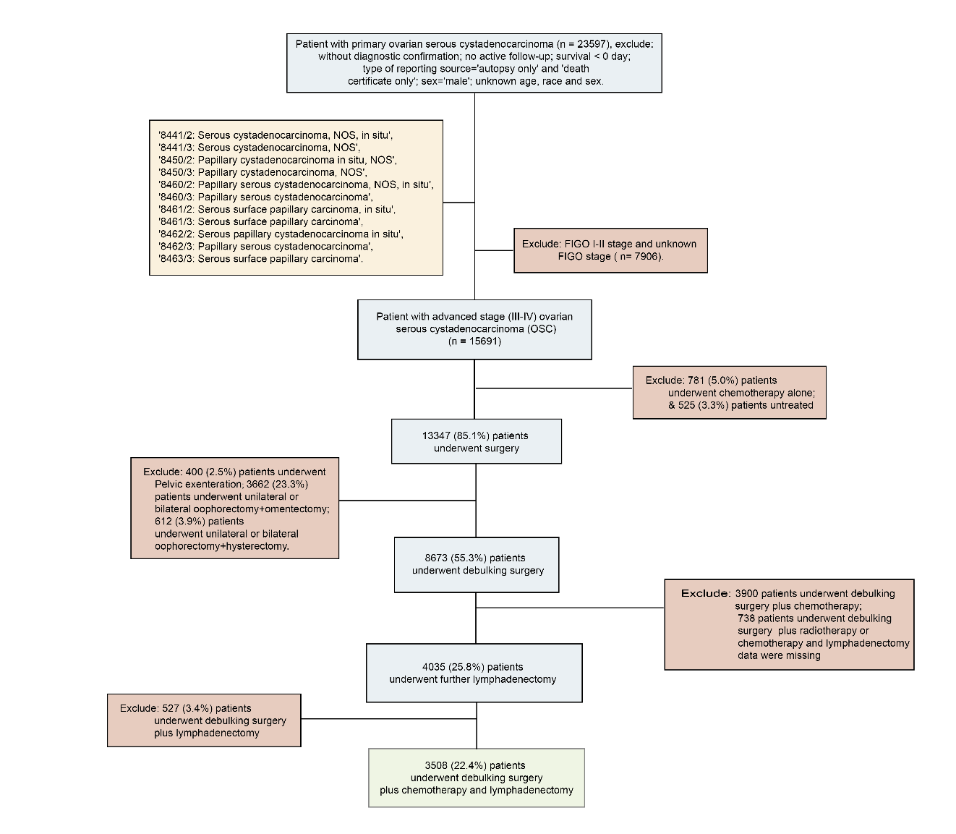
Supplementary Figure 1

Supplementary Figure 1. Eligibility criteria for collection of patients with advanced stage primary ovarian serous cystadenocarcinoma.

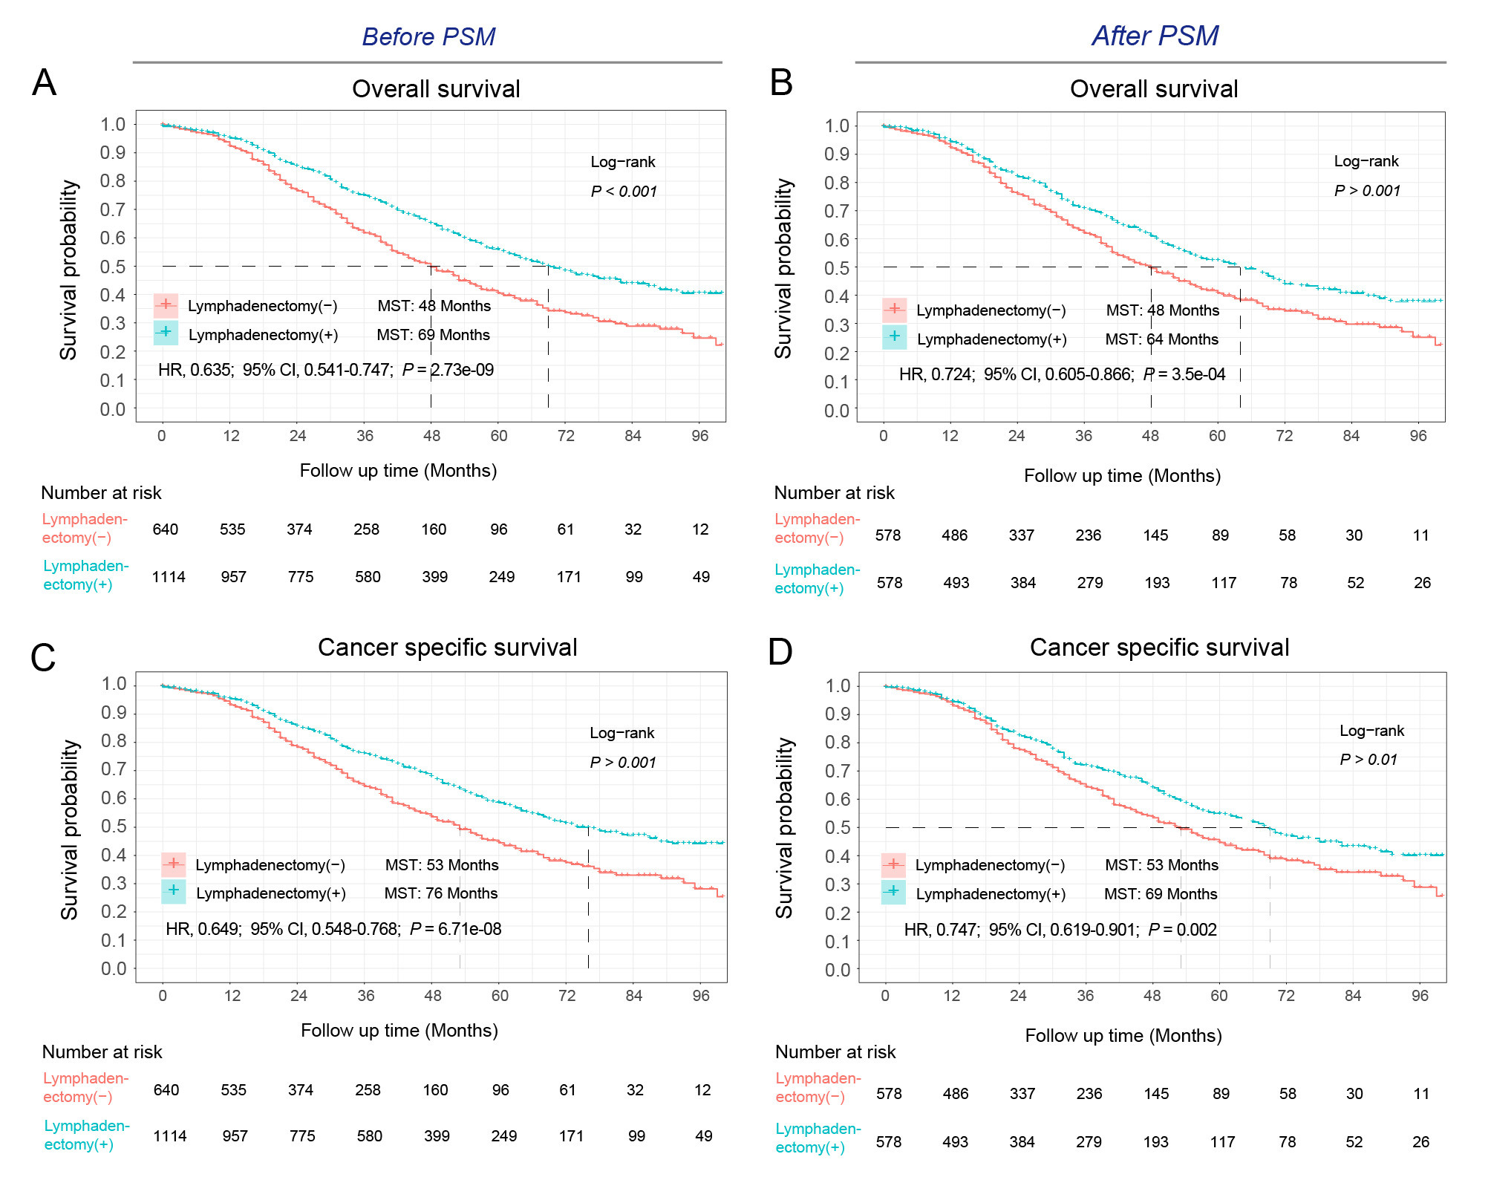
Supplementary Figure 2

Supplementary Figure 2. The effect of lymphadenectomy under R0 stratification before and after PSM matching on the OS and CSS of advanced OSC. A, Comparison of overall survival (OS) before PSM matching; B, Comparison of overall survival (OS) after PSM matching; C, Comparison of cancer-specific survival (CSS) before PSM matching; D, Comparison of cancer-specific survival (CSS) after PSM matching. P < 0.01 for all.

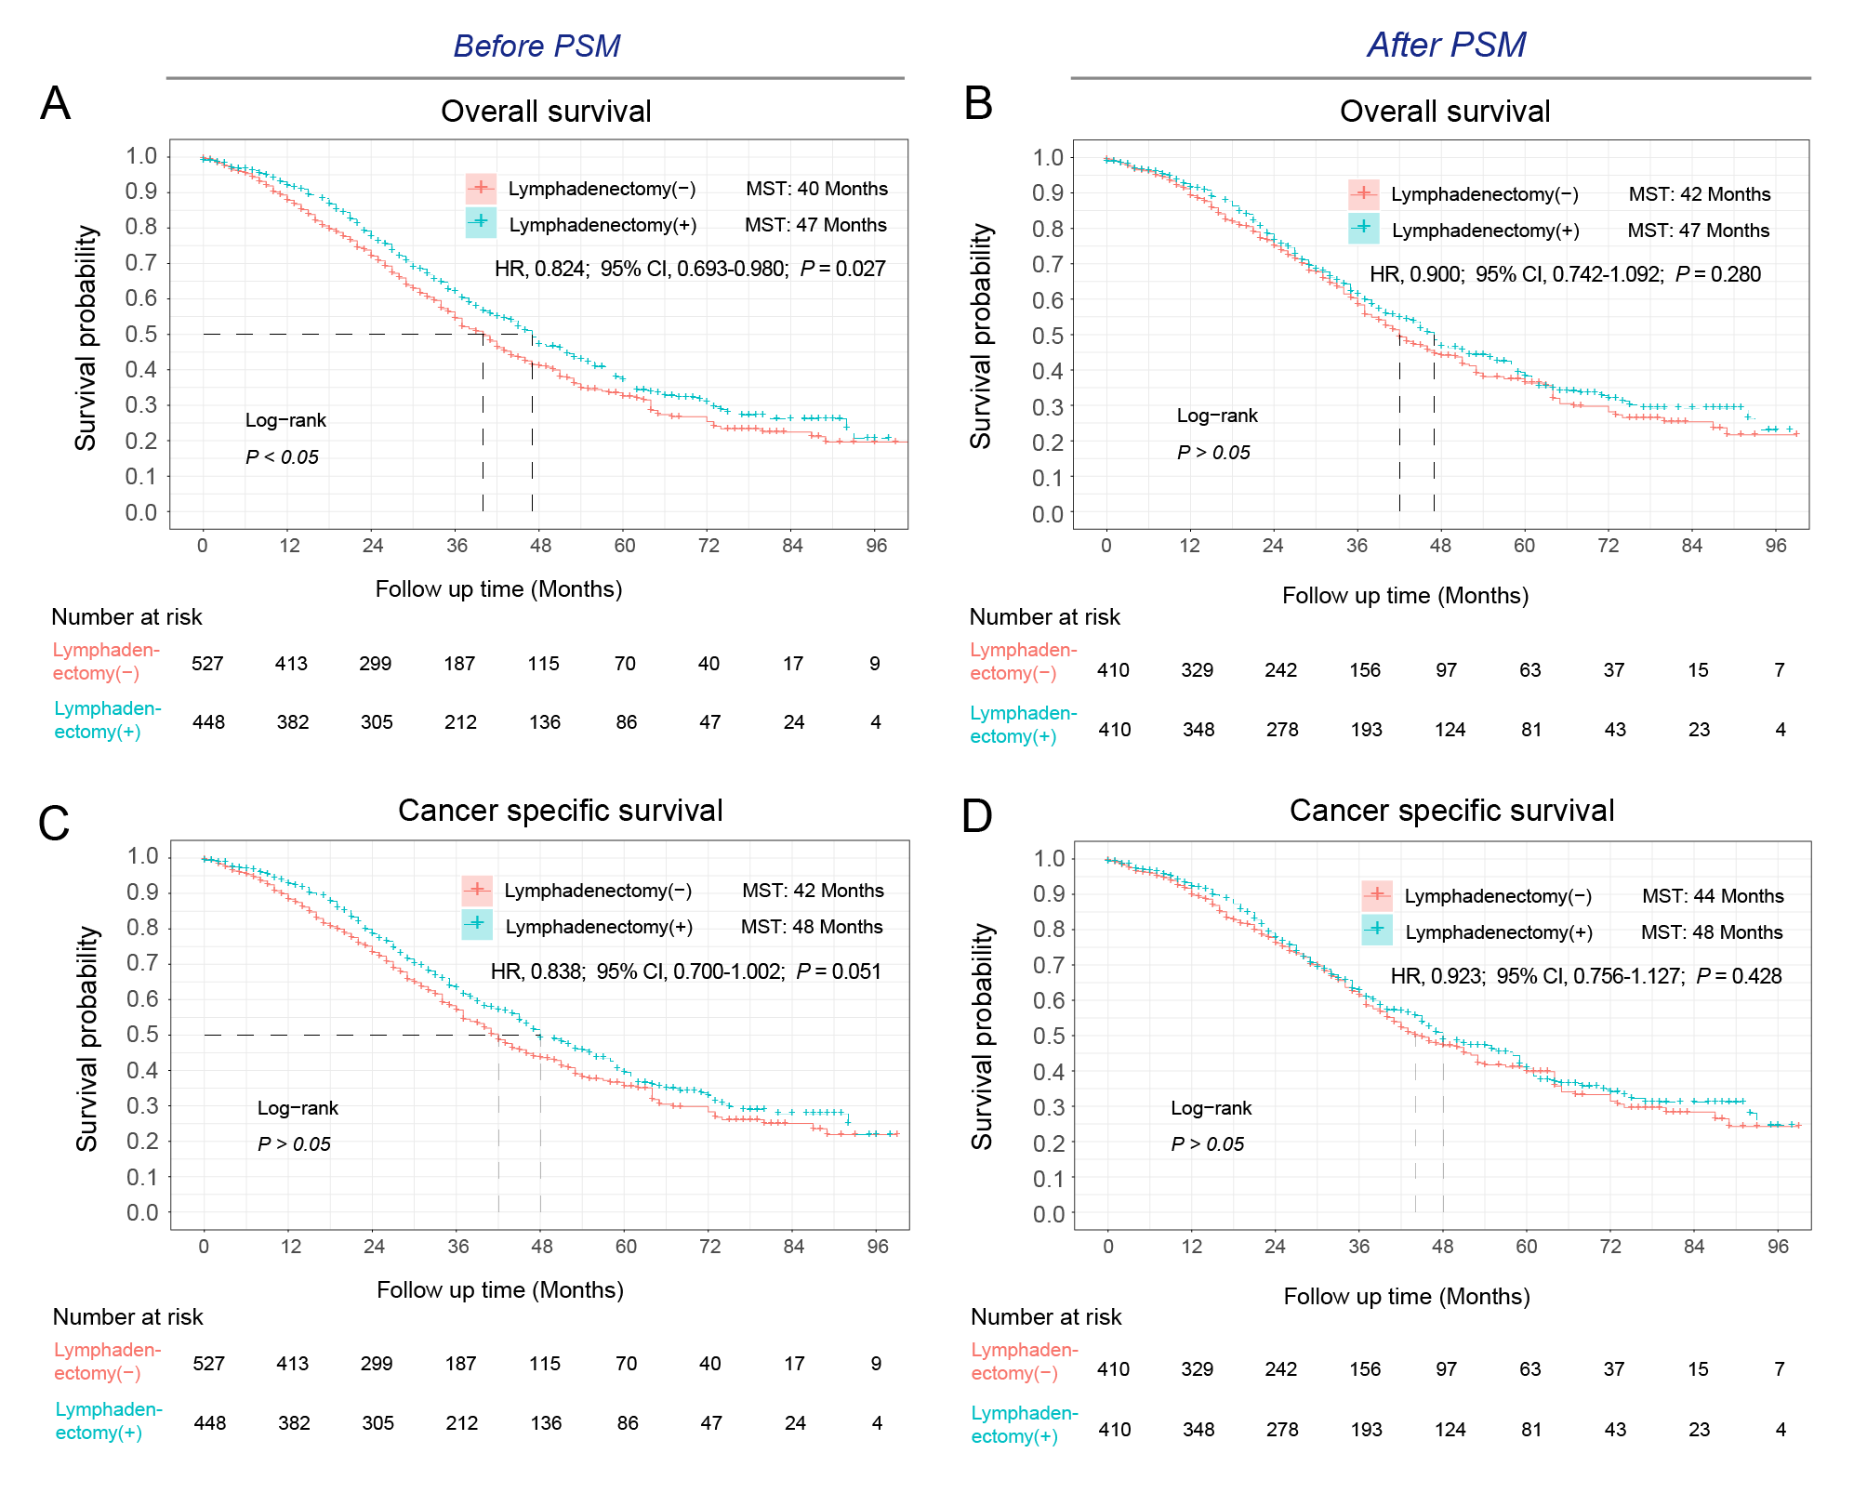
Supplementary Figure 3

Supplementary Figure 3. The effect of lymphadenectomy under “residual tumor nodule(s) of ≤ 1cm” stratification before and after PSM matching on the OS and CSS of advanced OSC. A, Comparison of overall survival (OS) before PSM matching; B, Comparison of overall survival (OS) after PSM matching; C, Comparison of cancer-specific survival (CSS) before PSM matching; D, Comparison of cancer-specific survival (CSS) after PSM matching.

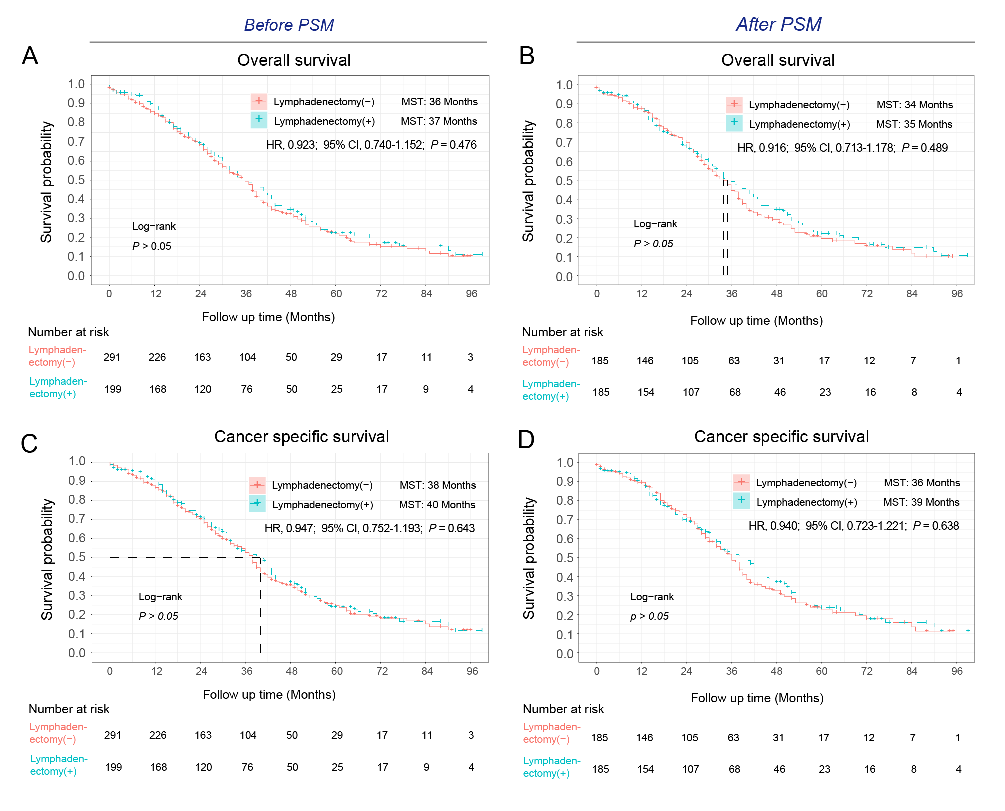
Supplementary Figure 4

Supplementary Figure 4. The effect of lymphadenectomy under “residual tumor nodule(s) of > 1cm” stratification before and after PSM matching on the OS and CSS of advanced OSC. A, Comparison of overall survival (OS) before PSM matching; B, Comparison of overall survival (OS) after PSM matching; C, Comparison of cancer-specific survival (CSS) before PSM matching; D, Comparison of cancer-specific survival (CSS) after PSM matching.

