Selective extraction of Crocin from Saffron using modified magnetic nanoparticles coated with molecularly imprinted polymer followed by UV-Visible spectrophotometry and high performance liquid chromatography

Ali gholami^{1*}, Mahshid Golestaneh², Hediye Bigdeli Azari¹
¹ Department of Analytical Chemistry, Faculty of Chemistry, University of Kashan, Kashan 87317-51167, Iran
² Department of Chemistry Education, Farhangian University, P.O. Box 14665-889, Tehran, Iran

*Corresponding authors: agholami@kashanu.ac.ir (Ali Gholami)

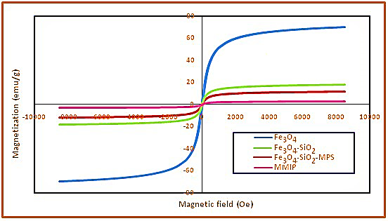
Fig. S1. Magnetization curves of Fe₃O₄, Fe₃O₄@SiO₂, Fe₃O₄@SiO₂-MPS, and MMIPs.

Fig. S2 The effect of time on the absorption percentage of crocin in the presence of 0.05 g MMIP and MNIP

Fig. S3 The effect of pH on the absorption percentage of crocin in the presence of 0.05 g MMIP

Fig. S4 Langmuir (a), Freundlich (b), and Temkin (c) isotherm models of crocin sorption on MMIP (temperature: 25 °C, contact time: 15 min).
A

Fig. S5 Pseudo-first-order kinetics (a), pseudo-second-order kinetics (b), and intraparticle diffusion kinetics (c) models of crocin adsorption on MMIP. Conditions: pH = 2, initial crocin concentration 20.0 mg L-1, amount of sorbent 50.0 mg.

Fig. S6. Calibration curve of crocin using UV-Visible spectrophotometry in optimum conditions

Fig. S7 Investigating the selectivity of MMIP and MNIP toward crocin in the presence of interfering food color

