SUPPLEMENTAL TABLES AND FIGURES

Table S1. Etiologies of lower respiratory tract disease
Etiology | Number of Events
Bacterial LRTD (N = 10 events in 10 participants)
Nocardia | 1
Aspiration pneumonia and or VAP | 4
Legionella spp. | 3
Pseudomonas aeruginosa | 1
MRSA | 1
Viral LRTD (N = 20 events in 18 participants)
Rhinovirus/enterovirus | 5
Metapneumovirus | 4
Coronavirus | 2
Adenovirus | 2
PIV3 | 2
RSV | 1
Influenza A | 1
Multiple viruses | 3
CMV, rhinovirus, adenovirus | 1
Influenza A and adenovirus | 1
CMV, rhinovirus | 1
Fungal LRTD (N = 27 events in 26 participants)
Probable pulmonary aspergillosis | 17
Proven pulmonary aspergillosis | 1
Probable pulmonary mucormycosis | 2
Possible invasive fungal pneumonia | 7
Idiopathic pneumonia syndrome (IPS) (N = 22 events in 18 participants)
With diffuse alveolar hemorrhage (DAH) | 9
Without DAH | 13
Other (N = 11 events in 11 participants)
Negative microbiologic workup, not consistent with definition of IPS | 11
Multifactorial (N = 35 events in 30 participants)
Bacterial and viral | 13
Pseudomonas spp. and rhinovirus | 1
Bacterial pneumonia NOS and PIV4 | 1
Mycobacterium abscessus and metapneumovirus | 1
E. coli and coronavirus | 1
Streptococcus viridans, rhinovirus, and adenovirus | 1
Bacterial pneumonia NOS and HHV-6 detected clinically | 1
Klebsiella pneumoniae, Nocardia spp., and PIV1 | 1
MSSA, rhinovirus | 1
Haemophilus influenzae, rhinovirus | 1
Streptococcus viridans and PIV3 | 1
Pseudomonas spp, adenovirus, rhinovirus | 1
Bacterial pneumonia (aspiration), metapneumovirus | 1
Bacterial pneumonia (aspiration), adenovirus | 1
Bacterial and fungal | 9
E. coli and probable pulmonary aspergillosis | 2
Polymicrobial bacterial pneumonia and probable pulmonary aspergillosis | 3
Pseudomonas spp. and probable pulmonary aspergillosis | 1
Bacterial pneumonia (aspiration) and probable pulmonary aspergillosis | 1
MSSA and possible fungal pneumonia | 1
Bacterial pneumonia (aspiration) and possible fungal pneumonia | 1
Viral and fungal | 4
PIV3 and probable pulmonary aspergillosis | 1
Metapneumovirus and probable pulmonary aspergillosis | 1
Rhinovirus and probable pulmonary mucormycosis | 1
Influenza B and possible pulmonary aspergillosis | 1
Bacterial, viral, and fungal | 3
Polymicrobial bacterial pneumonia, coronavirus, proven pulmonary  aspergillosis | 1
Stenotrophomonas maltophilia, rhinovirus, and probable pulmonary  aspergillosis | 1
Bacterial pneumonia (aspiration), PIV3, and probable pulmonary aspergillosis | 1
Possible infection and other non-infectious processes | 6

Table S2. HHV-6B-specific mRNA transcripts detected in BALF and plasma
HHV-6B DNA+ BAL at any levelª | HHV-6B U38 mRNA only detected | HHV-6B U90 mRNA only detected | U38 and U90 both detected | No HHV-6B mRNA detected
45 | 6 (13%) | 6 (13%) | 10 (22%) | 23 (51%)
HHV-6B DNA+ Plasma
18^{b} | 4^{c} (22%) | 2 (11%) | 10 (56%) | 2 (11%)
Data are presented as number (percentage).
ªOnly samples with HHV-6B DNA detected were tested for HHV-6B mRNA.
^{b}19 participants had HHV-6B DNA in plasma samples, but 1 did not have an available PAXgene blood tube collected for testing.
^{c}2 of these samples did not undergo testing for U90.

Table S3. Receive operator characteristic curve analysis to determine the performance characteristics of a given HHV-6B DNA viral load threshold in the BAL for predicting the detection of HHV-6B-specific mRNA transcripts
Viral load | Log10(viral  load) | Estimated  Probability | No. of  Correctly  Predicted  Events | No. of  Correctly  Predicted  Nonevents | No. of  Nonevents  Predicted  as Events | No. of  Events  Predicted  as  Nonevents | Sensitivity | 1 -  Specificity | PPV | NPV | Specificity
19.99 | 1.30091 | .15836 | 20 | 71 | 22 | 0 | 1.00 | .23656 | .47619 | 1.00000 | .76344
23.83 | 1.37704 | .15837 | 20 | 72 | 21 | 0 | 1.00 | .22581 | .48780 | 1.00000 | .77419
38.69 | 1.58760 | .15841 | 20 | 73 | 20 | 0 | 1.00 | .21505 | .50000 | 1.00000 | .78495
59.00 | 1.77085 | .15847 | 20 | 74 | 19 | 0 | 1.00 | .20430 | .51282 | 1.00000 | .79570
62.57 | 1.79638 | .15848 | 19 | 74 | 19 | 1 | .95 | .20430 | .50000 | .98667 | .79570
67.00 | 1.82607 | .15849 | 19 | 75 | 18 | 1 | .95 | .19355 | .51351 | .98684 | .80645
73.72 | 1.86761 | .15851 | 18 | 75 | 18 | 2 | .90 | .19355 | .50000 | .97403 | .80645
85.00 | 1.92942 | .15854 | 18 | 76 | 17 | 2 | .90 | .18280 | .51429 | .97436 | .81720
100.78 | 2.00337 | .15859 | 18 | 77 | 16 | 2 | .90 | .17204 | .52941 | .97468 | .82796
102.00 | 2.00860 | .15859 | 18 | 78 | 15 | 2 | .90 | .16129 | .54545 | .97500 | .83871
111.00 | 2.04532 | .15862 | 17 | 78 | 15 | 3 | .85 | .16129 | .53125 | .96296 | .83871
141.72 | 2.15144 | .15870 | 17 | 79 | 14 | 3 | .85 | .15054 | .54839 | .96341 | .84946
145.00 | 2.16137 | .15871 | 17 | 80 | 13 | 3 | .85 | .13978 | .56667 | .96386 | .86022
179.43 | 2.25388 | .15881 | 17 | 81 | 12 | 3 | .85 | .12903 | .58621 | .96429 | .87097
218.39 | 2.33923 | .15892 | 17 | 82 | 11 | 3 | .85 | .11828 | .60714 | .96471 | .88172
227.00 | 2.35603 | .15894 | 16 | 82 | 11 | 4 | .80 | .11828 | .59259 | .95349 | .88172
231.00 | 2.36361 | .15895 | 16 | 83 | 10 | 4 | .80 | .10753 | .61538 | .95402 | .89247
253.77 | 2.40443 | .15901 | 16 | 84 | 9 | 4 | .80 | .09677 | .64000 | .95455 | .90323
281.00 | 2.44871 | .15909 | 15 | 84 | 9 | 5 | .75 | .09677 | .62500 | .94382 | .90323
284.00 | 2.45332 | .15910 | 15 | 85 | 8 | 5 | .75 | .08602 | .65217 | .94444 | .91398
392.53 | 2.59387 | .15940 | 14 | 85 | 8 | 6 | .70 | .08602 | .63636 | .93407 | .91398
407.72 | 2.61036 | .15945 | 14 | 86 | 7 | 6 | .70 | .07527 | .66667 | .93478 | .92473
480.00 | 2.68124 | .15965 | 14 | 87 | 6 | 6 | .70 | .06452 | .70000 | .93548 | .93548
533.00 | 2.72673 | .15980 | 13 | 87 | 6 | 7 | .65 | .06452 | .68421 | .92553 | .93548
577.96 | 2.76190 | .15992 | 12 | 87 | 6 | 8 | .60 | .06452 | .66667 | .91579 | .93548
600.33 | 2.77839 | .15999 | 11 | 87 | 6 | 9 | .55 | .06452 | .64706 | .90625 | .93548
1232.00 | 3.09061 | .16177 | 11 | 88 | 5 | 9 | .55 | .05376 | .68750 | .90722 | .94624
1457.00 | 3.16346 | .16241 | 10 | 88 | 5 | 10 | .50 | .05376 | .66667 | .89796 | .94624
1592.36 | 3.20204 | .16279 | 10 | 89 | 4 | 10 | .50 | .04301 | .71429 | .89899 | .95699
1909.00 | 3.28081 | .16370 | 10 | 90 | 3 | 10 | .50 | .03226 | .76923 | .90000 | .96774
2012.00 | 3.30363 | .16399 | 9 | 90 | 3 | 11 | .45 | .03226 | .75000 | .89109 | .96774
2835.00 | 3.45255 | .16637 | 8 | 90 | 3 | 12 | .40 | .03226 | .72727 | .88235 | .96774
7506.16 | 3.87542 | .18036 | 7 | 90 | 3 | 13 | .35 | .03226 | .70000 | .87379 | .96774
8901.75 | 3.94948 | .18472 | 6 | 90 | 3 | 14 | .30 | .03226 | .66667 | .86538 | .96774
9650.00 | 3.98453 | .18709 | 5 | 90 | 3 | 15 | .25 | .03226 | .62500 | .85714 | .96774
10831.46 | 4.03469 | .19088 | 4 | 90 | 3 | 16 | .20 | .03226 | .57143 | .84906 | .96774
14320.23 | 4.15595 | .20240 | 3 | 90 | 3 | 17 | .15 | .03226 | .50000 | .84112 | .96774
29414.75 | 4.46857 | .25814 | 3 | 91 | 2 | 17 | .15 | .02151 | .60000 | .84259 | .97849
55816.00 | 4.74676 | .37673 | 2 | 91 | 2 | 18 | .10 | .02151 | .50000 | .83486 | .97849
62431.00 | 4.79540 | .40973 | 2 | 92 | 1 | 18 | .10 | .01075 | .66667 | .83636 | .98925
114339.00 | 5.05819 | .67275 | 1 | 92 | 1 | 19 | .05 | .01075 | .50000 | .82883 | .98925
278408.00 | 5.44468 | .98452 | 1 | 93 | 0 | 19 | .05 | .00000 | 1.00000 | .83036 | 1.00000

Table S4. Association of BAL HHV-6B DNA detection ≥218 copies/mL with overall mortality and death from respiratory failure by day 60 after the BAL in adjusted Cox models
 | Overall mortality |  | Death from respiratory failure
Variable | Adjusted HR (95% CI) | P | Adjusted HR (95% CI) | P
Age (years)  <60  ≥60 | Reference  1.50 (0.77-2.94) | 0.24 | Reference  1.26 (0.59-2.67) | 0.55
Maximum oxygen use pre-BALª  ≤2 L/minute  >2 L/minute | Reference  3.27 (1.60-6.71) | 0.001 | Reference  2.76 (1.25-6.09) | 0.012
Maximum corticosteroid use pre-BAL^{b}  <1 mg/kg/day  ≥1 mg/kg/day | Reference  1.66 (0.80-3.42) | 0.17 | Reference  0.95 (0.36-2.50) | 0.92
HHV-6B DNA in BAL, ≥218 copies/mL^{c}  No  Yes | Reference  1.81 (0.89-3.67) | 0.099 | Reference  2.35 (1.08-5.11) | 0.032
CI indicates confidence interval; HHV-6B, human herpesvirus 6B; BAL, bronchoalveolar lavage.
113 participants included in the model. There were 35 events for overall mortality and 27 events for death from respiratory failure (i.e., pulmonary death).
ªWithin 24 hours preceding the BAL.
^{b}Within 14 days pre-BAL, based on prednisone-equivalent dosing.
^{c}When stratified by a higher viral load threshold of ≥578 copies/mL (identified from ROC curves as having the best performance for identifying BAL samples with detection of both HHV-6B-specific mRNA transcripts, as opposed to either/or), the association with overall mortality increased (aHR, 2.86; 95% CI, 1.24-6.60; p = 0.014) and was similar for death from respiratory failure (aHR, 2.79; 95% CI, 1.11-7.03; p = 0.03).

Table S5. Demographic and clinical variables at the time of the BAL in the subgroup of 54 patients with whole blood RNASeq testing
 | Negative HHV-6B  DNA in BAL (N=37) | Positive HHV6-B DNA in BAL (any level) (N=16)ª | Total  (N=53^{b})
Age, years
21-40 | 10 (27%) | 6 (38%) | 16 (30%)
41-60 | 14 (38%) | 5 (31%) | 19 (36%)
>60 | 13 (35%) | 5 (31%) | 18 (34%)
Female sex | 12 (32%) | 6 (38%) | 18 (34%)
Race
Caucasian | 26 (70%) | 12 (75%) | 38 (72%)
Non-Caucasian | 10 (27%) | 4 (25%) | 14 (26%)
Unknown | 1 (3%) | 0 (0%) | 1 (2%)
Year of HCT
2015 | 3 (8%) | 0 (0%) | 3 (6%)
2016 | 8 (22%) | 2 (13%) | 10 (19%)
2017 | 13 (35%) | 3 (19%) | 16 (30%)
2018 | 9 (24%) | 6 (38%) | 15 (28%)
2019 | 4 (11%) | 5 (31%) | 9 (17%)
CMV serostatus
D- and R- | 6 (16%) | 2 (13%) | 8 (15%)
D+ or R+ | 31 (84%) | 12 (75%) | 43 (81%)
Missing | 0 (0%) | 2 (13%) | 2 (4%)
 | 6 (16%) | 2 (13%) | 8 (15%)
HCT comorbidity index Score^{c}
0 (low) | 4 (11%) | 1 (6%) | 5 (9%)
1-2 (intermediate) | 13 (35%) | 5 (31%) | 18 (34%)
>=3 (high) | 20 (54%) | 10 (63%) | 30 (57%)
HLA and donor
Matched related | 4 (11%) | 3 (19%) | 7 (13%)
Matched unrelated | 14 (38%) | 6 (38%) | 20 (38%)
Mismatched related | 7 (19%) | 1 (6%) | 8 (15%)
Mismatched unrelated | 12 (32%) | 6 (38%) | 18 (34%)
Cell source
Peripheral blood | 28 (76%) | 13 (81%) | 41 (77%)
Bone marrow | 7 (19%) | 3 (19%) | 10 (19%)
Umbilical cord blood | 2 (5%) | 0 (0%) | 2 (4%)
Myeloablative conditioning^{d} | 18 (49%) | 7 (44%) | 25 (47%)
Maximum corticosteroid
use pre-BALe
None | 17 (46%) | 6 (38%) | 23 (43%)
<2 mg/kg/day | 17 (46%) | 9 (56%) | 26 (49%)
≥2 mg/kg/day | 3 (8%) | 1 (6%) | 4 (8%)
Maximum oxygen use pre-BAL >2 L/minute^{f} | 15 (41%) | 8 (50%) | 23 (43%)
WBC count pre-BAL^{g}
>1,000 cells/mm³ | 33 (89%) | 16 (100%) | 49 (92%)
≤1,000 cells/mm³ | 3 (8%) | 0 (0%) | 3 (6%)
Missing | 1 (3%) | 0 (0%) | 1 (2%)
ALC pre-BAL^{g}
>300 cells/mm³ | 19 (51%) | 4 (25%) | 23 (43%)
≤300 cells/mm³ | 17 (46%) | 11 (69%) | 28 (53%)
Missing | 1 (3%) | 1 (6%) | 2 (4%)
ANC pre-BAL^{g}
>500 cells/mm³ | 32 (86%) | 13 (81%) | 45 (85%)
≤500 cells/mm³ | 4 (11%) | 2 (13%) | 6 (11%)
Missing | 1 (3%) | 1 (6%) | 2 (4%)
Day of BAL post-HCT (median, IQR) | 43 (27-76) | 44 (28-77) | 43 (27-76)
LRTD cause^{h}
Bacterial | 5 (14%) | 2 (13%) | 7 (13%)
Viral | 11 (30%) | 6 (38%) | 17 (32%)
Fungal | 11 (30%) | 6 (38%) | 17 (32%)
IPS | 10 (27%) | 2 (13%) | 12 (23%)
Data are presented as number (percentage), unless otherwise indicated.
HHV-6B indicates human herpesvirus 6B; BAL, bronchoalveolar lavage; D, donor; R, recipient; HLA, human leukocyte antigen; WBC, white blood cell; ALC, absolute lymphocyte count; ANC, absolute neutrophil count; LRTD, lower respiratory tract disease; IPS, idiopathic pneumonia syndrome.
ª10 participants in this group had BAL HHV-6B viral load ≥218 copies/mL.
^{b}1 of the 54 participants in this subgroup did not have a BAL fluid sample available for testing and are excluded from this Table.
^{c}Based on the HCT-comorbidity index.
^{d}Myeloablative regimens included any regimen containing ≥800 cGY TBI, any regimen containing carmustine/etoposide/cytarabine/melphalan (BEAM), or any regimen containing busulfan/cyclophosphamide with or without antithymocyte globulin.
^{e}Within 14 days pre-BAL, based on prednisone-equivalent dosing.
^{f}Within 24 hours preceding the BAL.
^{g}Closest sample within 3 days pre-BAL.

Table S6. Key characteristics in participants with blood genome-wide sequencing data stratified by LRTD category
IPS (N=12) |  | No HHV-6B ≥218 copies/mL in BALF or any detection in blood  (N=8) | HHV-6B ≥218 copies/mL in BALF (with or without any blood detection)  (N=2) | HHV-6B in blood (any level) but not detected in BALF (at ≥218 copies/mL)  (N=2)
Day post HCT | Median (IQR) | 36 (25-59) | 50 (23-76) | 24 (19-29)
WBCª | Median (IQR) | 3,800 (2,700-5,900) | 3,690 (3,600-3,780) | 15,670 (10,830-20,510)
ALCª | Median (IQR) | 293 (132-371) | 533 (227-839) | 410 (0.0-820)
ANCª | Median (IQR) | 3,120 (2,111-4,746) | 2,582 (2,027-3,137) | 10,226 (8,556-11,896)
Maximum corticosteroid use pre-BAL^{b} | None | 3 (38%) | 2 (100%) | 2 (100%)
 | <2 mg/kg/day | 4 (50%) | 0 | 0
 | ≥2 mg/kg/day | 1 (13%) | 0 | 0
Viral (N=17) |  | No HHV-6B ≥218 copies/mL in BALF or any detection in blood  (N=13) | HHV-6B ≥218 copies/mL in BALF (with or without any blood detection)  (N=3) | HHV-6B in blood (any level) but not detected in BALF (at ≥218 copies/mL)  (N=1)
Day post HCT | Median (IQR) | 85 (56-92) | 34 (27-57) | 21 (21-21)
WBCª | Median (IQR) | 4,790 (2,900-6,000) | 6,280 (4,330-8,560) | 2,740
ALCª | Median (IQR) | 564 (203-684) | 217 (0-342) | 137
ANCª | Median (IQR) | 3,308 (1,836-4,803) | 5,401 (2,685-5,992) | 1,754
Maximum corticosteroid use pre-BAL^{b} | None | 5 (38%) | 2 (67%) | 1 (100%)
 | <2 mg/kg/day | 7 (54%) | 0 | 0
 | >=2 mg/kg/day | 1 (8%) | 1 (33%) | 0
Fungal (N=17) |  | No HHV-6B ≥218 copies/mL in BALF or any detection in blood  (N=13) | HHV-6B ≥218 copies/mL in BALF (with or without any blood detection)  (N=4) | HHV-6B in blood (any level) but not detected in BALF (at ≥218 copies/mL)  (N=0)
Day post HCT | Median (IQR) | 41 (15-76) | 23 (16-30) | --
Total WBCª | Median (IQR) | 3,020 (1,300-5,000) | 3,535 (3,410-3,730) | --
ALCª | Median (IQR) | 172 (86-360) | 166 (110-319) | --
ANCª | Median (IQR) | 1,685 (418-3,934) | 2,514 (2,032-3,313) | --
Maximum corticosteroid use pre-BAL^{b} | None | 5 (38%) | 3 (75%) | --
 | <2 mg/kg/day | 8 (62%) | 1 (25%) | --
 | >=2 mg/kg/day | 0 | 0 | --
Bacterial (N=7) |  | No HHV-6B ≥218 copies/mL in BALF or any detection in blood  (N=6) | HHV-6B ≥218 copies/mL in BALF (with or without any blood detection)  (N=1) | HHV-6B in blood (any level) but not detected in BALF (at ≥218 copies/mL)  (N=0)
Day post HCT | Median (IQR) | 46 (36-83) | 52 | --
Total WBCª | Median (IQR) | 7,000 (1,910-9,280) | 8,800 | --
ALCª | Median (IQR) | 420 (91-516) | 185 | --
ANCª | Median (IQR) | 6,020 (1,665-7,702) | 216 | --
Maximum corticosteroid use pre-BAL^{b} | None | 2 (33%) | 0 | --
 | <2 mg/kg/day | 3 (50%) | 1 (100%) | --
 | >=2 mg/kg/day | 1 (17%) | 0 | --
HHV-6B indicates human herpesvirus 6B; BAL, bronchoalveolar lavage; WBC, white blood cell; ALC, absolute lymphocyte count; ANC, absolute neutrophil count; IPS, idiopathic pneumonia syndrome.
ªClosest sample within 3 days pre-BAL. Units of cells/mm³.
^{b}Within 14 days pre-BAL, based on prednisone-equivalent dosing.

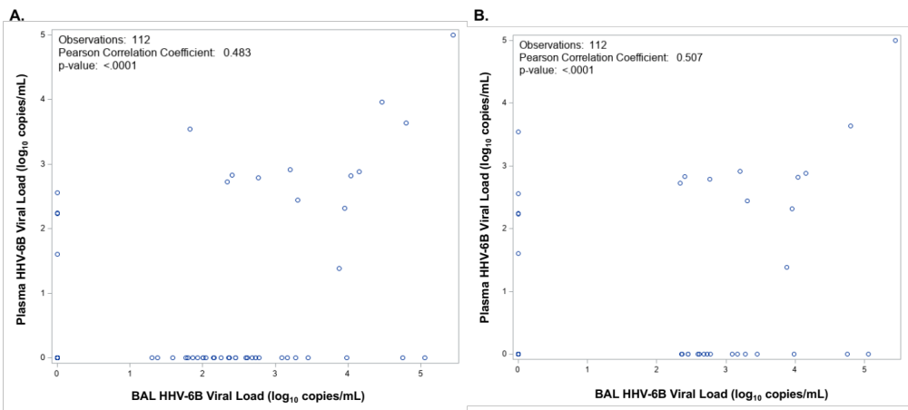

Figure S1. Correlation of BAL and plasma HHV-6B viral load.
Correlation of BAL and plasma HHV-6B viral load (A). With categorization of BAL fluid HHV-6B viral loads <218 copies/mL as 0 (i.e., indicative of viral shedding), there is higher correlation.

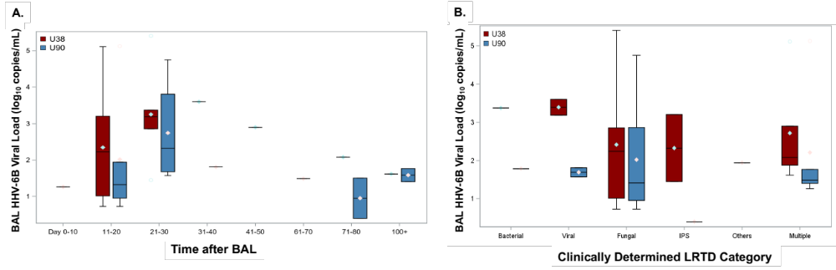

Figure S2. BAL fluid HHV-6B mRNA viral load over time and by LRTD category.
Data are shown from 22 BAL events that had HHV-6B mRNA detection for either the U38 or U90 transcript. LRTD indicates lower respiratory tract disease.

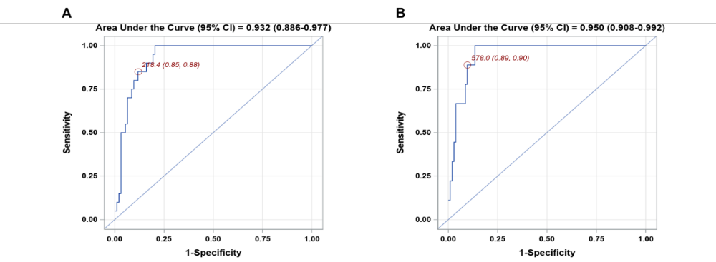

Figure S3. Receive operator characteristic (ROC) curve analyses to determine the performance characteristics of a given HHV-6B DNA viral load threshold in the BAL for predicting the detection of HHV-6B-specific mRNA transcripts (U38 and/or U90).
A viral load of 2.3 log₁₀ copies/mL (218 copies/mL) maximized sensitivity (85%) and specificity (88%) for the detection of either HHV-6B U38 or U90 mRNA (A). Negative and positive predictive values are demonstrated in Table S3. An ROC curve for predicting the detection of both U38 and U90 in the same sample identified a viral load threshold of ≥2.8 log₁₀ copies/mL (578 copies/mL) as the optimal cut point with AUC = 0.95 (95% CI, 0.91-0.99), sensitivity = 89%, and specificity = 90% (B).

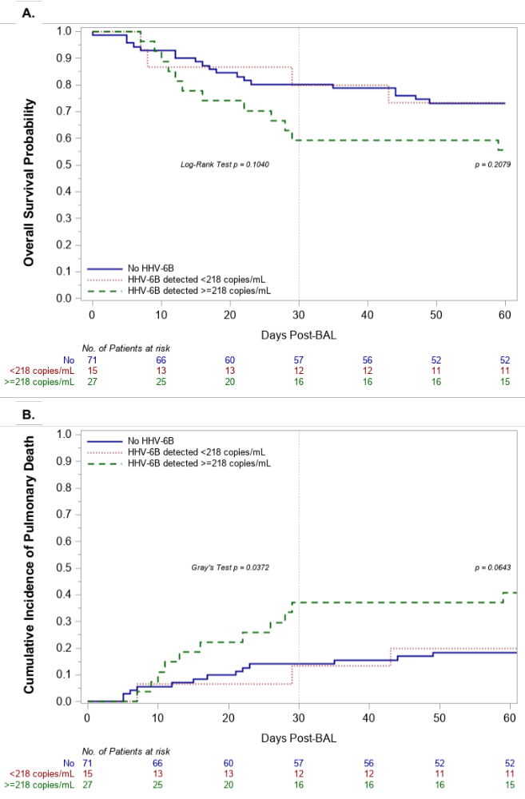

Figure S4. Kaplan Meier and cumulative incidence plots of time to overall mortality and death due to respiratory failure, respectively, among patients with BAL fluid HHV-6B viral load ≥218 copies/mL, detected but <218 copies/mL, and not detected.
Participants with HHV-6B DNA ≥218 copies/ml (2.3 log₁₀ copies/mL) in BALF based on the threshold predictive of mRNA detection (n=27) had increased overall mortality (adjusted hazard ratio [aHR], 1.81; 95% CI, 0.89-3.67; p=0.099) (A) and death from respiratory failure (aHR, 2.35; 95% CI, 1.08-5.11; p=0.032) (B) compared to those with HHV-6B detection but at levels <2.3 log₁₀ copies/mL and those without HHV-6B detection in models adjusted for age, oxygen use, and steroid use at the time of BAL in a multivariable Cox regression model. Deaths due to other causes were considered competing events in the cumulative incidence curve. The first and second log-rank or Gray’s test statistics in the figures depict the unadjusted comparison of the curves at day 30 and day 60 post-BAL, respectively.

