Supplementary Material

Table of Contents
eMethods 1. Newcastle-Ottawa Scale (NOS) Assessment 2
eMethods 2. Data extraction 4

eMethods 1. Newcastle-Ottawa Scale (NOS) Assessment

NOS quality assessment. We defined the following quality score: “good” quality score by 3 or 4 stars in the selection, 1 or 2 stars in comparability, and 2 or 3 stars in outcomes. Definition of “fair” quality score was defined as 2 stars in the selection, 1 or 2 stars in comparability, and 2 or 3 stars in outcomes. Finally, “poor” quality score was defined by 0 or 1 star(s) in the selection, 0 stars in comparability, and 0 or 1 star(s) in outcomes.
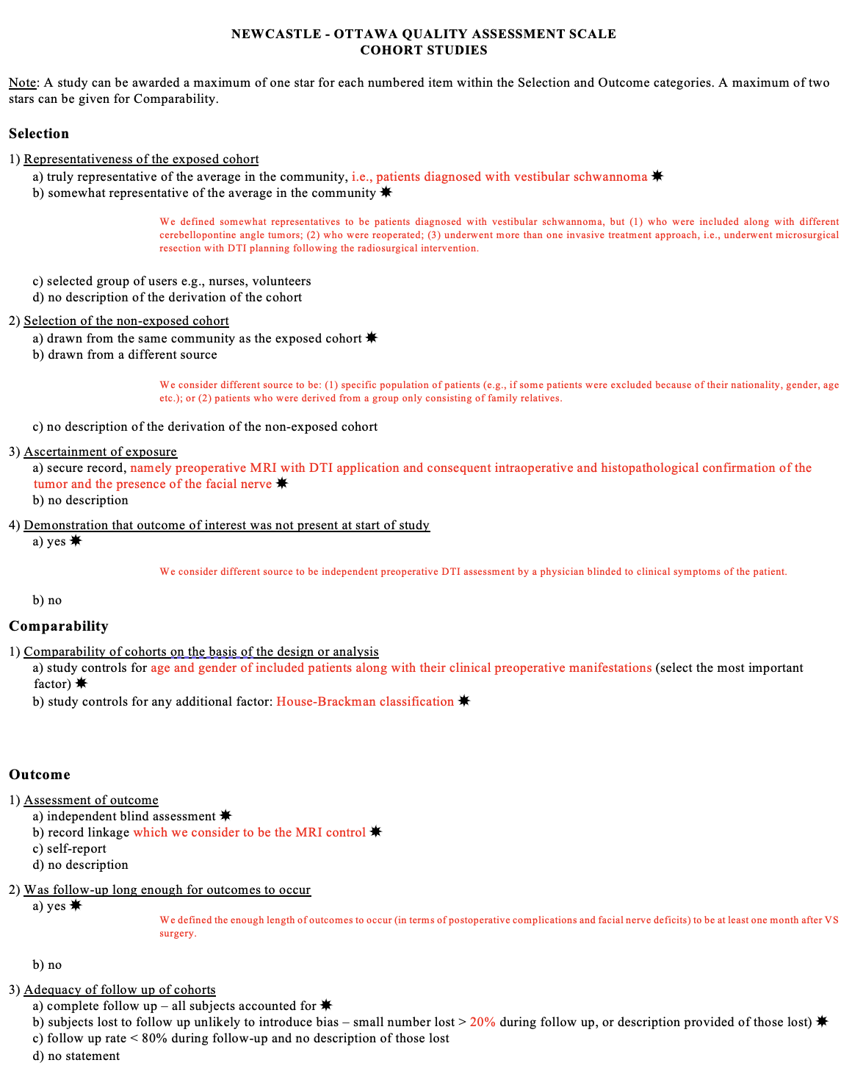
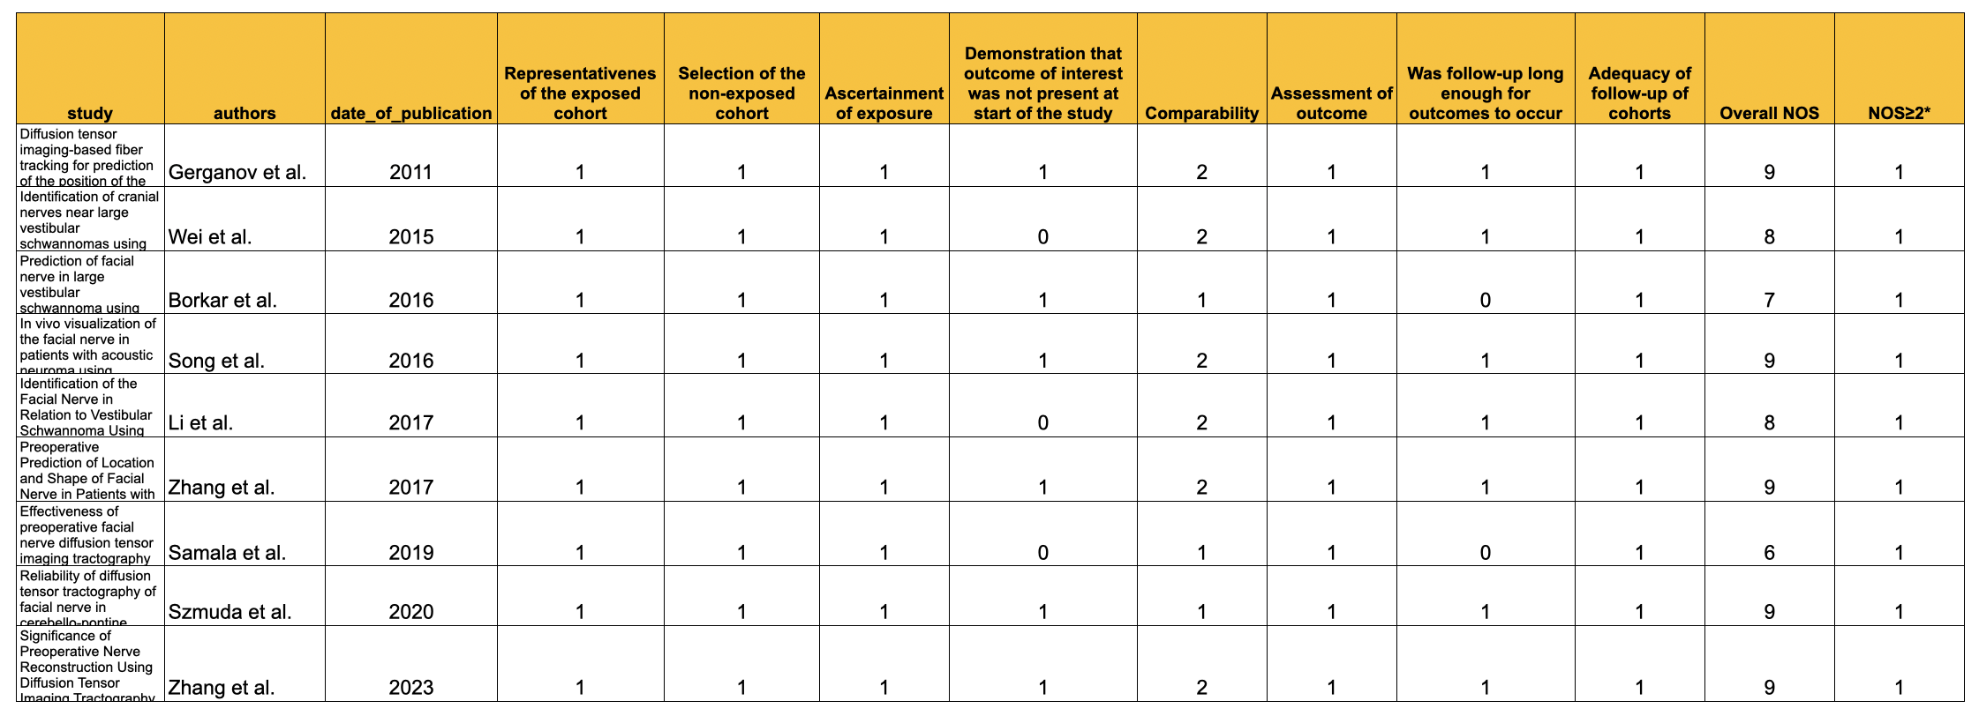
Table 1: Final evaluation of the risk of bias using the NOS in included studies.

eMethods 2. Data extraction
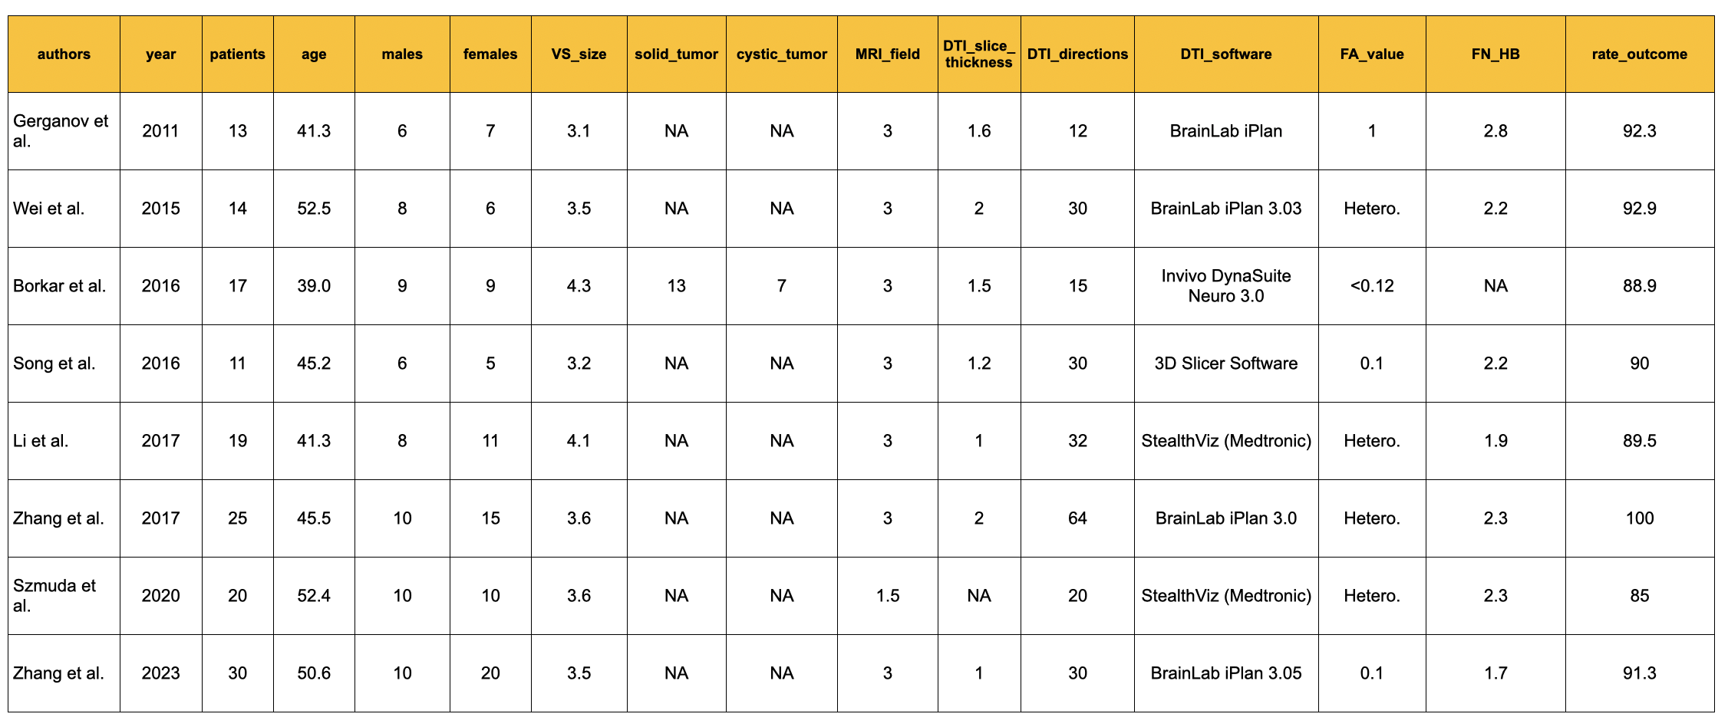

Table 2: Type of extracted data.

