Ferulic acid alleviates inflammatory manifestations in atopic dermatitis through modulation of the TRPV1/HMGB1 signaling pathway

Supplementary data

Supplementary Table 1. Primers are used in qRT-PCR for gene expression analyses.
Mouse | TRPV1  Forward: AGCCATCGCAAGGAGTATGTG  Reverse: GAGGATCATCTTCTCAATCATGACA | Calcineurin  Forward: AGATGCTGGTCAATGTTCTCAACA  Reverse: TATTGCTCGGATCTTGTTTCTGAT
Mouse | AGER  Forward: ATCCTACCTTCTCCTGCAGTTTCA  Reverse: CACCTTCAGGCTCAACCAACA | HMGB1  Forward: CAGATGACAAGCAGCCCTATGA  Reverse: TGCTCTTTTCAGCCTTGACCA
Mouse | MAPK  Forward: GCGCTACACCAACCTCTCGTA  Reverse: GTCTGGTGCTCAAAAGGACTGA | IL-6  Forward: AGACAAAGCCAGAGTCCTTCAGA  Reverse: CTGTTAGGAGAGCATTGGAAATTG
Mouse | GAPDH  Forward: AATGTGTCCGTCGTGGATCTG  Reverse: GCCCAAGATGCCCTTCAGT
Human | TRPV1  Forward: ACATGATCATCTTCACCATGGCT | Calcineurin  Forward: TGACTGAGATGCTGGTAAATGTCC
Human | Reverse: CTCCTAACACAGACAGGATCTCTCC | Reverse: CGGATCTTGTTCCTTATCACCTCT
Human | AGER  Forward: AGGGACTCTTAGCTGGCACTTG  Reverse: GCAGTGTGAAGAGCCCTGTCT | HMGB1  Forward: AGAAGTTCAAGGATCCCAATGC  Reverse: TCGCAACATCACCAATGGAC
Human | MAPK  Forward: AGGGTTCCTGACAGAATATGTGG  Reverse: TGCCAGAATGCAGCCTACAG | IL-6  Forward: GAGGCACTGGCAGAAAACAAC  Reverse: CAAACTCCAAAAGACCAGTGATGA
Human | GAPDH  Forward: CTCCTCCACCTTTGACGCTG  Reverse: CTCCTTGGAGGCCATGTGG
Supplementary Table 2. The histopathology evaluations of skin and spleen. The degrees of lesions were graded from one to three according to severity: 1 = minimal (< 25%); 2 = slight (25%-75%); 3 = moderate (75%-100%).
Organ | Histopathology | Group
Organ | Histopathology | Blank | DNCB | 0.03 µg/kg | 0.3 µg/kg | DEXA  (1 mg/kg)
Skin | Hyperkeratosis/serocellular pustule, epidermis | 0 | 2 | 1 | 0 | 0
Skin | Hyperplasia, epidermis | 0 | 3 | 1 | 0 | 0
Skin | Inflammation, dermis and subcutis | 0 | 3 | 1 | 1 | 0
Skin | Infiltration, mast cell, dermis, multifocal | 0 | 2 | 1 | 1 | 0
Ear | Hyperkeratosis/serocellular pustule, epidermis | 0 | 1 | 1 | 0 | 0
Ear | Hyperplasia, epidermis | 0 | 2 | 1 | 0 | 0
Ear | Inflammation, dermis and subcutis | 0 | 2 | 1 | 0 | 0
Ear | Infiltration, mast cell, dermis, multifocal | 0 | 2 | 1 | 1 | 0
-: No significant lesions.
1. Degree of lesions was graded from one to five depending on severity: 1 = minimal (< 1%); 2 = slight (1-25%); 3 = moderate (26-50%).
2. Incidence: Affected mice/ Total examined mice

Supplementary Figure 1. UV (CH₃CN, λ_{max}): 242, 296, 331 nm. IR (ν_{max}): 3350, 1660, 1450, 1213, 1175 cm⁻¹. ¹H NMR (CDCl₃) δ/ppm 3.95 (3H, s, 6-OCH₃), 6.48 (1H, d, J = 15.6 Hz, H-2), 6.93 (1H, d, J = 8.0 Hz, H-8), 7.05 (1H, d, J = 2.0 Hz, H-5), 7.12 (1H, dd, J = 8.0, 2.0 Hz, H-9), 7.59 (1H, d, J = 15.6 Hz, H-3).
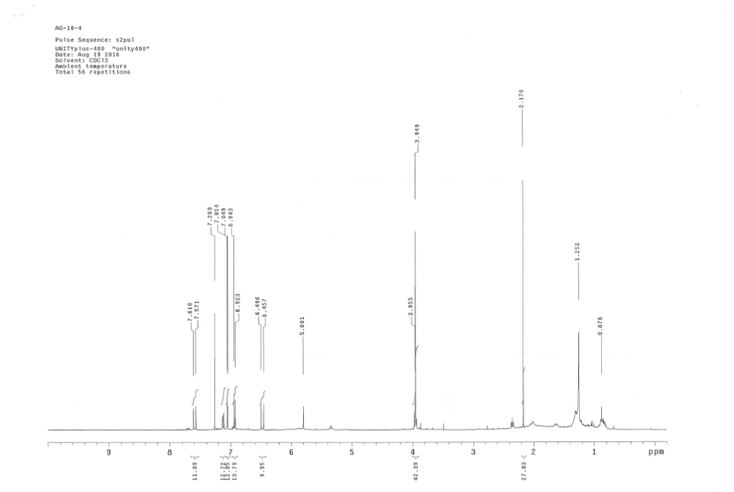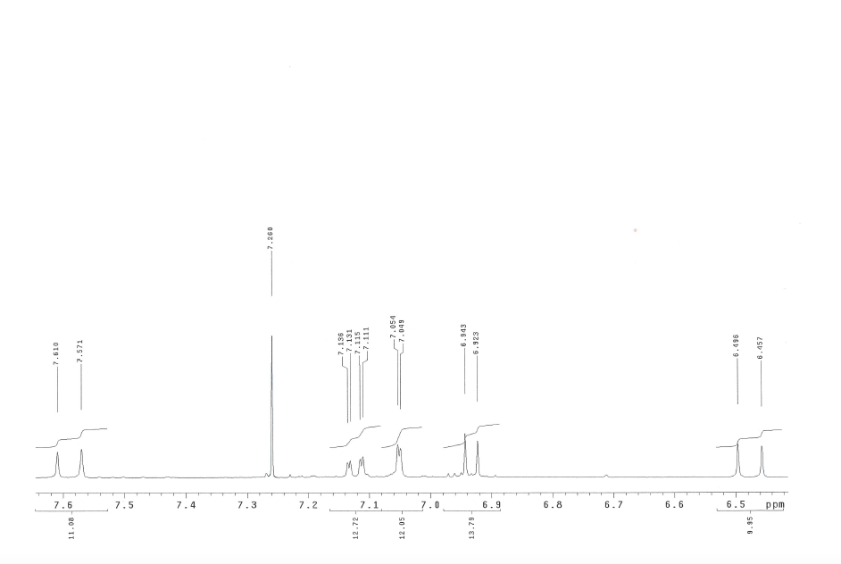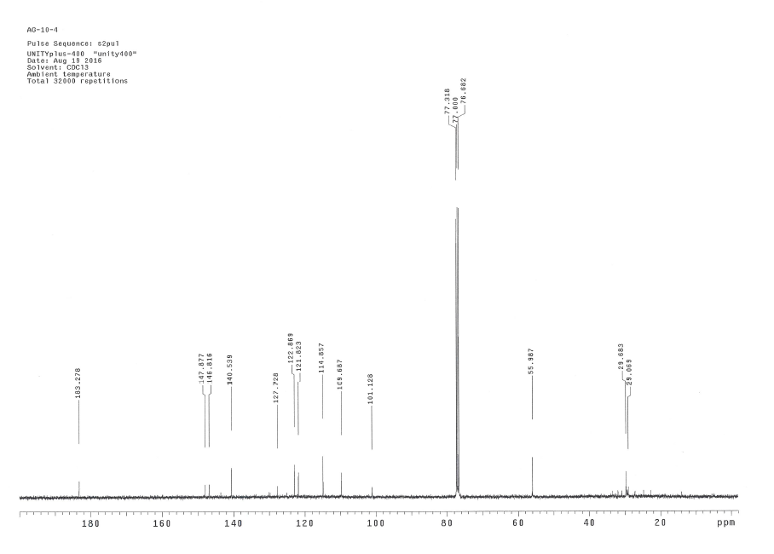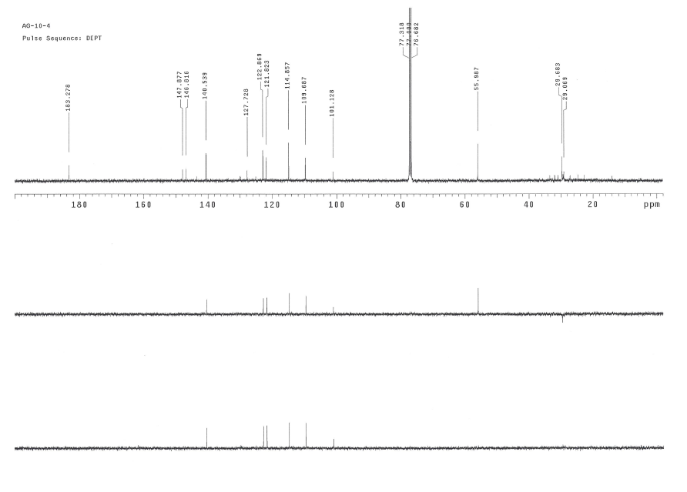

Supplementary Figure 2. The images were uncropped data of western blotting of RAW 264.7 and HaCaT cells.
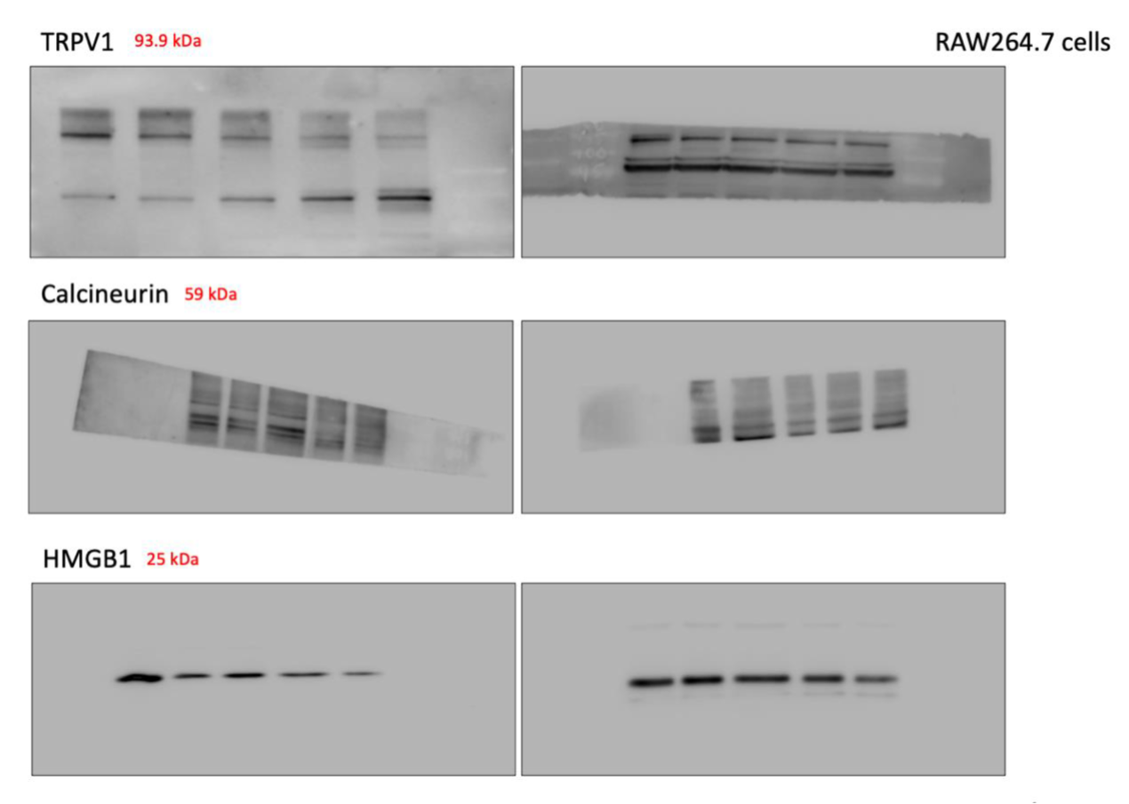
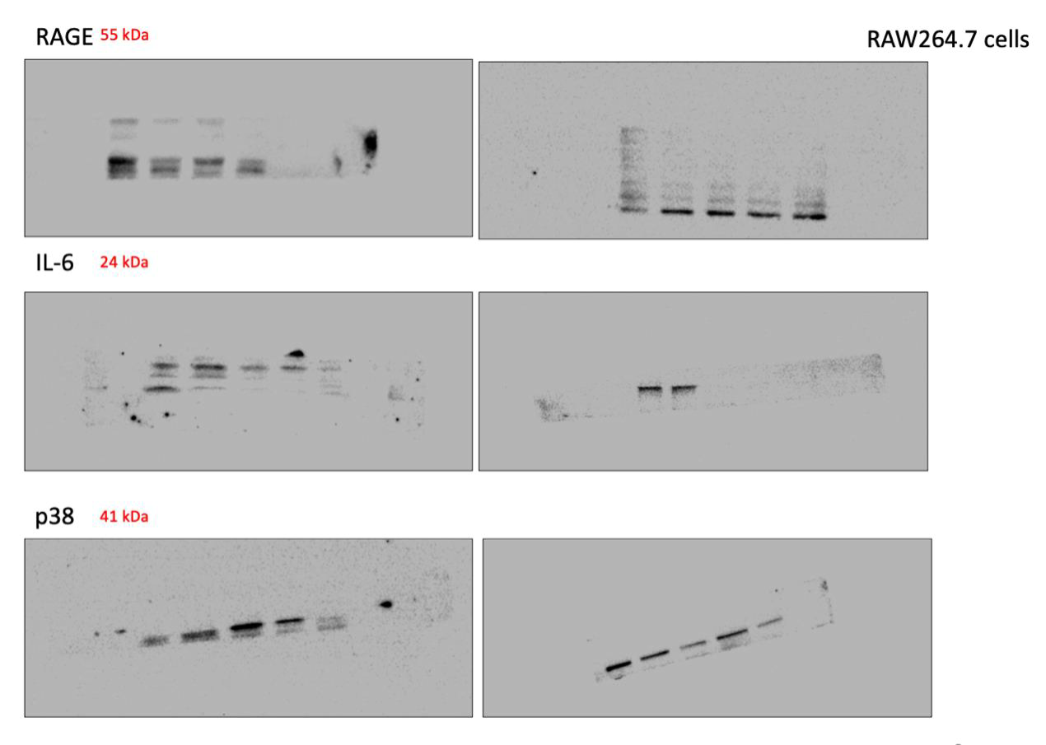
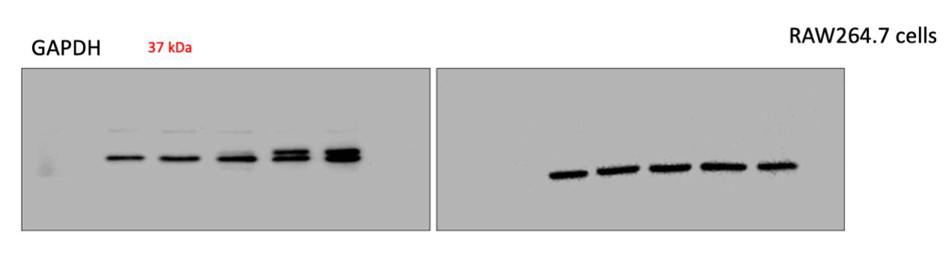
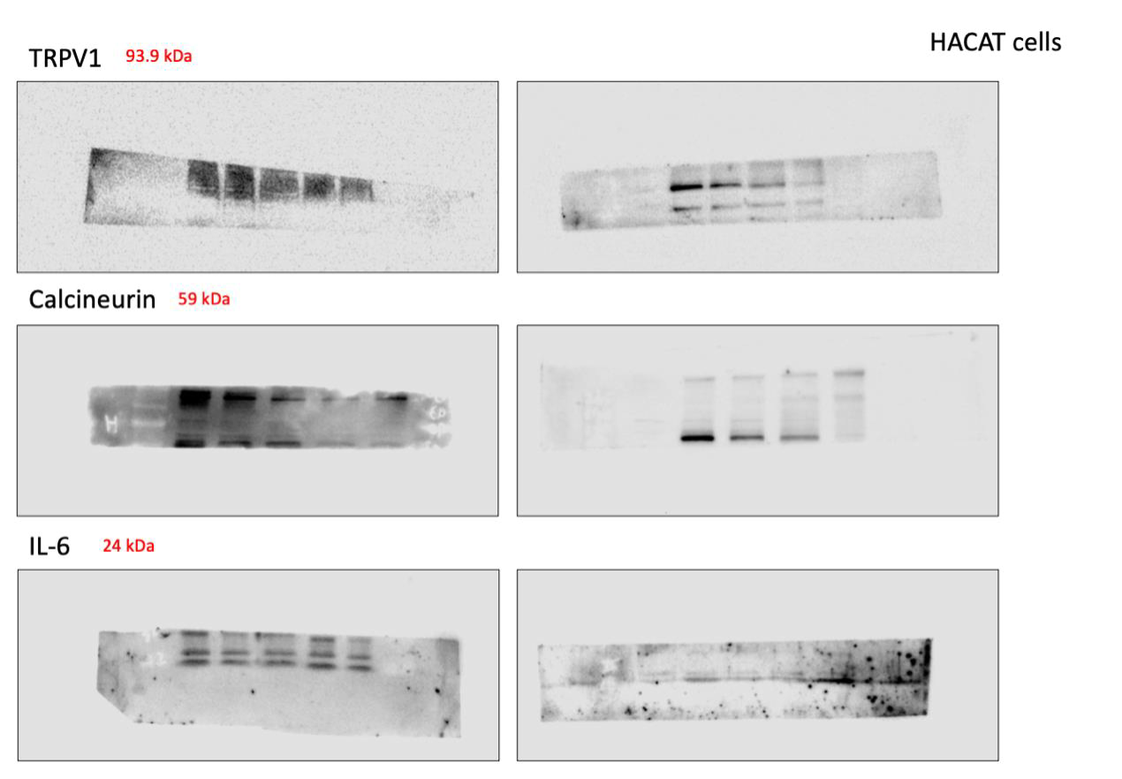
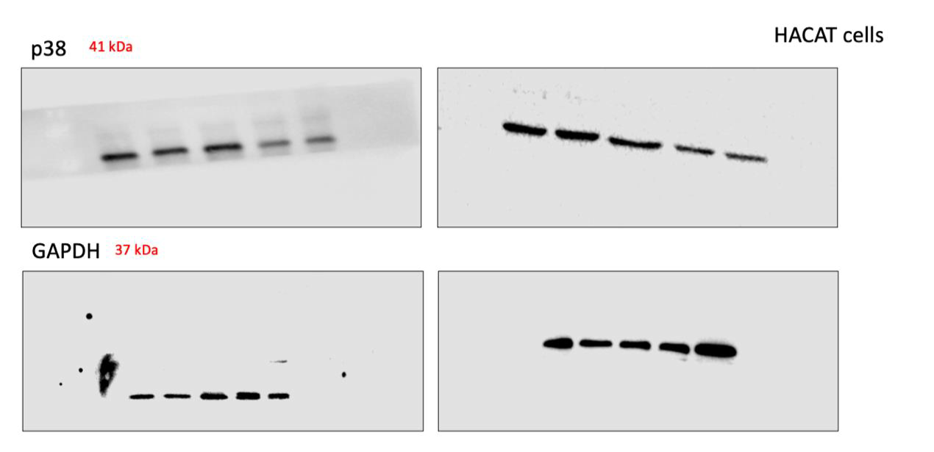

Supplementary Figure 3. The comparison of spleen and lymph node in each group. The grouping method was the same as in Fig. 3.
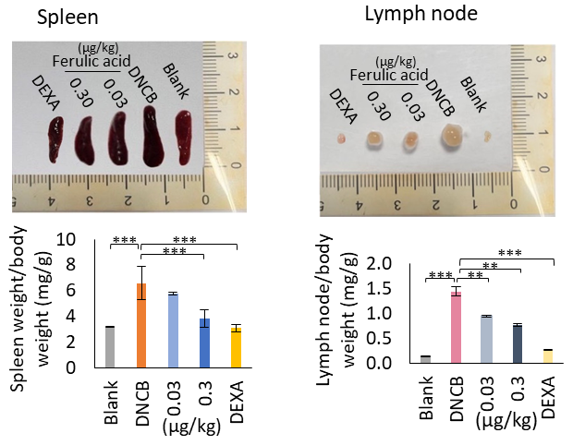

Supplementary Figure 4. Effects of ferulic acid on dorsal skin thickness in AD mouse skin lesions. (A) Epidermal thickness was presented in H&E staining sections (40×, 100×, and 400×; scale bar, 100 µm). The black triangle arrow indicated the boundary line between the epidermis and the dermis. (B) Mast cell was obtainable in toluidine blue staining sections (40×, 100×, and 400×; scale bar, 100 µm). The black arrow indicated mast cells.
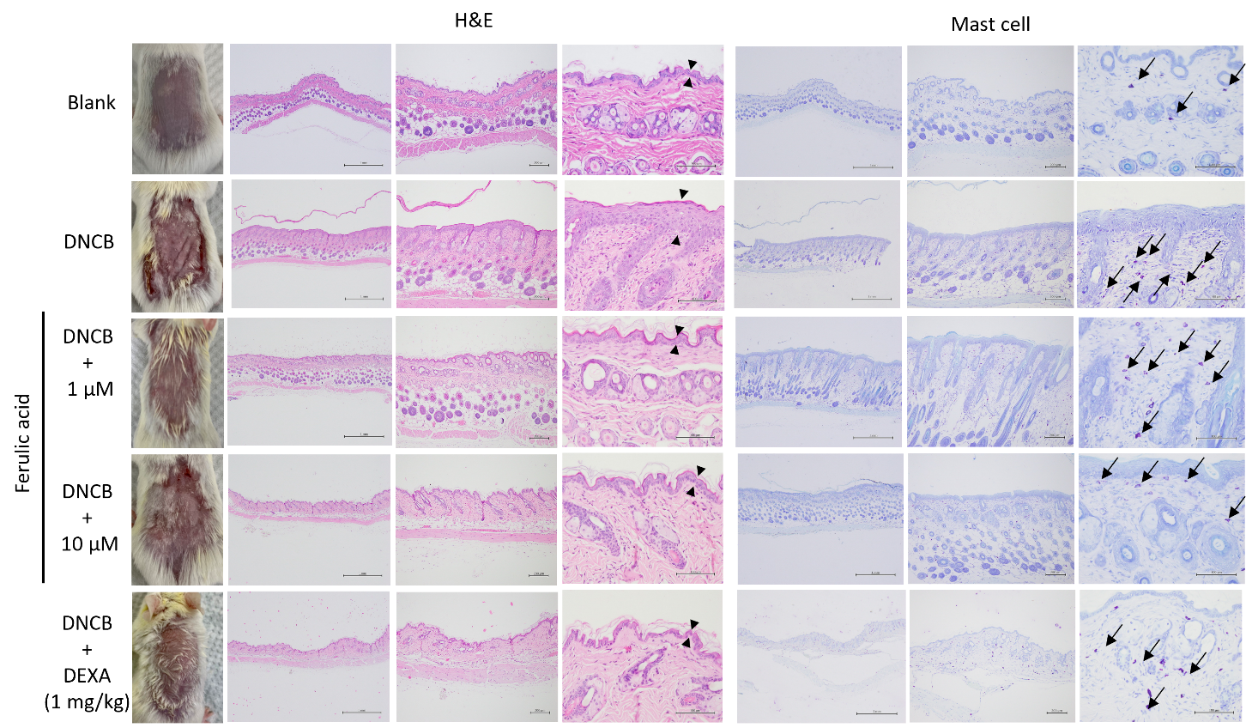

Supplementary Figure 5. Effects of ferulic acid on ear thickness in atopic dermatitis mouse skin lesions. (A) Epidermal thickness was presented in H&E staining sections (40×, 100×, and 400×; scale bar, 100 µm). The black triangle arrow indicated the boundary line between the epidermis and the dermis. (B) Mast cell was obtainable in toluidine blue staining sections (40×, 100×, and 400×; scale bar, 100 µm). The black arrow indicated mast cells.
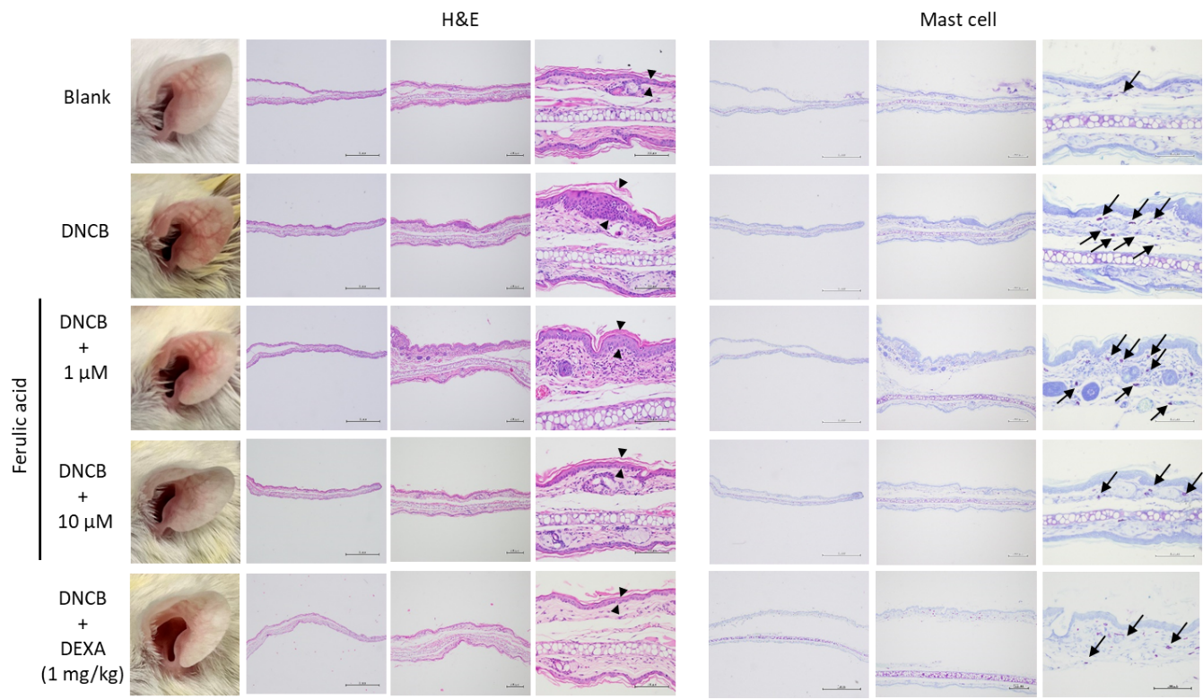

Supplementary Figure 6. The images were uncropped data of western blotting of spleen and skin tissue.
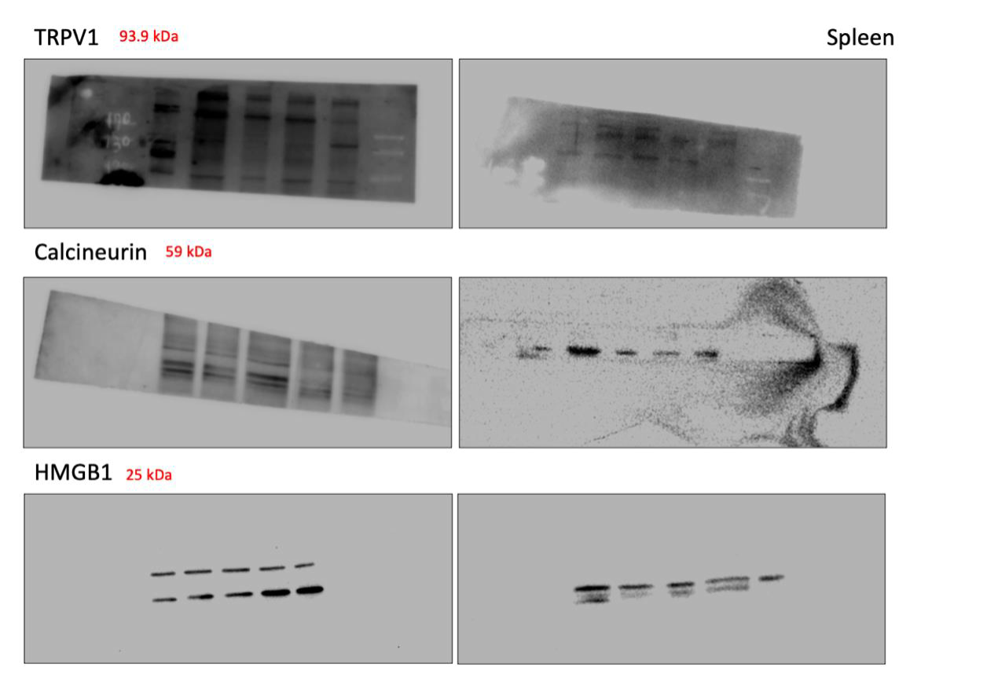
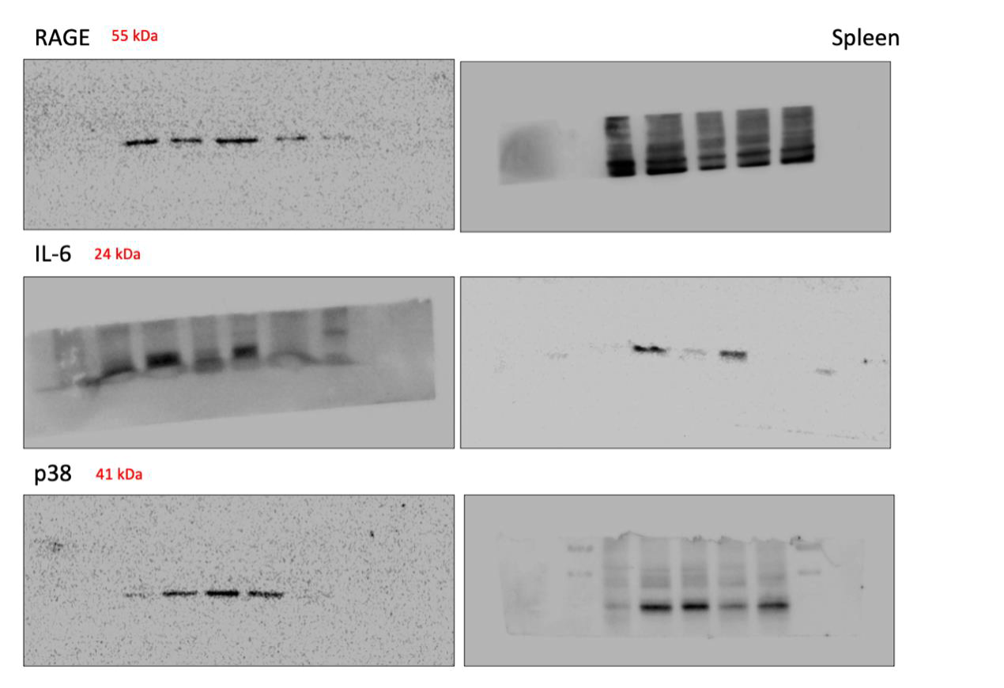
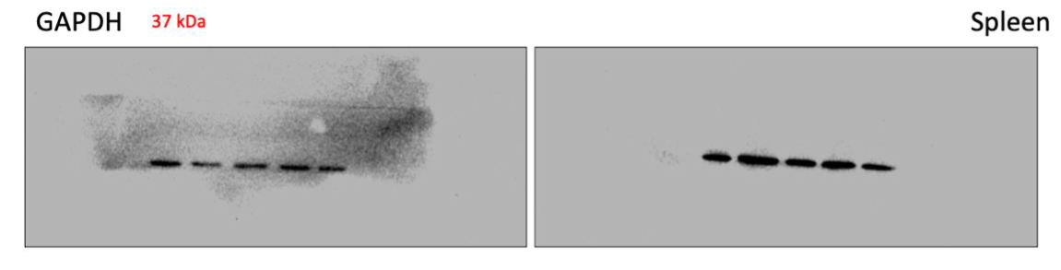
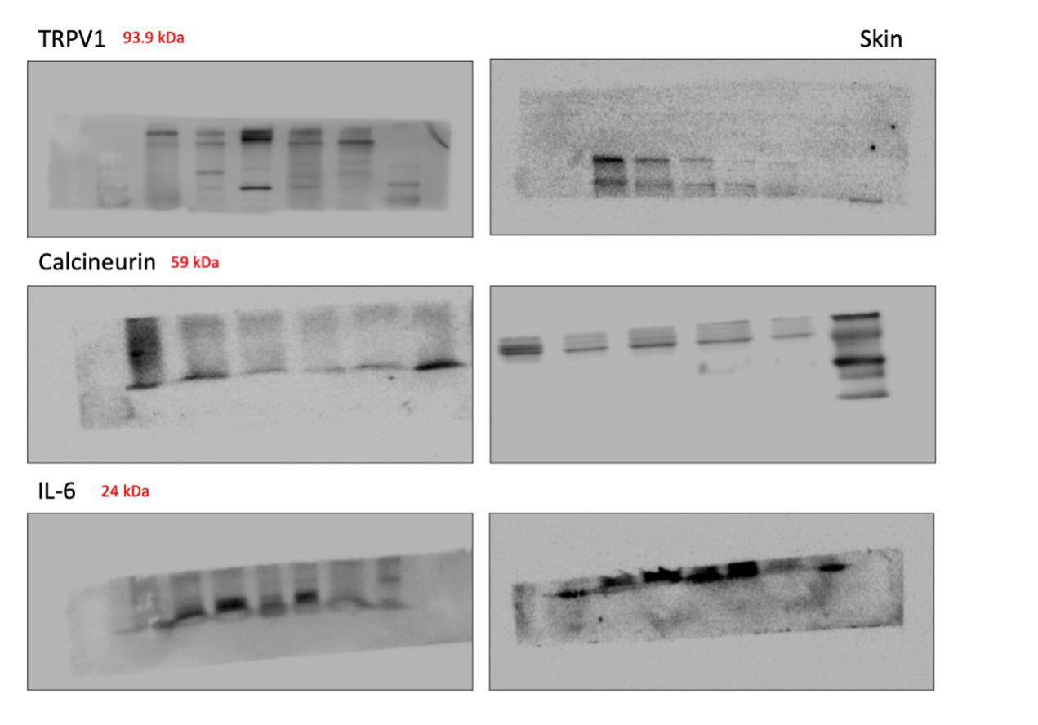
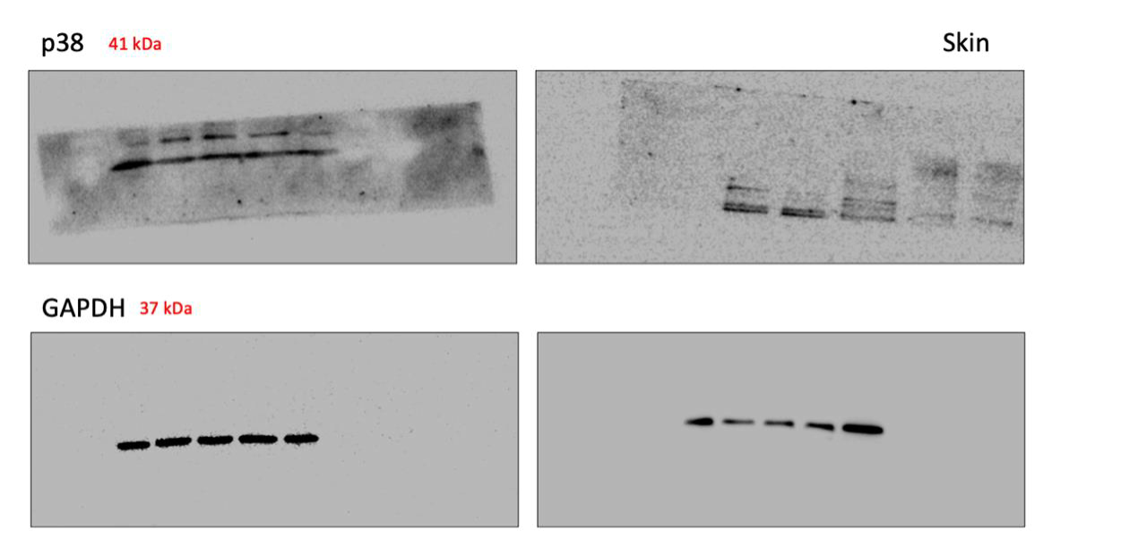

Supplementary Figure 7. The Animal Care and Use Committee of National Chung Hsing University approved all protocols and the guidelines regarding the handling and use of experimental animals adhered to the institution's guidelines (Approved IACUC Number: 111-026).
