A.

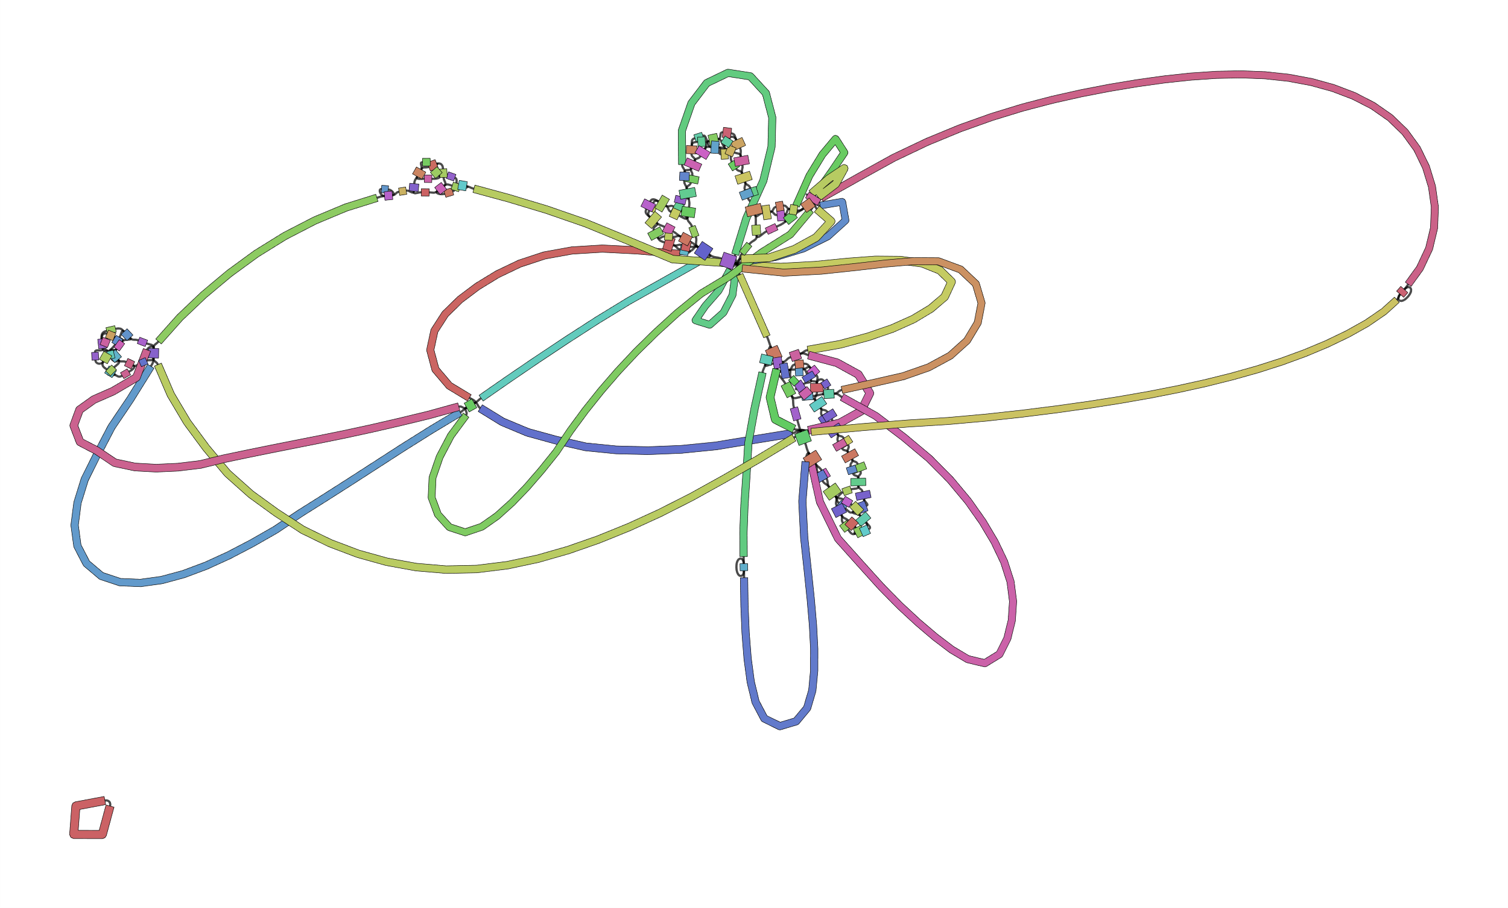
B.

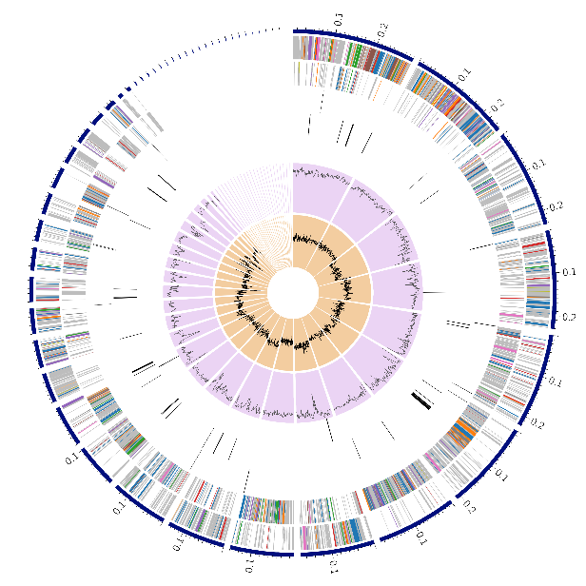

C.
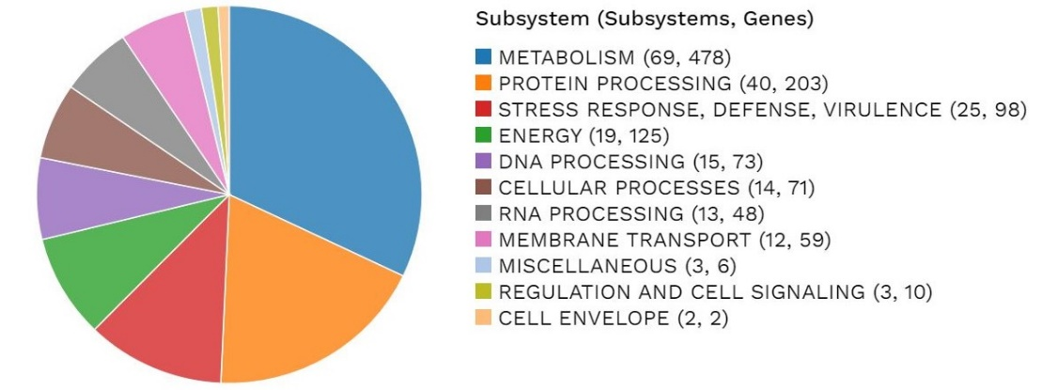

Figure S1. Assembly and annotation of strain PS04. A. Bandage plot of the assembled genome of strain PS04 using Unicycler B. Circular graphical display of the distribution of the genome annotations for B. beijingensis strain PS04, C. Colours of the CDS on the forward and reverse strand indicating the genes/subsystem they correspond to.

Features | B. beijingensis PS04
Contigs | 51
%GC content | 53.64
Largest contig | 290316
L50 | 7
Genome length | 3058094 bp
N50 | 189142
N75 | 102489
L75 | 12
CDS | 3,233
tRNA | 59
rRNA | 4
Hypothetical proteins | 1,317
Proteins with functional assignments | 1,916

Table S1: Summary of assembly and annotation features of strain PS04

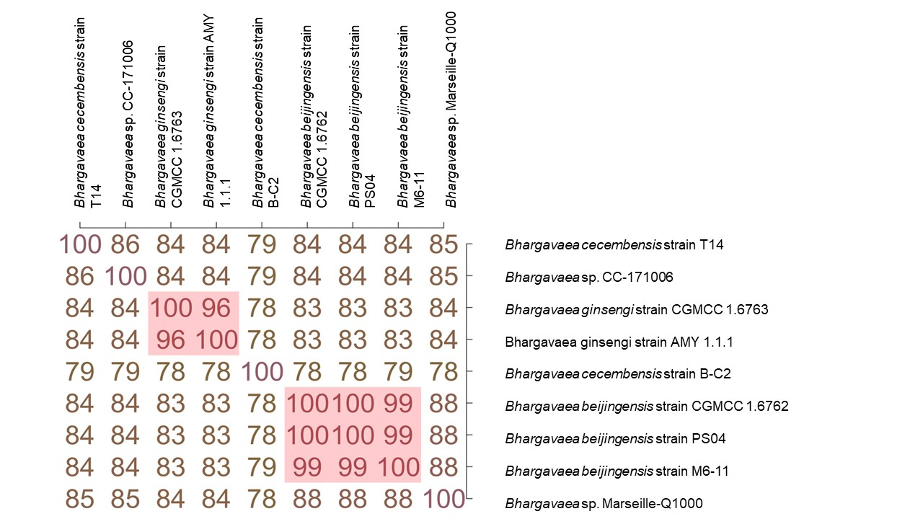

Figure S2. ANI analysis performed with members of the genus Bhargavaea showed that the genome of strain PS04 was similar to strain CGMCC 1.6763.

CRISPRCasFinder Results
>CRISPR sequence :1
GAAATCGGTAAAAAAGGCGGAGAAGCCACGGCGGAAAGCCACGACAGCGACTTCTACGCTGAAATCGGCAAAAAAGGCGGAGAAGCCAC
> CRISPR sequence :2
GAACTTCTTGGATTCGTACGCGAACTGTGAAGGCACCCCGATTTTCGCACGCGAACTTCTTGGATTCGTACGCAACC

