Additional file 1. Week 10 (ending April 4th) comparison of standardised coefficients at 25th, 50th, 75th and 90th quantiles and the mean function
 | Dependent variable:
 | OLS | quantile
 |  | regression
 | Mean Model | 25th quantile | 50th quantile | 75th quantile | 90th quantile
Intercept | 0.663*** | 0.257 | 0.644*** | 1.070*** | 1.490***
 | (0.108) | (0.162) | (0.171) | (0.190) | (0.195)
Interpersonal Globalisation [index] | 0.134 | 0.362 | 0.227 | 0.149 | -0.503
 | (0.171) | (0.238) | (0.254) | (0.225) | (0.419)
Trade Globalisation [index] | 0.082 | -0.008 | 0.074 | 0.116 | 0.099
 | (0.127) | (0.152) | (0.185) | (0.205) | (0.239)
Financial Globalisation [index] | -0.134 | -0.082 | 0.073 | 0.040 | -0.041
 | (0.159) | (0.237) | (0.245) | (0.231) | (0.262)
Urbanisation [rate] | -0.024 | 0.086 | 0.030 | -0.071 | -0.065
 | (0.129) | (0.162) | (0.180) | (0.203) | (0.264)
Population Density [log] | 0.505*** | 0.441** | 0.416** | 0.408 | 0.519
 | (0.156) | (0.185) | (0.204) | (0.247) | (0.349)
Urban Density [maximum] | -0.357** | -0.383** | -0.191 | -0.133 | -0.145
 | (0.147) | (0.163) | (0.202) | (0.495) | (0.689)
Areal Accessibility [mean] | 0.311** | 0.300 | 0.335 | 0.218 | -0.015
 | (0.155) | (0.197) | (0.229) | (0.367) | (0.416)
Human Development [index] | 0.636*** | 0.396 | 0.462 | 0.477 | 0.959**
 | (0.210) | (0.290) | (0.322) | (0.337) | (0.394)
Population aged 65 and over [%] | 0.337* | 0.344 | 0.408* | 0.393 | 0.237
 | (0.179) | (0.220) | (0.238) | (0.271) | (0.365)
Household Size [mean] | 0.344** | 0.356* | 0.442** | 0.384** | 0.402
 | (0.144) | (0.208) | (0.194) | (0.179) | (0.277)
Population [n] | 0.165* | 0.061 | 0.039 | 0.415** | 0.156
 | (0.091) | (0.151) | (0.188) | (0.173) | (0.213)
Financial:Interpersonal Globalisation | 0.211** | 0.284* | 0.129 | 0.169 | 0.354
 | (0.102) | (0.145) | (0.153) | (0.177) | (0.229)
Urban Density:Areal Accessibility | 0.048 | -0.027 | 0.074 | -0.136 | -0.343
 | (0.090) | (0.112) | (0.130) | (0.377) | (0.452)
Observations | 84 | 84 | 84 | 84 | 84
R² | 0.678
Adjusted R² | 0.619
Residual Std. Error | 0.679
F Statistic | 11.400***
Note: | *p**p***p<0.01

Additional file 2. Week 11 (ending March 11th) comparison of standardised coefficients at 25th, 50th, 75th and 90th quantiles and the mean function
 | Dependent variable:
 | OLS | quantile
 |  | regression
 | Mean Model | 25th quantile | 50th quantile | 75th quantile | 90th quantile
Intercept | 1.460*** | 1.210*** | 1.440*** | 1.790*** | 2.100***
 | (0.089) | (0.101) | (0.121) | (0.148) | (0.174)
Interpersonal Globalisation [index] | 0.104 | 0.251* | 0.110 | 0.031 | -0.033
 | (0.141) | (0.145) | (0.149) | (0.201) | (0.316)
Trade Globalisation [index] | 0.049 | 0.033 | 0.047 | 0.058 | -0.161
 | (0.105) | (0.111) | (0.125) | (0.170) | (0.208)
Financial Globalisation [index] | 0.030 | 0.141 | 0.171 | 0.234 | 0.121
 | (0.131) | (0.146) | (0.155) | (0.168) | (0.212)
Urbanisation [rate] | -0.014 | 0.077 | 0.072 | -0.012 | -0.184
 | (0.106) | (0.104) | (0.116) | (0.161) | (0.238)
Population Density [log] | 0.262** | 0.223* | 0.271 | 0.273 | 0.342
 | (0.129) | (0.121) | (0.170) | (0.250) | (0.301)
Urban Density [maximum] | -0.205* | -0.171 | -0.130 | -0.123 | 0.059
 | (0.121) | (0.107) | (0.124) | (0.242) | (0.599)
Areal Accessibility [mean] | 0.141 | 0.123 | 0.127 | 0.101 | -0.149
 | (0.128) | (0.131) | (0.156) | (0.240) | (0.336)
Human Development [index] | 0.629*** | 0.261 | 0.393* | 0.481* | 0.786**
 | (0.174) | (0.182) | (0.199) | (0.255) | (0.304)
Population aged 65 and over [%] | 0.235 | 0.269** | 0.354* | 0.388 | 0.114
 | (0.148) | (0.133) | (0.195) | (0.282) | (0.332)
Household Size [mean] | 0.292** | 0.274** | 0.332** | 0.338** | 0.183
 | (0.118) | (0.110) | (0.135) | (0.167) | (0.225)
Population [n] | 0.100 | -0.001 | -0.023 | 0.310** | 0.137
 | (0.075) | (0.113) | (0.122) | (0.131) | (0.162)
Financial:Interpersonal Globalisation | 0.160* | 0.160 | 0.108 | 0.102 | 0.367*
 | (0.084) | (0.101) | (0.113) | (0.145) | (0.211)
Urban Density:Areal Accessibility | 0.122 | 0.075 | 0.122 | 0.044 | -0.308
 | (0.075) | (0.072) | (0.081) | (0.194) | (0.405)
Observations | 84 | 84 | 84 | 84 | 84
R² | 0.735
Adjusted R² | 0.686
Residual Std. Error | 0.560
F Statistic | 14.900***
Note: | *p**p***p<0.01

Additional file 3. Week 12 (ending March 18th) comparison of standardised coefficients at 25th, 50th, 75th and 90th quantiles and the mean function
 | Dependent variable:
 | OLS | quantile
 |  | regression
 | Mean Model | 25th quantile | 50th quantile | 75th quantile | 90th quantile
Intercept | 2.100*** | 1.780*** | 2.100*** | 2.380*** | 2.840***
 | (0.082) | (0.113) | (0.123) | (0.151) | (0.162)
Interpersonal Globalisation [index] | 0.140 | 0.170 | 0.139 | 0.150 | 0.114
 | (0.130) | (0.140) | (0.156) | (0.227) | (0.286)
Trade Globalisation [index] | -0.024 | 0.049 | -0.105 | -0.138 | -0.379*
 | (0.096) | (0.116) | (0.116) | (0.162) | (0.199)
Financial Globalisation [index] | 0.113 | 0.236 | 0.198 | 0.232 | 0.165
 | (0.120) | (0.157) | (0.152) | (0.188) | (0.184)
Urbanisation [rate] | 0.023 | 0.086 | 0.035 | -0.187 | -0.242
 | (0.098) | (0.106) | (0.112) | (0.193) | (0.215)
Population Density [log] | 0.105 | 0.025 | 0.161 | 0.168 | 0.227
 | (0.118) | (0.128) | (0.159) | (0.249) | (0.265)
Urban Density [maximum] | -0.149 | -0.067 | -0.167 | -0.090 | -0.137
 | (0.111) | (0.115) | (0.113) | (0.221) | (0.437)
Areal Accessibility [mean] | 0.004 | 0.008 | 0.037 | 0.033 | -0.174
 | (0.118) | (0.131) | (0.138) | (0.257) | (0.290)
Human Development [index] | 0.485*** | 0.229 | 0.336* | 0.616** | 0.646**
 | (0.160) | (0.189) | (0.193) | (0.295) | (0.280)
Population aged 65 and over [%] | 0.108 | 0.226 | 0.291 | -0.005 | -0.001
 | (0.136) | (0.151) | (0.191) | (0.279) | (0.292)
Household Size [mean] | 0.146 | 0.180 | 0.265* | 0.119 | 0.083
 | (0.109) | (0.125) | (0.142) | (0.180) | (0.194)
Population [n] | 0.060 | -0.041 | -0.059 | 0.185 | 0.143
 | (0.069) | (0.119) | (0.111) | (0.154) | (0.155)
Financial:Interpersonal Globalisation | 0.142* | 0.199* | 0.101 | 0.091 | 0.105
 | (0.077) | (0.104) | (0.115) | (0.149) | (0.162)
Urban Density:Areal Accessibility | 0.138** | 0.104 | 0.098 | 0.171 | -0.249
 | (0.069) | (0.072) | (0.071) | (0.212) | (0.315)
Observations | 84 | 84 | 84 | 84 | 84
R² | 0.729
Adjusted R² | 0.679
Residual Std. Error | 0.515
F Statistic | 14.500***
Note: | *p**p***p<0.01

Additional file 4. Week 13 (ending March 25th) comparison of standardised coefficients at 25th, 50th, 75th and 90th quantiles and the mean function
 | Dependent variable:
 | OLS | quantile
 |  | regression
 | Mean Model | 25th quantile | 50th quantile | 75th quantile | 90th quantile
Intercept | 2.580*** | 2.270*** | 2.590*** | 2.930*** | 3.190***
 | (0.077) | (0.124) | (0.144) | (0.141) | (0.124)
Interpersonal Globalisation [index] | 0.184 | 0.240 | 0.172 | 0.184 | 0.097
 | (0.122) | (0.158) | (0.186) | (0.216) | (0.231)
Trade Globalisation [index] | -0.072 | -0.034 | -0.095 | -0.248 | -0.311*
 | (0.091) | (0.116) | (0.138) | (0.151) | (0.157)
Financial Globalisation [index] | 0.141 | 0.244 | 0.168 | 0.223 | 0.148
 | (0.114) | (0.161) | (0.182) | (0.185) | (0.159)
Urbanisation [rate] | 0.053 | 0.040 | 0.110 | -0.176 | -0.148
 | (0.092) | (0.101) | (0.131) | (0.195) | (0.188)
Population Density [log] | -0.009 | -0.024 | 0.008 | 0.322 | 0.191
 | (0.112) | (0.142) | (0.192) | (0.244) | (0.213)
Urban Density [maximum] | -0.112 | -0.053 | -0.139 | -0.039 | -0.224
 | (0.105) | (0.110) | (0.132) | (0.248) | (0.329)
Areal Accessibility [mean] | -0.096 | -0.029 | -0.121 | 0.150 | -0.138
 | (0.111) | (0.132) | (0.167) | (0.307) | (0.227)
Human Development [index] | 0.408*** | 0.235 | 0.226 | 0.562* | 0.432*
 | (0.151) | (0.183) | (0.223) | (0.285) | (0.241)
Population aged 65 and over [%] | 0.037 | 0.219 | 0.178 | 0.169 | 0.144
 | (0.128) | (0.170) | (0.235) | (0.221) | (0.233)
Household Size [mean] | 0.070 | 0.141 | 0.102 | 0.134 | 0.077
 | (0.103) | (0.142) | (0.172) | (0.162) | (0.157)
Population [n] | 0.044 | -0.030 | -0.048 | 0.070 | 0.104
 | (0.065) | (0.108) | (0.134) | (0.165) | (0.128)
Financial:Interpersonal Globalisation | 0.130* | 0.191* | 0.093 | 0.016 | 0.102
 | (0.073) | (0.111) | (0.133) | (0.157) | (0.135)
Urban Density:Areal Accessibility | 0.151** | 0.134** | 0.128 | 0.209 | -0.182
 | (0.065) | (0.065) | (0.084) | (0.321) | (0.250)
Observations | 84 | 84 | 84 | 84 | 84
R² | 0.741
Adjusted R² | 0.693
Residual Std. Error | 0.487
F Statistic | 15.400***
Note: | *p**p***p<0.01

Additional file 5. Week 14 (ending April 1st) comparison of standardised coefficients at 25th, 50th, 75th and 90th quantiles and the mean function
 | Dependent variable:
 | OLS | quantile
 |  | regression
 | Mean Model | 25th quantile | 50th quantile | 75th quantile
Intercept | 2.920*** | 2.600*** | 2.950*** | 3.270*** | 3.450***
 | (0.073) | (0.128) | (0.149) | (0.127) | (0.113)
Interpersonal Globalisation [index] | 0.220* | 0.299* | 0.180 | 0.155 | 0.131
 | (0.116) | (0.169) | (0.195) | (0.179) | (0.207)
Trade Globalisation [index] | -0.089 | -0.074 | -0.154 | -0.297** | -0.307**
 | (0.086) | (0.121) | (0.137) | (0.141) | (0.140)
Financial Globalisation [index] | 0.142 | 0.247 | 0.076 | 0.266 | 0.076
 | (0.108) | (0.167) | (0.191) | (0.174) | (0.151)
Urbanisation [rate] | 0.078 | 0.062 | 0.046 | -0.059 | -0.069
 | (0.088) | (0.109) | (0.161) | (0.182) | (0.179)
Population Density [log] | -0.101 | -0.076 | 0.013 | 0.177 | 0.099
 | (0.106) | (0.148) | (0.203) | (0.227) | (0.196)
Urban Density [maximum] | -0.079 | -0.035 | -0.187 | 0.002 | -0.271
 | (0.100) | (0.120) | (0.149) | (0.254) | (0.288)
Areal Accessibility [mean] | -0.172 | -0.079 | -0.118 | -0.028 | -0.192
 | (0.105) | (0.141) | (0.169) | (0.362) | (0.209)
Human Development [index] | 0.364** | 0.199 | 0.363 | 0.458 | 0.313
 | (0.143) | (0.193) | (0.258) | (0.277) | (0.228)
Population aged 65 and over [%] | -0.018 | 0.167 | 0.143 | 0.075 | 0.186
 | (0.122) | (0.174) | (0.240) | (0.207) | (0.214)
Household Size [mean] | 0.023 | 0.139 | 0.096 | 0.029 | 0.057
 | (0.098) | (0.141) | (0.186) | (0.142) | (0.141)
Population [n] | 0.044 | 0.006 | -0.024 | 0.033 | 0.067
 | (0.062) | (0.119) | (0.135) | (0.158) | (0.123)
Financial:Interpersonal Globalisation | 0.136* | 0.200* | 0.093 | 0.042 | 0.116
 | (0.069) | (0.119) | (0.135) | (0.199) | (0.113)
Urban Density:Areal Accessibility | 0.168*** | 0.157** | 0.132 | 0.188 | -0.066
 | (0.061) | (0.072) | (0.086) | (0.455) | (0.212)
Observations | 84 | 84 | 84 | 84 | 84
R² | 0.755
Adjusted R² | 0.710
Residual Std. Error | 0.462
F Statistic | 16.600***
Note: | *p**p***p<0.01

Additional file 6. Week 15 (ending April 8th) comparison of standardised coefficients at 25th, 50th, 75th and 90th quantiles and the mean function
 | Dependent variable:
 | OLS | quantile
 |  | regression
 | Mean Model | 25th quantile | 50th quantile | 75th quantile | 90th quantile
Intercept | 3.200*** | 2.810*** | 3.160*** | 3.530*** | 3.650***
 | (0.070) | (0.116) | (0.137) | (0.111) | (0.104)
Interpersonal Globalisation [index] | 0.241** | 0.368** | 0.221 | 0.194 | 0.146
 | (0.111) | (0.149) | (0.178) | (0.155) | (0.187)
Trade Globalisation [index] | -0.095 | -0.065 | -0.154 | -0.279** | -0.331***
 | (0.082) | (0.115) | (0.123) | (0.109) | (0.124)
Financial Globalisation [index] | 0.148 | 0.141 | 0.095 | 0.239 | 0.125
 | (0.103) | (0.171) | (0.165) | (0.145) | (0.141)
Urbanisation [rate] | 0.098 | 0.138 | 0.073 | 0.003 | 0.015
 | (0.084) | (0.104) | (0.144) | (0.163) | (0.163)
Population Density [log] | -0.172* | -0.166 | -0.019 | 0.094 | -0.010
 | (0.101) | (0.121) | (0.183) | (0.160) | (0.172)
Urban Density [maximum] | -0.011 | -0.005 | -0.157 | 0.036 | -0.174
 | (0.095) | (0.114) | (0.136) | (0.210) | (0.172)
Areal Accessibility [mean] | -0.238** | -0.130 | -0.142 | -0.041 | -0.275*
 | (0.100) | (0.130) | (0.149) | (0.173) | (0.162)
Human Development [index] | 0.360** | 0.169 | 0.307 | 0.449* | 0.290
 | (0.136) | (0.192) | (0.232) | (0.240) | (0.221)
Population aged 65 and over [%] | -0.071 | 0.039 | 0.087 | 0.009 | -0.030
 | (0.116) | (0.147) | (0.215) | (0.192) | (0.186)
Household Size [mean] | -0.005 | 0.012 | 0.066 | -0.017 | -0.079
 | (0.093) | (0.128) | (0.164) | (0.125) | (0.129)
Population [n] | 0.034 | 0.002 | -0.031 | 0.004 | 0.016
 | (0.059) | (0.111) | (0.119) | (0.067) | (0.102)
Financial:Interpersonal Globalisation | 0.134** | 0.278*** | 0.155 | 0.012 | 0.106
 | (0.066) | (0.100) | (0.121) | (0.097) | (0.090)
Urban Density:Areal Accessibility | 0.169*** | 0.154** | 0.104 | 0.276* | 0.110
 | (0.059) | (0.066) | (0.075) | (0.148) | (0.112)
Observations | 84 | 84 | 84 | 84 | 84
R² | 0.766
Adjusted R² | 0.722
Residual Std. Error | 0.440
F Statistic | 17.600***
Note: | *p**p***p<0.01

Additional file 7. Correlogram and Multicollinearity Diagnostics

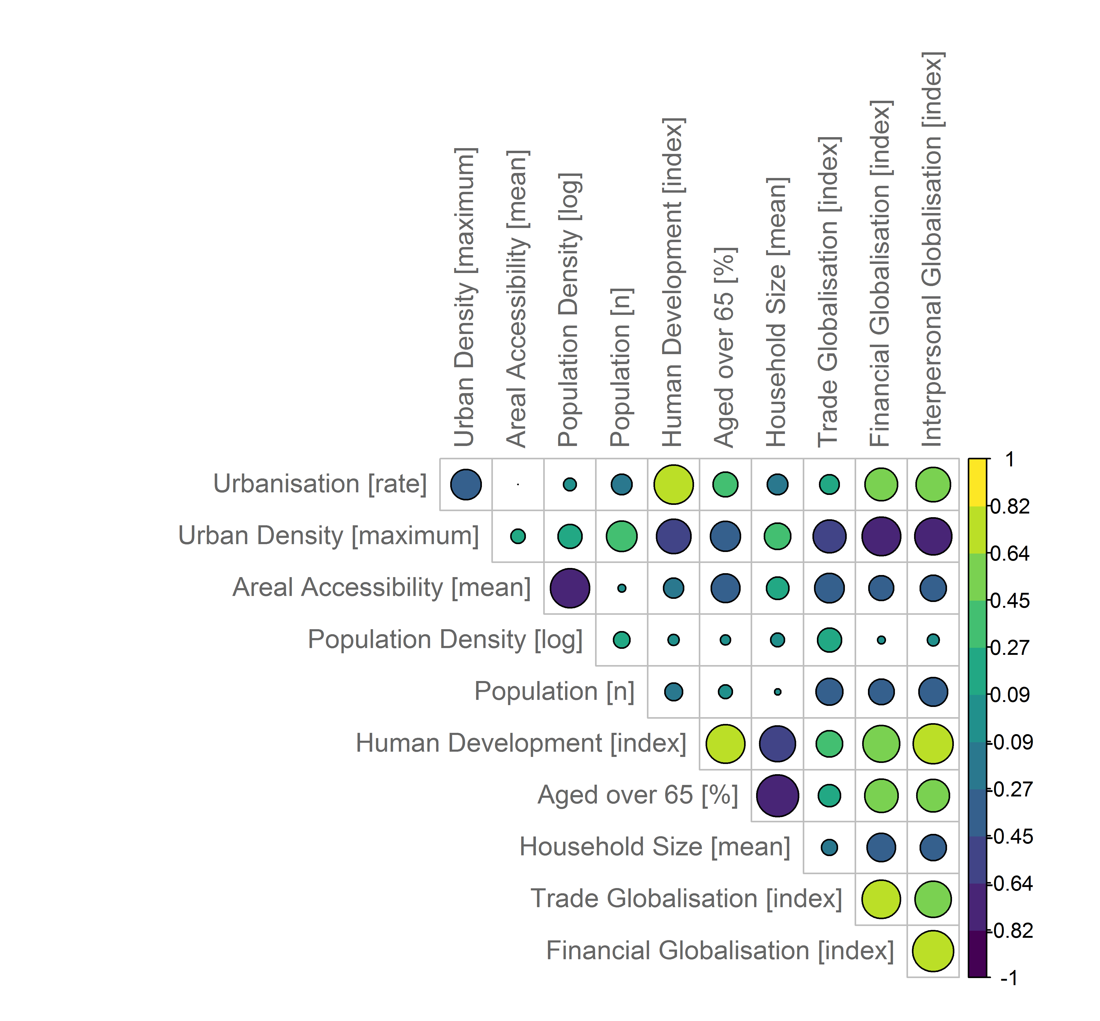
This depicts collinearities among the independent variables that is particularly pronounced between the human development index and globalization indices.

