Genetic risk factors for bortezomib-induced peripheral neuropathy in an Asian population: A genome-wide association study in South Korea

Young Gi Min¹, Sung-Yeoun Lee², Ehyun Lim², Mi-Young Park², Dong-ho Kim², Ja Min Byun³, Youngil Koh³, Junshik Hong³, Dong-Yeop Shin³, Sung-Soo Yoon³, Jung-Joon Sung¹, Seog Bae Oh DDS^{4, *}, Inho Kim^{3,*}

All supplementary figures were created by YGM using Microsoft PowerPoint (https://products.office.com/en-in/powerpoint version 16.16.3 (181015)).

Supplementary Figure 1. (A) A Q-Q plot of the observed and expected p-values with a lambda value of 1.02. (B) Significant correlation between GWAS-derived and machine learning-derived ranks, displayed in density contour plot.
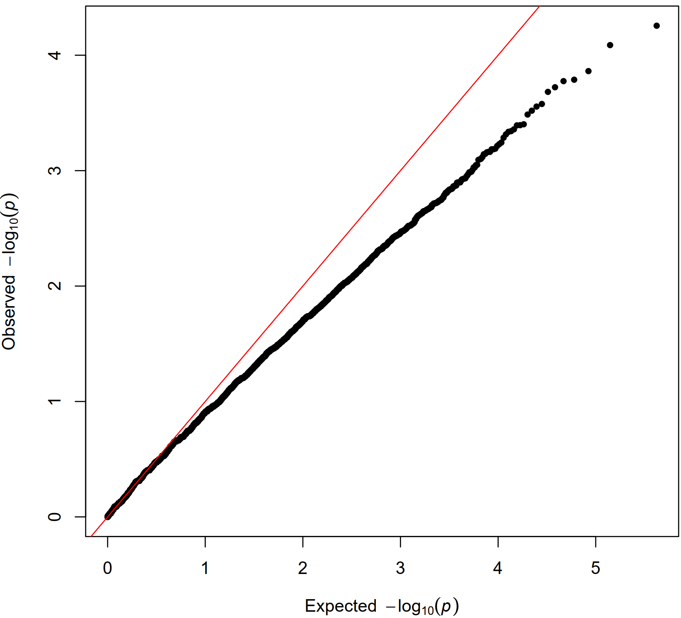
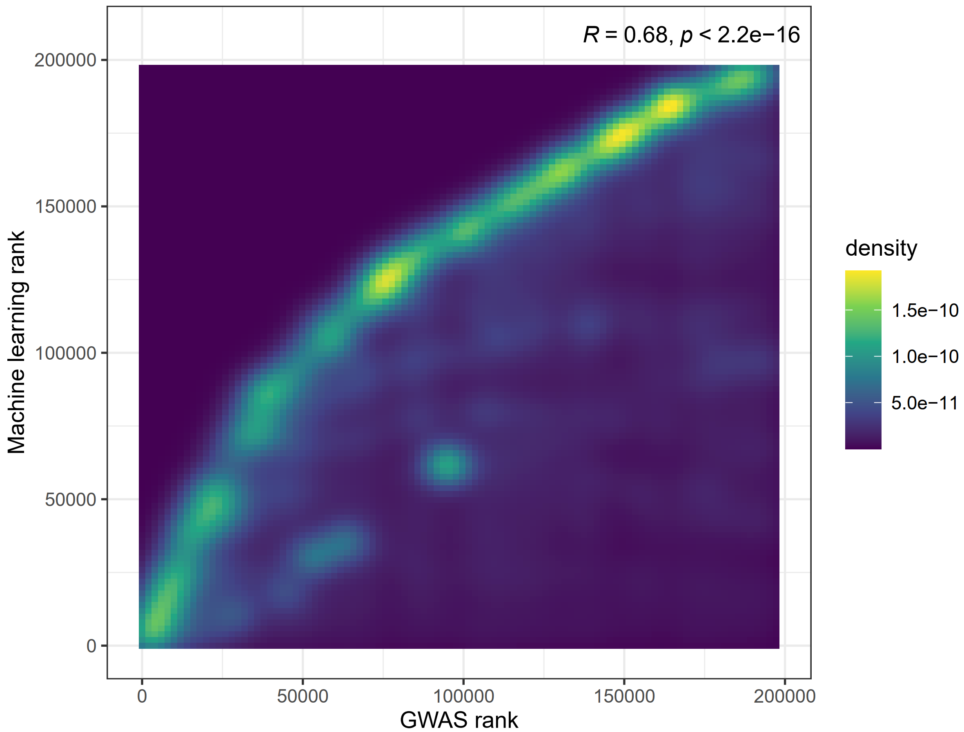
A
B

Supplementary Table 1. Baseline clinical characteristics of the entire cohort, according to the occurrence of BIPN during follow-up.
 | Entire cohort  (n=185) | No BIPN  (n=99) | BIPN  (n=86) | p-value
Female, % | 87 (47%) | 53 (54%) | 34 (40%) | 0.057
Age (yr) | 63 (9) | 63 (10) | 62 (9) | 0.2
BMI (kg/m²) | 24.9 (9.7) | 25.4 (13.0) | 24.2 (3.3) | >0.9
Diabetes | 35 (19%) | 22 (22%) | 13 (15%) | 0.2
Regimen |  |  |  | 0.008
VD | 36 (19%) | 24 (24%) | 12 (14%)
VMP | 66 (36%) | 41 (41%) | 25 (29%)
VTD | 83 (45%) | 34 (34%) | 49 (57%)
Administration route |  |  |  | 0.6
IV | 7 (3.8%) | 5 (5.1%) | 2 (2.3%)
SC | 164 (89%) | 86 (87%) | 78 (91%)
Both | 14 (7.6%) | 8 (8.1%) | 6 (7.0%)
ISS |  |  |  | 0.6
1 | 61 (34%) | 35 (36%) | 26 (31%)
2 | 66 (36%) | 37 (38%) | 29 (35%)
3 | 54 (30%) | 26 (27%) | 28 (34%)
Albumin | 3.64 (0.86) | 3.69 (0.98) | 3.57 (0.69) | 0.4
Beta-2 microglobulin | 5.7 (7.3) | 5.6 (8.7) | 5.8 (5.3) | 0.3
Calcium | 9.2 (0.96) | 9.22 (0.96) | 9.17 (0.96) | 0.9
Hemoglobin | 10.27 (2.23) | 10.34 (2.19) | 10.19 (2.28) | 0.6
Creatinine | 1.38 (1.52) | 1.33 (1.77) | 1.43 (1.18) | 0.11
Light chain |  |  |  | 0.4
Kappa | 106 (57%) | 61 (62%) | 45 (52%)
Lambda | 71 (38%) | 35 (35%) | 36 (42%)
Heavy chain |  |  |  | 0.7
IgA | 33 (18%) | 19 (19%) | 14 (16%)
IgG | 83 (45%) | 46 (46%) | 37 (43%)
Others | 69 (37.5%) | 34 (34%) | 35 (41.2%)

Supplementary Table 2. Random allocation of patients into discovery and validation cohorts stratified by clinical risk factors.
 | Discovery cohort  (n=74) | Validation cohort  (n=111) | p-value
Female, % | 34 (46%) | 53 (48%) | 0.8
Age (yr) | 63 (10) | 62 (9) | 0.5
BMI (kg/m²) | 25.7 (14.8) | 24.3 (3.2) | 0.6
Diabetes | 16 (22%) | 19 (17%) | 0.4
Regimen |  |  | >0.9
VD | 15 (20%) | 21 (19%)
VMP | 26 (35%) | 40 (36%)
VTD | 33 (45%) | 50 (45%)
Administration route |  |  | >0.9
IV | 3 (4.1%) | 4 (3.6%)
SC | 66 (89%) | 98 (88%)
Both | 5 (6.8%) | 9 (8.1%)
ISS |  |  | 0.4
1 | 28 (38%) | 33 (31%)
2 | 28 (38%) | 38 (36%)
3 | 18 (24%) | 36 (34%)
Incidence of BIPN | 31 (42%) | 55 (50%) | 0.3

SNP | Chr | Position | Gene Symbol | Allele | Linear regression
rs11238298 | 7 | 54219207 |  | C | 0.000251541
rs6708269 | 2 | 192666465 |  | G | 0.000539005
rs2884439 | 14 | 54290388 | LINC02331 | T | 0.000801038
rs6517852 | 21 | 20408410 |  | A | 0.00133367
rs1492577 | 6 | 150931131 | PLEKHG1 | T | 0.001946
rs6520592 | X | 39633818 |  | T | 0.00310265
rs201015 | 6 | 6664917 |  | C | 0.0032443
rs9902778 | 17 | 32297419 | ASIC2 | A | 0.0105848
rs2342645 | 6 | 169033040 | SMOC2 | T | 0.0108936
rs7574949 | 2 | 108661004 |  | A | 0.0154003
rs1490895 | 17 | 32266753 | ASIC2 | A | 0.0293745
rs2418495 | 2 | 59601449 |  | C | 0.0346582
rs2829271 | 21 | 26069828 |  | A | 0.0465916
rs12593557 | 15 | 67188578 |  | G | 0.0679279
rs3741132 | 11 | 73978243 | P4HA3 | G | 0.11359
rs4144827 | 2 | 164114775 |  | T | 0.120982
rs77527409 | 4 | 180316321 |  | G | 0.185815
rs678132 | 11 | 124493199 | TBRG1 | C | 0.229484
rs1432727 | 5 | 155451305 | SGCD | A | 0.728017
rs9521698 | 13 | 110984427 | COL4A2 | G | 0.903187
Supplementary Table 3. Association analysis of top 20 SNPs based on BIPN severity.

Supplementary Table 4. Functional annotation of significant SNPs using Ensembl Variant Effect Predictor (VEP). Asterisks (*) indicate cases where the reference allele in our research and the reference allele in the VEP differ, preventing the calculation of CADD scores.
SNP | Location | Allele | Risk Allele  (Our study) | Consequence | SYMBOL | BIOTYPE | AF | AF  EAS | AF  EUR | CADD  PHRED | CADD  RAW | SpliceAI_  pred_  DP_AG | SpliceAI_  pred_  DP_AL | SpliceAI_  pred_  SYMBOL
rs3741132 | 11:74267198-74267198 | A | A | 3_prime_UTR_variant,  NMD_transcript_variant | P4HA3 | nonsense_  mediated_  decay | 0.2266 | 0.2867 | 0.171 | 35 | 6.159314 | 36 | 38 | P4HA3
rs7574949* | 2:108044548-108044548 | G | A* | downstream_gene_variant | LINC01593 | lncRNA | 0.478 | 0.87 | 0.3767 | NA | NA | - | - | -
rs12593557 | 15:66896240-66896240 | A | A | intergenic_variant | - | - | 0.0226 | 0.0962 | 0.0109 | 0.007 | -1.00471 | - | - | -
rs4144827* | 2:163258265-163258265 | C | T* | intergenic_variant | - | - | 0.2658 | 0.4236 | 0.0686 | NA | NA | - | - | -
rs6517852 | 21:19036091-19036091 | G | G | intergenic_variant | - | - | 0.2161 | 0.2163 | 0.1421 | 10.93 | 0.944699 | - | - | -
rs2829271 | 21:24697514-24697514 | G | G | intergenic_variant | - | - | 0.4097 | 0.3214 | 0.5467 | 0.689 | -0.13864 | - | - | -
rs201015 | 6:6664684-6664684 | T | T | intergenic_variant | - | - | 0.3872 | 0.6657 | 0.3082 | 4.523 | 0.320211 | - | - | -
rs11238298* | 7:54151514-54151514 | T | C* | intergenic_variant | - | - | 0.5068 | 0.7044 | 0.6083 | NA | NA | - | - | -
rs6520592* | X:39774564-39774564 | C | T* | intergenic_variant | - | - | 0.6403 | 0.5249 | 0.8081 | NA | NA | - | - | -
rs1490895 | 17:33939734-33939734 | G | G | intron_variant | ASIC2 | protein_  coding | 0.3097 | 0.2857 | 0.2942 | 0.986 | -0.06369 | 13 | -11 | ASIC2
rs9902778 | 17:33970400-33970400 | G | G | intron_variant | ASIC2 | protein_  coding | 0.4451 | 0.4901 | 0.5278 | 1.183 | -0.02558 | 40 | -5 | ASIC2
rs1492577 | 6:150609995-150609995 | C | C | intron_variant | PLEKHG1 | protein_  coding | 0.1613 | 0.1349 | 0.2584 | 3.626 | 0.243296 | -46 | -35 | PLEKHG1
rs2342645 | 6:168632360-168632360 | G | G | intron_variant | SMOC2 | protein_  coding | 0.3934 | 0.4256 | 0.4245 | 2.368 | 0.129463 | -1 | 3 | SMOC2
rs2884439 | 14:53823670-53823670 | G | G | intron_variant,  non_coding_transcript_variant | LINC02331 | lncRNA | 0.5841 | 0.4484 | 0.7266 | 2.721 | 0.163733 | - | - | -
rs2418495 | 2:59374314-59374314 | A | A | intron_variant,  non_coding_transcript_variant | - | lncRNA | 0.4463 | 0.621 | 0.498 | 8.552 | 0.710564 | - | - | -
rs6708269* | 2:191801739-191801739 | A | G* | intron_variant,  non_coding_transcript_variant | - | lncRNA | 0.8207 | 0.8919 | 0.7137 | NA | NA | - | - | -

Supplementary Table 5. Association analysis of previously reported 17 SNPs based on BIPN severity.
SNP | Chr | Position | Gene Symbol | Allele | Linear regression
rs2274578 | 6 | 41921089 | MED20 | G | 0.009
rs619824 | 10 | 102821531 | CYP17A1 | C | 0.282
rs2229113 | 11 | 117998955 | IL10RA | A | NA
rs1474642 | 6 | 170543473 | PSMB1 | G | 0.530
rs7172 | 1 | 151399662 | PSMB4 | A | 0.995
rs1545981 | 3 | 57105944 | IL17RD | A | 0.858
rs3136516 | 11 | 46739206 | F2 | A | 0.625
rs4553808 | 2 | 203866282 | CTLA4 | G | 0.603
rs2228233 | 14 | 24369959 | NFATC4 | C | 0.765
rs35604 | 16 | 16068119 | ABCC1 | G | 0.671
rs5370 | 6 | 12296022 | EDN1 | T | 0.438
rs1261134 | 18 | 55264532 | TCF4 | T | 0.836
rs2839629 | 21 | 43032912 | PKNOX1 | G | 0.815
rs8058696 | 16 | 16185012 | ABCC6 | C | 0.393
rs9954562 | 18 | 79387472 | NFATC1 | T | 0.954
rs2384937 | 16 | 15953968 | ABCC1 | C | NA
rs4151060 | 10 | 101538342 | BTRC | T | NA

