Whole process of standardization of diffusion-weighted: Phantom validation and clinical application according to the QIBA profile

Supplementary Material
Supplementary Material 1. NIST/QIBA diffusion phantom (A) and detailed information about the phantom and preparation method for temperature stability (B)
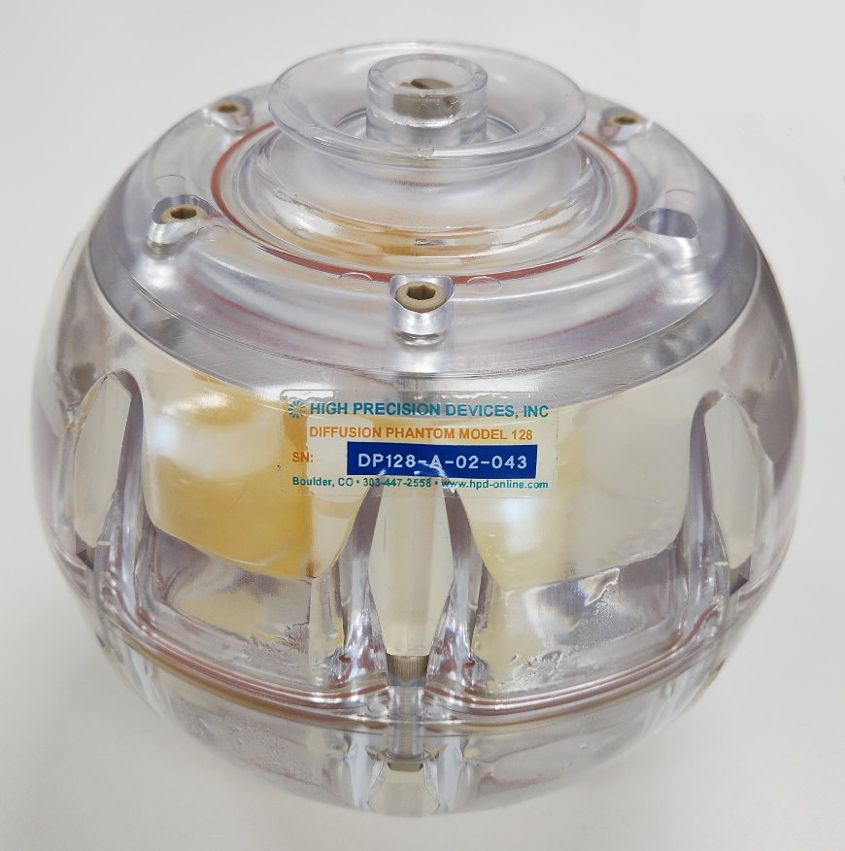
(A)

(B) A spherical phantom measuring 194 mm in diameter housing 13 vials (30 mL) filled with varying concentrations of polyvinylpyrrolidone (PVP, [0, 10, 20, 30, 40, and 50% w/w]) was tested. The central vial was filled with pure water (0%), and two arrays of vials containing PVP solution ranging from 0% to 50% consisted of the inner ring and outer ring. PVP solution was used to generate physiologically relevant apparent diffusion coefficient (ADC) values, and a higher concentration of PVP resulted in a lower ADC value. Considering the temperature sensitivity of diffusion properties, the ADC value of each PVP concentration at 0℃ verified by the National Institute of Standards and Technology was used as reference standard. To obtain homogeneity and stability of the phantom temperature during the test, the space between the cylinders was filled with crushed ice and tap water prior to scanning over one hour according to the instructions provided by the Quantitative Imaging Biomarker Alliance. The phantom was maintained at approximately 0℃ during the scanning.

Supplementary Material 2. Details of analytical method of the image quality assessment software
The quantitative analysis of DWI was performed by measuring the ADC values from volumes-of-interest (VOIs) derived from circular regions of interest (ROIs) measuring 19.6 mm in diameter on five slices. ADC maps were created from multiple DWI b-value pairs, and for the clinical DWI protocol, b-values of 1000 and 0 s/mm² were used. ADC map was created using mono-exponential model. The reference standard for the ADC value of each PVP concentration was the NIST-verified value provided by the QIBA profile. The analytical method used in the commercial software was identical to the standard analysis software provided by the Quantitative Imaging Data Warehouse (QIBA QIDW, rsna.org/qidw). QIBAphan, open-source DWI phantom QC analysis software provided by QIBA QIDW, can be accessed online at https://bit.ly/2QXLo3e. QIBAphan converts QIBA DWI data from classic DICOM format into uniform data structures for generating QC statistics. Users select ROI centers in each slice of the DWIs, and the software automatically generates statistics on the ADC values across the VOIs. QIBAphan provides a QC report that includes processed output ROI statistics and performance metrics in CSV files.

Supplementary Material 3. Details of items for image assurance
Low SNR: Visualization of anatomical features in tissues of interest at all b-values was evaluated.
Ghost/parallel imaging artifacts: The presence of the discrete ghosts from extraneous signal sources along the phase-encode direction obscuring the tissue of interest was evaluated.
Severe spatial distortion: Severe spatial distortions affecting ADC values and the apparent size/shape/volume of tissues of interest were investigated.
Eddy currents: Blur or spatial misalignment between low and high b-value diffusion-weighted imaging (DWI), particularly at the edges of anatomical features, was evaluated.
Fat suppression: Superposition of unsuppressed fat signal on the tissue of interest was assessed.
Motion artefacts: The presence of cerebrospinal fluid (CSF) pulsation in the ventricles or cardiac pulsation near large vessels and the brainstem was assessed.
Nyquist ghost: Duplication of an anatomical structure or distortion of an image occurring in the phase encoding direction was evaluated.
Supplementary Figure 1. The phantom data analysis reports using QIBA acquisition protocol of (A) Architect, (B) Ingenia, (C) Vida and (D) Avanto.
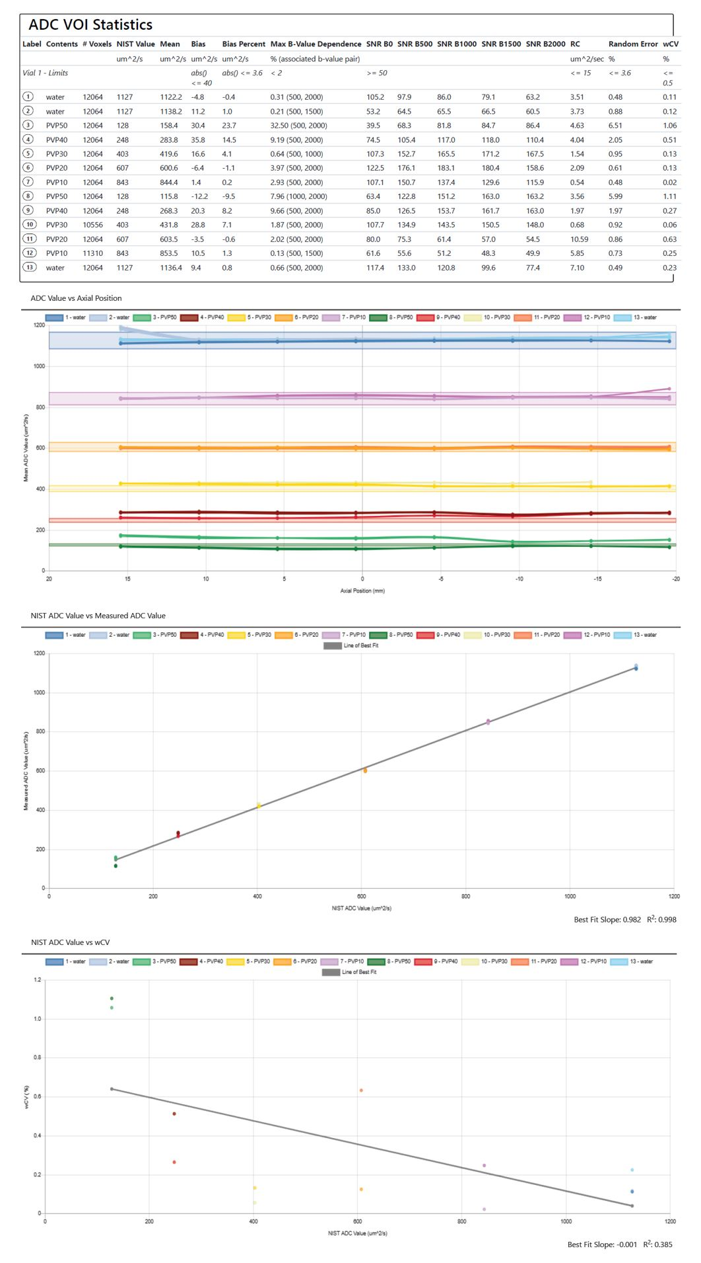
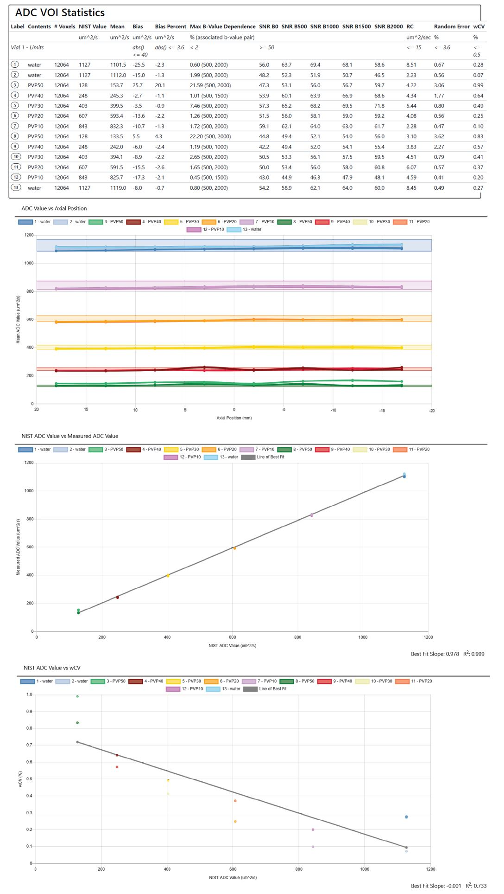
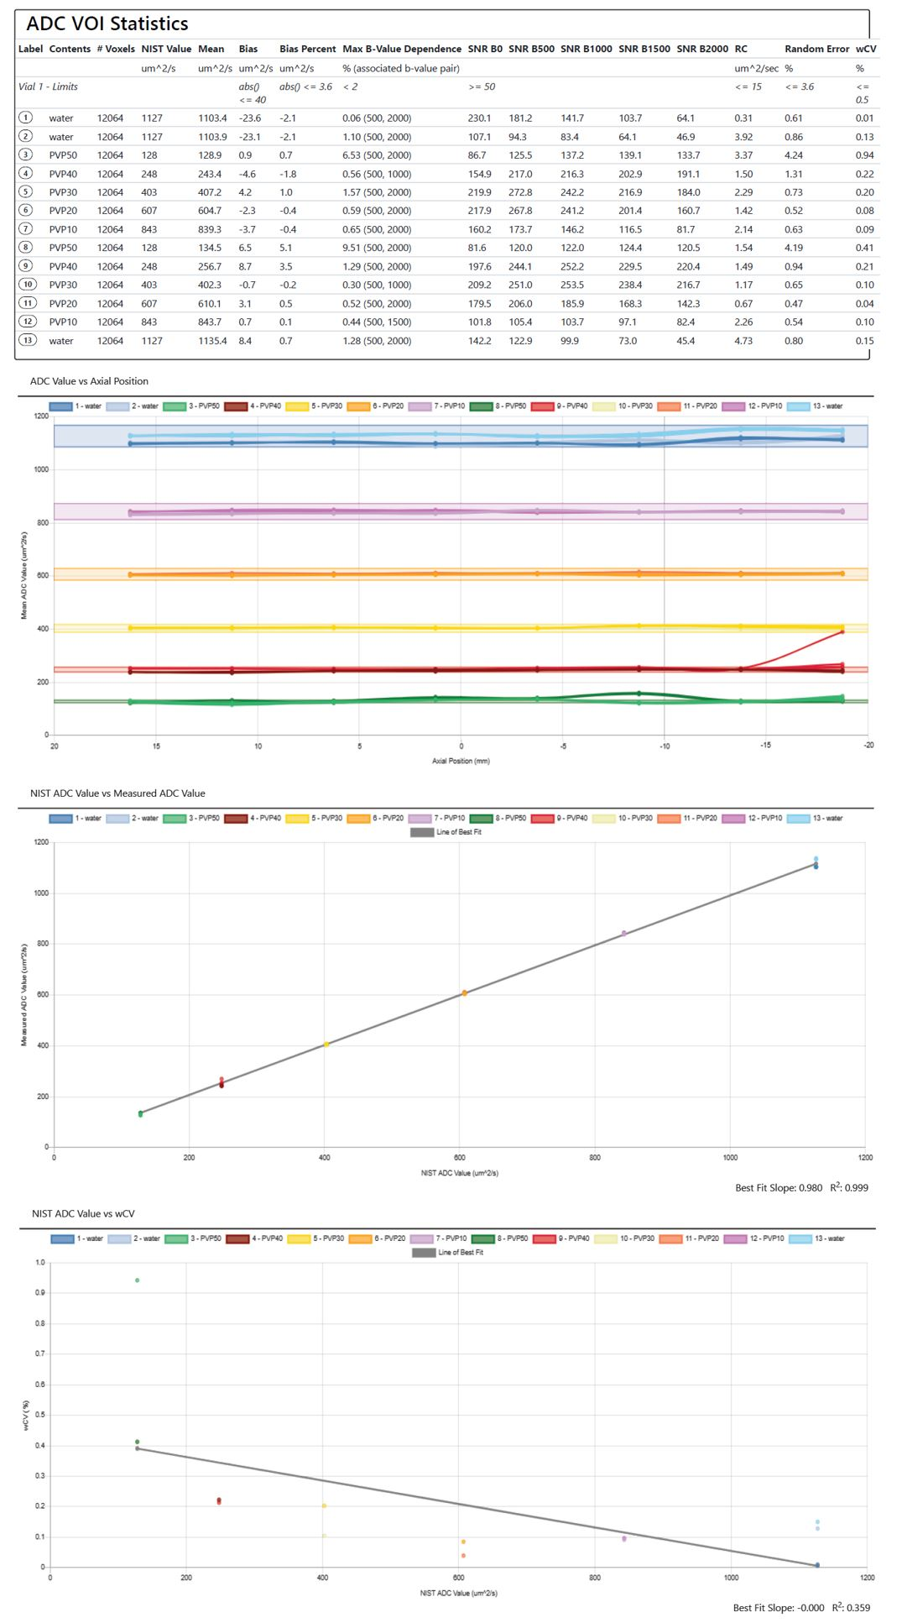
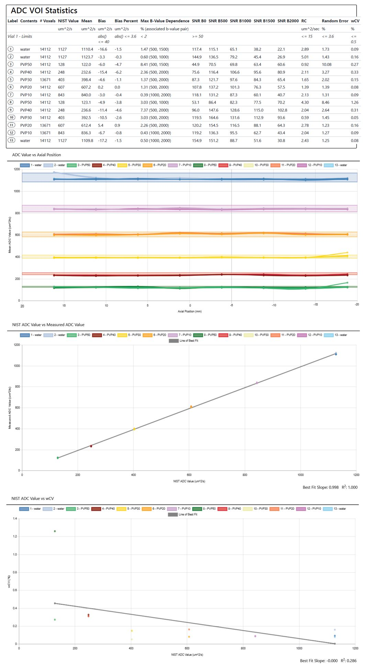
Supplementary Figure 2. The phantom data analysis reports using the clinical acquisition protocols of (A) Architect, (B) Ingenia, (C) Vida and (D) Avanto.

