Appendix

Appendix A: P-values of Mood’s pairwise median tests
Table A1. SRP Mood’s pairwise median tests for 2016
Parameter |  | Income group 1 | Income group 2 | Income group 3 | Income group 4 | Income group 5 | Income group 6 | Income group 7 | Income group 8
Cooling slope | Income group 1 | 1 | 0.1869 | 0.00419 | 0.00336 | 4.13E-05 | 3.68E-08 | 7.35E-11 | 7.75E-17
Cooling slope | Income group 2 | 0.1869 | 1 | 0.1168 | 0.1178 | 0.000579 | 2.61E-07 | 7.35E-11 | 3.86E-16
Cooling slope | Income group 3 | 0.00419 | 0.1168 | 1 | 0.6354 | 0.1565 | 0.000942 | 8.29E-07 | 2.43E-11
Cooling slope | Income group 4 | 0.00336 | 0.1178 | 0.6354 | 1 | 0.01447 | 7.14E-06 | 6.29E-11 | 2.02E-16
Cooling slope | Income group 5 | 4.13E-05 | 0.000579 | 0.1565 | 0.01447 | 1 | 0.005004 | 7.62E-07 | 1.62E-12
Cooling slope | Income group 6 | 3.68E-08 | 2.61E-07 | 0.000942 | 7.14E-06 | 0.005004 | 1 | 0.06961 | 9.01E-07
Cooling slope | Income group 7 | 7.35E-11 | 7.35E-11 | 8.29E-07 | 6.29E-11 | 7.62E-07 | 0.06961 | 1 | 0.001201
Cooling slope | Income group 8 | 7.75E-17 | 3.86E-16 | 2.43E-11 | 2.02E-16 | 1.62E-12 | 9.01E-07 | 0.001201 | 1
Heating slope | Income group 1 | 1 | 0.6711 | 0.1749 | 0.1977 | 0.2186 | 0.1977 | 0.1562 | 0.1562
Heating slope | Income group 2 | 0.6711 | 1 | 0.1562 | 0.1562 | 0.1562 | 0.1562 | 0.04491 | 0.01096
Heating slope | Income group 3 | 0.1749 | 0.1562 | 1 | 0.6711 | 0.6771 | 0.7121 | 0.7121 | 0.5304
Heating slope | Income group 4 | 0.1977 | 0.1562 | 0.6711 | 1 | 0.7121 | 0.8965 | 0.3528 | 0.1562
Heating slope | Income group 5 | 0.2186 | 0.1562 | 0.6771 | 0.7121 | 1 | 0.6195 | 0.2572 | 0.1562
Heating slope | Income group 6 | 0.1977 | 0.1562 | 0.7121 | 0.8965 | 0.6195 | 1 | 0.4236 | 0.1562
Heating slope | Income group 7 | 0.1562 | 0.04491 | 0.7121 | 0.3528 | 0.2572 | 0.4236 | 1 | 0.5587
Heating slope | Income group 8 | 0.1562 | 0.01096 | 0.5304 | 0.1562 | 0.1562 | 0.1562 | 0.5587 | 1
Cooling balance point | Income group 1 | 1 | 0.9735 | 0.9735 | 0.9735 | 0.9735 | 0.9735 | 0.9735 | 0.9735
Cooling balance point | Income group 2 | 0.9735 | 1 | 0.9735 | 0.9735 | 0.9735 | 0.9735 | 0.9735 | 0.9735
Cooling balance point | Income group 3 | 0.9735 | 0.9735 | 1 | 0.9754 | 0.9941 | 0.9735 | 0.9735 | 0.9735
Cooling balance point | Income group 4 | 0.9735 | 0.9735 | 0.9754 | 1 | 0.9941 | 0.9754 | 0.9735 | 0.9735
Cooling balance point | Income group 5 | 0.9735 | 0.9735 | 0.9941 | 0.9941 | 1 | 0.9754 | 0.9735 | 0.9735
Cooling balance point | Income group 6 | 0.9735 | 0.9735 | 0.9735 | 0.9754 | 0.9754 | 1 | 0.9735 | 0.9735
Cooling balance point | Income group 7 | 0.9735 | 0.9735 | 0.9735 | 0.9735 | 0.9735 | 0.9735 | 1 | 0.9735
Cooling balance point | Income group 8 | 0.9735 | 0.9735 | 0.9735 | 0.9735 | 0.9735 | 0.9735 | 0.9735 | 1
Heating balance point | Income group 1 | 1 | 0.1691 | 0.3049 | 0.4785 | 0.01301 | 0.01301 | 0.02353 | 0.03879
Heating balance point | Income group 2 | 0.1691 | 1 | 0.7811 | 0.4785 | 0.6637 | 0.4785 | 0.6779 | 0.5322
Heating balance point | Income group 3 | 0.3049 | 0.7811 | 1 | 0.6743 | 0.4316 | 0.307 | 0.4785 | 0.3976
Heating balance point | Income group 4 | 0.4785 | 0.4785 | 0.6743 | 1 | 0.05511 | 0.03879 | 0.1102 | 0.09124
Heating balance point | Income group 5 | 0.01301 | 0.6637 | 0.4316 | 0.05511 | 1 | 0.6743 | 0.7811 | 0.7681
Heating balance point | Income group 6 | 0.01301 | 0.4785 | 0.307 | 0.03879 | 0.6743 | 1 | 0.8712 | 0.9542
Heating balance point | Income group 7 | 0.02353 | 0.6779 | 0.4785 | 0.1102 | 0.7811 | 0.8712 | 1 | 0.9172
Heating balance point | Income group 8 | 0.03879 | 0.5322 | 0.3976 | 0.09124 | 0.7681 | 0.9542 | 0.9172 | 1
Base load | Income group 1 | 1 | 0.3068 | 0.000384 | 0.000348 | 2.11E-05 | 6.56E-08 | 1.62E-09 | 4.29E-12
Base load | Income group 2 | 0.3068 | 1 | 0.02001 | 0.009735 | 0.00072 | 5.34E-05 | 4.52E-08 | 4.59E-10
Base load | Income group 3 | 0.000384 | 0.02001 | 1 | 1 | 0.4228 | 0.1945 | 0.000348 | 1.50E-05
Base load | Income group 4 | 0.000348 | 0.009735 | 1 | 1 | 0.03404 | 0.002735 | 3.59E-06 | 1.62E-09
Base load | Income group 5 | 2.11E-05 | 0.00072 | 0.4228 | 0.03404 | 1 | 0.3139 | 0.000215 | 2.92E-06
Base load | Income group 6 | 6.56E-08 | 5.34E-05 | 0.1945 | 0.002735 | 0.3139 | 1 | 0.006601 | 0.000141
Base load | Income group 7 | 1.62E-09 | 4.52E-08 | 0.000348 | 3.59E-06 | 0.000215 | 0.006601 | 1 | 0.007036
Base load | Income group 8 | 4.29E-12 | 4.59E-10 | 1.50E-05 | 1.62E-09 | 2.92E-06 | 0.000141 | 0.007036 | 1
Temperature based consumption | Income group 1 | 1 | 0.4108 | 0.00017 | 7.14E-05 | 5.45E-07 | 7.35E-09 | 6.94E-13 | 1.46E-13
Temperature based consumption | Income group 2 | 0.4108 | 1 | 0.01184 | 0.02554 | 0.002277 | 6.73E-07 | 1.75E-10 | 1.81E-11
Temperature based consumption | Income group 3 | 0.00017 | 0.01184 | 1 | 0.4963 | 0.6193 | 0.09623 | 0.000326 | 3.03E-07
Temperature based consumption | Income group 4 | 7.14E-05 | 0.02554 | 0.4963 | 1 | 0.3044 | 0.001715 | 5.75E-07 | 2.01E-07
Temperature based consumption | Income group 5 | 5.45E-07 | 0.002277 | 0.6193 | 0.3044 | 1 | 0.006732 | 5.13E-06 | 4.34E-07
Temperature based consumption | Income group 6 | 7.35E-09 | 6.73E-07 | 0.09623 | 0.001715 | 0.006732 | 1 | 0.06671 | 2.70E-05
Temperature based consumption | Income group 7 | 6.94E-13 | 1.75E-10 | 0.000326 | 5.75E-07 | 5.13E-06 | 0.06671 | 1 | 0.007036
Temperature based consumption | Income group 8 | 1.46E-13 | 1.81E-11 | 3.03E-07 | 2.01E-07 | 4.34E-07 | 2.70E-05 | 0.007036 | 1

Table A2. ComEd Mood’s pairwise median test for 2020-2021
Parameter |  | Income group 1 | Income group 2 | Income group 3 | Income group 4 | Income group 5 | Income group 6 | Income group 7 | Income group 8
Cooling slope | Income group 1 | 1 | 8.88E-06 | 7.49E-80 | 4.57E-157 | 2.85E-205 | 2.88E-205 | 1.01E-203 | 3.31E-198
Cooling slope | Income group 2 | 8.88E-06 | 1 | 6.06E-155 | 0 | 0 | 0 | 0 | 0
Cooling slope | Income group 3 | 7.49E-80 | 6.06E-155 | 1 | 4.82E-91 | 2.34E-286 | 8.21E-287 | 5.87E-265 | 6.70E-140
Cooling slope | Income group 4 | 4.57E-157 | 0 | 4.82E-91 | 1 | 6.16E-116 | 7.22E-117 | 6.19E-102 | 1.39E-39
Cooling slope | Income group 5 | 2.85E-205 | 0 | 2.34E-286 | 6.16E-116 | 1 | 0.8179 | 0.8179 | 0.008727
Cooling slope | Income group 6 | 2.88E-205 | 0 | 8.21E-287 | 7.22E-117 | 0.8179 | 1 | 0.6688 | 0.01344
Cooling slope | Income group 7 | 1.01E-203 | 0 | 5.87E-265 | 6.19E-102 | 0.8179 | 0.6688 | 1 | 0.006879
Cooling slope | Income group 8 | 3.31E-198 | 0 | 6.70E-140 | 1.39E-39 | 0.008727 | 0.01344 | 0.006879 | 1
Cooling balance point | Income group 1 | 1 | 0.01138 | 1.86E-05 | 2.81E-08 | 1.23E-15 | 0 | 0 | 0
Cooling balance point | Income group 2 | 0.01138 | 1 | 0.000708 | 6.56E-08 | 0 | 0 | 0 | 0
Cooling balance point | Income group 3 | 1.86E-05 | 0.000708 | 1 | 0 | 0 | 0 | 0 | 0
Cooling balance point | Income group 4 | 2.81E-08 | 6.56E-08 | 0 | 1 | 0 | 0 | 0 | 0
Cooling balance point | Income group 5 | 1.23E-15 | 0 | 0 | 0 | 1 | 0 | 0 | 0
Cooling balance point | Income group 6 | 0 | 0 | 0 | 0 | 0 | 1 | 0 | 0
Cooling balance point | Income group 7 | 0 | 0 | 0 | 0 | 0 | 0 | 1 | 0.01138
Cooling balance point | Income group 8 | 0 | 0 | 0 | 0 | 0 | 0 | 0.01138 | 1

Table A3. Utility X Mood’s pairwise median test for 2018
Parameter |  | Income group 1 | Income group 2 | Income group 3 | Income group 4 | Income group 5 | Income group 6 | Income group 7 | Income group 8
Cooling slope | Income group 1 | 1.0E+00 | 3.5E-01 | 1.1E-09 | 2.5E-34 | 5.3E-67 | 1.5E-184 | 1.1E-235 | 0.0E+00
Cooling slope | Income group 2 | 3.5E-01 | 1.0E+00 | 1.1E-13 | 2.2E-56 | 1.1E-133 | 0.0E+00 | 0.0E+00 | 0.0E+00
Cooling slope | Income group 3 | 1.1E-09 | 1.1E-13 | 1.0E+00 | 1.1E-30 | 7.1E-174 | 0.0E+00 | 0.0E+00 | 0.0E+00
Cooling slope | Income group 4 | 2.5E-34 | 2.2E-56 | 1.1E-30 | 1.0E+00 | 2.8E-138 | 0.0E+00 | 0.0E+00 | 0.0E+00
Cooling slope | Income group 5 | 5.3E-67 | 1.1E-133 | 7.1E-174 | 2.8E-138 | 1.0E+00 | 0.0E+00 | 0.0E+00 | 0.0E+00
Cooling slope | Income group 6 | 1.5E-184 | 0.0E+00 | 0.0E+00 | 0.0E+00 | 0.0E+00 | 1.0E+00 | 2.3E-98 | 5.7E-191
Cooling slope | Income group 7 | 1.1E-235 | 0.0E+00 | 0.0E+00 | 0.0E+00 | 0.0E+00 | 2.3E-98 | 1.0E+00 | 7.0E-111
Cooling slope | Income group 8 | 0.0E+00 | 0.0E+00 | 0.0E+00 | 0.0E+00 | 0.0E+00 | 5.7E-191 | 7.0E-111 | 1.0E+00
Heating slope | Income group 1 | 1.0E+00 | 0.0E+00 | 0.0E+00 | 3.8E-02 | 5.5E-01 | 1.9E-41 | 9.0E-25 | 2.5E-33
Heating slope | Income group 2 | 0.0E+00 | 1.0E+00 | 1.4E-06 | 5.4E-24 | 1.7E-35 | 2.9E-109 | 1.4E-77 | 1.4E-47
Heating slope | Income group 3 | 0.0E+00 | 1.4E-06 | 1.0E+00 | 8.2E-72 | 1.1E-122 | 0.0E+00 | 1.5E-219 | 4.3E-58
Heating slope | Income group 4 | 3.8E-02 | 5.4E-24 | 8.2E-72 | 1.0E+00 | 6.6E-18 | 2.4E-297 | 7.0E-141 | 4.9E-28
Heating slope | Income group 5 | 5.5E-01 | 1.7E-35 | 1.1E-122 | 6.6E-18 | 1.0E+00 | 1.4E-262 | 4.7E-100 | 3.2E-22
Heating slope | Income group 6 | 1.9E-41 | 2.9E-109 | 0.0E+00 | 2.4E-297 | 1.4E-262 | 1.0E+00 | 0.0E+00 | 9.5E-05
Heating slope | Income group 7 | 9.0E-25 | 1.4E-77 | 1.5E-219 | 7.0E-141 | 4.7E-100 | 0.0E+00 | 1.0E+00 | 3.3E-11
Heating slope | Income group 8 | 2.5E-33 | 1.4E-47 | 4.3E-58 | 4.9E-28 | 3.2E-22 | 9.5E-05 | 3.3E-11 | 1.0E+00
Cooling balance point | Income group 1 | 1.0E+00 | 2.8E-11 | 4.4E-11 | 1.0E-03 | 4.6E-05 | 4.4E-11 | 6.6E-17 | 1.4E-31
Cooling balance point | Income group 2 | 2.8E-11 | 1.0E+00 | 1.7E-01 | 9.3E-11 | 1.4E-08 | 5.6E-02 | 9.2E-02 | 2.0E-12
Cooling balance point | Income group 3 | 4.4E-11 | 1.7E-01 | 1.0E+00 | 0.0E+00 | 1.5E-13 | 4.6E-01 | 9.4E-12 | 3.8E-28
Cooling balance point | Income group 4 | 1.0E-03 | 9.3E-11 | 0.0E+00 | 1.0E+00 | 6.3E-03 | 8.0E-28 | 9.5E-125 | 1.7E-88
Cooling balance point | Income group 5 | 4.6E-05 | 1.4E-08 | 1.5E-13 | 6.3E-03 | 1.0E+00 | 4.7E-29 | 3.2E-160 | 3.6E-86
Cooling balance point | Income group 6 | 4.4E-11 | 5.6E-02 | 4.6E-01 | 8.0E-28 | 4.7E-29 | 1.0E+00 | 4.3E-29 | 2.6E-55
Cooling balance point | Income group 7 | 6.6E-17 | 9.2E-02 | 9.4E-12 | 9.5E-125 | 3.2E-160 | 4.3E-29 | 1.0E+00 | 1.0E-14
Cooling balance point | Income group 8 | 1.4E-31 | 2.0E-12 | 3.8E-28 | 1.7E-88 | 3.6E-86 | 2.6E-55 | 1.0E-14 | 1.0E+00
Heating balance point | Income group 1 | 1.0E+00 | 5.4E-04 | 3.3E-02 | 1.1E-03 | 3.3E-02 | 1.3E-03 | 6.2E-03 | 2.4E-01
Heating balance point | Income group 2 | 5.4E-04 | 1.0E+00 | 1.8E-09 | 9.0E-25 | 4.2E-12 | 2.0E-01 | 4.9E-02 | 5.7E-03
Heating balance point | Income group 3 | 3.3E-02 | 1.8E-09 | 1.0E+00 | 2.3E-03 | 2.4E-01 | 0.0E+00 | 0.0E+00 | 5.4E-04
Heating balance point | Income group 4 | 1.1E-03 | 9.0E-25 | 2.3E-03 | 1.0E+00 | 0.0E+00 | 0.0E+00 | 0.0E+00 | 2.7E-10
Heating balance point | Income group 5 | 3.3E-02 | 4.2E-12 | 2.4E-01 | 0.0E+00 | 1.0E+00 | 0.0E+00 | 0.0E+00 | 5.4E-04
Heating balance point | Income group 6 | 1.3E-03 | 2.0E-01 | 0.0E+00 | 0.0E+00 | 0.0E+00 | 1.0E+00 | 8.0E-02 | 1.4E-02
Heating balance point | Income group 7 | 6.2E-03 | 4.9E-02 | 0.0E+00 | 0.0E+00 | 0.0E+00 | 8.0E-02 | 1.0E+00 | 4.9E-02
Heating balance point | Income group 8 | 2.4E-01 | 5.7E-03 | 5.4E-04 | 2.7E-10 | 5.4E-04 | 1.4E-02 | 4.9E-02 | 1.0E+00
Base load | Income group 1 | 1.0E+00 | 2.7E-04 | 3.8E-09 | 4.0E-01 | 8.7E-01 | 4.4E-01 | 6.4E-01 | 2.7E-16
Base load | Income group 2 | 2.7E-04 | 1.0E+00 | 1.6E-02 | 6.6E-16 | 1.4E-11 | 1.7E-09 | 1.5E-12 | 9.1E-42
Base load | Income group 3 | 3.8E-09 | 1.6E-02 | 1.0E+00 | 3.9E-85 | 4.7E-69 | 2.0E-47 | 2.8E-64 | 3.2E-75
Base load | Income group 4 | 4.0E-01 | 6.6E-16 | 3.9E-85 | 1.0E+00 | 2.4E-09 | 1.0E-12 | 2.7E-04 | 2.9E-24
Base load | Income group 5 | 8.7E-01 | 1.4E-11 | 4.7E-69 | 2.4E-09 | 1.0E+00 | 2.2E-03 | 1.9E-01 | 2.0E-33
Base load | Income group 6 | 4.4E-01 | 1.7E-09 | 2.0E-47 | 1.0E-12 | 2.2E-03 | 1.0E+00 | 6.0E-04 | 3.6E-35
Base load | Income group 7 | 6.4E-01 | 1.5E-12 | 2.8E-64 | 2.7E-04 | 1.9E-01 | 6.0E-04 | 1.0E+00 | 3.1E-28
Base load | Income group 8 | 2.7E-16 | 9.1E-42 | 3.2E-75 | 2.9E-24 | 2.0E-33 | 3.6E-35 | 3.1E-28 | 1.0E+00
Temperature based consumption | Income group 1 | 1.0E+00 | 0.0E+00 | 0.0E+00 | 1.2E-01 | 7.4E-01 | 2.5E-03 | 2.9E-05 | 2.8E-43
Temperature based consumption | Income group 2 | 0.0E+00 | 1.0E+00 | 6.0E-02 | 1.1E-25 | 4.2E-28 | 1.2E-53 | 3.3E-57 | 1.2E-118
Temperature based consumption | Income group 3 | 0.0E+00 | 6.0E-02 | 1.0E+00 | 1.1E-117 | 7.2E-146 | 9.6E-182 | 1.1E-197 | 8.7E-188
Temperature based consumption | Income group 4 | 1.2E-01 | 1.1E-25 | 1.1E-117 | 1.0E+00 | 1.1E-01 | 5.2E-21 | 2.3E-31 | 2.3E-91
Temperature based consumption | Income group 5 | 7.4E-01 | 4.2E-28 | 7.2E-146 | 1.1E-01 | 1.0E+00 | 3.0E-19 | 6.7E-34 | 1.4E-87
Temperature based consumption | Income group 6 | 2.5E-03 | 1.2E-53 | 9.6E-182 | 5.2E-21 | 3.0E-19 | 1.0E+00 | 5.2E-02 | 4.3E-57
Temperature based consumption | Income group 7 | 2.9E-05 | 3.3E-57 | 1.1E-197 | 2.3E-31 | 6.7E-34 | 5.2E-02 | 1.0E+00 | 5.1E-50
Temperature based consumption | Income group 8 | 2.8E-43 | 1.2E-118 | 8.7E-188 | 2.3E-91 | 1.4E-87 | 4.3E-57 | 5.1E-50 | 1.0E+00

5.2 Appendix B. Spearman rank correlations of income groups and energy behavior parameters
Table A4. Spearman rank correlations of income groups and energy behavior parameters
Utility | Year | Parameter | Spearman
SRP | 2016 | Base load | 0.98
SRP | 2017 | Base load | 1.00
SRP | 2018 | Base load | 0.98
SRP | 2019 | Base load | 0.88
SRP | 2016 | Cooling balance point | -0.85
SRP | 2017 | Cooling balance point | 0.11
SRP | 2018 | Cooling balance point | -0.33
SRP | 2019 | Cooling balance point | -0.36
SRP | 2016 | Cooling slope | 0.98
SRP | 2017 | Cooling slope | 1.00
SRP | 2018 | Cooling slope | 1.00
SRP | 2019 | Cooling slope | 0.74
SRP | 2016 | Heating balance point | -0.90
SRP | 2017 | Heating balance point | -0.95
SRP | 2018 | Heating balance point | -0.62
SRP | 2019 | Heating balance point | -0.08
SRP | 2016 | Heating slope | 0.83
SRP | 2017 | Heating slope | 0.93
SRP | 2018 | Heating slope | 0.55
SRP | 2019 | Heating slope | 0.48
SRP | 2016 | Ratio between cooling and heating slopes | 0.74
SRP | 2017 | Ratio between cooling and heating slopes | -0.07
SRP | 2018 | Ratio between cooling and heating slopes | 0.88
SRP | 2019 | Ratio between cooling and heating slopes | 0.29
SRP | 2016 | Temperature-dependent consumption | 0.98
SRP | 2017 | Temperature-dependent consumption | 1.00
SRP | 2018 | Temperature-dependent consumption | 0.86
SRP | 2019 | Temperature-dependent consumption | 0.76
ComED | 2020-2021 | Cooling balance point | -0.93
ComED | 2020-2021 | Cooling slope | 0.93
ComED | 2020-2022 | Heating balance point | -0.63
ComED | 2020-2023 | Heating slope | 0.95
ComED | 2020-2024 | Ratio between cooling and heating slopes | -0.98
Utility X | 2018 | Base load | 0.62
Utility X | 2019 | Base load | 0.29
Utility X | 2020 | Base load | -0.12
Utility X | 2018 | Cooling balance point | 0.76
Utility X | 2019 | Cooling balance point | 0.67
Utility X | 2020 | Cooling balance point | 0.34
Utility X | 2018 | Cooling slope | 1.00
Utility X | 2019 | Cooling slope | 1.00
Utility X | 2020 | Cooling slope | 0.98
Utility X | 2018 | Heating balance point | -0.50
Utility X | 2019 | Heating balance point | 0.50
Utility X | 2020 | Heating balance point | -0.29
Utility X | 2018 | Heating slope | 0.76
Utility X | 2019 | Heating slope | 0.24
Utility X | 2020 | Heating slope | -0.26
Utility X | 2018 | Ratio between cooling and heating slopes | 0.52
Utility X | 2019 | Ratio between cooling and heating slopes | 0.90
Utility X | 2020 | Ratio between cooling and heating slopes | 0.98
Utility X | 2018 | Temperature-dependent consumption | 0.76
Utility X | 2019 | Temperature-dependent consumption | 0.81
Utility X | 2020 | Temperature-dependent consumption | 0.93

5.3 Appendix C: Sample sizes by income group
Table A4. Income groups used in the cooling analysis of this study and sample sizes by utility region
Group | Income Bracket | Salt River Project |  |  |  | Utility X |  |  | ComEd
Group | Income Bracket | 2016 | 2017 | 2018 | 2019 | 2018 | 2019 | 2020 | 2020-2021
Income group 1 | <$15,000 | 172 | 170 | 100 | 24 | 2,515 | 2,600 | 1,890 | 1,765
Income group 2 | $15,000 - $24,999 | 255 | 237 | 178 | 41 | 5,184 | 9,273 | 8,034 | 7,435
Income group 3 | $25,000 - $34,999 | 250 | 249 | 164 | 44 | 18,082 | 12,820 | 30,729 | 13,182
Income group 4 | $35,000 - $49,999 | 444 | 395 | 303 | 68 | 45,318 | 38,116 | 42,439 | 26,316
Income group 5 | $50,000 – $74,999 | 689 | 597 | 461 | 103 | 155,321 | 159,824 | 215,484 | 44,395
Income group 6 | $75,000 - $99,999 | 468 | 423 | 338 | 74 | 66,092 | 75,563 | 102,430 | 30,714
Income group 7 | $100,000 - $149,999 | 495 | 436 | 364 | 64 | 47,272 | 51,539 | 85,330 | 27,807
Income group 8 | >$150,000 | 356 | 292 | 260 | 47 | 4,930 | 5,615 | 16,068 | 7,677

5.4 Appendix D: Boxplots of energy behavior parameters for SRP 2017-2019
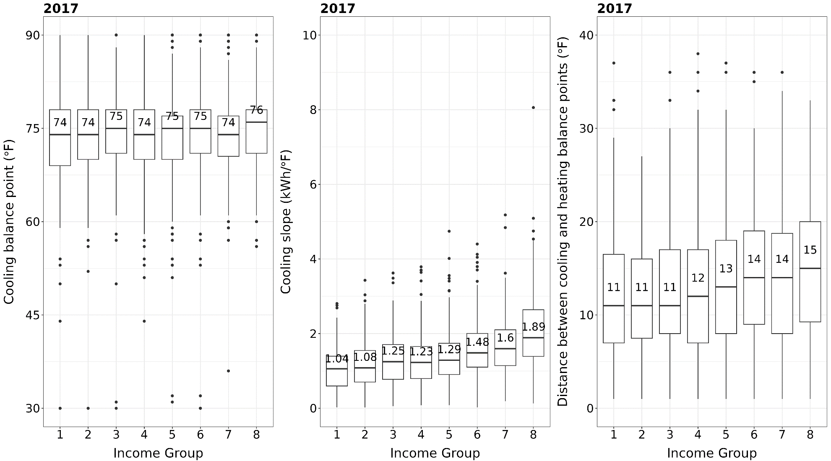
Figure A1. Cooling balance point, cooling slope, and balance point gap by income group for SRP in 2017
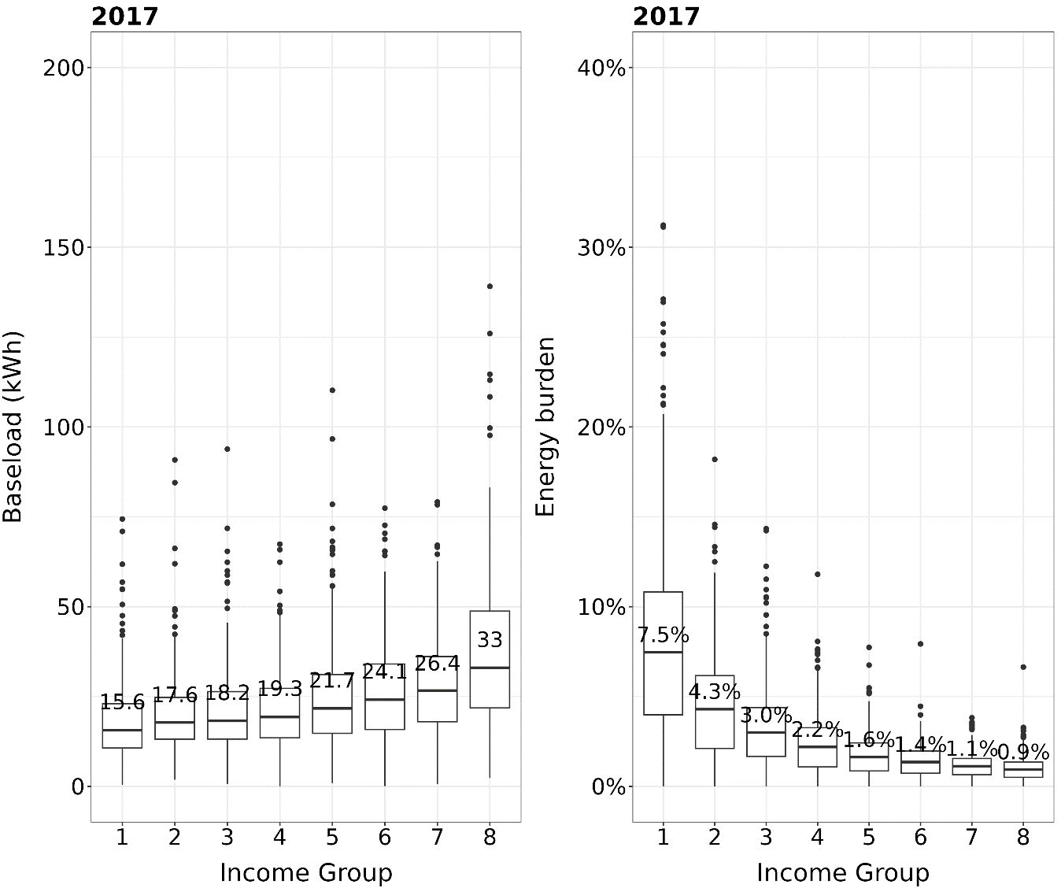

Figure A2. Baseload and energy burden by income group for SRP in 2017
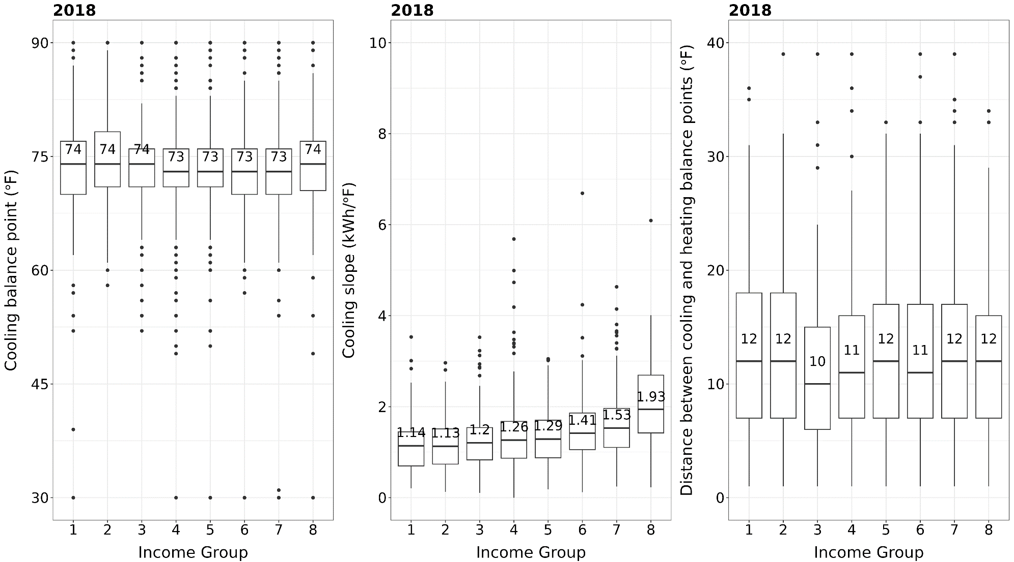

Figure A3. Cooling balance point, cooling slope, and balance point gap by income group for SRP in 2018
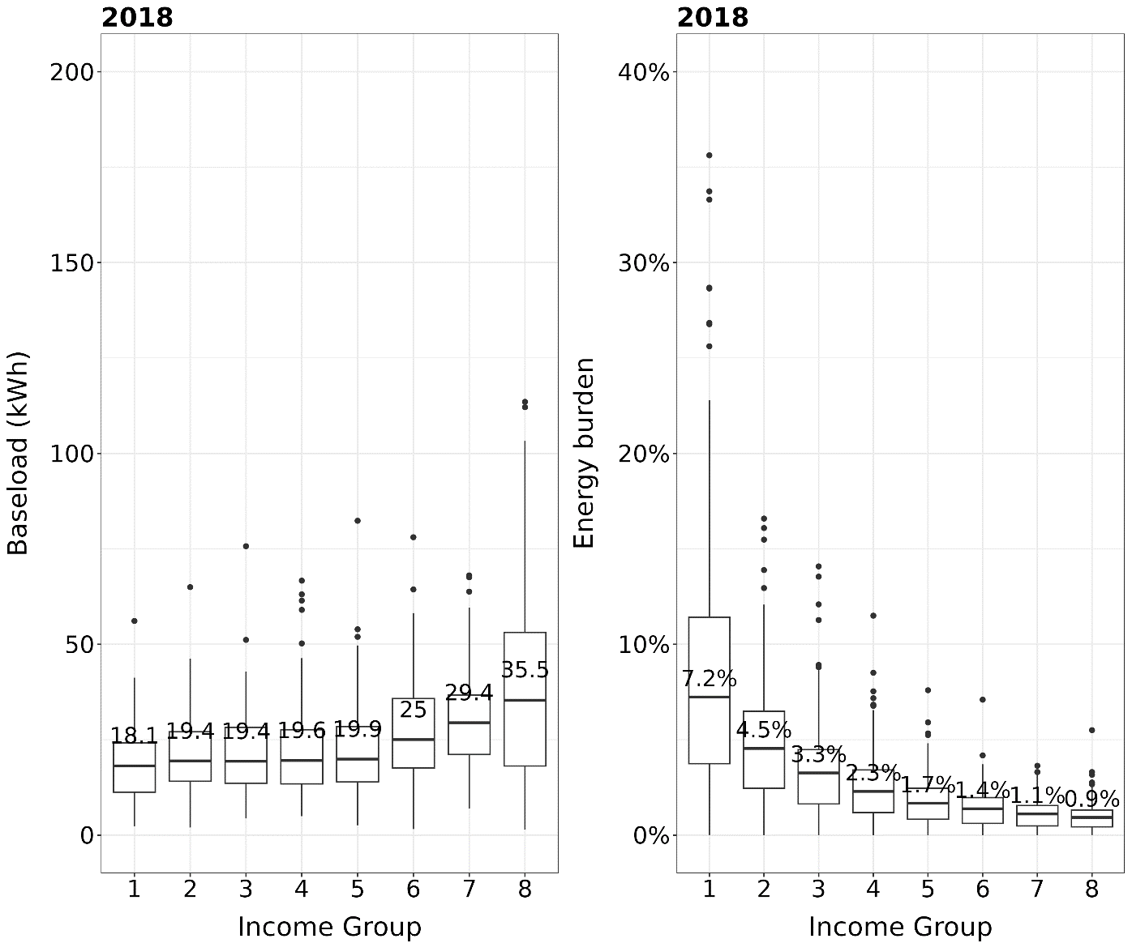

Figure A4. Baseload and energy burden by income group for SRP in 2018
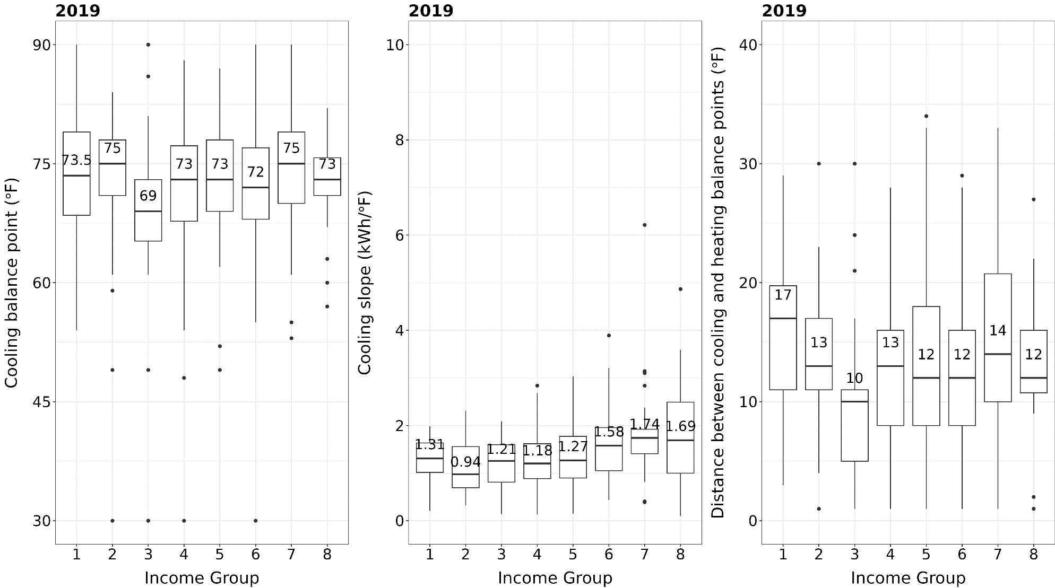

Figure A5. Cooling balance point, cooling slope, and balance point gap by income group for SRP in 2019
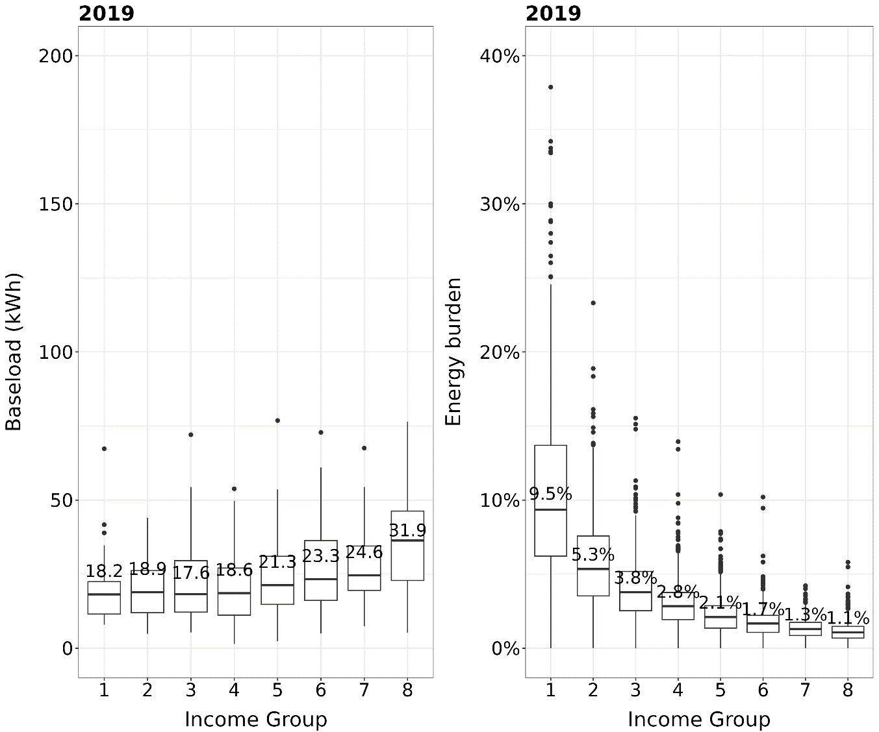

Figure A6. Baseload and energy burden by income group for SRP in 2019

5.5 Appendix E. Distribution of residence sizes of the SRP sample

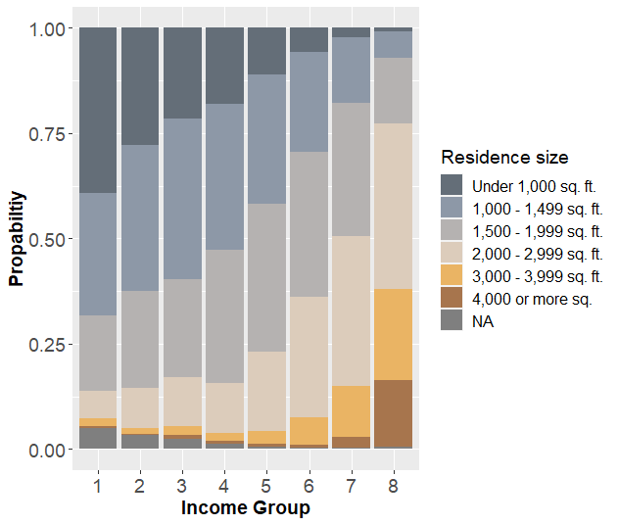
Figure A7. Distribution of residence sizes of the SRP sample

5.6 Appendix F. Scatter plot matrices of energy behavior parameters with correlation
From Figure A8, we observe a weak positive correlation between heating slope and energy burden (r = 0.495), which is intuitive because this region is dominated by heating needs. We also observe a slight positive correlation between cooling balance point and cooling slope (r = 0.494), indicating waiting longer into the summer to start using their cooling system is slightly correlated with a higher cooling slope, which could be an indication of lower-income households having less efficient appliances causing a positive correlation between cooling balance point and cooling slope.
Figure A9 shows that the only weak correlation among the energy behavior parameters is a positive correlation between heating slope and base load (r = 0.538), meaning those consuming more energy for heating are also more likely to have a higher base load, despite only the lowest three income groups are included in the scatter plot analysis, further indicating the high level of inequality in the Utility X region compared to the other two regions.

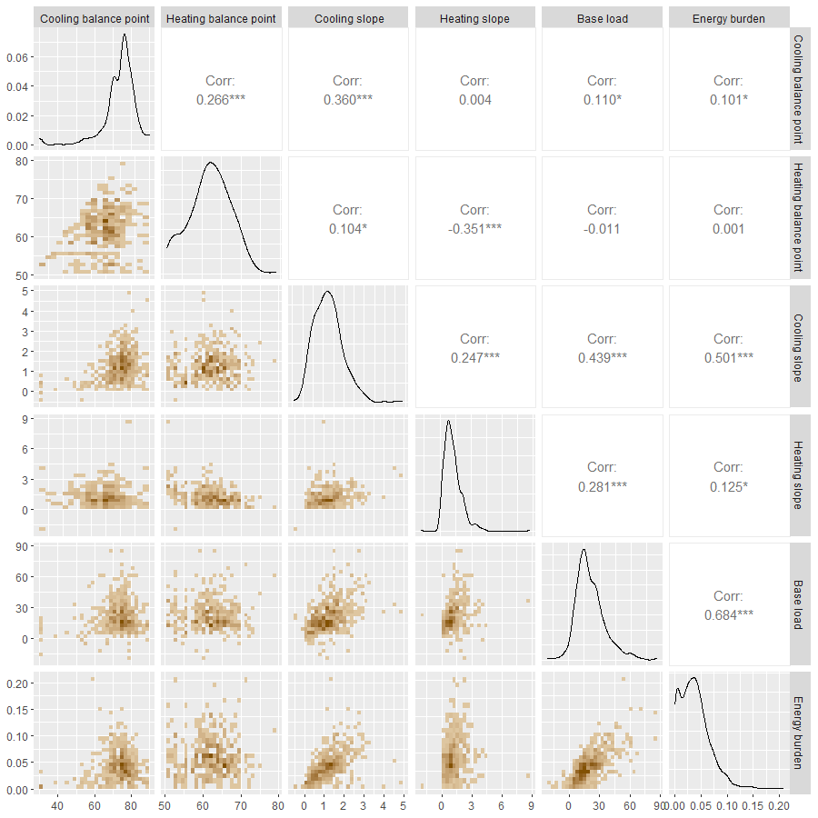
Figure A8. Scatter plot matrix of the interaction between the energy behavior parameters (bottom half), Pearson’s correlation between each pair (top half), and distribution of each parameter (diagonal), for the lowest three income groups for SRP sample in 2016

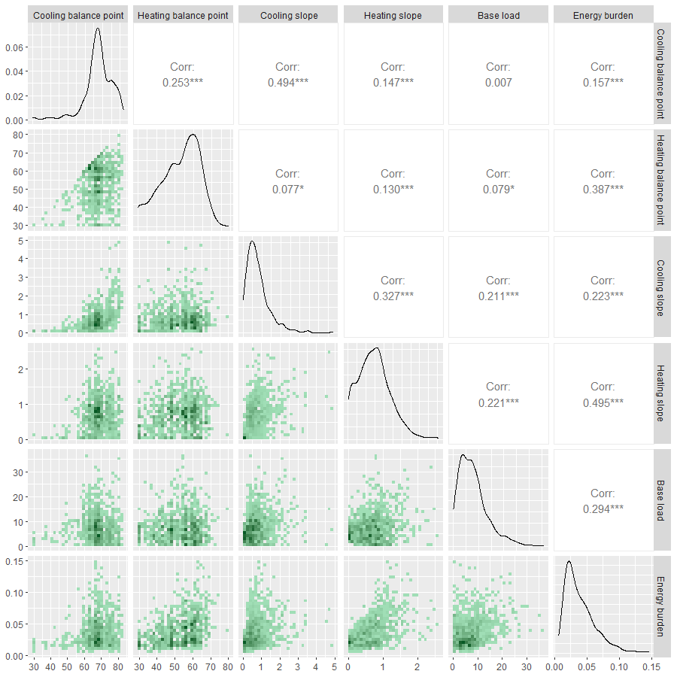
Figure A9. Scatter plot matrix of the interaction between the energy behavior parameters (bottom half), Pearson’s correlation between each pair (top half), and distribution of each parameter (diagonal), for the lowest three income groups for ComEd sample in 2020-2021
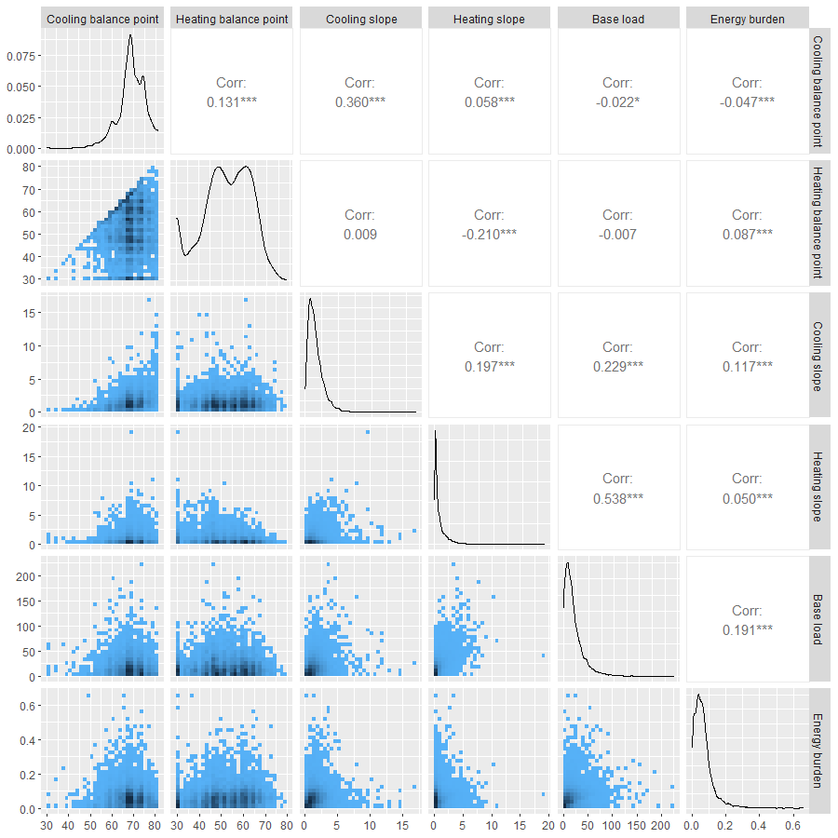
Figure A10. Scatter plot of the interaction between the energy behavior parameters (bottom half), Pearson’s correlation between each pair (top half), and distribution of each parameter (diagonal

