Band structure and density of states
The electronic band structures of boron nitride and sulphur nanoparticle are shown in Fig 1(a) and Fig 1(b) and density states in Fig 2(a) and Fig 2(b). The BN nanosheets exhibited semiconducting properties with a calculated bandgap of 6.1 eV. The total and PDOS show that the top of the valence band consists of nitrogen atoms, whereas the conduction band is mainly composed of boron atoms, as shown in Figs. 2 (a) and 2 (b).
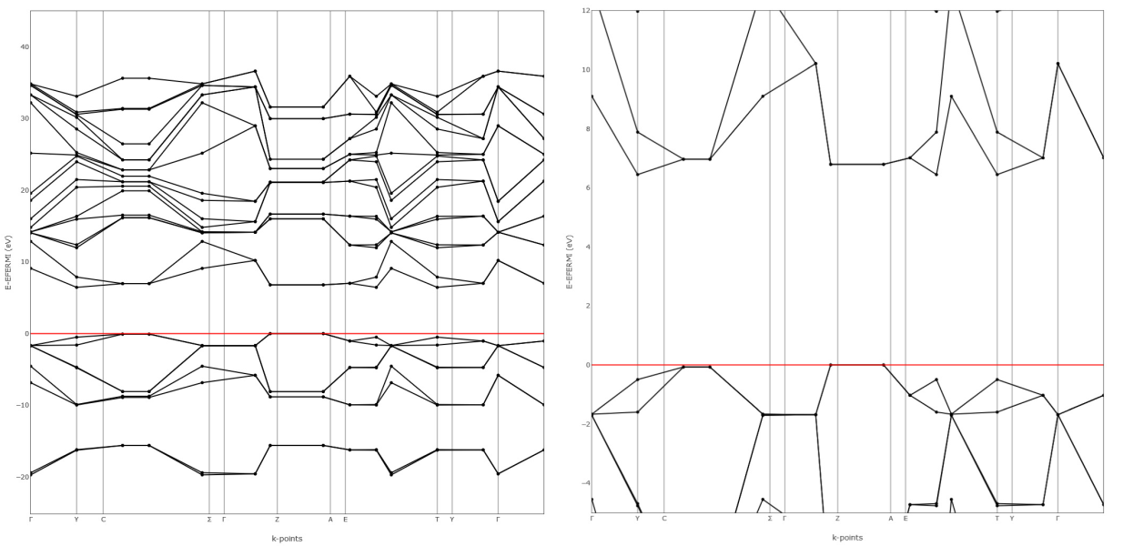
Fig 1(a) Electronic band structures of BN Fig 1(b) Electronic band structures of Sulphur

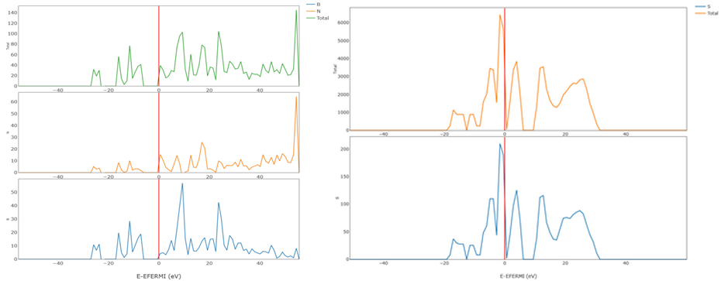

Fig 2(a) Density states for nano boron nitride Fig 2(b) Density states for nano Sulphur
Atomic Force Microscope (AFM)
AFM images of green-synthesized nano boron nitride and nano sulphur particles are shown in Fig 3(a) and 3(b). The AFM height of a single layer was reported to increase to 2 nm. Thus, the height profile measurements clearly suggested that these three h-BNNs consisted of a few layers (< 5 nm). The single-layer nano sheets are shown in Fig 3(a).
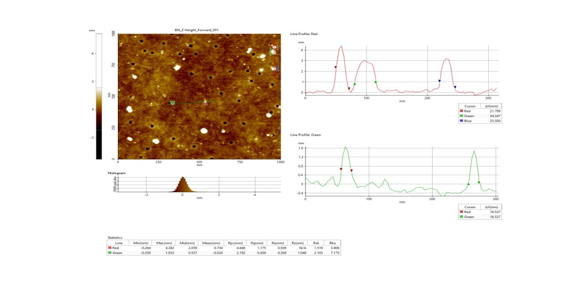
Fig 3(a)AFM images of green synthesised nano boron nitride particle
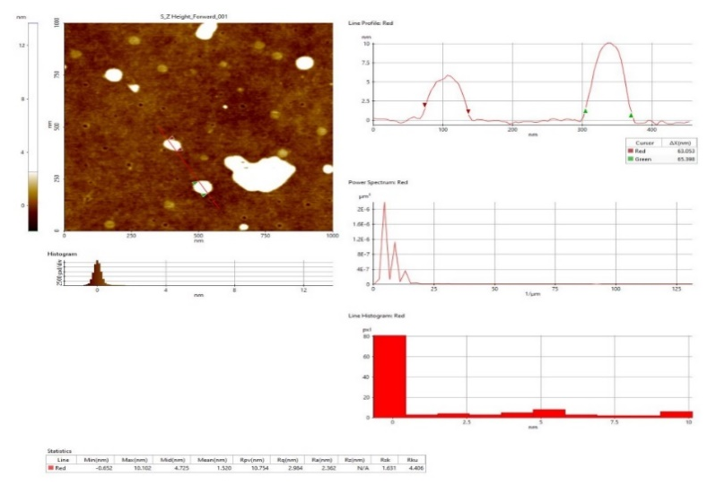
Fig 3(b)AFM images of green synthesised suplhur nanoparticle
AFM results confirm the successful exfoliation with the dominance of a single layer to a few layers of nano sheets. AFM images of the green-synthesized nanosulphur showed that small particles were closely anchored throughout the lm surface. The height curve along the line in the phase diagram shows the size distribution of the sulphur nanoparticles in the range of 10–60 nm, as shown in Fig 12 (b).
Experiment I- Impact of nanoparticles on sunflower shoot growth and root characteristics
Germination per cent, Mean days of germination (days), CVG and MDG (Table 1)
The treatments had a considerable impact on seed germination. Germination was higher with 2000 ppm nBN (GsP) (96.8%), 750 ppm nS (GsP) (96.2%), 1000 ppm nBN (GsP) (95.9%), 500 ppm nS (GsP) (94.8%), 750 ppm nS (CP) (94.6%), and 2000 ppm nBN (CP) (93.7%). The control treatment had a much greater mean day of germination (4.86 days) than the other treatments did. The lowest mean number of days of germination (2.56 days) was obtained in the 1000 ppm concentration of nBN (GsP). Among the various concentrations of nBN (CP), the 2000 ppm concentration had the lowest mean number of days of germination (3.01 days). Lower mean days of germination (2.72 days) were recorded in the 750 ppm treatment among different concentrations of nS (GsP), and the same concentration (750 ppm) also resulted in lower mean days of germination (2.98 days) among different concentrations of nS (CP). These findings demonstrated that there was considerable variation in the co-efficient of germination velocity. The greater the CVG value, the faster the germination. Compared to the control, 2000 ppm nBN (GsP) had significantly higher CVG (28.9), and the same concentration (2000 ppm) had significantly higher CVG (26.6) across various concentrations of nBN (CP) (13.7). A higher CVG (28.0) was recorded at 750 ppm among different concentrations of nS (GsP), and the same concentration (750 ppm) also recorded a higher CVG (25.6) among different concentrations of nS. (CP). In the case of MDG, 2000 ppm nBN (GsP) recorded a substantially higher MDG (20.2), and the same concentration (2000 ppm) also recorded a higher MDG (17.9) across different concentrations of nBN (CP), compared to the control (12.2). A higher MDG (19.7) was observed at 750 ppm among the different concentrations of nS (GsP), and the same concentration (750 ppm) also recorded a higher MDG (16.5) across different concentrations of nS (CP).

Table 1: Germination parameters of sunflower as influenced by different forms and levels
of nBN and nS
Sl. No. | Treatments | Mean days of germination | Coefficient of velocity of germination (CVG) | Mean daily germination (MDG) | Germination  ( %)
01 | 250 ppm nBN (CP) | 3.78 | 14.1 | 12.3 | 78.6
02 | 500 ppm nBN (CP) | 3.69 | 16.8 | 13.8 | 82.2
03 | 750 ppm nBN (CP) | 3.62 | 22.2 | 15.8 | 86.4
04 | 1000 ppm nBN (CP) | 3.58 | 24.2 | 16.7 | 90.0
05 | 2000 ppm nBN (CP) | 3.01 | 26.6 | 17.9 | 93.7
06 | 3000 ppm nBN (CP) | 3.55 | 22.6 | 16.3 | 76.6
07 | 250 ppm nBN (GsP) | 3.51 | 15.4 | 12.8 | 87.2
08 | 500 ppm nBN (GsP) | 3.45 | 20.9 | 15.5 | 88.9
09 | 750 ppm nBN (GsP) | 2.68 | 22.5 | 15.9 | 89.0
10 | 1000 ppm nBN (GsP) | 2.56 | 26.7 | 18.0 | 95.9
11 | 2000 ppm nBN (GsP) | 2.88 | 28.9 | 20.2 | 96.8
12 | 3000 ppm nBN (GsP) | 3.01 | 23.1 | 16.7 | 88.6
13 | 250 ppm nS (CP) | 3.68 | 16.1 | 12.9 | 79.8
14 | 500 ppm nS (CP) | 3.25 | 19.4 | 15.5 | 88.7
15 | 750 ppm nS (CP) | 2.98 | 25.6 | 16.5 | 94.6
16 | 1000 ppm nS (CP) | 3.24 | 24.7 | 17.4 | 86.2
17 | 2000 ppm nS (CP) | 3.65 | 18.6 | 13.7 | 84.8
18 | 3000 ppm nS (CP) | 3.36 | 15.7 | 12.7 | 80.2
19 | 250 ppm nS (GsP) | 3.28 | 19.4 | 13.7 | 88.7
20 | 500 ppm nS (GsP) | 3.08 | 22.7 | 15.9 | 94.8
21 | 750 ppm nS (GsP) | 2.72 | 28.0 | 19.7 | 96.2
22 | 1000 ppm nS (GsP) | 2.89 | 21.3 | 15.7 | 89.0
23 | 2000 ppm nS (GsP) | 3.24 | 18.9 | 14.5 | 80.6
24 | 3000 ppm nS (GsP) | 3.67 | 16.3 | 13.5 | 76.8
25 | Control | 4.86 | 13.7 | 12.2 | 75.5
 | SEm± | 0.18 | 0.21 | 0.11 | 1.24
 | CD (P=0.01) | 0.58 | 0.68 | 0.36 | 3.98
 | CV (%) | 3.26 | 3.98 | 4.12 | 5.86

4.1.2 Root and shoot length (cm) (Table 2)
In terms of root length, 2000 ppm nBN (GsP) (9.88 cm) was substantially longer than 750 ppm nS (GsP) (9.85 cm), 1000 ppm nBN (GsP) (9.38 cm), 2000 ppm nBN (CP) (9.28 cm), 750 ppm nS (CP) (8.86 cm), or 1000 ppm nS (CP) (8.79 cm) (3.56 cm). The maximum root length was measured 10 DAS with 2000 ppm nBN (GsP) (15.89 cm), which was comparable to 750 ppm nS (GsP) (15.01 cm), 1000 ppm nBN (GsP) (14.57 cm), 750 ppm nS (CP) (14.51 cm), and 2000 ppm nBN (CP) (14.21 cm) (8.44 cm). Similarly, the maximum shoot length was measured at 750 ppm nS (GsP) (12.01 cm), which was comparable to that of 2000 ppm nBN (GsP) (11.99 cm) and 1000 ppm nBN (GsP) (11.68 cm) (5.78 cm). At 10 DAS, 750 ppm nS (GsP) (17.81 cm) was substantially greater than 2000 ppm nBN (CP) (17.21 cm), 2000 ppm nBN (GsP) (16.99 cm), and 1000 ppm nBN (GsP) (16.89 cm) compared to the control (10.01 cm).
4.1.3 Seedling vigour index- I (SVI-I) and Seedling vigour index- II (SVI-II)
Seed treatment with various concentrations of green synthesized and commercial products of nBN and nS at various levels had a substantial effect on SVI-I and SVI-II (Table 3). SVI-I was significantly greater in 2000 ppm nBN (GsP) (2117) than in 750 ppm nS (GsP) (2103) or 1000 ppm nBN (GsP) (2103). (2019). SVI-I levels were greater in 2000 ppm nBN (GsP) because of the longer root and shoot lengths. Similarly, seed treatment with varying quantities of green synthesized and commercial products of nBN and nS had a substantial effect on SVI-II. Significantly higher SVI-II was recorded in 2000 ppm nBN (GsP) (2987), which was on par with 750 ppm of nS (GsP) (2898). Higher SVI-II was recorded in 2000 ppm nBN (GsP) owing to faster growth and higher dry matter accumulation.

Table 3: Seedling vigour index of sunflower as influenced by different forms and levels of nBN and nS
Sl No. | Treatments | 5 days after sowing |  |  | 10 days after sowing
Sl No. | Treatments | Root length  (cm) | Shoot length  (cm) | SVI-I | Root length  (cm) | Shoot length  (cm) | SVI-II
01 | 250 ppm nBN (CP) | 3.69 | 5.49 | 722 | 8.71 | 10.23 | 1356
02 | 500 ppm nBN (CP) | 5.23 | 7.23 | 1024 | 9.89 | 11.69 | 1574
03 | 750 ppm nBN (CP) | 7.24 | 9.24 | 1424 | 12.12 | 14.89 | 2112
04 | 1000 ppm nBN (CP) | 8.11 | 9.89 | 1619 | 13.23 | 15.74 | 2235
05 | 2000 ppm nBN (CP) | 9.28 | 11.24 | 1922 | 14.21 | 17.21 | 2654
06 | 3000 ppm nBN (CP) | 7.69 | 9.87 | 1345 | 12.88 | 14.56 | 1980
07 | 250 ppm nBN (GsP) | 4.18 | 6.41 | 924 | 8.89 | 11.35 | 1745
08 | 500 ppm nBN (GsP) | 6.89 | 9.1 | 1421 | 11.87 | 13.87 | 2125
09 | 750 ppm nBN (GsP) | 7.26 | 9.43 | 1486 | 12.56 | 14.77 | 2368
10 | 1000 ppm nBN (GsP) | 9.38 | 11.68 | 2019 | 14.57 | 16.89 | 2844
11 | 2000 ppm nBN (GsP) | 9.88 | 11.99 | 2117 | 15.89 | 16.99 | 2987
12 | 3000 ppm nBN (GsP) | 8.09 | 10.01 | 1604 | 12.89 | 15.01 | 2354
13 | 250 ppm nS (CP) | 4.26 | 6.189 | 834 | 9.88 | 11.05 | 1589
14 | 500 ppm nS (CP) | 6.92 | 8.89 | 1403 | 10.99 | 13.21 | 1981
15 | 750 ppm nS (CP) | 8.86 | 10.87 | 1867 | 14.51 | 15.89 | 2331
16 | 1000 ppm nS (CP) | 8.79 | 10.81 | 1689 | 13.98 | 15.56 | 2001
17 | 2000 ppm nS (CP) | 5.12 | 7.12 | 1037 | 10.16 | 13.24 | 1755
18 | 3000 ppm nS (CP) | 4.12 | 6.19 | 827 | 9.23 | 11.25 | 1688
19 | 250 ppm nS (GsP) | 5.12 | 7.35 | 1105 | 10.54 | 13.66 | 1985
20 | 500 ppm nS (GsP) | 7.25 | 9.78 | 1614 | 12.65 | 14.87 | 2574
21 | 750 ppm nS (GsP) | 9.85 | 12.01 | 2103 | 15.01 | 17.81 | 2898
22 | 1000 ppm nS (GsP) | 7.14 | 9.19 | 1454 | 12.24 | 13.89 | 2126
23 | 2000 ppm nS (GsP) | 5.89 | 8.09 | 1127 | 10.81 | 12.88 | 1756
24 | 3000 ppm nS (GsP) | 4.89 | 7.24 | 932 | 9.81 | 11.24 | 1559
25 | Control | 3.56 | 5.78 | 705 | 8.44 | 10.01 | 1299
 | SEm± | 0.38 | 0.21 | 35.7 | 0.58 | 0.64 | 41.8
 | CD (P=0.01) | 1.21 | 0.68 | 110.8 | 1.82 | 1.92 | 129.8
 | CV (%) | 4.39 | 3.89 | 4.67 | 4.16 | 4.88 | 5.12

4.1.4 Root parameters
The findings revealed a considerable variation in root characteristics (Table 4) as impacted by varied doses of green-synthesized and commercial nBN and nS seed priming. Seed treatment with 2000 ppm nBN (GsP) yielded a better average root diameter (1.21 mm), root volume (1.67 cm3), root length volume (106354 cm m3), surface area (69.61 cm2), and forks (4735), compared to 750 ppm nS. (GsP). The seeds treated with 750 ppm nS (GsP) had an average diameter of 1.02 mm, a root volume of 1.47 cm3, a root length volume of 106211 cm m3, a surface area of 69.04 cm2, and forks (4498). Higher average root diameter (0.61 mm), root volume (1.06 cm3), root length volume (97269 cm m3), surface area (67.24 cm2), and forks (4234) were found at 2000 ppm. At 750 ppm, increased average root diameter (0.89 mm), root volume (1.34 cm3), root length volume (85431 cm m3), surface area (67.54 cm2), and forks (4323) were reported.

Table 4 Root parameters of sunflower as influenced by different forms and levels of nBN and nS at 5 DAS
Sl No. | Treatments | Average diameter (mm) | Root volume (cm³) | Root length volume¹  (cm m⁻³) | Surface area (cm²) | Forks
01 | 250 ppm nBN (CP) | 0.29 | 0.72 | 49697 | 61.74 | 2595
02 | 500 ppm nBN (CP) | 0.35 | 0.77 | 57687 | 62.92 | 2947
03 | 750 ppm nBN (CP) | 0.40 | 0.83 | 77404 | 65.15 | 3611
04 | 1000 ppm nBN (CP) | 0.47 | 0.91 | 81912 | 66.26 | 3942
05 | 2000 ppm nBN (CP) | 0.61 | 1.06 | 97269 | 67.24 | 4234
06 | 3000 ppm nBN (CP) | 0.39 | 0.78 | 72567 | 65.91 | 3838
07 | 250 ppm nBN (GsP) | 0.54 | 0.94 | 63954 | 61.92 | 2649
08 | 500 ppm nBN (GsP) | 0.71 | 1.18 | 77881 | 64.90 | 3537
09 | 750 ppm nBN (GsP) | 0.88 | 1.31 | 86787 | 65.59 | 3742
10 | 1000 ppm nBN (GsP) | 0.97 | 1.41 | 104232 | 67.60 | 4341
11 | 2000 ppm nBN (GsP) | 1.21 | 1.67 | 106354 | 69.61 | 4735
12 | 3000 ppm nBN (GsP) | 0.53 | 0.94 | 86274 | 65.92 | 3841
13 | 250 ppm nS (CP) | 0.51 | 0.94 | 58236 | 62.91 | 2944
14 | 500 ppm nS (CP) | 0.69 | 1.12 | 72603 | 64.02 | 3275
15 | 750 ppm nS (CP) | 0.89 | 1.34 | 85431 | 67.54 | 4323
16 | 1000 ppm nS (CP) | 0.71 | 1.18 | 73336 | 67.01 | 4166
17 | 2000 ppm nS (CP) | 0.61 | 1.02 | 64320 | 63.19 | 3027
18 | 3000 ppm nS (CP) | 0.44 | 0.85 | 61865 | 62.26 | 2750
19 | 250 ppm nS (GsP) | 0.71 | 1.12 | 72750 | 63.57 | 3140
20 | 500 ppm nS (GsP) | 0.89 | 1.35 | 94337 | 65.68 | 3769
21 | 750 ppm nS (GsP) | 1.02 | 1.47 | 106211 | 69.04 | 4498
22 | 1000 ppm nS (GsP) | 0.94 | 1.29 | 77917 | 65.27 | 3647
23 | 2000 ppm nS (GsP) | 0.74 | 1.15 | 64357 | 63.84 | 3221
24 | 3000 ppm nS (GsP) | 0.65 | 0.98 | 57137 | 62.84 | 2923
25 | Control | 0.21 | 0.65 | 47608 | 61.47 | 2515
 | SEm± | 0.04 | 0.06 | 61.26 | 0.41 | 78.23
 | CD (P=0.01) | 0.19 | 0.21 | 210.34 | 1.34 | 256.6
 | CV (%) | 4.12 | 3.91 | 4.36 | 3.33 | 4.87
 | F-test | ** | ** | ** | ** | **

Experiment II- Impact of nanoparticles on sunflower shoot growth and root characteristics.
Table 5: Germination parameters of sunflower as influenced by different forms and levels of nBN and nS
Sl No. | Treatments | Mean days of germination | Co- efficient of velocity of germination (CVG) | Mean daily germination  (MDG) | Germination  ( %)
01 | 1000 ppm nBN (CP) | 3.61 | 24.1 | 16.8 | 90.4
02 | 1250 ppm nBN (CP) | 3.49 | 24.7 | 17.1 | 91.9
03 | 1500 ppm nBN (CP) | 3.32 | 25.2 | 17.6 | 92.6
04 | 1750 ppm nBN (CP) | 3.18 | 26.2 | 17.9 | 92.9
05 | 2000 ppm nBN (CP) | 2.98 | 27.1 | 18.1 | 93.8
06 | 2250 ppm nBN (CP) | 3.11 | 26.8 | 17.7 | 89.8
07 | 1000 ppm nBN (GsP) | 2.56 | 26.1 | 18.4 | 95.2
08 | 1250 ppm nBN (GsP) | 2.44 | 27.6 | 18.9 | 95.9
09 | 1500 ppm nBN (GsP) | 2.19 | 32.9 | 22.2 | 98.2
10 | 1750 ppm nBN (GsP) | 2.66 | 30.3 | 21.2 | 96.2
11 | 2000 ppm nBN (GsP) | 2.88 | 29.2 | 20.5 | 96.0
12 | 2250 ppm nBN (GsP) | 3.12 | 28.7 | 20.1 | 90.1
13 | 550 ppm nS (CP) | 3.25 | 19.1 | 15.6 | 89.6
14 | 600 ppm nS (CP) | 3.18 | 22.6 | 15.9 | 90.2
15 | 650 ppm nS (CP) | 3.12 | 24.8 | 16.2 | 91.8
16 | 700 ppm nS (CP) | 3.08 | 25.1 | 16.5 | 93.1
17 | 750 ppm nS (CP) | 2.98 | 26.1 | 16.9 | 94.8
18 | 800 ppm nS (CP) | 3.19 | 25.4 | 16.3 | 88.4
19 | 550 ppm nS (GsP) | 3.08 | 22.1 | 17.1 | 94.9
20 | 600 ppm nS (GsP) | 2.44 | 32.4 | 21.9 | 97.8
21 | 650 ppm nS (GsP) | 2.52 | 31.0 | 21.1 | 97.0
22 | 700 ppm nS (GsP) | 2.68 | 29.6 | 20.6 | 96.5
23 | 750 ppm nS (GsP) | 2.72 | 28.2 | 19.9 | 96.0
24 | 800 ppm nS (GsP) | 3.12 | 27.6 | 19.1 | 90.4
25 | Control | 4.98 | 13.9 | 12.4 | 74.6
 | SEm± | 0.15 | 0.19 | 0.14 | 0.32
 | CD (P=0.01) | 0.49 | 0.61 | 0.45 | 1.01
 | CV (%) | 3.76 | 3.84 | 4.12 | 5.92
 | F-test | ** | ** | ** | **

Table 6: Seedling vigour index of sunflower as influenced by different forms and levels of nBN and nS
Sl No. | Treatments | 5 Days after sowing |  |  | 10 Days after sowing
Sl No. | Treatments | Root length  (cm) | Shoot length  (cm) | SVI-I | Root length  (cm) | Shoot length  (cm) | SVI-II
01 | 1000 ppm nBN (CP) | 8.10 | 9.81 | 1619 | 12.01 | 15.08 | 2619
02 | 1250 ppm nBN (CP) | 8.28 | 9.98 | 1678 | 13.52 | 15.28 | 2820
03 | 1500 ppm nBN (CP) | 8.69 | 10.56 | 1783 | 14.22 | 15.86 | 2960
04 | 1750 ppm nBN (CP) | 9.01 | 10.89 | 1849 | 14.56 | 16.14 | 3027
05 | 2000 ppm nBN (CP) | 9.31 | 11.19 | 1923 | 15.49 | 16.56 | 3183
06 | 2250 ppm nBN (CP) | 7.80 | 8.89 | 1499 | 11.42 | 14.23 | 2473
07 | 1000 ppm nBN (GsP) | 9.41 | 11.71 | 2011 | 16.81 | 16.96 | 3394
08 | 1250 ppm nBN (GsP) | 9.59 | 11.88 | 2059 | 17.54 | 17.11 | 3504
09 | 1500 ppm nBN (GsP) | 10.98 | 12.99 | 2354 | 19.81 | 18.29 | 3922
10 | 1750 ppm nBN (GsP) | 9.97 | 12.01 | 2114 | 17.83 | 17.28 | 3559
11 | 2000 ppm nBN (GsP) | 9.89 | 11.65 | 2068 | 17.63 | 16.91 | 3497
12 | 2250 ppm nBN (GsP) | 9.00 | 11.02 | 1804 | 11.73 | 16.31 | 2696
13 | 550 ppm nS (CP) | 6.98 | 8.91 | 1424 | 11.28 | 14.66 | 2493
14 | 600 ppm nS (CP) | 7.24 | 9.02 | 1467 | 11.84 | 14.98 | 2589
15 | 650 ppm nS (CP) | 7.89 | 9.25 | 1573 | 13.45 | 15.22 | 2805
16 | 700 ppm nS (CP) | 8.56 | 9.89 | 1718 | 14.72 | 15.38 | 2978
17 | 750 ppm nS (CP) | 8.89 | 10.81 | 1868 | 16.43 | 16.21 | 3273
18 | 800 ppm nS (CP) | 8.20 | 9.75 | 1587 | 10.03 | 15.02 | 2381
19 | 550 ppm nS (GsP) | 9.56 | 9.81 | 1838 | 16.55 | 15.23 | 3195
20 | 600 ppm nS (GsP) | 10.87 | 12.89 | 2324 | 19.42 | 18.24 | 3873
21 | 650 ppm nS (GsP) | 9.92 | 12.31 | 2156 | 18.62 | 17.50 | 3687
22 | 700 ppm nS (GsP) | 9.89 | 12.11 | 2123 | 18.15 | 17.31 | 3604
23 | 750 ppm nS (GsP) | 9.80 | 12.08 | 2100 | 17.62 | 17.08 | 3512
24 | 800 ppm nS (GsP) | 8.87 | 10.12 | 1717 | 12.1 | 15.66 | 2680
25 | Control | 3.49 | 5.84 | 696 | 8.21 | 9.89 | 1491
 | SEm± | 0.28 | 0.18 | 36.8 | 0.22 | 0.24 | 43.9
 | CD (P=0.01) | 0.91 | 0.59 | 115.2 | 0.69 | 0.75 | 135.7
 | CV (%) | 4.11 | 4.39 | 5.21 | 3.87 | 4.65 | 5.12
 | F- test | ** | ** | ** | ** | ** | **

Table 7: Root parameters of sunflower as influenced by different forms and levels of nBN and nS at 5 DAS

Sl No. | Treatments | Average diameter (mm) | Root volume  (cm³) | Root length  volume¹  (cm m⁻³) | Surface area (cm²) | Forks
01 | 1000 ppm nBN (CP) | 0.45 | 0.89 | 81872 | 66.21 | 3938
02 | 1250 ppm nBN (CP) | 0.48 | 0.93 | 83569 | 66.38 | 3998
03 | 1500 ppm nBN (CP) | 0.52 | 0.97 | 87425 | 66.57 | 4087
04 | 1750 ppm nBN (CP) | 0.58 | 1.01 | 95236 | 66.78 | 4100
05 | 2000 ppm nBN (CP) | 0.63 | 1.04 | 97246 | 67.89 | 4244
06 | 2250 ppm nBN (CP) | 0.55 | 0.99 | 93654 | 66.61 | 4125
07 | 1000 ppm nBN (GsP) | 0.95 | 1.42 | 104323 | 67.49 | 4341
08 | 1250 ppm nBN (GsP) | 1.02 | 1.49 | 107256 | 67.98 | 4562
09 | 1500 ppm nBN (GsP) | 1.35 | 1.81 | 109989 | 70.89 | 4887
10 | 1750 ppm nBN (GsP) | 1.28 | 1.72 | 108569 | 70.12 | 4802
11 | 2000 ppm nBN (GsP) | 1.23 | 1.70 | 106359 | 69.63 | 4738
12 | 2250 ppm nBN (GsP) | 1.18 | 1.51 | 105231 | 69.14 | 4711
13 | 550 ppm nS (CP) | 0.71 | 1.18 | 72689 | 64.12 | 3279
14 | 600 ppm nS (CP) | 0.75 | 1.21 | 74568 | 64.89 | 3645
15 | 650 ppm nS (CP) | 0.81 | 1.27 | 78542 | 65.74 | 3987
16 | 700 ppm nS (CP) | 0.86 | 1.31 | 82236 | 66.91 | 4122
17 | 750 ppm nS (CP) | 0.91 | 1.35 | 85431 | 67.89 | 4333
18 | 800 ppm nS (CP) | 0.83 | 1.29 | 80241 | 66.54 | 4215
19 | 550 ppm nS (GsP) | 0.92 | 1.36 | 94337 | 67.98 | 3789
20 | 600 ppm nS (GsP) | 1.32 | 1.76 | 109796 | 70.86 | 4865
21 | 650 ppm nS (GsP) | 1.25 | 1.68 | 108745 | 70.18 | 4815
22 | 700 ppm nS (GsP) | 1.14 | 1.55 | 107451 | 70.12 | 4528
23 | 750 ppm nS (GsP) | 1.08 | 1.49 | 106211 | 69.05 | 4498
24 | 800 ppm nS (GsP) | 0.98 | 1.41 | 100589 | 68.23 | 4326
25 | Control | 0.23 | 0.78 | 65236 | 62.69 | 3451
 | SEm± | 0.01 | 0.02 | 84.23 | 0.21 | 12.56
 | CD (P=0.01) | 0.05 | 0.07 | 260.69 | 0.65 | 40.12
 | CV (%) | 3.98 | 4.22 | 4.36 | 3.78 | 4.51
 | F-test | ** | ** | ** | ** | **

