Supplementary Materials

One-pot green solid-state synthesis of Cu₂O/microcrystalline cellulose composite with high anti-pathogenic activity
Ke Sun¹, Han Hu¹, Zirong He¹, Zhuojun Xiao¹, Xiaoqian Jin¹, Chen Zheng¹ & Yi Liu^{*1,2}

¹Materials Genome Institute, Shanghai University, Shanghai 200444, China
²Zhejiang Laboratory, Hangzhou 311100, China

*Corresponding author. E-mail address: yiliu@shu.edu.cn (Y. L.)

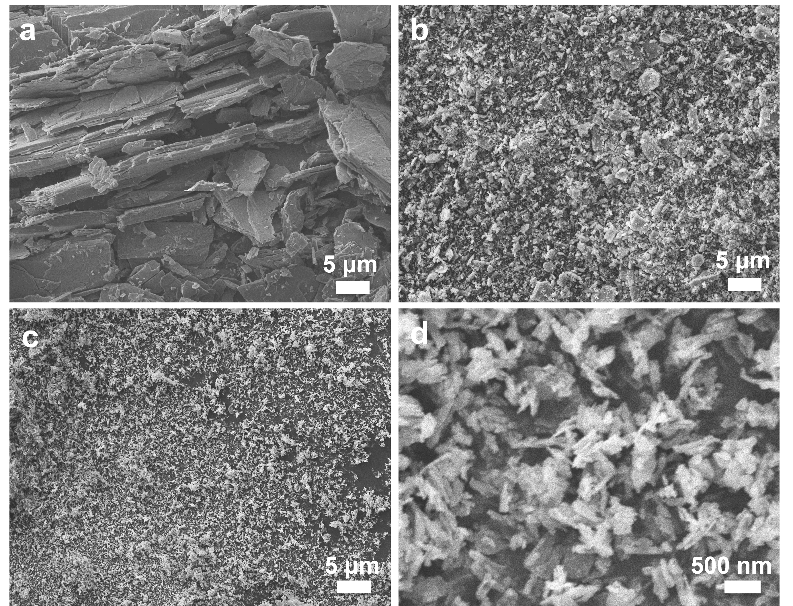
Supplementary Fig. 1. SEM images of copper formate. a Untreated sample; b after BM-Ⅰ for 6 h; c, d after BM-Ⅰ for 12 h.

Supplementary Fig. 2. XRD spectra of copper formate. a untreated sample and b after BM-Ⅰ for 12 h.

Supplementary Table 1. The ratio of Cu⁺ and Cu²⁺ on the surface of the Cu₂O/MCC composite. The results were determined by the fitted peaks area ratio of the XPS Cu2p_{3/2} spectrum.

Sample | Cu⁺ ratio (%) | Cu²⁺ ratio (%)
Cu₂O/MCC composite | 93.8 | 6.2

Supplementary Table 2. Mass ratio of Cu and Cu₂O for the Cu₂O/MCC composite. The results were determined by ICP-OES. a: Ignoring the trace amount of CuO, the mass ratio of Cu₂O was calculated according to the mass ratio of Cu element (88.82 %) relative to Cu₂O.

Sample | Cu atomic mass ratio  (wt. %) | ª Cu₂O mass ratio  (wt. %)
Cu₂O/MCC composite | 17.09 | 19.24

Supplementary Fig. 3. Particle size distribution histogram of Cu₂O for the Cu₂O/MCC composite. The result is based on three SEM images of the Cu₂O/MCC composite, 100 Cu₂O particles in the SEM images were analyzed for statistics.

Supplementary Fig. 4. XRD spectra of the sintered product of a untreated copper formate, b Cu powders (particle size: 200 nm, commercial purchase), and c copper formate/MCC powders.
Experimental conditions: 200 mg of untreated copper formate powders, Cu powders, and pre-prepared copper formate/MCC powders were separately added to three alumina ceramic crucibles and then placed into the isothermal region of box-type resistance furnace. The furnace was heated to 230 ℃ by the heating rate of 5 ℃/min and sintered at 230 °C for 12 min in air atmosphere. After air cooling to room temperature the sintered product was obtained.

Supplementary Fig. 5. The C1s XPS spectra of MCC and the Cu₂O/MCC composite.

Supplementary Table 3. Relative energy differences calculated by DFT between the original cellobiose unit and that after deprotonation of hydroxyl groups at C2, C3, and C6 positions, respectively. E is the total energy of the cellobiose unit after deprotonation and E₀ is the total energy of the cellobiose unit.

Deprotonation site | Total energy (kcal/mol) | E-E₀ (kcal/mol)
none | -863489.92 | 0
C2-OH | -863070.30 | 419.62 (5.03)
C3-OH | -863070.57 | 419.35 (4.76)
C6-OH | -863075.33 | 414.59 (0.00)

Supplementary Fig. 6. a Images of antibacterial experiments for the Cu₂O/MCC composite against E. coli and S. aureus. b The Inhibition rates for E. coli and S. aureus. Error bars indicated the standard deviations among three repeated experiments.

Supplementary Fig. 7. Evolution of XRD spectra of the Cu₂O/MCC composite as function of time in the structure stability tests at humid and high-ambient temperature conditions (35 ℃ and 85 % relative humidity) up to 60 days.

