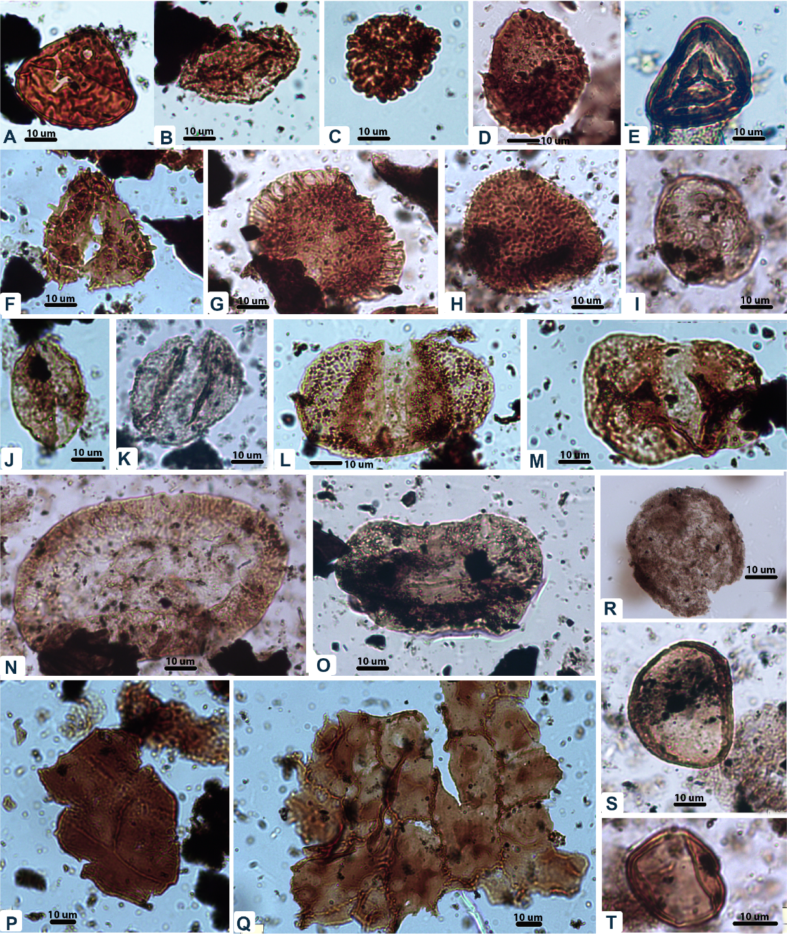
FIG. SI-1. The Palynomorphs Plate includes several important taxa. A. Camarozonosporites rudis (Leschik 1955) Klaus 1960, 83.4 m; B. Aratrisporites minimus Schulz 1967, 83.4 m; C. Uvaesporites argenteaeformis (Bolkhovitina 1953) Schulz 1967, 83.6 m; D. Apiculatisporites sp., 120.15 m; E. Striatella seebergensis Mädler, 1964; 120.15 m; F. Acanthotriletes microspinosus (Ibrahim, 1933) Potonié & Kremp, 1955; 200.05 m; G. Limbosporites denmeadii (de Jersey 1962) de Jersey & Raine 1990, 153.3 m; H. Osmundacidites wellmanii Couper 1953, 154.1 m; I. Craterisporites rotundus de Jersey, 1970, 167.4 m; J. Monosulcites spp., 83.4 m; K. Scheuringipollenites ovatus, 233.3 m; L. Alisporites australis de Jersey 1962, 120.15 m; M. Pteruchipollenites sp., 154.1; N. Parasaccites spp. 233.3 m; O. Staurosaccites quadrifidus, 167.4; P. cuticle of Dicroidium sp. Q. cuticle of Dicroidium odontopteroides Morris 1845, 83.4; R. Tasmanites sp., 289.1 m; S-T. Pilasporites calculus Balme and Hennelly 1956; 233.3 m.

