Table S1. SNPs used as instruments and their association with the exposure(Coronary atherosclerosis ) and the outcome(Chronic periodontitis,Acute periodontitis)
SNP | CHR | EA | OA | Exposure |  |  |  | R² | F | Outcome |  |  |  | Outcome
 |  |  |  | EAF | BETA | SE | P-value | R² | F | EAF | BETA | SE | P-value | EAF | BETA | SE | P-value
 |  |  |  | Coronary atherosclerosis |  |  |  |  |  | Chronic periodontitis |  |  |  | Acute periodontitis
rs1010322 | 17 | G | C | 0.545707 | -0.00296845 | 0.000454 | 4.44E-08 | 0.000118 | 42.769750 | 0.5091 | -0.003300 | 0.0225 | 0.8847 | 0.5091 | -0.039400 | 0.0744 | 0.5966
rs10172929 | 2 | G | T | 0.121944 | 0.00393956 | 0.00072 | 7.74E-11 | 0.000083 | 29.947430 | 0.08985 | -0.008300 | 0.0398 | 0.8349 | 0.08984 | -0.091300 | 0.1326 | 0.490801
rs10305838 | 4 | C | T | 0.139509 | 0.00423309 | 0.000651 | 7.30E-09 | 0.000117 | 42.324940 | 0.1343 | 0.023400 | 0.0329 | 0.4771 | 0.1343 | 0.159000 | 0.1091 | 0.145
rs10774624 | 12 | A | G | 0.513708 | -0.00263554 | 0.000456 | 3.08E-13 | 0.000093 | 33.455860 | 0.5971 | -0.022600 | 0.023 | 0.3252 | 0.5973 | 0.117800 | 0.0761 | 0.1218
rs11372849 | 15 | TC | T | 0.477223 | 0.00331449 | 0.000455 | 1.34E-09 | 0.000147 | 53.161240 | 0.403 | 0.042800 | 0.0229 | 0.0617803 | 0.4028 | 0.114300 | 0.0759 | 0.132
rs11591147 | 1 | T | G | 0.0176733 | -0.0103698 | 0.00171 | 1.57E-10 | 0.000102 | 36.762840 | 0.03608 | 0.016900 | 0.0607 | 0.7805 | 0.03608 | 0.050800 | 0.1988 | 0.7981
rs11617955 | 13 | A | T | 0.113121 | -0.0046192 | 0.000722 | 5.49E-32 | 0.000113 | 40.938560 | 0.0974 | 0.028400 | 0.0379 | 0.4533 | 0.09737 | 0.147700 | 0.126 | 0.2411
rs117733303 | 6 | G | A | 0.0186119 | 0.0196413 | 0.001668 | 4.93E-10 | 0.000384 | 138.590200 | 0.01125 | 0.020400 | 0.1055 | 0.8465 | 0.01123 | -0.390100 | 0.3562 | 0.2735
rs12369441 | 12 | C | T | 0.0698759 | -0.00552825 | 0.000889 | 1.01E-73 | 0.000107 | 38.707190 | 0.07859 | 0.004800 | 0.0418 | 0.9093 | 0.0786 | 0.049800 | 0.1385 | 0.719
rs1333042 | 9 | G | A | 0.498058 | 0.00819557 | 0.000451 | 1.95E-08 | 0.000913 | 330.042500 | 0.4212 | -0.029700 | 0.0227 | 0.1906 | 0.4213 | 0.013500 | 0.0753 | 0.858
rs145436496 | 19 | A | G | 0.0299222 | 0.00751876 | 0.001339 | 4.08E-10 | 0.000087 | 31.540250 | 0.02618 | -0.009400 | 0.071 | 0.8951 | 0.02618 | -0.144200 | 0.2351 | 0.539699
rs147932234 | 2 | C | T | 0.127585 | 0.00427065 | 0.000683 | 2.86E-08 | 0.000108 | 39.077950 | 0.1132 | 0.012600 | 0.0354 | 0.721601 | 0.1132 | -0.053900 | 0.1174 | 0.6461
rs1620712 | 3 | G | C | 0.846132 | 0.00347676 | 0.000626 | 9.31E-09 | 0.000085 | 30.801270 | 0.8106 | 0.045600 | 0.0287 | 0.1124 | 0.8105 | 0.116200 | 0.095 | 0.2213
rs16986953 | 2 | A | G | 0.0679806 | 0.00517997 | 0.000902 | 4.93E-12 | 0.000091 | 32.981600 | 0.07351 | 0.074100 | 0.0429 | 0.0838996 | 0.07343 | 0.225800 | 0.1423 | 0.1126
rs2028900 | 2 | T | C | 0.450318 | 0.00313271 | 0.000454 | 1.22E-10 | 0.000132 | 47.716870 | 0.4018 | 0.011200 | 0.0229 | 0.6256 | 0.4017 | -0.101000 | 0.0758 | 0.1827
rs2107595 | 7 | A | G | 0.151529 | 0.00405567 | 0.00063 | 2.80E-10 | 0.000115 | 41.428810 | 0.1946 | 0.026400 | 0.0284 | 0.3514 | 0.1945 | 0.110100 | 0.0939 | 0.2411
rs2133189 | 1 | T | C | 0.714278 | 0.00315447 | 0.0005 | 8.26E-11 | 0.000110 | 39.811420 | 0.7397 | -0.004500 | 0.0255 | 0.8615 | 0.7397 | -0.020300 | 0.0847 | 0.8109
rs2839812 | 11 | A | T | 0.720828 | -0.00327179 | 0.000504 | 2.76E-12 | 0.000117 | 42.196650 | 0.7853 | -0.012000 | 0.0273 | 0.6592 | 0.7854 | 0.154700 | 0.0904 | 0.0869801
rs28451064 | 21 | A | G | 0.13177 | 0.00475997 | 0.000681 | 2.32E-10 | 0.000135 | 48.857180 | 0.1534 | 0.008800 | 0.0311 | 0.776301 | 0.1534 | -0.005400 | 0.1029 | 0.9578
rs28601761 | 8 | G | C | 0.419467 | -0.00293316 | 0.000463 | 1.22E-15 | 0.000111 | 40.182440 | 0.4125 | -0.004800 | 0.0228 | 0.8338 | 0.4125 | -0.030500 | 0.0755 | 0.6857
rs3127580 | 6 | T | C | 0.15801 | 0.00494556 | 0.000618 | 4.21E-09 | 0.000177 | 64.036720 | 0.1242 | 0.021800 | 0.0339 | 0.5199 | 0.1242 | 0.135400 | 0.113 | 0.2306
rs4237541 | 10 | C | T | 0.42932 | 0.0026842 | 0.000457 | 5.64E-70 | 0.000096 | 34.524820 | 0.329 | -0.016900 | 0.0239 | 0.48 | 0.3291 | 0.002700 | 0.0793 | 0.9725
rs55730499 | 6 | T | C | 0.0813848 | 0.014607 | 0.000826 | 3.43E-23 | 0.000865 | 312.834900 | 0.04562 | -0.000800 | 0.0539 | 0.9875 | 0.04563 | 0.267800 | 0.1824 | 0.142
rs602633 | 1 | G | T | 0.782537 | 0.00541689 | 0.000546 | 1.81E-09 | 0.000272 | 98.408900 | 0.7829 | -0.003300 | 0.0272 | 0.902 | 0.7829 | -0.064200 | 0.09 | 0.4759
rs72664318 | 1 | G | A | 0.0920377 | -0.00469955 | 0.000781 | 1.41E-12 | 0.000100 | 36.164940 | 0.1085 | 0.051400 | 0.0362 | 0.1552 | 0.1085 | 0.165700 | 0.1191 | 0.1642
rs7495616 | 15 | G | C | 0.758775 | -0.00373793 | 0.000528 | 2.30E-11 | 0.000139 | 50.169490 | 0.6351 | 0.009200 | 0.0234 | 0.693499 | 0.6351 | 0.097300 | 0.0774 | 0.2086
rs7500448 | 16 | G | A | 0.253443 | -0.00349441 | 0.000523 | 7.38E-11 | 0.000124 | 44.695650 | 0.2048 | 0.004400 | 0.0278 | 0.8735 | 0.2048 | 0.110600 | 0.0925 | 0.2316
rs77265569 | 19 | T | G | 0.113197 | -0.00469525 | 0.000721 | 5.46E-10 | 0.000117 | 42.418860 | 0.1025 | 0.030900 | 0.037 | 0.4045 | 0.1024 | 0.042500 | 0.1217 | 0.7272
rs9285476 | 6 | G | C | 0.297986 | -0.00307398 | 0.000495 | 3.65E-19 | 0.000107 | 38.505650 | 0.232 | -0.023800 | 0.0266 | 0.3693 | 0.2321 | -0.025100 | 0.088 | 0.7759
rs9349379 | 6 | G | A | 0.405522 | 0.00410929 | 0.000459 | 6.16E-11 | 0.000222 | 80.058300 | 0.4506 | 0.027800 | 0.0225 | 0.2171 | 0.4504 | -0.037100 | 0.0746 | 0.6191
rs1010322 | 17 | G | C | 0.545707 | -0.00296845 | 0.000454 | 4.44E-08 | 0.000118 | 42.769750 | 0.5092 | -0.000200 | 0.0261 | 0.9931 | 0.5092 | -0.000200 | 0.0261 | 0.9931
rs10172929 | 2 | G | T | 0.121944 | 0.00393956 | 0.00072 | 7.74E-11 | 0.000083 | 29.947430 | 0.08987 | 0.001900 | 0.0461 | 0.9677 | 0.08987 | 0.001900 | 0.0461 | 0.9677
rs10305838 | 4 | C | T | 0.139509 | 0.00423309 | 0.000651 | 7.30E-09 | 0.000117 | 42.324940 | 0.1343 | 0.015700 | 0.0382 | 0.6814 | 0.1343 | 0.015700 | 0.0382 | 0.6814
rs10774624 | 12 | A | G | 0.513708 | -0.00263554 | 0.000456 | 3.08E-13 | 0.000093 | 33.455860 | 0.5972 | -0.025600 | 0.0267 | 0.3366 | 0.5972 | -0.025600 | 0.0267 | 0.3366
rs11372849 | 15 | TC | T | 0.477223 | 0.00331449 | 0.000455 | 1.34E-09 | 0.000147 | 53.161240 | 0.4029 | 0.036400 | 0.0266 | 0.1715 | 0.4029 | 0.036400 | 0.0266 | 0.1715
rs11591147 | 1 | T | G | 0.0176733 | -0.0103698 | 0.00171 | 1.57E-10 | 0.000102 | 36.762840 | 0.03607 | -0.004700 | 0.0707 | 0.9469 | 0.03607 | -0.004700 | 0.0707 | 0.9469
rs11617955 | 13 | A | T | 0.113121 | -0.0046192 | 0.000722 | 5.49E-32 | 0.000113 | 40.938560 | 0.09738 | 0.018800 | 0.0439 | 0.6688 | 0.09738 | 0.018800 | 0.0439 | 0.6688
rs117733303 | 6 | G | A | 0.0186119 | 0.0196413 | 0.001668 | 4.93E-10 | 0.000384 | 138.590200 | 0.01125 | 0.000600 | 0.1222 | 0.9959 | 0.01125 | 0.000600 | 0.1222 | 0.9959
rs12369441 | 12 | C | T | 0.0698759 | -0.00552825 | 0.000889 | 1.01E-73 | 0.000107 | 38.707190 | 0.07858 | -0.003600 | 0.0486 | 0.9401 | 0.07858 | -0.003600 | 0.0486 | 0.9401
rs1333042 | 9 | G | A | 0.498058 | 0.00819557 | 0.000451 | 1.95E-08 | 0.000913 | 330.042500 | 0.4212 | -0.024800 | 0.0264 | 0.3463 | 0.4212 | -0.024800 | 0.0264 | 0.3463
rs145436496 | 19 | A | G | 0.0299222 | 0.00751876 | 0.001339 | 4.08E-10 | 0.000087 | 31.540250 | 0.02619 | 0.013300 | 0.0825 | 0.872 | 0.02619 | 0.013300 | 0.0825 | 0.872
rs147932234 | 2 | C | T | 0.127585 | 0.00427065 | 0.000683 | 2.86E-08 | 0.000108 | 39.077950 | 0.1132 | -0.007400 | 0.0411 | 0.8578 | 0.1132 | -0.007400 | 0.0411 | 0.8578
rs1620712 | 3 | G | C | 0.846132 | 0.00347676 | 0.000626 | 9.31E-09 | 0.000085 | 30.801270 | 0.8106 | 0.041700 | 0.0333 | 0.2116 | 0.8106 | 0.041700 | 0.0333 | 0.2116
rs16986953 | 2 | A | G | 0.0679806 | 0.00517997 | 0.000902 | 4.93E-12 | 0.000091 | 32.981600 | 0.07349 | 0.074600 | 0.0498 | 0.1337 | 0.07349 | 0.074600 | 0.0498 | 0.1337
rs2028900 | 2 | T | C | 0.450318 | 0.00313271 | 0.000454 | 1.22E-10 | 0.000132 | 47.716870 | 0.4017 | 0.008000 | 0.0266 | 0.7634 | 0.4017 | 0.008000 | 0.0266 | 0.7634
rs2107595 | 7 | A | G | 0.151529 | 0.00405567 | 0.00063 | 2.80E-10 | 0.000115 | 41.428810 | 0.1945 | 0.010700 | 0.0329 | 0.7443 | 0.1945 | 0.010700 | 0.0329 | 0.7443
rs2133189 | 1 | T | C | 0.714278 | 0.00315447 | 0.0005 | 8.26E-11 | 0.000110 | 39.811420 | 0.7397 | -0.015600 | 0.0296 | 0.5986 | 0.7397 | -0.015600 | 0.0296 | 0.5986
rs2839812 | 11 | A | T | 0.720828 | -0.00327179 | 0.000504 | 2.76E-12 | 0.000117 | 42.196650 | 0.7853 | -0.032700 | 0.0317 | 0.303 | 0.7853 | -0.032700 | 0.0317 | 0.303
rs28451064 | 21 | A | G | 0.13177 | 0.00475997 | 0.000681 | 2.32E-10 | 0.000135 | 48.857180 | 0.1535 | 0.025800 | 0.0361 | 0.4751 | 0.1535 | 0.025800 | 0.0361 | 0.4751
rs28601761 | 8 | G | C | 0.419467 | -0.00293316 | 0.000463 | 1.22E-15 | 0.000111 | 40.182440 | 0.4125 | -0.000600 | 0.0264 | 0.9823 | 0.4125 | -0.000600 | 0.0264 | 0.9823
rs3127580 | 6 | T | C | 0.15801 | 0.00494556 | 0.000618 | 4.21E-09 | 0.000177 | 64.036720 | 0.1242 | 0.028700 | 0.0394 | 0.4663 | 0.1242 | 0.028700 | 0.0394 | 0.4663
rs4237541 | 10 | C | T | 0.42932 | 0.0026842 | 0.000457 | 5.64E-70 | 0.000096 | 34.524820 | 0.3291 | -0.003700 | 0.0277 | 0.8932 | 0.3291 | -0.003700 | 0.0277 | 0.8932
rs55730499 | 6 | T | C | 0.0813848 | 0.014607 | 0.000826 | 3.43E-23 | 0.000865 | 312.834900 | 0.04559 | -0.053900 | 0.0623 | 0.3868 | 0.04559 | -0.053900 | 0.0623 | 0.3868
rs602633 | 1 | G | T | 0.782537 | 0.00541689 | 0.000546 | 1.81E-09 | 0.000272 | 98.408900 | 0.7828 | -0.022800 | 0.0316 | 0.4702 | 0.7828 | -0.022800 | 0.0316 | 0.4702
rs72664318 | 1 | G | A | 0.0920377 | -0.00469955 | 0.000781 | 1.41E-12 | 0.000100 | 36.164940 | 0.1085 | 0.055500 | 0.0421 | 0.187 | 0.1085 | 0.055500 | 0.0421 | 0.187
rs7495616 | 15 | G | C | 0.758775 | -0.00373793 | 0.000528 | 2.30E-11 | 0.000139 | 50.169490 | 0.635 | -0.021000 | 0.0272 | 0.4411 | 0.635 | -0.021000 | 0.0272 | 0.4411
rs7500448 | 16 | G | A | 0.253443 | -0.00349441 | 0.000523 | 7.38E-11 | 0.000124 | 44.695650 | 0.2048 | -0.013700 | 0.0323 | 0.671001 | 0.2048 | -0.013700 | 0.0323 | 0.671001
rs77265569 | 19 | T | G | 0.113197 | -0.00469525 | 0.000721 | 5.46E-10 | 0.000117 | 42.418860 | 0.1024 | 0.031500 | 0.043 | 0.4646 | 0.1024 | 0.031500 | 0.043 | 0.4642
rs9285476 | 6 | G | C | 0.297986 | -0.00307398 | 0.000495 | 3.65E-19 | 0.000107 | 38.505650 | 0.232 | -0.038700 | 0.0308 | 0.2093 | 0.232 | -0.038700 | 0.0308 | 0.2093
rs9349379 | 6 | G | A | 0.405522 | 0.00410929 | 0.000459 |  | 0.000222 | 80.058300 | 0.4506 | 0.035600 | 0.0261 | 0.1731 | 0.4506 | 0.035600 | 0.0261 | 0.1731

Table S2. SNPs used as instruments and their association with Periodontitis and Coronary atherosclerosis
SNP | CHR | EA | OA | Exposure |  |  |  | R² | F | Outcome
 |  |  |  | EAF | BETA | SE | P-value | R² | F | EAF | BETA | SE | P-value
 |  |  |  | Periodontitis |  |  |  |  |  | Coronary atherosclerosis
rs1156327 | 16 | C | T | 0.955122 | -1.45154 | 0.230464 | 3.01E-10 | 0.039100 | 39.58768 | NA | -0.00159329 | 0.00109625 | 0.146113
rs1633266 | 1 | T | C | 0.866037 | -0.932039 | 0.168355 | 3.09E-08 | 0.030500 | 30.58612 | NA | -0.000864424 | 0.000662904 | 0.192236
rs17184007 | 12 | C | T | 0.0552399 | 1.34625 | 0.232341 | 6.86E-09 | 0.033300 | 33.50487 | NA | -0.000871304 | 0.000988783 | 0.378217
rs17718700 | 3 | C | T | 0.0745311 | 1.21728 | 0.222666 | 4.58E-08 | 0.029700 | 29.82506 | NA | -0.00173348 | 0.000859413 | 0.0436908
rs3811273 | 14 | G | A | 0.0729717 | 1.21618 | 0.202939 | 2.06E-09 | 0.035500 | 35.8404 | NA | 0.000355115 | 0.000869028 | 0.682809
rs9557237 | 13 | C | G | 0.0567299 | 1.33266 | 0.235001 | 1.42E-08 | 0.031900 | 32.09279 | NA | 2.36E-05 | 0.000975092 | 0.980691

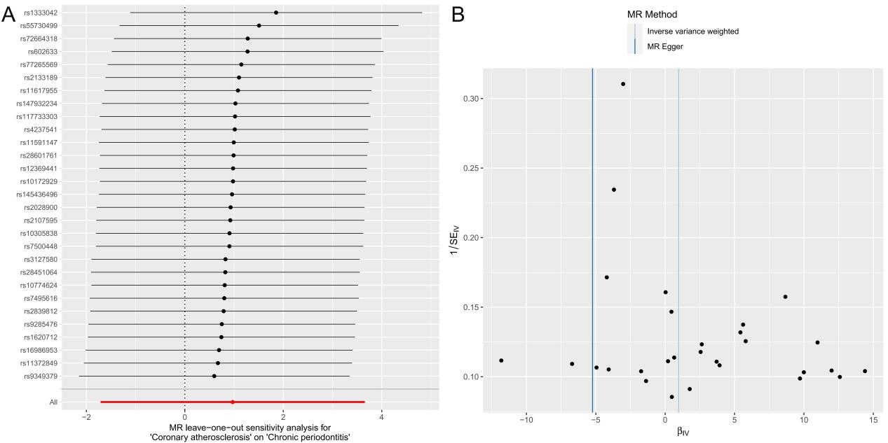
Figure S1. A. MR leave-one-out sensitivity analysis for CAs on chronic periodontitis. B. Funnel plot to visualize overall heterogeneity of Mendelian randomization assessment for the effect of CAs on chronic periodontitis. (MR, Mendelian randomization; SE, standard error; IV, instrument variable)

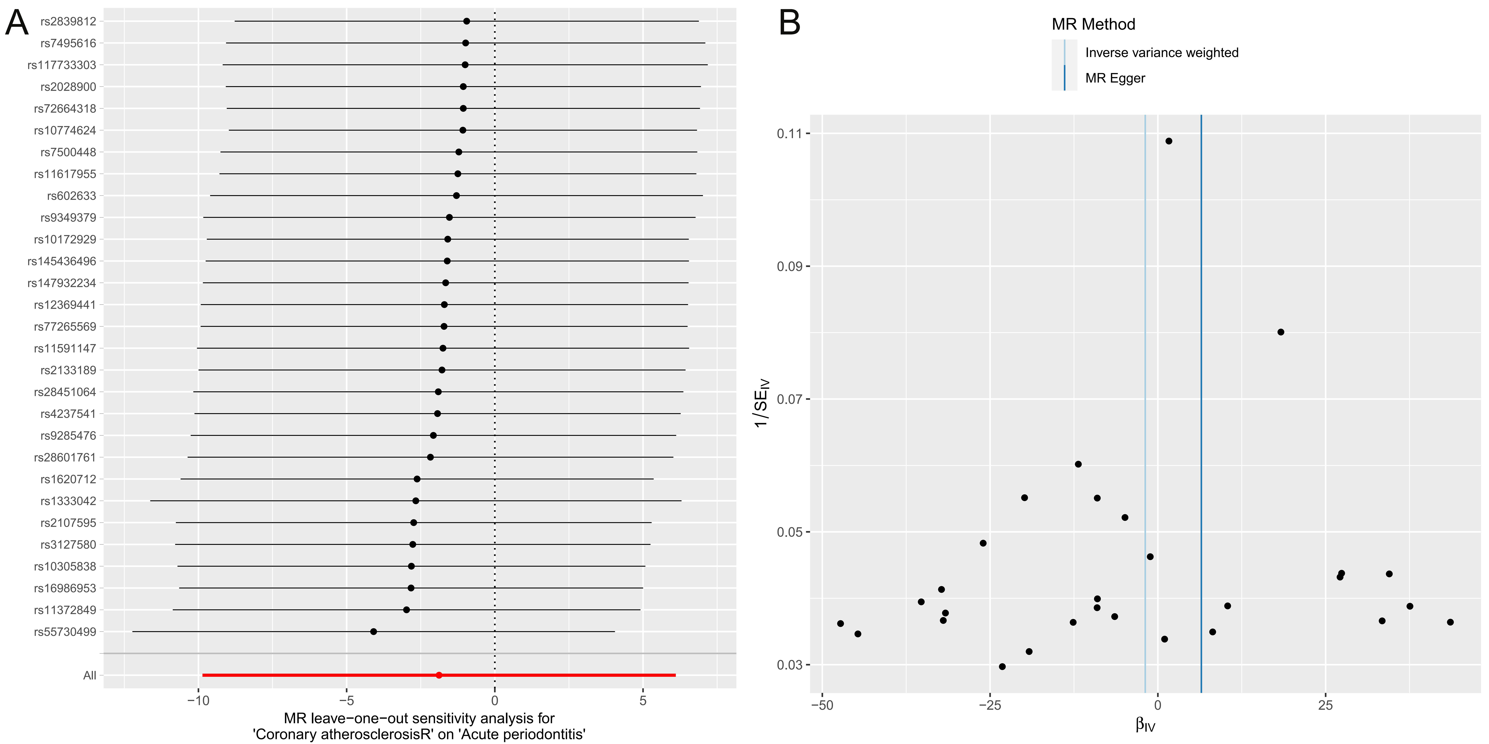
Figure S2. A. MR leave-one-out sensitivity analysis for CAs on acute periodontitis. B. Funnel plot to visualize overall heterogeneity of Mendelian randomization assessment for the effect of CAs on acute periodontitis. (MR, Mendelian randomization; SE, standard error; IV, instrument variable)

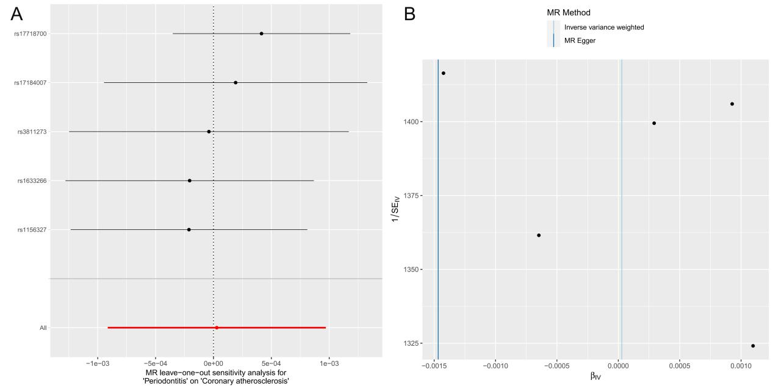
Figure S3. A. MR leave-one-out sensitivity analysis for (chronic and acute) periodontitis on CAs. B. Funnel plot to visualize overall heterogeneity of Mendelian randomization assessment for the effect of (chronic and acute) periodontitis on CAs. (MR, Mendelian randomization; SE, standard error; IV, instrument variable)

