Supplementary Materials for

Non-canonical function of Pannexin1 promotes cellular senescence and renal fibrosis post-acute kidney injury

Liuwei Huang et al.

*Corresponding author. Email: wangjun1975@smu.edu.cn
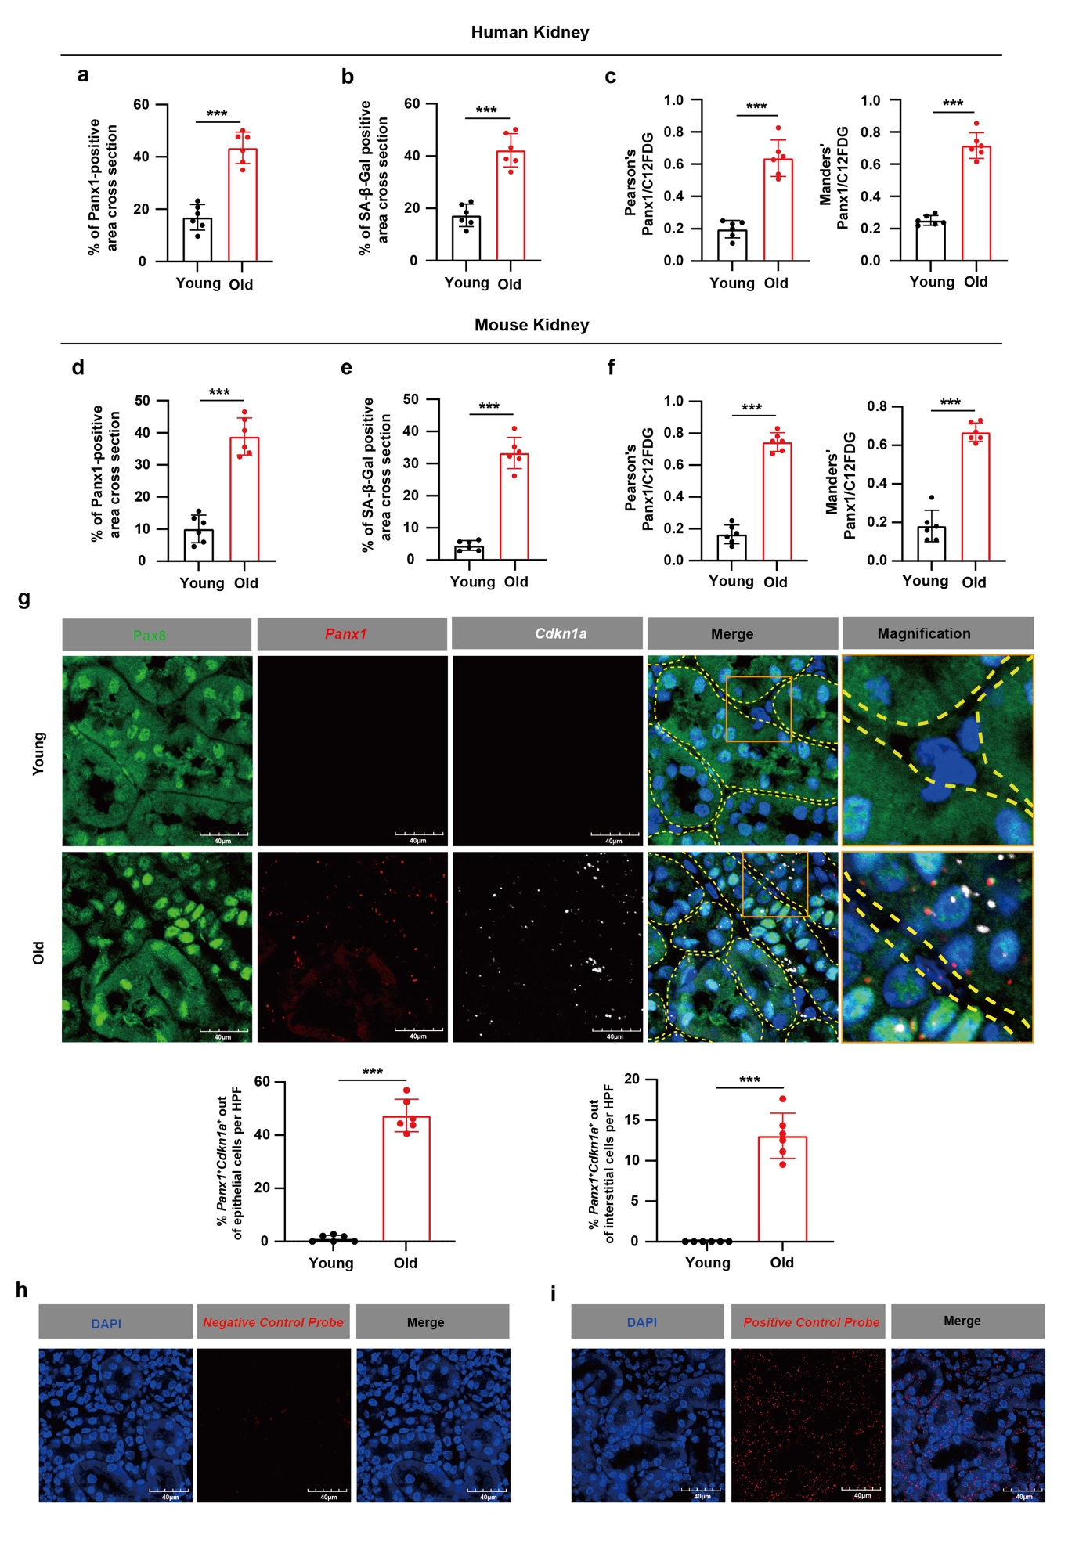
Appendix Figure. S1. Related to Figure.1
a Quantification of Panx1-positive area in human renal tissue.
b Quantification of SA-β-Gal-positive area in human renal tissue.
c Quantification of Panx1and C12FDG colocalization in human renal tissue using Pearson’s correlation coefficient and the Manders’ overlap coefficient.
d Quantification of Panx1-positive area in mouse renal tissue.
e Quantification of SA-β-Gal-positive area in mouse renal tissue.
f Quantification of Panx1and C12FDG colocalization in mouse renal tissue using Pearson’s correlation coefficient and the Manders’ overlap coefficient.
g RNAscope multiplexed in situ hybridization staining of Panx1 and Cdkn1a co-stained with immunofluorescence of Pax8 and DAPI in mouse renal tissue and quantification of Panx1⁺Cdkn1a⁺ cells out of epithelial cells or interstitial cells per high power field (HPF) in renal tissue sections. n = 6 mice per group. Scale bar: 40 μm.
h-i RNAscope positive and negative controls, with DAPI staining shown in blue.
h A probe against DapB was used as the negative control. Scale bar: 40 μm.
i A probe against PPIB was used as the positive control. Scale bar: 40 μm.
Data are expressed as means ± SD. Two group comparisons were conducted using the Student’s t-test. ***P < 0.001.

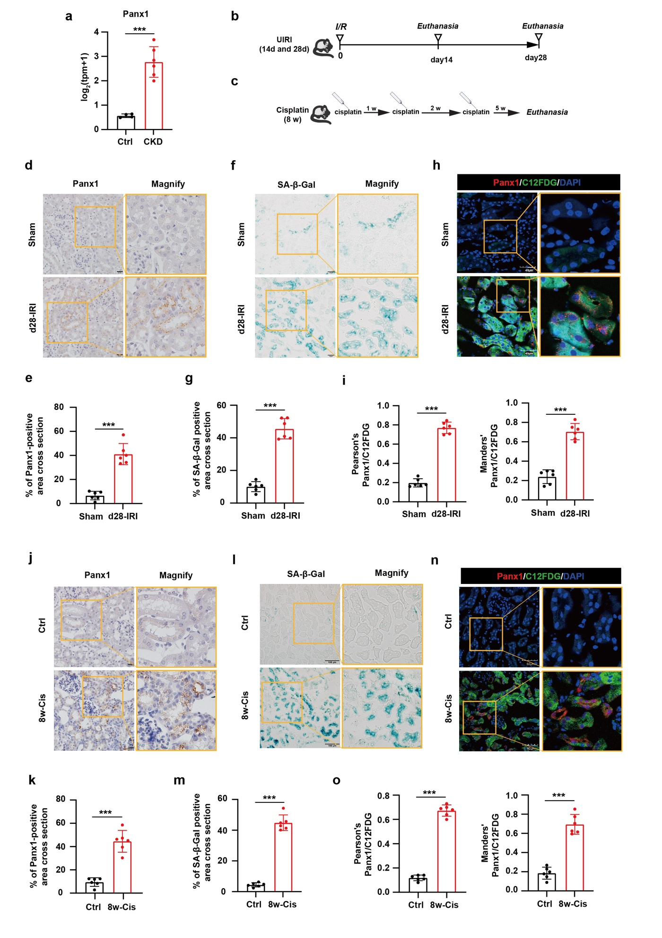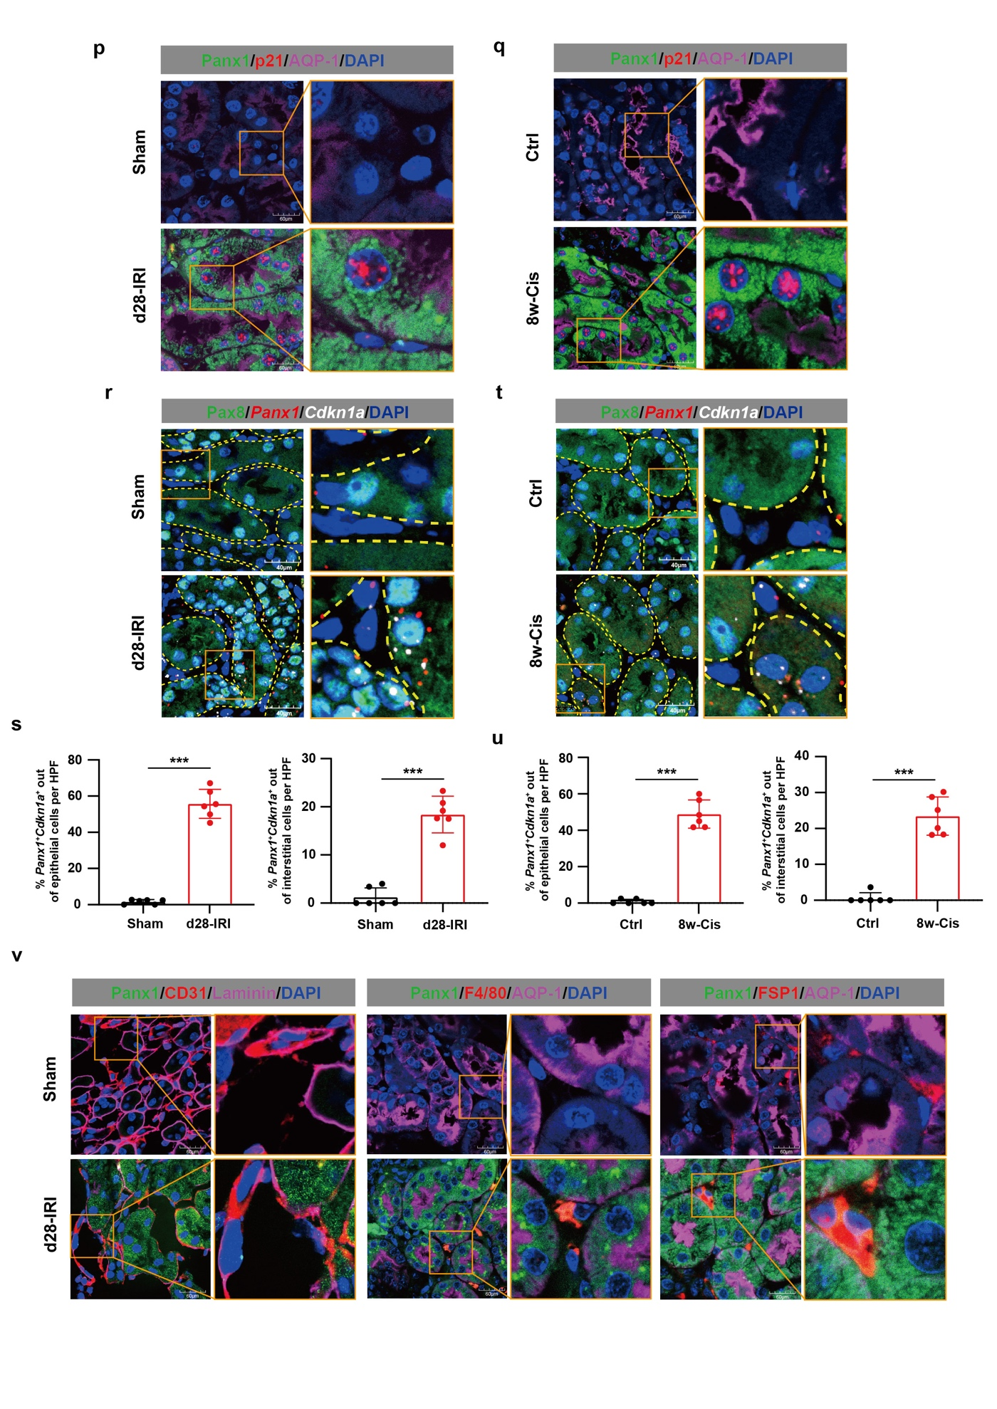
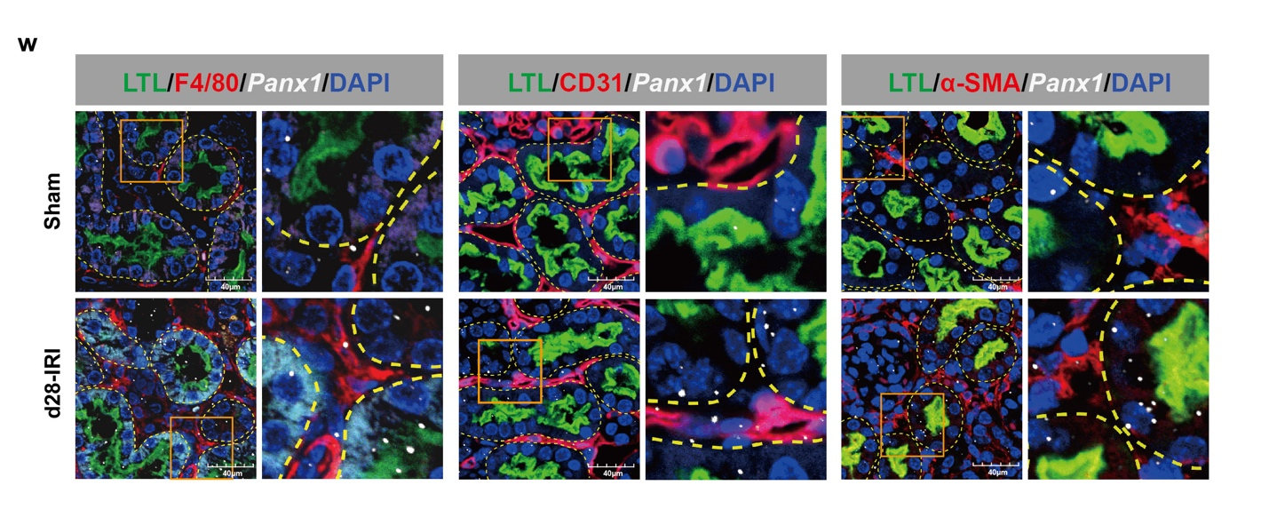
Appendix Figure. S2. Enhanced Panx1 expression in the renal tissues of uIRI and RLDC murine models
a Panx1 expression level in the kidney tissue of mice with control group (uninjured, n = 4) versus RUUO group (35 days following reversible unilateral ureteric obstruction injury, n = 6). RNA-seq data were acquired from GSE157866.
b Experimental design of the unilateral renal ischemia-reperfusion model for inducing AKI-CKD transition in mice.
c Experimental design of the repeated low-dose cisplatin model for inducing AKI-CKD murine transition in mice.
d Representative immunohistochemical staining images showing Panx1 expression in renal tissue. Scale bar: 20 μm.
e Quantification of Panx1-positive areas in renal tissue. n = 6
f Representative images of SA-β-Gal staining in renal tissue. Scale bar: 100 μm.
g Quantification of SA-β-Gal positive-areas in renal tissue. n = 6
h Colocalization of Panx1 and C12FDG in renal tissue. Scale bar: 60 μm.
i Quantification of Panx1and C12FDG colocalization in renal tissue by Pearson’s coefficient and the Manders’ coefficient.
j-o Three doses of cisplatin treatments were given in C57BL/6 mice and mice were euthanized 8 weeks after the first dose of cisplatin.
j Representative immunohistochemical staining images of Panx1 in renal tissue. Scale bar: 20 μm.
k Quantification of Panx1 positive area in renal tissue. n = 6
l Representative staining images of SA-β-Gal in renal tissue. Scale bar: 100 μm.
m Quantification of SA-β-Gal positive area in renal tissue. n = 6
n Colocalization of Panx1 C12FDG in renal tissue. Scale bar: 60 μm.
o Quantification of the colocalization of Panx1with C12FDG using Pearson’s correlation coefficient and the Manders’ overlap coefficient. n = 6.
p Representative immunofluorescence staining of Panx1, p21, and AQP-1, counterstained with DAPI, in renal tissue from a uIRI murine model. Scale bar: 60 μm.
q Representative immunofluorescence staining of Panx1 with p21, and AQP-1, counterstained with DAPI, in renal tissue from a RLDC murine model. Scale bar: 60 μm.
r RNAscope multiplexed in situ hybridization staining of Panx1 and Cdkn1a co-stained with immunofluorescence of Pax8 and DAPI in renal tissue from a uIRI murine model.
s Panx1⁺Cdkn1a⁺ cells out of epithelial cells or interstitial cells per high power field (HPF) in renal tissue sections. n = 6 mice per group. Scale bar: 40 μm.
t RNAscope multiplexed in situ hybridization staining of Panx1 and Cdkn1a co-stained with immunofluorescence of Pax8 and DAPI in renal tissue from a RLDC murine model.
u Panx1⁺Cdkn1a⁺ cells out of epithelial cells or interstitial cells per high power field (HPF) in renal tissue sections. n = 6 mice per group. Scale bar: 40 μm.
v Representative immunofluorescence staining of Panx1 with CD31, F4/80, and FSP1 in renal tissue from a uIRI murine model. Scale bar: 60 μm.
w RNAscope in situ hybridization staining of Panx1 co-stained with immunofluorescence of F4/80, CD31, αSMA, and lotus tetragonolobus lectin (LTL, marker of the proximal tubule) staining in renal tissue from a uIRI murine model. Scale bar: 40 μm.
Data are expressed as means ± SD. Two group comparisons were conducted using the Student’s t-test. ***P < 0.001.
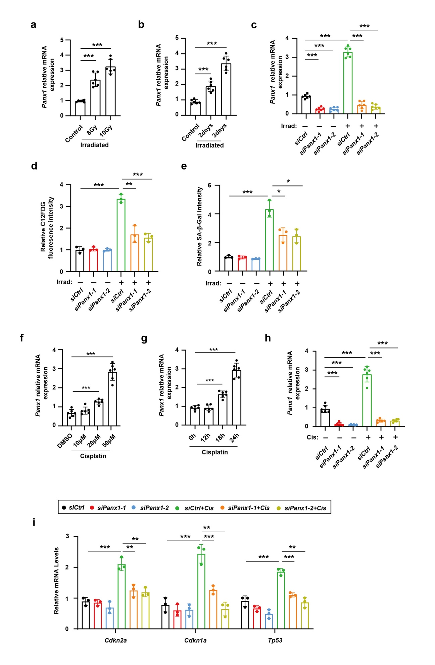
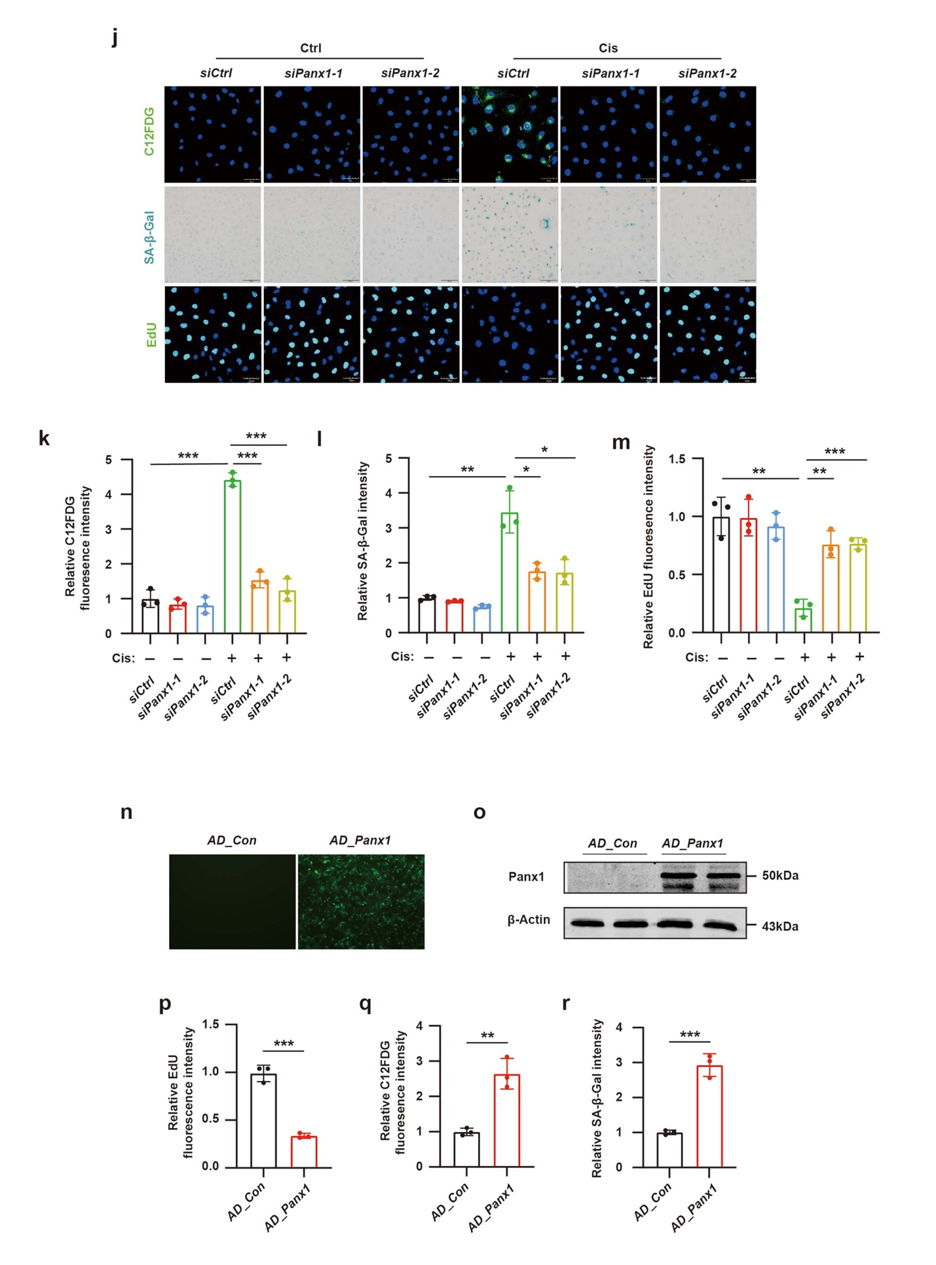
Appendix Figure. S3. Related to Figure. 2
a The qPCR analysis of Panx1 mRNA from HK-2 cells irradiated with 8 Gy or 10 Gy X-rays. Cells were harvested on day 3 after irradiation. n = 6 independent experiments.
b The qPCR analysis of Panx1 mRNA from HK-2 cells irradiated with 8 Gy X-rays. Cells were harvested on day 2 or day 3 after irradiation. n = 6 independent experiments.
c-e HK-2 cells were pretreated with a control empty vector (siCtrl) or two independent Panx1-targeting siRNA (siPanx1-1 and 2) via retroviral vectors, followed by irradiation with 8Gy X-rays. Cells were harvested on day 3 post irradiation.
c Validation of Panx1-knockdown efficiency by qPCR analysis of Panx1 mRNA in HK-2 cells irradiated with 8 Gy X-rays. n = 6 independent experiments.
d Quantification of C12FDG immunofluorescence density in irradiated HK-2 cells treated with Panx1 siRNA. n = 3 independent experiments.
e Quantification of SA-β-Gal staining density in irradiated HK-2 cells treated with Panx1 siRNA. n = 3 independent experiments.
f The qPCR analysis of Panx1 mRNA from HK-2 cells treated with various doses of cisplatin (10, 20, 50μM). Cells were harvested at 24 hours after cisplatin treatment. n = 6 independent experiments.
g The qPCR analysis of Panx1 mRNA from HK-2 cells which were treated with 50μM cisplatin. Cells were harvested at 12, 18, and 24 hours after cisplatin treatment. n = 6 independent experiments.
h Validation of Panx1-knockdown efficiency by qPCR analysis of Panx1 mRNA in HK-2 cells treated with 50 µM cisplatin for 24 hours. n = 6 independent experiments.
i-m HK-2 cells were pretreated with a control empty vector (siCtrl) or two independent Panx1-targeting siRNA (siPanx1-1 and 2) via retroviral vectors, followed by treatment with 50 μM cisplatin for 24 h.
i The qPCR analysis of Cdkn2a, Cdkn1a and Tp53. n = 3 independent experiments.
j Representative staining images of C12FDG, SA-β-Gal and EdU. Scale bar: 50 μm for EdU and C12FDG and Scale bar: 100 μm for SA-β-Gal.
k Quantification of C12FDG immunofluorescence density. n = 3 independent experiments.
l Quantification of SA-β-Gal staining density. n = 3 independent experiments.
m Quantification of EdU staining density. n = 3 independent experiments.
n Evaluation of transfection efficiency in HK-2 cells transfected with Panx1 adenovirus for 48 hours.
o Immunoblot analysis of Panx1 protein level in HK-2 cells transfected with Panx1 adenovirus for 48 hours.
p Quantification of EdU staining density in HK-2 cells transfected with Panx1 adenovirus. n = 3 independent experiments.
q Quantification of C12FDG immunofluorescence density in HK-2 cells transfected with Panx1 adenovirus. n = 3 independent experiments.
r Quantification of SA-β-Gal staining density in HK-2 cells transfected with Panx1 adenovirus. n = 3 independent experiments.
Data are expressed as mean ± SD. Statistical analysis of multiple groups was conducted using one-way ANOVA, and Dunnet’s correction for multiple comparisons. Two group comparisons were conducted using the Student’s t-test. *P < 0.05, **P < 0.01, ***P < 0.001.
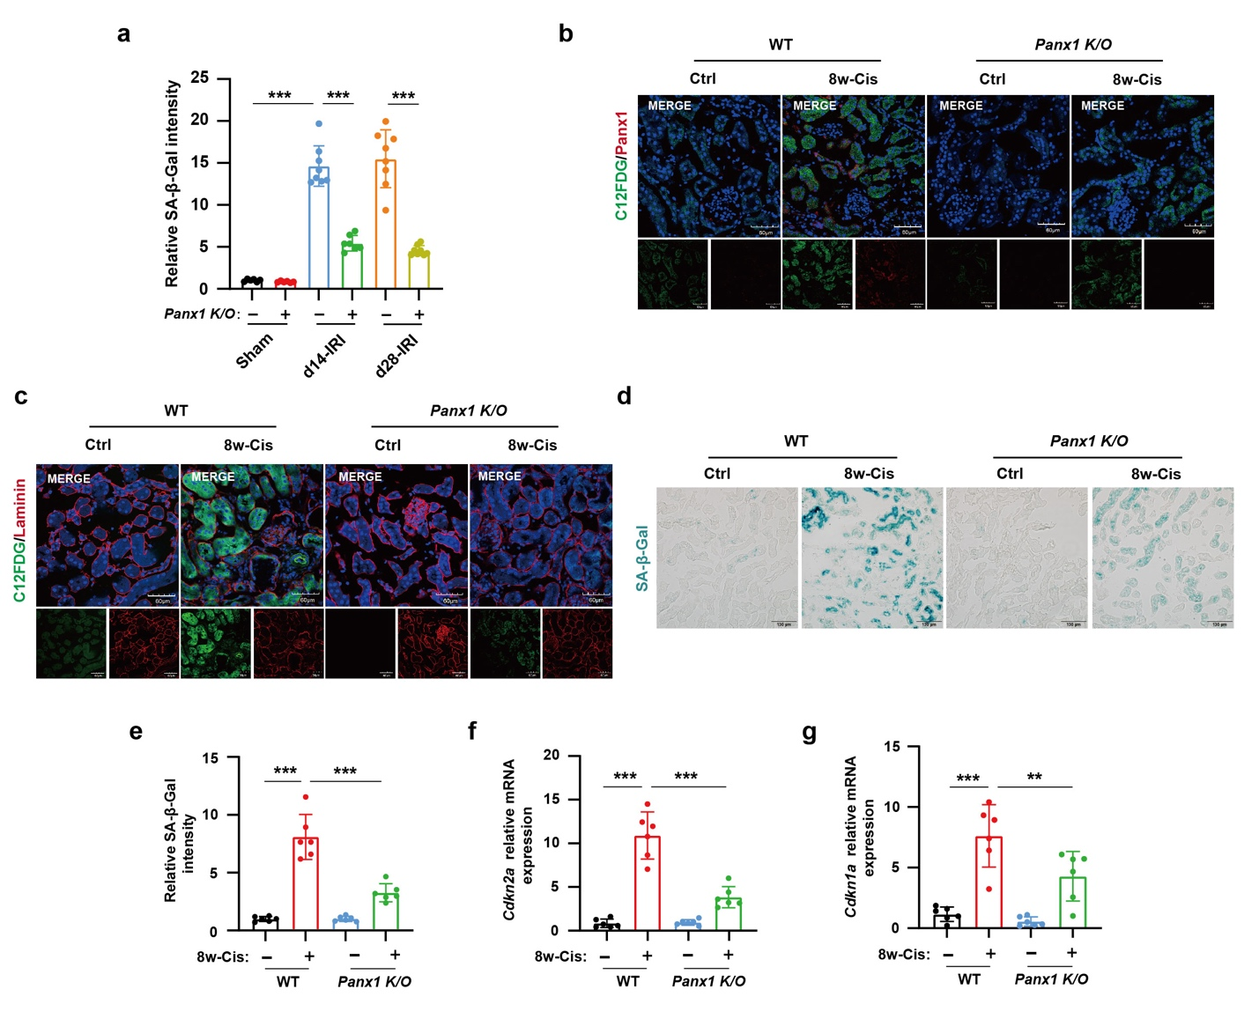
Appendix Figure. S4. Related to Figure 3.
a Quantification of SA-β-Gal staining density in renal tissues of uIRI murine model. n = 6-8 mice per group.
b-g Three doses of cisplatin treatments were given in wild type (WT) or Panx1 knock out (K/O) C57BL/6 mice and mice were euthanized 8 weeks after the first dose of cisplatin.
b Representative immunofluorescent co-staining of C12FDG and Panx1, with DAPI counterstaining in renal tissues. Scale bar: 60 μm.
c Representative immunofluorescent co-staining of C12FDG and Laminin, with DAPI counterstaining in renal tissues. Scale bar: 60 μm.
d Representative staining images of SA-β-gal in renal tissues. Scale bar: 50 μm.
e Quantification of SA-β-Gal staining density in renal tissues. n = 6 mice per group.
f, g The qPCR analysis of Cdkn2a and Cdkn1a in renal tissues. n = 6 mice per group.
Data are expressed as mean ± SD. Statistical analysis of multiple groups was conducted using one-way ANOVA, and Dunnet’s correction for multiple comparisons. *P < 0.05, **P < 0.01, ***P < 0.001.
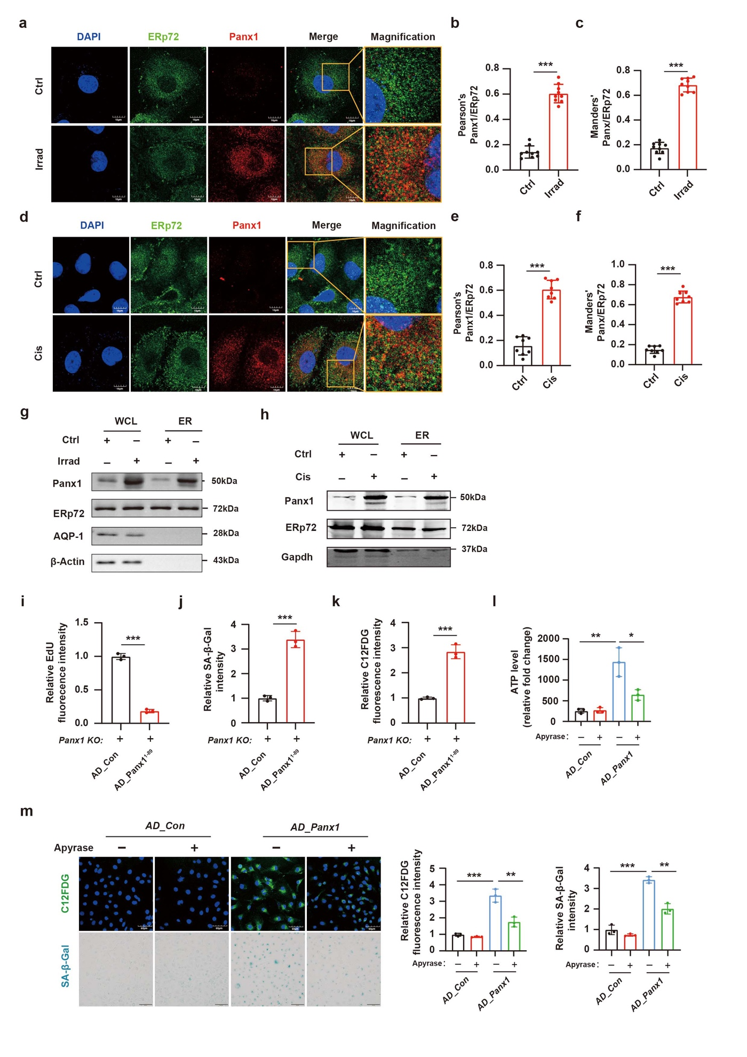
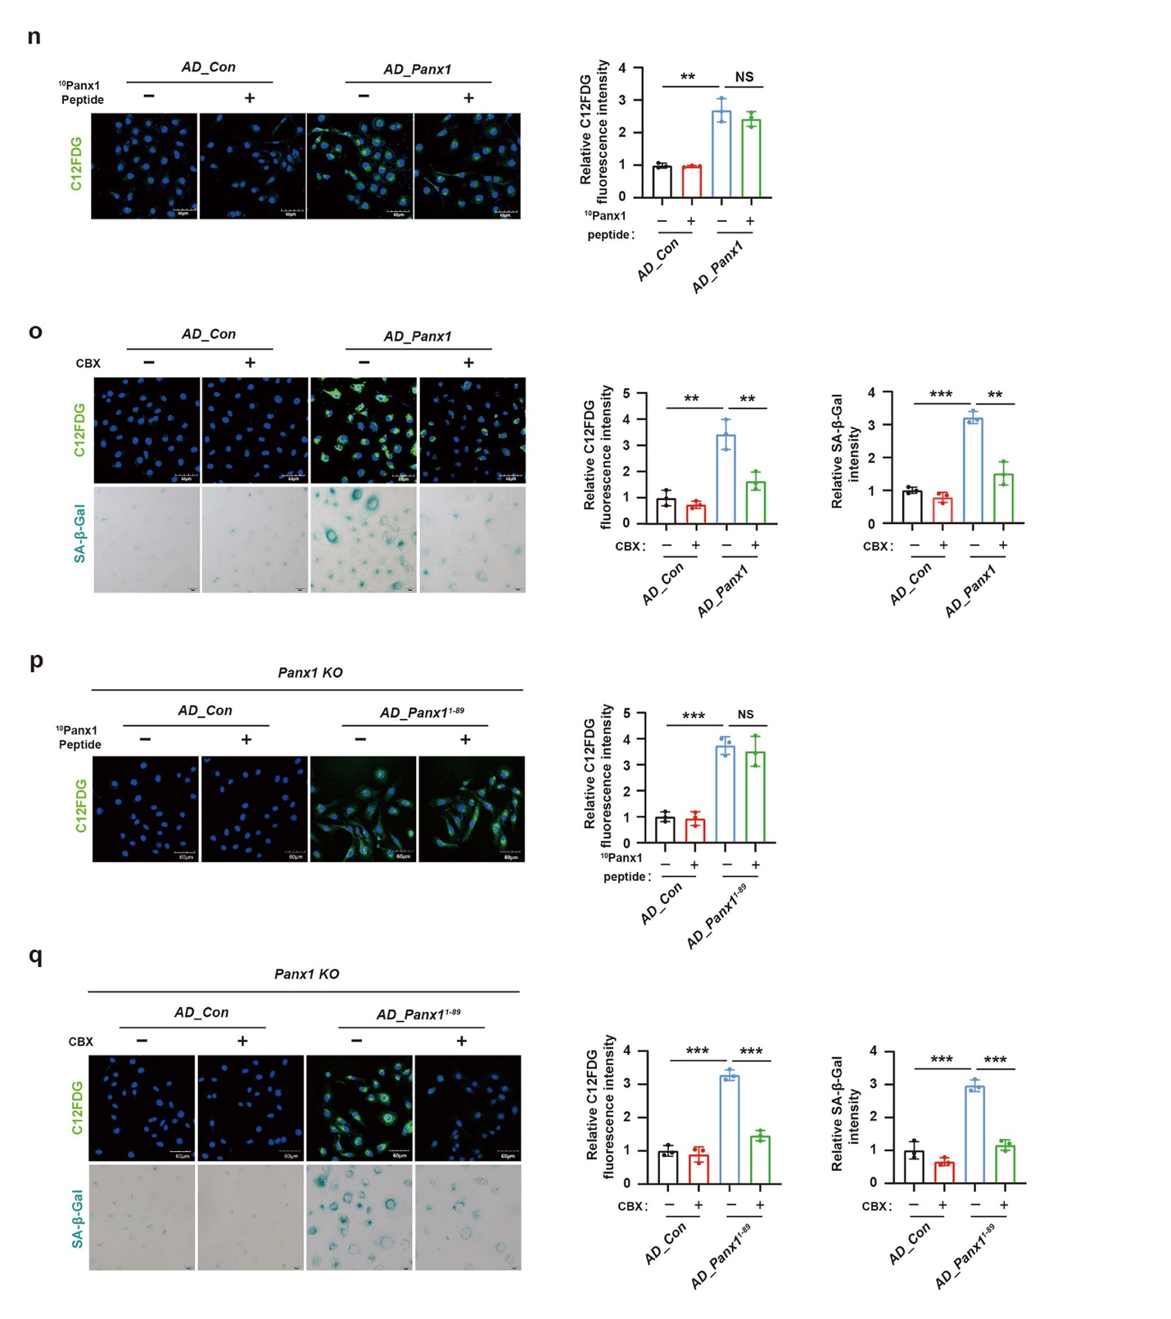

Appendix. Figure S5. Related to Figure 4.
a Representative immunofluorescent co-staining image of Panx1, ERp72, and DAPI in HK-2 cells irradiated with 8 Gy X-rays and harvested on day 3 after irradiation. Scale bar: 20 μm.
b, c Quantification of the Pearson’s coefficient and the Manders’ coefficient to measure the colocalization of Panx1 with ERp72. Control group n = 13 cells; Irradiation group n=17-19 cells.
d Representative immunofluorescent co-staining images of Panx1, ERp72, and DAPI in HK-2 cells treated with 50μM cisplatin and harvested after 24 hours. Scale bar: 20 μm.
e, f Quantification of the Pearson’s coefficient and the Manders’ coefficient to measure the colocalization of Panx1 with ERp72. Control group n = 12 cells; Cisplatin group n = 19 cells.
g Representative immunoblot analysis of Panx1 in whole cell lysates and ER fractions in HK-2 cells treated with irradiation.
h Representative immunoblot analysis of Panx1 in whole cell lysates and ER fractions in HK-2 cells treated with cisplatin.
i-k Panx1 adenovirus (AD_Panx1) or Panx1¹⁻⁸⁹ adenovirus (AD_Panx1¹⁻⁸⁹) was transfected into Panx1 knockout HK-2 cells for 48 hours before harvest.
i Quantification of EdU staining density in HK-2 cells. n = 3 independent experiments.
j Quantification of SA-β-Gal staining density in HK-2 cells. n = 3 independent experiments.
k Quantification of C12FDG staining density in HK-2 cells. n = 3 independent experiments.
l Relative extracellular ATP levels of HK-2 cells pretreated with 20 U/ml Apyrase for 30 mins before being transfected with Panx1 adenovirus for 48 hours.
m Representative staining images of C12FDG and SA-β-Gal and quantification of staining density in HK-2 cells pretreated with apyrase before being transfected with Panx1 adenovirus. Scale bar: 60 μm for C12FDG panels and Scale bar: 100 μm for SA-β-Gal panel. n = 3 independent experiments.
n-q Panx1 adenovirus (AD_Panx1) or Panx1¹⁻⁸⁹ adenovirus (AD_Panx1¹⁻⁸⁹) was transfected into Panx1 knockout HK-2 cells for 48 hours before harvest. Carbenoxolone (CBX) or ¹⁰Panx1 peptide was added to the medium both before and after transfection.
n Representative staining images of C12FDG and quantification of staining density in HK-2 cells treated with ¹⁰Panx1 peptide. Scale bar: 60 μm. n = 3 independent experiments.
o Representative staining images of C12FDG and SA-β-Gal and quantification of staining density in HK-2 cells treated with CBX. Scale bar: 60 μm for C12FDG panels and Scale bar: 100 μm for SA-β-Gal panel. n = 3 independent experiments.
p Representative staining images of C12FDG and quantification of staining density in HK-2 cells treated with ¹⁰Panx1 peptide. Scale bar: 60 μm. n = 3 independent experiments.
q Representative staining images of C12FDG and SA-β-Gal and quantification of staining density in HK2 cells treated with CBX. Scale bar: 60 μm for C12FDG panels and Scale bar: 100 μm for SA-β-Gal panel. n = 3 independent experiments.
Data are expressed as mean ± SD. Statistical analysis of multiple groups was conducted using one-way ANOVA, and Dunnet’s correction for multiple comparisons. Two group comparisons were conducted using the Student’s t-test. *P < 0.05, **P < 0.01, ***P < 0.001.

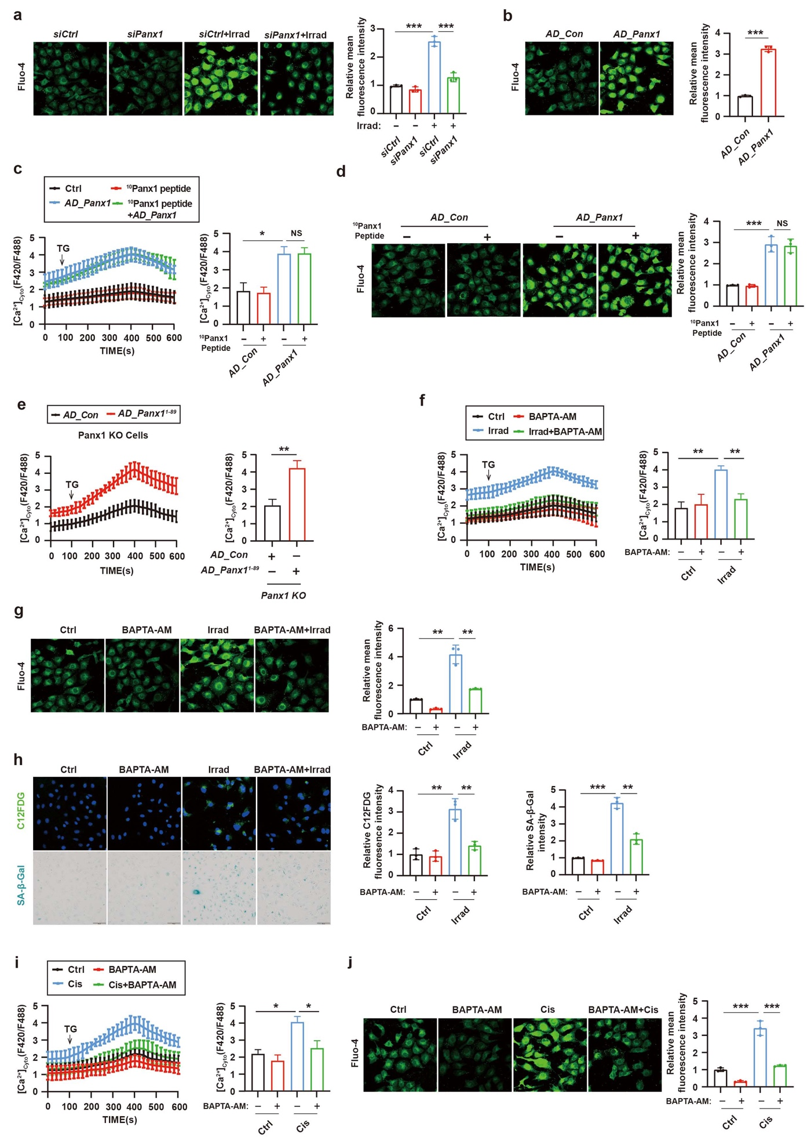
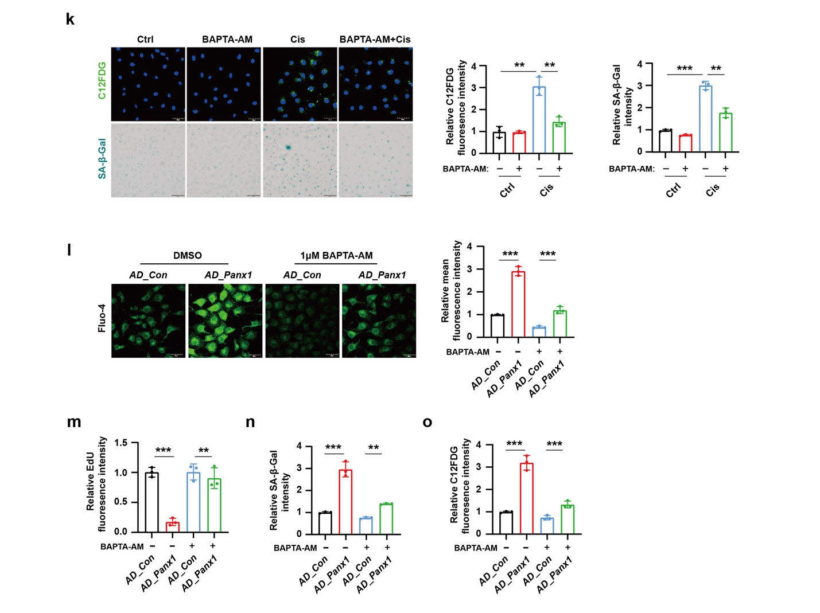
Appendix. Figure S6. Related to Figure 5.
a Representative immunofluorescent image of cytosolic Ca²⁺ in HK-2 cells and quantification of immunofluorescent density showed that Panx1 knockdown could reverse the irradiation-induced increase of intracellular Ca²⁺. n = 3 independent experiments. Scale bar: 50 μm.
b Representative immunofluorescent images of cytosolic Ca²⁺ in HK-2 cells and quantification of immunofluorescent density showed that Panx1 adenovirus transfection could increase the intracellular Ca²⁺. n = 3 independent experiments. Scale bar: 50 μm.
c,d ¹⁰Panx1 peptide was added to the culture medium of HK-2 cells following transfection with Panx1 adenovirus.
c Representative traces of the changes in cytosolic [Ca²⁺] and the maximum peak of cytosolic [Ca²⁺] (n = 3 independent experiments; total cells analyzed: AD_Con, n = 178 cells; ¹⁰Panx1 peptide, n = 177 cells; AD_Panx1, n = 150 cells; ¹⁰Panx1 peptide+AD_Panx1, n = 165 cells).
d Representative images of cytosolic Ca²⁺ in HK-2 cells and quantification of immunofluorescence density. n = 3 independent experiments. Scale bar: 50 μm.
e Control adenovirus (AD_Con) or Panx1¹⁻⁸⁹ adenovius (AD_Panx1¹⁻⁸⁹) was transfected into Panx1 knockout HK-2 cells for 48 hours before harvest. Representative traces of the changes in cytosolic [Ca²⁺] and the maximum peak of cytosolic [Ca²⁺] (n = 3 independent experiments; total cells analyzed: AD_Con, n = 141 cells; AD_Panx1¹⁻⁸⁹, n = 123 cells).
f-h HK-2 cells were pre-treated with 1 μM BAPTA-AM and then treated with 8 Gy X-rays. Cells were harvested at 3 days after irradiation.
f Representative traces of the changes in cytosolic [Ca²⁺] and the maximum peak of cytosolic [Ca²⁺] (n = 3 independent experiments; total cells analyzed: Control, n = 54 cells; BAPTA-AM, n = 48 cells; Irradiation, n = 50 cells; BAPTA-AM+Irradiation, n = 56 cells).
g Representative immunofluorescent images of cytosolic Ca²⁺ in HK-2 cells and quantification of immunofluorescence density. n = 3 independent experiments. Scale bar: 50 μm.
h Representative staining images of C12FDG and SA-β-Gal and quantitative analysis. n = 3 independent experiments. Scale bar: 60 μm for C12FDG and Scale bar: 100 μm for SA-β-Gal.
i-k HK-2 cells were pre-treated with 1 μM BAPTA-AM and then treated with 50μM cisplatin for 24 hours.
i Representative traces of the changes in cytosolic [Ca²⁺] and the maximum peak of cytosolic [Ca²⁺] (n = 3 independent experiments; total cells analyzed: Ctrl, n = 173 cells; BAPTA-AM, n = 163 cells; Cis, n = 120 cells; BAPTA-AM + Cis, n = 130 cells).
j Representative immunofluorescent images of cytosolic Ca²⁺ in HK-2 cells and quantification of immunofluorescence analysis. n = 3 independent experiments. Scale bar: 50 μm.
k Representative staining images of C12FDG and SA-β-Gal and quantitative analysis. n = 3 independent experiments. Scale bar: 60 μm for C12FDG and Scale bar: 100 μm for SA-β-Gal.
l-o HK-2 cells were pretreated with 1 μM BAPTA-AM and then transfected with Panx1 adenovirus or empty control virus.
l Representative immunofluorescent images of cytosolic Ca²⁺ in HK-2 cells and quantification of immunofluorescence density. n = 3 independent experiments. Scale bar: 50 μm.
m Quantitative analysis of EdU staining in Fig 5d. n = 3 independent experiments.
n, o Quantitative analysis of SA-β-Gal and C12FDG staining in Fig 5e. n = 3 independent experiments.
Data are expressed as mean ± SD. Statistical analysis of multiple groups was conducted using one-way ANOVA, and Dunnet’s correction for multiple comparisons. Two group comparisons were conducted using the Student’s t-test. *P < 0.05, **P < 0.01, ***P < 0.001, NS: not significant.
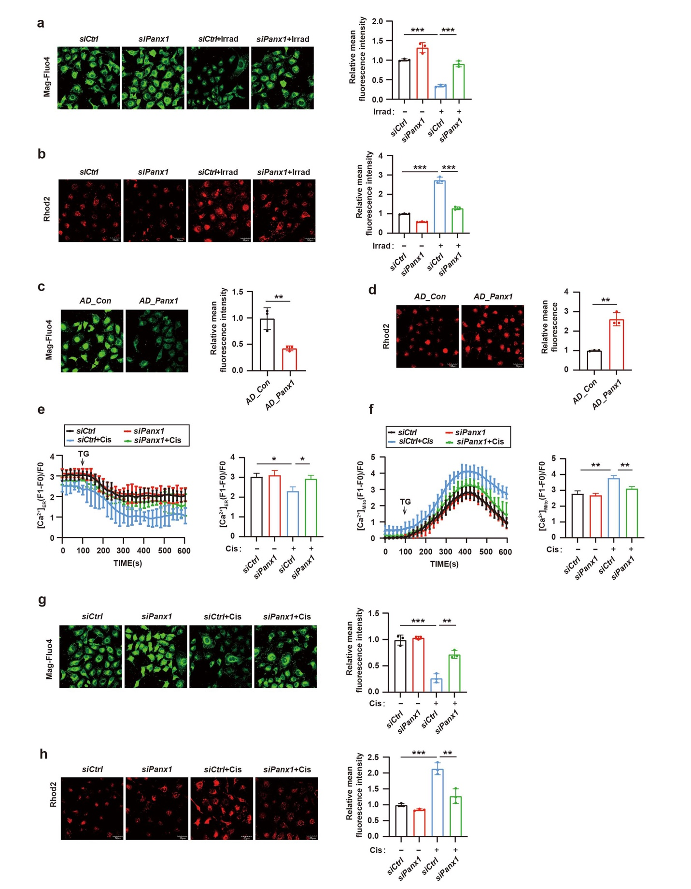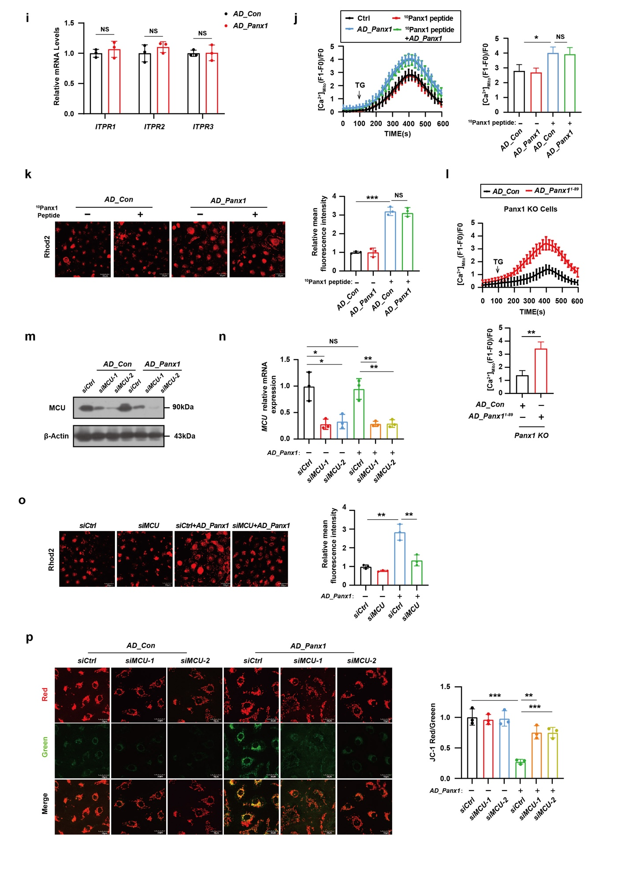

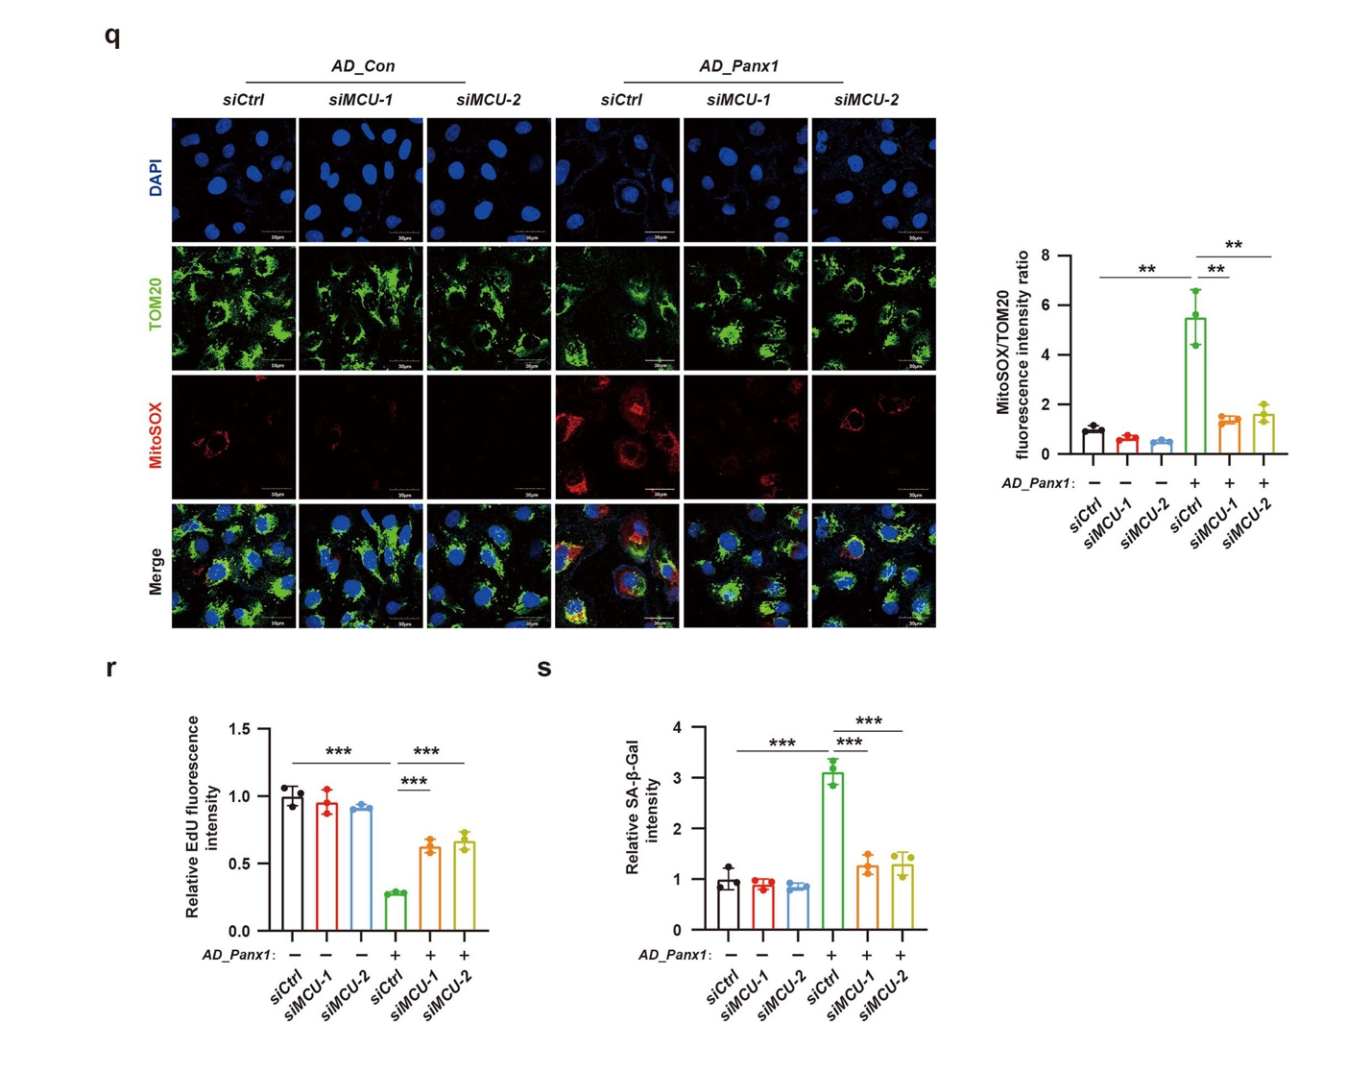
Appendix. Figure S7. Related to Figure 6.

a,b HK-2 cells were pretreated with a control empty vector (siCtrl) or two independent Panx1-targeting siRNA (siPanx1-1 and 2) via retroviral vectors, followed by irradiation with 8Gy X-rays. Cells were harvested on day 3 post irradiation.
a Representative immunofluorescent image of ER Ca²⁺ and quantification of immunofluorescence density. n = 3 independent experiments. Scale bar: 50 μm.
b Representative immunofluorescent image of mitochondria Ca²⁺ and quantification of immune fluorescence density. n = 3 independent experiments. Scale bar: 50 μm.
c Representative immunofluorescent image of ER Ca²⁺ and quantification of immune florescence density in HK-2 cells transfected with Panx1 adenovirus. n = 3 independent experiments. Scale bar: 50 μm.
d Representative immunofluorescent image of mitochondria Ca²⁺ and quantification of immune fluorescence density in HK-2 cells transfected with Panx1 adenovirus. n = 3 independent experiments. Scale bar: 50 μm.
e-h HK-2 cells were pretreated with a control empty vector (siCtrl) or two independent Panx1-targeting siRNA (siPanx1-1 and 2) via retroviral vectors, followed by treatment with 50 μM cisplatin for 24 h.
e Representative traces of the changes in ER [Ca²⁺] and the maximum peak of ER [Ca²⁺] (n = 3 independent experiments; total cells analyzed: siCtrl, n = 60 cells; siPanx1, n = 58 cells; siCtrl + Cis, n = 46 cells; siPanx1 + Cis, n = 48 cells).
f Representative traces of the changes in mitochondria [Ca²⁺] and the maximum peak of mitochondria [Ca²⁺] (n = 3 independent experiments; total cells analyzed: siCtrl, n = 50 cells; siPanx1, n = 48 cells; siCtrl + Cis, n = 44 cells; siPanx1 + Cis, n = 40 cells).
g Representative images of ER Ca²⁺ and quantification of immunofluorescence density. n = 3 independent experiments. Scale bar: 50 μm.
h Representative images of mitochondrial Ca²⁺ and quantification of immunofluorescence density. n = 3 independent experiments. Scale bar: 50 μm.
i The qPCR analysis of ITPR1, ITPR2 and ITPR3 in HK-2 cells transfected with Panx1 adenovirus. n = 3 independent experiments.
j,k Panx1 adenovirus (AD_Panx1) was transfected into Panx1 knockout HK-2 cells for 48 hours before harvest. ¹⁰Panx1 peptide was added into the medium after transfection.
j Representative traces of the changes in mitochondria [Ca²⁺] and the maximum peak of mitochondria [Ca²⁺] (n = 3 independent experiments; total cells analyzed: AD_Con, n = 80 cells; ¹⁰Panx1 peptide, n = 76 cells; AD_Panx1, n = 70 cells; ¹⁰Panx1 peptide + AD_Panx1, n = 78 cells).
k Representative images of mitochondrial Ca²⁺ and quantification of immunofluorescence density. n = 3 independent experiments. Scale bar: 50 μm.
l Control adenovirus (AD_Con) or Panx1¹⁻⁸⁹ adenovius (AD_Panx1¹⁻⁸⁹) was transfected into Panx1 knockout HK-2 cells for 48 hours before harvest. Representative traces of the changes in mitochondria [Ca²⁺] and the maximum peak of mitochondria [Ca²⁺] (n = 3 independent experiments; total cells analyzed: AD_Con, n = 161 cells; AD_Panx1¹⁻⁸⁹, n = 144 cells).
m-s HK-2 cells were pretreated with a control empty vector (siCtrl) or two independent MCU-targeting siRNA (siMCU-1 and 2) via retroviral vectors, followed by transfection with Panx1 adenovirus.
m Immunoblot analysis of MCU protein level in HK-2 cells.
n Validation of MCU-knockdown efficiency by qPCR analysis of MCU mRNA in HK-2 cells. n = 3 independent experiments.
o Representative images of mitochondrial Ca²⁺ and quantification of immunofluorescence density. n = 3 independent experiments. Scale bar: 50 μm.
p Representative immunofluorescence staining images of JC-1 and quantification of immunofluorescence analysis. n = 3 independent experiments. Scale bar: 30 μm.
q Representative immunofluorescence staining images of MitoSOX and TOM20 in HK-2 cells, and quantitative analysis of MitoSOX fluorescence intensity. n = 3 independent experiments. Scale bar: 30 μm.
r Quantification of EdU staining density in HK-2 cells in Fig 6f. n = 3 independent experiments.
s Quantification of SA-β-Gal staining density in HK-2 cells in Fig 6f. n = 3 independent experiments.
Data are expressed as mean ± SD. Statistical analysis of multiple groups was conducted using one-way ANOVA, and Dunnet’s correction for multiple comparisons. Two group comparisons were conducted using the Student’s t-test. *P < 0.05, **P < 0.01, ***P < 0.001, NS: not significant.

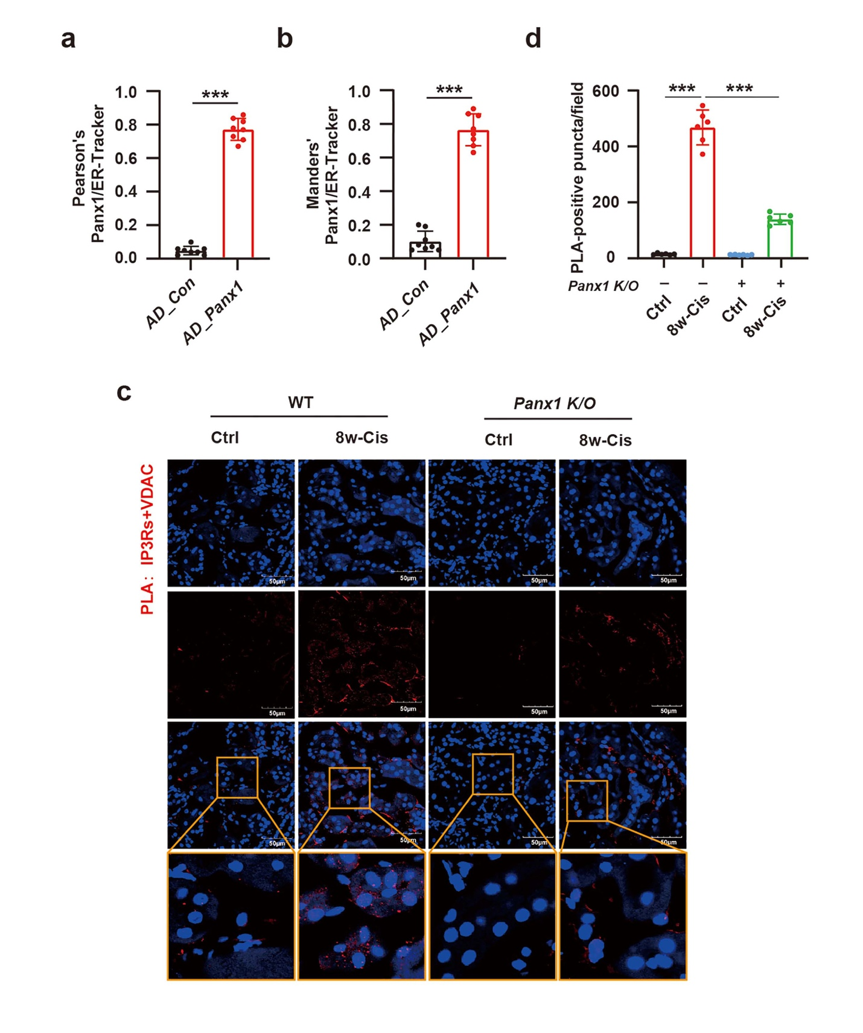
Appendix Figure. S8. Supplemental figure related to Figure 7.
a, b Co-localization between Panx1 and ER markers were calculated using Pearson’s coefficient and Manders’ coefficient (AD_Con, n = 11 cells; AD_Panx1 48h, n = 13 cells).
c Three doses of cisplatin treatments were given in wild type (WT) or Panx1 knock out (K/O) C57BL/6 mice and mice were euthanized 8 weeks after the first dose of cisplatin. In situ proximity ligation assay (PLA) was performed to visualize the proximity between IP3Rs (ER membrane protein) and VDAC (mitochondria outer membrane protein) in the kidneys of mice. Representative immunofluorescent co-staining images of PLA (red) and DAPI (blue) in the kidney. Scale bar: 30 μm.
d Quantification of PLA-positive dots per mice. n = 6 mice per group.
Data are expressed as mean ± SD. Statistical analysis of multiple groups was conducted using one-way ANOVA, and Dunnet’s correction for multiple comparisons. Two group comparisons were tested using the Student’s t-test. *P < 0.05, **P < 0.01, ***P < 0.001.

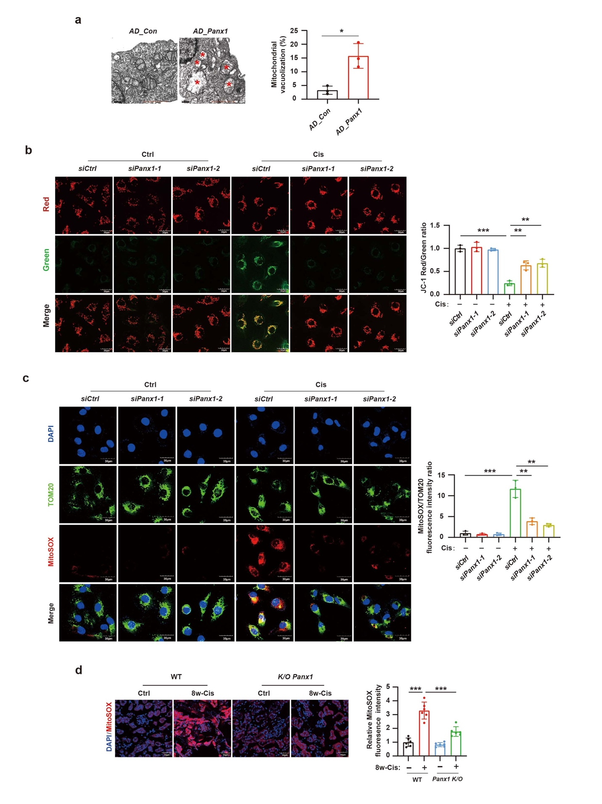
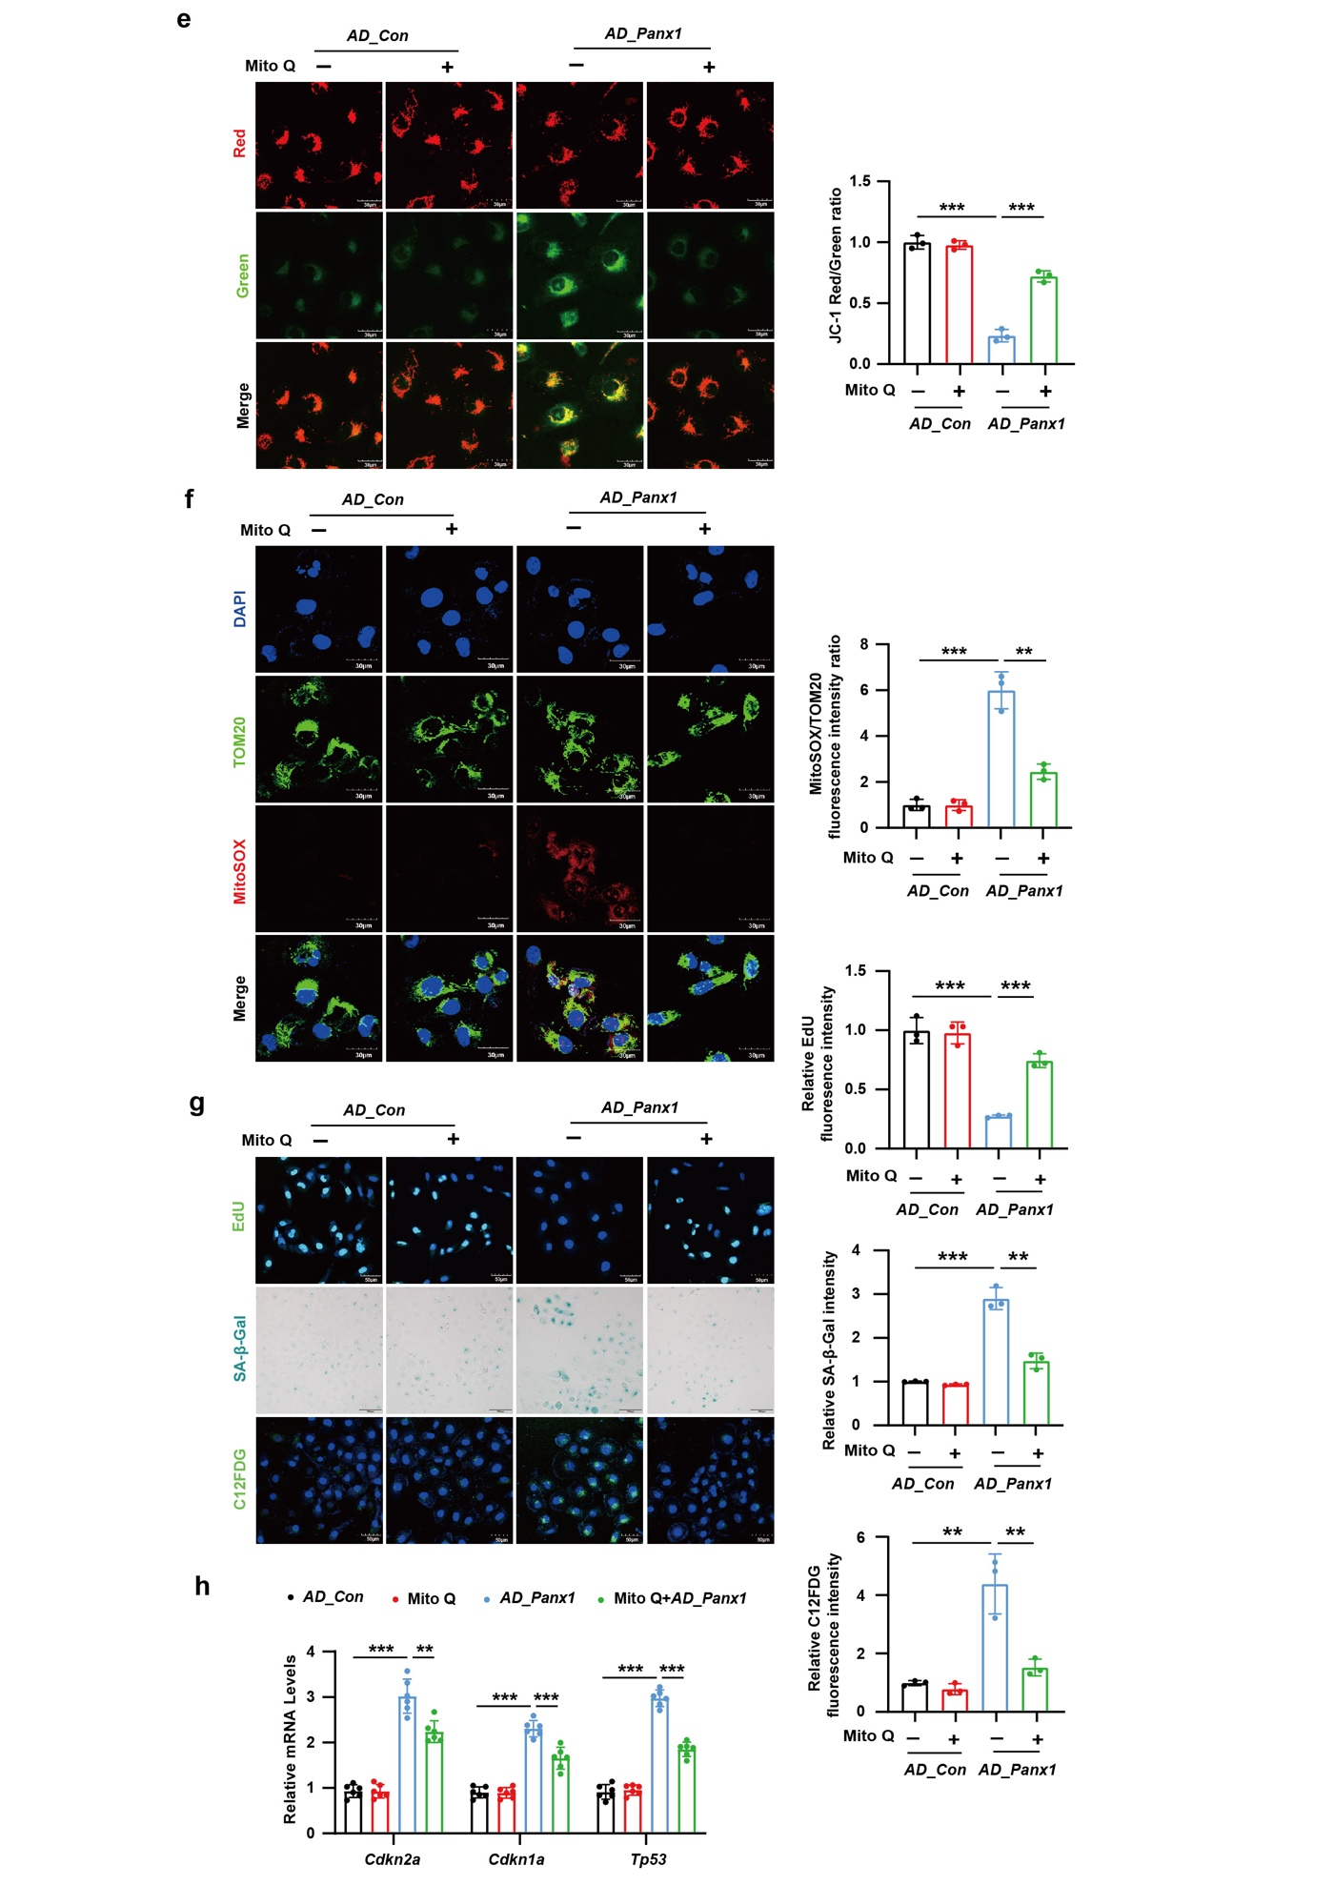
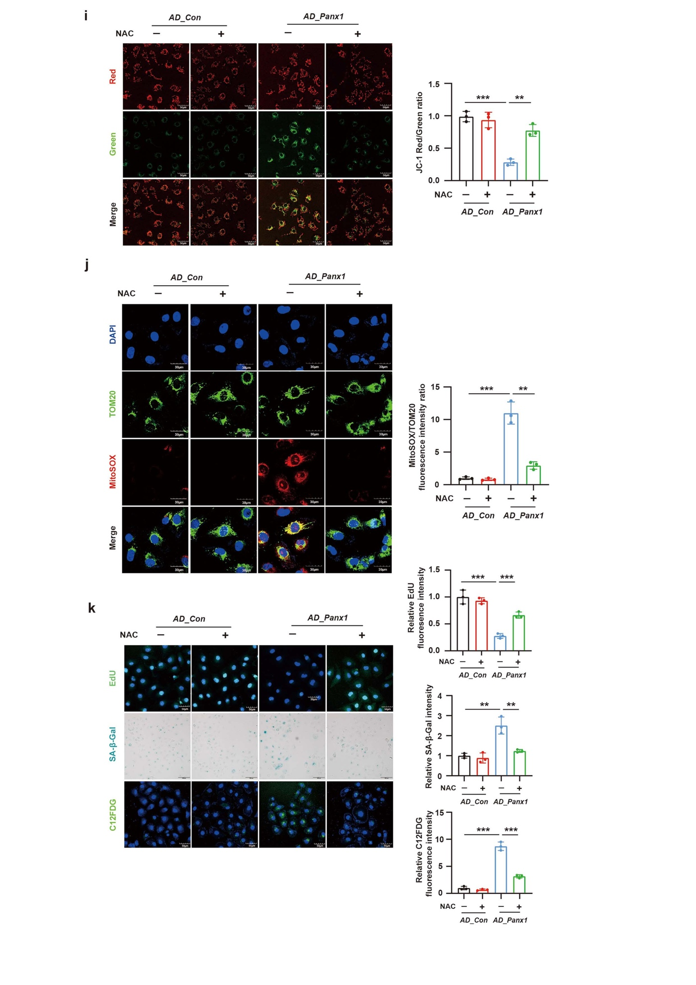
Appendix Figure. S9. Related to Figure 8.
a Representative TEM images and quantified analysis of vacuolated mitochondria in HK-2 cells transfected with Panx1 adenovirus. n = 20-30 mitochondria in 3 fields per group. Scale bar: 0.5 μm.
b,c HK-2 cells were pretreated with a control empty vector (siCtrl) or two independent Panx1-targeting siRNA (siPanx1-1 and 2) via retroviral vectors, followed by treatment with 50 μM cisplatin for 24 h.
b Representative immunofluorescence staining images of JC-1 and quantification of immunofluorescence analysis showed that Panx1 knockdown could improve mitochondrial membrane potential in HK-2 cells stimulated with cisplatin. n = 3 independent experiments. Scale bar: 30 μm.
c Representative immunofluorescence staining images of MitoSOX and TOM20 in HK-2 cells, and quantitative analysis of MitoSOX fluorescence intensity. These data demonstrated that Panx1 knockdown could decrease mitochondrial ROS generation in HK-2 cells stimulated with cisplatin. n = 3 independent experiments. Scale bar: 50 μm.
d Representative immunofluorescent staining images of MitoSOX in renal tissue from mice treated with cisplatin, accompanied by quantitative analysis of fluorescence intensity. n = 3 independent experiments. Scale bar: 50 μm.
e-h Panx1 adenovirus was transfected into HK-2 cells for 48 hours. MitoQ was added to the medium both before and after transfection.
e Representative immunofluorescence staining images of JC-1 in HK-2 cells and quantification of immunofluorescence analysis. n = 3 independent experiments. Scale bar: 30 μm.
f Representative immunofluorescence staining images of MitoSOX and TOM20 in HK-2 cells and quantitative analysis of MitoSOX fluorescence intensity. n = 3 independent experiments. Scale bar: 50 μm.
g Representative staining images of EdU, SA-β-Gal, and C12FDG in HK-2 cells and quantitative analysis of staining intensities. n = 3 independent experiments. Scale bar: 50 μm for EdU and C12FDG panels and Scale bar: 100 μm for SA-β-Gal panel.
h Representative mRNA levels of Cdkn2a, Cdkn1a, and Tp53 in HK-2 cells. n = 6 independent experiments.
i-k Panx1 adenovirus was transfected into HK-2 cells for 48 hours. NAC was added to the medium both before and after transfection.
i Representative immunofluorescence staining images of JC-1 in HK-2 cells and quantitative analysis of staining intensities. n = 3 independent experiments. Scale bar: 30 μm.
j Representative immunofluorescence staining images of MitoSOX and TOM20 in HK-2 cells and quantitative analysis of MitoSOX fluorescence intensity. n = 3 independent experiments. Scale bar: 50 μm.
k Representative staining images of EdU, SA-β-Gal, C12FDG in HK-2 cells and quantitative analysis of staining intensities. n = 3 independent experiments. Scale bar: 50 μm for EdU and C12FDG and Scale bar: 100 μm for SA-β-Gal.
Data are expressed as mean ± SD. Statistical analysis of multiple groups was conducted using one-way ANOVA, and Dunnet’s correction for multiple comparisons. Two group comparisons were tested using the Student’s t-test. *P < 0.05, **P < 0.01, ***P < 0.001.

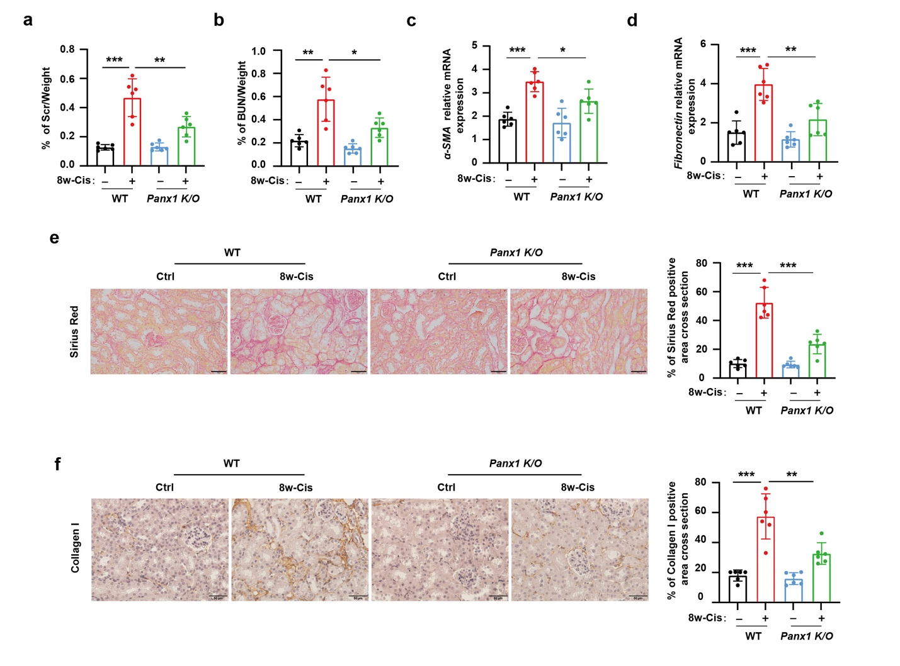
Appendix Figure. S10. Related to Figure 9.
Three doses of cisplatin treatments were given in wild type (WT) or Panx1 knock out (K/O) C57BL/6 mice and mice were euthanized 8 weeks after the first dose of cisplatin.
a Serum creatinine (Cr) level compared between WT group and Panx1 K/O group.
b Serum BUN level compared between WT group and Panx1 K/O group.
c, d Relative mRNA levels of αSMA and Fibronectin in the renal tissue showed that deletion of Panx1 decreased the upregulated renal fibrosis markers induced by cisplatin.
e, f Representative staining images of Sirius Red and Collagen I and quantification data showed the anti-fibrotic effects of Panx1 deletion in multiple cisplatin treatment murine model. Scale bar for Sirius Red: 50 μm, Scale bar for Collagen I: 20 μm
n = 6 mice per group. Data are expressed as mean ± SD. Statistical analysis of multiple groups was conducted using one-way ANOVA, and Dunnet’s correction for multiple comparisons. *P < 0.05, **P < 0.01, ***P < 0.001, NS: not significant.

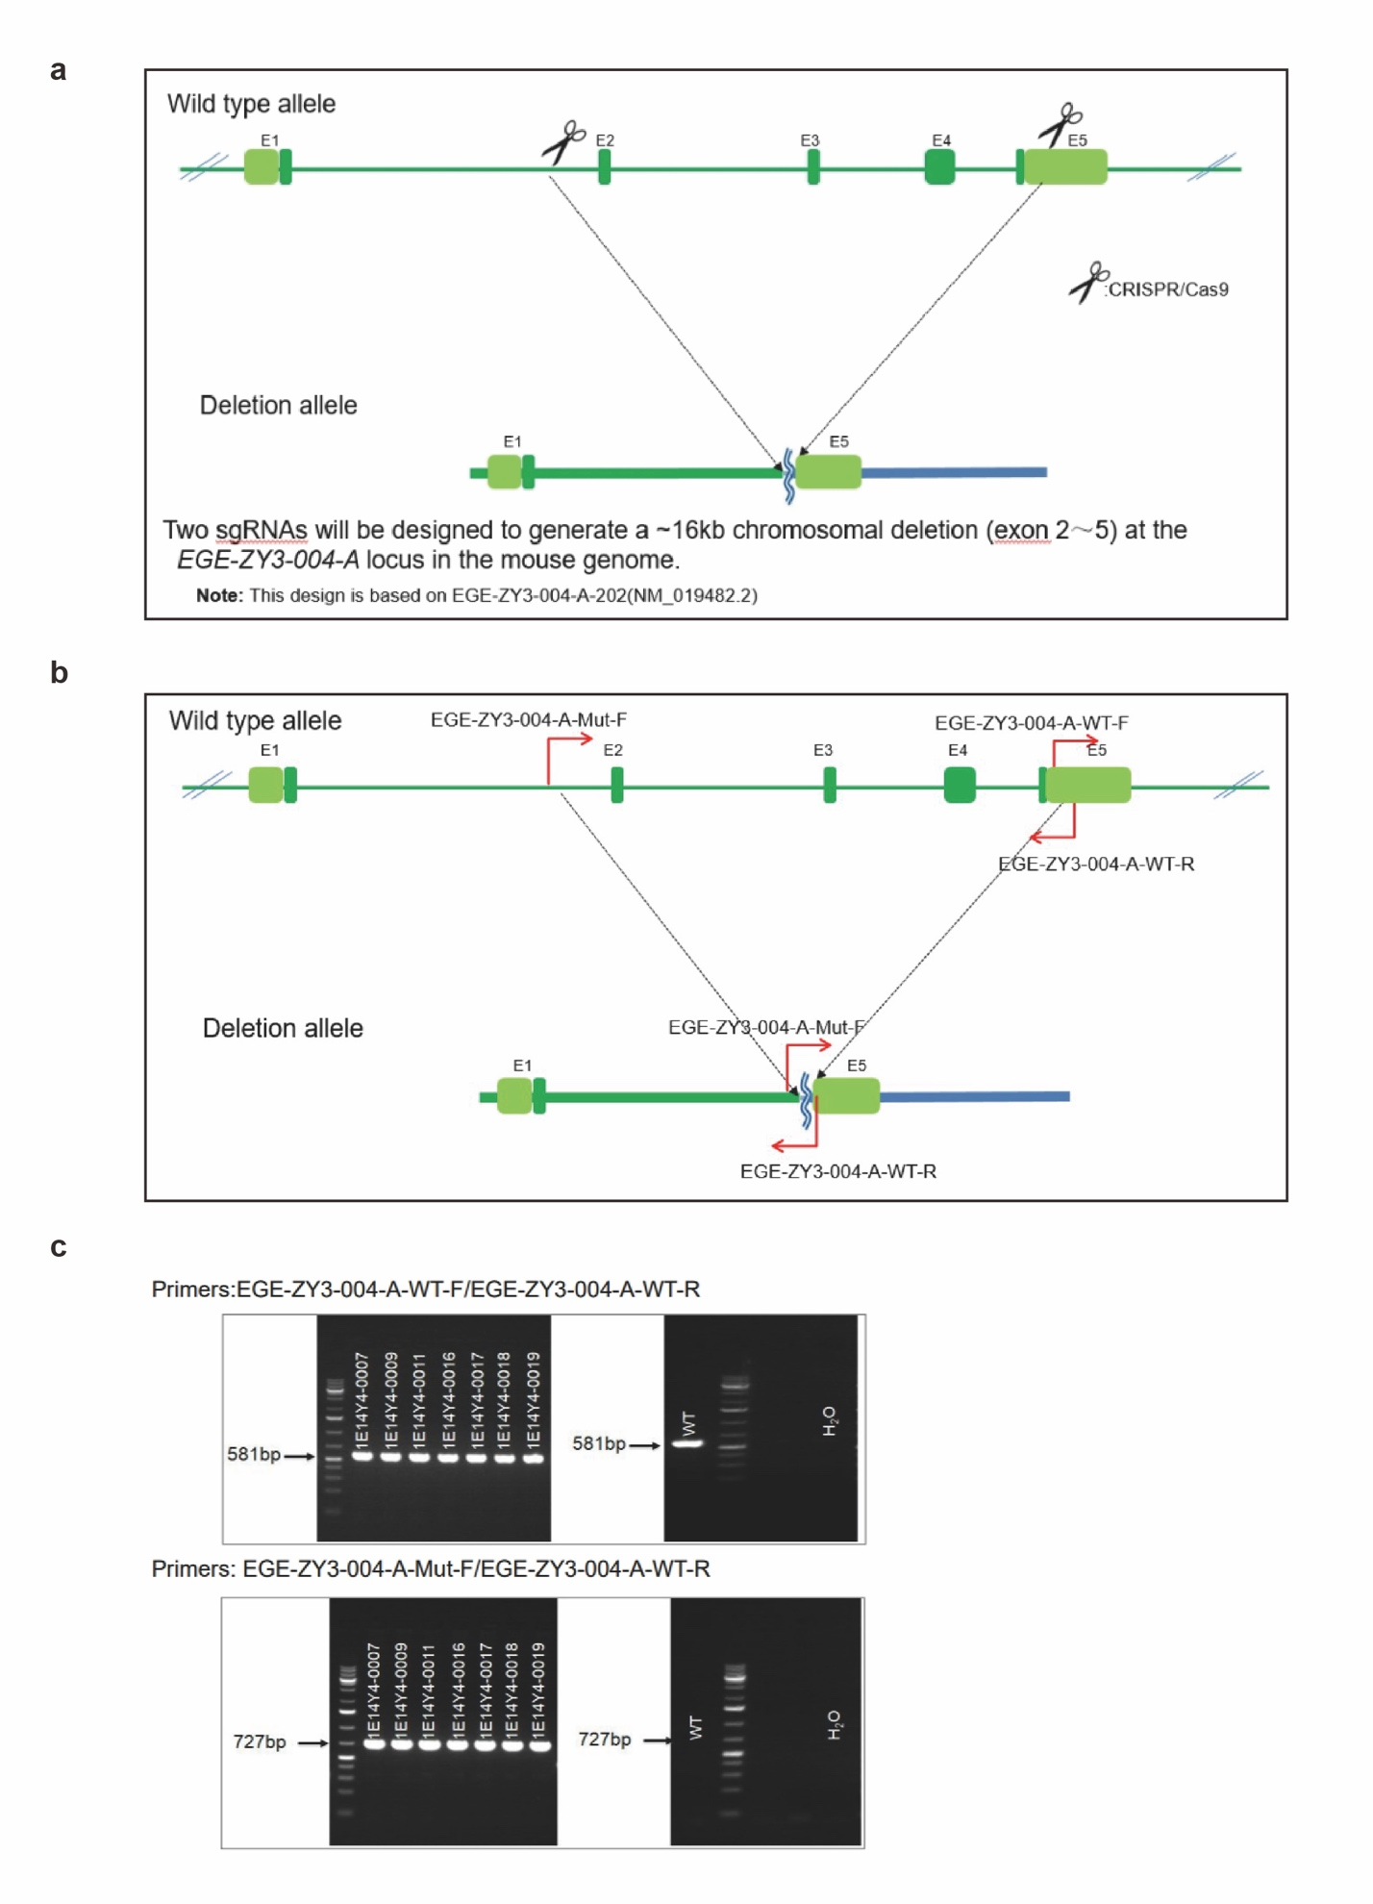
Appendix Figure. S11.
a Scheme of the modified region of Panx1 gene. Positions of Cas9 generated double-stranded breaks are indicated as scissors.
b Scheme of the designation of the primers.
c Genotyping of the F1 heterozygous mice was conducted by PCR using corresponding primer sets.

 | Young，n = 6 | Old，n = 6
Age range(year) | 20-29 (24.2 ± 3.31) | 68-78 (72 ± 4.34)
Scr at biopsy(μmol/L) | 45-93 (70.9 ± 15.99) | 118-130.9 (125.4 ± 5.96)
Biopsy indication | Microscopic hematuria | N/A
Biopsy findings  (no. of patients) | Thin basement membrane nephropathy or no specific pathologic alterations (6/6) | N/A
Values are expressed as the mean ± SD. Scr, serum creatinine. N/A, not available.
Table S1. Characteristics of the old and young individuals

 | Ctrl，n = 8 | AKD，n = 9
Age range(year) | 13-41 (28 ± 8.83) | 22-58 (40 ± 13.98）
Scr at biopsy(umol/L) | 29.9-93.8 (65.29 ± 22.73) | 116.8-426 (286.36 ± 99.69）
Biopsy indication | Microscopic hematuria
Biopsy findings  (no. of patients) | Thin basement membrane nephropathy or no specific pathologic alterations (8/8) | Acute tubular necrosis (9/9)

A total of 9 renal biopsy samples were obtained from patients with acute tubular necrosis which was induced by drug or ischemia and patients underwent renal biopsy between 7 and 90 days after an AKI episode. Patients with CKD history or over 60 years old were excluded. Values are expressed as the mean ± SD. Scr, serum creatinine.

Table S2. Characteristics of the control group and AKD group patients

Gene name | Forward (5’ to 3’) | Reverse (5’ to 3’)
Human.β-Actin | GATTCCTATGTGGGCGACGA | AGGTCTCAAACATGATCTGGGT
Human.Panx1 | GTGGCTGCATAAGTTTTTCCCC | TCTCTCATGTCAAGGTCACGC
Human.Cdkn2a | ATGGAGCCTTCGGCTGACT | GTAACTATTCGGTGCGTTGGG
Human.Cdkn1a | GCCTGTCCACCATCTCCCTAT | TTCAAGCACAGTTATTCTGGACCTT
Human.Tp53 | ACCTATGGAAACTACTTCCTGAAA | ACCTATGGAAACTACTTCCTGAAA
Human.IL-1β | CTGTCCTGCGTGTTGAAAGA | TTGGGTAATTTTTGGGATCTACA
Human.IL-6 | ACTCACCTCTTCAGAACGAATTG | CCATCTTTGGAAGGTTCAGGTTG
Human.IFN-β | ATGACCAACAAGTGTCTCCTCC | GGAATCCAAGCAAGTTGTAGCTC
Human.TGF-β | ACCACACCAGCCCTGTTC | CGTCAGCACCAGTAGCCA
Human.MCU | TACACCAGAGGATCGCTTC | TCATCAGAGGGCACAACA
Human.ITPR1 | CTGTGCTCGTGGATGTTCT | CCTTCTGGCGTCTGTGTT
Human.ITPR2 | CAACGCCAAGGTTTAAGG | TGGAAGGATTGGTTCAGG
Human.ITPR3 | AGCAGGGCAGCAAAGTG | GGCGGGAGAACCAGTAGA
Mouse.β-Actin | CAGCTGAGAGGGAAATCGTG | CGTTGCCAATAGTGATGACC
Mouse.GAPDH | TGTTTCCTCGTCCCGTAGA | ATCTCCACTTTGCCACTGC
Mouse.Cdkn2a | CATCTGGAGCAGCATGGAGTC | GCACCGTAGTTGAGCAGAAGA
Mouse.Cdkn1a | CCTGTCACTGTCTTGTACCCT | GCGTTTGGAGTGGTAGAAATCT
Mouse.Tp53 | ACCTGAAGACCAAGAAGGG | GACCGGGAGGATTGTGT
Mouse.CollagenI | ATCTCCTGGTGCTGATGGAC | ACCTTGTTTGCCAGGTTCAC
Mouse.Fibronectin | CGAGGTGACAGAGACCACAA | CTGGAGTCAAGCCAGACACA
Mouse.α-SMA | GCCCAGAGCAAGAGAGG | TGTCAGCAGTGTCGGATG
Mouse. ITPR1 | GATGAAGTGGACAGGGATG | CGGAAGGTGGTAAAGGC
Mouse.ITPR2 | TACGCATGAGAACCGAGA | CCAGAGGACAGAGAATCCA

Table S3. Primers used for qPCR

