Supplementary Information

Surface Engineering of Halide Perovskites with 2D Covalent Organic Framework Nanoparticles for Surface-Enhanced Gas Capture with Ultra-sensitive Sensing Properties
Wen Ye et al

DFT calculation

The structure optimizations were executed by using the projector augmented wave method according to the density functional theory (DFT), which could be realized by Vienna ab-initio Simulation Package (VASP) ^{1, 2, 3}. All geometric optimizations were carried out with the Perdew–Burke–Ernzerhof (PBE) exchange and correlation energy within generalized gradient approximation (GGA) ^{4, 5}. The plane-wave energy cutoff was set to 400 eV. The Brillouin-zone sampling were conducted using Monkhorst-Pack (MP) grids of special points with the separation of 0.04 Å⁻¹. The self-consistence-field convergence criterion was set to 10⁻⁴ eV, and the atomic positions were optimized with the convergence criterion of 0.05 eV/Å. A Gaussian smearing of 0.05 eV was applied to speed up self-consistent field convergence. A vacuum height of 15 Å along the vertical direction was selected to avoid the unwanted interaction between the slab and its period images. The electrostatic potential was obtained used the Dmol³ code ⁶.

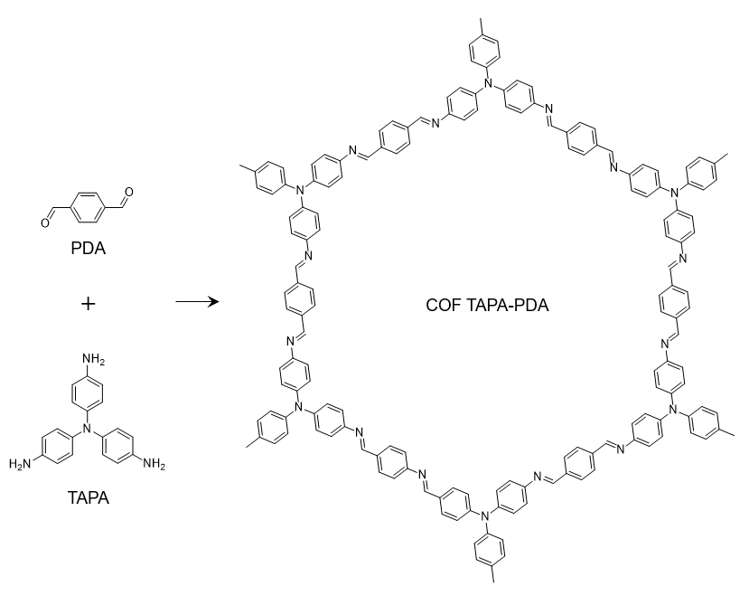

Supplementary Fig. 1 Synthesis of TAPA-PDA COF.

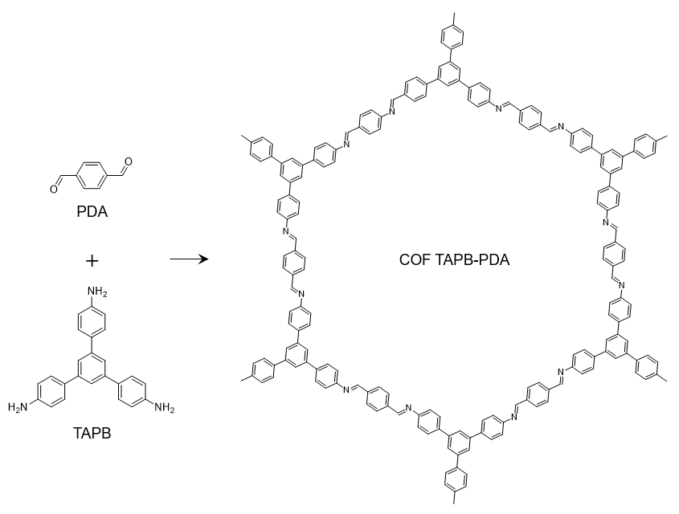
Supplementary Fig. 2 Synthesis of TAPB-PDA COF.

Supplementary Fig. 3 Particle size distribution of TAPB-PDA COF colloids.

Supplementary Fig. 4 Formation process of TAPA–PDA COF colloidal nanoparticles.

Supplementary Fig. 5 Particle size distribution of TAPA-PDA COF colloids.

Supplementary Fig. 6 XRD pattern of Cs₂PdBr₆ powder.

Supplementary Fig. 7 XRD pattern comparison of Cs₂PdBr₆ powder and hollow nanospheres.

Supplementary Fig. 8 XPS spectra of the N 1s region of TAPA-PDA@Cs₂PdBr₆ and TAPA-PDA.

Supplementary Fig. 9 XPS spectra of the N 1s region of TAPB-PDA@Cs₂PdBr₆ and TAPB-PDA.

Supplementary Fig. 10 The response of Cs₂PdBr₆ to NO₂ after mixing different proportions of COF TAPB-PDA colloids. a), b), c), d), e) denote the addition of 1mL, 2mL, 3mL, 4mL, and 5mL of colloid, respectively.

Supplementary Fig. 11 The response of Cs₂PdBr₆ to NO₂ after mixing different proportions of COF TAPA-PDA colloids. a, b, c, d, e denote the addition of 1mL, 2mL, 3mL, 4mL, and 5mL of colloid, respectively.

Supplementary Fig. 12 Response and recovery time of TAPB-PDA@Cs₂PdBr₆ sensor to 4 ppm NO₂.

Supplementary Fig. 13 Response and recovery time of TAPA-PDA@Cs₂PdBr₆ sensor to 4ppm NO₂.

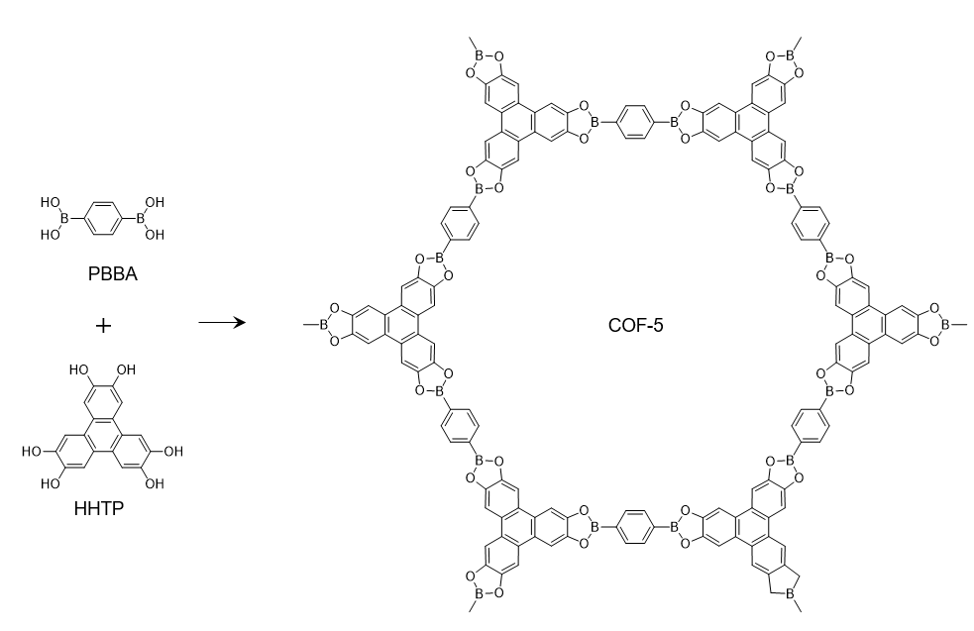
Supplementary Fig. 14 Synthesis of COF-5.

Supplementary Fig. 15 SEM images of uniformly dispersed COF-5 colloids.

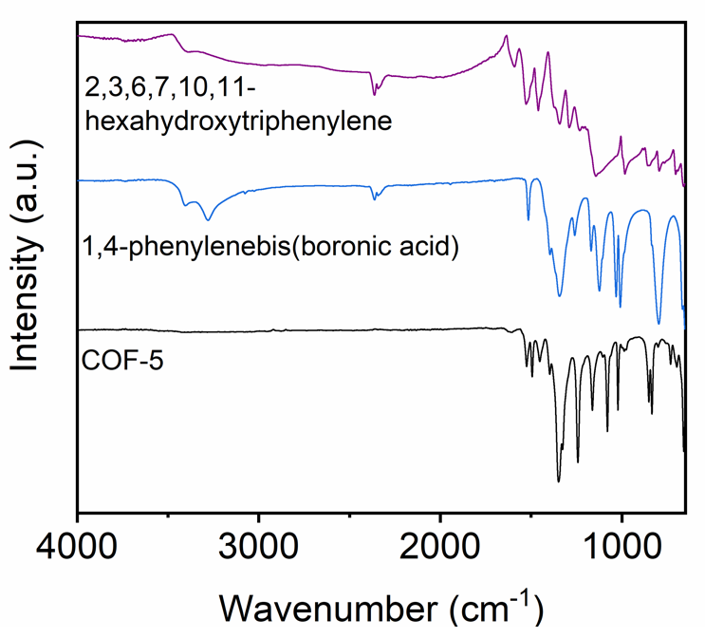
Supplementary Fig. 16 FTIR spectra of COF-5.

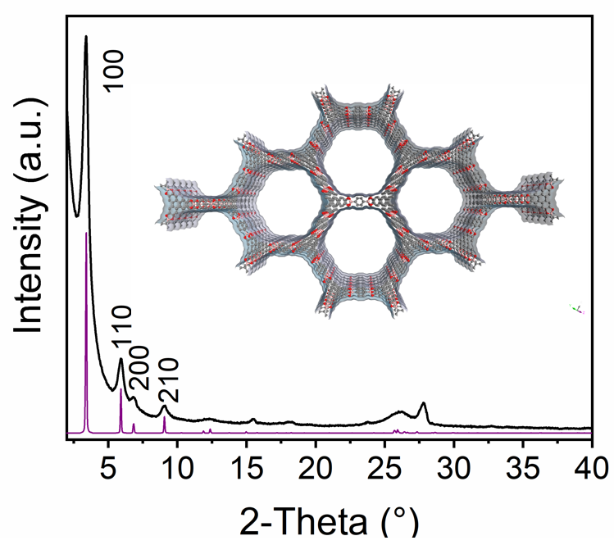
Supplementary Fig. 17 XRD patterns of COF-5.

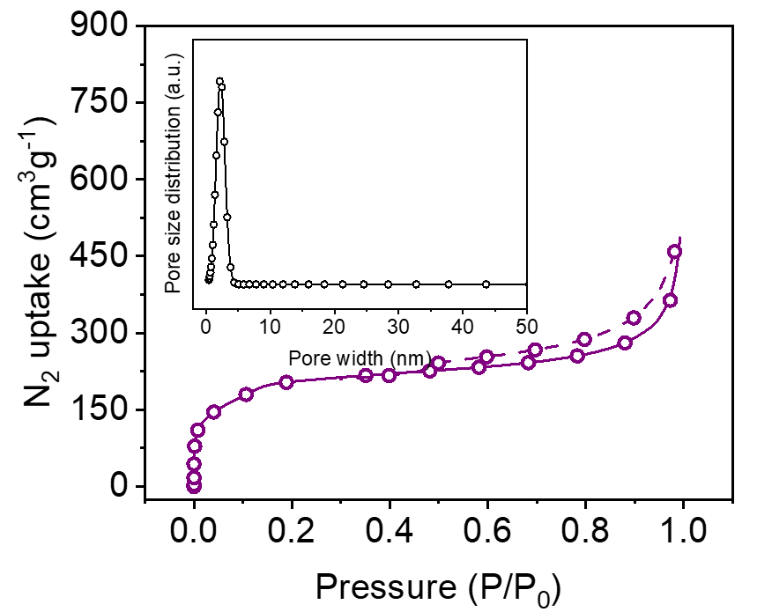
Supplementary Fig. 18 N₂ sorption isotherms and pore size distribution (inset) of COF-5.

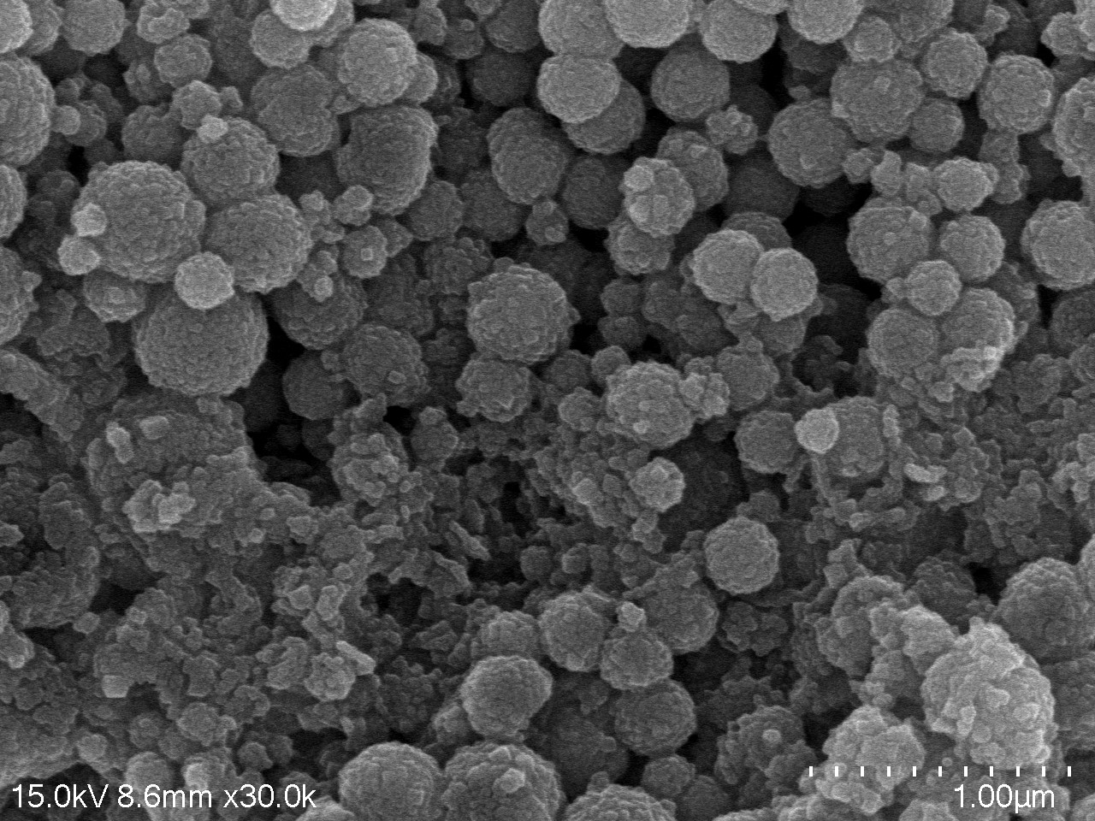

Supplementary Fig. 19 SEM images of COF-5@Cs₂PdBr₆.

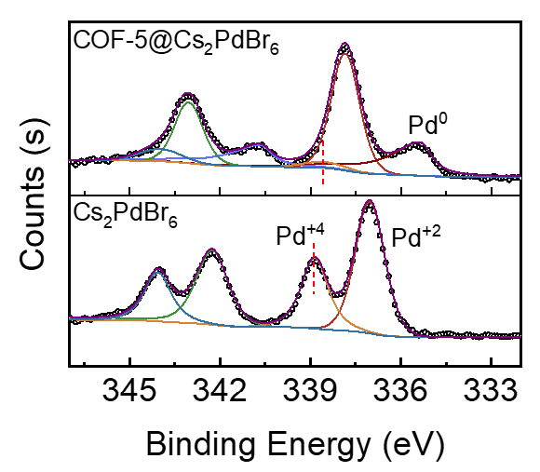
Supplementary Fig. 20 XPS spectra of the Pd 3d region of COF-5@Cs₂PdBr₆ and Cs₂PdBr₆.

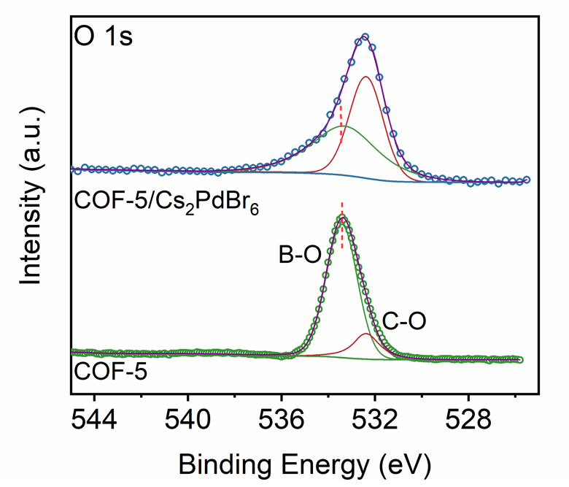

Supplementary Fig. 21 XPS spectra of the O 1s region of COF-5@Cs₂PdBr₆ and COF-5.

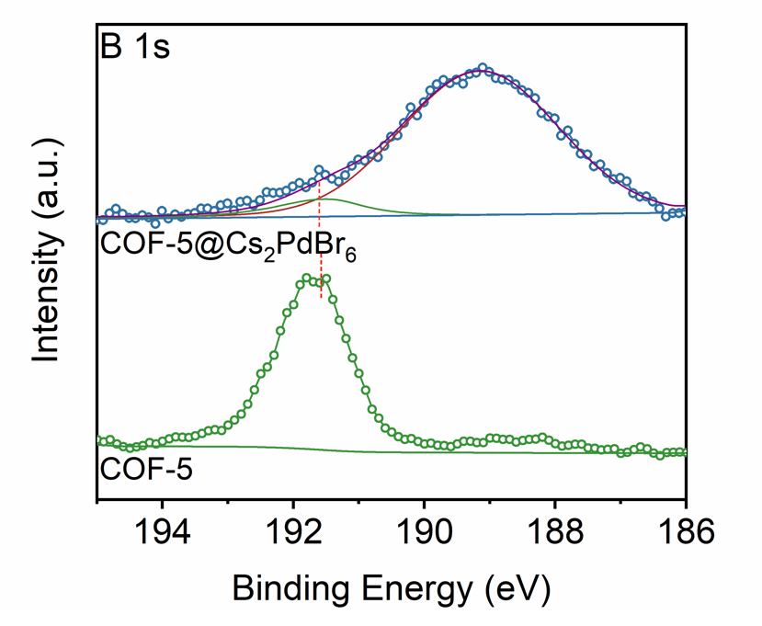

Supplementary Fig. 22 XPS spectra of the B 1s region of COF-5@Cs₂PdBr₆ and COF-5.

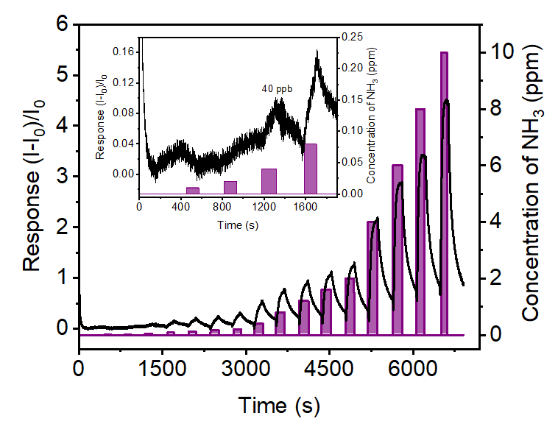
Supplementary Fig. 23 Real-time response of the COF-5@Cs₂PdBr₆ sensor with increasing concentrations of NH₃ (from 10 ppb to 10 ppm).

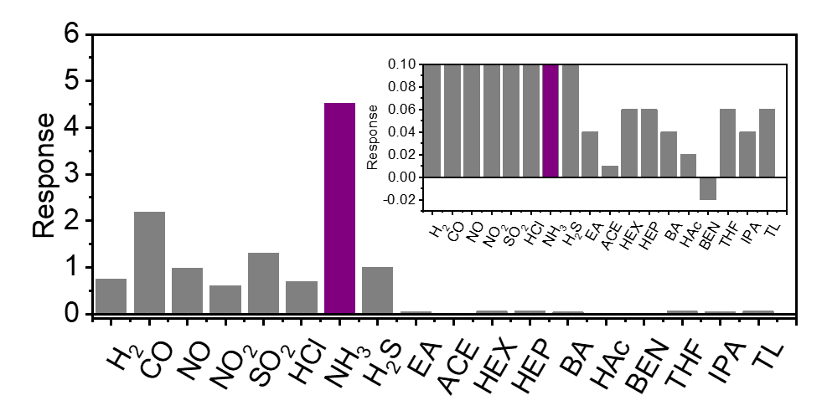

Supplementary Fig. 24 Gas selectivity of the COF-5@Cs₂PdBr₆ sensor (Air is the carrier gas, and all gas concentrations are 10 ppm.).

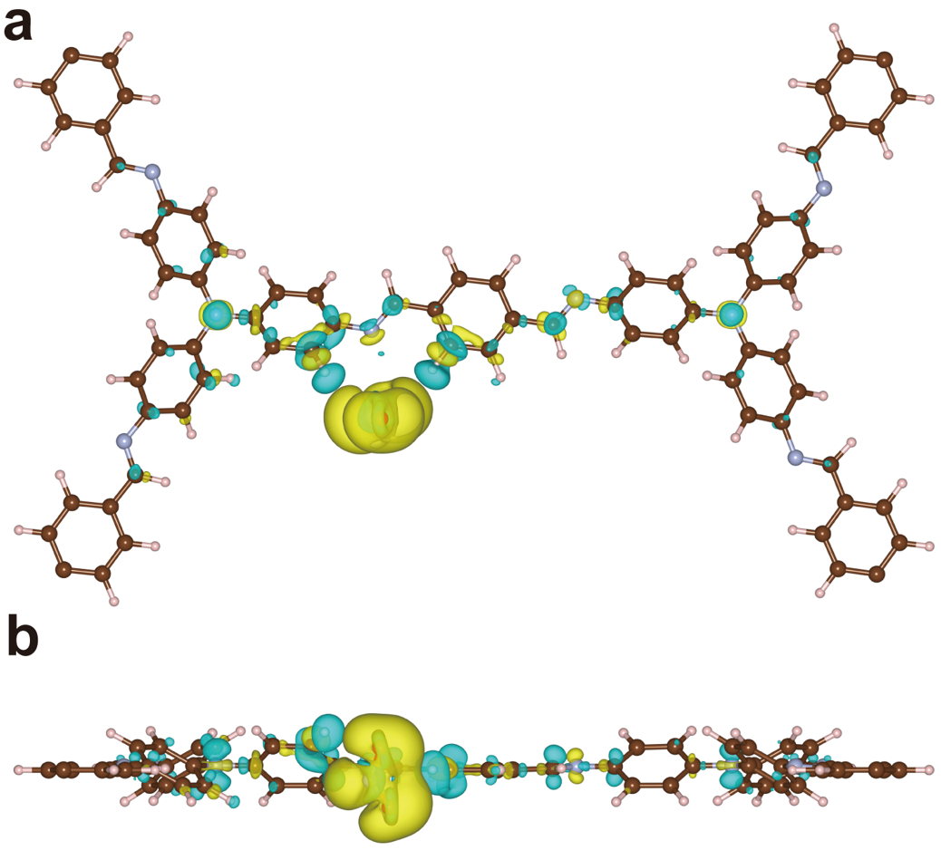
Supplementary Fig. 25 Top and side views of differential charge density of NO₂. The charge transfer difference between NO₂ and COF TAPA-PDA layers, where the yellow and cyan areas indicate the charge accumulation and depletion with iso-surfaces. The brown, pink and periwinkle balls refer to C, H and N atoms, respectively.

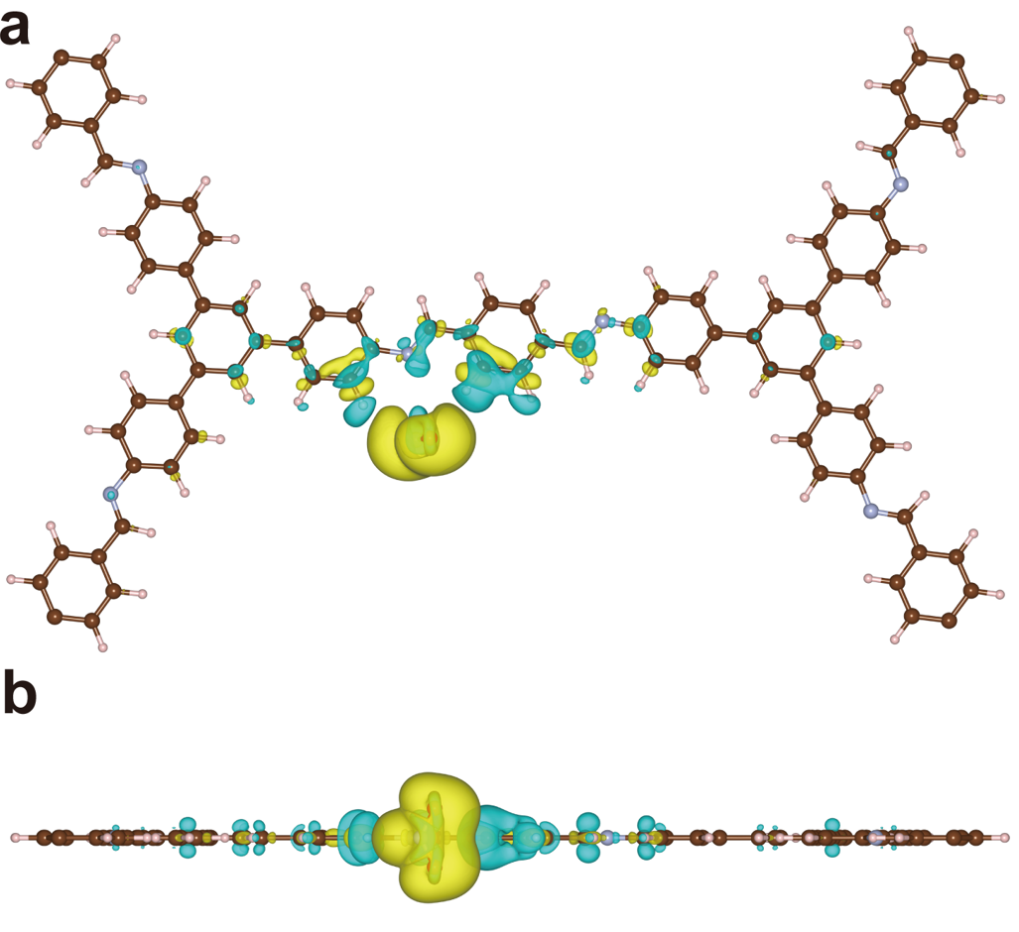

Supplementary Fig. 26 Top and side views of differential charge density of NO₂. The charge transfer difference between NO₂ and COF TAPB-PDA layers, where the yellow and cyan areas indicate the charge accumulation and depletion with iso-surfaces. The brown, pink and periwinkle balls refer to C, H and N atoms, respectively.

Supplementary Table 1. The lowest detection limit and recovery time of Cs₂PdBr₆ to NO₂ after mixing different proportions of COF TAPB-PDA colloids.

V_{TAPB-PDA} colloid (mL) | 1 | 2 | 3 | 4 | 5
Lowest detection limit（ppb）  Recovery time (s, 4 ppm) | 40  140 | 20  64 | 20  68 | 80  121 | 1200  72

Supplementary Table 2. The lowest detection limit and recovery time of Cs₂PdBr₆ to NO₂ after mixing different proportions of COF TAPA-PDA colloids.

V_{TAPA-PDA} colloid (mL) | 1 | 2 | 3 | 4 | 5
Lowest detection limit（ppb）  Recovery time (s, 4 ppm) | 40  149 | 20  250 | 20  >1000 | 40  >1000 | 400  >1000

Supplementary Table 3. The lower limit of detection reported for perovskite-based NO₂ sensors.
Material | Temperature for detection (℃) | Lower limit of detection (ppm) | Reference
2D/3D perovskites n-OA₂Pb(I_{x}Br_{1−x})₄  (CH₃NH₃PbBr₃)/[InGaZnO (IGZO)]  ZnO/CsPbBr₃  FA_{0.83}Cs_{0.17}PbI₃  TpPa-1/Cs₂PdBr₆  CsCu₂I₃  CH₃NH₃PbBr₃  Cs₂SnI₆  PyPbI₃/FA_{0.83}Cs_{0.17}PbI₃  CsPbBr₃  BA₂EA₂Pb₃I₁₀  MAPbI₃/NCNT  MASnI₃  Cs₂TeI₆  CsPbBr₃/ZnO  FA_{0.80}MA_{0.15}Cs_{0.05}PbI_{2.55}Br_{0.45}  Cs₃Cu₂Br₅@graphene, Cs₂AgBiBr₆@graphene  Au/MASnI₃/SnO₂  [(Et)₂MP]PbBr₃ and [(Et)₂MP]PbI₃  MASnI₃/SnO₂ | RT  RT  RT  RT  RT  RT  RT  RT  RT  RT  RT  RT  RT  RT  RT  RT  RT  RT  RT  RT | 2  0.25  0.5  0.5  0.04  0.02  0.1  1  0.5  0.2  1  1  0.025  0.025  1  0.2  0.05  0.5  1  0.025 | ⁷  ⁸  ⁹  ¹⁰  ¹¹  ¹²  ¹³  ¹⁴  ¹⁵  ¹⁶  ¹⁷  ¹⁸  ¹⁹  ²⁰  ²¹  ²²  ²³  ²⁴  ²⁵  ²⁶

References

1. Kresse G, Hafner J. Ab initio molecular dynamics for liquid metals. Physical review B 47, 558 (1993).

2. Kresse G, Furthmüller J. Efficient iterative schemes for ab initio total-energy calculations using a plane-wave basis set. Physical review B 54, 11169 (1996).

3. Kresse G, Furthmüller J. Efficiency of ab-initio total energy calculations for metals and semiconductors using a plane-wave basis set. Computational materials science 6, 15-50 (1996).

4. Perdew JP, Wang Y. Accurate and simple analytic representation of the electron-gas correlation energy. Physical review B 45, 13244 (1992).

5. Perdew JP, Burke K, Ernzerhof M. Generalized gradient approximation made simple. Physical review letters 77, 3865 (1996).

6. Delley B. From molecules to solids with the DMol 3 approach. The Journal of chemical physics 113, 7756-7764 (2000).

7. John AT, et al. Mixed-dimensional organic–inorganic metal halide perovskite (OIMHP) based gas sensors with superior stability for NO 2 detection. Materials Advances 3, 1263-1271 (2022).

8. Vijjapu MT, Surya SG, He J-H, Salama KN. Highly Selective Self-Powered Organic–Inorganic Hybrid Heterojunction of a Halide Perovskite and InGaZnO NO2 Sensor. ACS Applied Materials & Interfaces 13, 40460-40470 (2021).

9. Chizhov A, et al. Photoresistive gas sensor based on nanocrystalline ZnO sensitized with colloidal perovskite CsPbBr3 nanocrystals. Sensors and Actuators B: Chemical 329, 129035 (2021).

10. Lu Z, Lou C, Cheng A, Zhang J, Sun J. A sensitive and ultrafast FA0. 83Cs0. 17PbI3 perovskite sensor for NO2 detection at room temperature. Journal of Alloys and Compounds 919, 165831 (2022).

11. Ye W, et al. Halide Perovskite glues activate two-dimensional covalent organic framework crystallites for selective NO2 sensing. Nature Communications 14, 2133 (2023).

12. Sun X, et al. Lead-free CsCu 2 I 3 perovskite nanostructured networks gas sensor for selective detection of trace nitrogen dioxide at room temperature. IEEE Sensors Journal 21, 14677-14684 (2021).

13. Zhu R, et al. High-performance room-temperature NO2 sensors based on CH3NH3PbBr3 semiconducting films: Effect of surface capping by alkyl chain on sensor performance. Journal of Physics and Chemistry of Solids 129, 270-276 (2019).

14. Hung PT, et al. Growth and NO2 sensing properties of Cs2SnI6 thin film. Materials Research Bulletin 147, 111628 (2022).

15. Cheng A, Zhao J, Wang X-A, Lu Z, Qi Y, Sun J. Hybrid 1D/3D-Structured Perovskite as a Highly Selective and Stable Sensor for NO2 Detection at Room Temperature. Molecules 28, 2615 (2023).

16. Kim J, et al. P-type charge transport and selective gas sensing of all-inorganic perovskite nanocrystals. ACS Materials Letters 2, 1368-1374 (2020).

17. Han S, Wang G-E, Xu G, Luo J, Sun Z. Ferroelectric perovskite‐type films with robust in‐plane polarization toward efficient room-temperature chemiresistive sensing. Fundamental Research 3, 362-368 (2023).

18. Lee GY, et al. Nitrogen‐Dopant‐Induced Organic–Inorganic Hybrid Perovskite Crystal Growth on Carbon Nanotubes. Advanced Functional Materials 29, 1902489 (2019).

19. Hien VX, Hung PT, Han J, Lee S, Lee J-H, Heo Y-W. Growth and gas sensing properties of methylammonium tin iodide thin film. Scripta Materialia 178, 108-113 (2020).

20. Hoat PD, et al. Synthesis of Cs2TeI6 thin film and its NO2 gas-sensing properties under blue-light illumination. Scripta Materialia 207, 114305 (2022).

21. Yueyue L, et al. CsPbBr3 quantum dots enhanced ZnO sensing to NO2 at room temperature. Sensors and Actuators B: Chemical 368, 132189 (2022).

22. Chen H, et al. Superior self‐charged and‐powered chemical sensing with high performance for NO2 detection at room temperature. Advanced Optical Materials 8, 1901863 (2020).

23. Casanova-Chafer J, Garcia-Aboal R, Atienzar P, Llobet E. Unraveling the gas-sensing mechanisms of lead-free perovskites supported on graphene. ACS sensors 7, 3753-3763 (2022).

24. Chen Y, et al. Light enhanced room temperature resistive NO 2 sensor based on a gold-loaded organic–inorganic hybrid perovskite incorporating tin dioxide. Microchimica Acta 186, 1-10 (2019).

25. Chen J, Wang C, Zhao J, Liang G, Xu G, Wang G-E. A novel strategy for enhancing NO2 sensitivity of new 1D organic–inorganic metal halide hybrids. Inorganic Chemistry Communications 152, 110668 (2023).

26. Hien VX, Hoat PD, Hung PT, Lee S, Lee J-H, Heo Y-W. Room-temperature NO2 sensor based on a hybrid nanomaterial of methylammonium tin iodide submicron spheres and tin dioxide nanowires. Scripta Materialia 188, 107-111 (2020).

