Supplementary Material

Table S1. Edge weights matrix of PHQ-9 and GAD-7 items
Table S2. Edge weights matrix of PCS, MCS, PHQ-9 and GAD-7 items
Fig. S1. Bootstrapped confidence intervals of edge weights
Fig. S2. Network comparison for the depressive and anxiety symptoms by gender
Fig. S3. Network comparison of network structure and global strength by gender

Table. S1. Edge weights matrix of PHQ-9 and GAD-7 items
 | PHQ1 | PHQ2 | PHQ3 | PHQ4 | PHQ5 | PHQ6 | PHQ7 | PHQ8 | PHQ9 | GAD1 | GAD2 | GAD3 | GAD4 | GAD5 | GAD6 | GAD7
PHQ1 | 0.000
PHQ2 | 0.149 | 0.000
PHQ3 | 0.000 | 0.013 | 0.000
PHQ4 | 0.301 | 0.034 | 0.233 | 0.000
PHQ5 | 0.000 | 0.000 | 0.173 | 0.164 | 0.000
PHQ6 | 0.082 | 0.294 | 0.000 | 0.054 | 0.162 | 0.000
PHQ7 | 0.087 | 0.008 | 0.032 | 0.010 | 0.047 | 0.048 | 0.000
PHQ8 | 0.000 | 0.000 | 0.074 | 0.000 | 0.075 | 0.015 | 0.298 | 0.000
PHQ9 | 0.000 | 0.132 | 0.045 | 0.034 | 0.000 | 0.143 | 0.030 | 0.068 | 0.000
GAD1 | 0.077 | 0.109 | 0.000 | 0.059 | 0.027 | 0.021 | 0.024 | 0.000 | 0.000 | 0.000
GAD2 | 0.000 | 0.084 | 0.012 | 0.019 | 0.000 | 0.008 | 0.071 | 0.000 | 0.000 | 0.201 | 0.000
GAD3 | 0.063 | 0.070 | 0.000 | 0.009 | 0.000 | 0.026 | 0.003 | 0.000 | 0.000 | 0.236 | 0.344 | 0.000
GAD4 | 0.043 | 0.048 | 0.034 | 0.050 | 0.000 | 0.009 | 0.016 | 0.000 | 0.025 | 0.082 | 0.191 | 0.130 | 0.000
GAD5 | 0.000 | 0.000 | 0.000 | 0.036 | 0.000 | 0.000 | 0.033 | 0.197 | 0.063 | 0.000 | 0.080 | 0.000 | 0.219 | 0.000
GAD6 | 0.000 | 0.117 | 0.054 | 0.084 | 0.067 | 0.051 | 0.000 | 0.094 | 0.013 | 0.122 | 0.054 | 0.086 | 0.136 | 0.146 | 0.000
GAD7 | 0.000 | 0.076 | 0.020 | 0.000 | 0.000 | 0.133 | 0.071 | 0.000 | 0.015 | 0.006 | 0.007 | 0.140 | 0.000 | 0.182 | 0.035 | 0.000

Table. S2. Edge weights matrix of PCS, MCS, PHQ-9 and GAD-7 items
 | PCS | MCS
PHQ1 | 0.000 | -0.115
PHQ2 | 0.000 | -0.117
PHQ3 | -0.010 | -0.025
PHQ4 | -0.009 | -0.067
PHQ5 | 0.000 | 0.000
PHQ6 | 0.000 | -0.085
PHQ7 | 0.000 | 0.000
PHQ8 | -0.027 | -0.018
PHQ9 | 0.000 | -0.016
GAD1 | 0.000 | -0.081
GAD2 | -0.045 | 0.000
GAD3 | 0.000 | -0.014
GAD4 | 0.000 | -0.063
GAD5 | 0.000 | 0.000
GAD6 | 0.000 | -0.124
GAD7 | -0.015 | 0.000

Fig. S1. Bootstrapped confidence intervals of edge weights
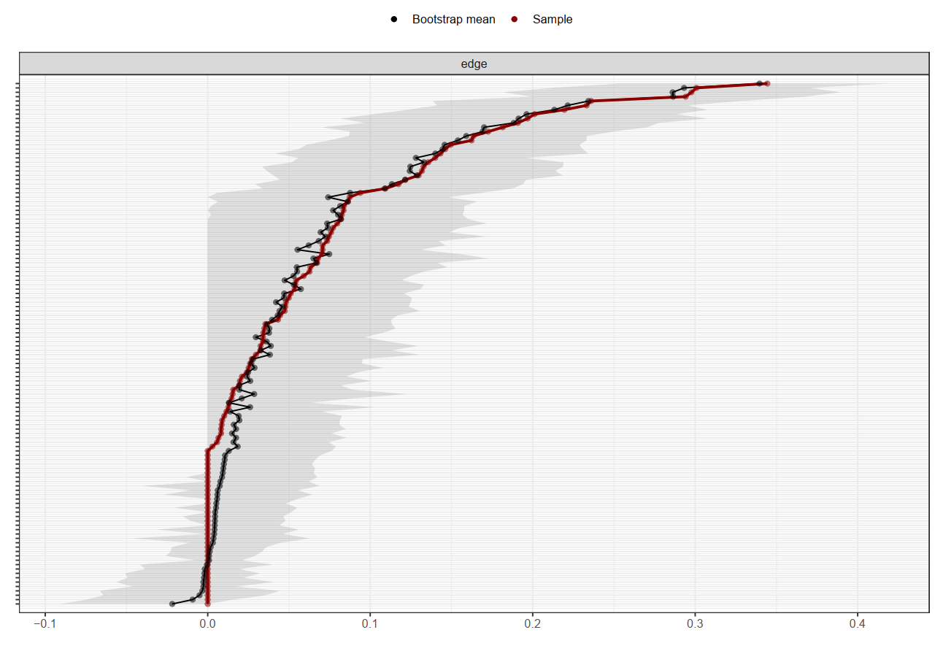

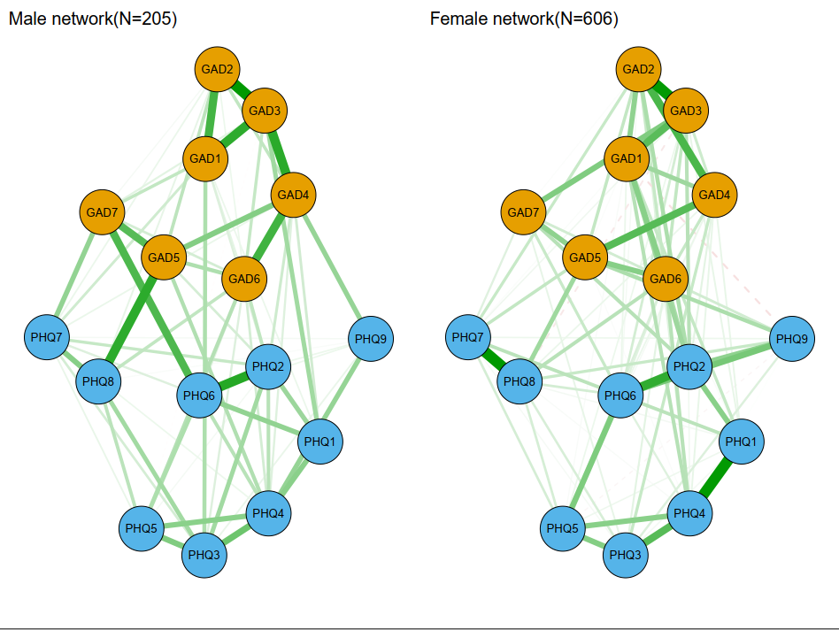
Fig. S2. Network comparison for the depressive and anxiety symptoms by gender
Fig. S3. Network comparison of network structure and global strength by gender
