Supplemental Information:
Climate change and its influence on water systems increases the cost of electricity system decarbonization

Table of Contents
1. Additional results 2
1.1. Cooling + Hydropower and Water Load Scenarios 2
1.2. Cooling Load Scenarios 4
1.3. Hydropower and Water Load Scenarios 5
2. Climate projections 7
3. Methodological details 8
3.1. The WWSM model and the load change analysis 8
3.2. Overview of SWITCH model and input data 8
3.2.1. Objective function 9
3.2.2. Investment-related constraints 10
3.2.3. Operations-related constraints 10
3.2.4. Policy-related constraints 11
3.2.5. Geographic and temporal resolution 12
3.2.6. Generators 13
3.2.6.1. Existing generators 13
3.2.6.2. Candidate generators 14
3.2.6.3. Technology assumptions on lifetime, capacity factors, efficiencies 17
3.2.7. Transmission 19
3.2.8. Costs 20
3.2.8.1. Overnight capital cost, variable O&M cost, fixed O&M cost 20
3.2.8.2. Connection costs 25
3.2.8.3. Fuel costs and Emissions 25
3.2.8.4. Transmission costs 26
3.2.9. Load 26
3.2.10. Planning reserves 27
3.2.11. Policies 27
3.2.11.1. Renewable Portfolio Standards 27
3.2.11.2. Carbon cap 27
4. Supplemental References 28

Additional results
The main manuscript primarily focuses on the 2050 results from the SWITCH scenarios where climate impacts on cooling and heating loads, water-related loads, and hydropower generation are all included. The Supplemental Text Section 1.1 below includes results on online generating capacity, annual generation, and transmission capacity for all investment periods (2030, 2035, 2040, 2045, and 2050) for these scenarios.
In addition to the SWITCH runs where all climate impacts are included, we have also run the SWITCH model isolating the effect on the grid buildout of only climate impacts on cooling load, and of only climate impacts on water-related load and hydropower generation. The results for all investment periods on online generating capacity, annual generation, and transmission capacity for these scenarios are included in Supplemental Text Section 1.2. and Supplemental Text Section 1.3., respectively.

Cooling + Hydropower and Water Load Scenarios
Below are the results for all investment periods for the climate scenarios where climate impacts on cooling and heating load, as well as hydropower and water-related load, are included in SWITCH.
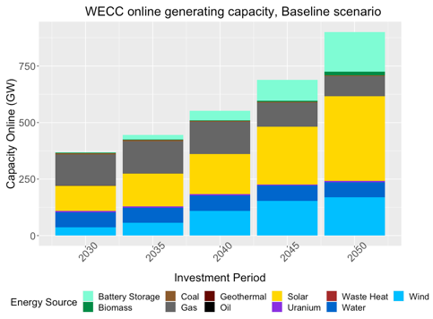  (a) | 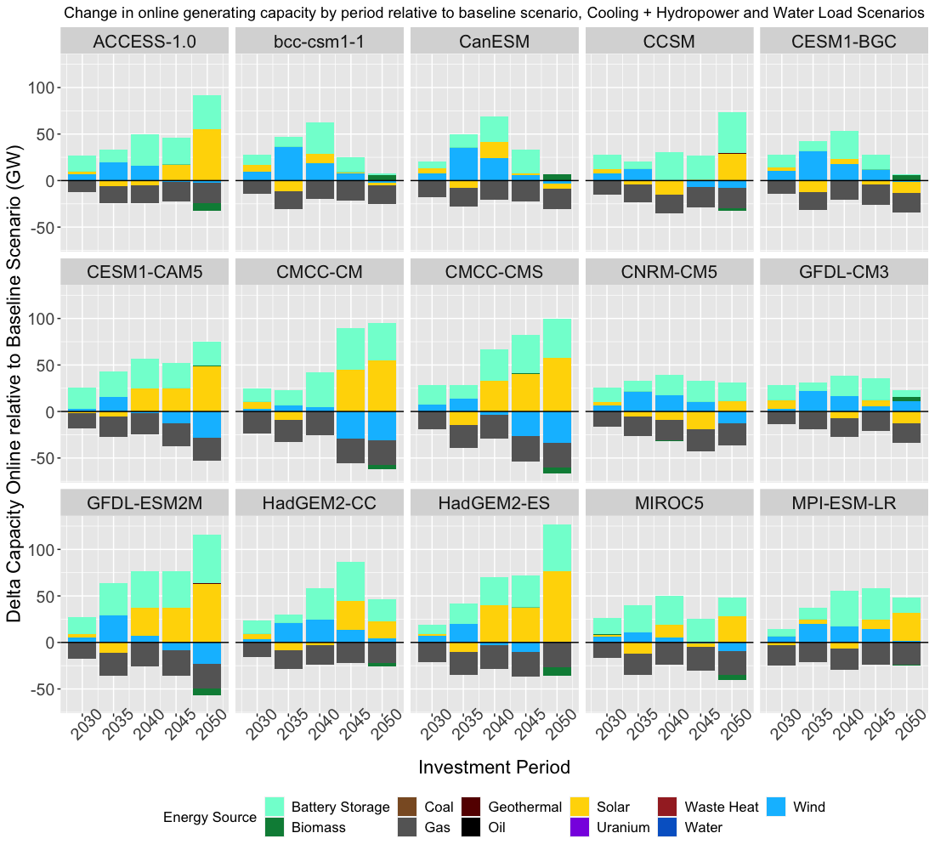  (b)
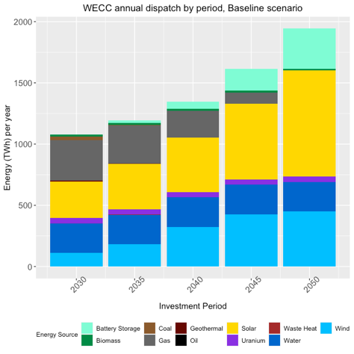  (c) | 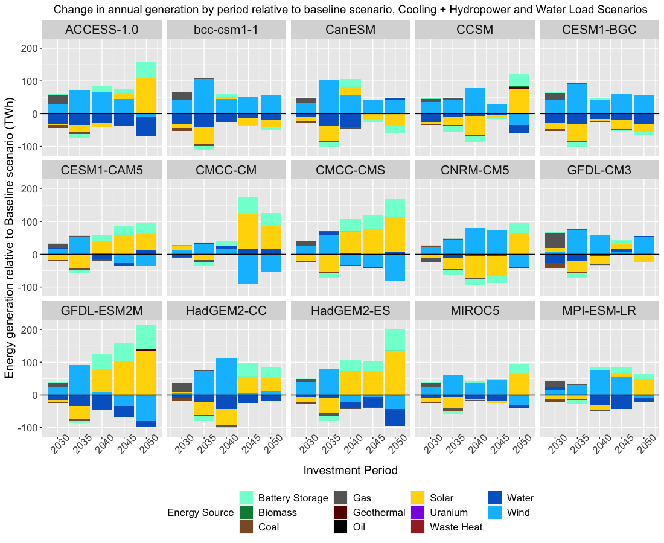  (d)
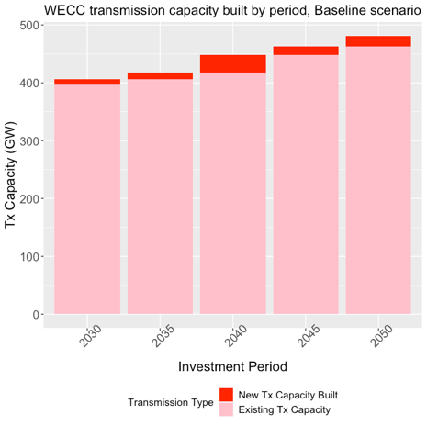  (e) | 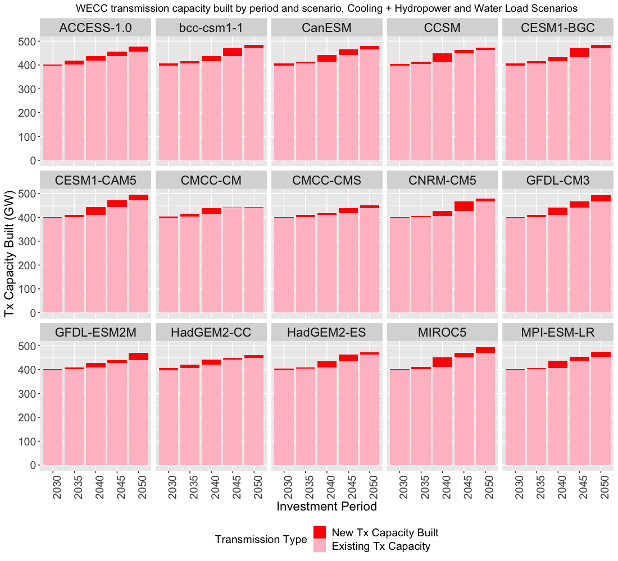  (f)
Supplementary Figure 1. Baseline and climate scenario results for capacity online, energy generation, and transmission capacity with climate impacts on cooling load, hydropower, and water-related load included. (a) Baseline Scenario and (b) change in total generation capacity online by investment period 2030 – 2050 relative to Baseline Scenario. (c) Baseline scenario and (d) change in annual generation by investment period 2030 – 2050 relative to Baseline Scenario. The energy storage bars in (c) and (d) indicate discharge of battery storage (equivalent to energy generation). (e) Baseline Scenario and (f) Existing and new transmission capacity built in 2030 - 2050.

Cooling Load Scenarios
Below are the results for all investment periods for the climate scenarios where only the climate impacts on cooling and heating load are included in SWITCH.
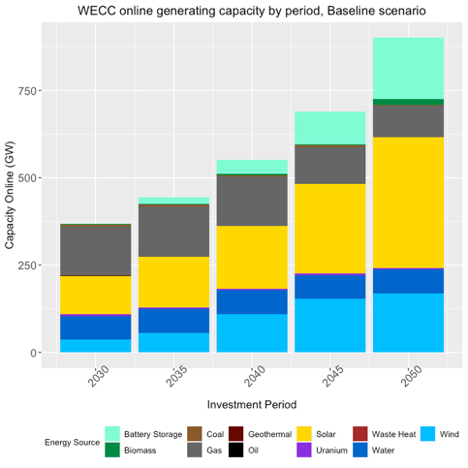  (a) | 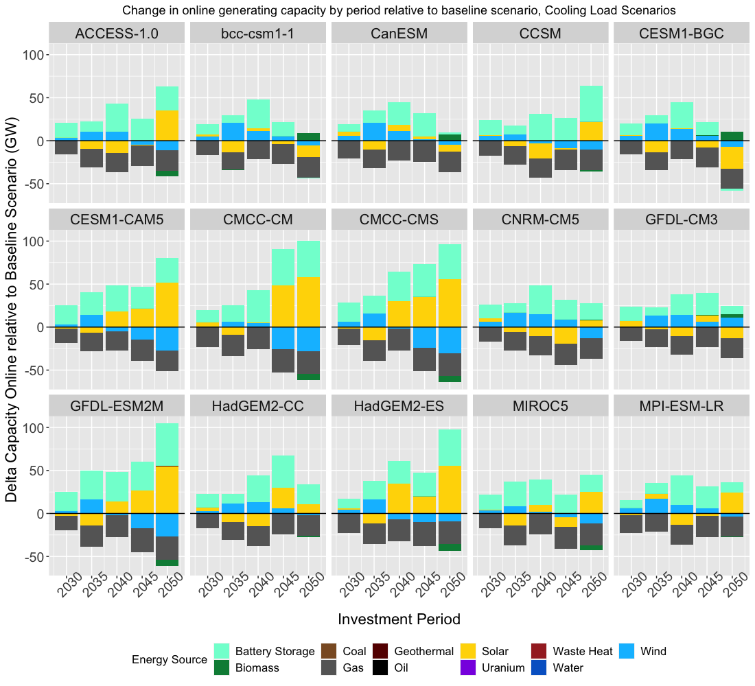  (b)
(c) | 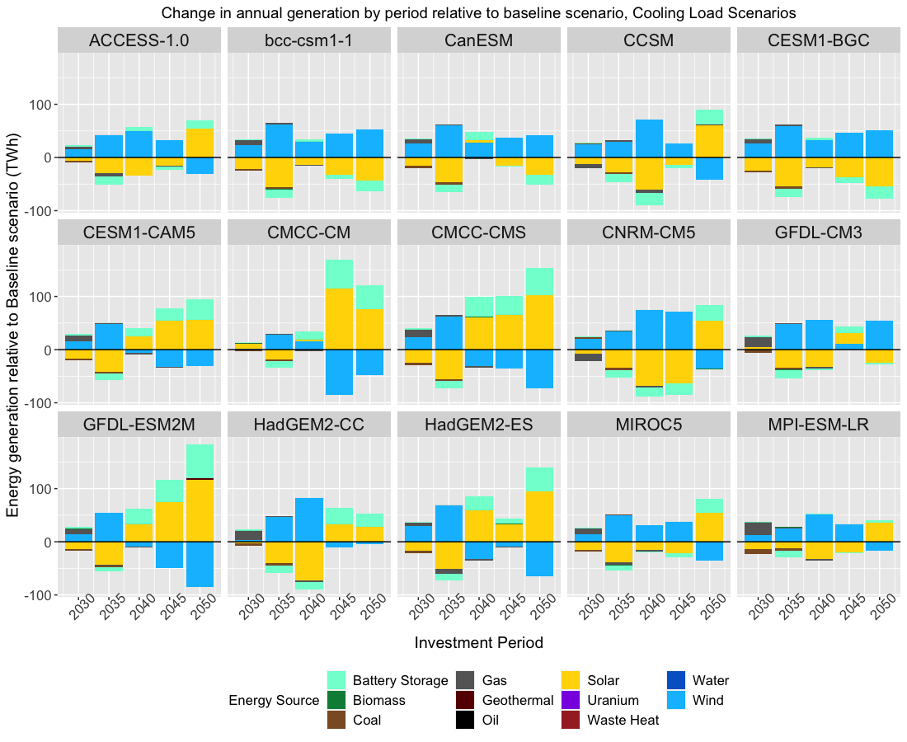  (d)
(e) | 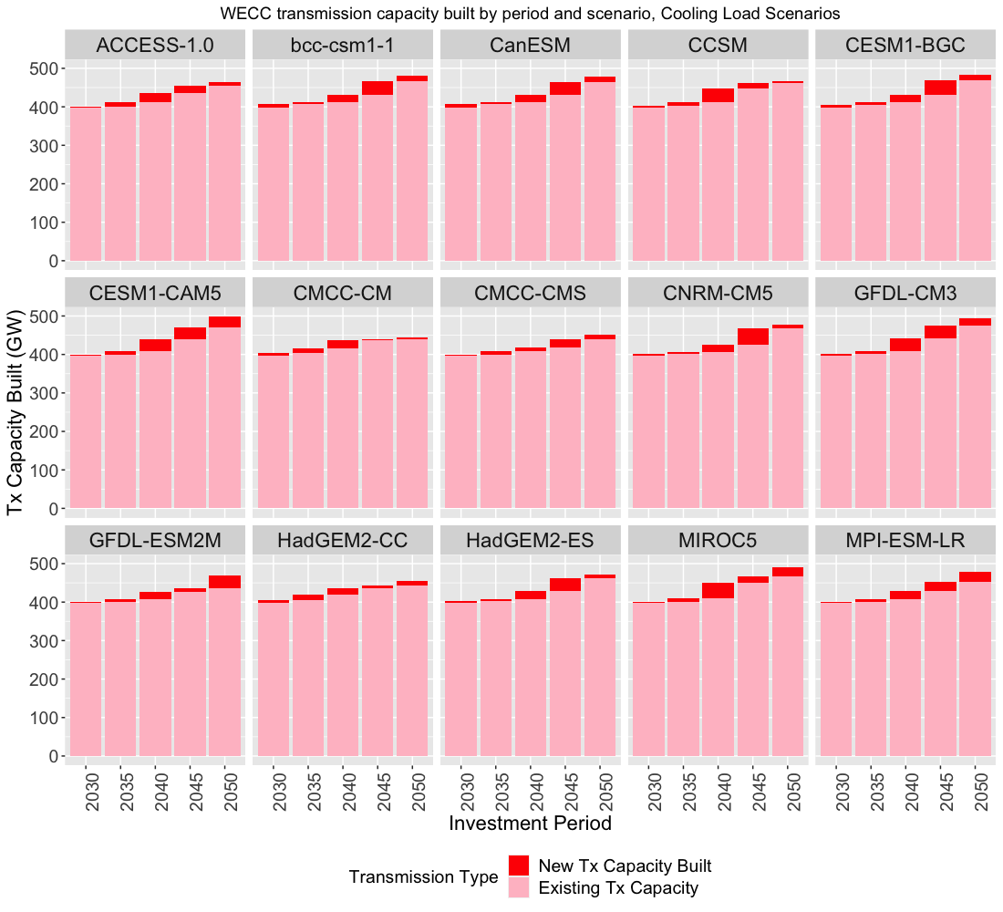  (f)
Supplementary Figure 2. Baseline and climate scenario results for capacity online, energy generation, and transmission capacity with climate impacts on cooling load only included. (a) Baseline Scenario and (b) change in total generation capacity online by investment period 2030 – 2050 relative to Baseline Scenario. (c) Baseline scenario and (d) change in annual generation by investment period 2030 – 2050 relative to Baseline Scenario. The energy storage bars in (c) and (d) indicate discharge of battery storage (equivalent to energy generation). (e) Baseline Scenario and (f) Existing and new transmission capacity built in 2030 - 2050.

Hydropower and Water Load Scenarios
Below are the results for all investment periods for the climate scenarios where climate impacts on only hydropower and water-related load are included in SWITCH.
(a) | 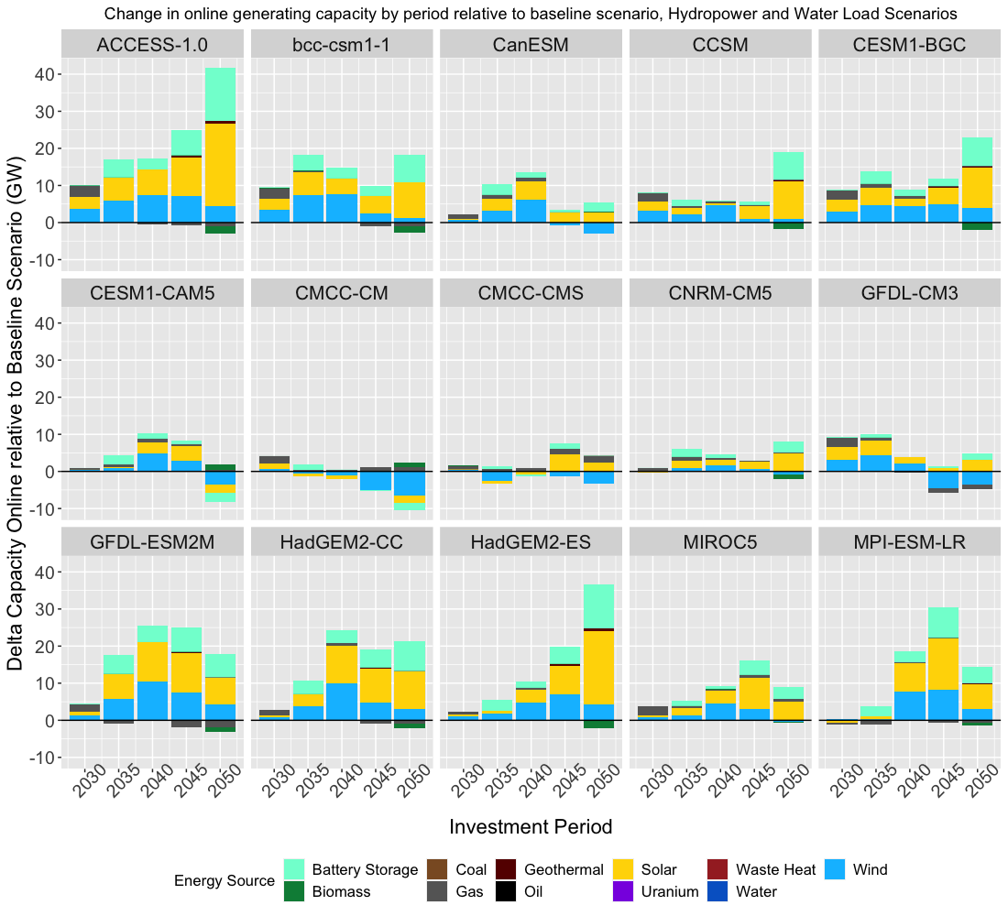  (b)
(c) | 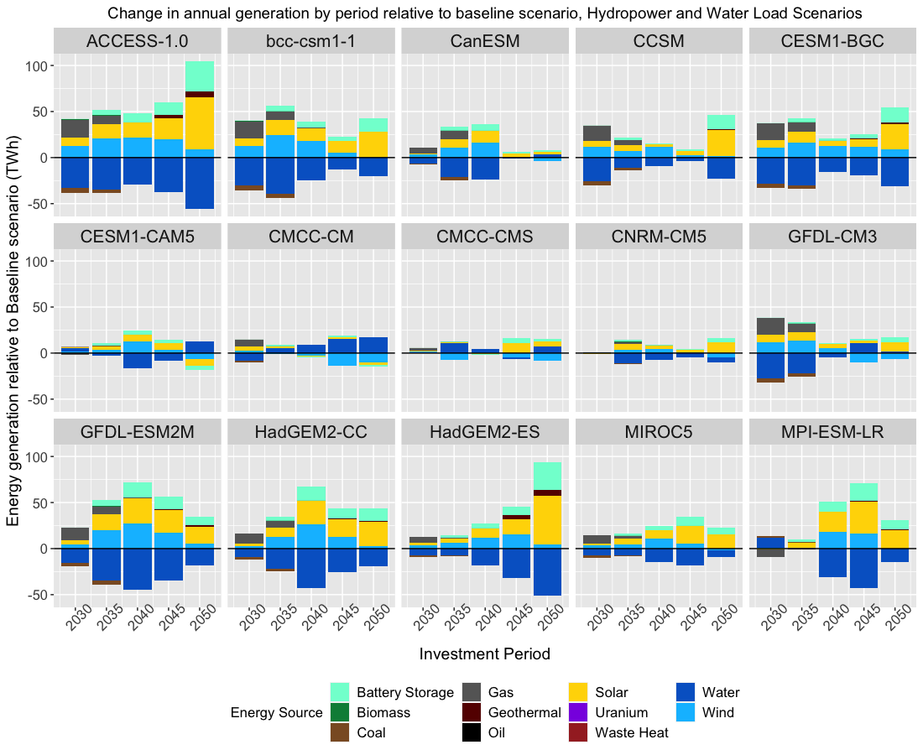  (d)
(e) | 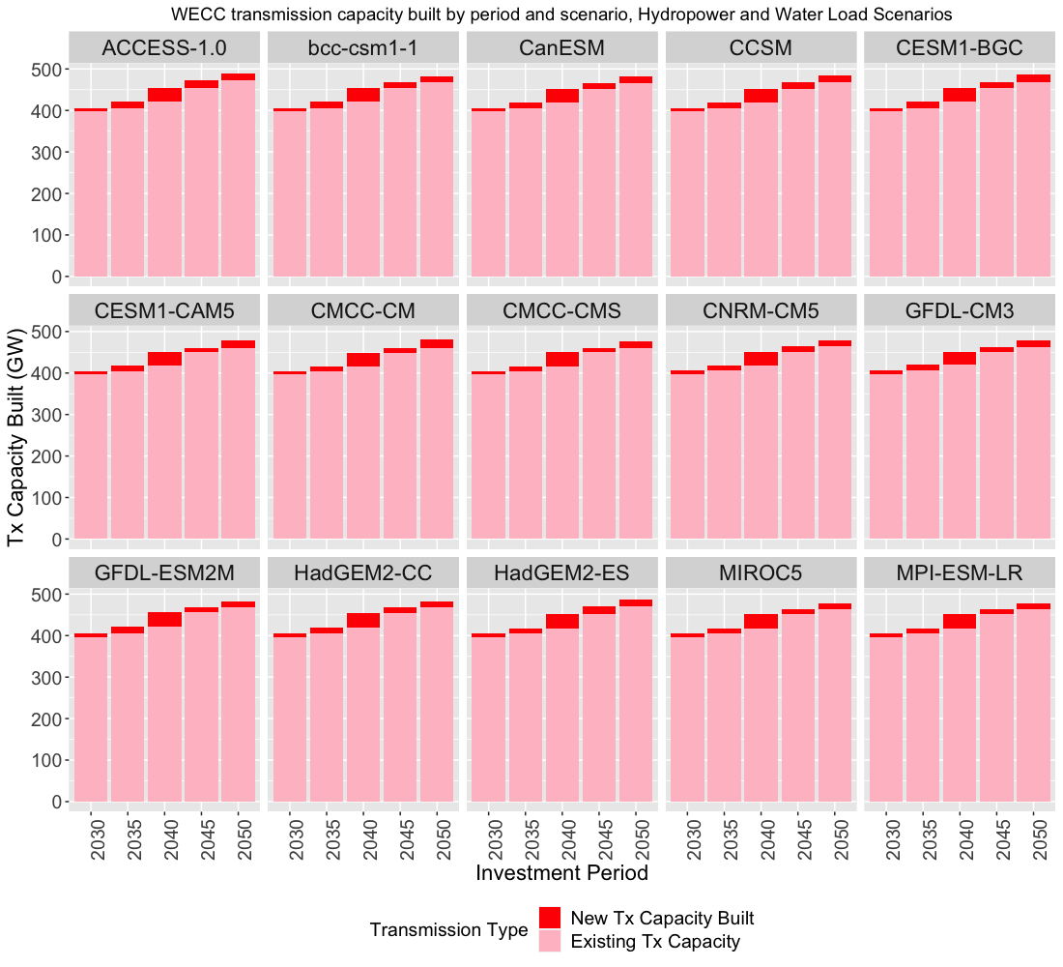  (f)
Supplementary Figure 3. Baseline and climate scenario results for capacity online, energy generation, and transmission capacity with climate impacts on hydropower and water-related load only included. (a) Baseline Scenario and (b) change in total generation capacity online by investment period 2030 – 2050 relative to Baseline Scenario. (c) Baseline scenario and (d) change in annual generation by investment period 2030 – 2050 relative to Baseline Scenario. The energy storage bars in (c) and (d) indicate discharge of battery storage (equivalent to energy generation). (e) Baseline Scenario and (f) Existing and new transmission capacity built in 2030 - 2050.

Climate projections
Supplementary Figure 4 summarizes compared to historical climate data¹, the climate projection ensemble average of the “raw” daily precipitation (a) and temperature (b) data from the 15 GCMs (ACCESS-1.0, CCSM, CESM-BGC, CMCC-CMS, CMCC-CM, CESM-CAM5, CNRM-CM5, CanESM, GFDL-CM3, GFDL-ESM2M, HadGEM2-CC, HadGEM2-ES, MIROC5, MPI-ESM-LR, bcc-csm1-1) for 2020 – 2060, before downscaling and bias correction. Across the ensemble, drying is concentrated in the Southern half of the WUS, while the Pacific Northwest sees increases in precipitation. Temperatures rise across the entire WUS, but at a higher rate in the Inter-Mountain West, and to a lesser extent in coastal areas. We note that the climate scenarios in this analysis use the LOCA downscaled and bias corrected projections from this ensemble for the climate scenarios.
(a)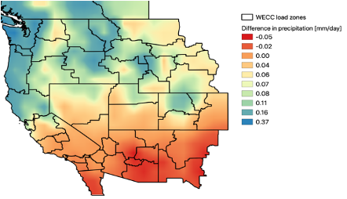 | (b)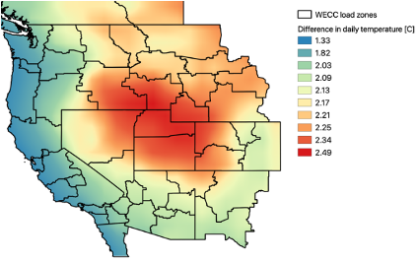
Supplementary Figure 4. Ensemble difference in average daily precipitation and daily temperature from historical average. (a) Ensemble difference in daily precipitation in [mm/day]. (b) Ensemble difference in average daily temperature [ºC] from historical average. The ensemble values are annual average values of daily precipitation and temperature for 2020 – 2060 across all 15 GCMs (ACCESS-1.0, CCSM, CESM-BGC, CMCC-CMS, CMCC-CM, CESM-CAM5, CNRM-CM5, CanESM, GFDL-CM3, GFDL-ESM2M, HadGEM2-CC, HadGEM2-ES, MIROC5, MPI-ESM-LR, bcc-csm1-1), and these are subtracted from annual average values from Livneh 1980 – 2010 historical data at the 1º resolution. These maps have been resampled to a higher resolution using a nearest neighbors approach for the purposes of illustration.

Methodological details

The WWSM model and the load change analysis
A detailed description of the WWSM, its inputs, and its outputs under the ensemble of 15 climate projections is provided in a prior study.² A detailed description of the parameters for load change per change in Cooling Degree Day (CDD) and Heating Degree Day (HDD) is provided in a prior study³. Supplementary Figure 5 below illustrates the spatial patterns of those load change parameters since we have mapped them from the original National Renewable Energy Laboratory Regional Energy Deployment System (ReEDS) zones to the SWITCH load zones, for 2050.
(a) | (b)
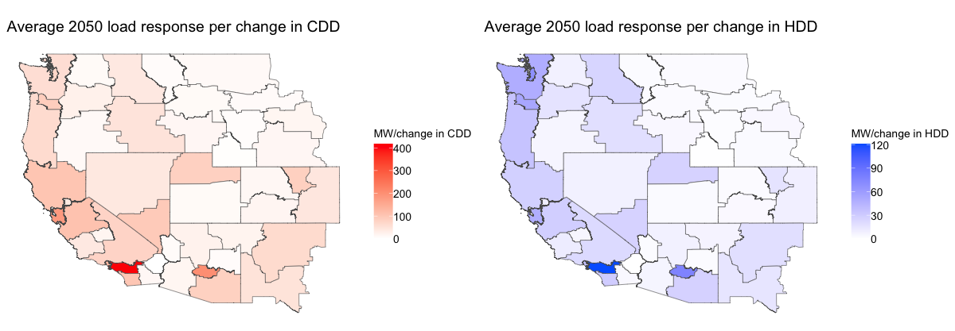
Supplementary Figure 5. Average load responses for cooling and heating by load zone. (a) Average 2050 load response (MW) per change in Cooling Degree Day (CDD). (b) Average 2050 load response (MW) change in Heating Degree Day (HDD). The load responses have been averaged across all the time points in 2050 for each SWITCH load zone, and were interpolated spatially from the parameters originally calculated for the ReEDS model load zones.

Overview of SWITCH model and input data
To optimize long-term energy system buildout under climate projections and given water sector adaptations, we use the capacity expansion model SWITCH. SWITCH is an open-source model with high spatial and temporal resolution designed to plan a system with high levels of renewable resources ⁴, and has been used to evaluate system expansion in several case studies of the Western U.S. ^{5–7}. We build on the SWITCH 2.0 (Python) version from a recent study ⁴, and use an academic license of the Gurobi solver ⁸, to evaluate the optimal generation and transmission capacity expansion decisions for the Western Interconnect or Western Electricity Coordinating Council (WECC) region out to 2050. SWITCH makes investment and operations decisions for five time periods and a sample of hours per period between 2030 and 2050. The objective function minimizes the expected value of the total net present value of generation and transmission operations and investment. We describe the objective function and main constraints of the optimization model ⁴, as well as the input data and assumptions used for the analysis below. A detailed description and full mathematical formulation of the SWITCH model is described in a prior paper and its accompanying Supplemental Materials ⁴.

Objective function
In this analysis we use a deterministic linear formulation of SWITCH to optimize the investment and operations of generation and transmission capacity. The objective function is the total net present value (NPV) cost of the power system (investment and operations). The key decision variables include investment in generation and transmission capacity (BuildGen and BuildTx, in MW of capacity built of each generator and transmission line, respectively for each investment period among the set of available candidate generators and transmission lines), and dispatch (DispatchGen and DispatchTx, hourly generation and transmission line flows for each generator and transmission line online in that period). In addition, the model decides the energy capacity for building battery storage (BuildStorageEnergy in MWh), and when and how much batteries charge and discharge (ChargeStorage). Transmission flows between load zones are represented as a simple “transport” model, where flows (a decision variable) between zones are constrained by line limits which are an aggregation of the limits of individual lines between regions. This simplification maintains a linear model, rather than including a representation of non-linear and computationally expensive AC power-flow.
$$min\sum_{p∈P}{d_{p}\left\{\sum_{c^{f}∈C^{fixed}}{c_{p}^{f}}+\sum_{t∈T_{p}}{w_{t}^{year}\sum_{c^{v}∈C^{var}}{c_{t}^{v}}}\right\}}$$
Where:
$d_{p}=$ discounting factor, which first converts annual payments into a lump sum equivalent at the beginning of an investment period, and then converts all costs into NPV terms. In this analysis we use an interest rate r of 5%, and all costs have a baseyear of 2018. The formula for the factor is below, where  is the number of years in each period (5 years in this analysis), and $st_{p}$ is the start year of each period.
$$d_{p}=\frac{1-{\left(1+r\right)}^{-y_{p}}}{r}*{\left(1+r\right)}^{-\left(st_{p}-baseyear\right)}$$
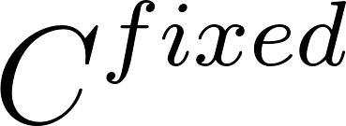 = is the set of fixed costs components indexed for each period $c_{p}^{f}$, which include capital costs (overnight cost to construct generation, transmission, and storage capacity) and fixed operations and maintenance (O&M) for online generators. These costs are in $/MW-year.
$w_{t}^{year}$ is the weight in the period of each sampled time point t.
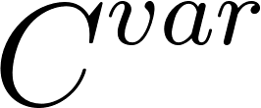 is the set of variable costs indexed for each time point $c_{t}^{v}$, including fuel costs for generators and variable O&M costs, in $/MWh (non-discounted real dollars).
The optimization is subject to a number of constraints, including the main ones listed below.

Investment-related constraints
Capacity investments in generation, for each generator and period $K_{g,p}^{G}$, cannot exceed cumulative limits on available capacity $k̅_{g}^{G}$ for that particular generator:
$$K_{g,p}^{G}≤k̅_{g}^{G}$$
Additional constraints track the level of existing capacity, cumulative installed capacity over subsequent periods, and retired capacity. Fixed costs for generator capacity (overnight, connection, and fixed O&M costs) are calculated based on $K_{g,p}^{G}$.
Costs for transmission capacity built are calculated based on the $K_{l,p}^{L}$, the cumulative transfer capacity of each line, capital costs per MW per km, length of each line, and cost multipliers that account for varying terrain and economic costs along each transmission corridor.

Operations-related constraints
In each load zone, power withdrawals $p_{z,t}^{w}$ (from electricity demand, charging storage, and exports to other load zones) must equal power injections $p_{z,t}^{i}$ (from generation, discharging storage, and imports from other zones) for each time point:
$$min\sum_{p∈P^{inject}}{p_{z,t}^{i}}=\sum_{p∈P^{withdraw}}{p_{z,t}^{w}}$$
At each time point, the dispatch of generation $P_{g,t}$cannot exceed available capacity $K_{g,t,p}$ given forced outage rates $η_{g}$, and transmission flows $F_{l,t}$ cannot exceed available line limits given available transmission capacity in that period and transmission efficiency derating factors ${(η}_{l}*K_{l,p}$):
$$0≤P_{g,t}≤η_{g}K_{g,tp}$$
$$0≤F_{l,t}≤η_{l}K_{l,p}$$
There are special dispatch constraints specific to different generator types:
1) Solar PV and Wind: hourly generation cannot exceed the exogenously determined hourly capacity factor $η_{g,t}$
$$0≤P_{g,t}≤η_{g,t}η_{g}K_{g,t,p}$$
2) Hydropower: average generation across all the time points (hours) of a day must match historical average generation $p_{g,s}^{h,avg}$of that month, and exceed the minimum generation $p_{g,s}^{h,min}$ of that month (in our analysis we sample 24 hourly timepoints for each day-long timeseries):
$$P_{g,t}≥p_{g,s}^{h,min}$$
$$\frac{1}{num_{s}}*\sum_{t∈T_{s}}{P_{g,t}}=p_{g,s}^{h,avg}$$
3) Battery storage: charging $C_{g,t}$ and the state of charge $Z_{g,t}$ are limited by installed capacity (in MW as with other generators and in MWh, $K_{g,p}^{S}$ and charging rates relative to maximum power output rate $r_{g}^{max}$, and batteries must balance charging and discharging over a given time period, subject to round-trip charging efficiency $η_{g}$. In this analysis we assume the battery must be balanced over the course of a day, the round-trip efficiency is 75%, and the charging rate is equal to the maximum power output ($r_{g}^{max} = 1$).
$$0≤C_{g,t}≤r_{g}^{max}*P_{g,t}$$
$$0≤Z_{g,t}≤K_{g,p}^{S}$$
This equation tracks the state of charge depending on charging and discharging rates in each timepoint.
$$0≤Z_{g,t}=Z_{g,t-1}+\left(η_{g}C_{g,t}-P_{g,t}\right)δ_{t}^{T}$$
4) To maintain grid reliability, SWITCH includes a planning reserve requirement. During the peak load hour of the year, the total available capacity must meet or exceed a percentage $k_{π}$ (defaults to 15%) above peak load $l_{z,t}$ in a given “reserves zone.” To contribute towards this reserve requirement $r_{π,t}^{r}$, capacity $r_{π,t}^{c}$ is credited to generators based on their installed capacity, and to battery storage based on the expected discharging output available at the peak hour in the reserves zone. Imports across transmission lines into the reserves zone are credited similarly to storage, based on the expected flows during the peak hour. We define reserves zones as the set of load zones for the same utility (i.e. all the load zones comprising the Southern California Edison, SCE, service territory). In this analysis fossil generators are still allowed to provide capacity for reserves to meet the planning reserve requirement, even with the 2050 carbon cap, but this is an area for future sensitivity analysis.
$$r_{π,t}^{r}=\left(1+k_{π}\right)*l_{z,t}$$
$$\sum_{r^{c}∈R^{cap}}{r_{π,t}^{c}}≥\sum_{r^{r}∈R^{req}}{r_{π,t}^{r}}$$

Policy-related constraints
SWITCH includes constraints to represent state Renewable Portfolio Standard (RPS) requirements for each period, whereby a mandated percentage ($rps_{p}$) of annual load must be met with generation from renewable sources over the year $P_{g,t}w_{t}^{period}$(from non-fuel sources and renewable fuels). All generation from renewable sources is summed and must equal or equal or exceed the RPS requirement times the annual load for each zone:
$$\sum_{g∈G_{r}}{\sum_{t∈T_{g,p}}{P_{g,t}w_{t}^{period}}}≥\sum_{t∈T_{p}}{\sum_{z∈Z}{l_{z,t}}}w_{t}^{period}$$
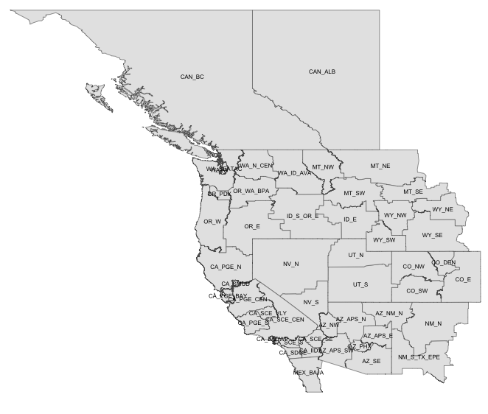
Annual carbon emissions ($AnnualEmissions_{p}$) calculated based on the emissions intensity of fuel in tCO₂/MMBtu $ξ_{f}$ and dispatch (MWh) and heat rate 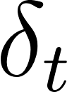 (MMBTu/MWh), must not exceed the specified carbon cap in tons of CO₂/year for that investment period ($cap_{p}$). A carbon cap is specified for California and for all the WECC region.:
$$AnnualEmissions_{p}=\sum_{g∈G^{F}}{\sum_{f∈ε_{g}^{F}}{\sum_{t∈T_{g}∩T_{p}}{δ_{t}R_{g,t,f}}x}\left(ξ_{f}\right)}$$
$$AnnualEmissions_{p}≤cap_{p}$$

Geographic and temporal resolution
Supplementary Figure 6. Map of SWITCH load zones in the WECC region.
The WECC study area of this analysis is divided up into 50 “load zone” regions, covering all or parts of Washington, Oregon, California, Arizona, Nevada, New Mexico, Utah, Idaho, Montana, Wyoming, Colorado, and Texas in the US; British Columbia and Alberta in Canada; and the northern portion of Baja California in Mexico (Supplementary Figure 6). Load zone boundaries were used from prior SWITCH-WECC analyses ^{5,6}, which constructed the regions based on state lines, North American Electric Reliability Corporation (NERC) control areas, utility service territory boundaries, and high-population metropolitan areas. Some utility service territories were divided into multiple zones if there was a large amount of high-voltage transmission connectivity existing within the same service territory (i.e. CA_PGE_BAY, CA_PGE_CEN, CA_PGE_S, CA_PGE_N for Pacific Gas & Electric or PG&E). The boundaries were also constructed to represent zones that are unlikely to have transmission congestion within the zone (since only transmission between zones is included), and between which there has historically been transmission congestion (reflecting pathways where additional transmission may be needed).
The temporal resolution of the analysis includes 5 investment periods, each of a five-year duration: 2030 (covering 2028 – 2032), 2035 (covering 2033 - 2037), 2040 (covering 2038 – 2042), 2045 (covering 2043 – 2047), and 2050 (covering 2048 – 2052). The duration of these investment periods reflect the typical planning horizon of a utility, and the length of time often needed to plan and build generation and transmission infrastructure. Because of computation limitations on simulating both investment and detailed hourly operations, a sample of 576 hours is selected to represent the typical grid dispatch for each investment period. For one year per period, for 2 days of each of 12 months, a 1-hour duration time slice is sampled for 24 hours of the day. The hours are sampled from the peak and median load day of each month. In total, 2880 hours are simulated (5 periods x 1 year/period x 12 months/year x 2 days/month x 24 hours/day = 2880 hours). The SWITCH dispatch results (i.e. costs, generation, transmission flows, emissions, etc.) related to each of these sampled hours is multiplied with an hourly weight, the share of all hours in the year that is represented by that hour, to calculate the typical annual value (i.e. annual operating cost, generation, transmission flow, emissions, etc.). The hours sampled from the peak day of each month have a “day” weight of 1, while the hours sampled from the median day have a “day” weight of the number of days of the month minus 1. This sampling strategy is adopted from prior SWITCH WECC studies which conducted a “dispatch verification” analysis that tested the sensitivity of results compared to hourly simulations (where all 8760 hours per year were simulated), finding that the buildout of the grid was still robust and did not violate constraints on peak and average days ⁶.

Generators

Existing generators
As inputs into SWITCH, we include the list of individual generators that are existing and/or are planned for the WECC region. For the US portion of WECC, we extract the list of generators and their characteristics (such as location, fuel source, generating technology, online year, and retirement year if any) from the Energy Information Administration (EIA) Form 860 ⁹. At the time of the data collection (in late 2019/early 2020), the latest complete year of data was the 2018 EIA Form 860. We include generators from this form that are flagged with any of these statuses: operating, standby/backup, new unit under construction, cold standby, out of service but will be returned to service, construction complete but not yet in commercial operation, not under construction but site prep underway, and under construction. Generators are assigned to load zones based on their latitude and longitude.
The EIA Form 860 also includes planned retirement years for generators, if known. Generators are not allowed to operate beyond their expected lifetime, and therefore planned retirement years are used to calculate the lifetime of the plant to be included in the SWITCH runs. Monthly data was used from more recent Form 860 data to confirm that there were no additional planned retirements. For generators with no known retirement years, we assign a default maximum lifetime based on the generating technology (Table 2).
For thermal generators, we join the list of generators from Form 860 with the monthly generation and fuel use from the EIA Form 923, for the available years 2004 – 2018 at the time of data collection¹⁰. We use the historical monthly generation and fuel use from Form 923 to calculate the second-best (or second-lowest) heat rate (MMBtu/MWh) for each generator, avoiding any outliers from the best heat rate. This heat rate is then used in the SWITCH dispatch optimization to calculate the fuel use and associated variable cost and emissions from dispatching thermal generators.
Hydropower generators are constrained to generate at their average historical monthly capacity factor ⁵. We extract the monthly generation by generator from 2004 – 2018 (the most recent complete data at the time of the analysis) from the Form 923. For each generator, we calculate the average power for each month (monthly generation/hours in month) and estimate that the proxy for minimum flows for each generator is the power generated at half the average monthly level. For the SWITCH Baseline Scenario (without climate change), for each generator we calculate the average monthly power (and minimum flow power) over the years 2004 – 2018. These average values are repeated for all future investment periods of the SWITCH simulation (from 2030 – 2050). Monthly hydropower capacity factors by generator for the Canadian load zones (British Columbia and Alberta) are used from the prior SWITCH database, based on data from Statistics Canada Tables ⁵.
The set of existing generators for the Canadian and Mexican load zones are used from the data previously compiled for prior SWITCH-WECC analysis, originally from the WECC Transmission Expansion Planning Policy Committee database of generators, and were not updated for this study ^{5,7}.

Candidate generators
One of the key decision variables in SWITCH is the capacity investment of generation, out of a set of candidate generators with specific generating technologies and fuel sources, load zone locations, and other physical and financial generating characteristics. We use the dataset of candidate generators that was previously compiled in prior SWITCH-WECC analyses ^{7,5,6}.
Candidate onshore and offshore wind generators were derived based on wind power output from a gridded 3TIER Western Wind and Solar Integration Study dataset ¹¹ and a gridded Canadian wind developer dataset, and a selection of prime sites based on criteria including high wind energy density, and proximity to transmission ⁵. A portion of candidate generators were screened out in California if they were in “Category 3, high environmental risk” locations, which include areas legally excluded for development, protected areas with ecological or social value, conservation regions, and prime agricultural land ¹².
Candidate solar generators include Residential PV (rooftop PV on homes), Commercial PV (rooftop PV on commercial buildings), Central PV (utility-scale), and Concentrating Solar Power with and without storage (solar thermal trough systems with or without thermal energy storage). Distributed Residential and Commercial PV candidate generation had been derived based on a gridded population density dataset, solar insolation data from NREL’s (now deprecated) Solar Prospector tool, and assumptions on rooftop area and solar cell characteristics ⁵. Available land and capacity for Central PV and Concentrating Solar Power candidate generators were screened based on land exclusion criteria (including national parks, wildlife areas, and steep terrain), solar insolation from the System Advisor Model from the National Renewable Energy Laboratory ¹³, and assumptions on the solar technology characteristics ⁵.
To simulate the dispatch of wind and solar generators, we use an exogenous dataset of hourly capacity factors by generator that had been constructed in prior SWITCH analyses ^{5,6}. For wind generators, hourly capacity factors for the candidate generator set were calculated from the 3TIER Western Wind and Solar Integration Study wind speed dataset ¹¹ using idealized turbine power curves. For solar generators, hourly capacity factors for the candidate generator set are calculated from the System Advisor, using data from 2006 (consistent with the base weather year underlying the load profiles) ¹³. Central PV and onshore wind generators with capacity-weighted average capacity factors below the 75th percentile for their technology were screened out to only have the candidate set among a computationally tractable, and commercially viable, set of higher-quality resource sites ⁵. For existing solar and wind generators, we average the hourly capacity factors for all solar and wind generators, respectively, in each load zone, and assign all the generators in that load zone the average capacity factor for the given technology.
Biogas (from landfill, wastewater treatment plants, and manure) candidate generator availability is derived from an assessment of the technical resource/feed stock availability ¹⁴. Bioliquid generators are allowed to be reinstalled in their current locations but no new bioliquid plants are assumed. No new biomass (bio solid) candidate generators are assumed, but cogeneration bio solid generation is allowed to be reinstalled at the end of its lifetime ⁵. Candidate geothermal generators are based on the current locations and capacity of existing plants that may be reinstalled after retirement ⁵. We assume there is no candidate hydropower generation.
Natural gas combined cycle generators and combustion turbines do not have imposed maximum capacity limits. Coal generators are not allowed to be installed in California but are otherwise allowed to expand without capacity limits. Cogeneration plants (with gas combined cycle or combustion turbine plants) are given the option to be reinstalled at current locations after reaching their maximum age, at current capacity limits. We assume that there is no new candidate nuclear generation available.
Battery storage is available for installation in all load zones and investment periods, without capacity limits. An AC-DC-AC storage efficiency of 75%, a lifetime of 10 years, and a variable O&M cost of 0 is assumed, consistent with prior SWITCH analyses ⁵. We model all battery storage as 4-hour duration, by setting the ratio of energy to power of storage to 4. Long duration energy storage is not included in this analysis but will be the subject of future research.
Supplementary Table 1 summarizes the maximum capacity available for the set of candidate generators, and the capacity installed for existing generators.
Supplementary Table 1. WECC total available capacity of existing and candidate generation.
Existing or Candidate Generator | Energy Source | Generation Technology | Capacity Limit (GW)
Existing Generator | Biogas | Biogas | 0.2
Existing Generator | Biogas | Biogas Internal Combustion Engine | 0.3
Existing Generator | Biogas | Biogas Internal Combustion Engine Cogen | 0.2
Existing Generator | Biogas | Biogas Steam Turbine | 0.1
Existing Generator | Bio Liquid | Bio Liquid Steam Turbine Cogen | 0.4
Existing Generator | Bio Solid | Bio Solid Steam Turbine | 0.6
Existing Generator | Bio Solid | Bio Solid Steam Turbine Cogen | 0.5
Existing Generator | Coal | Coal Steam Turbine | 42.2
Existing Generator | Coal | Coal Steam Turbine Cogen | 0.3
Existing Generator | Distillate Fuel Oil | Distillate Fuel Oil Combustion Turbine | 0.4
Existing Generator | Distillate Fuel Oil | Distillate Fuel Oil Internal Combustion Engine | 0.4
Existing Generator | Electricity | Battery Storage | 1.1
Existing Generator | Gas | CCGT | 54.8
Existing Generator | Gas | CCGT Cogen | 7.7
Existing Generator | Gas | Gas Combustion Turbine | 23.6
Existing Generator | Gas | Gas Combustion Turbine Cogen | 4.3
Existing Generator | Gas | Gas Internal Combustion Engine | 1.1
Existing Generator | Gas | Gas Internal Combustion Engine Cogen | 0.4
Existing Generator | Gas | Gas Steam Turbine | 16.0
Existing Generator | Gas | Gas Steam Turbine Cogen | 0.3
Existing Generator | Gas | Other Turbine | 0.0
Existing Generator | Geothermal | Geothermal | 4.5
Existing Generator | Residual Fuel Oil | Gas Combustion Turbine | 0.2
Existing Generator | Solar | Central PV | 22.0
Existing Generator | Solar | Concentrating Solar Power Trough, No Storage | 0.4
Existing Generator | Solar | Steam Turbine | 1.4
Existing Generator | Uranium | Nuclear | 7.7
Existing Generator | Waste Heat | Other Turbine | 0.0
Existing Generator | Waste Heat | Steam Turbine | 0.2
Existing Generator | Water | Hydropower | 63.3
Existing Generator | Water | Pumped Storage | 4.3
Existing Generator | Wind | Onshore Wind | 27.3
Existing Generator | Total |  | 286.0
Candidate Generators | Biogas | Biogas | 0.0
Candidate Generators | Biogas | Biogas Internal Combustion Engine Cogen | 0.1
Candidate Generators | Bio Liquid | Bio Liquid Steam Turbine Cogen | 0.3
Candidate Generators | Bio Solid | Bio Solid Steam Turbine Cogen | 0.4
Candidate Generators | Coal | Coal Integrated Gasification Combined Cycle (IGCC) | Not limited, except not allowed in CA
Candidate Generators | Coal | Coal Steam Turbine | Not limited, except not allowed in CA
Candidate Generators | Coal | Coal Steam Turbine Cogen | 0.7
Candidate Generators | Electricity | Battery Storage | Not limited
Candidate Generators | Gas | Combined Cycle Gas Turbine (CCGT) | Not limited
Candidate Generators | Gas | CCGT Cogen | 6.9
Candidate Generators | Gas | Gas Combustion Turbine | Not limited
Candidate Generators | Gas | Gas Combustion Turbine Cogen | 4.6
Candidate Generators | Gas | Gas Internal Combustion Engine Cogen | 0.1
Candidate Generators | Gas | Gas Steam Turbine Cogen | 0.3
Candidate Generators | Geothermal | Geothermal | 11.1
Candidate Generators | Solar | Central PV | 3,270.2
Candidate Generators | Solar | Commercial PV | 52.7
Candidate Generators | Solar | Concentrating Solar Power Trough, 6 hours storage | 3,695.3
Candidate Generators | Solar | Concentrating Solar Power Trough, No Storage | 5,362.5
Candidate Generators | Solar | Residential PV | 125.3
Candidate Generators | Wind | Offshore Wind | 6.4
Candidate Generators | Wind | Onshore Wind | 521.4
Candidate Generators | Total |  | 13,058.2

Technology assumptions on lifetime, capacity factors, efficiencies
For all existing generators and candidate generators, we assume the following default technology assumptions based on the generating technology and fuel source (Supplementary Table 2), primarily based on the technology and cost assumptions from Black & Veatch ¹⁵ and a CEC Cost of Generation Report collected in the prior SWITCH analyses ^{5,7} and converted to $2018, with some technology values (natural gas combined cycle, natural gas turbine, battery, wind, solar PV, solar CSP, and geothermal) updated based on NREL’s 2020 Annual Technology Baseline ¹⁶. For existing generators with known planned retirement years, a specific lifetime is calculated.
Supplementary Table 2. Technology assumptions for existing and candidate generators.
Fuel Source | Generating Technology | Lifetime (Years) | Forced Outage Rate (%) | Scheduled Outage Rate (%)
Biogas | Biogas | 20 | 4% | 6%
Biogas | Biogas Internal Combustion Engine | 20 | 4% | 6%
Biogas | Biogas Internal Combustion Engine Cogen | 20 | 11% | 4%
Biogas | Biogas Steam Turbine | 20 | 13% | 9%
Bio Liquid | Bio Liquid Steam Turbine Cogen | 40 | 13% | 9%
Bio Solid | Bio Solid Steam Turbine | 20 | 4% | 6%
Bio Solid | Bio Solid Steam Turbine Cogen | 40 | 13% | 9%
Coal | Coal IGCC | 40 | 8% | 12%
Coal | Coal Steam Turbine | 40 | 4% | 6%
Coal | Coal Steam Turbine Cogen | 40 | 6% | 10%
Distillate Fuel Oil | Distillate Fuel Oil Combustion Turbine | 40 | 4% | 6%
Distillate Fuel Oil | Distillate Fuel Oil Internal Combustion Engine | 20 | 4% | 6%
Electricity | Battery Storage | 10 | 2% | 1%
Gas | CCGT | 40 | 4% | 6%
Gas | CCGT Cogen | 20 | 4% | 6%
Gas | Gas Combustion Turbine | 40 | 4% | 6%
Gas | Gas Combustion Turbine Cogen | 20 | 3% | 5%
Gas | Gas Internal Combustion Engine | 20 | 4% | 6%
Gas | Gas Internal Combustion Engine Cogen | 20 | 3% | 5%
Gas | Gas Steam Turbine | 60 | 4% | 6%
Gas | Gas Steam Turbine Cogen | 40 | 13% | 9%
Gas | Other Turbine | 40 | 4% | 6%
Geothermal | Geothermal | 20 | 0% | 0%
Residual Fuel Oil | Gas Combustion Turbine | 40 | 4% | 6%
Solar | Central PV | 20 | 0% | 0%
Solar | Commercial PV | 20 | 0% | 0%
Solar | Concentrating Solar Power Trough 6h Storage | 20 | 6% | 0%
Solar | Concentrating Solar Power Trough No Storage | 20 | 0% | 0%
Solar | Residential PV | 20 | 0% | 0%
Solar | Steam Turbine | 20 | 4% | 6%
Uranium | Nuclear | 80 | 4% | 6%
Waste Heat | Other Turbine | 40 | 4% | 6%
Waste Heat | Steam Turbine | 40 | 4% | 6%
Water | Hydropower | 200 | 5% | 5%
Water | Pumped Storage | 200 | 5% | 5%
Wind | Offshore Wind | 20 | 5% | 1%
Wind | Onshore Wind | 20 | 0% | 0%

Transmission
The SWITCH optimization includes the construction of new transmission lines and the operations of existing and new transmission as decision variables. The model includes a set of 105 existing aggregated transmission lines between load areas within the WECC, based on a prior SWITCH analyses that aggregated the thermal limits of individual high-voltage lines between load areas from a Ventyx purchased dataset and Federal Energy Regulatory Commission (FERC) data ⁵. New transmission capacity may be added to existing transmission corridors or constructed between 20 adjacent load zone pairs where there is currently no transmission. The line length assumed is 1.3 times the straight-line distance between the largest substations in each load zone, based on a prior analysis that calculated this as the average ratio between line length and straight-line distance between transmission substations in WECC ⁵. For every 100 miles of distance, a 1% efficiency loss is assumed, based on typical losses for high-voltage transmission ¹⁷. For both existing and newly constructed transmission lines, the maximum power transfer on each line is the thermal limit multiplied by a derating factor. The 0.95 derating factor for alternating current (AC) lines is from a prior SWITCH analysis and is meant to capture the combined effect of stability concerns, loop flows, voltage concerns, power factors less than unity, and overloading of individual transmission lines within the bundle, that are difficult to model in detail in the linear model ⁵.

Costs

Overnight capital cost, variable O&M cost, fixed O&M cost
The SWITCH optimization includes several types of costs in the decision to invest and/or operate in generation. Costs for candidate generators include overnight capital cost (applied to the built capacity), fixed O&M costs per MW-year of operations, and variable O&M costs per MWh of operation. Mature technologies (biogas, bioliquid, biosolid, coal, gas cogeneration, gas steam turbine) are assumed to have their real costs stay constant over time, whereas other technologies are assumed to decrease costs over time with technology improvements and economies of scale. Capital, fixed O&M, and variable O&M costs by generator technology type originate primarily from Black & Veatch estimates for the mature technologies ^{5,15}. For technologies with changing costs over time (battery, solar PV, solar CSP, wind, geothermal, gas CCGT, gas CT), we compile cost data from NREL’s 2020 Annual Technology Baseline database using the “Moderate Scenario” which is based on the of median projections from the literature ¹⁶. For wind and central solar PV, we also account for lower overnight costs in the first investment period from the Production Tax Credit and Investment Tax Credit, respectively ^{18,19}. For battery storage, we separate out the capital costs into $/MW (balance of system battery cost) and $/MWh (battery pack cost which would be multiplied by the storage duration hours) costs ¹⁶. The costs we use assume a four-hour duration battery. The average costs by five-year investment period, energy source, and technology are in Supplementary Table 3. Capital costs for existing generators are considered sunk costs and we do not include them in the total system costs; they do not affect future investment decisions. Variable O&M costs for existing generators are set to be the same as for candidate generators. Costs do not include any additional incentives or changes related to the Inflation Reduction Act passed in 2022.
Supplementary Table 3. Average capital, fixed O&M, and variable O&M costs by investment period for candidate generation ($2018).
Energy Source | Generation Technology | Investment Period | Overnight capital cost ($/MW) | Fixed O&M cost ($/MW-year) | Variable O&M cost ($/MWh)
Bio Gas | Bio Gas | 2030 | 2,118,354 | 64,380 | 9.20
Bio Gas | Bio Gas | 2035 | 2,118,354 | 64,380 | 9.20
Bio Gas | Bio Gas | 2040 | 2,118,354 | 64,380 | 9.20
Bio Gas | Bio Gas | 2045 | 2,118,354 | 64,380 | 9.20
Bio Gas | Bio Gas | 2050 | 2,118,354 | 64,380 | 9.20
Bio Gas | Bio Gas Internal Combustion Engine Cogen | 2030 | 1,588,766 | 48,285 | 16.00
Bio Gas | Bio Gas Internal Combustion Engine Cogen | 2035 | 1,588,766 | 48,285 | 16.00
Bio Gas | Bio Gas Internal Combustion Engine Cogen | 2040 | 1,588,766 | 48,285 | 16.00
Bio Gas | Bio Gas Internal Combustion Engine Cogen | 2045 | 1,588,766 | 48,285 | 16.00
Bio Gas | Bio Gas Internal Combustion Engine Cogen | 2050 | 1,588,766 | 48,285 | 16.00
Bio Liquid | Bio Liquid Steam Turbine Cogen | 2030 | 3,225,737 | 80,012 | 16.80
Bio Liquid | Bio Liquid Steam Turbine Cogen | 2035 | 3,225,737 | 80,012 | 16.80
Bio Liquid | Bio Liquid Steam Turbine Cogen | 2040 | 3,225,737 | 80,012 | 16.80
Bio Liquid | Bio Liquid Steam Turbine Cogen | 2045 | 3,225,737 | 80,012 | 16.80
Bio Liquid | Bio Liquid Steam Turbine Cogen | 2050 | 3,225,737 | 80,012 | 16.80
Bio Solid | Bio Solid Steam Turbine Cogen | 2030 | 3,225,737 | 80,012 | 16.80
Bio Solid | Bio Solid Steam Turbine Cogen | 2035 | 3,225,737 | 80,012 | 16.80
Bio Solid | Bio Solid Steam Turbine Cogen | 2040 | 3,225,737 | 80,012 | 16.80
Bio Solid | Bio Solid Steam Turbine Cogen | 2045 | 3,225,737 | 80,012 | 16.80
Bio Solid | Bio Solid Steam Turbine Cogen | 2050 | 3,225,737 | 80,012 | 16.80
Coal | Coal Integrated Gasification Combined Cycle (IGCC) | 2030 | 4,503,135 | 34,924 | 7.34
Coal | Coal Integrated Gasification Combined Cycle (IGCC) | 2035 | 4,503,135 | 34,924 | 7.34
Coal | Coal Integrated Gasification Combined Cycle (IGCC) | 2040 | 4,503,135 | 34,924 | 7.34
Coal | Coal Integrated Gasification Combined Cycle (IGCC) | 2045 | 4,503,135 | 34,924 | 7.34
Coal | Coal Integrated Gasification Combined Cycle (IGCC) | 2050 | 4,503,135 | 34,924 | 7.34
Coal | Coal Steam Turbine | 2030 | 3,245,403 | 25,828 | 4.57
Coal | Coal Steam Turbine | 2035 | 3,245,403 | 25,828 | 4.57
Coal | Coal Steam Turbine | 2040 | 3,245,403 | 25,828 | 4.57
Coal | Coal Steam Turbine | 2045 | 3,245,403 | 25,828 | 4.57
Coal | Coal Steam Turbine | 2050 | 3,245,403 | 25,828 | 4.57
Coal | Coal Steam Turbine Cogen | 2030 | 2,434,058 | 19,371 | 4.20
Coal | Coal Steam Turbine Cogen | 2035 | 2,434,058 | 19,371 | 4.20
Coal | Coal Steam Turbine Cogen | 2040 | 2,434,058 | 19,371 | 4.20
Coal | Coal Steam Turbine Cogen | 2045 | 2,434,058 | 19,371 | 4.20
Coal | Coal Steam Turbine Cogen | 2050 | 2,434,058 | 19,371 | 4.20
Electricity | Battery Storage | 2030 | 148,998 | 20,838 | 0.0
Electricity | Battery Storage | 2035 | 136,955 | 19,154 | 0.0
Electricity | Battery Storage | 2040 | 127,825 | 17,877 | 0.0
Electricity | Battery Storage | 2045 | 118,695 | 16,600 | 0.0
Electricity | Battery Storage | 2050 | 111,390 | 15,579 | 0.0
Gas | CCGT | 2030 | 983,270 | 12,863 | 4.50
Gas | CCGT | 2035 | 964,052 | 12,863 | 4.50
Gas | CCGT | 2040 | 949,017 | 12,863 | 4.50
Gas | CCGT | 2045 | 934,888 | 12,863 | 4.50
Gas | CCGT | 2050 | 921,047 | 12,863 | 4.50
Gas | CCGT Cogen | 2030 | 1,035,945 | 5,314 | 4.12
Gas | CCGT Cogen | 2035 | 1,035,945 | 5,314 | 4.12
Gas | CCGT Cogen | 2040 | 1,035,945 | 5,314 | 4.12
Gas | CCGT Cogen | 2045 | 1,035,945 | 5,314 | 4.12
Gas | CCGT Cogen | 2050 | 1,035,945 | 5,314 | 4.12
Gas | Gas Combustion Turbine | 2030 | 898,070 | 11,395 | 2.16
Gas | Gas Combustion Turbine | 2035 | 879,375 | 11,395 | 2.16
Gas | Gas Combustion Turbine | 2040 | 866,097 | 11,395 | 2.16
Gas | Gas Combustion Turbine | 2045 | 853,766 | 11,395 | 2.16
Gas | Gas Combustion Turbine | 2050 | 841,582 | 11,395 | 2.16
Gas | Gas Combustion Turbine Cogen | 2030 | 548,292 | 4,430 | 33.58
Gas | Gas Combustion Turbine Cogen | 2035 | 548,292 | 4,430 | 33.58
Gas | Gas Combustion Turbine Cogen | 2040 | 548,292 | 4,430 | 33.58
Gas | Gas Combustion Turbine Cogen | 2045 | 548,292 | 4,430 | 33.58
Gas | Gas Combustion Turbine Cogen | 2050 | 548,292 | 4,430 | 33.58
Gas | Gas Internal Combustion Engine Cogen | 2030 | 565,136 | 4,430 | 33.58
Gas | Gas Internal Combustion Engine Cogen | 2035 | 565,136 | 4,430 | 33.58
Gas | Gas Internal Combustion Engine Cogen | 2040 | 565,136 | 4,430 | 33.58
Gas | Gas Internal Combustion Engine Cogen | 2045 | 565,136 | 4,430 | 33.58
Gas | Gas Internal Combustion Engine Cogen | 2050 | 565,136 | 4,430 | 33.58
Gas | Gas Steam Turbine Cogen | 2030 | 418,841 | 26,717 | 4.46
Gas | Gas Steam Turbine Cogen | 2035 | 418,841 | 26,717 | 4.46
Gas | Gas Steam Turbine Cogen | 2040 | 418,841 | 26,717 | 4.46
Gas | Gas Steam Turbine Cogen | 2045 | 418,841 | 26,717 | 4.46
Gas | Gas Steam Turbine Cogen | 2050 | 418,841 | 26,717 | 4.46
Geothermal | Geothermal | 2030 | 7,657,557 | 173,486 | 0.0
Geothermal | Geothermal | 2035 | 7,439,487 | 173,105 | 0.0
Geothermal | Geothermal | 2040 | 7,255,350 | 173,105 | 0.0
Geothermal | Geothermal | 2045 | 7,075,771 | 173,105 | 0.0
Geothermal | Geothermal | 2050 | 6,935,197 | 173,105 | 0.0
Solar | Central PV | 2030 | 862,956 | 10,106 | 0.0
Solar | Central PV | 2035 | 799,236 | 9,360 | 0.0
Solar | Central PV | 2040 | 762,088 | 8,925 | 0.0
Solar | Central PV | 2045 | 724,940 | 8,490 | 0.0
Solar | Central PV | 2050 | 695,221 | 8,142 | 0.0
Solar | Commercial PV | 2030 | 1,072,404 | 7,689 | 0.0
Solar | Commercial PV | 2035 | 976,987 | 7,005 | 0.0
Solar | Commercial PV | 2040 | 916,606 | 6,572 | 0.0
Solar | Commercial PV | 2045 | 856,224 | 6,139 | 0.0
Solar | Commercial PV | 2050 | 807,919 | 5,793 | 0.0
Solar | CSP Trough 6h Storage | 2030 | 4,936,304 | 53,458 | 3.59
Solar | CSP Trough 6h Storage | 2035 | 4,459,444 | 52,447 | 3.59
Solar | CSP Trough 6h Storage | 2040 | 4,208,274 | 52,447 | 3.59
Solar | CSP Trough 6h Storage | 2045 | 4,081,775 | 52,447 | 3.59
Solar | CSP Trough 6h Storage | 2050 | 4,004,187 | 52,447 | 3.59
Solar | CSP Trough No Storage | 2030 | 4,682,402 | 56,149 | 0.0
Solar | CSP Trough No Storage | 2035 | 4,476,765 | 56,149 | 0.0
Solar | CSP Trough No Storage | 2040 | 4,268,248 | 56,149 | 0.0
Solar | CSP Trough No Storage | 2045 | 4,063,821 | 56,149 | 0.0
Solar | CSP Trough No Storage | 2050 | 3,894,478 | 56,149 | 0.0
Solar | Residential PV | 2030 | 1,207,786 | 9,058 | 0.0
Solar | Residential PV | 2035 | 1,057,875 | 7,934 | 0.0
Solar | Residential PV | 2040 | 991,136 | 7,434 | 0.0
Solar | Residential PV | 2045 | 924,396 | 6,933 | 0.0
Solar | Residential PV | 2050 | 871,005 | 6,533 | 0.0
Wind | Offshore Wind | 2030 | 2,719,755 | 112,298 | 0.0
Wind | Offshore Wind | 2035 | 2,537,575 | 112,298 | 0.0
Wind | Offshore Wind | 2040 | 2,413,209 | 112,298 | 0.0
Wind | Offshore Wind | 2045 | 2,294,938 | 112,298 | 0.0
Wind | Offshore Wind | 2050 | 2,204,359 | 112,298 | 0.0
Wind | Onshore Wind | 2030 | 1,242,532 | 38,988 | 0.0
Wind | Onshore Wind | 2035 | 1,177,088 | 37,489 | 0.0
Wind | Onshore Wind | 2040 | 1,126,280 | 36,029 | 0.0
Wind | Onshore Wind | 2045 | 1,074,244 | 34,568 | 0.0
Wind | Onshore Wind | 2050 | 1,031,764 | 33,400 | 0.0

Connection costs
In addition to capital costs for the construction of a generator itself, for candidate generators we also add a connection cost to reflect the expense of connecting to the grid. This connection cost originally derived from EIA data and compiled in a prior SWITCH analysis ⁵ is either a “generic” cost if the generator is not located at a specific site (for gas, coal, biosolid, biogas, or battery storage), or is calculated for a specific site (for onshore wind, offshore wind, geothermal, central PV, and CSP with and without storage). There is no connection cost applied for existing generation.

Fuel costs and Emissions
Fuel costs are applied to non-renewable generators (natural gas, coal, fuel oil, uranium) and originate from the EIA’s Annual Energy Outlook (AEO) compiled from a prior WECC analysis ⁷. Gas costs differ by load zone based differences in regional market prices and the wellhead price ⁵. Supplementary Table 4 shows the average costs for each decadal investment period, across all the load zones, in $2018. The fuel costs for bio solid generators are based on supply curves derived based on estimates of the economically feasible volumes of biomass feedstock available by load zone and different fuel price tiers ⁵.
Supplementary Table 4. Average fuel costs across load zones, by investment period ($/MMBtu in $2018).
Fuel Source | 2030 | 2035 | 2040 | 2045 | 2050
Bio Liquid | 0.01 | 0.01 | 0.01 | 0.01 | 0.01
Coal | 2.15 | 2.23 | 2.27 | 2.29 | 2.32
Distillate Fuel Oil | 22.72 | 24.19 | 25.34 | 25.97 | 27.13
Gas | 5.19 | 5.22 | 5.33 | 5.65 | 6.27
Residual Fuel Oil | 16.22 | 17.41 | 18.31 | 18.77 | 19.81
Uranium | 0.87 | 0.99 | 1.13 | 1.31 | 1.50

Transmission costs
The cost of building new transmission lines is calculated as the product of a line length, a base $/MW/km cost, a terrain multiplier that reflects the topography differences that make a line more expensive to construct, and an economic multiplier that represents differences in labor, permitting, and other “soft” costs between WECC load zones.
We assume a base $960/MW-km cost, which is the cost for constructing a 500 kV line in the WECC from the ReEDS capacity expansion model database ($1,347/MW-mile in $2010 dollars, converted to $/MW-km and $2018 dollars) ¹⁷. For the economic multiplier, for all lines within California we use a factor of 2.25, between California and other WECC load zones we use a factor of 1.125, and within other WECC load zones we use a factor of 1 (keeping the base cost as it is) from the the ReEDS documentation ¹⁷. Steeper terrain and urban land area increase transmission construction costs. Terrain multipliers come from a prior SWITCH GIS analysis that overlaid the transmission line paths over a gridded dataset of terrain-dependent transmission costs, that had been derived from the slope and the land cover in the WECC region ⁵. The multipliers range from 0.7 to 3.4. Transmission lines also have a fixed O&M cost applied to reflect upkeep costs for lines, which is assumed to be 3% of capital costs from the prior SWITCH analysis.

Load
The future load assumed in this analysis was developed in a prior study and represents a case of high energy efficiency and building electrification, as well as increased adoption of Zero Emissions Vehicles (ZEVs), primarily from electric vehicles ⁷. The load forecast achieves a doubling of the rate of energy efficiency by 2030 in California, compliant with the state’s SB 350 legislative targets, aggressive building electrification starting in 2020, growing industry electrification, and high levels of electric vehicle adoption. Hourly demand profiles from 2006 (consistent with the weather-year used for calculating solar and wind capacity factors) from FERC Form 714 and a dataset procured from ITRON were used as a base from which demand projects (residential, commercial, industrial, transportation) were created and scaled by sector to meet states’ policy targets and reflect population growth ²⁰. Where detailed state/province-level load forecasts with state efficiency, electrification, and population estimates were available (including California, Washington, Oregon, British Columbia, and Alberta) load zone forecasts were scaled to those projections; otherwise forecasts were scaled to the EIA’s Annual Energy Outlook projections in the prior SWITCH analysis ^{7,21}. In the 2017 Annual Energy Outlook Electric projections used, population growth across the U.S. is on average 0.6% annually, based on the U.S. Census Bureau’s mid-case projections at the time ²¹. Electric vehicles are assumed to charge in an “unmanaged” way (without smart charging or time-of-use rates), based on charging profiles developed with an agent-based mobility model BEAM ^{22,23}.

Planning reserves
We assume that the load zones in the WECC region must meet a planning reserve margin of 15%, that is, the model is required to build capacity to meet 115% of the peak load in each reserve area. The reserve requirement is applied by reserve area; utilities like Southern California Edison (SCE) and Pacific Gas & Electric (PG&E) that span multiple load zones have a combined reserve requirement across their total region. All generator technologies are assumed to be eligible to provide capacity towards meeting the planning reserve requirement. Thermal generators contribute their nameplate capacity, solar and wind generators contribute as much as their capacity factor during the peak hour, hydropower generators contribute as much as their monthly capacity factors for all hours of that month (which are adjusted for the climate projections), battery storage contributes as much as it discharges during the peak hour, and net transmission imports contribute as much as the flows during the peak hour.

Policies

Renewable Portfolio Standards
We include state Renewable Portfolio Standard (RPS) policies in SWITCH as a constraint requiring a fraction of electricity demand be generated by renewable generators. Qualifying RPS-eligible technologies include solar PV and CSP, wind, geothermal, biogas, bio solid, bio liquid, and hydropower. We include the annual schedule of RPS requirements by state ²⁴. Because of computational tractability, the RPS constraint is calculated as a WECC-wide load-weighted average requirement (total RPS-eligible generation annually must equal or exceed the sum-product of annual load for each load zone and the RPS percentage requirement for that load zone), rather than accounting for the stocks, flows, and transmission imports of renewable power from specific generators.

Carbon cap
A constraint on carbon emissions from generators can be imposed in SWITCH by load zone and investment period. In this analysis, for the Baseline Scenario we assume a decline of carbon emissions to 0 by the 2050 investment period for all load zones in WECC, following the mandate already set in California by SB 100 legislation ³, and Biden’s campaign and administration’s policy goals to reach carbon-neutral electricity generation by 2035 (Supplementary Table 5) ⁸⁹. We separately track the carbon cap for California because of SB 100 legislation⁹⁰. To measure compliance with this constraint, SWITCH tracks the emissions from each generator and aggregates to the load zone, based on emissions intensity for each fuel source ⁹¹ (Supplementary Table 6).
Supplementary Table 5. WECC-wide and California Carbon Cap Average by Investment Period.
Investment Period | WECC Carbon Cap (tCO₂/year) | CA Carbon Cap (tCO₂/year)
2030 | 152,053,196 | 37,735,500
2035 | 115,635,151 | 25,333,333
2040 | 77,879,944 | 12,666,667
2045 | 33,321,089 | 1,520,000
2050 | 0 | 0

Supplementary Table 6. Emissions Intensity of Fuel-based Energy Sources (tons CO2/BTU).
Fuel | CO₂ Intensity of Fuel
Coal | 0.09552
Distillate Fuel Oil | 0.07315
Gas | 0.05306
Residual Fuel Oil | 0.0788

Supplemental References
1. Livneh, B. et al. A Long-Term Hydrologically Based Dataset of Land Surface Fluxes and States for the Conterminous United States: Update and Extensions. Journal of Climate 26, 9384–9392 (2013).
2. Yates, D., Szinai, J. & Jones, A. Modeling the Water Systems of the Western US to Support Climate-Resilient Electricity System Planning. Preprint at https://doi.org/10.1002/essoar.10512623.1 (2022).
3. Sullivan, P., Colman, J. & Kalendra, E. Predicting the Response of Electricity Load to Climate Change. https://www.nrel.gov/docs/fy15osti/64297.pdf (2015).
4. Johnston, J., Henriquez-Auba, R., Maluenda, B. & Fripp, M. Switch 2.0: A modern platform for planning high-renewable power systems. SoftwareX 10, 100251 (2019).
5. Mileva, A., Johnston, J., Nelson, J. H. & Kammen, D. M. Power system balancing for deep decarbonization of the electricity sector. Applied Energy 162, 1001–1009 (2016).
6. Nelson, J. et al. High-resolution modeling of the western North American power system demonstrates low-cost and low-carbon futures. Energy Policy 43, 436–447 (2012).
7. Wei, M. et al. Building a Healthier and More Robust Future: 2050 Low-Carbon Energy Scenarios for California. https://www.energy.ca.gov/2019publications/CEC-500-2019-033/CEC-500-2019-033.pdf (2017).
8. Gurobi - The fastest solver. Gurobi https://www.gurobi.com/.
9. EIA. Form EIA-860. https://www.eia.gov/electricity/data/eia860/.
10. Form EIA-923 detailed data with previous form data (EIA-906/920). https://www.eia.gov/electricity/data/eia923/.
11. Western Wind Data Set. National Renewable Energy Laboratory https://www.nrel.gov/grid/western-wind-data.html.
12. Wu, G. C., Torn, M. S. & Williams, J. H. Incorporating Land-Use Requirements and Environmental Constraints in Low-Carbon Electricity Planning for California. Environ. Sci. Technol. 49, 2013–2021 (2015).
13. System Advisor Model (SAM). National Renewable Energy Laboratory https://sam.nrel.gov/.
14. Milbrandt, A. A Geographic Perspective on the Current Biomass Resource Availability in the United States. https://www.nrel.gov/docs/fy06osti/39181.pdf (2005).
15. Black & Veatch. Cost and Performance Data for Power Generation Technologies, Prepared for the National Renewable Energy Laboratory. https://refman.energytransitionmodel.com/publications/1921 (2012).
16. National Renewable Energy Laboratory (NREL). Data | Electricity | 2020 Annual Technology Baseline | NREL. Annual Technology Baseline https://atb.nrel.gov/electricity/2020/data.php.
17. Cole, W. et al. Regional Energy Deployment System (ReEDS) Model Documentation: Version 2019. https://www.osti.gov/biblio/1606151 (2020) doi:10.2172/1606151.
18. WINDExchange: Production Tax Credit and Investment Tax Credit for Wind. DOE Office of Energy Efficiency and Renewable Energy https://windexchange.energy.gov/projects/tax-credits.
19. Residential and Commercial ITC Factsheets. Energy.gov https://www.energy.gov/eere/solar/articles/residential-and-commercial-itc-factsheets.
20. Form No. 714 - Annual Electric Balancing Authority Area and Planning Area Report | Federal Energy Regulatory Commission. https://www.ferc.gov/industries-data/electric/general-information/electric-industry-forms/form-no-714-annual-electric/data.
21. Assumptions to the Annual Energy Outlook 2017. https://www.eia.gov/outlooks/aeo/assumptions/pdf/0554(2017).pdf (2017).
22. Szinai, J. K., Sheppard, C. J. R., Abhyankar, N. & Gopal, A. R. Reduced grid operating costs and renewable energy curtailment with electric vehicle charge management. Energy Policy 136, 111051 (2020).
23. Sheppard, C., Waraich, R., Campbell, A., Gopal, A. & Pozdnukov, A. Modeling plug-in electric vehicle charging demand with BEAM, the framework for behavior energy autonomy mobility. https://eta.lbl.gov/publications/modeling-plug-electric-vehicle (2017).
24. State Renewable Portfolio Standards and Goals. National Conference of State Legislatures https://www.ncsl.org/research/energy/renewable-portfolio-standards.aspx.

