Supplementary Figure S1.

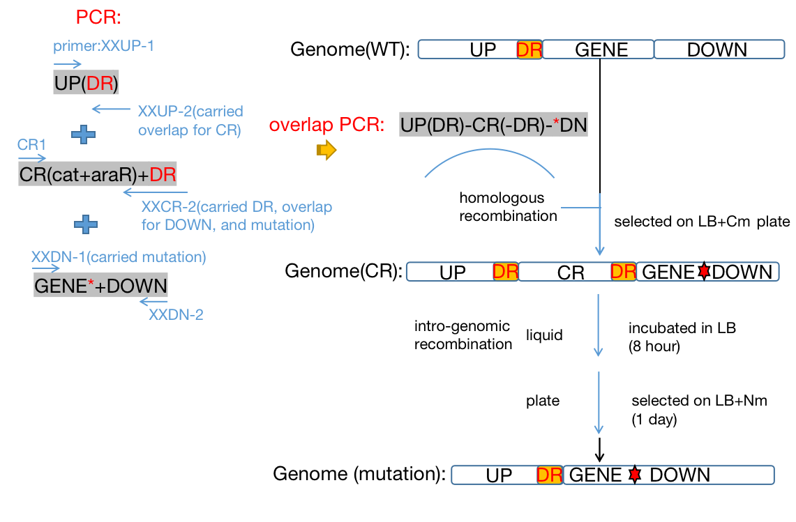
Figure legends
Schematic of the strategy used to construct the mutants investigated in this study. Three steps are needed for the construction of the mutants: PCR, homologous recombination, and intragenomic recombination. Firstly, the UP, CR+DR, and GENE*+DOWN fragments were cloned by PCR using the primer pairs designated as XXUP-1/XXUP-2, CR1/XXCR-2, and XXDN-1/XXDN-2, where XX indicates the name of the target gene. The primer (as well as the corresponding fragments) XXUP-2 and XXCR-2 carried overlapping sequences with CR and DOWN, respectively, which were used to fuse the sequences by overlap-extension PCR using the primers XXUP-1 and XXDN-2, generating UP(DR)-CR(-DR)-*DN. It should be noted that the first DR (direct repeat, 20bp), is part of the UP fragment which can be cloned from the genome, and the second DR was introduced by the primer XXCR-2. The mutations were introduced on the primers XXCR-2 and XXDN-1, or alternatively, on XXCR-2 and XXUP-1. Secondly, the overlapped fragment was used to transform Bacillus subtilis BSLY, and the transformants were selected on LB plates with 8 µg/mL chloramphenicol. During this process, there was homologous recombination between the fragment and genome via the UP and DOWN fragments. The transformants were verified by PCR using the primers XXUP-1 and XXDN-2, and the mutation was verified by sequencing. Finally, the verified transformants were cultured in LB broth for intragenomic recombination of the DR fragments. The culture was plated onto LB agar plates with 20 μg/mL neomycin. After 1 day, the transformants were selected and verified by PCR using the primers XXUP-1 and XXDN-2. This method is similar to the previously published paraR-neo/cat-araR counter-selection gene deletion system [38], and is also similar to another publication [39].

Supplementary Table S1 Bacterial strains and plasmids used in this study
Name | Relevant phenotype | Source /reference
Strains
B. subtilis 168 | Wide-type strain, trpC2 | Lab stock (from China General Microbiological Culture Collection Center)
E. coli DH5α | Standard cloning strain | TransGen
BSYXM | B. subtilis 168, araR: para-neo, ribO*,  rib+(gsiB) | This Study&[27]
BSLY | BSYXM, purA*(P242L) | This Study&[3]
BSR | BSLY, rpe* (504/654 nt) | This Study
BSRN | BSLY, Δrpe(M1*) | This Study
BST | BSLY, Δtkt(M1*) | This Study
BSRT | BSR, Δtkt(M1*) | This Study
BSRNE | BSRN/pHP13 (spe) | This Study
BSRN1 | BSRN/pHP01 | This Study
BSRN2 | BSRN/pHP02 | This Study
BSR02 | BSR/pMA5 (spe) | This Study
BSR03 | BSR/pMA03 | This Study
BSR04 | BSR/pMA04 | This Study
BSR05 | BSR/pMA05 | This Study
BSR06 | BSR/pMA06 | This Study
BSR07 | BSR/pMA07 | This Study
BSR08 | BSR/pMA08 | This Study
BSR09 | BSR/pMA09 | This Study
BSR10 | BSR/pMA10 | This Study
BSR21 | BSR, Δykgb | This Study
BSR22 | BSR, Δyqec | This Study
BSR23 | BSR, ΔyqjI | This Study
BSR24 | BSR, ΔgntZ | This Study
BSR25 | BSR, Δzwf | This Study
BSR01 | BSR/pMX45 | This Study
BSRT01 | BSRT/pMX45 | This Study
BSR02 | BSR01/pHP13 (spe^{r}) | This Study
BSR03 | BSR01/pHP03 | This Study
BSR04 | BSR01/pHP04 | This Study
Plasmid
pHP13(spe)  pHP01 | Spe^{r}, PvegI  pHP13(spe)-PvegI-rpe* | [36]  This Study
pHP02 | pHP13(spe)-PvegI-rpe | This Study
pHP03 | pHP13(spe)-PvegI-zwf243 | This Study
pHP04 | pHP13(spe)-PvegI-gnd361 | This Study
pMA5(spe) | Spe^{r}, PhpaII | [35]
pMA03 | pMA5(spe)-PhpaII-ribA | This Study
pMA04 | pMA5(spe)-PhpaII-guaA | This Study
pMA05 | pMA5(spe)-PhpaII-gmk | This Study
pMA06 | pMA5(spe)-PhpaII-ykgB | This Study
pMA07 | pMA5(spe)-PhpaII-prs | This Study
pMA08 | pMA5(spe)-PhpaII-purF | This Study
pMA09 | pMA5(spe)-PhpaII-gntZ | This Study
pMA10 | pMA5(spe)-PhpaII-zwf | This Study
pMX45 | Ery^{r}, pSM19035-derived plasmid, carrying a complete rib operon | [3]

Supplemental Table S2 Primers used in this study
Name | Sequence (5’–3')
araRfw | TAGTAAGTAATCGCGTTCAT
araR/Para | GCCAGCCCGAGCTCCAATTGACAGAAAATGCAAACAAG
Paraf | ATTGGAGCTCGGGCTGGC
Nmr | ATTGGAGCTCGGGCTGGC
araR/Nmr | TGACCTCTAATAATTGTTAAATTTGAGCCTGAGTTGATCA
araRrv | CGGGCAGAGGAATGGGGCTA
purA242-UP1 | GATCACTTCAAAGCTAAAGCACA
purA242-UP2 | GTTTGTTGAACTAATGGGTGCTTTAGTTGAAGAGATCGTGACACCGCCGGCAACCAGGGT TAGATGACGTAACAAACGGGTATGTTCCTTGGTCGATATCG
purA242-CR2 | CCGATCGTGACACCGCCGGCAACCAGGGTTAGATGACGTAACTTATTCATTCAGTTTTCGTGCG
purA242-DN1 | GTTACGTCATCTAACCCTGGTTGCCGGCGGTGTCACGATCGG
purA242-DN2 | CAACGAGATTTATAATATCACGAAC
ribO-UP1 | GAGAGCGAAACAGGACGGTTTTGACC
ribO-UP2 | CGTTTGTTGAACTAATGGGTGCTTTAGTTGAAGACCGCCGGTCGGGATTTCCATCCTGCC CCGAAGG
ribO-CR2 | GTCACGGGCTCTAAAGCAAATGTGCTTTACTACCGCCGGTCGGGATTTCCATCCTGCCCCGAAGGATACAATTTATTCATTCAGTTTTCGTGCG
ribO-DN1 | TAGTAAAGCACATTTGCTTTAGAGC
ribO-DN2 | CTTTGTCGGTTTTGCCGTCAGTTTG
rpe-mu-UP1 | CTCAGCGGTTCAGCCTTCT
rpe-mu-UP2 | TTGAACTAATGGGTGCTTTAGTTGAAGACGCCGCCGTCTACTTCA
CR1 | TCTTCAACTAAAGCACCCATT
rpe-mu-CR2 | GGAGCGGTTTCTTTGTTGACGCCGCCGTCTACTTCAATTAACAGATCTTTTTTCCTTTTTTATTCATTCAGTTTTCGTGCG
rpe-mu-DN1 | TCAACAAAGAAACCGCTCC
rpe-mu-DN2 | TCCCCTCCTATAACGTCCC
rpe-ko-UP1 | AAGTGCAAATCGCGGTTGA
rpe-ko-UP2 | TGAACTAATGGGTGCTTTAGTTGAAGATTATTTATATGCTAATACCTCGGCTTTC
rpe-ko-CR2 | GGAAAGAATAGATGGTGCAACCTTTATTTATATGCTAATACCTCGGCTTTCTGTCTTTAATCTTTATTCATTCAGTTTTCGTGCG
rpe-ko-DN1 | AGGTTGCACCATCTATTCTTTCC
rpe-ko-DN2 | GGCGTTCTTGCTCCGTTATG
tkt-ko-UP1 | AGCCAGCGGATATGAAATG
tkt-ko-UP2 | TGAACTAATGGGTGCTTTAGTTGAAGAGTGCGAATGGTAGCAACTGAT
tkt-ko-CR2 | CTGAGAAGCCGTATTCGTTAATGTGCGAATGGTAGCAACTGATTTCTTTTCAATTGTATCCATTATTCATTCAGTTTTCGTGCG
tkt-ko-DN1 | ATTAACGAATACGGCTTCTCAG
tkt-ko-DN2 | GCGGGTGATGAATGATTGC
ribA1 | TGTACAATAAATGTAGTGAGGTGGATGCAATGTTTCATCCGATAGAAGAAG
ribA2 | ACGTTGTAAAACGACGGCCAGTGAATTTAGAAATGAAGTAAATGACCTAGCT
purF1 | TGTACAATAAATGTAGTGAGGTGGATGCAATGCTTGCTGAAATCAAAGGCT
purF2 | ACGTTGTAAAACGACGGCCAGTGAATTTATTTGGTTAATACTGCTTCTTTTAC
prs1 | TGTACAATAAATGTAGTGAGGTGGATGCAATGTCTAAT  CAATACGGAGATAAG
prs2 | ACGTTGTAAAACGACGGCCAGTGAATTTAGCTGAACAGATAGCTGACTGAT
guaA1 | TGTACAATAAATGTAGTGAGGTGGATGCAATGACAAAGTTAGTGAATGAAATGAT
guaA2 | ACGTTGTAAAACGACGGCCAGTGAATTTATTCCCACTCAATCGTCG
gmk1 | TGTACAATAAATGTAGTGAGGTGGATGCAATGAAAGAAAGAGGGTTATTAA
gmk2 | ACGTTGTAAAACGACGGCCAGTGAATTTATTCAACCTCCAGCATTTT
ndk1 | TGTACAATAAATGTAGTGAGGTGGATGCAATGATGGAAAAGACTTTTATCATG
ndk2 | ACGTTGTAAAACGACGGCCAGTGAATTTAATAGATCCAGCCTGCCA
zwf1 | TGTACAATAAATGTAGTGAGGTGGATGCAGTGAAAACAAACCAACAACCAAAA
zwf2 | ACGTTGTAAAACGACGGCCAGTGAATTTATATGTTCCACCAGTGTAAGCC
gntZ1 | TGTACAATAAATGTAGTGAGGTGGATGCAATGTTCAATTCGATTGGTGTCA
gntZ2 | ACGTTGTAAAACGACGGCCAGTGAATTTATTCAGACCAATTCGTATGG
ykgB1 | TGTACAATAAATGTAGTGAGGTGGATGCAATGACAAAATACATAGGATAT
ykgB2 | ACGTTGTAAAACGACGGCCAGTGAATTTATACTTGATGTAAAAACTTT
zwf-ko-UP1 | TATCACCGGAGAACACAACAGATC
zwf-ko-UP1 | TGAACTAATGGGTGCTTTAGTTGAAGACTTCCAACTCCTACCACTGCA
zwf-ko-CR2 | TCCCAGTGTGCAAAGTTTGTTGCATCGCCTTCCAACTCCTACCACTGCAAACTCTTCTCCGATTTGTCTTATTCATTCAGTTTTCGTGCG
zwf-ko-DN1 | GCGATGCAACAAACTTTGCACA
zwf-ko-DN2 | AGGTGAGCTTGATAGCTACCTG
ygkB-ko-UP1 | CAAGCGGGAACACCCTG
ygkB-ko-UP2 | TGAACTAATGGGTGCTTTAGTTGAAGAGAATAAATTCCTTCGCTTCCGCCTTTTGTATATGTTCCCA
ygkB-ko-CR2 | GTCAATCGGCCGGTTTCTTTGTCTCGAATAAATTCCTTCGCTTCCGCCTTTTGTATATGTTCCCATTATTCATTCAGTTTTCGTGCG
ygkB-ko-DN1 | GAGACAAAGAAACCGGCCG
ygkB-ko-DN2 | AGGCGACTGCCTTTGTTAGAG
yqjI-ko-UP1 | GGCGTCTGATATGAAAAAACCGC
yqjI-ko-UP2 | CGGATGGAATAATAGTCGTGAAAGC
yqjI-ko-CR2 | AGCTGTCATAGTAGGCTAATGCGCTTGAGGGTGTTTCCAAGGATTGGACAAATTCTTCAATGCTGTAAGTTATTCATTCAGTTTTCGTGCG
yqjI-ko-DN1 | CTCAAGCGCATTAGCCTACTATG
yqjI-ko-DN2 | CTTCGCGACATGGTGCAAAAC
yqeC-ko-UP1 | GGTTTCTGCTTTTCGCCAATATTGG
yqeC-ko-UP2 | TGAACTAATGGGTGCTTTAGTTGAAGACTCAGCCCCGTATGCTTTCAG
yqeC-ko-CR2 | GGTTTCCACCGTCCATTTTCCTTCACCCTCAGCCCCGTATGCTTTCAGTTCATCAACAGCCGCTTGATTATTCATTCAGTTTTCGTGCG
yqeC-ko-DN1 | GGTGAAGGAAAATGGACGGTG
yqeC-ko-DN2 | CCATCGCATAGCCAGGACG
gntZ-ko-UP1 | CAAACTGATCGCGGATTCAGG
gntZ-ko-UP2 | TGAACTAATGGGTGCTTTAGTTGAAGACCCAGTCCAGCAACGGAAATA
gntZ-ko-CR2 | ACTTTTCGCAGGCCTGTTTGATAGGCCCAGTCCAGCAACGGAAATAATGGTTTCCAGCAATGTCCTTATTCATTCAGTTTTCGTGCG
gntZ-ko-DN1 | CCTATCAAACAGGCCTGCG
gntZ-ko-DN2 | GTTTGGATAACGCCGTCTGG
pHP13-1 | ATTCACTGGCCGTCGTTTTACAAC
pHP13-2 | AAGCCTGGGGTGCCTAATGAGT
PvegI-1 | TTAGGCACCCCAGGCTTGCAAGTTCACCGTCAAGAGTCAATATTC
PvegI-2 | TGCATCCACCTCACTACATTTATTG
pMA5-1 | CATATGAGTTATGCAGTTTGTAGAATGCAAAAAG
pMA5-2 | TAAATCGCTCCTTTTTAGGTGGCACAA
rpe-1 | TGTACAATAAATGTAGTGAGGTGGATGCAATGTTTATGATAAAGGTTGCACCATCTATTCTTTC
rpe-2 | ACGTTGTAAAACGACGGCCAGTGAATTTATTATTTACTTCCTCTGATTTC
rpoA-RT-UP | CGTCGTATCCTCTTATCCTCACTC
rpoA-RT-DN | CATCTTCCACAACGCCTTCAAT
atpA-RT-UP | CCATCCGATTGAGACGCTTGAG
atpA-RT-DN | GTATGCCTGTGCCGCTTTCA
tkt-RT-UP | CGTGTATTCGGCGGAACTT
tkt-RT-DN | CTGCTGCTGTCTCATTGC
gntZ-RT-UP | AAGCATTCAGTGAGCAGCCAAAT
gntZ-RT-DN | CCGTCCATATCAGTCCGTTCGTA
ywlF-RT-UP | GGCGAAGTTGACAGAGGCATT
ywlF-RT-DN | CGATCACCCGTTCACCCATC
prs-RT-UP | CGGTGCGACTCGTGTGATT
prs-RT-DN | CGATGAGGATAGCAGTCTTCCC
zwf-RT-UP | CTGAGAGCACTGCGTCCTATTG
zwf-RT-DN | CACCAGCCCATCTGAAGTTGTC
ykgB-RT-UP | GACGGTGTGTTGACTGAATCC
ykgB-RT-DN | GGATGGCAGAAACGACTTGG
yqjI-RT-UP | CTTGACCCAGCTTTAGGCGATT
yqjI-RT-DN | GTTCTCCTGATGACAACACA
yqeC-RT-UP | CTGATCCTGAGATTGCCAAA
yqeC--RT-DN | GCAGTGCGGAAGCATCCT
gntZ--RT-UP | CGGTGAAGTCGGTGCGTTAA
gntZ-RT-DN | GCATGTCGGCATATTCAA
prs-RT-UP | CGGTGCGACTCGTGTGATT
prs-RT-DN | CGATGAGGATAGCAGTCTTCCC
purE-RT-UP | CTGAACGGAATGGATTCAC
purE-RT-DN | CGGGCAAGGTCTTCGTCAAAT
guaA-RT-UP | CGACGGCATGACATCTGA
guaA-RT-DN | GGCGGCTTACTTGTAATATCA
guaB-RT-UP | GCTTCCTCTCGTAGATGACCAGA
guaB-RT-DN | CACATCAACATTGGCTTCAACAAG
gmk-RT-UP | CAGTAACCACAAGAAGTCC
gmk-RT-DN | CCGTAATAATTGCCGACATAC
ndk-RT-UP | GGTGTCCAACGTCAGCTCATT
ndk-RT-DN | CCTTGATGTTCGGCGTAGT

