Primer sequences
Human AGBL2_F：CACCATGGAGTCTACCTTTGGC
Human AGBL2_R：AGTCCAGAAGGGTGTCACAGAC
Human β-actin_F: CTCCATCCTGGCCTCGCTGT
Human β-actin_R:GCTGTCACCTTCACCGTTCC

Antibodies
AGBL2 (DF3980, Affinity Biosciences, Changzhou, China, 1:500)
AKT (AF0836, Affinity Biosciences, Changzhou, China, 1:1000)
Phospho-AKT (AF0016, Affinity Biosciences, Changzhou, China, 1:1000)
GAPDH (GB15002-100, Servicebio，Wuhan, China, 1:1000）
α-tubulin (BM1452, Bosterbio, Wuhan, China, 1:500)
Detyrosinated alpha Tubulin (ab254154, abcam, Shanghai, China, 1:500)
Anti-Mouse IgG (GB23302, Servicebio，Wuhan, China, 1:1000）
Anti-Rabbit IgG (GB23303, Servicebio，Wuhan, China, 1:1000）

Abbreviations
RCC renal cell carcinoma
VEGF vascular endothelial growth factor
GSEA Gene Set Enrichment Analysis
KEGG Kyoto Encyclopedia of Genes and Genomes
GO Gene Ontology
TCGA The Cancer Genome Atlas
ROC receiver operating characteristic
KM Kaplan-Meier
OS overall survival
DSS disease specific survival
PFI progression-free interval
IHC Immunohistochemistry
KIRC kidney renal clear cell carcinoma
KIRP Kidney renal papillary cell carcinoma
BRCA Breast invasive carcinoma
ESCA Esophageal carcinoma
GBM Glioblastoma multiforme
HNSC Head and Neck squamous cell carcinoma
LIHC Liver hepatocellular carcinoma
STAD Stomach adenocarcinoma
KICH Kidney Chromophobe
LUSC Lung squamous cell carcinoma
PAAD Pancreatic adenocarcinoma
THCA Thyroid carcinoma

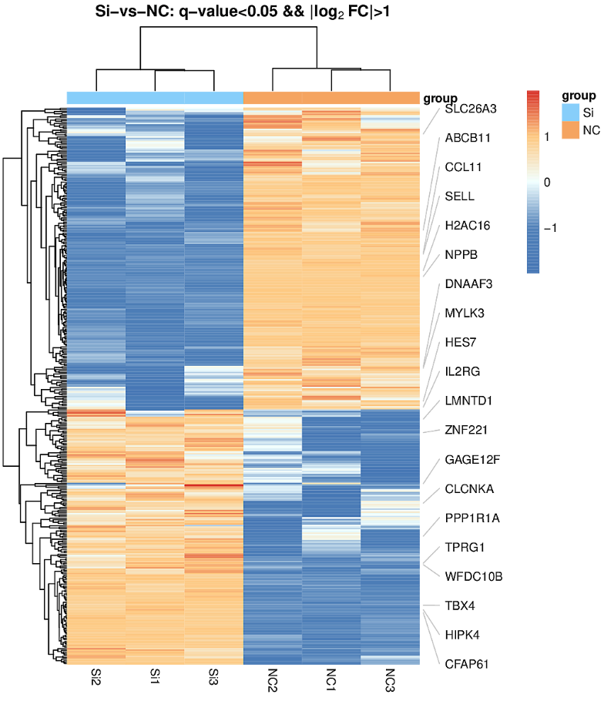
Supplementary Figure 1
Heatmap based on high-throughput sequencing showing two clusters of differentially expressed genes clustering between the two groups
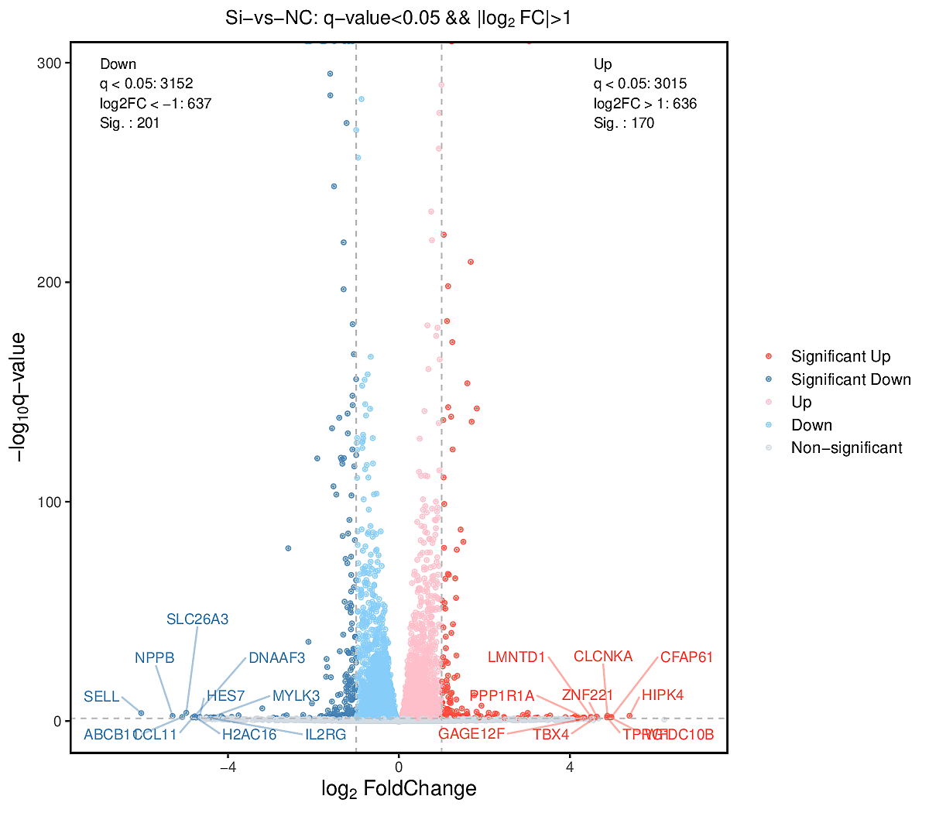
Supplementary Figure 2
Volcano plot based on high-throughput sequencing, analyzing two groups of differentially expressed genes

Supplementary Figure 3
GSEA analysis using data from high-throughput sequencing demonstrates signaling pathways associated that may be associated with AGBL2.
(A),Insulin-like growth factor binding(GO_0005520), (B)Wnt-protein binding(GO_0017147), (C)RIG-I-like receptor signaling pathway(hsa04622), (D)Toll-like receptor signaling pathway(hsa04620), (E)Inflammatory mediator regulation of TRP channels(hsa04750), (F)Fc epsilon RI signaling pathway(hsa04664), (G)NOD-like receptor signaling pathway(hsa04621), (H)VEGF signaling pathway(hsa04370), (I)Basal cell carcinoma(hsa05217), (G)Cell adhesion molecules(hsa04514), (K)Cell cycle(hsa04110), (K)TRAF3-dependent IRF activation pathway(R-HSA-918233), (L)VEGFA-VEGFR2 Pathway(R-HSA-4420097)

