Supplementary information
On-surface synthesis of a radical 2D supramolecular organic framework

Federico Frezza,^{1,2,7} Adam Matěj,^{1,3,7} Ana Sánchez-Grande,^{1,}* Manuel Carrera,⁴ Pingo Mutombo,^{1,5} Manish Kumar,¹ David Curiel,^{4,}* Pavel Jelínek^{1,6,}*

¹ Institute of Physics, The Czech Academy of Sciences, Cukrovarnická 10, 162 00, Prague 6, Czech Republic.
² Faculty of Nuclear Sciences and Physical Engineering, Czech Technical University in Prague Břehová 78/7, 11519 Prague 1, Czech Republic.
³ Department of Physical Chemistry, Faculty of Science, Palacký University, 17. Listopadu 12, 779 00, Olomouc, Czech Republic.
⁴ Department of Organic Chemistry, University of Murcia Campus of Espinardo, 30100 Murcia, Spain.
⁵ Département de Raffinage et Pétrochimie, Faculté de Pétrole, Gaz et Énergies Renouvelables, Université de Kinshasa, BP 127, Kinshasa XI, République Démocratique du Congo.
⁶ CATRIN-RCPTM, Palacký University, Šlechtitelů 27, 783 71, Olomouc, Czech Republic.
⁷ These authors contributed equally.
* Authors to whom correspondence should be addressed

Synthetic procedure
Reagents and solvents used for the synthesis were commercial suppliers and were used without further purification. Unless stated otherwise, the reactions were carried out under nitrogen atmosphere. Column chromatography was run with silica gel 60 A CC 70-200 μm as stationary phase. ¹H-NMR and ¹³C-NMR spectra were recorded at room temperature with a Bruker AV400 or AV300 spectrometers. Chemical shifts are referred to the residual peak of the deuterated solvent. Mass spectra were measured with an HPLC-MS TOF 6220 instrument.

Scheme S1. Synthetic route toward compound 1.

3-chloro-2-(m-methylphenylamino)pyridine, I: A round bottom flask equipped with a reflux condenser was charged with 1,2-dichloropyridine (7.42 g, 50 mmol) and m-Toluidine (16 mL, 150 mmol). The mixture was heated at 170 °C for 2 hours. After cooling down, the crude was dissolved in CH₂Cl₂ (100 ml) and washed with Na₂CO₃ (aq., sat.) (3x50 ml). The organic phase was dried over Na₂SO₄, filtered and the solvent was evaporated under reduced pressure. The crude was purified by column chromatography, using hexane/ethyl acetate (9/1) as eluent, to yield 3-chloro-2-(m-methylphenylamino)pyridine (10.1 g, 98% yield) as a dark red oil.
¹H-NMR (400 MHz, CDCl₃), δ (ppm): 8.01 (dd, J = 4.9, 1.6 Hz, 1H), 7.41 (dd, J = 7.7, 1.6 Hz, 1H), 7.34 (d, J = 8.0 Hz, 1H), 7.31 (s, 1H), 7.11 (t, J = 7.8 Hz, 1H), 6.81 (s, 1H), 6.73-6.78 (m, 1H), 6,54 (dd, J = 7.7, 4.9, 1H), 2.25 (s, 3H). ¹³C-NMR (101 MHz, CDCl₃), δ (ppm): 151.4, 145.8, 139.6, 138.7, 136.6, 128.8, 123.7, 120.6, 117.2, 116.1, 115.3, 21.6. HRMS (ESI), m/z, [M+H]⁺, calc. for C₁₂H₁₂ClN₂: 219.0684, found: 219.0694.

7-methyl-α-carboline, II: A mixture of 3-chloro-2-(m-methylphenylamino)pyridine (4.93 g, 23 mmol), Pd(dba)₂ (4 mol%), PCy₃·HBF₄ (8 mol%) and DBU (8.8 mL, 58 mmol) in dry 1,4-dioxane (100 mL) was bubbled with nitrogen for 20 minutes. Then, this mixture was placed in a sealed tube and heated in an oven at 180 °C for 3 days. Once the reaction cooled down, the solvent was evaporated under reduced pressure. The dark crude was purified by column chromatography using dichloromethane/ethyl acetate (3/1) as eluent. The product was obtained as an analytically pure yellow solid (2.8 g, 67% yield).
¹H-NMR (300 MHz, CDCl₃), δ (ppm): 10.93 (s, 1H), 8.49 (dd, J = 5.0, 1.6 Hz, 1H), 8.31 (dd, J = 7.7, 1.6 Hz, 1H), 7.94 (d, J = 8.0 Hz, 1H), 7.35-7.37 (m, 1H), 7.20 (dd, J = 7.7, 5.0 Hz, 1H), 7.09-7.13 (m, 1H), 2.56 (s, 3H). ¹H-NMR (300 MHz, DMSO), δ (ppm): 11.70 (s, 1H), 8.35-8-42 (m, 2H), 8.00 (d, J = 8.0 Hz, 1H), 7.28-7.34 (m, 1H), 7.15 (dd, J = 7.6, 4.9 Hz, 1H), 7.00-7.06 (m, 1H), 2.46 (s, 3H). ¹³C-NMR (75 MHz, DMSO-d₆), δ (ppm): 152.0, 145.4, 139.3, 136.3, 127.8, 120.9, 120.9, 118.1, 115.5, 114.8, 111.2, 21.8. HRMS (ESI), m/z, [M+H]⁺, calc. for C₁₂H₁₁N₂: 183.0917, found: 183.0921.

6-bromo-7-methyl-α-carboline, III: N-Bromosuccinimide (0.37 g, 2 mmol) was added portionwise to a stirred suspension of 7-methyl-α-carboline (0.37 g, 2 mmol) in CH₂Cl₂ (20 mL) at 0 °C. Stirring was continued for 1 day. The solvent was evaporated under reduced pressure and the crude was triturated with methanol. A white solid was collected by filtration to obtain 0.46 g of 6-bromo-7-methyl-α-carboline (86 %).
¹H-NMR (300 MHz, DMSO-d₆), δ (ppm): 11.80 (s, 1H), 8.43 (d, J = 7.5 Hz, 1H), 8.30-8.39 (m, 2H), 7.41 (s, 1H), 7.13 (dd, J = 7.6, 4.9 Hz, 1H), 2.44 (s, 3H). ¹³C-NMR (75 MHz, DMSO-d₆), δ (ppm): 152.2, 146.4, 138.3, 135.0, 128.7, 124.4, 120.4, 115.3, 114.7, 114.4, 113.1, 23.4. HRMS (ESI), m/z, [M+H]⁺, calc. for C₁₂H₁₀BrN₂: 261.0022, found: 261.0026.

2-bromo-7-methyl-9-tert-butoxycarbonyl-α-carboline, IV: A round bottom flask was charged with 6-bromo-7-methyl-α-carboline (0.26 g, 1 mmol), di-tert-butyl dicarbonate (0.95 g, 4.4 mmol), 4-(dimethylamino)pyridine (0.09 g, 0.8 mmol) and acetonitrile (10 mL). The orange mixture was stirred at room temperature overnight. Then, the solvent was evaporated under reduced pressure and the crude was purified by column chromatography using hexane/ethyl acetate (4/1) as eluent. The product was isolated as a white solid (0.33 g, 91 %).
¹H-NMR (400 MHz, CDCl₃), δ (ppm): 8.60 (dd, J = 4.9, 1.7 Hz, 1H), 8.13 (s, 1H), 8.13 (dd, J= 7.7, 1.7 Hz, 1H), 8.06 (s, 1H), 7.27 (dd, J = 7.7, 4.9 Hz, 1H), 2.55 (s, 3H), 1.77 (s, 9H). ¹³C-NMR (75 MHz, CDCl₃), δ (ppm): 151.6, 149.5, 147.5, 137.5, 136.9, 127.9, 123.7, 122.2, 119.3, 118.9, 118.2, 117.8, 84.8, 28.4, 24.4. HRMS (ESI), m/z, [M+H]⁺, calc. for C₁₇H₁₈BrN₂O₂: 361.0546, found: 361.0554.

1,3,5-tris(7-methyl-α-carbolin-6-yl)benzene, 1: A Schlenk flask was loaded with compound IV (0.62 g, 1.7 mmol), 1,3,5-tris(4,4,5,5-tetramethyl-1,3,2-dioxaborolan-2-yl)benzene (0.18 g, 0.5 mmol), (dppf)PdCl₂ (10 mol%) and Cs₂CO₃ (1.65 g, 5 mmol). Inert atmosphere was made through vacuum/nitrogen cycles. Another mixture of water (3 mL) and 1,4-dioxane (15 mL) was bubbled with nitrogen for 20 minutes and added to the Schlenk flask. The reaction was stirred at 90 °C for three days. After cooling down, water was added to the reaction flask and the resulting slurry was filtered to obtain a white solid that was purified by column chromatography using dichloromethane/tetrahydrofurane (95/5 to 1/3 gradient) as eluent. The isolated pale yellow solid was deprotected by stirring with trifluoroacetic acid (0.8 mL, 10 mmol) in CH₂Cl₂ (3 mL) at room temperature. The final product was isolated as an off-white solid (0.13 g, 51 %).
¹H-NMR (300 MHz, DMSO-d₆), δ (ppm): 11.75 (s, 1H), 8.50 (dd, J = 7.7, 1.3 Hz, 1H), 8.37 (dd, J = 4.8, 1.6 Hz, 1H), 8.20 (s, 1H), 7.46 (s, 2H), 7.16 (dd, J = 7.7, 4.9 Hz, 1H), 2.57 (s, 3H). ¹³C-NMR (75 MHz, DMSO-d₆): 152.3, 145.7, 141.7, 138.5, 134.1, 133.5, 128.9, 128.3, 122.3, 118.8, 115.5, 114.9, 112.3, 21.5. HRMS (ESI), m/z, [M+H]⁺, calc. for C₄₂H₃₁N₆: 619.2605, found: 619.2628.

¹H-NMR (400 MHz, CDCl₃) of compound I.
¹³C-NMR (101 MHz, CDCl₃) of compound I.
¹H-NMR (300 MHz, DMSO-d₆) of compound II.
¹³C-NMR (75 MHz, DMSO-d₆) of compound II.
¹H-NMR (300 MHz, DMSO-d₆) of compound III.
¹³C-NMR (75 MHz, DMSO-d₆) of compound III.
¹H-NMR (400 MHz, CDCl₃) of compound IV.
¹³C-NMR (75 MHz, CDCl₃) of compound IV.
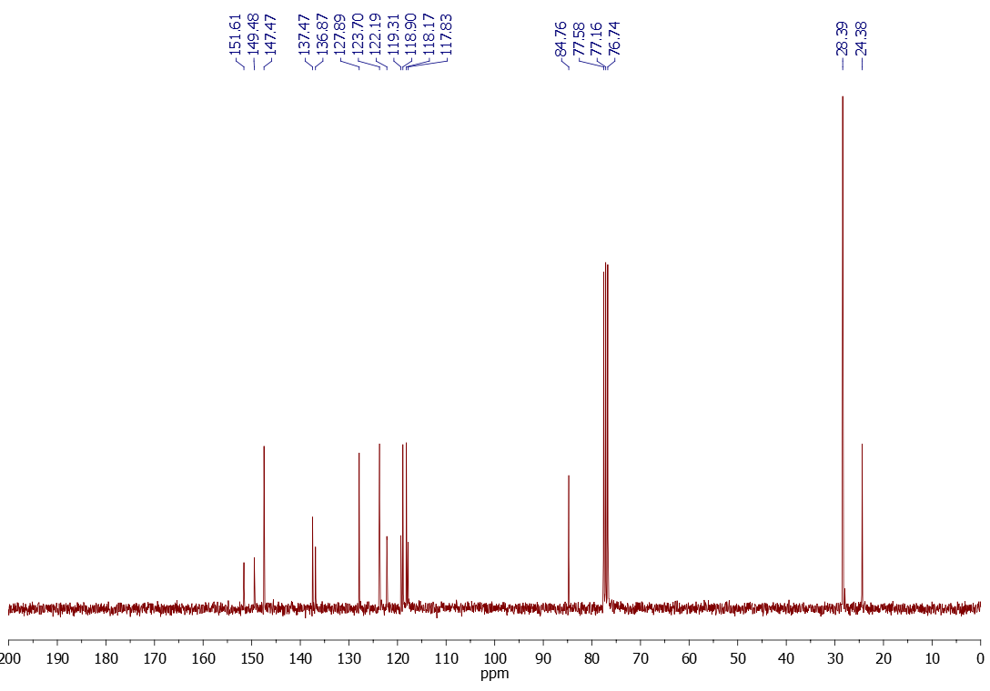

¹H-NMR (300 MHz, DMSO-d₆) of compound 1.
¹³C-NMR (75 MHz, DMSO-d₆) of compound 1.
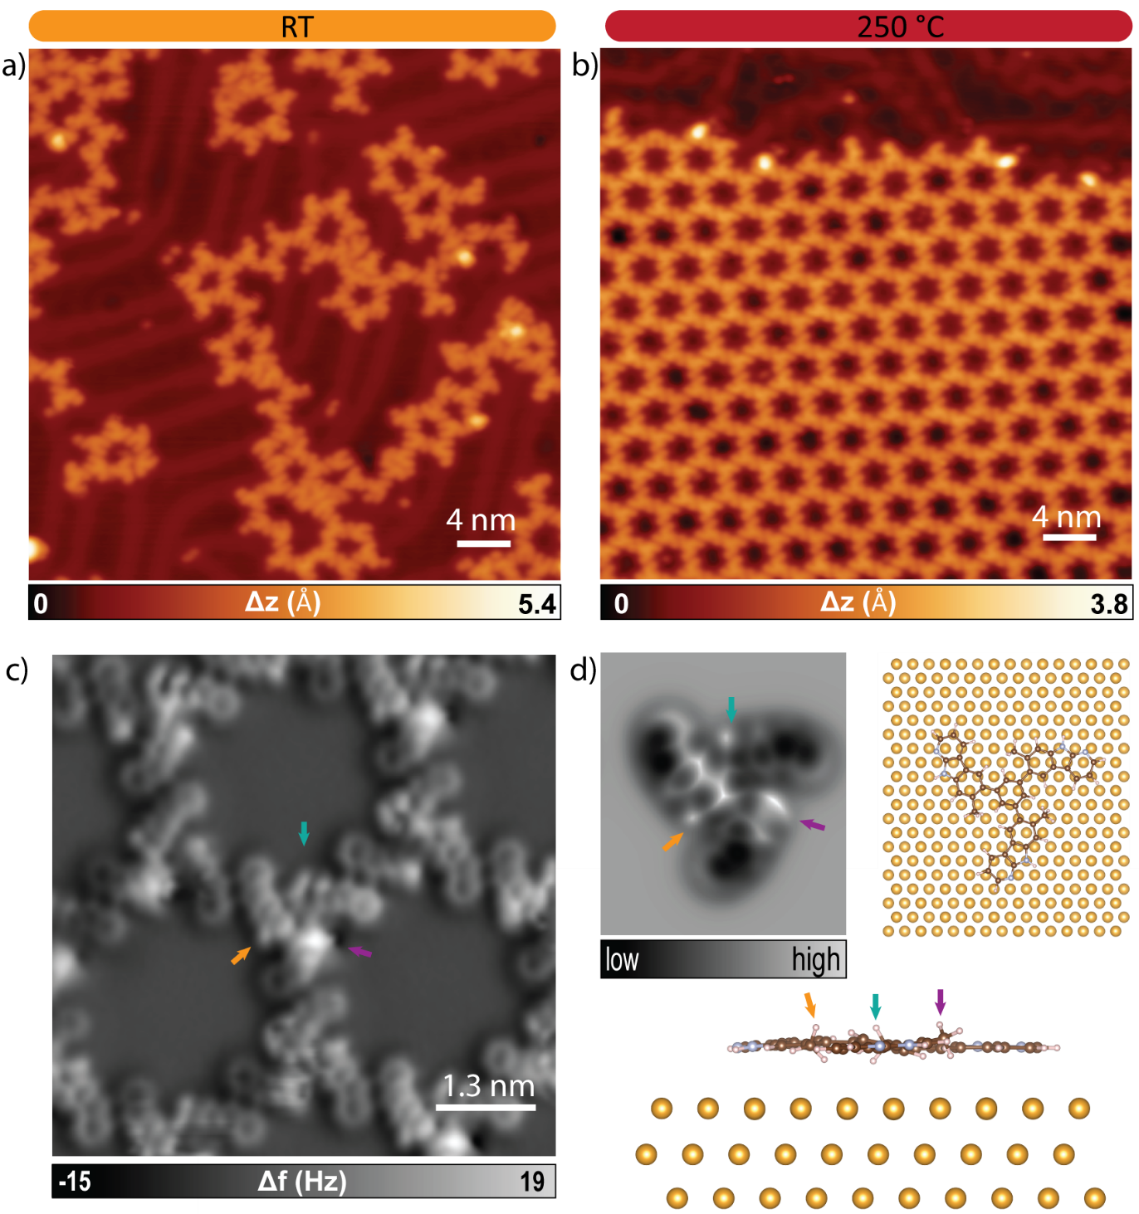
Figure S1. Deposition of 1 on the Au(111) substrate at RT and subsequent annealing at 250 °C. (a) Overview STM image of 1 adopting different configurations after deposition on the Au(111) crystal kept at RT (V_{b} = 200 mV, I_{t} = 100 pA) . (b) Overview STM image after annealing at 250 °C forming homochiral assemblies of 1 (V_{b} = 100 mV, I_{t} = 200 pA). (c) Nc-AFM image after the annealing at 250 °C revealing the non-planar geometry of 1 with one methyl group protruding (purple arrow), other in plane (orange arrow) and the third one slightly pushed down (cyan arrow) (V_{b} = 1 mV). (d) DFT equilibrium geometry of 1 on Au(111) confirming the non-planar geometry.
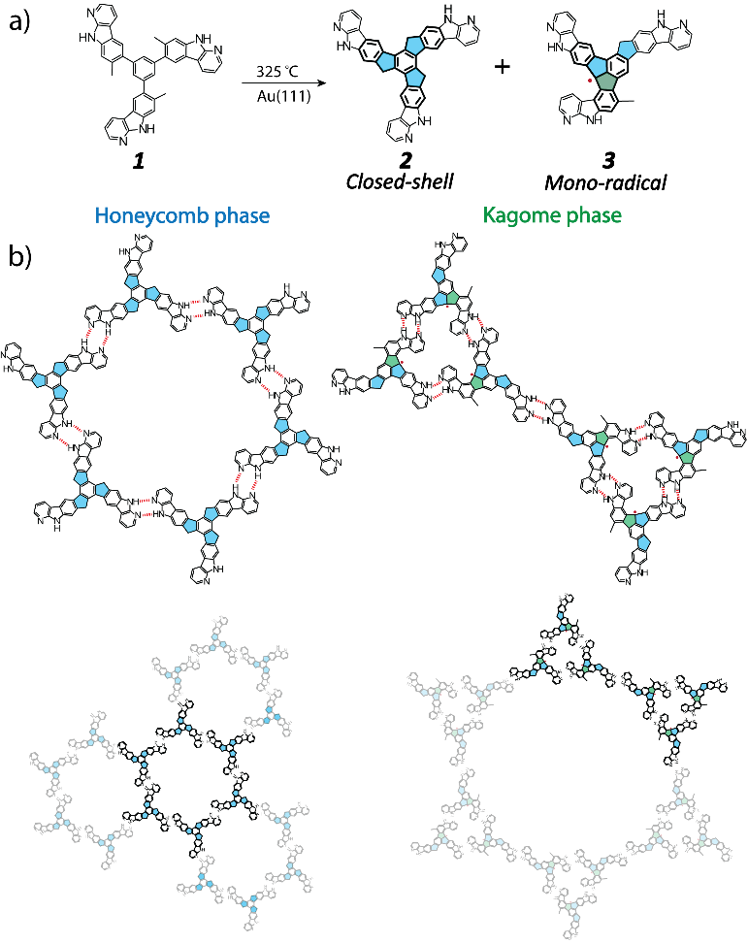
Scheme S2. a) Synthesis of closed-shell product 2 and mono-radical 3. b) Molecular representation of homochiral hydrogen-bond-directed self-assembly of 2, forming a honeycomb lattice (left), and 3, forming a Kagome lattice (right).
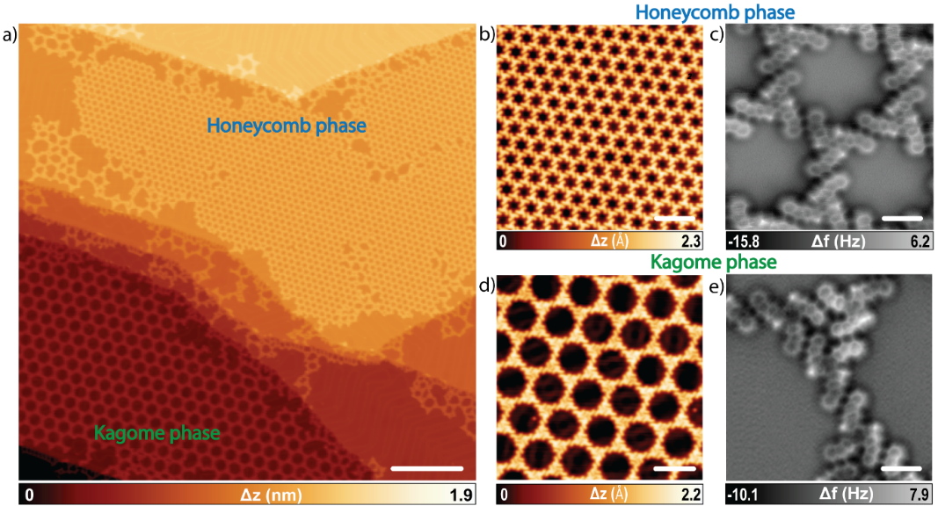
Figure S2. Hydrogen-bonded organic frameworks formed after annealing 1 on Au(111) at 325 °C. (a) Large-scale STM image showing the formation of the honeycomb and Kagome phases (V_{b} = 500 mV, I_{t} = 20 pA, scale bar = 40 nm). (b) Overview STM image of the honeycomb phase (V_{b} = 40 mV, I_{t} = 200 pA, scale bar = 7 nm). (c) Nc-AFM image of the honeycomb phase formed by product 2 (V_{b} = 1 mV, scale bar = 1 nm). (d) Overview STM image of the Kagome phase (V_{b} = 100 mV, I_{t} = 200 pA, scale bar = 7 nm). (e) Nc-AFM image of the Kagome phase formed by product 3 (V_{b} = 1 mV, scale bar = 1 nm).

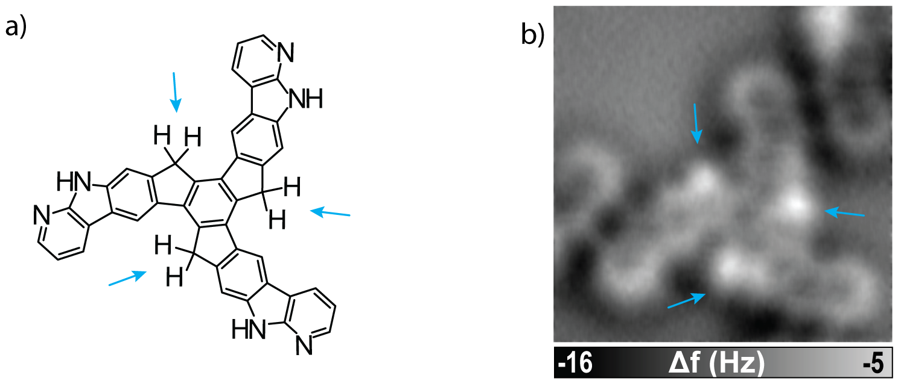
Figure S3. Structural characterization of 2 on Au(111). (a) Structure of 2. Blue arrows highlight the apical carbon atoms of the five-membered rings with C-H bonds above and below the plane containing the conjugated molecule. (b) Nc-AFM image of 2 where the presence of three hydrogen atoms pointing out of the plane is elucidated through the bright spots (marked by blue arrows).

Scheme of the proposed reaction mechanism
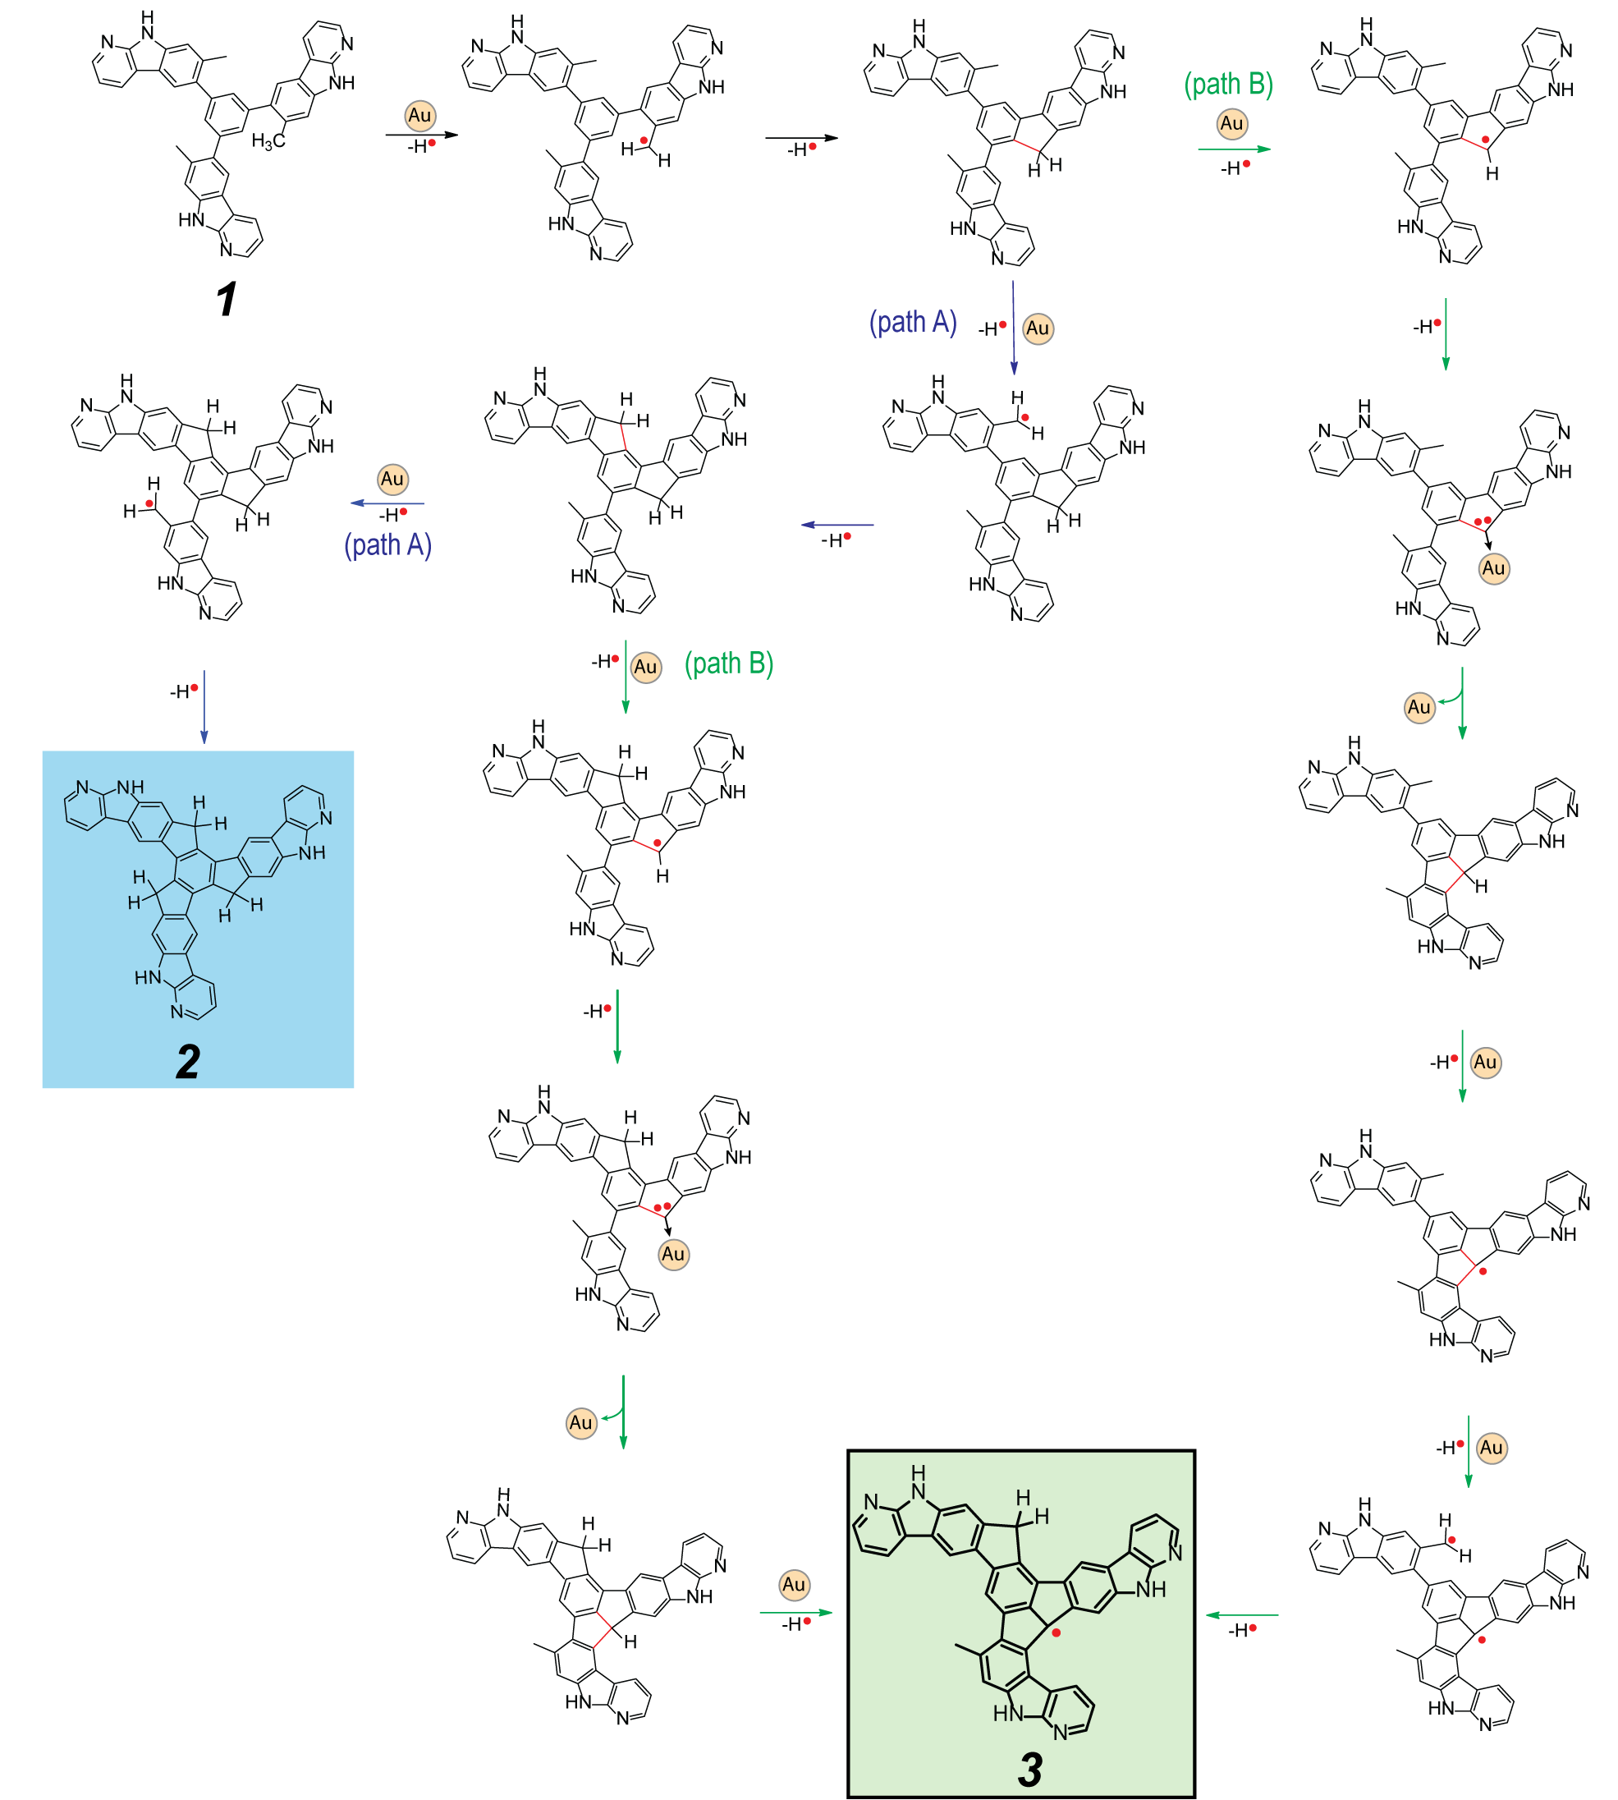
Scheme S3. Scheme of the reaction mechanism toward the formation of 2 and 3 on Au(111)

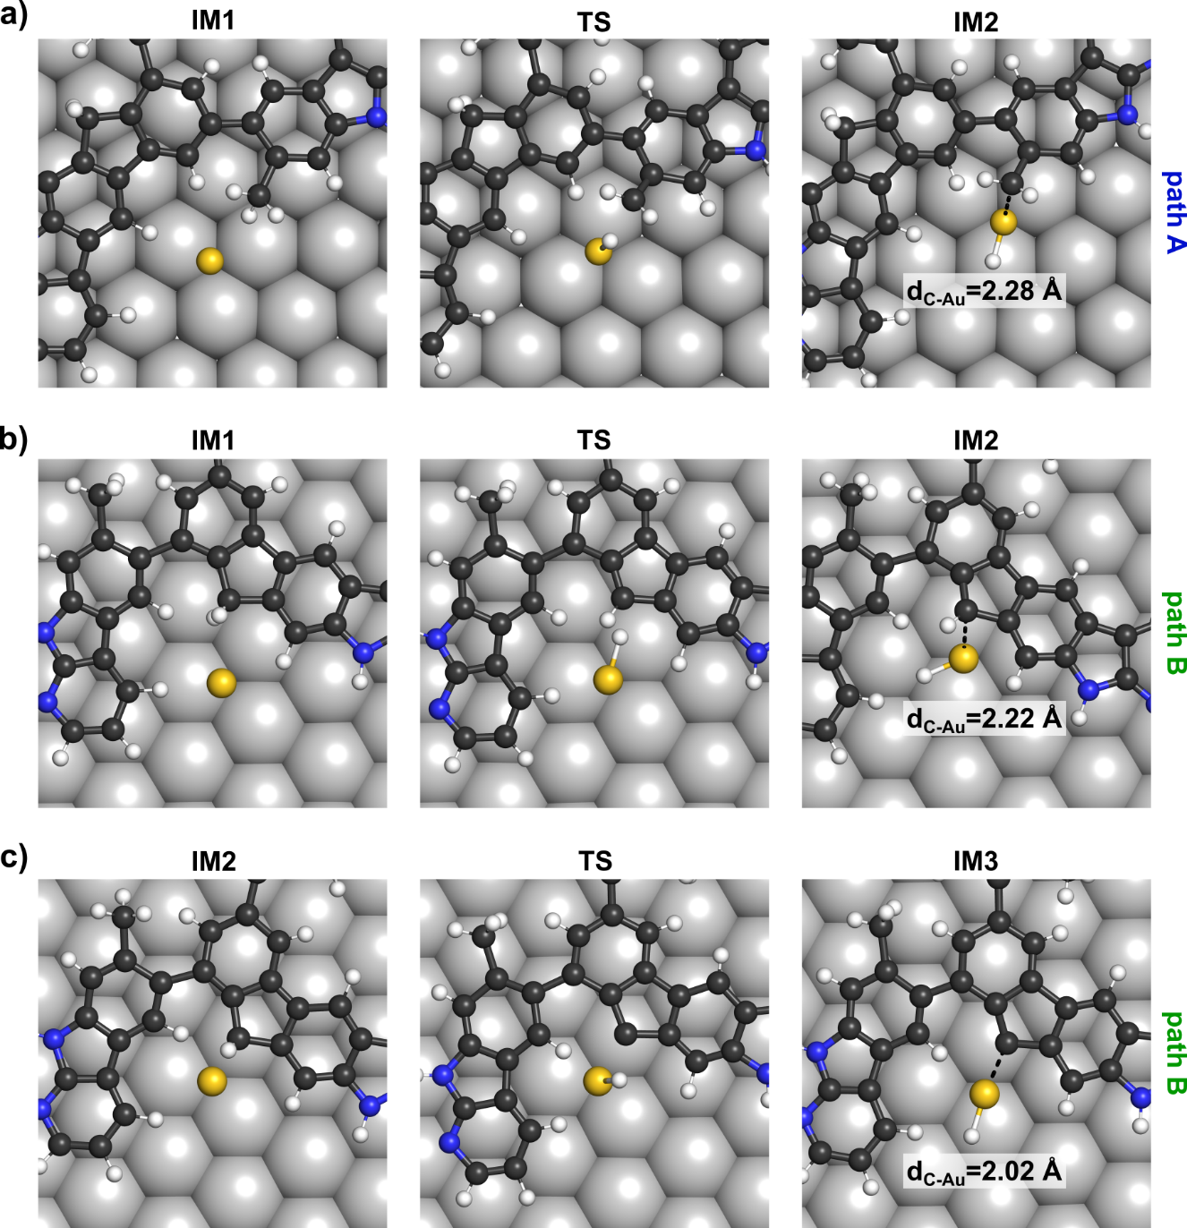
Figure S4. The atomic configuration of characteristic intermediate (IM) species involved in the dehydrogenation processes catalyzed by a single gold atom toward the formation of 2 (a) and 3(b-c) obtained from free energy QM/MM simulations (see Figure 2 in the main text). The final configurations (IM2 and IM3) are energetically stabilized by the formation of Au-C bond, which passivates the radical character of the carbon involved in the cleavage of the C-H bond.

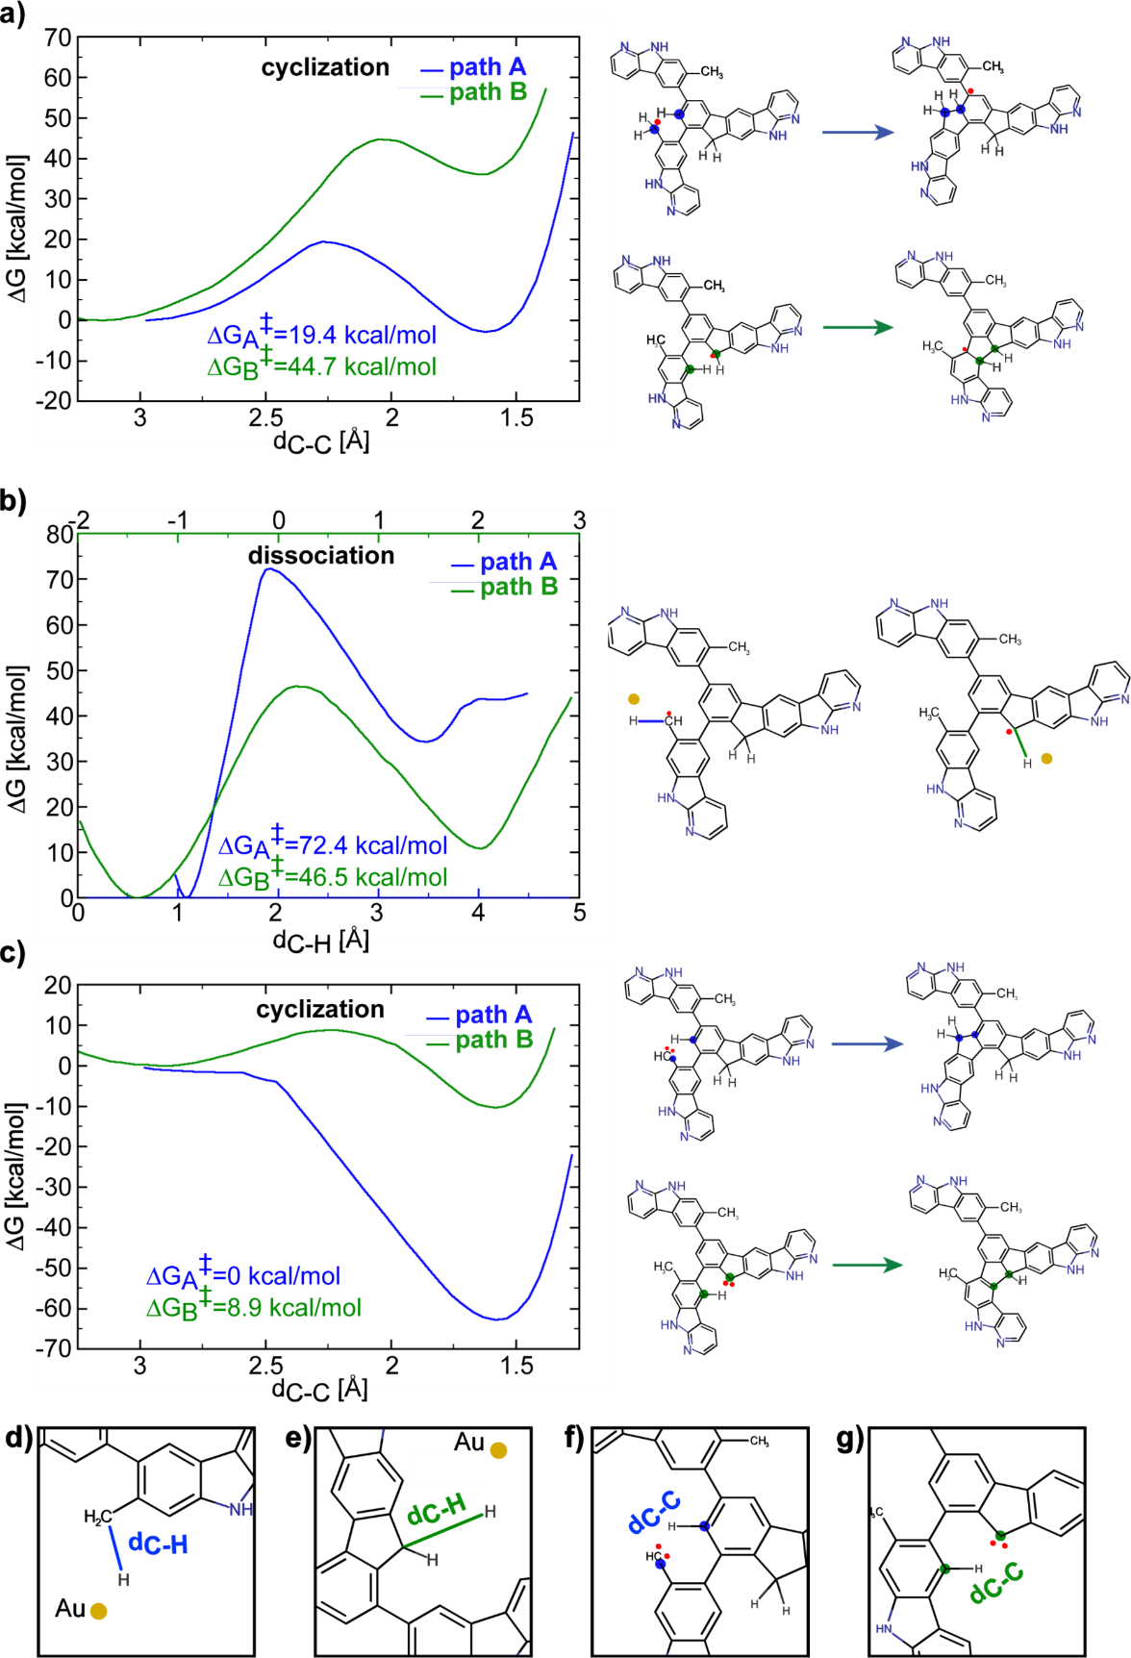
Figure S5. (a-c) Calculated free energy profiles for reaction steps following dissociations at bifurcations. (a) Cyclization step of formed mono-radicals. (b) Dissociation of mono-radicals to form carbenoid intermediates. (c) Cyclization of carbenoid species to form indenofluorene (path A), and fluoradene (path B). (d-g) Illustration of defined reaction coordinates used in presented umbrella sampling simulations.
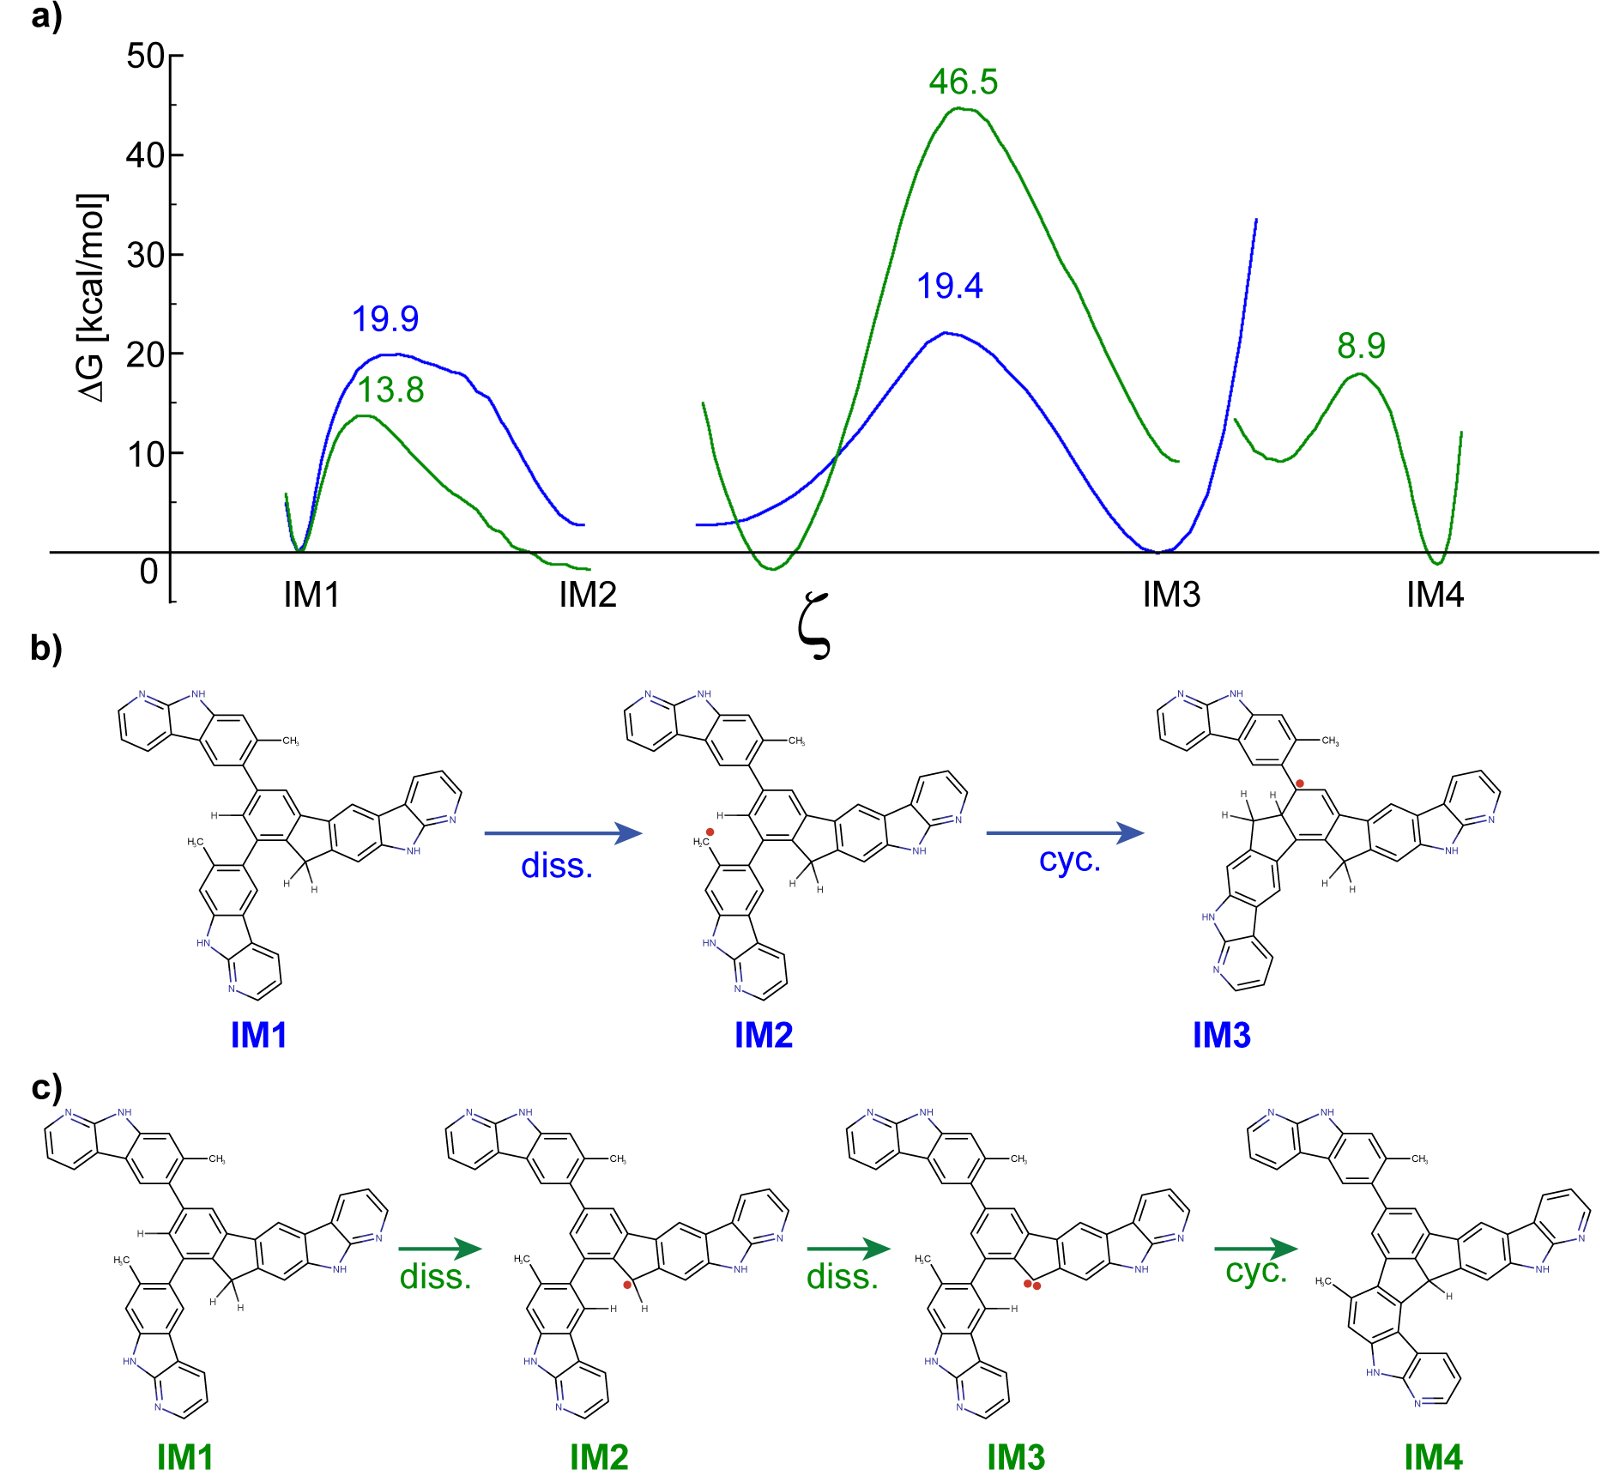
Figure S6. Proposed sequence of reaction steps at the first bifurcation. (a) Free energy profiles of consecutive steps aligned to the ∆G of the intermediate from the preceding step. Barrier heights are marked above each transition state. (b) Proposed sequence leading to the formation of indenofluorene after the first bifurcation. (c) Proposed sequence leading to the formation of fluoradene.

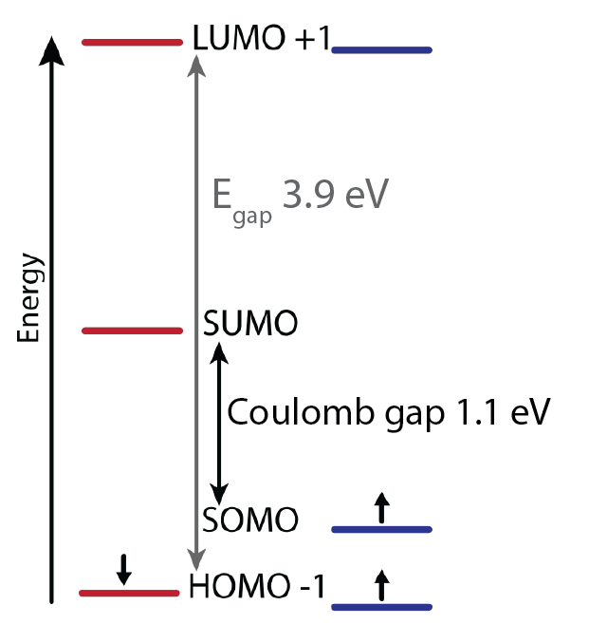
Figure S7. Schematic representation of the calculated spin diagram of 3.

Table S1. Total energies of open-shell and closed-shell forms of 3, a cluster of 4 Au atoms and 4 Au atoms with extra H atom, and the energy balance for different XC-functionals (PBE, PBE0, and B3LYP).
Total energy/XC functionals | PBE (eV) | PBE0 (eV) | B3LYP (eV)
Open-shell 3 (a) | -52861.9506 | -52863.5536 | -52925.3248
Closed-shell 3 (b) | -52878.4395 | -52880.2215 | -52942.0607
Au₄ | -2142602.9384 | -2142603.9492 | -2142671.6703
Au₄H | -2142619.6239 | -2142620.6365 | -2142688.4789
H | -13.5980 | -13.6278 | -13.6565
H₂ | -31.7373 | -31.7980 | -32.1144
E_{3a}+Au₄H – E_{3b}- Au₄ | -0.1966 | -0.0194 | -0.0727
E_{3a}+H₂ – E_{3b}- H | -1.6504 | -1.5023 | -1.7220

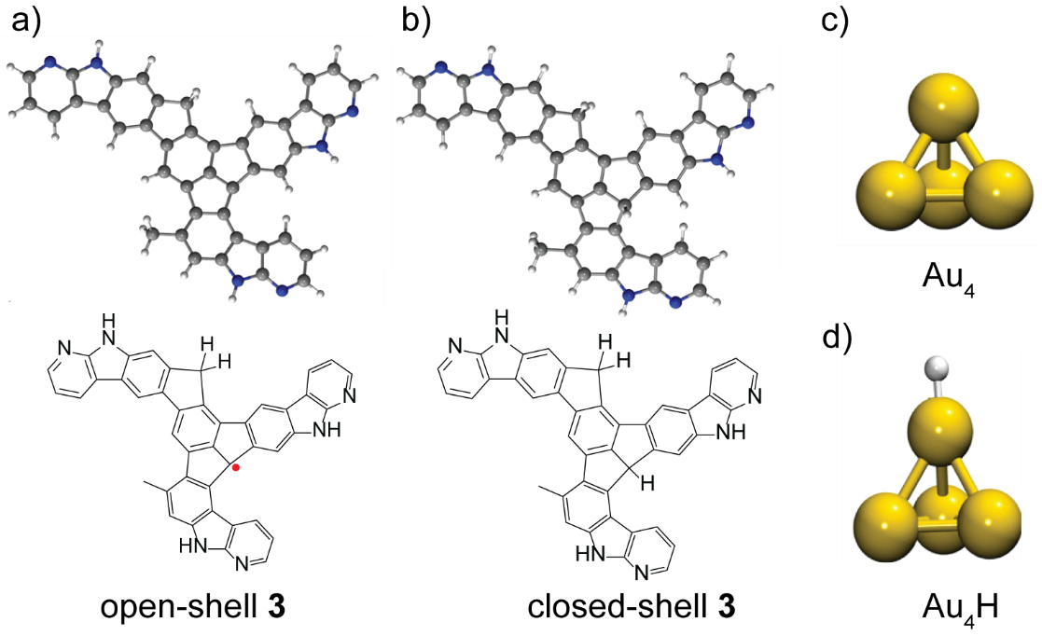
Figure S8. Analysis of thermodynamic stability of the open-shell (a) and the closed-shell (b) variant of product 3 in the presence of Au adatom (c). The closed-shell variant of 3 consists of passivation of fluoradene unit with extra hydrogen, as shown in Figure (b). A cluster of 4 Au atoms represents the gold adatom on Au(111) surface to make such calculations computationally feasible for hybrid exchange-correlation functionals. Figure (d) displays Au₄ with extra hydrogen atom.

