Appendix B.
Combined graph of transitions, the participant’s self-reported challenging behavioral patterns and self-rated emotions, average dynamic complexity of all emotions, and extraordinary events.
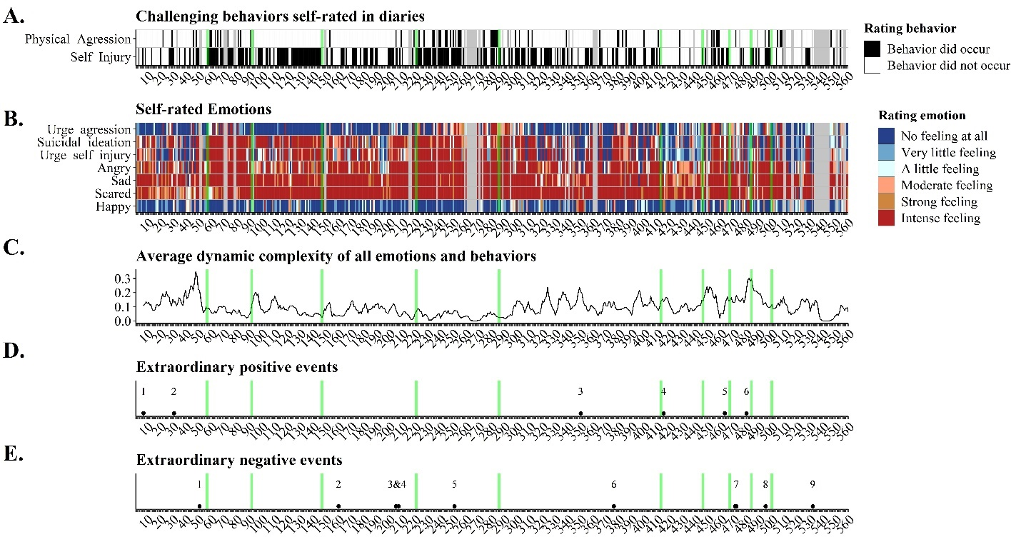Note. Green vertical lines reflect identified transitions. Panel A shows the raw data of self-reported physical aggression and self-injury. Gray cells are missing data. Panel B is a raw data resonance diagram which reflects, on a colour-coded scale, the intensity of seven emotions. Panel C reflects the average dynamic complexity the emotions visualized in panel B. High values reflect unstable patterns, whereas low dynamic complexity reflects stability during the 7 days prior. Panel D and E reflect pinpointed extraordinary positive and negative events identified in the daily records.

