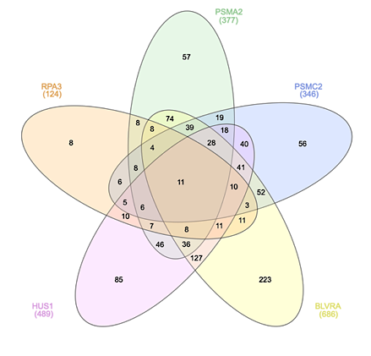
A
Table 4. A. Top common compounds for all targets obtained from Xena browser; B. Top targeting compounds obtained from CMap; C. Top targeting compounds obtained from LINCS database.
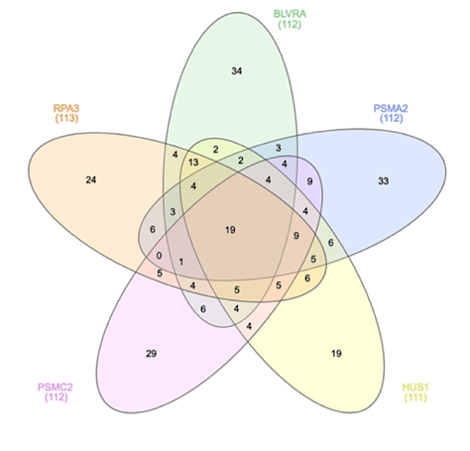
A
Table 5A. DrugBank common compounds against all selected target proteins obtained after molecular docking along with their binding energies for each target.
Table 5B. Binding energies of common DrugBank compounds for each target.

Table 6. EC50 values of drug candidates against the selected targets in GBM cell lines.
A
Table 7. IC50 (uM) values of GSK2126458, linifanib, nilotinib and temozolomide in GBM cell lines.

