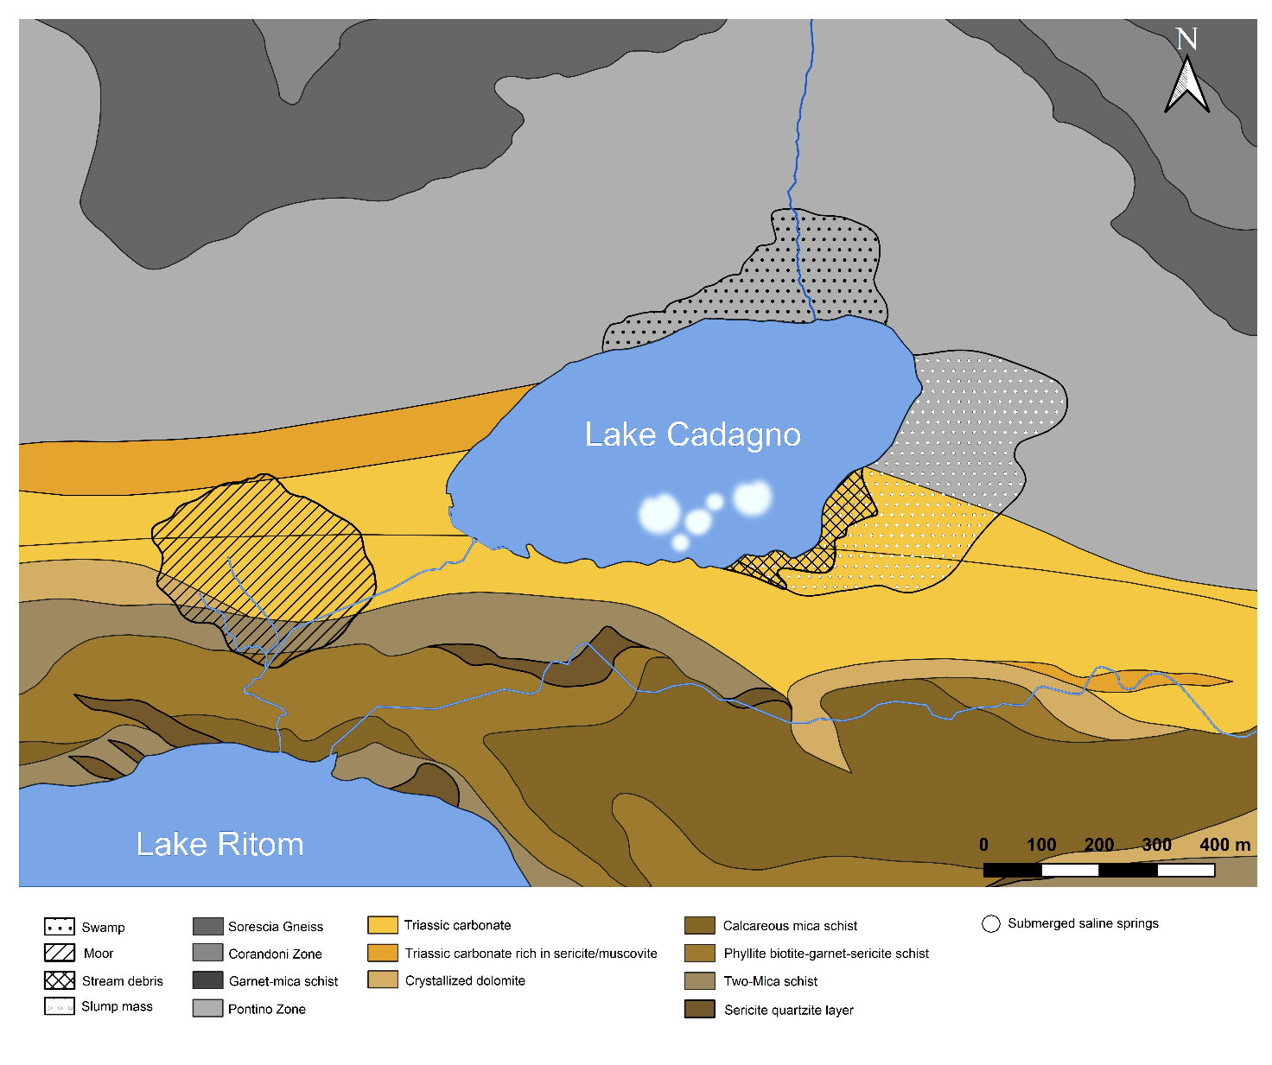
Figure S1. Overview of the geological composition of the Piora valley. The Piora-syncline is colored in yellow. Map created using QGIS® software (version 3.32.1). Data sourced from the Swiss Federal Office of Topography (https://www.swisstopo.admin.ch/).

