Analyzing Tattoo Pigments in a Laboratory Setting: Application of UV-Vis and FTIR Spectroscopy Methods supported with Chemometric Modelling
¹Ajay Vikram Singh*, ²Girija Bansod, ¹Angelina Schumann, ¹Frank S. Bierkandt, ¹Peter Laux, ³ Sweta Vijay Nakhale, ⁴Amruta Shelar ⁵Rajendra Patil, ¹Andreas Luch
¹German Federal Institute for Risk Assessment (BfR), Department of Chemical and Product Safety, Max-Dohrn-Straße 8-10, 10589 Berlin, Germany
²Rajiv Gandhi Institute of IT and Biotechnology, Bharati Vidyapeeth (deemed to be) University, Pune- 411045, India
³PES's Modern College of Arts, Science and Commerce Ganeshkhind, Pune, Maharashtra 411053. India
⁴Department of Technology, Savitribai Phule Pune University, Pune 411007, India
⁵Department of Biotechnology, Savitribai Phule Pune University, Pune 411007, India
⁵Department of Biotechnology, Savitribai Phule Pune University, Pune 411007, India
Supporting Table S1. Pigment ID and serial dilution in 96 well plat from A to H well

For serial dilution experiment, we choose one pigment from each group of PR254 (ID: P-22-025), PR170 (ID: P-22-024) and PB15:3 (ID: P-22-191). To calculate the concentration of an unknown pigment sample using optical density (OD), we first created a standard curve using the known concentrations of pigments and their corresponding OD values after serial deletions as shown below and figure 2. (A-C) upper panel.

Dilution Factor | Volume of stock used | Volume of diluent used | Final Volume | Final Concentration (μg/mL)
1:139 | 0.1 mL | 13.8 mL | 13.9 mL | 35.95
1:69 | 0.1 mL | 6.8 mL | 6.9 mL | 72.46
1:45 | 0.1 mL | 4.4 mL | 4.5 mL | 111.11
1:34 | 0.1 mL | 3.3 mL | 3.4 mL | 147.06
1:27 | 0.1 mL | 2.6 mL | 2.7 mL | 185.19
1:22 | 0.1 mL | 2.1 mL | 2.2 mL | 227.27
1:19 | 0.1 mL | 1.8 mL | 1.9 mL | 263.16
1:16.5 | 0.1 mL | 1.55 mL | 1.65 mL | 303.03

The equation for the standard curve that relates the optical density (OD) to the concentration of the pigment is:
OD = m x [Pigment] + b
where [Pigment] is the concentration of the pigment in the solution, m is the slope of the line, and b is the y-intercept.
To find the concentration of an unknown sample, one can rearrange the equation to solve for [Pigment]:
[Pigment] = (OD - b) / m
where OD is the optical density of the unknown sample, and m and b are the slope and y-intercept values obtained from the standard curve.

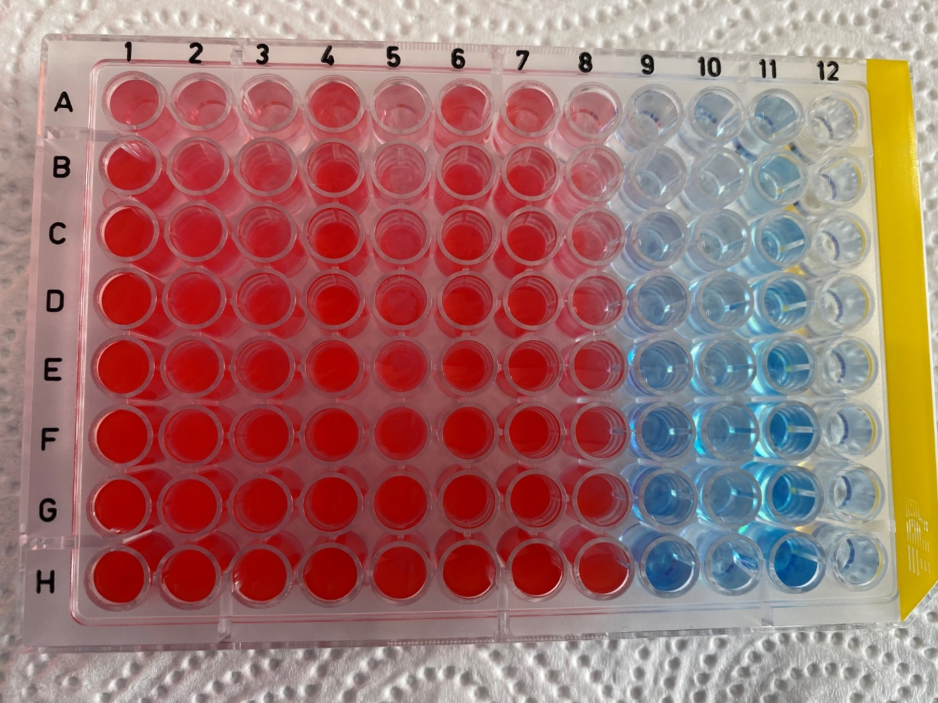

Figure S1. Known dilution from table 1 depicted as qualitative observation in 96 well plate.

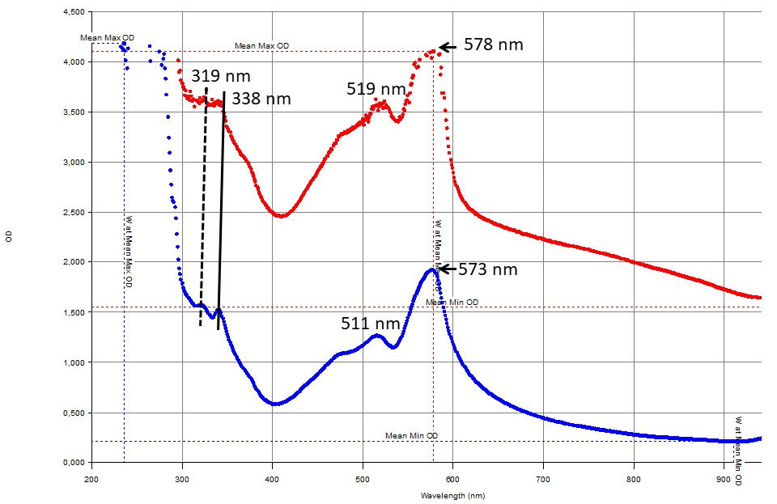

Figure S2. UV-Vis spectra showing finger print region of main peaks from different supplier of pigment red (PR 170).

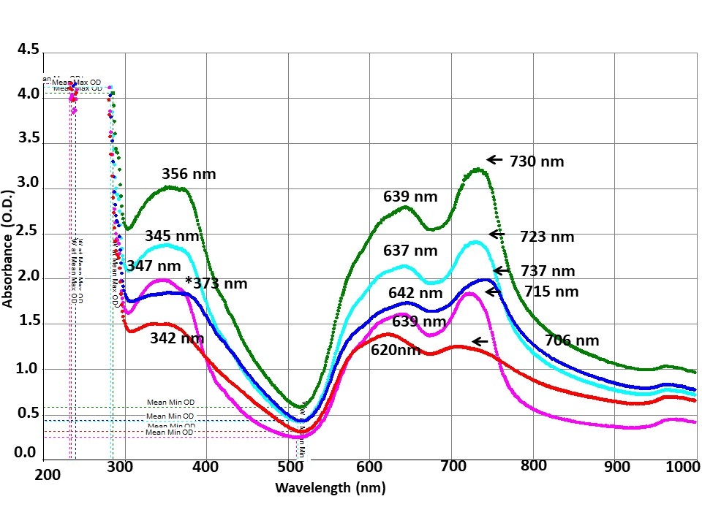
Figure S3. UV-Vis spectra showing finger print region of main peaks from different supplier of pigment blue (PB15:3).

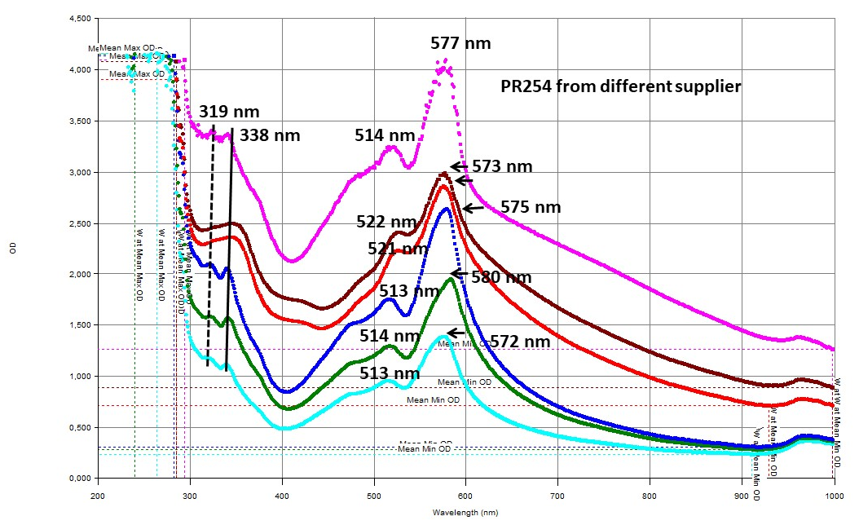
Figure S4. UV-Vis spectra showing finger print region of main peaks from different supplier of pigment red (PR 254).

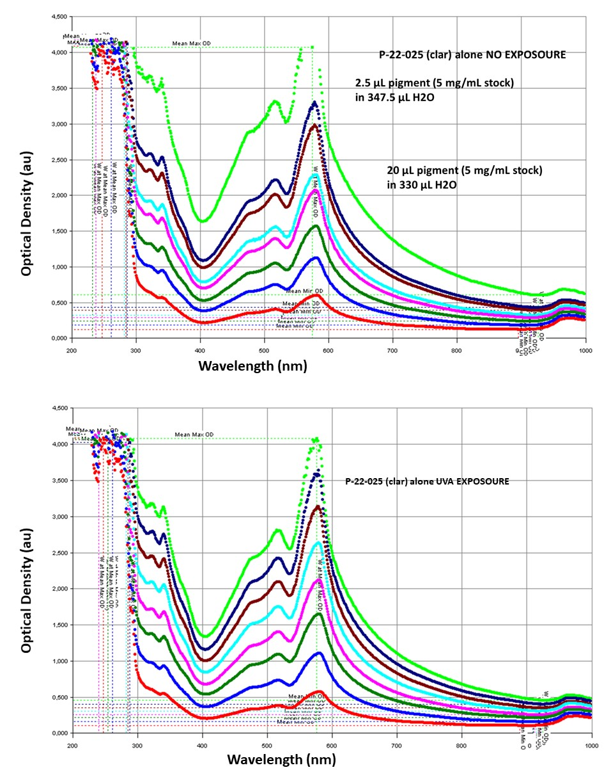

Figure S5. UV-Vis before and after exposure to UVA to analyse the photolysis of pigment red 170. Inset text in upper panel show absorbance limit of instrument (green curve) of lowest dilution vs. highest dilution measured.

Figure S6. Qualitative analysis of light fastness before (A) and after exposure (B) of a drop of pigment Red 254 from figure S5

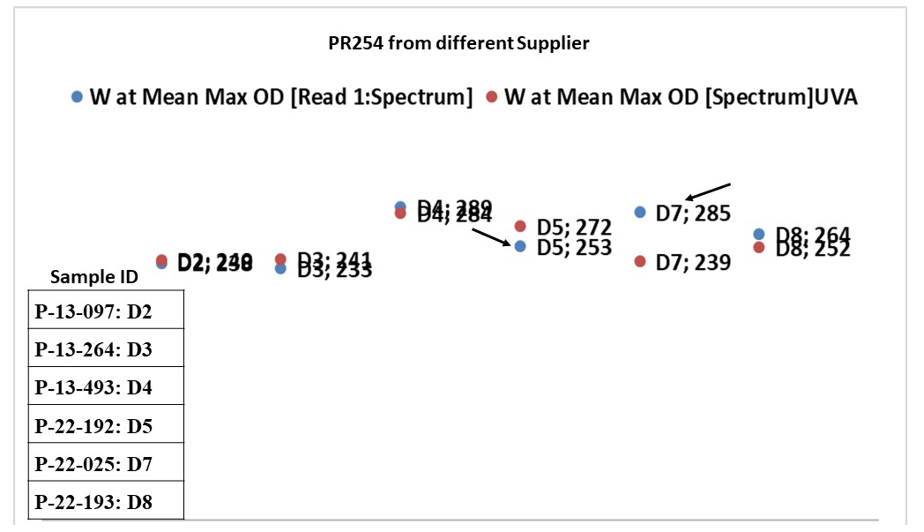
Figure S6. Shift in Wavelength at Mean max OD or peak absorption wavelength before and after UVA exposure pigment red PR 254 (arrow show shift). D2-D8 well positions in 96 well plate. "Mean" in the context of wavelength at mean max OD refers to the average value of the maximum optical density (OD) of a sample across a range of wavelengths.

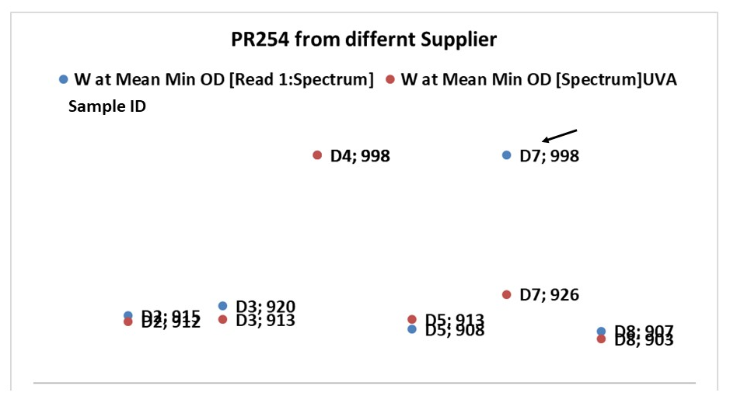
Figure S7. Shift in Wavelength at Mean min OD or the peak minimum (trough) before and after UVA exposure for Pigment red PR254 (arrow show shift). D2-D8 well positions in 96 well plate.

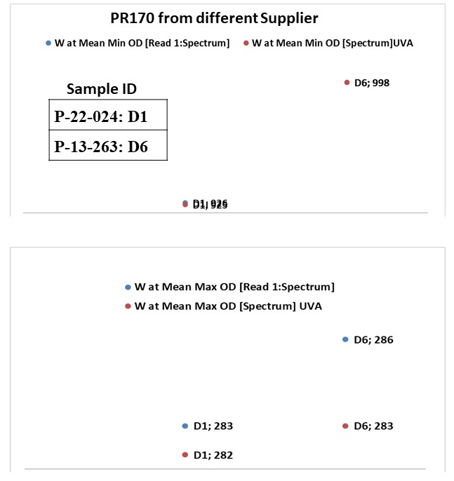

Figure S8. Shift in Wavelength at Mean max OD or peak absorption wavelength, and Mean min OD or the peak minimum (trough) before/after UVA exposure for Pigment red PR 170.

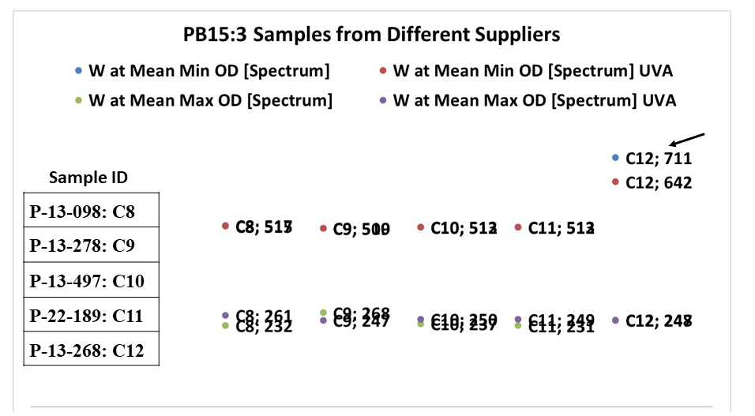
Figure S9. Shift in Wavelength at Mean max OD or peak absorption wavelength, and Mean min OD or the peak minimum (trough) before/after UVA exposure for Pigment Blue PB15:3. `C´ represent well position in 96 well plate used for the spectra recording and arrow indicate sample showing shift after UVA exposure.

Table S2. FTIR Peaks missing or detected as single peak among pigments from different suppliers with same CAS#
w: weak, m:middle/medium, s:strong
Missing - Single
Table S2.A

PR 170: P-22-024 | PR 170: P-13-263
3663 w
3395 s | 3395 s
3295 w | 3296 w
3174 s | 3174 s
3069 w | 3069 w
2988 w | 2988 w
2935 w | 2937 w
2881 w | 2881 w
2765 w | 2767 w
S-H stretching from thiol | 2600 w
 | 2446 w
O=C=O stretching from CO₂ | 2285 w
CΞN stretching from nitrile | 2229 w
Shift in CΞN stretching from nitrile | 2168 w
2162 w | Shift CΞN stretching from nitrile
N=N=N stretching from azide | 2150 w
Shift N=N=N stretching from azide | 2101 w
2035 w | 2036 w
1979 w | 1980 w
 | 1952 w
 | 1914 w
 | 1875 w
 | 1828 w
 | 1760 w
1678 s | 1679 s
1655 s | 1656 s
1610 w | 1610 s
1597 m | 1597 m
1549 m | 1549 s
1536 s | 1538 s
 | 1512 s
1494 m | 1494 s
 | 1483 s
1450 s | 1450 s
 | 1419 s
1383 s | 1384 s
1362 m | 1362 m
1332 m | 1332 m
1306 m | 1306 m
1286 m | 1286 m
1262 m | 1262 m
1225 s | 1226 m
 | 1205 m
1191 m | 1191 m
1161 m | 1162 m
1148 s | 1149
1137 w | 1138 w
1117 m | 1116 m
 | 1050 w
1041 w | 1041 w/m
1014 s | 1015 s
961 m | 961 m
930 m | 930 m
893 m | 893 m
 | 849 m
833 m | 833 m
816 w | 816 m
805 m | 805 m
777 w | 777 m
749 w | 750 m
738 s | 740 m
 | 729 m
703 m | 703 m
664 w | 664 m
652 w | 653 m
632 w | 632 w
572 m | 572 m
538 m

Table S2.B
PR 254: P-22-025  Clariant | PR 254: P-13-264 – Clariant – DEB2177548 | PR 254: P-13-097  - | PR 254: P-13-493  BASF | PR 254: P-22-00192 KREMER | PR254: P – 22-00193 – Chem Cruz
3298 w | 3299 w | 3299 w | 3299 | 3298 w | 3299 w
3131 w | 3131 w | 3131 w | 3131 w | 3131 w | 3131 w
3079 w | 3079 w | 3079 w | 3079 w | 3079 w | 3079 w
unsaturated alkenes, sp² | 3058 w | 3058 w | 3058 w | 3058 w | 3058 vw
Sp2 Alekenes | 3030 w | 3030 w | 3030 w | 3030 w | 3030 w
2988 w | 2988 w | 2988 w | asymmetrical  stretching of methyl group | 2988 w | Asym –CH3 stretch
 |  |  |  |  | 2978 w
2881 w | 2882 w | 2881 w | 2881 w | 2882 w | 2881 w
2840 w | 2840 w | 2840 w | 2840 w | 2840 | 2840 w
2803 w | 2803 w | 2803 w | 2803 w | 2803 | 2803 w
2764 w | 2764 w | 2764 w | 2763 w | 2763 | 2765 w
2541 w | 2543 w | 2541 w |  | 2541 | -SH
  Thiol S-H stretch
2499 w | 2499 w | 2500 w | 2499 w | 2499 | 2500 w
2437 w | 2437 w | 2437 w | 2436 w | 2437 | 2437 w
2349 w * | CO2 in beam
2293 w | 2293 w | 2293 w | 2293 w | 2293 | 2293 w
2256 w | 2256 w | 2256 w | 2256 w | 2256 | 2258 w
2196 w | 2196 w | 2196 w | 2197 w | 2196 w | 2198 w
2161 w | 2161 w | 2161 w | 2161 w | 2161 w | 2161 w
2073 w | 2073 w | 2073 w | 2073 w | 2073 w | 2074 w
1979 w | 1979 w | 1979 w | 1979 w | 1979 w | 1980 w
1950 w | 1950 w | 1950 w | 1950 w | 1950 w | 1950 w
1928 w | 1928 w | 1928 w | 1928 w | 1928 w | 1928 w
1901 w | 1901 w | 1901 w | 1901 w | 1901 w | 1901 w
C-H bending Aromatic grp | 1817 w | 1816 w | 1816 w | 1816 w | 1818 w
 | Acid Halide (-Cl, Br etc. |  |  | 1802 w
1722 m | 1722 w | 1722 w | 1722 w | 1722 w | 1722 w
1682 w | 1682 w | 1683 w | 1683 w | 1682 w | 1682 w
1599 s | 1599 s | 1600 s | 1599 s | 1599 s | 1599 s
1559 w | 1559 w | 1559 w | 1559 w | 1559 w | 1559 w
1552 w | 1552 w | 1552 w | 1552 w | 1552 w | 1552 w
1495 s | 1495 s | 1496 s | 1495 s | 1495 s | 1496 s
1469 w | 1469 w | 1469 w | 1469 w | 1469 w | 1469 w
1445 s | 1445 s | 1445 s | 1445 s | 1445 s | 1445 s
1402 m | 1402 m | 1402 m | 1402 m | 1402 m | 1402 m
 | S=O stretching sulphonic acid, or esters/ethers |  |  | 1344
1327 m | 1327 m | 1327 m | 1327 m | 1327 m | 1327 m
1316 w | 1316 w | 1316 w | 1316 w | 1316 w | 1316 w
1303 w | 1303 w | 1303 w | 1303 w | 1303 w | 1303 w
1282 m | 1282 w/m | 1282 m | 1282 m | 1282 m | 1282 w
1202 w | 1202 w | 1202 w | 1202 w | 1202 w | 1202 w
1192 s | 1192 s | 1192 s | 1192 s | 1192 s | 1192 s
1141 s | 1141 s | 1141 s | 1141 s | 1141 s | 1141 w
1111 w | 1111 w | 1111 w | 1111 w | 1111 w | 1111 w
1092 s | 1092 s | 1092 s | 1092 s | 1092 s | 1092 m
1089 s | 1089 s | 1089 s | 1089 s | 1089 s | 1089 s
1034 m | 1034 m | 1034 m | 1034 m | 1034 m | 1034 m
1013 s | 1013 s | 1013 s | 1013 s | 1013 s | 1013 m
976 w | 976 w | 976 w | 976 w | 976 w | 976 w
954 m | 954 w | 954 w | 954 w | 954 w | 954 w
Monosubstituted alekenes | 898 w | 898 w | 898 w | 898 w
844 m | 844 w | 845 m | 844 w | 844 w | 844 w
840 s | 840 s | 840 s | 840 s | 840 s | 840 w
822 m | 822 m | 823 m | 824 m | 824 m | 822 w
808 w | 808 w | 808 w | 808 w | 808 w | 808 w
751 s | 752 s | 753 s | 752 s | 752 s | 753 s
713 s | 713 s | 713 s | 713 s | 713 s | 713 s
622 s | 623 s | 623 s | 623 s | 622 s | 623 s

Table S2.C

PB15:3 P-13-098 | PB15:3 P-13-278 | PB15:3 P-13-268 | PB15:3 P-13-497  BASF - 57869917
-OH stretch alcohol | 3218 w
-CH stretch Alkene | 3080 w | 3080 w | 3080 w
3048 w | 3048 w |  | 3048 w
3029 w | 3029 w | 3029 w | 3028 w
-CH stretch Alkene |  | 3013 w | 3013 w
2949 w | 2949 w | 2948 w | 2948 w
2864 w | 2864 w | 2864 w | 2864 w
 | 2821 w | -CHO
2772 w | 2772 m | 2772 w | 2772 w
2649 w | 2649 w | 2649 w | 2650 w
 |  |  | 2595 w
2571 w | 2571 w | 2571 w | 2571 w
2466 w | 2466 w | 2466 w
 |  |  | 2442 w
2434 w | 2435 m/w | 2434 w
2384 w | 2384 m | 2384 w
 | 2284 w | 2384 w
2253 w | 2253 w | 2252 w
2225 w | 2227 m | 2225 w | 2225 w
 | 2169 w |  | 2168 w
C-N-triple bond of nitriles | 2147 w | 2147 w | 2148 w
2100 w | 2100 w | 2100 w | 2100 w
 | 2084 w
2035 w | 2034 w | 2034 w | 2035 w
 |  |  | 1978 w
1966 m | 1967 w | 1966 w | 1966 w
 | 1945 w
1898 m | 1899 m | 1898 w | 1898 w
 | 1868 w
1822 w/m | 1824 m | 1822 w | 1822 w
 |  | 1756 w | 1756 w
1750 w | 1750 w
 | 1733 w |  | 1733 w
1722 w | C=O
 | C=O | 1717 w
1699 w | C=O shift | 1699 w | 1699 w
1695 w | C=O shift | 1695 w | 1695 w
 |  | 1683 w | 1683 w
1652 w | 1652 w | 1652 w | 1652 w
1609 s | 1609 m | 1610 m | 1610 m
1589 m | 1589 w | 1589 w/m | 1589 w
 |  | 1557 vw | 1557 w
  C=C stretching | cyclic alkene
1505 s | 1505 s | 1505 s | 1505 s
1480 w | 1480 w | 1480 w | 1480 w
1464 s | 1464 m | 1464 s | 1464 s
1419 s | 1419 s | 1419 s | 1420 s
 | 1372 w |  | 1372 w
1333 s | 1332 s | 1332 s | 1332 s
1287 s | 1287 s | 1287 s | 1287 s
1203 w | 1203 w | 1203 w | 1203 w
1174 w | 1174 w | 1174 w | 1174 w
1165 s | 1165 s | 1165 s | 1165 s
1118 s | 1118 s | 1118 s | 1118 s
1102 m | 1102 m | 1102 m | 1102 m
1088 s | 1088 s | 1088 s | 1088 s
1067 s | 1067 s | 1067 s | 1067 s
1004 w | 1004 w | 1003 w | 1004 w
984 w | 984 w | 984 w | 984 w
957 w | 957 w | 957w | 957 w
950 w | 950 w | 950 w | 950 w
900 s | 900 s | 900 s/m | 900 s
879 s/m | 878 m/s | 878 m | 878 s
803 w | 803 w | 803 w | C=C bending in alkene
780 s | 780 s | 780 s/m | 780 s
Shift in C=C bending in alkene | 773 | 773 w | 773 w
754 s | 754 s | 753 s | 754 s
728 s | 728 s | 728 s | 728 s
690 w | 690 m | 690 w | 690 w
679 w | 680 w | 679 w | 679 w
638 m | 638 m | 638 w | 638 w
572 m | 572 m | 572 m | 572 w

Chemometric Modelling IR peak correlation and PCA among colorant cohorts
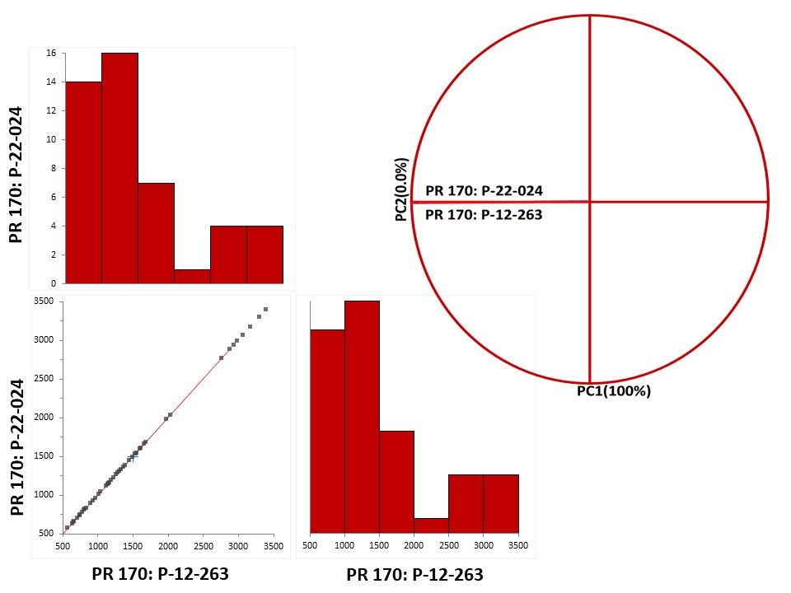
Figure S10. (A-B) Chemometric PCA monoplot showing 1.a) scatterplot matrix and 1.b) Correlation Monoplot for PR170 from different manufacturers
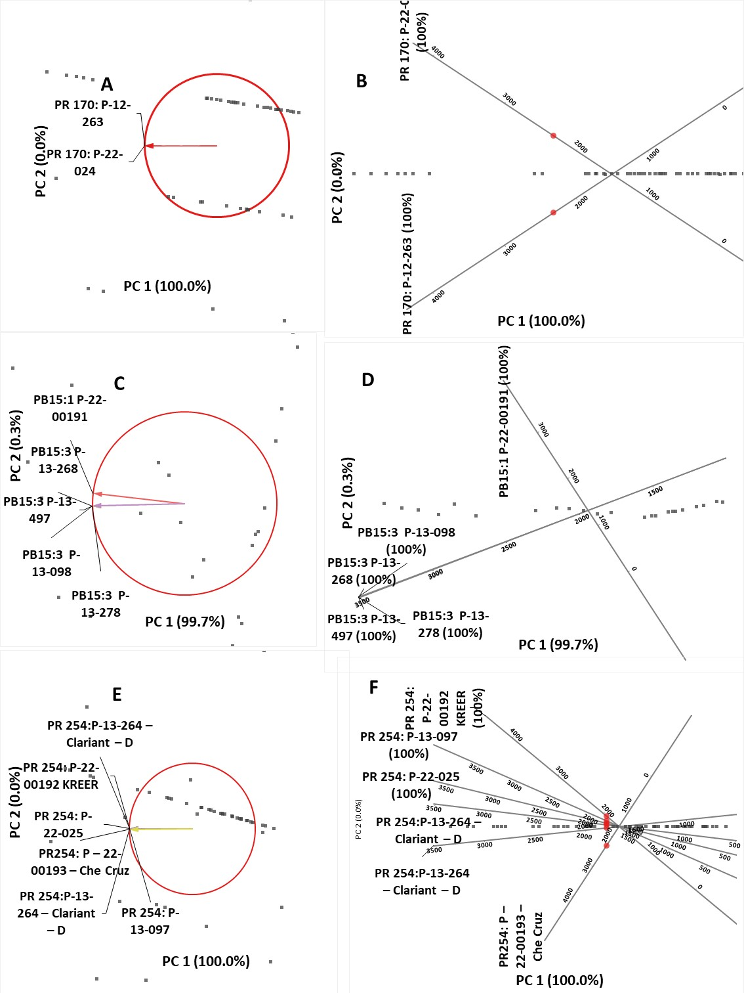
Figure S.11 Chemometric Biplot that displays multivariate data by representing the observations as points and the variables as vectors. The variables are plotted in two dimensions, with each variable represented by an arrow pointing in the direction of its maximum variation. The length of the arrow represents the importance of the variable in explaining the variation of the data. (1a, b, c: correlation biplot for PR170, PB15:3 & PR254 respectively; 2a, b, c: PCA biplot for PR170, , PB15:3 & PR254 respectively).

Supporting method: Chemometric Modelling and PCA
PIGMENT RED 170
Variable | Mean | SD | Minimum | Median | Maximum
PR 170: P-22-024 | 1495.1 | 809.8 | 572 | 1274.0 | 3395
PR 170: P-12-263 | 1495.5 | 809.9 | 572 | 1274.0 | 3395

COVARIANCE
 | PR 170: P-22-024 | PR 170: P-12-263
PR 170: P-22-024 | 655711 | 655801
PR 170: P-12-263 | 655801 | 655891

CORRELATION
Correlation
 | PR 170: P-22-024 | PR 170: P-12-263
PR 170: P-22-024 | - | 1.000 | Pearson's r
 | - | 1.000 | Spearman's rs
 | - | 1.000 | Kendall's tau
PR 170: P-12-263 | 1.000 | -
 | 1.000 | -
 | 1.000 | -

Principal Components
 | Component | Variance | Proportion | Cumulative proportion
 | 1 | 2.000 | 1.000 | 1.000
 | 2 | 3.515E-07 | 0.000 | 1.000

Coefficients
 | Component
 | 1 | 2
PR 170: P-22-024 | -0.707 | 0.707
PR 170: P-12-263 | -0.707 | -0.707

Quality of representation
Dimension | PR 170: P-22-024 | PR 170: P-12-263
1 | 1.000 | 1.000
2 | 1.000 | 1.000

PIGMENT RED 254
Variable | Mean | SD | Minimum | Median | Maximum
PR 254: P-22-025 | 1663.0 | 730.1 | 622 | 1482.0 | 3298
PR 254:P-13-264 – DEB2177548: 1 | 1663.1 | 730.1 | 623 | 1482.0 | 3299
PR 254:P-13-264 – DEB2177548: 2 | 1663.3 | 730.1 | 623 | 1482.5 | 3299
PR 254: P-13-097 | 1663.1 | 730.0 | 623 | 1482.0 | 3299
PR 254: P-22-00192 | 1663.1 | 730.0 | 622 | 1482.0 | 3298
PR254: P – 22-00193 – | 1663.3 | 730.2 | 623 | 1482.5 | 3299

COVARIANCE

 |  |  | PR 254: P-22-025 | PR 254:P-13-264 –DEB2177548: 1 | PR 254:P-13-264 – DEB2177548: 2 | PR 254: P-13-097 | PR 254: P-22-192 | PR254: P – 22-193 –
 |  | PR 254: P-22-025 | 533076 | 533096 | 533028 | 533006 | 533024 | 533151
 |  | PR 254:P-13-264 – DEB2177548: 1 | 533096 | 533115 | 533047 | 533025 | 533043 | 533170
 |  | PR 254:P-13-264 –DEB2177548: 2 | 533028 | 533047 | 532980 | 532958 | 532976 | 533103
 |  | PR 254: P-13-097 | 533006 | 533025 | 532958 | 532935 | 532953 | 533081
 |  | PR 254: P-22-00192 | 533024 | 533043 | 532976 | 532953 | 532971 | 533099
 |  | PR254: P – 22-00193 – | 533151 | 533170 | 533103 | 533081 | 533099 | 533226
 |  | CORRELATION | PR 254: P-22-025 | PR 254:P-13-264 – Clariant – DEB2177548: 1 | PR 254:P-13-264 – Clariant – DEB2177548: 2 | PR 254: P-13-097 | PR 254: P-22-00192 KREER | PR254: P – 22-00193 – Che Cruz
 |  | PR 254: P-22-025 | - | 1.000 | 1.000 | 1.000 | 1.000 | 1.000 | Pearson's r
 |  |  | - | 1.000 | 1.000 | 1.000 | 1.000 | 1.000 | Spearman's
 |  |  | - | 1.000 | 1.000 | 1.000 | 1.000 | 1.000 | Kendall's tau
 |  | PR 254:P-13-264 – DEB2177548: 1 | 1.000 | - | 1.000 | 1.000 | 1.000 | 1.000
 |  |  | 1.000 | - | 1.000 | 1.000 | 1.000 | 1.000
 |  |  | 1.000 | - | 1.000 | 1.000 | 1.000 | 1.000
 |  | PR 254:P-13-264 – DEB2177548: 2 | 1.000 | 1.000 | - | 1.000 | 1.000 | 1.000
 |  |  | 1.000 | 1.000 | - | 1.000 | 1.000 | 1.000
 |  |  | 1.000 | 1.000 | - | 1.000 | 1.000 | 1.000
 |  | PR 254: P-13-097 | 1.000 | 1.000 | 1.000 | - | 1.000 | 1.000
 |  |  | 1.000 | 1.000 | 1.000 | - | 1.000 | 1.000
 |  |  | 1.000 | 1.000 | 1.000 | - | 1.000 | 1.000
 |  | PR 254: P-22-00192 | 1.000 | 1.000 | 1.000 | 1.000 | - | 1.000
 |  |  | 1.000 | 1.000 | 1.000 | 1.000 | - | 1.000
 |  |  | 1.000 | 1.000 | 1.000 | 1.000 | - | 1.000
 |  | PR254: P – 22-00193 | 1.000 | 1.000 | 1.000 | 1.000 | 1.000 | -
 |  |  | 1.000 | 1.000 | 1.000 | 1.000 | 1.000 | -
 |  |  | 1.000 | 1.000 | 1.000 | 1.000 | 1.000 | -

PRINCIPAL COMPONENTS
Component | Variance | Proportion | Cumulative proportion
1 | 6.000 | 1.000 | 1.000
2 | 4.704E-07 | 0.000 | 1.000
3 | 2.356E-07 | 0.000 | 1.000
4 | 1.761E-07 | 0.000 | 1.000
5 | 8.349E-08 | 0.000 | 1.000
6 | 6.335E-08 | 0.000 | 1.000

COEFFICIENTS
 | Component
 | 1 | 2 | 3 | 4 | 5 | 6
PR 254: P-22-025 | -0.408 | 0.134 | 0.622 | -0.006 | 0.181 | -0.629
PR 254:P-13-264 DEB2177548: 1 | -0.408 | 0.067 | 0.358 | -0.193 | 0.349 | 0.736
PR 254:P-13-264 –DEB2177548: 2 | -0.408 | -0.057 | -0.382 | -0.793 | -0.165 | -0.165
PR 254: P-13-097 | -0.408 | 0.242 | -0.581 | 0.388 | 0.523 | -0.112
PR 254: P-22-00192 | -0.408 | 0.455 | -0.002 | 0.296 | -0.718 | 0.152
PR254: P – 22-00193 | -0.408 | -0.842 | -0.015 | 0.309 | -0.170 | 0.019

QUALITY OF REPRESENTATION
Dimension | PR 254: P-22-025 | PR 254:P-13-264 – Clariant – DEB2177548: 1 | PR 254:P-13-264 – Clariant – DEB2177548: 2 | PR 254: P-13-097 | PR 254: P-22-00192 KREER | PR254: P – 22-00193 – Che Cruz
1 | 1.000 | 1.000 | 1.000 | 1.000 | 1.000 | 1.000
2 | 1.000 | 1.000 | 1.000 | 1.000 | 1.000 | 1.000
3 | 1.000 | 1.000 | 1.000 | 1.000 | 1.000 | 1.000
4 | 1.000 | 1.000 | 1.000 | 1.000 | 1.000 | 1.000
5 | 1.000 | 1.000 | 1.000 | 1.000 | 1.000 | 1.000
6 | 1.000 | 1.000 | 1.000 | 1.000 | 1.000 | 1.000

PIGMENT BLUE
Variable | Mean | SD | Minimum | Median | Maximum
PB15:3 P-13-098 | 1938.9 | 600.1 | 1174 | 1822.0 | 3029
PB15:3 P-13-278 | 1939.1 | 600.2 | 1174 | 1824.0 | 3029
PB15:3 P-13-268 | 1938.8 | 600.0 | 1174 | 1822.0 | 3029
PB15:3 P-13-497 | 1938.9 | 600.0 | 1174 | 1822.0 | 3028
PB15:1 P-22-00191 | 1319.9 | 723.3 | 572 | 1119.0 | 2772

COVARIANCE

 | PB15:3 P-13-098 | PB15:3 P-13-278 | PB15:3 P-13-268 | PB15:3 P-13-497 | PB15:1 P-22-00191
PB15:3 P-13-098 | 360107 | 360145 | 360070 | 360033 | 429927
PB15:3 P-13-278 | 360145 | 360184 | 360108 | 360071 | 429957
PB15:3 P-13-268 | 360070 | 360108 | 360032 | 359995 | 429870
PB15:3 P-13-497 | 360033 | 360071 | 359995 | 359959 | 429827
PB15:1 P-22-00191 | 429927 | 429957 | 429870 | 429827 | 523113

CORRELATION
 | PB15:3 P-13-098 | PB15:3 P-13-278 | PB15:3 P-13-268 | PB15:3 P-13-497 | PB15:1 P-22-00191
PB15:3 P-13-098 | - | 1.000 | 1.000 | 1.000 | 0.991 | Pearson's r
 | - | 1.000 | 1.000 | 1.000 | 0.999 | Spearman's rs
 | - | 1.000 | 1.000 | 1.000 | 0.992 | Kendall's tau
PB15:3 P-13-278 | 1.000 | - | 1.000 | 1.000 | 0.991
 | 1.000 | - | 1.000 | 1.000 | 0.999
 | 1.000 | - | 1.000 | 1.000 | 0.992
PB15:3 P-13-268 | 1.000 | 1.000 | - | 1.000 | 0.991
 | 1.000 | 1.000 | - | 1.000 | 0.999
 | 1.000 | 1.000 | - | 1.000 | 0.992
PB15:3 P-13-497 | 1.000 | 1.000 | 1.000 | - | 0.991
 | 1.000 | 1.000 | 1.000 | - | 0.999
 | 1.000 | 1.000 | 1.000 | - | 0.992
PB15:1 P-22-00191 | 0.991 | 0.991 | 0.991 | 0.991 | -
 | 0.999 | 0.999 | 0.999 | 0.999 | -
 | 0.992 | 0.992 | 0.992 | 0.992 | -

PRINCIPAL COMPONENT

Component | Variance | Proportion | Cumulative proportion
1 | 4.985 | 0.997 | 0.997
2 | 0.01511 | 0.003 | 1.000
3 | 1.021E-06 | 0.000 | 1.000
4 | 3.068E-07 | 0.000 | 1.000
5 | 1.791E-07 | 0.000 | 1.000

COEFFICIENTS
 | Component
 | 1 | 2 | 3 | 4 | 5
PB15:3 P-13-098 | -0.448 | -0.221 | -0.178 | -0.769 | -0.356
PB15:3 P-13-278 | -0.448 | -0.223 | 0.842 | 0.175 | -0.097
PB15:3 P-13-268 | -0.448 | -0.223 | -0.196 | -0.021 | 0.843
PB15:3 P-13-497 | -0.448 | -0.223 | -0.470 | 0.614 | -0.390
PB15:1 P-22-00191 | -0.445 | 0.895 | 0.001 | 0.001 | 0.001

