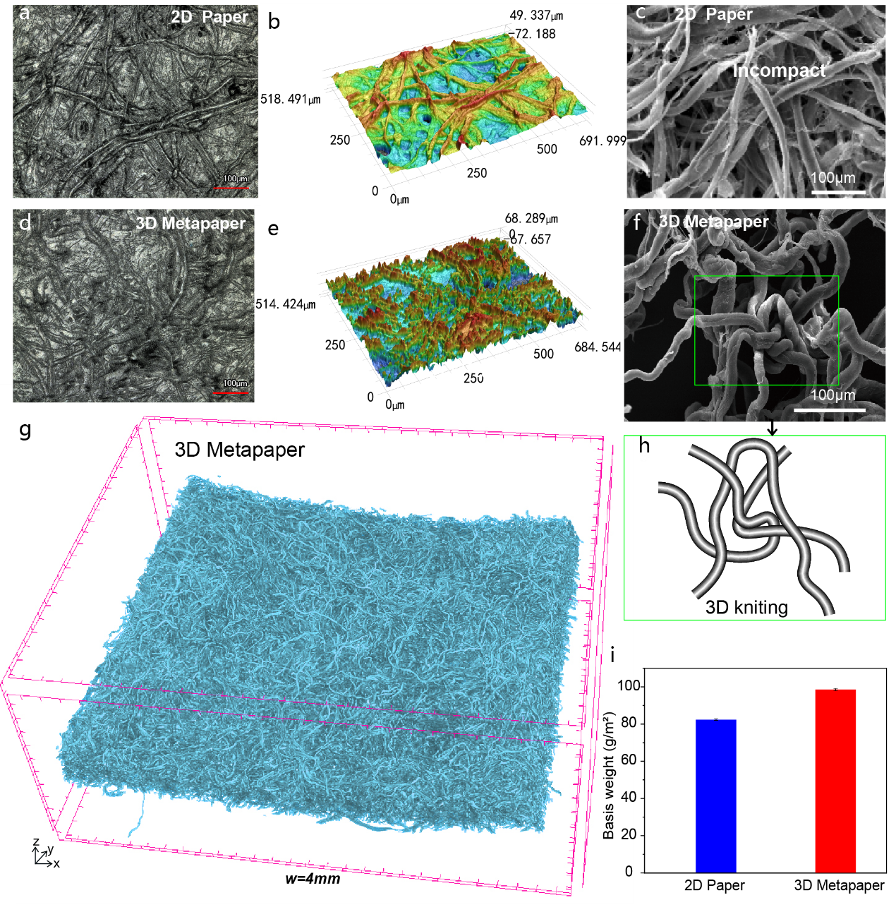
Extended Data Figure 1 | Structural characterization of 2D Paper and 3D Metapaper. a, b, Laser confocal image of 2D paper. The fibers are cross-stacked. c, SEM image of 2D paper after submersion in water(freeze-dried). Loose interlaced layers of fibers are stacked. d, e, Laser confocal image of 3D Metapaper. f. SEM image of fiber entanglement in 3D Metapaper. h, Model of fiber entanglement corresponding to figure f. g, Micro-CT image of 3D Metapaper (w=4 mm). The network structure of the fibers is clearly illustrated. I, Basis weight comparison of 2D Paper and 3D Metapaper.

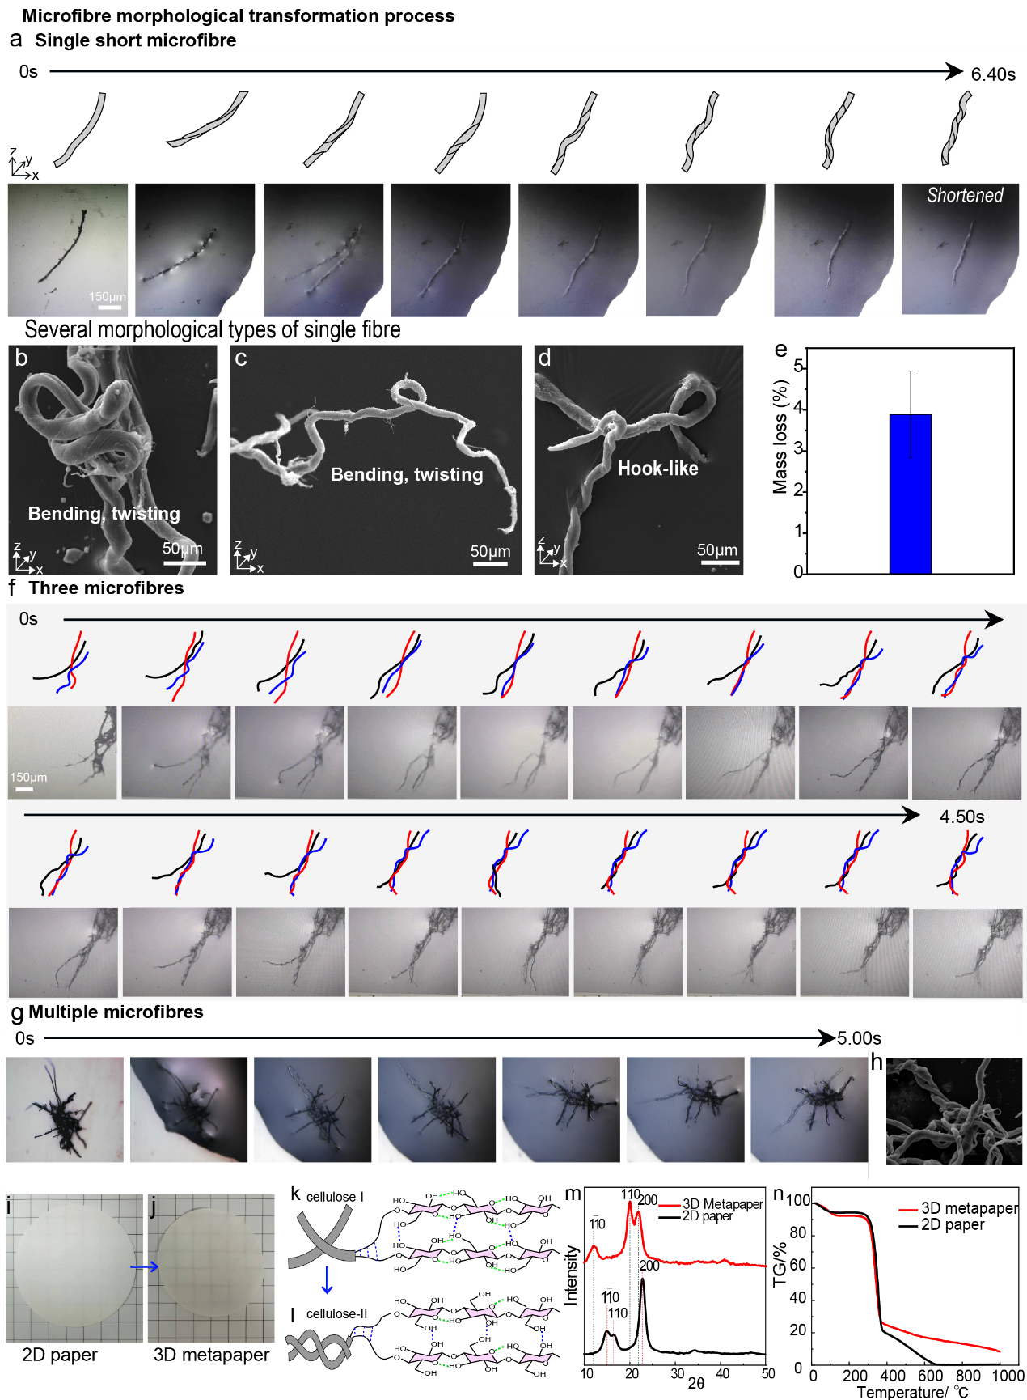
Extended Data Figure 2 | The formation process and mechanism of 3D Metapaper. a, Model and micrographs of changes in fiber morphology following alkali treatment of single fiber at every moment. The fiber is rotated several times, and the radial length of the fiber is shortened. b, c, d, Several morphological changes SEM images of the single fiber after alkali treatment. Fibers are bent, twisted, and folded in 3d space. This morphological variation allows forming strong lock-lock relationships between neighbouring fibers. e, The weight loss of fibers after treatment with concentrated alkali solutions. f, Models of the morphological changes and corresponding micrographs when three cross-stacked fibers are treated with alkali. The microscope photographs show the rapid twisting and bending of fibers within 3 s of alkali treatment, with adjacent fibers entangled during the twisting process. g, Microscopic photos document the morphological changes during the multiple fibers with alkali treatment. h, SEM image of the structure of multiple fibers after alkali treatment. The fibers are shown to be highly entangled together. i, Photo from 2D paper to 3D Metapaper. Compared to 2D paper, the surface area of 3D Metapaper is reduced to 79.51% of its original 2D paper size. k, j, Cellulose crystal type from type I to type II. m, XRD plot of 3D Metapaper and 2D paper. n, TG curves of 2D paper and 3D Metapaper.

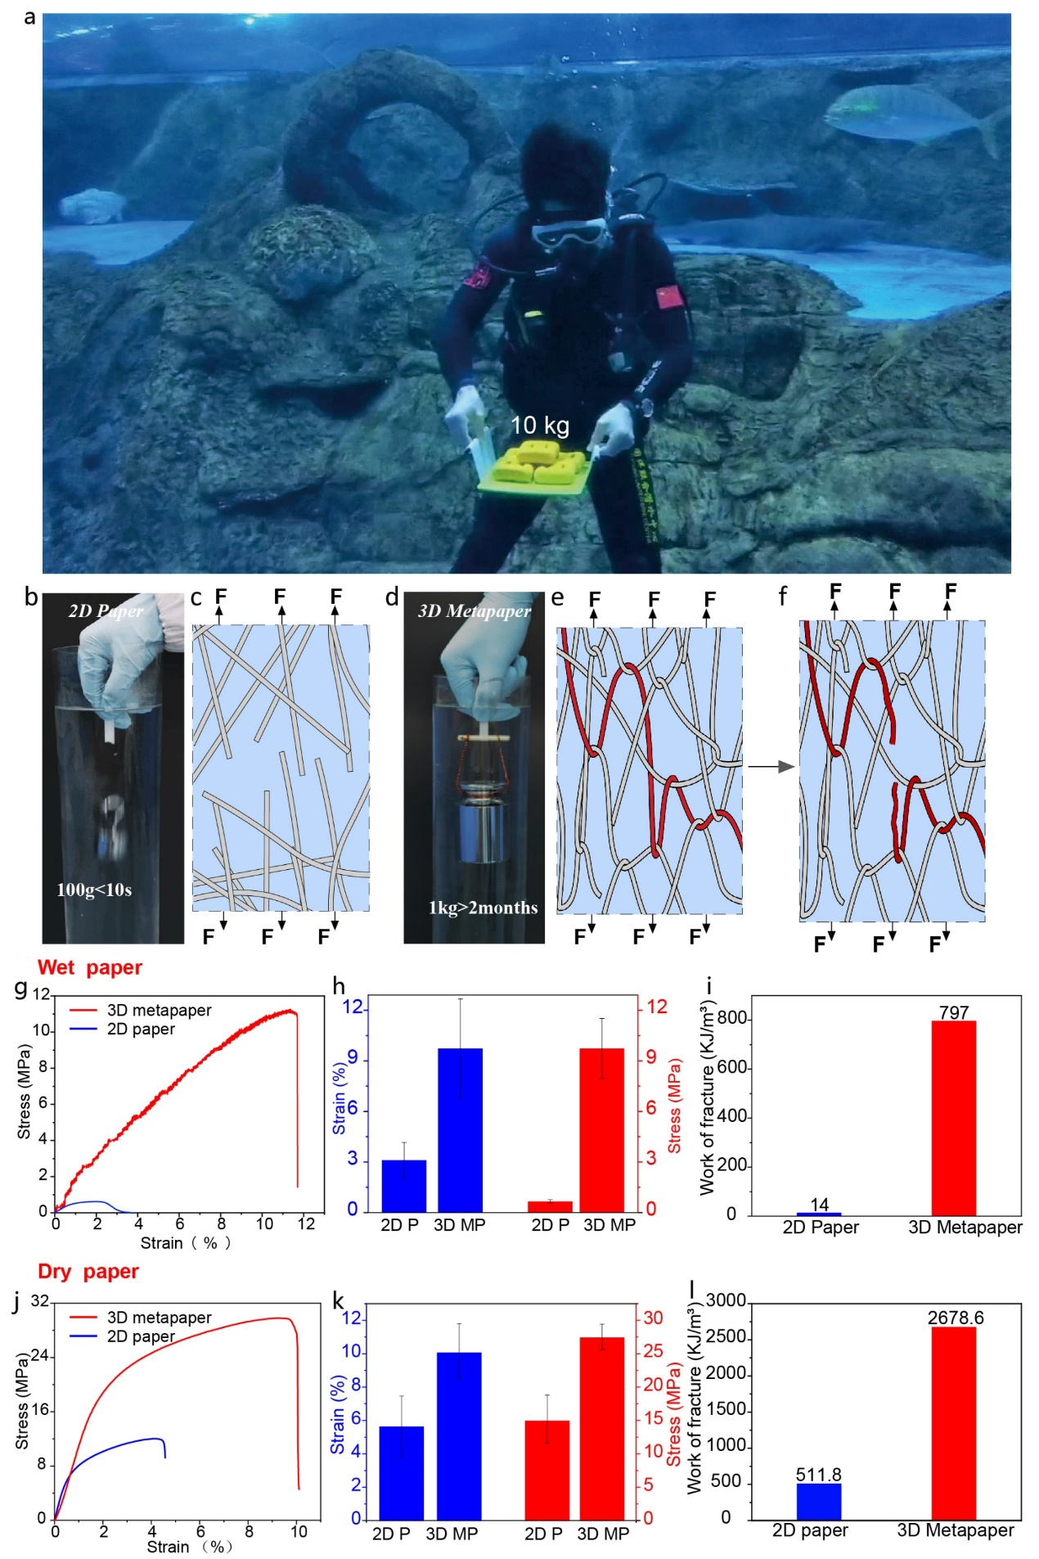
Extended Data Figure 3 | a, 3D Metapaper can hold 10 kg in water, fully demonstrating its wet strength. b, d Photos of 1cm wide 2D paper and 3D Metapaper in water with weights. b, The 2D paper could not hold a 100g weight in water for more than 10s, while d, the 3D Metapaper could hold a weight of more than 1kg in water for a long time without damage. c, Schematic of 2D paper fractured by tension in water. e, Schematic of 3d Metapaper fractured by tension in water. g, h, Comparison of the tensile stress-strain curves and the numerical stress and strain values for wet 2D paper and wet 3D Metapaper, respectively. i, The comparison of the fracture work of 2D paper and 3D Metapaper in g. The wet test sample is that paper has been submerged in water for 1 hour. J, k, Comparison of the tensile stress-strain curves, and the numerical stress and strain values for dry 2D paper and dry 3D Metapaper, respectively. l, Comparison of the work of fracture for 2D paper and 3D Metapaper in j.

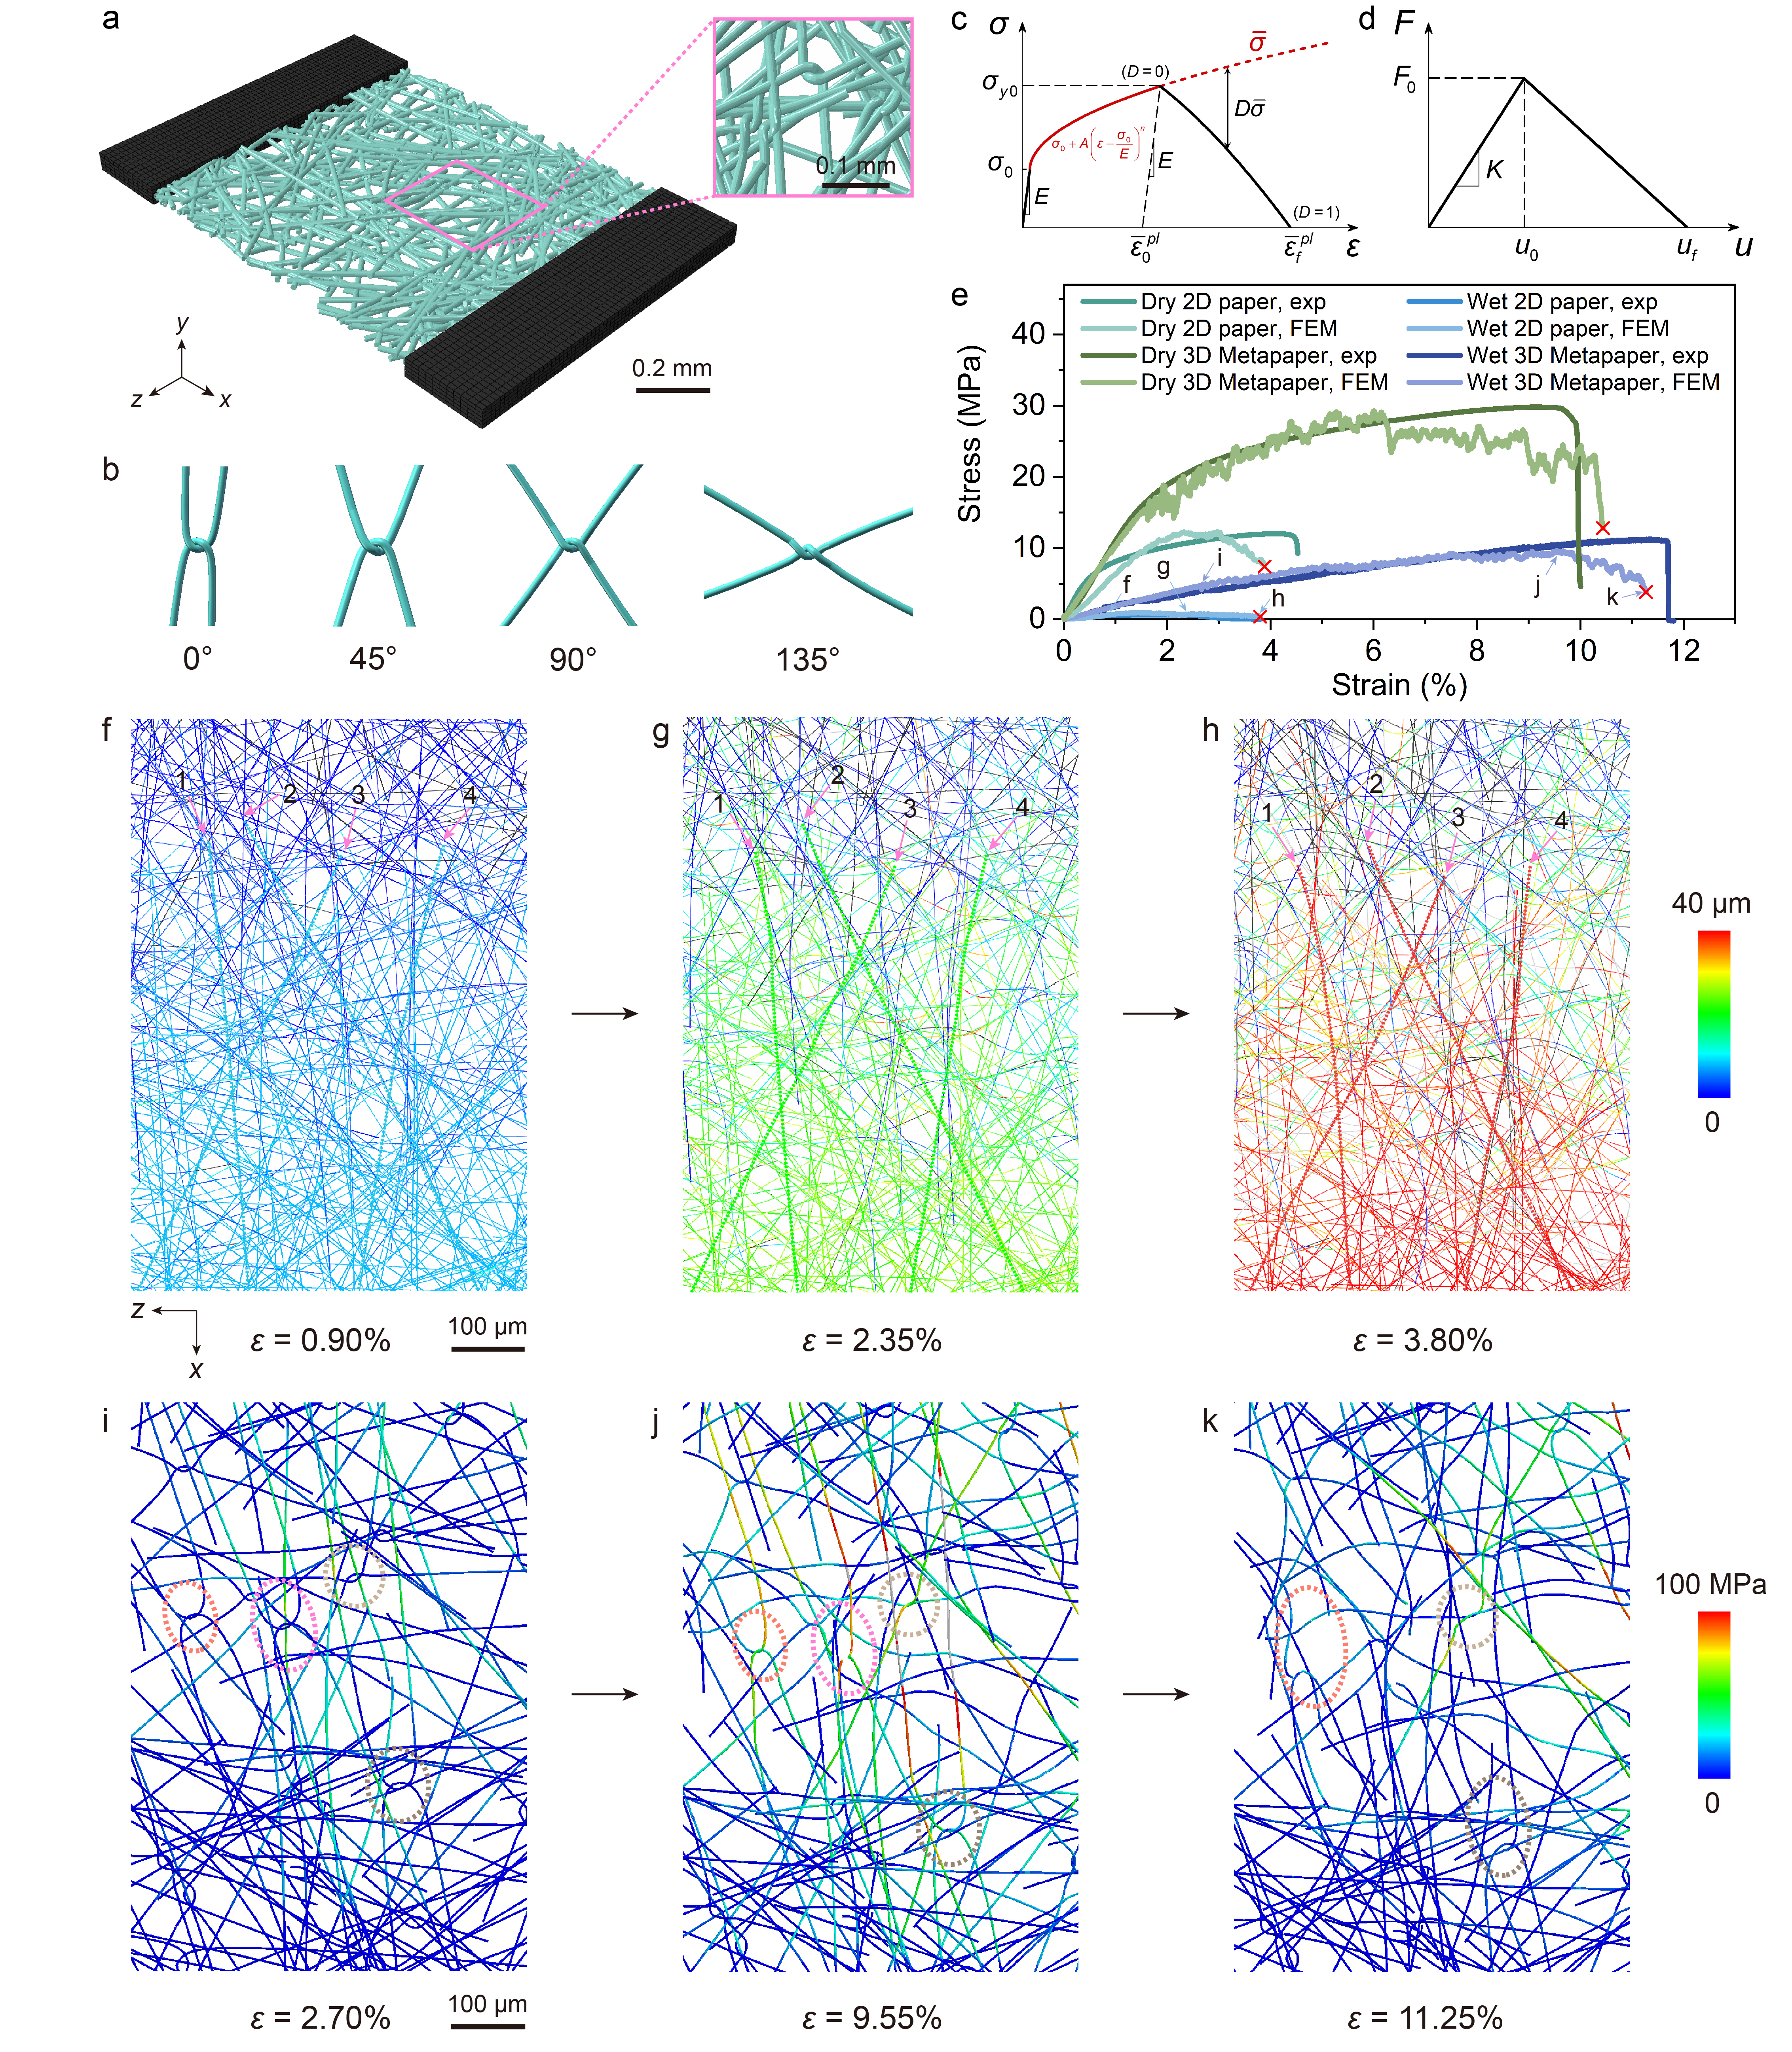
Extended Data Figure 4 | Finite element simulations for 2D paper and 3D Metapaper in dry and wet conditions. a, Simulated model of 3D Metapaper consisting of fiber network. b, Basic building blocks in 3D Metapaper. c, Stress-strain curve of fiber. d, Force-displacement relationship of inter-fiber bond. e, Comparisons of tensile stress-strain curves of 2D paper and 3D Metapaper in dry and wet conditions from experiments and simulations. f-h, Vertical displacement contours of fibers in local representative region of 2D paper at different strains corresponding to points f-h on the stress-strain curves in c. The pulling-out events of four fibers are indicated by dashed lines. i-k, Tensile stress contours of fibers in local representative region of 3D Metapaper at different strains corresponding to points i-k on the stress-strain curves in c. The breakage of knitted fibers is circled by dashed lines.
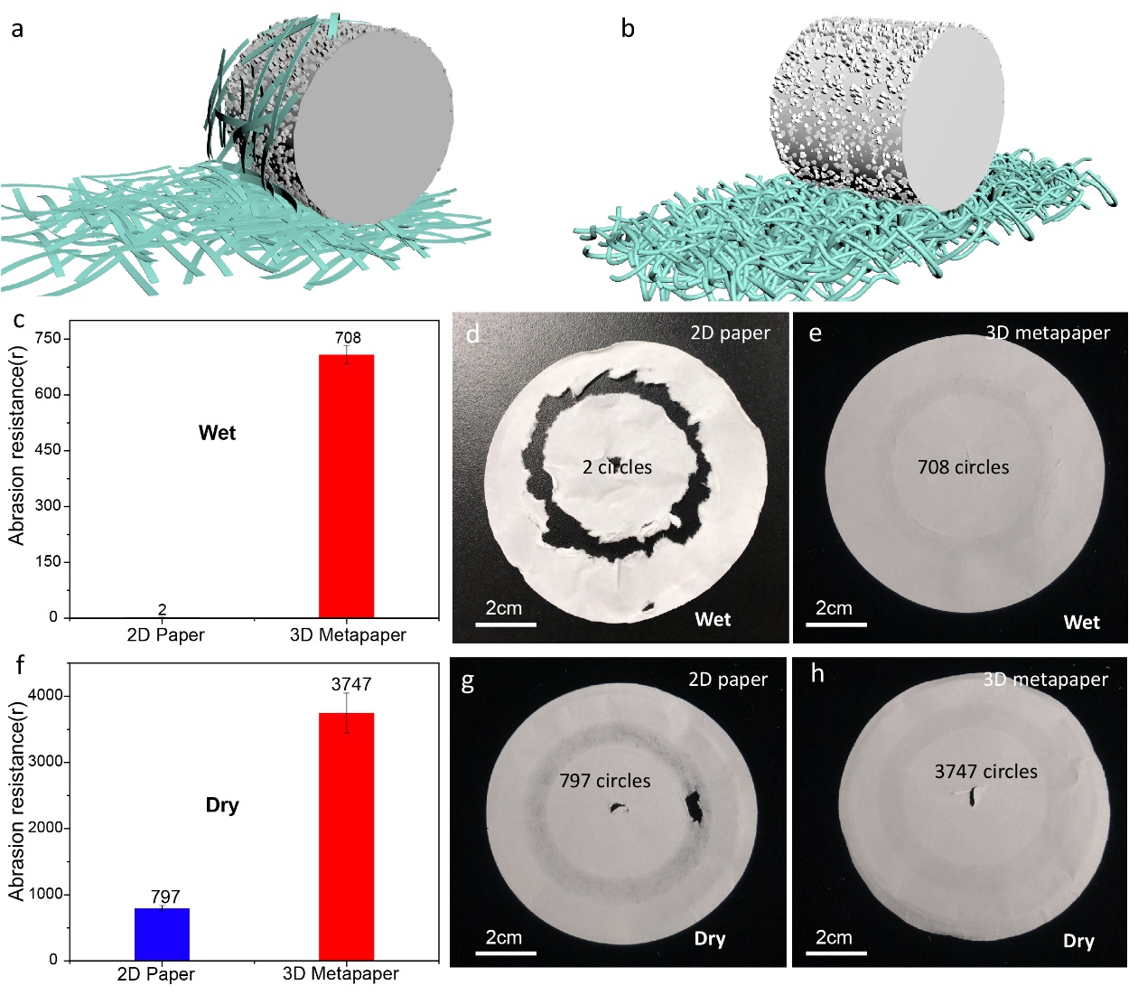
Extended Data Figure 5 | Abrasion resistance for 2D paper and 3D Metapaper in dry and wet conditions. a, b, Schematic model for 2D Paper and 3D Metapaper in wear testing. c, f, Number of wear turns for 2D paper and 3D Metapaper in dry and wet conditions. d, In the wet state, the 2D paper breaks down completely after 2 circles. e, the 3D Metapaper shows only slight ring marks after 708 circles. g, the dry 2D paper breaks through after 797 circles, whereas h, the 3D Metapaper can be sanded for 3747 consecutive circles.

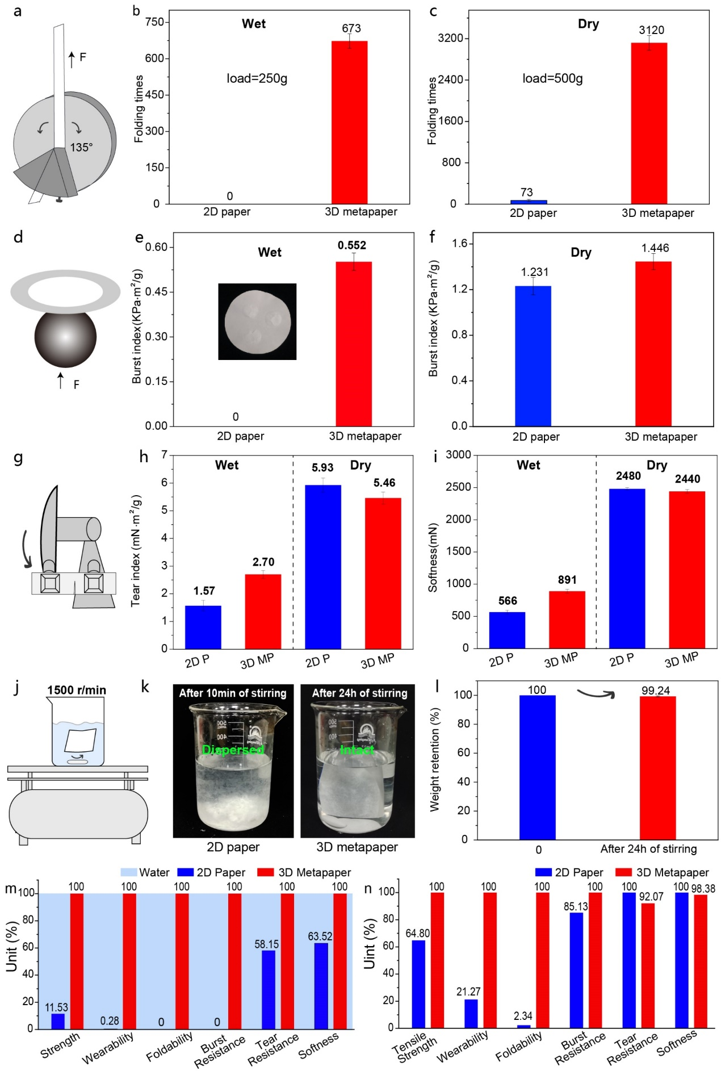
Extended Data Figure 6 | a, Schematic model of the paper folding resistance testing. b, The ultimate folding times of wet 2D paper compared to 3D Metapaper at a load of 250 g. c, A comparison of the ultimate folding times for dry 2D paper and 3D Metapaper at a load of 500g. d, Schematic model for burst strength testing. e, f, Burst index of 2D paper and 3D Metapaper in dry and wet conditions. g, Schematic model for tear resistance testing. h, Tear index of 2D paper and 3D Metapaper in dry and wet condition. i, Softness of 2D paper and 3D Metapaper in dry and wet conditions. j, Magnetic stirrer. k, Photos of 2D and 3D paper after stirring at 1500/min for 10 minutes and 24 hours. i, Mass retention of the 3D paper after 24 hours of stirring. The paper is intact with only a minimal amount of fiber loss. m, n, Comparison of different mechanical properties of 3D Metapaper and 2D Paper in wet and dry states, respectively. The data is normalized to the highest value for each property.

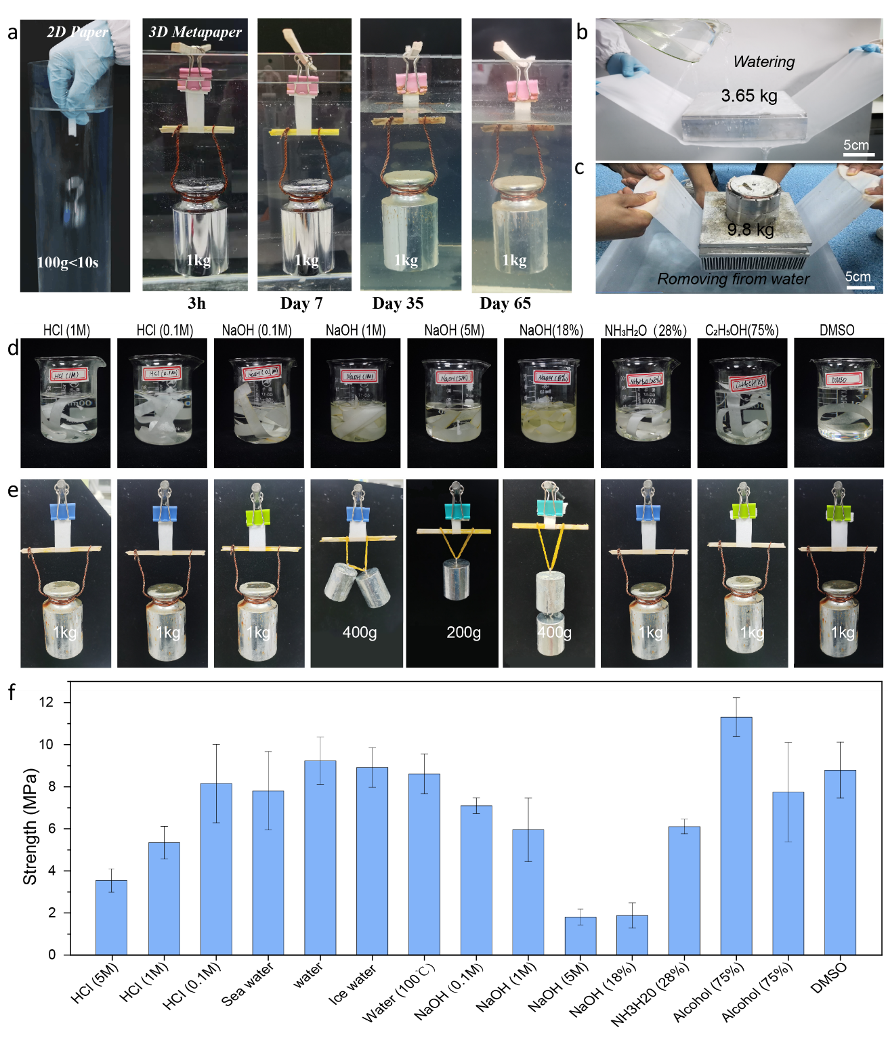
Extended Data Figure 7 | The unique 3D microstructure imparts stability to the paper properties, ensuring long-term use in various environments. a, Photos of 1cm wide 2D paper and 3D Metapaper in water for 3h, 7 days, 35 days, and 65 days of continuous load 1kg. Due to the presence of microorganisms in the water, the surface of the paper was slightly corroded in later days, but the paper still had a very high load-bearing capacity. The total dissolved solids in water are 212 mg/L. The different lengths of paper in the photos are due to the angle from which they were taken. b, c, The 3D Metapaper still has good weight-bearing capacity when watering or exiting from water. d, e, f, Strength of 3D Metapaper at different temperatures and solutions. The paper is submerged in the solution for at least ten minutes and tested for its ability to support weights and its tensile strength.

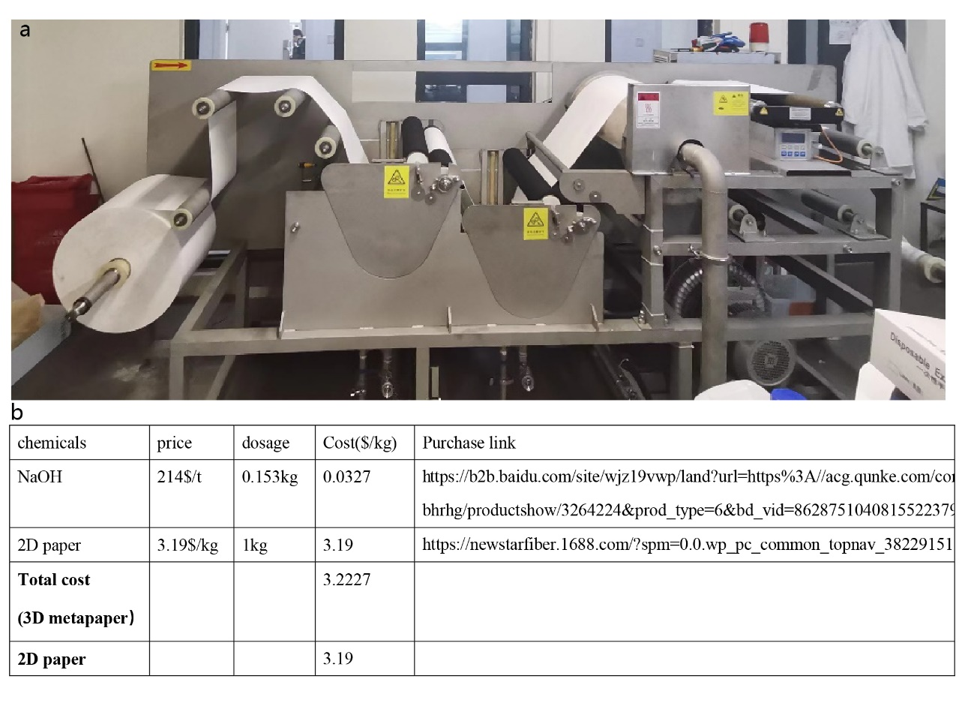
Extended Data Figure 8 | The roll-to-roll manufacturing process used for 3D Metapaper. a, We designed a roll-to-roll process and equipment in our laboratory that has successfully enabled the production of 3D Metapaper at scale. b, Production costs of 3D Metapaper versus 2D paper.

Extended Data Table 1 | Parameters used for constitutive relationship (shown in Extended Data Figure 4c and Eq. (1)) of fibers in dry and wet conditions
 | Fibers
 | Dry | Wet
Elastic modulus E (MPa) | 8000 | 1500
Elastic limit σ₀ (MPa) | 100 | 30
Constant for the power-law hardening A (MPa) | 900 | 600
Exponent for the power-law hardening n | 0.6 | 0.7
Plastic strain at the onset of damage | 0.18 | 0.18
Displacement at failure (mm) | 0.001 | 0.001

Extended Data Table 2 | Parameters used for cohesive zone model (shown in Extended Data Figure 4d and Eq. (2)) of inter-fiber bonds in dry and wet conditions
 | Inter-fiber bonds
 | Dry | Wet
Peak force F₀ (mN) | 10.78 | 3.85
Separation distance u_{f} (μm) | 2.30 | 2.30
Stiffness K (N/m) | 35918.88 | 12828.17

