Supporting Information file
Half dome carbon nitride structures

A. La Torre^{1,2,3}

- ALT Carbotecnologia srls and Carbastrial limited, Via Del Nuovo Tiro a Segno 15/1 Pescara, 65128, Italy, virtual office at 16 Bridge Street Kington Herefordshire HR5 3DJ, UK.
- Institut de Physique et Chimie des Matériaux de Strasbourg, UMR 7504 CNRS, Université de Strasbourg, 23 rue du Loess, 67034 Strasbourg, France.
- University of Nottingham, School of Chemistry, University Park, Nottingham, NG72RD, UK.

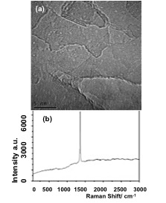

Figure S1: (a) Bright field TEM images of an FLBN flake and (b) Raman spectrum of the FLBN flake.

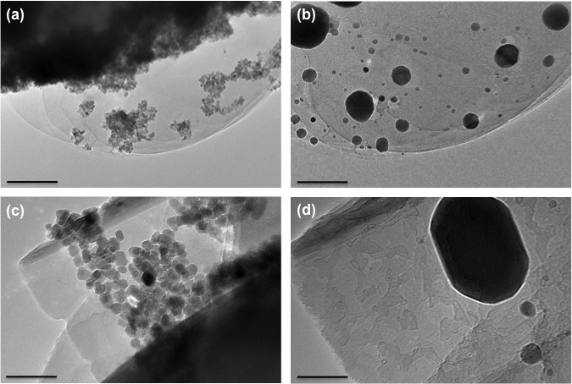

Figure S2: Transformation of Fe₂O₃ nanoplates to Fe nanoparticles at 850 °C. (b,d). Fe₂O₃ presents a nanopletelet shape. (a,c) Iron nanoparticles ripened after their reduction, and particle migration can be observed between particles. The shape of the nanoplatelet iron oxide nanoparticles changed to round during the reduction process.

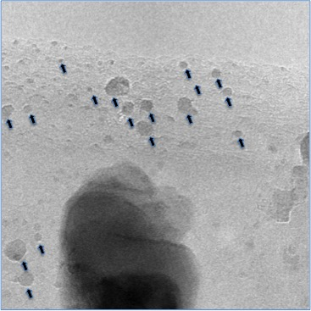

Figure S3: TEM image showing the particle migration process. During particle migration, the nanoparticles/small clusters form half-dome structures at the FLBN step edges.

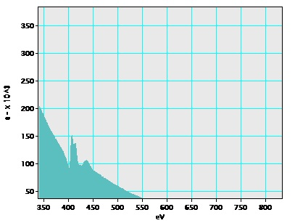

Figure S4: STEM-EELS on a half dome structure grown on few-layer graphene was performed solely to be certain that the nitrogen of the organic capping agent was retained.

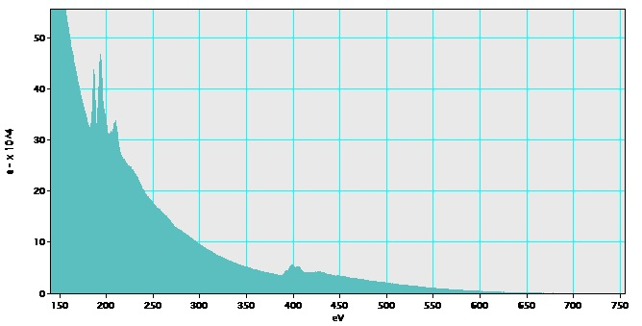

Figure S5: EELS of FLBN. The boron peaks are at 192 eV, 204 eV, and 218 eV. Nitrogen 408 eV and 418 eV. The carbon peak is absent

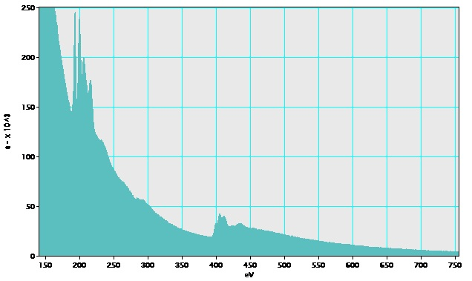Figure S6: EELS of the half dome structure grown on FLBN. The boron peaks are at 192 eV, 204 eV, and 218 eV, the nitrogen peaks are at 400 eV and 408 eV, the carbon peaks are 284.5 eV, and the broadness of the carbon K-edge is unusual for pure sp²-hybridized carbon and is comparable to that observed for materials containing sp¹ and/or sp² carbon and carbon nitride.

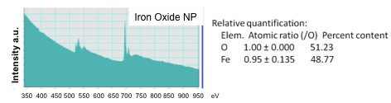

Figure S7: EELS of the Fe₂O₃ nanoparticles: The three oxygen peaks are at 500, 530, and 550 nm, and the iron peak is at 700 nm.

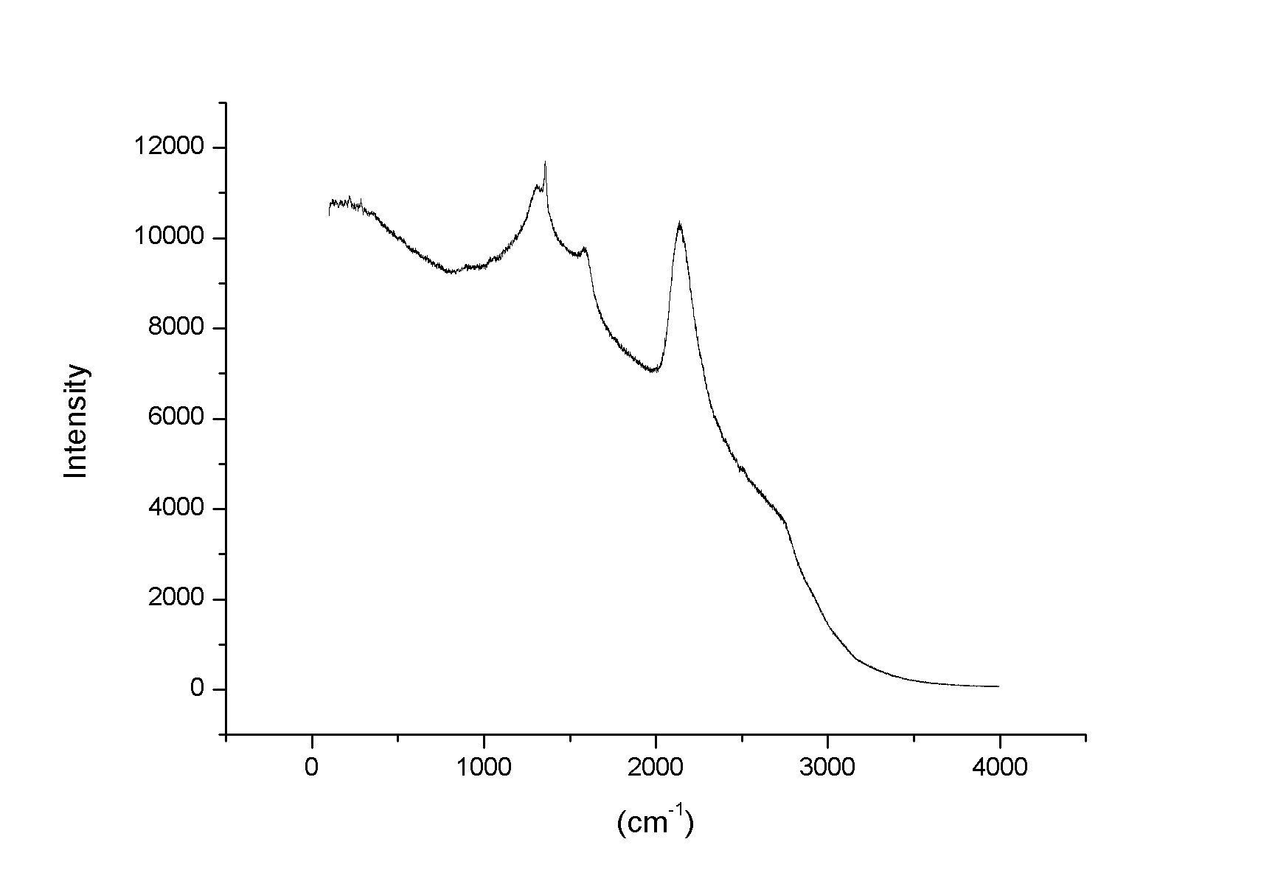
Figure S8: Stretching of the Ciano group of the CN sp¹ chain at 2200 cm⁻¹.

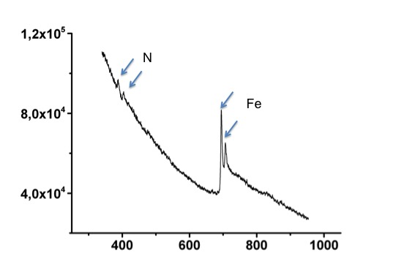

Figure S9: EELS carried out on a half dome structure protruding from iron nanoparticles showing the presence of nitrogen peaks at 400 and 408 eV. The EELS clearly shows the formation of iron as the two peaks ca. 700 eV, and the O peak that was expected to be at 530 eV is absent. The Π peak at 400 and the σ peak of nitrogen might indicate that the sp¹ CN chain is free standing and embedded in a sp² CN domain.²³

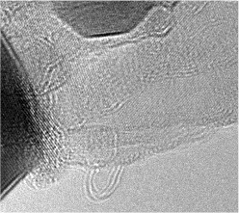

Figure 10: Bright field TEM images of the CN half dome structure images supported by video file 3.

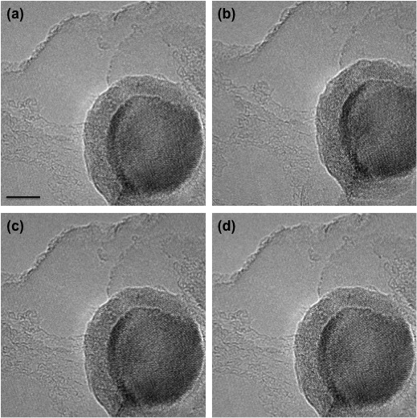

Figure 11: Time series images during the formation of the half dome structure. The formation of chains protruding the iron particle can be seen in the figure supported by the video file.

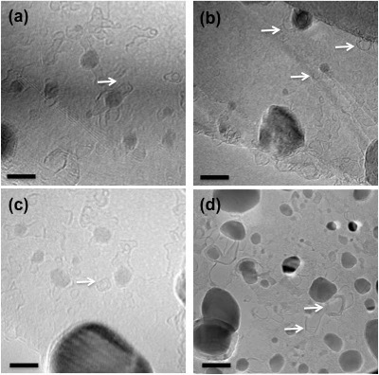

Figure 12: (a-c) Bright field TEM images of the BN half dome structure protruding the particles, (d) BN multilayer half dome structures.

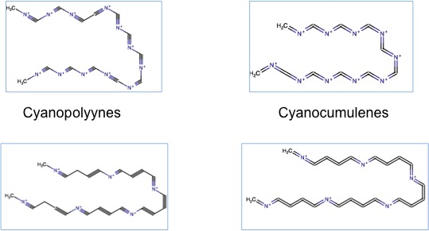

Figure 13: Cyanopolyynes chains.

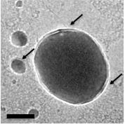
Figure 14: CN@HDS surrounding the metal core of FeNPs. The arrows indicate CN@HDS.

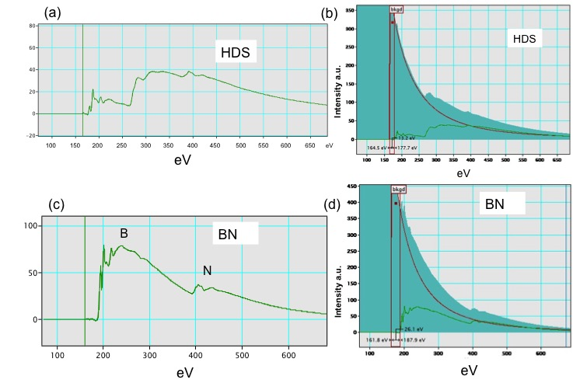

Figure 15: EELS of CN@HDS and CN@HDS compared with ELLS of FLBN.

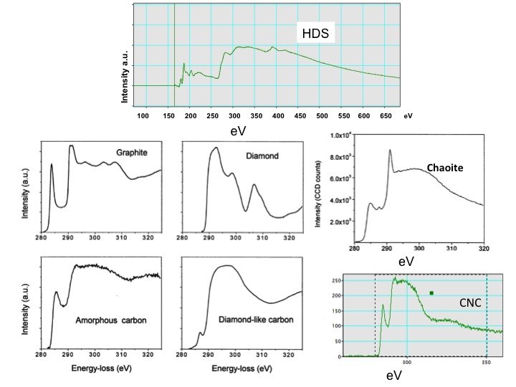

Figure 16: High-energy EELS of CN@HDS compared to the other forms of carbon.

