A 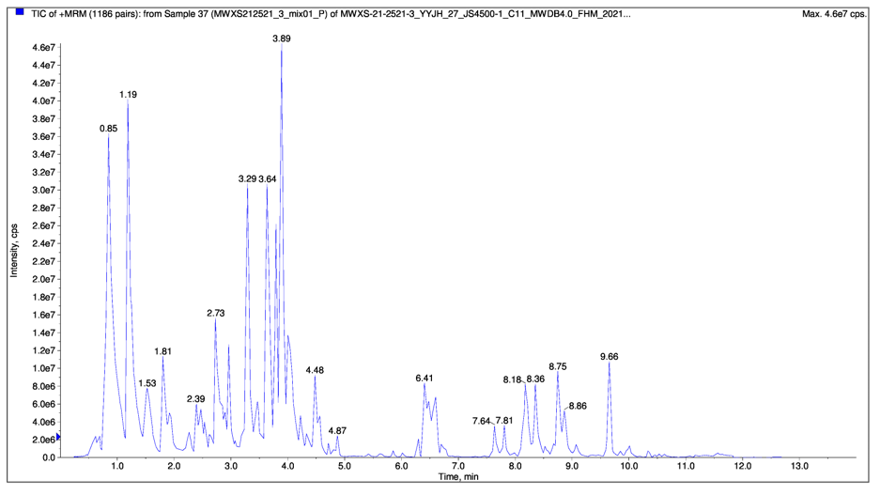
B 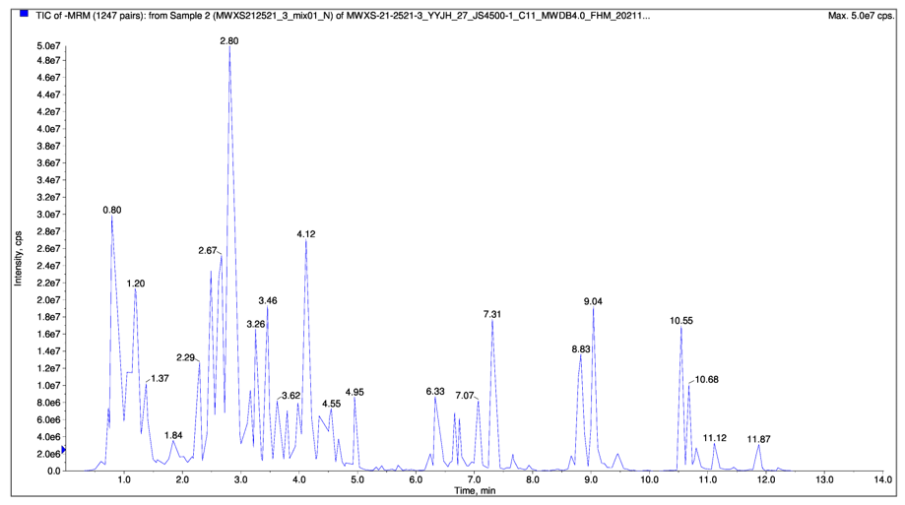

C 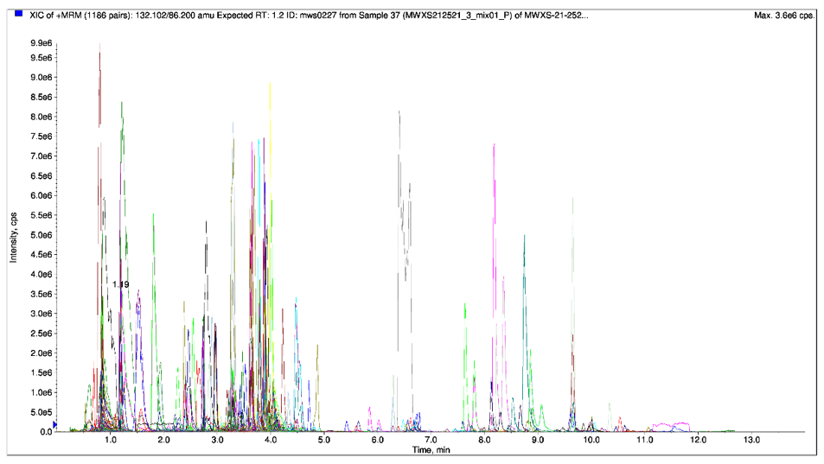
D 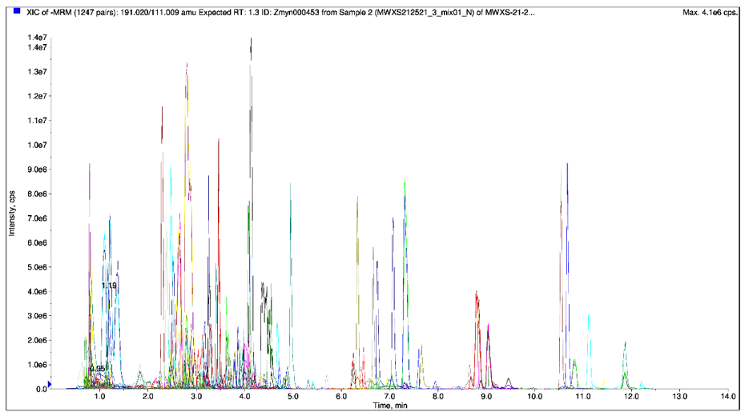
Fig. S1. Total ion current of one quality control sample, as revealed by mass spectrometry detection in positive and negative mode (A-B), and a multi-peak detection plot of the metabolites in the multiple reaction monitoring mode (C-D).

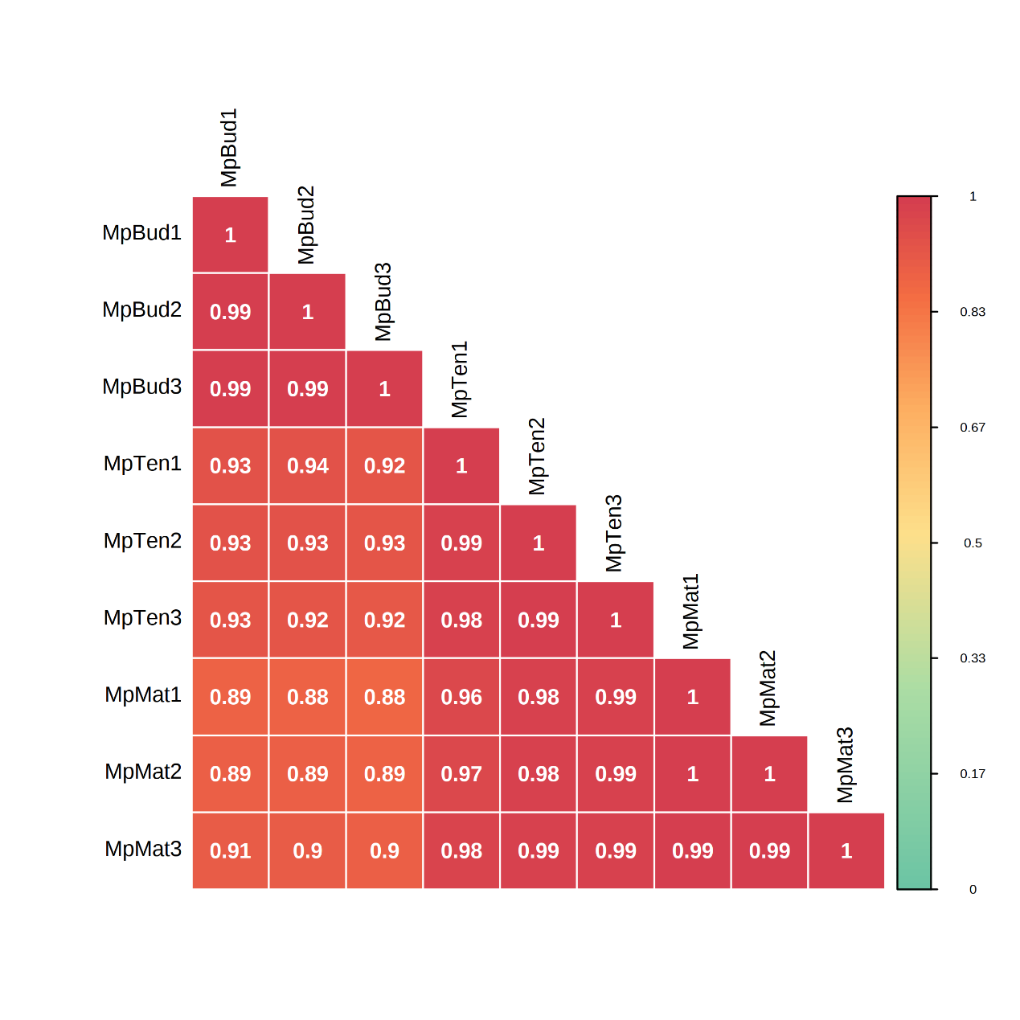Fig. S2. Correlation diagram between samples.
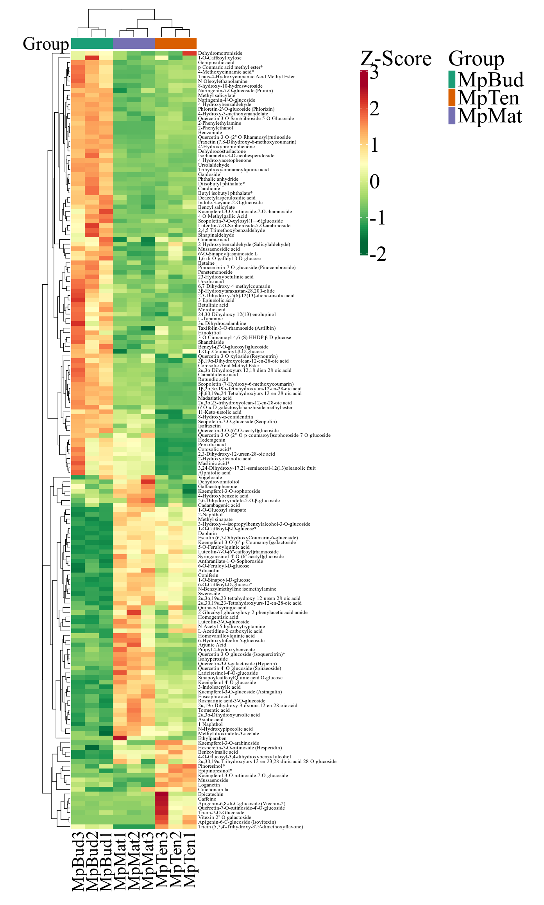
Fig. S3. The number of different types in secondary metabolites during the development of Mp leaves. Each sample is represented by a column, and each metabolite is represented by a row. The abundance of each metabolite is represented by a bar with specific color. The up-regulated and down-regulated metabolites are indicated by different shade colors of red and green, respectively. 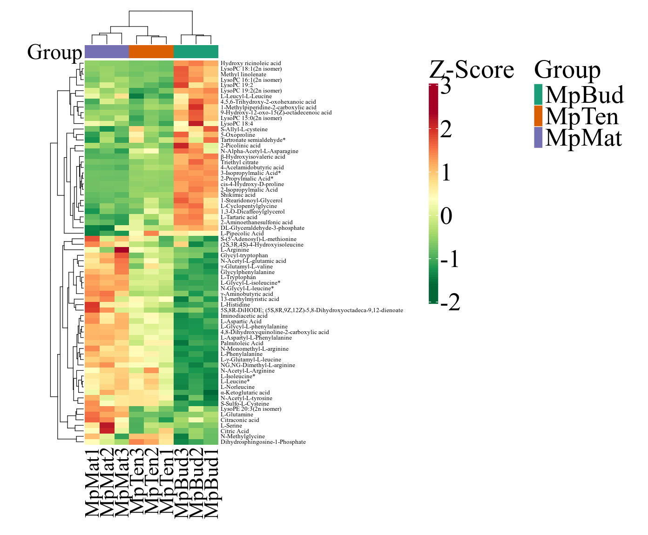
Fig. S4. The number of different types in primary metabolites during the development of Mp leaves. Each sample is represented by a column, and each metabolite is represented by a row. The abundance of each metabolite is represented by a bar with specific color. The up-regulated and down-regulated metabolites are indicated by different shade colors of red and green, respectively.
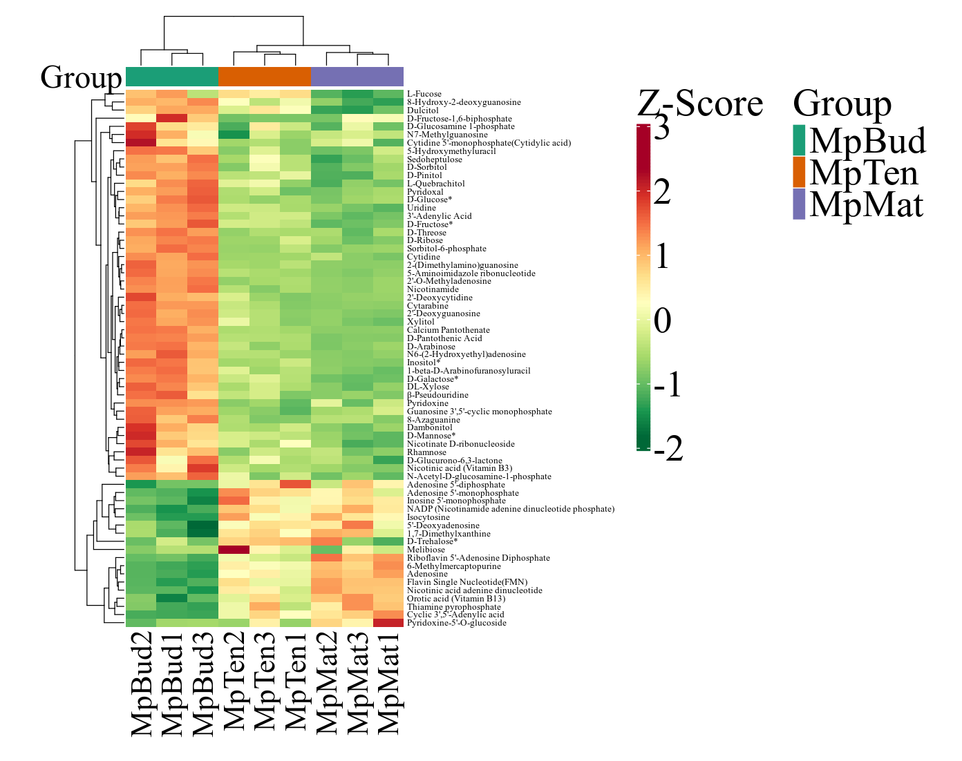
Fig. S5. The number of different types in other metabolites during the development of Mp leaves. Each sample is represented by a column, and each metabolite is represented by a row. The abundance of each metabolite is represented by a bar with specific color. The up-regulated and down-regulated metabolites are indicated by different shade colors of red and green, respectively.

