Natural and artificial antimicrobial peptide designs: A comparative study of Mastoparan C and BP52
Hai Bui Thi Phuong^{1,2}, Yen Do Hai¹, Viet Nguyen Huu¹, Anh Luong The¹, Minh Nguyen Hong^{2,3}, Huy Luong Xuan ^{1*}
¹ Faculty of Pharmacy, Phenikaa University, Hanoi 12116, Vietnam.
² Faculty of Biotechnology, Chemistry and Environmental Engineering, Phenikaa University, Hanoi 12116, Vietnam.
³ Bioresource Research Center, PHENIKAA University, Hanoi 12116, Vietnam.
*: Corresponding authors. E-mail: huy.luongxuan@phenikaa-uni.edu.vn;

- Peptide sequences
 | Code |  | 1 | 2 | 3 | 4 | 5 | 6 | 7 | 8 | 9 | 10 | 11 | 12 | 13 | 14
1 | BP52 | H | K | K | L | F | K | K | I | L | K | W | L |  |  |  | NH₂
2 | MPC | H | L | N | L | K | A | L | L | A | V | A | K | K | I | L | NH₂

- Materials
Commercially available solvents and reagents were used as received. All Fmoc-protected α-amino acids and 1-[(1-(cyano-2-ethoxy-2-oxoethylideneaminooxy)-dimethylamino-morpholino)] uranium hexafluorophosphate (COMU) were purchased from AK Scientific. Rink Amide MBHA resin was purchased from NovaBiochem. Piperidine, N,N-dimethylformamide (DMF), N,N-diisopropylethylamine (DIEA), and trifluoroacetic acid (TFA) were purchased from Daejung. Triisopropylsilane (TIS) was purchased from Sigma-Aldrich.

- Methods
Peptide synthesis. All peptides were prepared using Fmoc chemistry on Rink Amide MBHA resin with a loading capacity of 0.67mmol/g [1]. The dry resin (179 mg, 120 µmol) was swelled in DMF for 10 min before using. The Fmoc protecting group was removed by treatment with 20% piperidine in DMF (2 x 10 min). Amino acids were coupled for 30 min using COMU as an activating agent (4.75 equiv.), 5 equiv. of Fmoc-protected amino acid, and 10 equiv. of DIEA in DMF. After each coupling or deprotection reaction, the resin was washed with dichloromethane (DCM) (1 x 2 min), DMF (1 x 2 min), DCM (1 x 2 min), and DMF (2 x 2 min).
Purification. After the final Fmoc-deprotection reaction, resin was washed with NMP (2 x 2 min) and DCM (5 x 2 min) and dried in vacuo overnight. The peptides were deprotected and cleaved from the resin by treating them with a mixture of TFA/TIS/water (95/2.5/2.5) for 2 hours and precipitated by adding a 1:1 mixture of n-pentane and diethyl ether. The precipitate was collected by centrifugation, dissolved in a 1:4 mixture of acetonitrile and water, and filtered to remove the resin. The products were purified through reverse phase high-performance liquid chromatography (RP-HPLC) using a Zorbax C18 column (Agilent, 5µm, 9.4 x 250 mm), and then characterized by Agilent 6400 Series Triple Quadrupole LC/MS System.

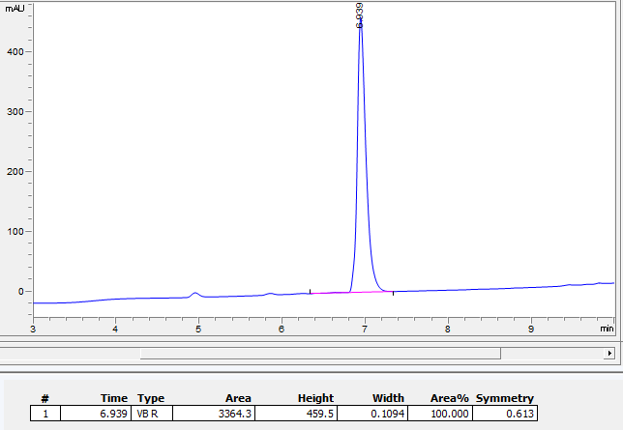
Figure 1. HPLC chromatogram of MPC.

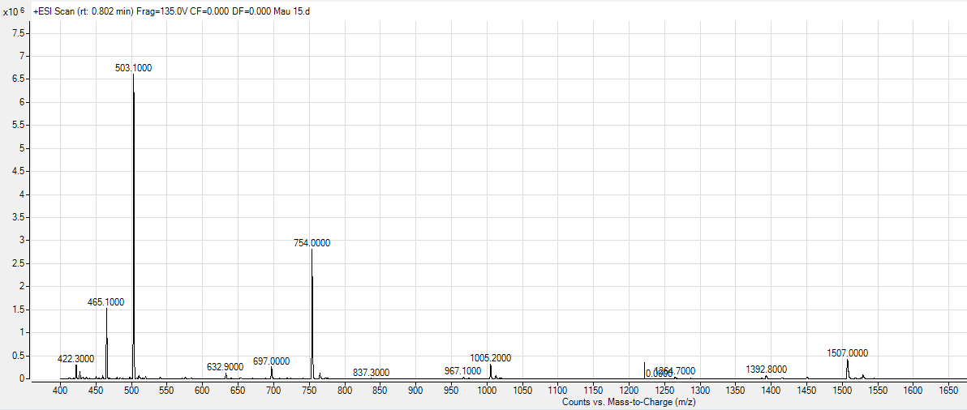
Figure 2. Electrospray mass spectrum (positive ion mode) of MPC.
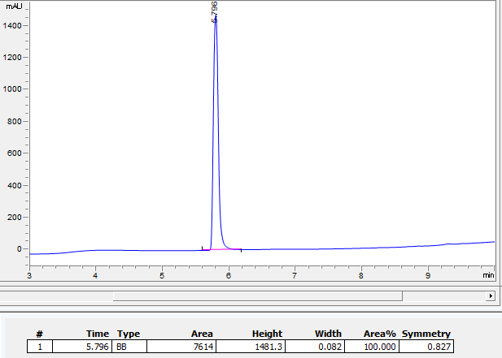
Figure 3. HPLC chromatogram of BP52
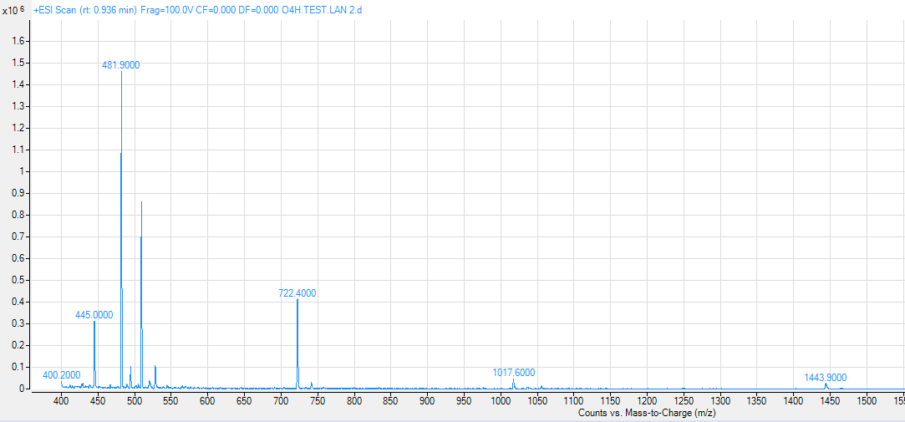
Figure 4. Electrospray mass spectrum (positive ion mode) of BP52.
HPLC chromatogram of purified peptides. 5-100% B for 0-8 min; 100% B for 8-9 min; 100-5% B for 9-11 min; 5% B for 11-12 min. A: 0.1%TFA in H2O, B: 0.1%TFA in acetonitrile (ACN), flow rate 1mL/min.
Electrospray mass spectrum (positive ion mode) of AMPs. 30-80% B for 0-2 min; 80-30% B for 2-4 min. A: 0.1%TFA in H2O, B: 0.1%TFA in Acetonitrile (ACN), flow rate 1mL/min.
Table 1. Formula and mass data of MPC and BP52
Product code | Molecular formula | m/z | Calculated mass | Found mass
MPC | C₇₂H₁₃₅N₁₉O₁₅ | [M+1H]⁺/1 | 1507.0465 | 1507.0000
MPC | C₇₂H₁₃₅N₁₉O₁₅ | [M+2H]²⁺/2 | 754.0272 | 754.0000
MPC | C₇₂H₁₃₅N₁₉O₁₅ | [M+3H]³⁺/3 | 503.0207 | 503.1000
BP52 | C₇₄H₁₂₆N₁₈O₁₁ | [M+1H]⁺/1 | 1443.9930 | 1443.9000
BP52 | C₇₄H₁₂₆N₁₈O₁₁ | [M+2H]²⁺/2 | 722.5010 | 722.4000
BP52 | C₇₄H₁₂₆N₁₈O₁₁ | [M+3H]³⁺/3 | 482.0030 | 481.9000

Antimicrobial assay. Antimicrobial activity was evaluated by the standard broth microdilution method with a slight modification measuring the minimal inhibitory concentration (MIC) values [2]. The antimicrobial assay was conducted against four Gram-positive strains (Bacillus cereus ATCC 11778, Enterococcus faecalis ATCC 29212, Listeria monocytogenes) and three strains of Gram-negative bacteria (Escherichia coli ATCC 25922, Pseudomonas aeruginosa ATCC 27853, Salmonella enterica ATCC 13076). These strains of bacteria were pre-cultured with 5 ml lysogeny broth (LB) medium (10g/L polypeptone, 5g/L bacto-yeast extract and 10g/L NaCl) overnight at 37°C. The peptides dissolved in sterilized PBS buffer were prepared with 2-fold dilutions from 4µM to 128µM in 96-well round-bottom microtiter plates. The peptide solution and the bacterial inoculums were diluted using LB broth. The bacterial suspension (10⁴ CFU/ml) was then dispensed into the peptide-containing wells. After 24 hours of incubation at 37°C, the 96-well microtiter plates were examined to determine MICs, the lowest peptide concentration, which ultimately inhibits cell growth. The antimicrobial assay was repeated in three independent experiments.
In the independent experiment, Candida albicans cells were cultured in YM medium (10g/L glucose, 3g/L malt extract, 5g/L peptone, 3g/L yeast extract) at 37°C. The antimicrobial assay of target peptides against Candida albicans cells was conducted by using the described method above.
Hemolysis assay. AMPs were dissolved in PBS. 10µl of serially diluted peptides (8 and 128µM final concentration) was added to 190µl of suspensions of human red blood cells (10% v/v in PBS) and incubated for 30 min at 37°C. After centrifugation, the supernatants were diluted with 10-fold PBS and the absorbance at 405nm was measured for each solution. The blood suspension treated with 0.2% Triton X-100 was used as a control for 100% hemolysis [3]. The percentage of hemolysis was determined using following equation:
% Hemolysis = | OD_{405nm} sample x 100%
% Hemolysis = | OD_{405nm} positive control
Cellular viability assays. For cell death experiments, human lung carcinoma cells (A427, ATCC) were cultured in RPMI-1640 with 1mM sodium pyruvate, 50μg/ml Gentamicin, non-essential amino acids (1:100) and 5% fetal calf serum (FCS) at 5% CO_{2,} 37ºC. Human lung carcinoma cells were seeded on 96-well plates (2x10⁴/well, Tecan Group Ltd) and incubated with peptide in serum-free RPMI-1640 at 37°C. FCS was added after 1 hour. After 24 h incubation, 10µL of CCK-8 solution (MedChemExpress, NJ, USA) was added to each well of the plate and incubated for 1h in an incubator. Absorbance was measured at 450 nm using a microplate reader [4]. % Viability = (treated-blank)/(untreated-blank)*100%. Bank sample includes CCK-8/RPMI without cells.
References
1. Kim Y-W, Grossmann TN, Verdine GL. Synthesis of all-hydrocarbon stapled α-helical peptides by ring-closing olefin metathesis. Nature Protocols. 2011;6(6):761-71. doi:10.1038/nprot.2011.324.
2. European Committee for Antimicrobial Susceptibility Testing of the European Society of Clinical M, Infectious D. Determination of minimum inhibitory concentrations (MICs) of antibacterial agents by broth dilution. Clinical Microbiology and Infection. 2003;9(8):ix-xv. doi:https://doi.org/10.1046/j.1469-0691.2003.00790.x.
3. Luong HX, Kim D-H, Lee B-J, Kim Y-W. Antimicrobial and Hemolytic Activity of Stapled Heptapeptide Dimers. Bulletin of the Korean Chemical Society. 2016;37(8):1199-203. doi:https://doi.org/10.1002/bkcs.10839.
4. Hien TT, Ambite I, Butler D, Wan MLY, Tran TH, Höglund U et al. Bladder cancer therapy without toxicity—A dose-escalation study of alpha1-oleate. International Journal of Cancer. 2020;147(9):2479-92. doi:https://doi.org/10.1002/ijc.33019.

