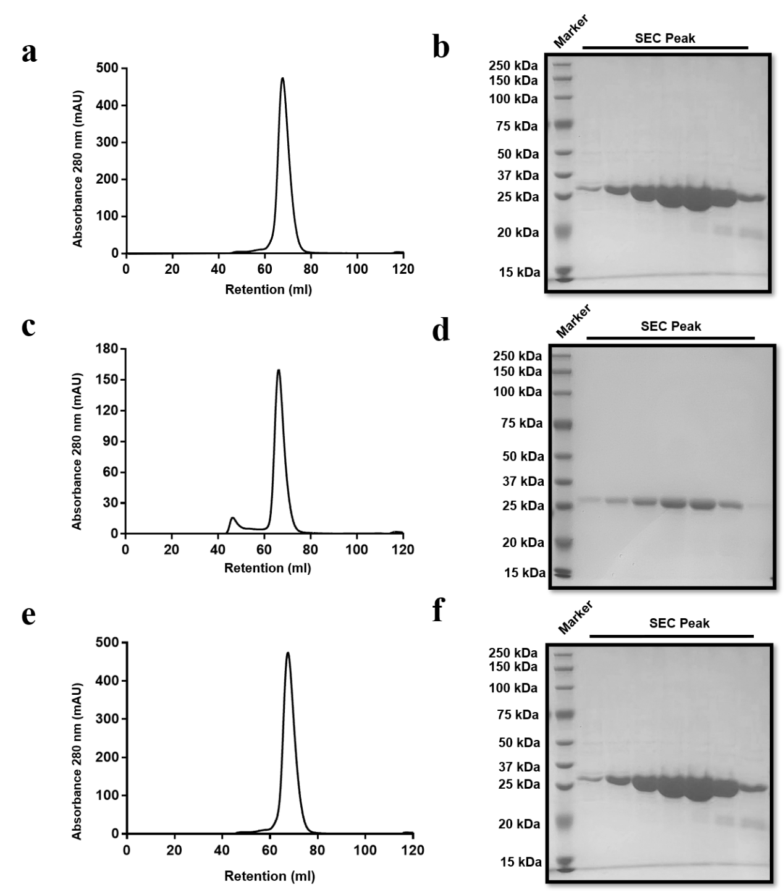
Extended Data Fig.1 Profiles of the size exclusion chromatography and SDS-PAGE analysis of SenB, CbSenB, and RsSenB. a, Size exclusion chromatography of SenB. b, SDS-PAGE analysis of the purified SenB. c, Size exclusion chromatography of CbSenB. d, SDS-PAGE analysis of the purified CbSenB. e, Size exclusion chromatography of RsSenB. f, SDS-PAGE analysis of the purified RsSenB.

Extended Data Fig.2 LC-MS analysis of the mBBr derivatives of the SenB-catalysed products using different UDP-sugars as the sugar donors. a, (+) ESI MS and MS/MS spectra for UDP-Glc-mBBr. b, (+) ESI MS and MS/MS spectra for UDP-Gal-mBBr. c, (+) ESI MS and MS/MS spectra for UDP-GlcNAc-mBBr. d, (+) ESI MS and MS/MS spectra for UDP-GalNAc-mBBr. e, (+) ESI MS and MS/MS spectra for UDP-Xyl-mBBr. f, (+) ESI MS and MS/MS spectra for UDP-Rha-mBBr.

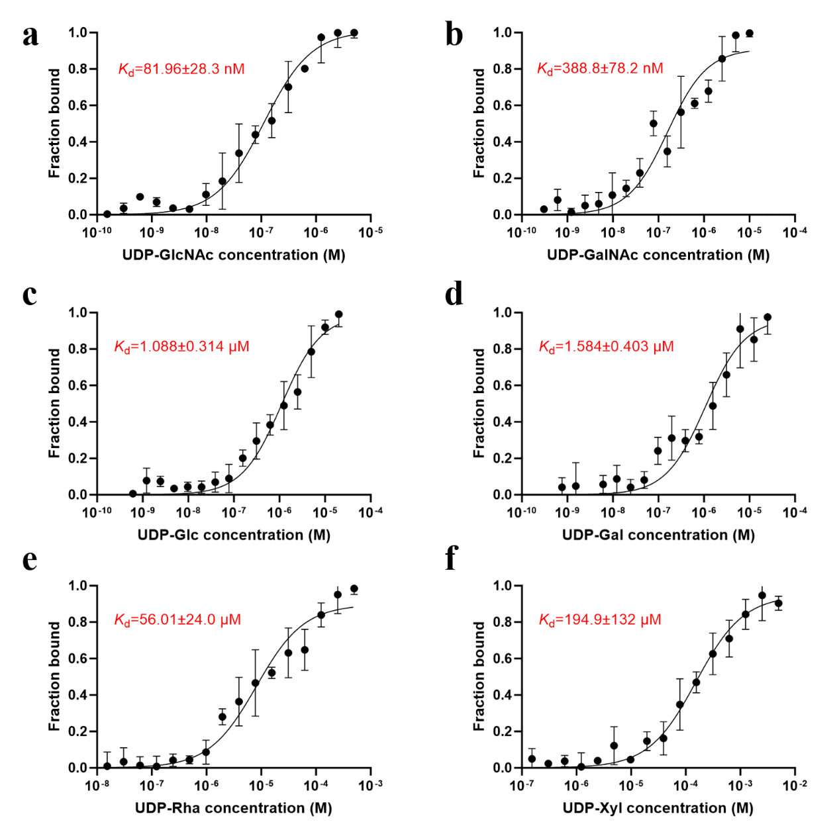
Extended Data Fig.3 Statistics of K_{d} values of SenB for binding of different UDP-sugars. a, UDP-GlcNAc. b, UDP-GalNAc. c, UDP-Glc. d, UDP-Gal. e, UDP-Rha. f, UDP-Xyl.
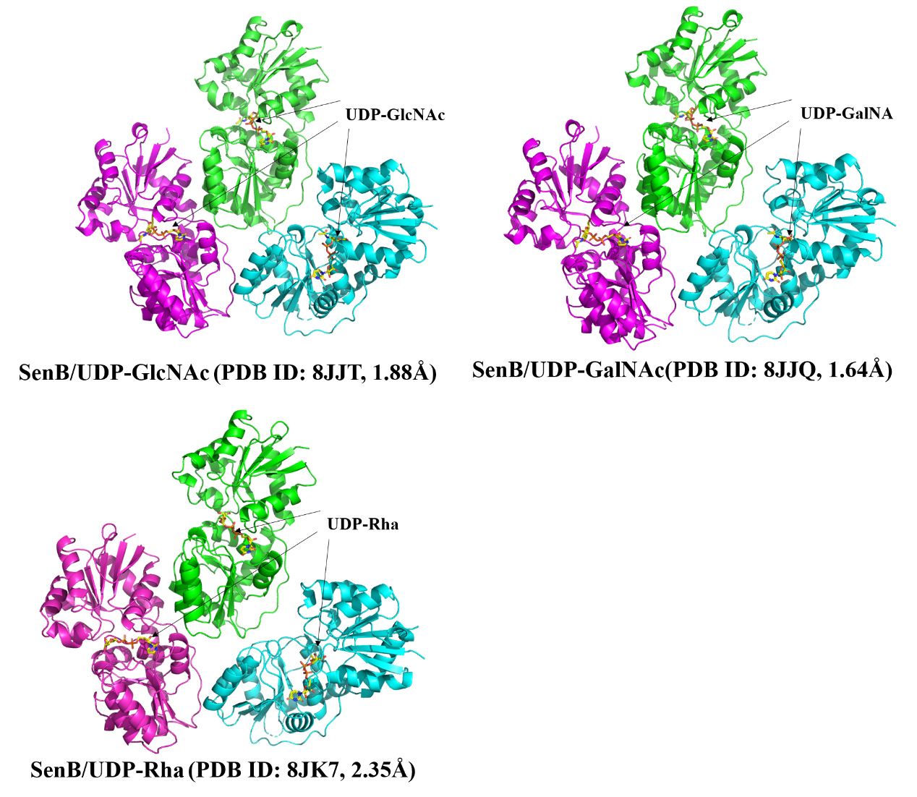
Extended Data Fig.4 The structures of SenB complexed with various sugar donors were determined in this work.

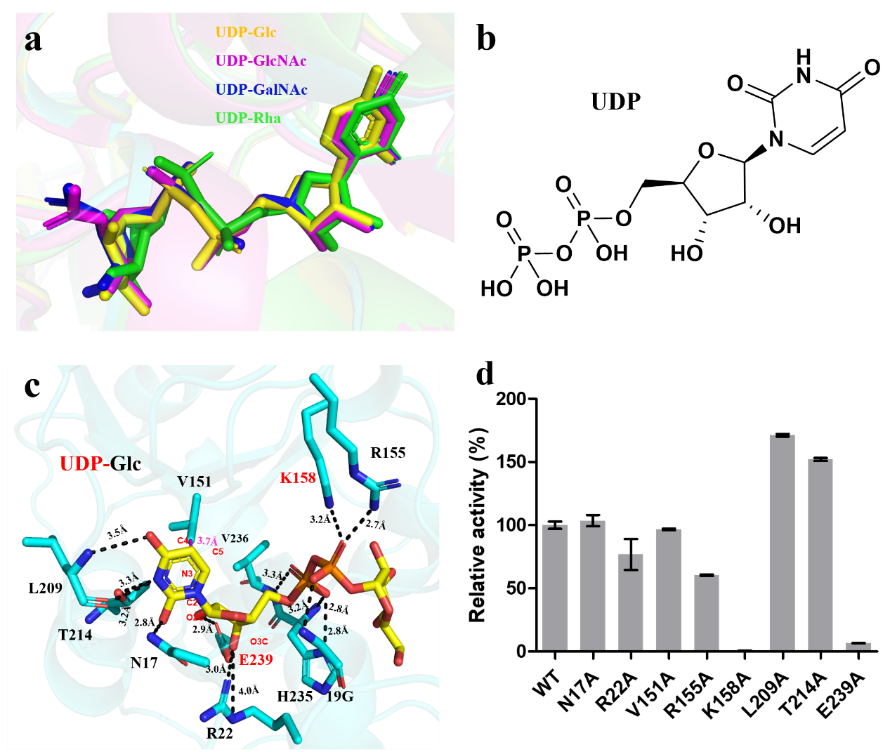
Extended Data Fig.5 Structural basis for UDP binding. a, Structural superposition of four complex structures of SenB. b, Chemical structure of UDP. c, Interaction between UDP and SenB. d, Relative catalytic activities of the SenB mutants involved in the UDP interaction

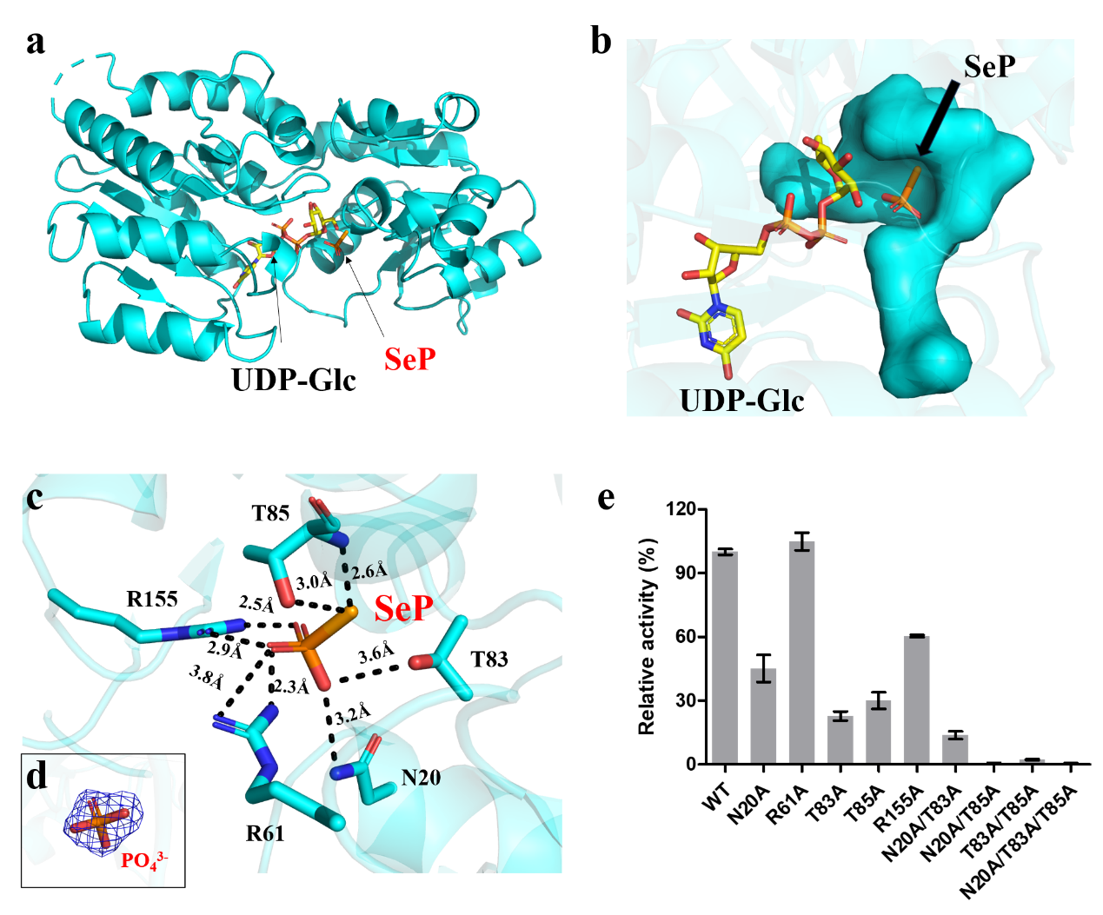
Extended Data Fig.6 Structural basis for SeP binding. a, The ternary complex structure of SenB/UDP-Glc/SeP. b, The narrow SeP binding pocket of SenB. c, Interaction between SeP and SenB. d, 2Fo-Fc electron density maps of PO₄³⁻ contoured at 2.0σ. e, Relative catalytic activity of the SenB mutants using UDP-Glc as the sugar donor.

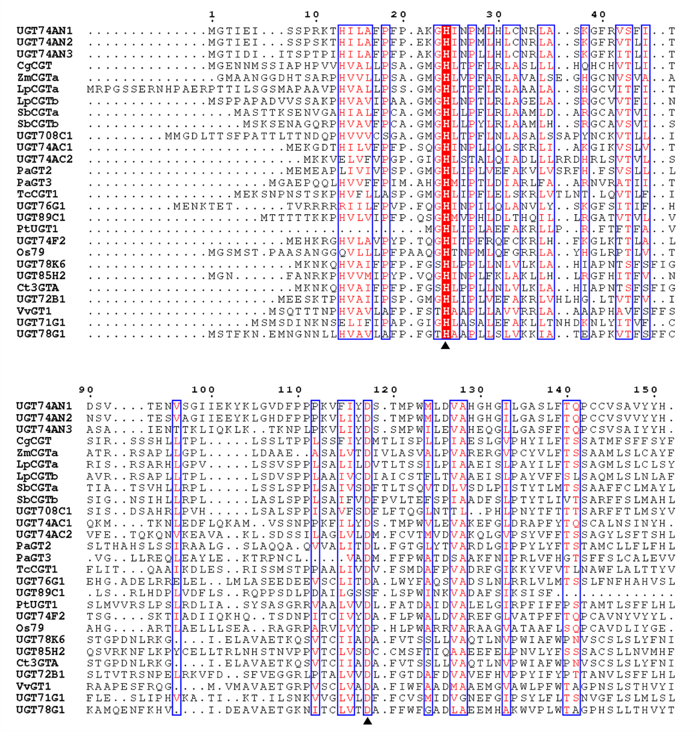
Extended Data Fig.7 Sequence alignment of GT-B type glycosyltransferase. The His-Asp catalytic dyad were labeled with black triangle. The GenBank number of these glycosyltransferase were listed in Supplementary Table6.

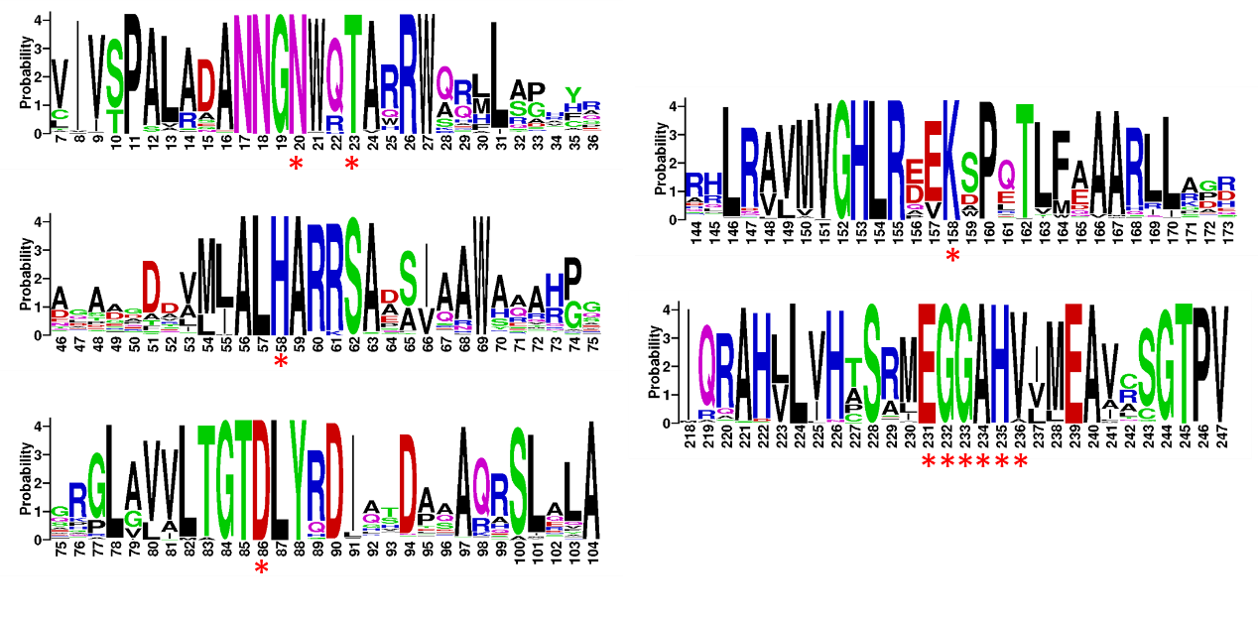
Extended Data Fig.8 Residue conservative analysis of more than 200 homologous sequences of SenB. The residues N20/T23, H58/D86/K158, and EGGAHV labeled with a red asterisk

