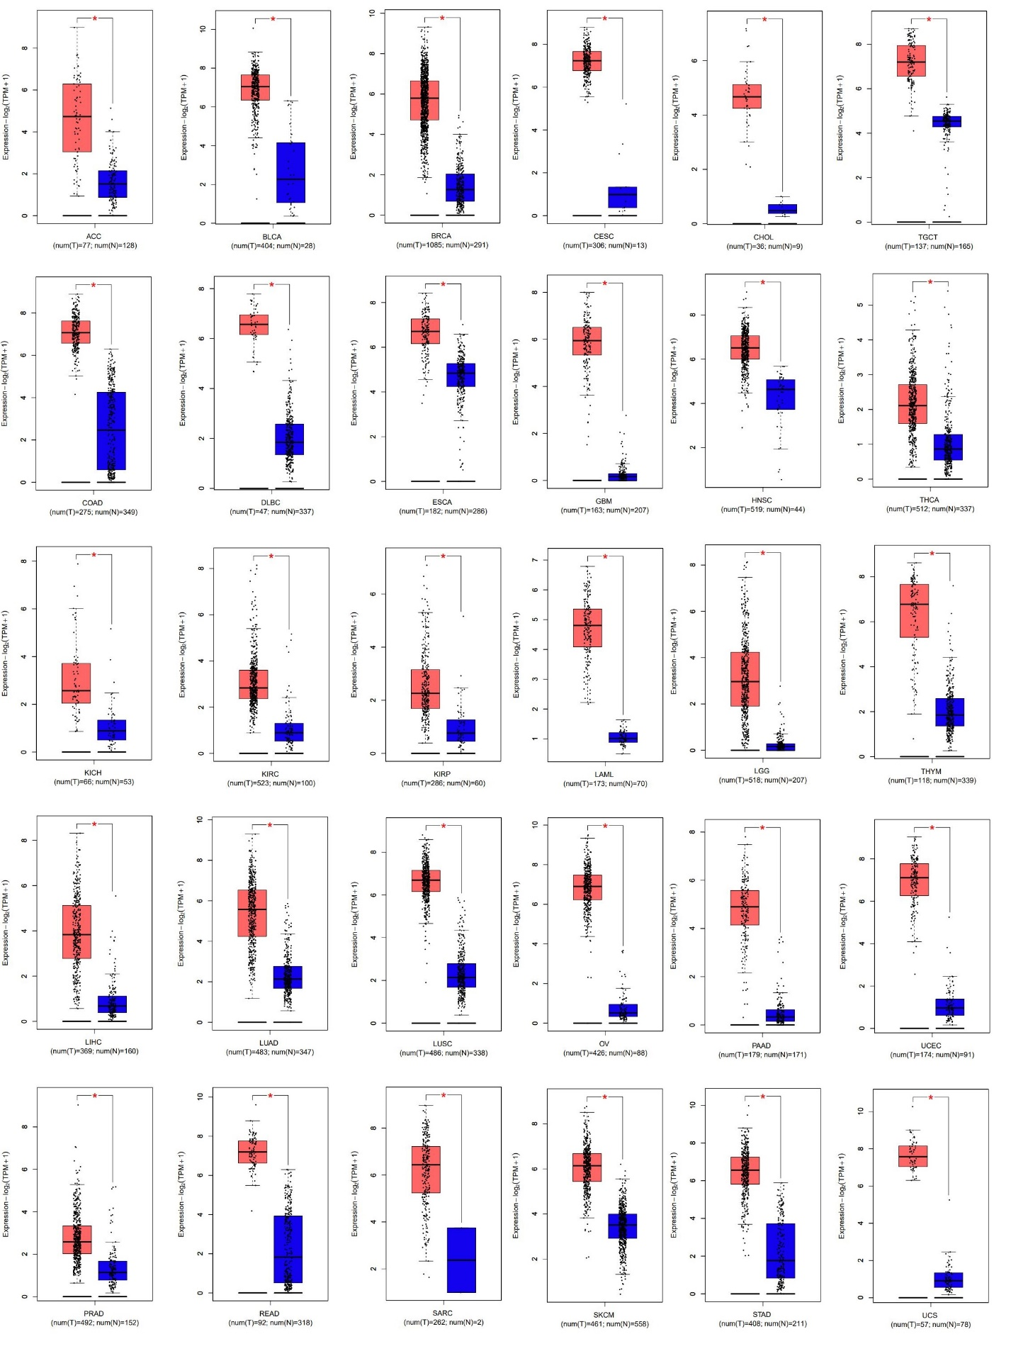 Supplementary file 1 figure 1. UBE2C gene expression in different cancer types. With P value < 0.01 and |LogFC| > 1, UBE2C was up-regulated in 30 types of cancer.
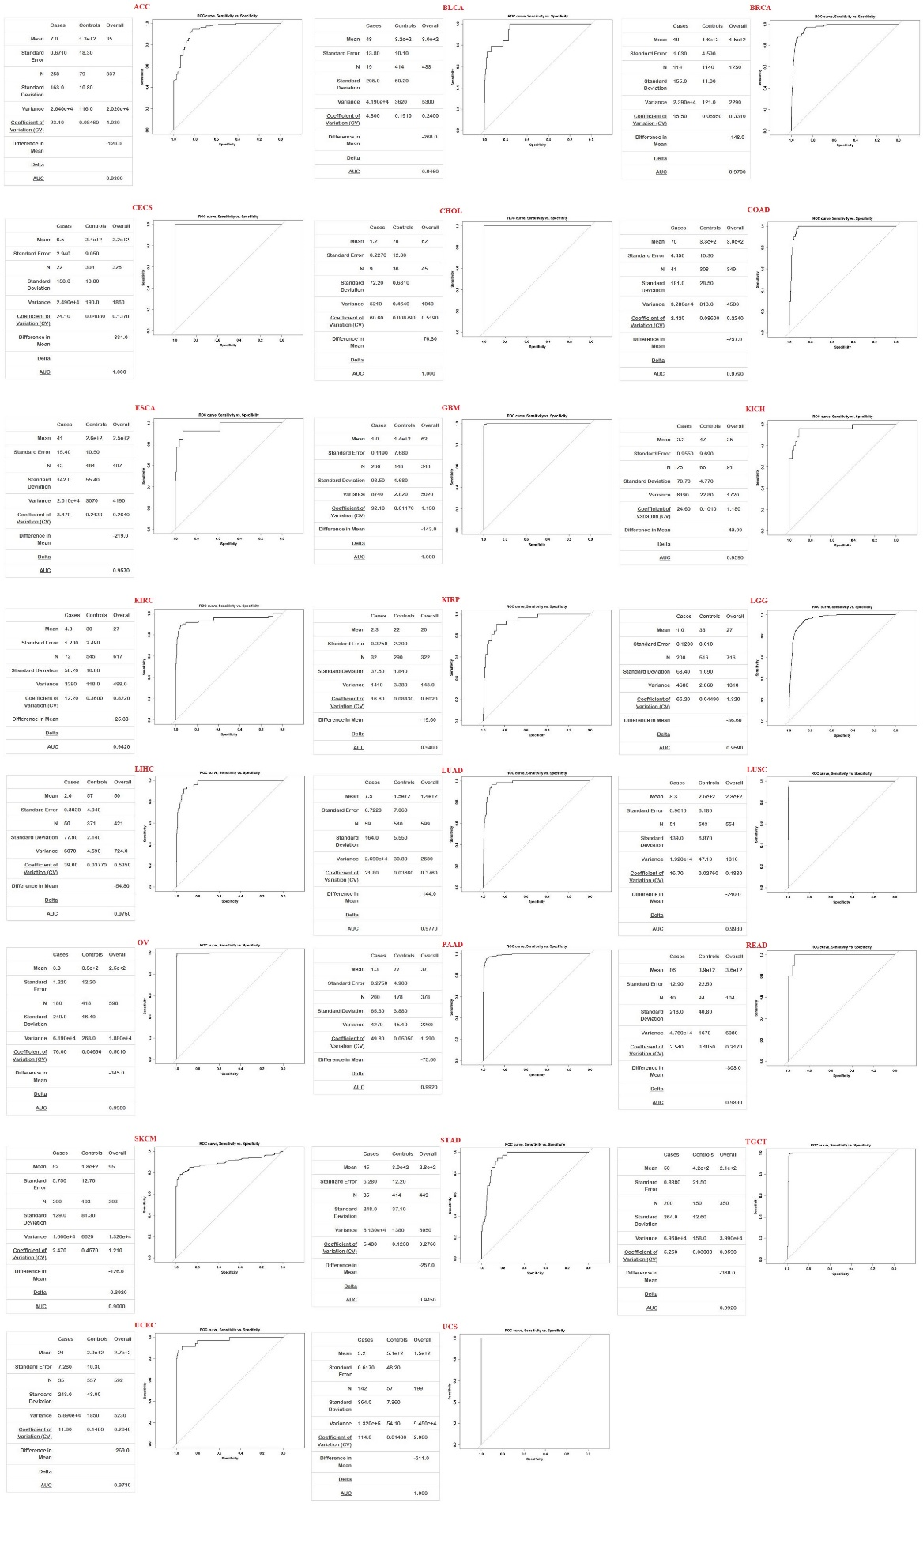
Supplementary file 1 figure 2. Diagnostic value of UBE2C in different types of cancer. UBE2C can be a diagnostic factor in CESC, CHOL, GBM, and UCS with AUC = 100%.

