Table 3 Wear morphology of rake and flank face of three milling inserts after cutting 100 times
Milling insert | Morphology of flank wear | Morphology of rake face wear
PcBN | 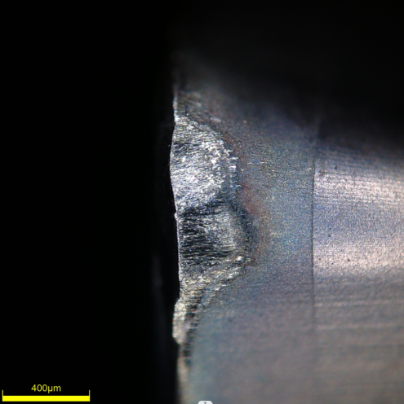  Abrasive wear | 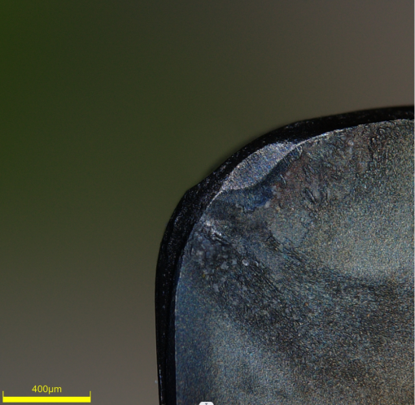  Abrasive wear
C-PcBN | 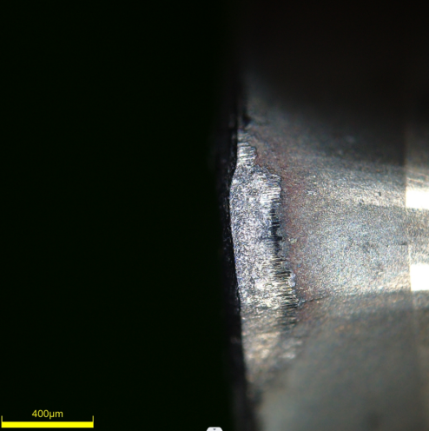  Abrasive wear | 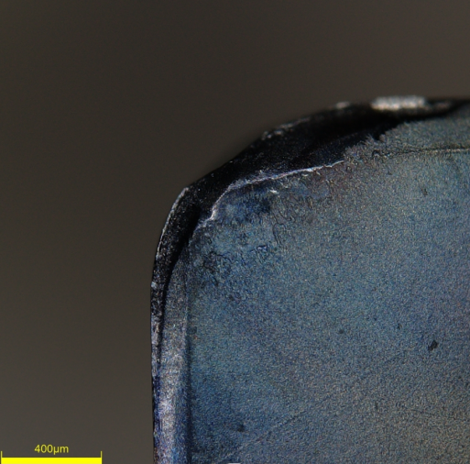  Abrasive wear
C-YG | 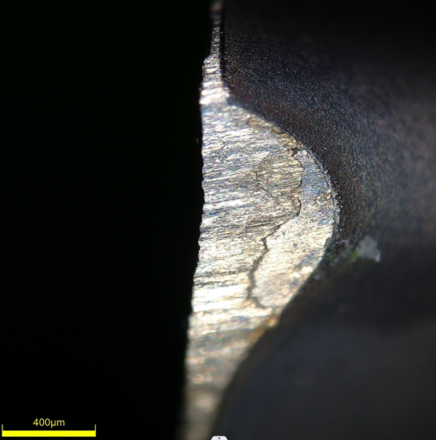  Coating wear  Coating peeling | 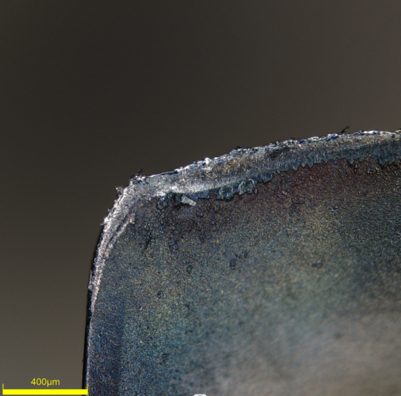  Chipping

