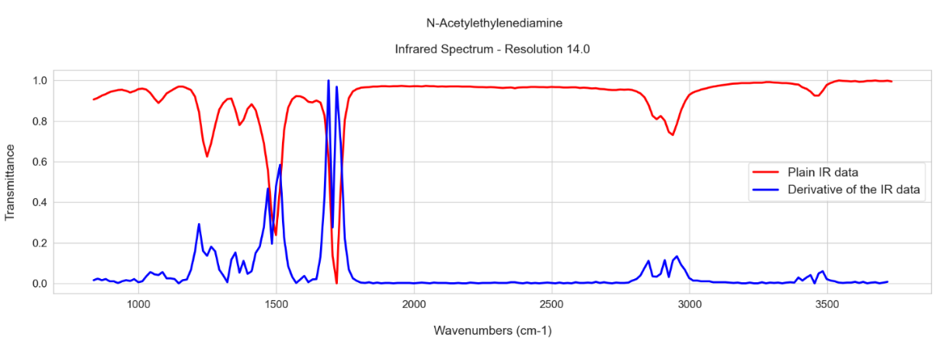
Figure S1. A plot of the Infrared spectrum of the N-Acetylethylenediamine with a resolution equal to 14 cm⁻¹ along with the calculated and normalized derivative values.

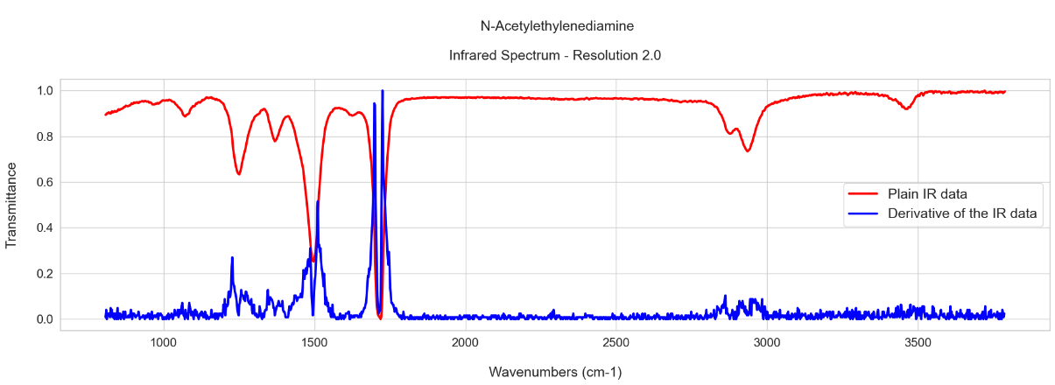
Figure S2. A plot of the Infrared spectrum of the N-Acetylethylenediamine with a resolution equal to 2 cm^{-1,} along with the calculated and normalized derivative values

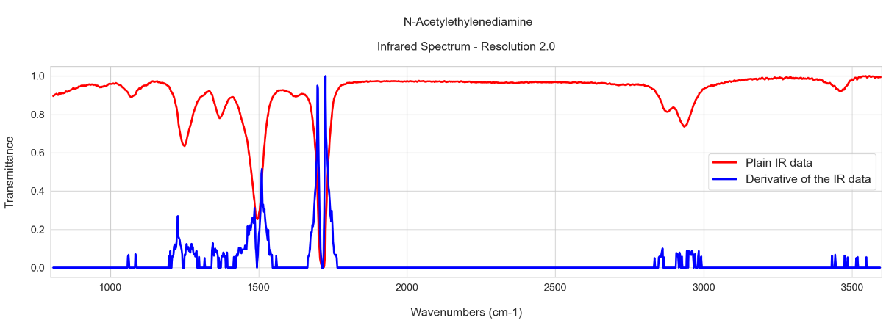
Figure S3. A plot of the Infrared spectrum of the N-Acetylethylenediamine with a resolution equal to 2 cm⁻¹ in which the denoising algorithm on the derivative data was applied (bottom), compared to the previous plot of the Infrared spectrum of the N-Acetylethylenediamine with the resolution equal to 2 cm⁻¹ (top)

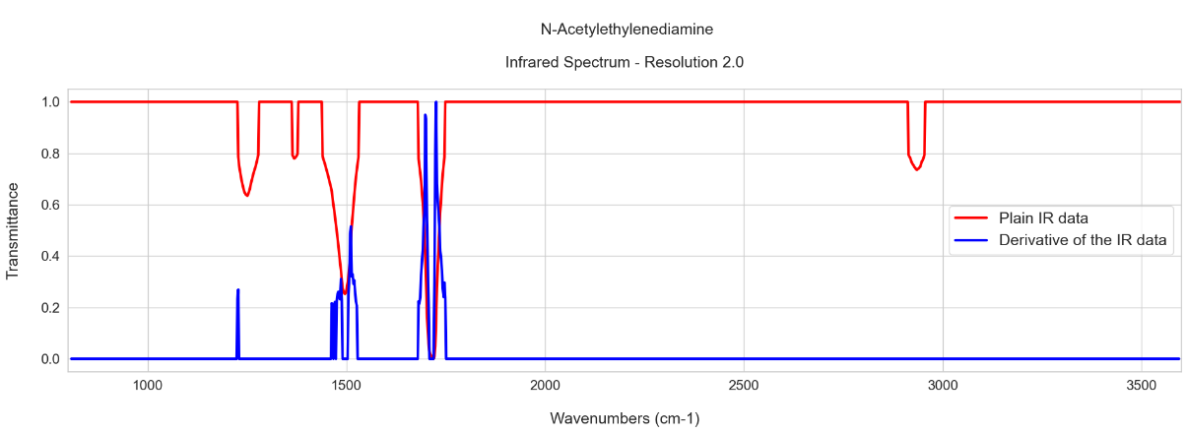
Figure S4. A plot of the Infrared spectrum of the N-Acetylethylenediamine with a resolution equal to 2 cm⁻¹ in which the categorical algorithm along with the Numerical Correction algorithm was applied for the threshold value equal to 20% for both the derivative and plain data (bottom), compared to the previous plot of the Infrared spectrum of the N-Acetylethylenediamine with the resolution equal to 2 cm-1 (top)

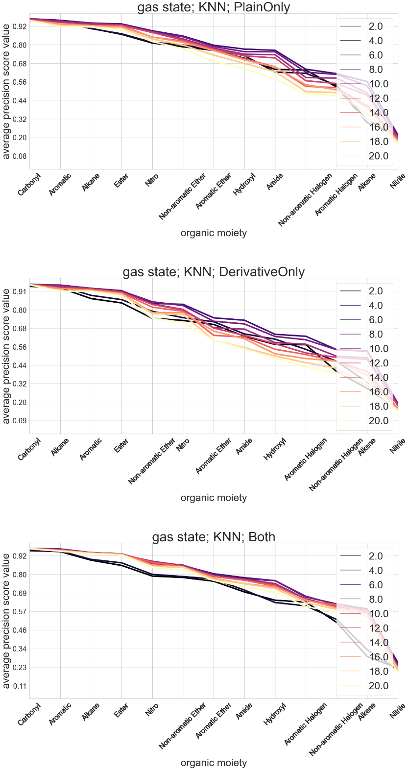
Figure S5. Plots of average precision metric score values for each organic moiety. The figure contains individual plots that differ in what data-handling method was used (PlainOnly, DerivativeOnly, or Both). The ML model that was used was the KNN model. Each line in the individual plot represents the average precision metric score values obtained from the data of a given resolution

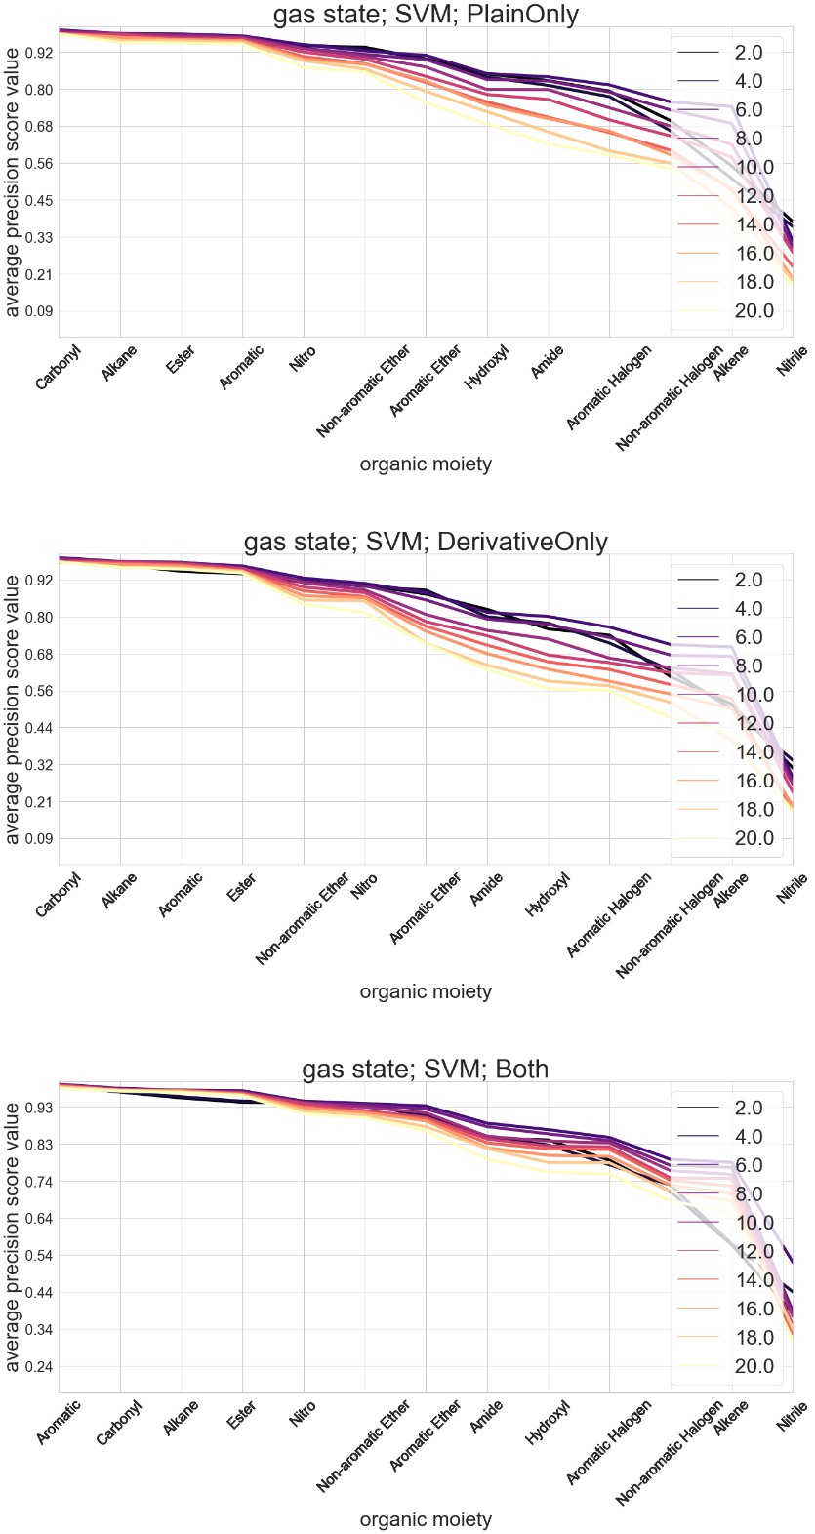
Figure S6. Plots of average precision metric score values for each organic moiety. The figure contains individual plots that differ in what data-handling method was used (PlainOnly, DerivativeOnly, or Both). The ML model that was used was the SVM model. Each line in the individual plot represents the average precision metric score values obtained from the data of a given resolution

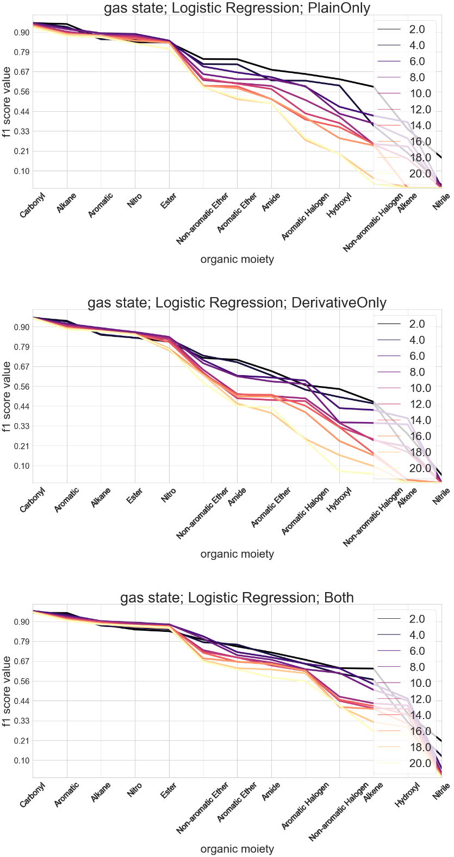
Figure S7. Plots of f1 metric score values for each organic moiety. The figure contains individual plots that differ in what data-handling method was used (PlainOnly, DerivativeOnly, or Both). The ML model that was used was the Logistic Regression model. Each line in the individual plot represents the f1 metric score values obtained from the data of a given resolution

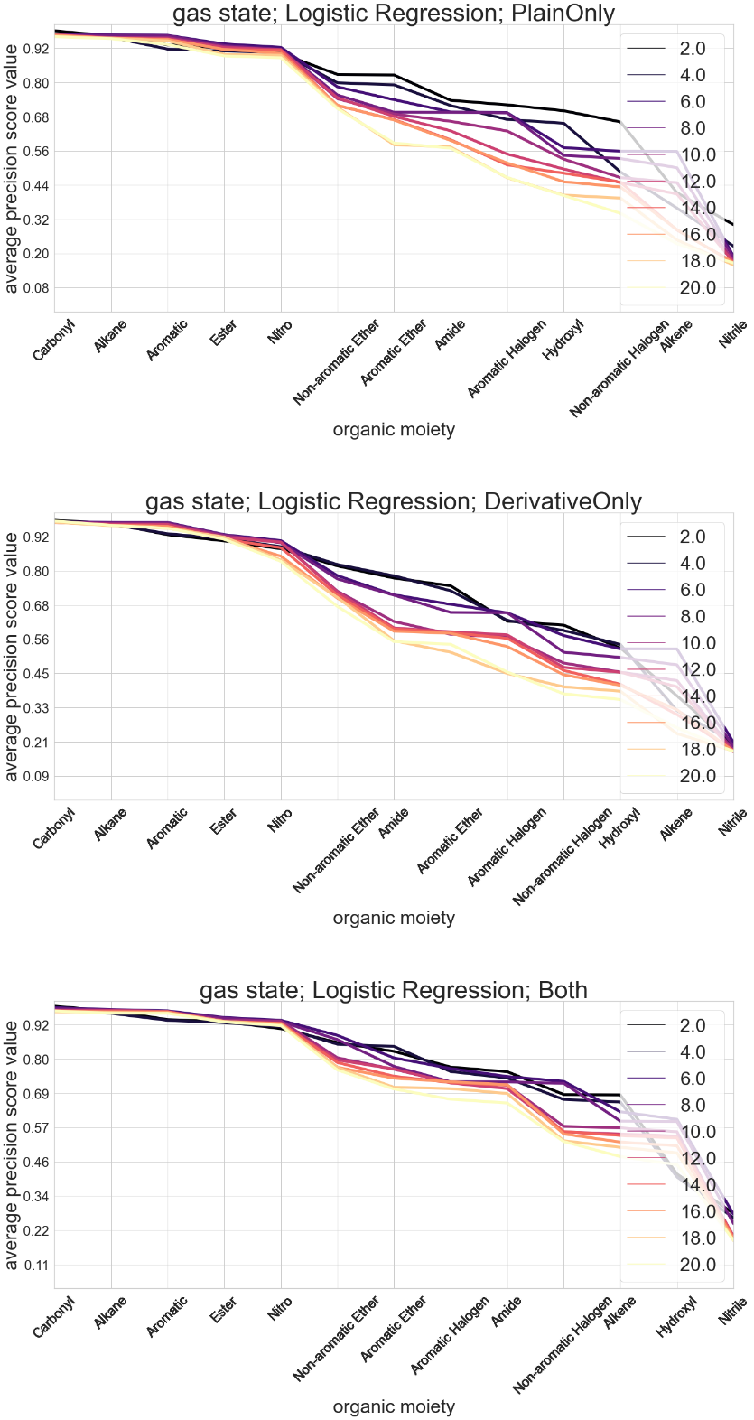
Figure S8. Plots of average precision metric score values for each organic moiety. The figure contains individual plots that differ in what data-handling method was used (PlainOnly, DerivativeOnly, or Both). The ML model that was used was the Logistic Regression model. Each line in the individual plot represents the average precision metric score values obtained from the data of a given resolution

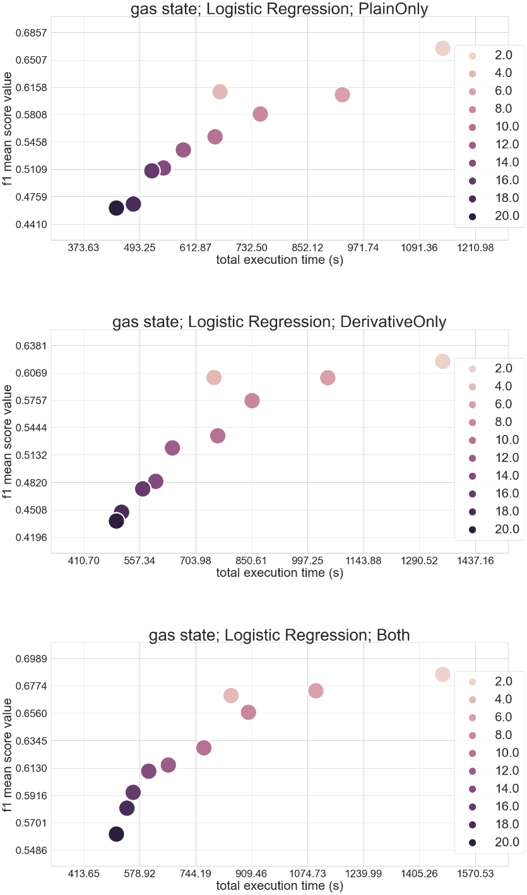
Figure S9. Plots of the mean f1 score values for all organic moieties and the respective total execution time. The figure contains individual plots that differ in what data-handling method was used (PlainOnly, DerivativeOnly, or Both). The ML model that was used was the Logistic Regression model. Each dot represents the mean f1 metric score values of all the examined organic moieties obtained from the data of a given resolution

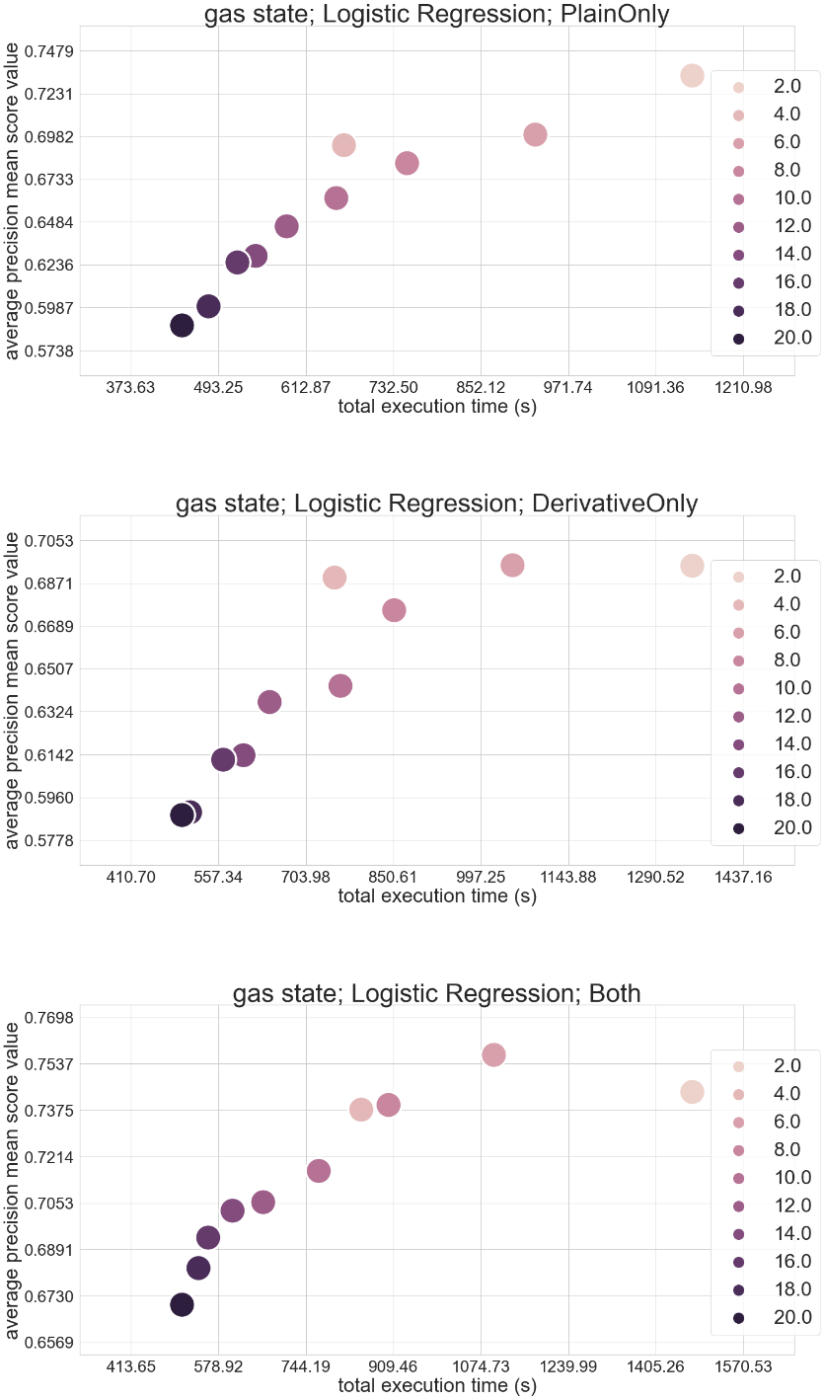
Figure S10. Plots of the mean average precision score values for all organic moieties and the respective total execution time. The figure contains individual plots that differ in what data-handling method was used (PlainOnly, DerivativeOnly, or Both). The ML model that was used was the Logistic Regression model. Each dot represents the mean average precision metric score values of all the examined organic moieties obtained from the data of a given resolution

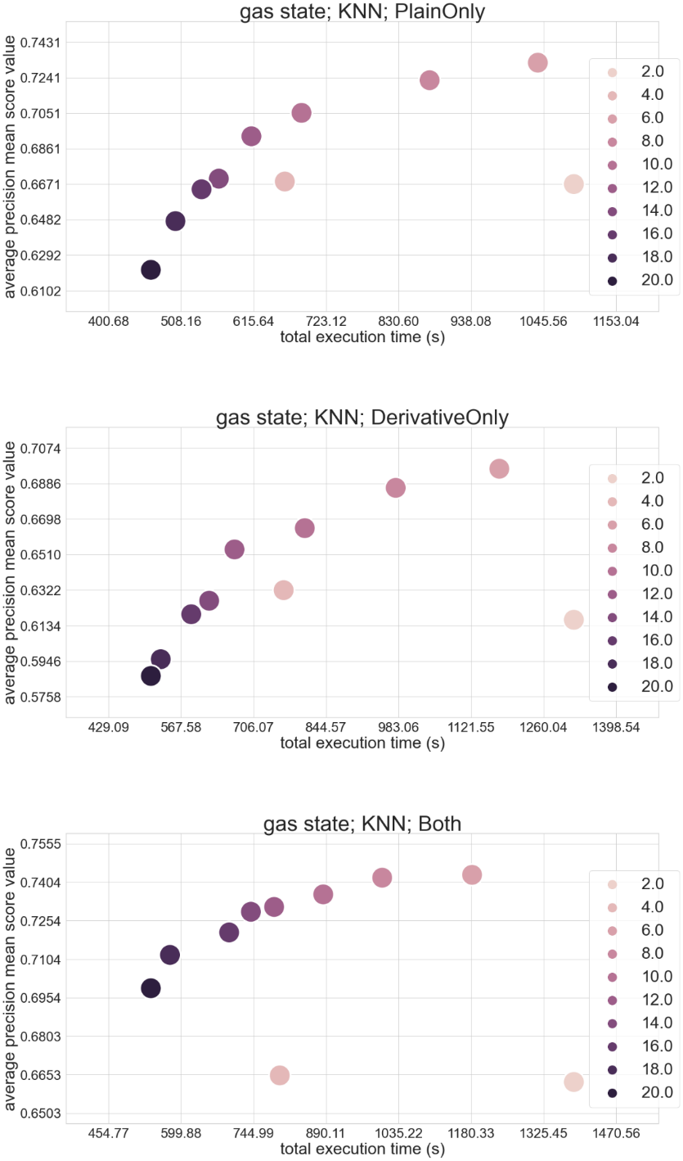
Figure S11. Plots of the mean average precision score values for all organic moieties and the respective total execution time. The figure contains individual plots that differ in what data-handling method was used (PlainOnly, DerivativeOnly, or Both). The ML model that was used was the KNN model. Each dot represents the mean average precision metric score values of all the examined organic moieties obtained from the data of a given resolution

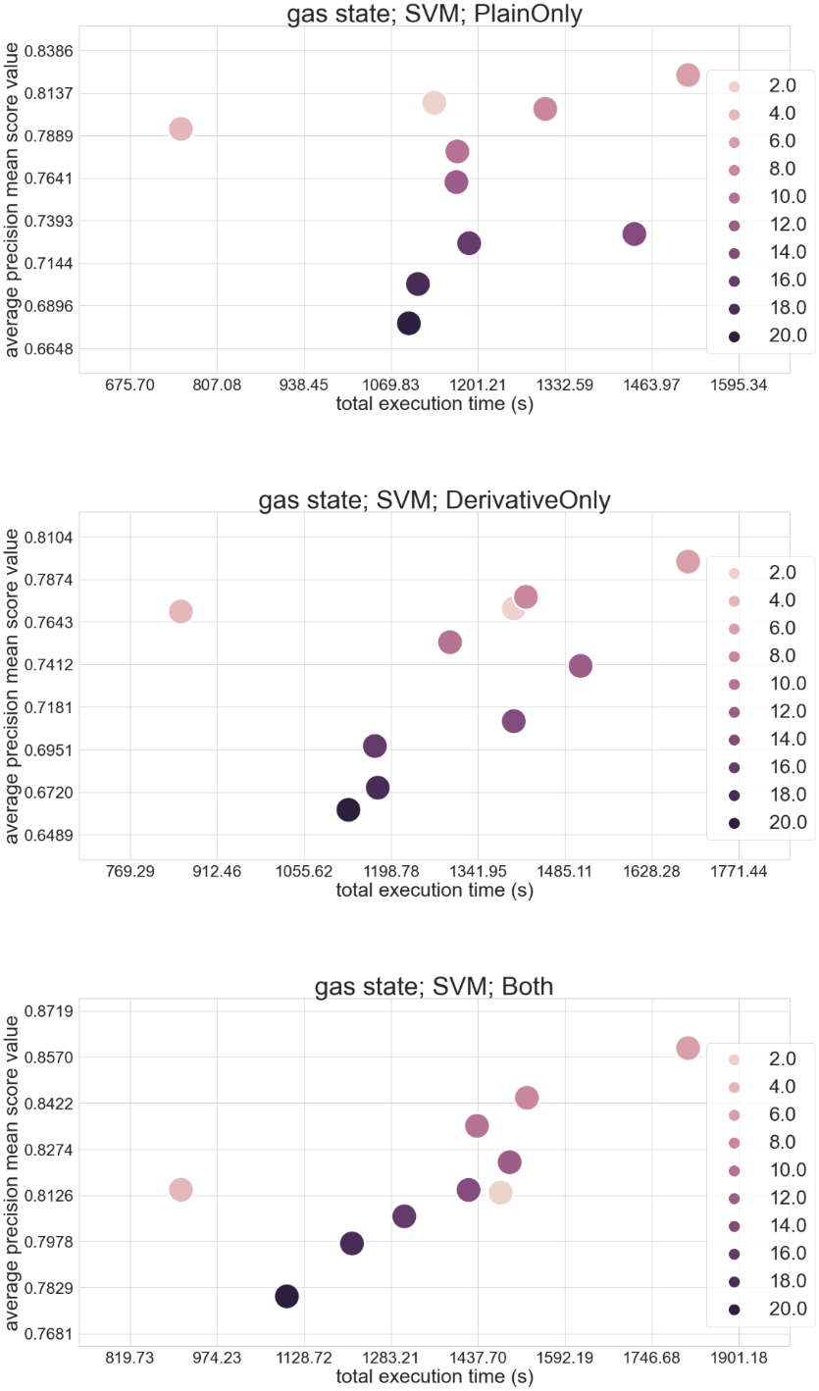
Figure S12. Plots of the mean average precision score values for all organic moieties and the respective total execution time. The figure contains individual plots that differ in what data-handling method was used (PlainOnly, DerivativeOnly, or Both). The ML model that was used was the SVM model. Each dot represents the mean average precision metric score values of all the examined organic moieties obtained from the data of a given resolution

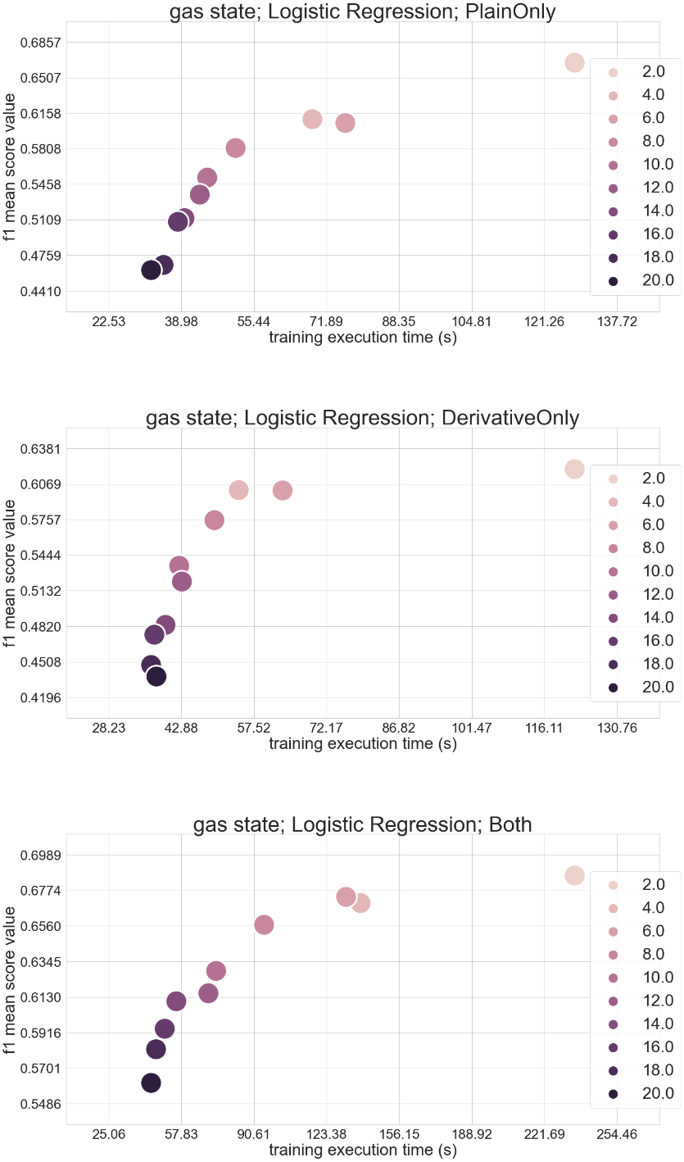
Figure S13. Plots of the mean f1 score values for all organic moieties and the respective training execution time. The figure contains individual plots that differ in what data-handling method was used (PlainOnly, DerivativeOnly, or Both). The ML model that was used was the Logistic Regression model. Each dot represents the mean f1 metric score values of all the examined organic moieties obtained from the data of a given resolution

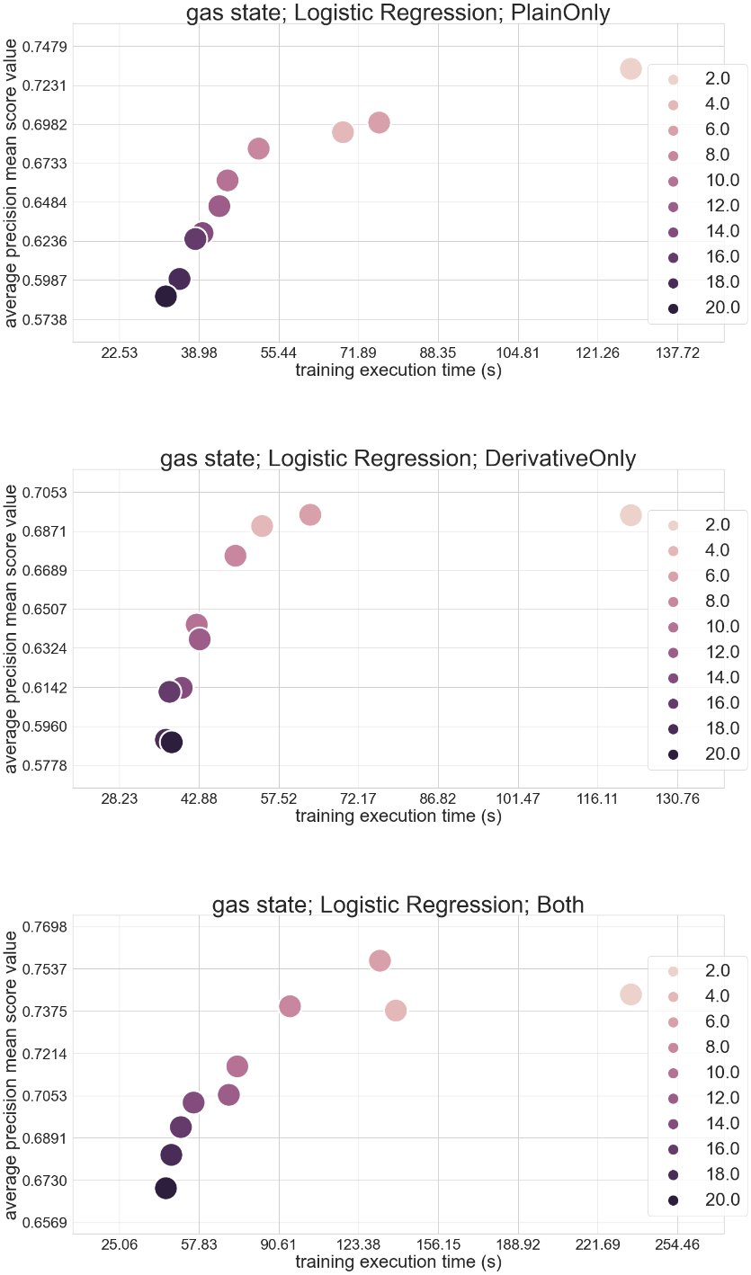
Figure S14. Plots of the mean average precision score values for all organic moieties and the respective training execution time. The figure contains individual plots that differ in what data-handling method was used (PlainOnly, DerivativeOnly, or Both). The ML model that was used was the Logistic Regression model. Each dot represents the mean average precision metric score values of all the examined organic moieties obtained from the data of a given resolution

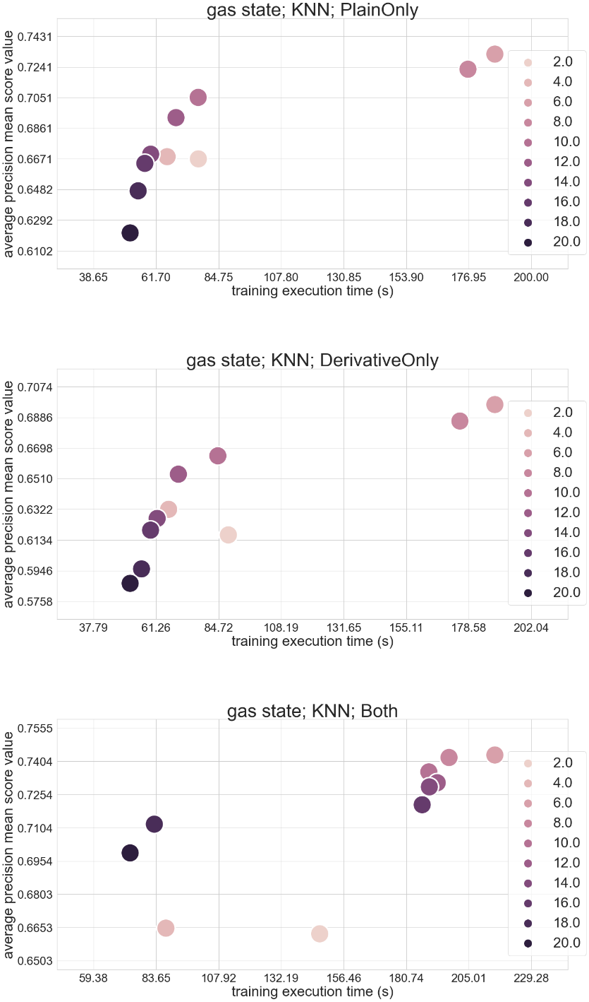
Figure S15. Plots of the mean average precision score values for all organic moieties and the respective training execution time. The figure contains individual plots that differ in what data-handling method was used (PlainOnly, DerivativeOnly, or Both). The ML model that was used was the KNN model. Each dot represents the mean average precision metric score values of all the examined organic moieties obtained from the data of a given resolution

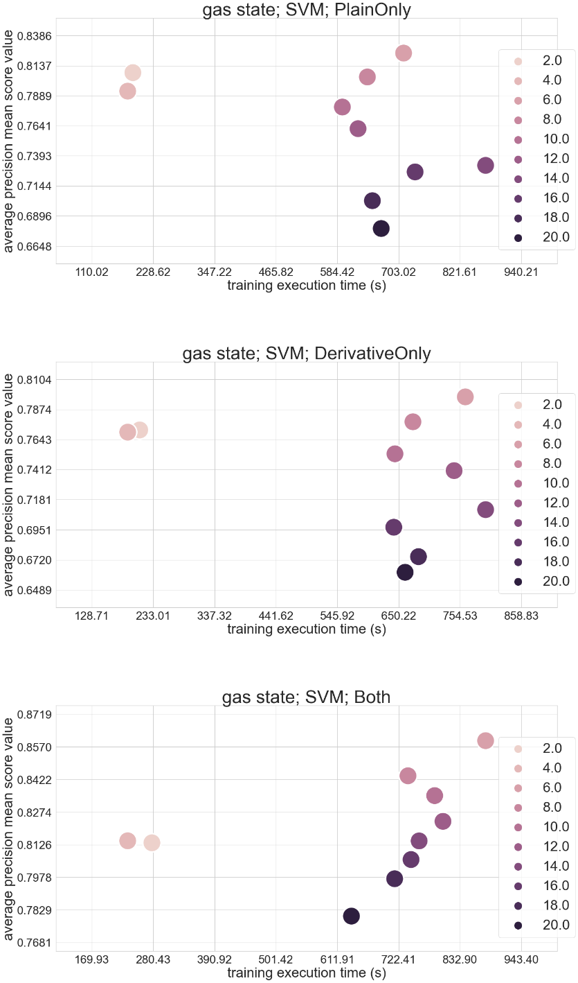
Figure S16. Plots of the mean average precision score values for all organic moieties and the respective training execution time. The figure contains individual plots that differ in what data-handling method was used (PlainOnly, DerivativeOnly, or Both). The ML model that was used was the SVM model. Each dot represents the mean average precision metric score values of all the examined organic moieties obtained from the data of a given resolution

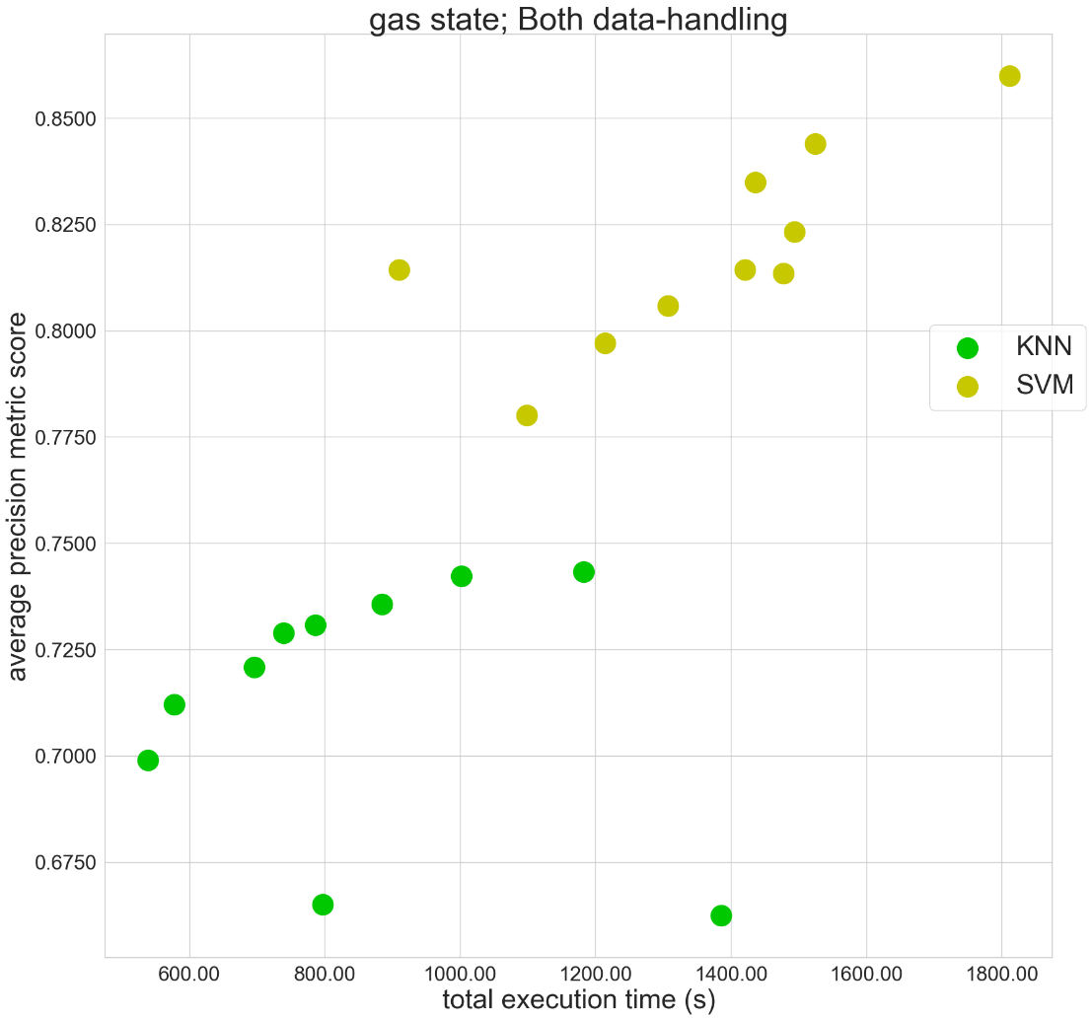
Figure S17. A direct comparison of the mean average precision metric score values across the resolutions for the KNN and the SVM models along with the mean total execution time

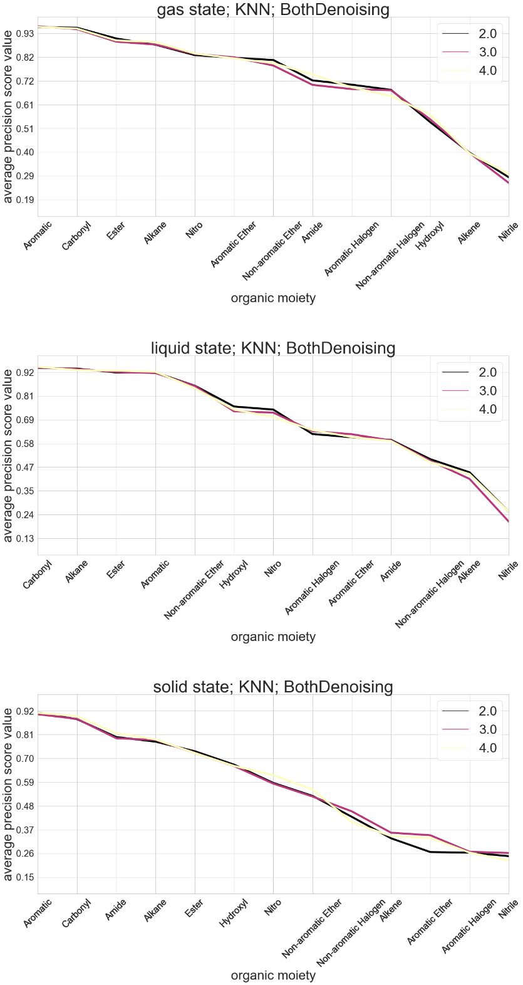
Figure S18. Plots of average precision score value for each organic moiety. The figure contains individual plots that were generated for the Both data-handling method along with applying the denoising algorithm. The plots differ in what state the molecules were in (gas, liquid, or solid).. Each line in the individual plot represents the average precision metric score values obtained from the data of a given resolution

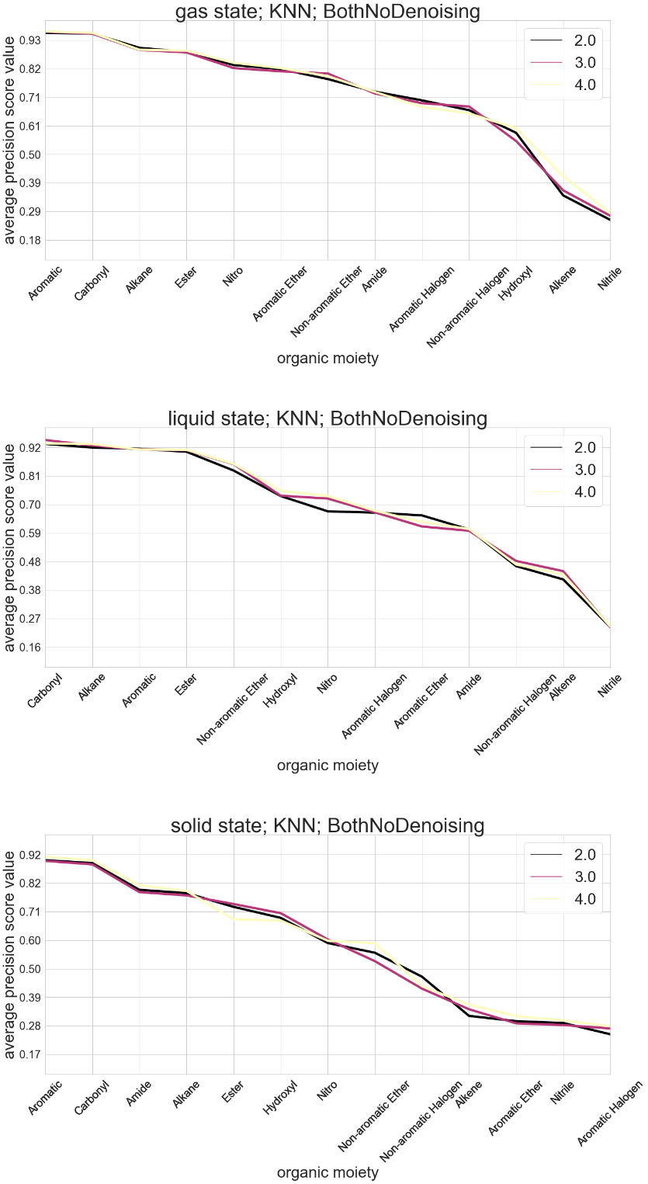
Figure S19. Plots of average precision score value for each organic moiety. The figure contains individual plots that were generated for the Both data-handling method without applying the denoising algorithm. The plots differ in what state the molecules were in (gas, liquid, or solid).. Each line in the individual plot represents the average precision metric score values obtained from the data of a given resolution

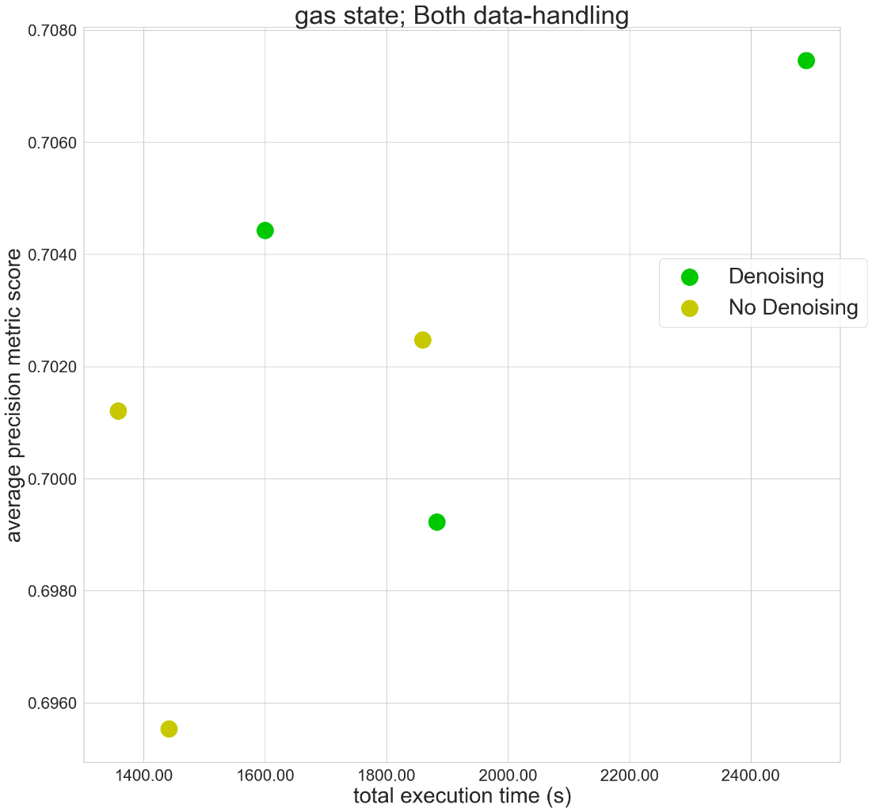
Figure S20. A direct comparison of the mean average precision metric score values across the resolutions for the KNN model, with or without applying the denoising algorithm, along with the mean total execution time.

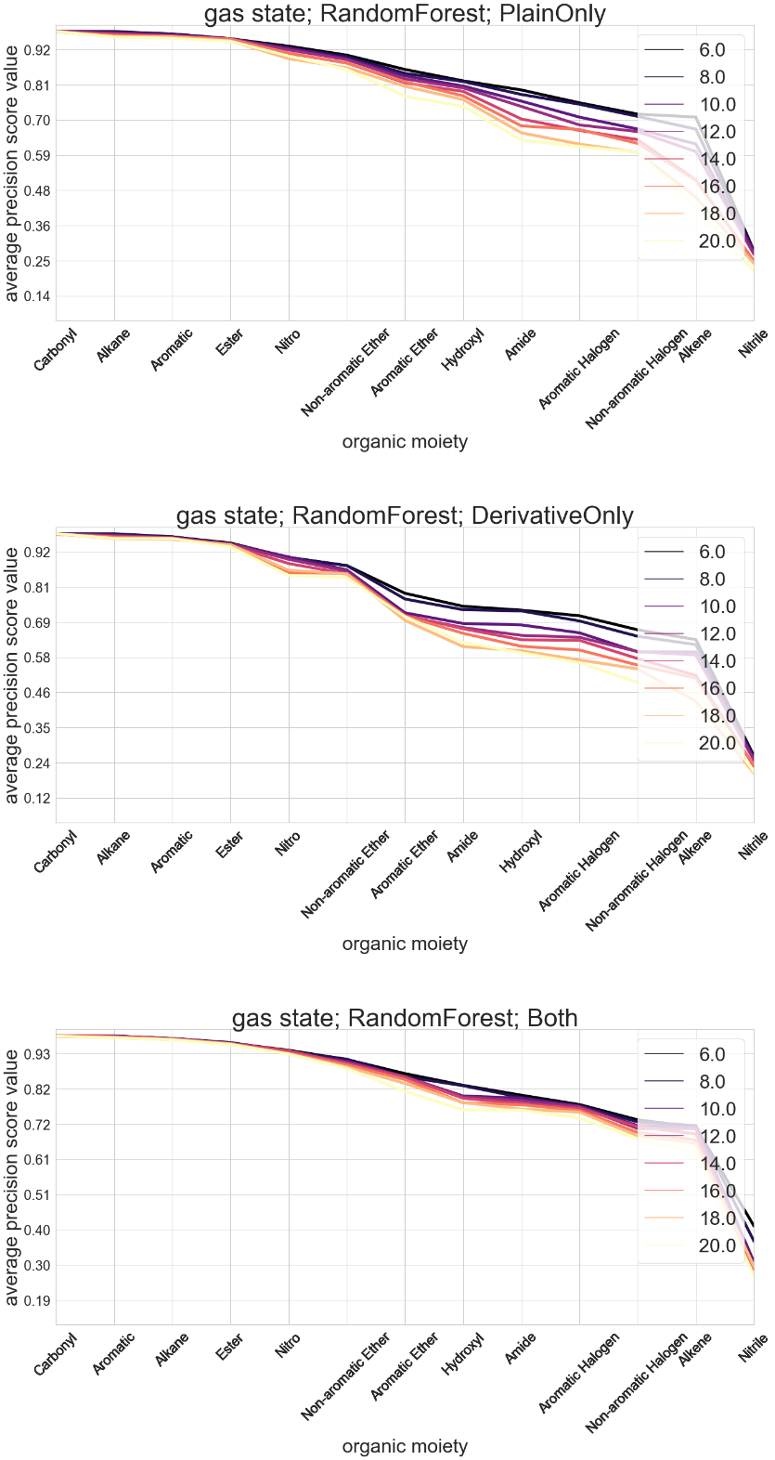
Figure S21. Plots of average precision metric score values for each organic moiety. The figure contains individual plots that differ in what data-handling method was used (PlainOnly, DerivativeOnly, or Both). The ML model that was used was the Random Forest model. Each line in the individual plot represents the average precision metric score values obtained from the data of a given resolution

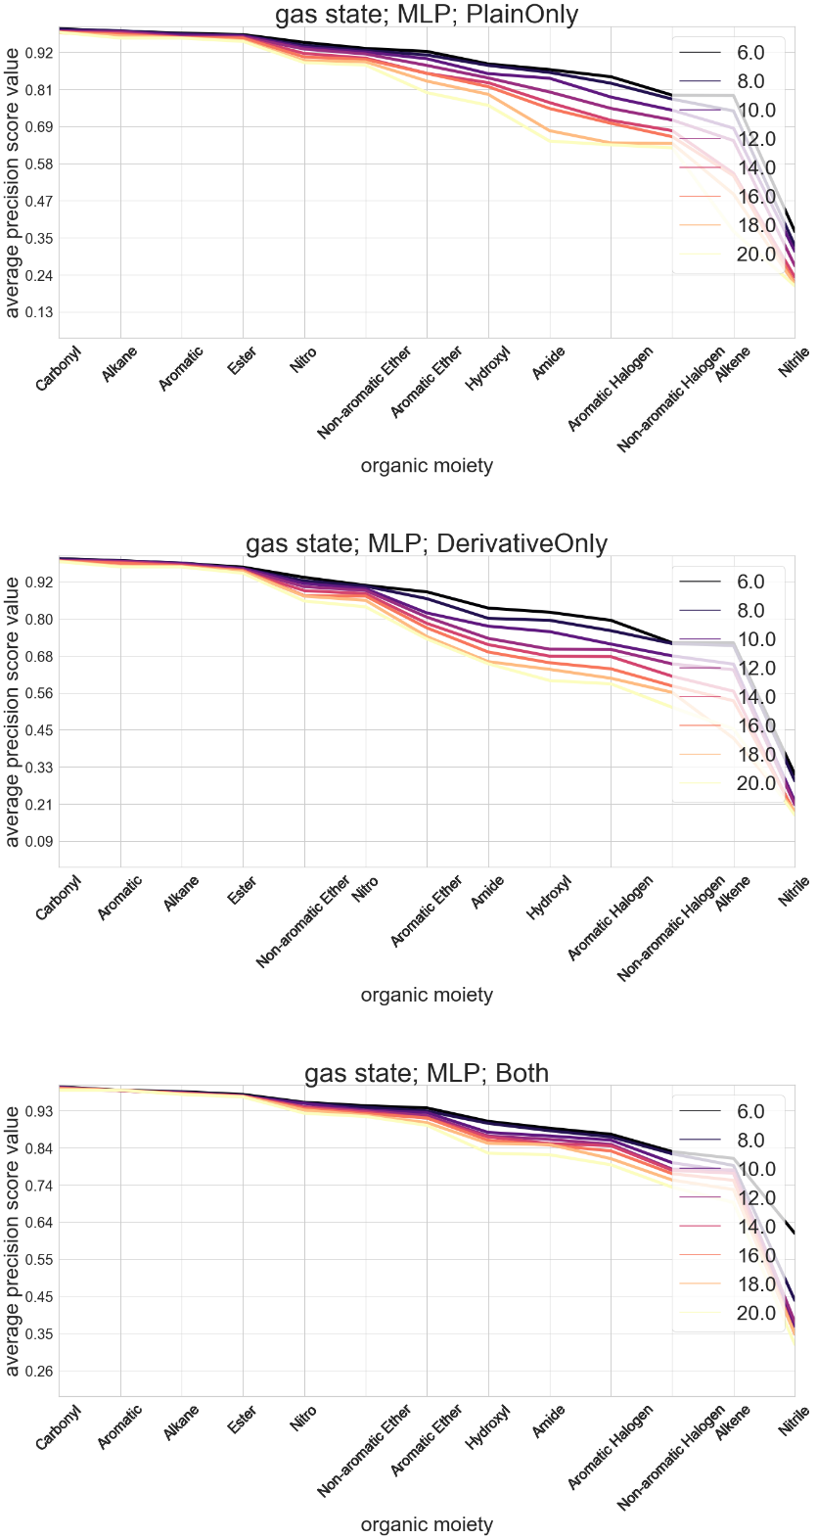
Figure S22. Plots of average precision metric score values for each organic moiety. The figure contains individual plots that differ in what data-handling method was used (PlainOnly, DerivativeOnly, or Both). The ML model that was used was the MLP model. Each line in the individual plot represents the average precision metric score values obtained from the data of a given resolution

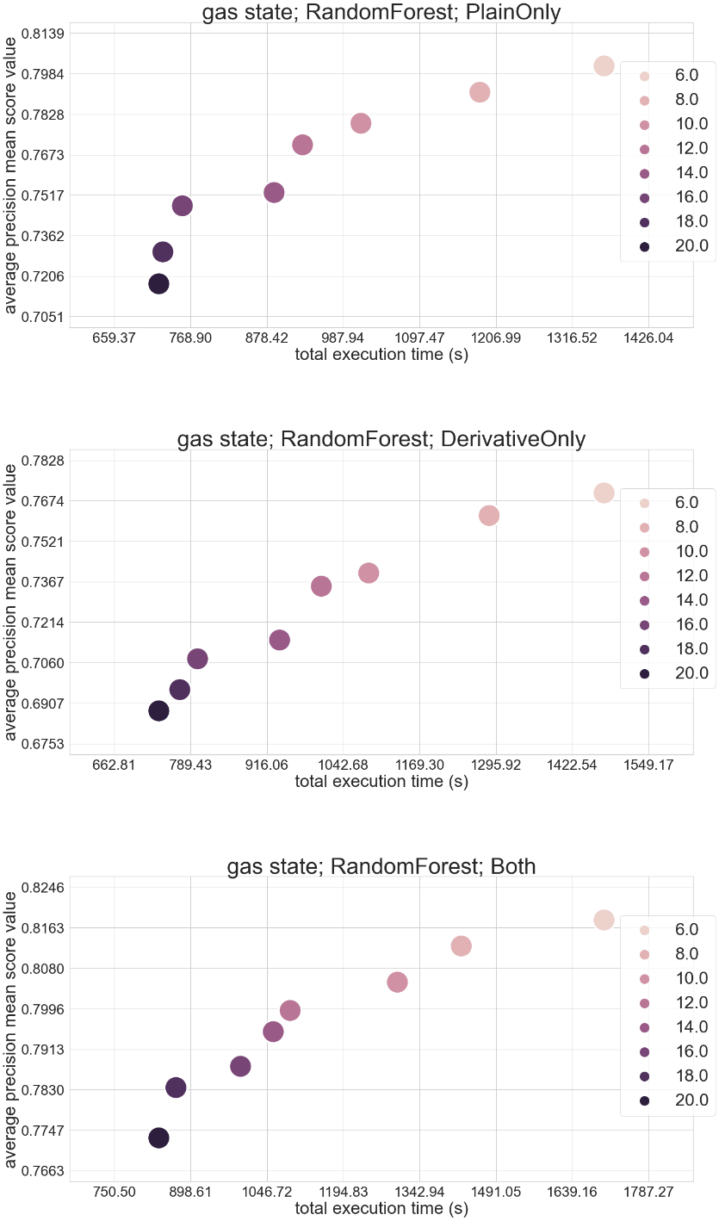
Figure S23. Plots of the mean average precision score values for all organic moieties and the respective total execution time. The figure contains individual plots that differ in what data-handling method was used (PlainOnly, DerivativeOnly, or Both). The ML model that was used was the Random Forest model. Each dot represents the mean average precision metric score values of all the examined organic moieties obtained from the data of a given resolution

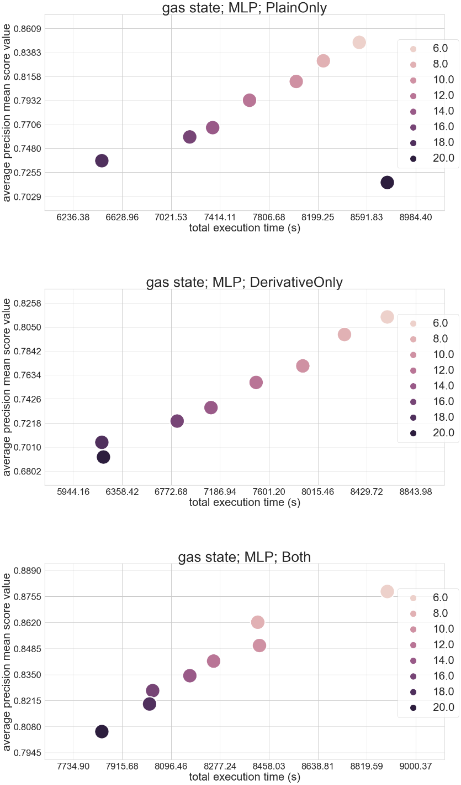
Figure S24. Plots of the mean average precision score values for all organic moieties and the respective total execution time. The figure contains individual plots that differ in what data-handling method was used (PlainOnly, DerivativeOnly, or Both). The ML model that was used was the MLP model. Each dot represents the mean average precision metric score values of all the examined organic moieties obtained from the data of a given resolution

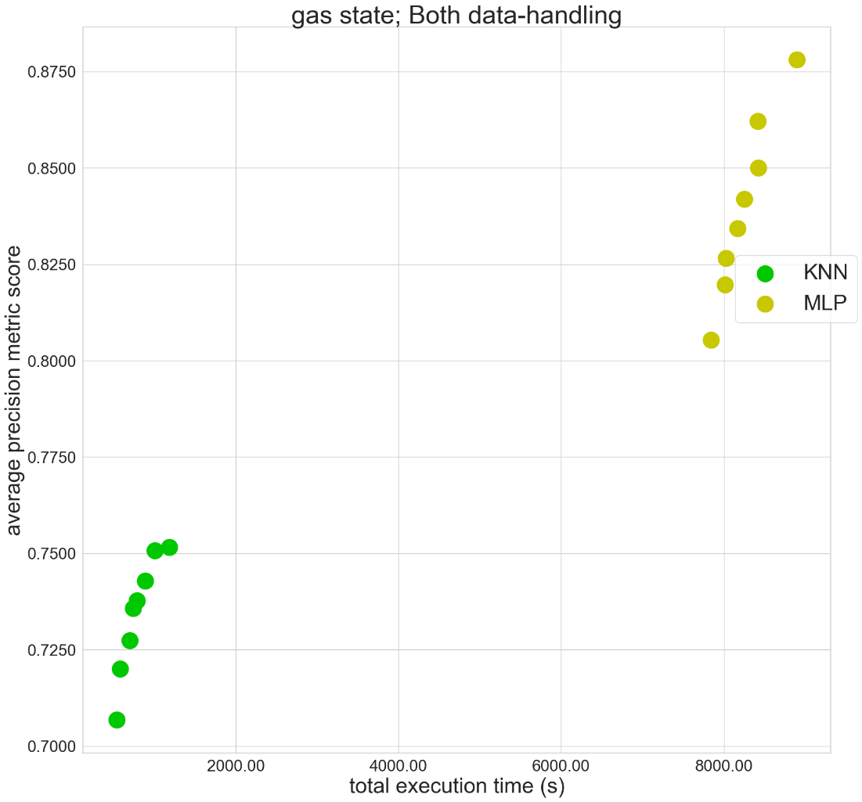
Figure S25. A direct comparison of the mean average precision metric score values across the resolutions for the KNN and the MLP models along with the mean total execution time

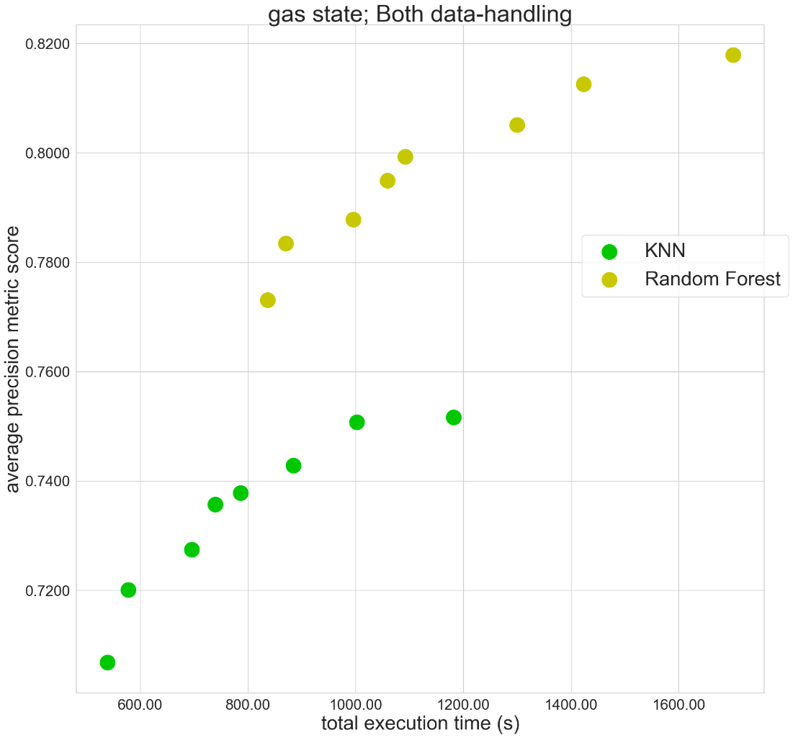
Figure S26. A direct comparison of the mean average precision metric score values across the resolutions for the KNN and the Random Forest models along with the mean total execution time

