Supplementary information

A)
B)

Figure S1. Comparison in A) autotrophic and B) heterotrophic cell abundance; cells mL⁻¹ between flow cytometry and microscopy.

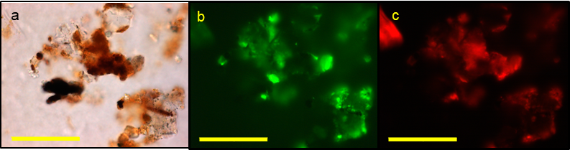

Figure S2. shows a) organic matter and mineral fragments under brightfield view b) SYBR-PI-stained fluorescence of the same image under the FITC n filter cube c) SYBR-PI-stained fluorescence under the Cy 3 filter cube. Images b and c; notice no cells but high fluorescence. Scale bar is 500 µm.

Table S1. Total, potentially viable and potentially non-viable cell abundance for snow, superimposed ice and surface glacial ice (up to 25 cm) in early July, across the 7 stakes on Foxfonna. Values are total ± standard deviation. “-” signifies no cells detected.
 | Cell abundance (cells mL⁻¹) in early July
Stake | Snow |  |  | Superimposed ice |  |  | Surface glacial ice (up to 25 cm)
 | Total | Potentially viable | Potentially non-viable | Total | Potentially viable | Potentially non-viable | Total | Potentially viable | Potentially non-viable
NW | 19 ± 2 | 17 ± 2 | 2 ± 1 | 30 ± 0 | - | 30 ± 0 | 1473 ± 0 | 11 ± 0 | 1462 ± 0
SW | 731 ± 267 | 13 ± 4 | 717 ± 270 | 34 ± 0 | 1 ± 0 | 33 ± 0 | 385 ± 0 | 2 ± 0 | 383 ± 0
S1 | 142 ± 30 | 3 ± 2 | 139 ± 31 | 433 ± 0 | 8 ± 0 | 425 ± 0 | 1071 ± 0 | 250 ± 0 | 821 ± 0
SE | 5 ± 0 | 3 ± 0 | 2 ± 0 | - | - | - | 26 ± 0 | 13 ± 0 | 13 ± 0
NE | 30 ± 11 | 29 ± 10 | 1 ± 1 | 595 ± 0 | - | 595 ± 0 | 264 ± 0 | 197 ± 0 | 67 ± 0
AWS | 1578 ± 727 | 20 ± 4 | 1557 ± 729 | 23 ± 0 | 1 ± 0 | 22 ± 0 | 167 ± 0 | 167 ± 0 | -
N | 35 ± 2 | 12 ± 3 | 23 ± 4 | 677 ± 0 | 445 ± 0 | 232 ± 0 | not sampled | not sampled | not sampled

Table S2. Total, potentially viable and potentially non-viable cell abundance for snow and superimposed ice in late July, across the 7 stakes on Foxfonna. Values are total ± standard deviation. “-” signifies no cells detected.

 | Cell abundance (cells mL⁻¹) in late July
Stake | Snow |  |  | Superimposed ice |  |  | Surface glacial ice (up to 25 cm)
 | Total | Potentially viable | Potentially non-viable | Total | Potentially viable | Potentially non-viable | Total | Potentially viable | Potentially non-viable
NW | 489 ± 0 | 477 ± 0 | 12 ± 0 | - | - | - | 1111± 0 | 0 ± 0 | 1111 ± 0
SW | 3493 ± 0 | 2 ± 0 | 3491 ± 0 | - | - | - | 580 ± 0 | 580 ± 0 | 0
S1 | - | - | - | - | - | - | 640 ± 0 | 62 ± 0 | 578 ± 0
SE | - | - | - | - | - | - | 283 ± 0 | 13 ± 0 | 270 ± 0
NE | 1 ± 0 | - | 1 ± 0 | - | - | - | 447 ± 0 | 0 | 447 ± 0
AWS | 680 ± 0 | 432 ± 0 | 249 ± 0 | 185 ± 0 | 185 ± 0 | - | 173 ± 0 | 173 ± 0 | 0
N | 12 ± 2 | 9 ± 0 | 3 ± 1 | - | - | - | 2478 ± 0 | 0 | 2478 ± 0

