Supplement information
Table 1 List of Rwanda land cover classes

Code | Land cover class name | Area (Ha) | Percentage share
1.0 | Consolidated tea plantations | 17,821 | 0.7
1.1 | Hillside agricultural land | 1,343,933 | 53.1
2.1 | Non-rice agricultural wetland | 55,807 | 2.2
2.2 | Paddy rice wetland | 21,848 | 0.9
2.3 | Non-cropped wetlands | 37,743 | 1.5
3.0 | Rangeland | 144,490 | 5.7
4.1 | Urban settlements | 31,612 | 1.2
4.2 | Rural settlements | 78,928 | 3.1
5.0 | Bare land/rocks | 15,404 | 0.6
6.0 | Water bodies | 135,295 | 5.3
7.0 | National parks | 241,455 | 9.5
8.0 | Protected wetland | 12,201 | 0.5
9.0 | Forest plantations | 395,001 | 15.6
Source: NISR-SAS (2021)

Supplement information Table 2 The fraction of the total area per stratum per landscape. Slope_ soil depth area (%) after overlaying Soil depth and slope classes representing the potential agroforestry area in all four landscapes. The number of individual trees (counts) encountered in each stratum per landscape are indicated between brackets.

Stratum | Description of strata |  | Study plots |  |  |  | Total
Stratum | Slope | Soil depth | Karama | Nyamugari | Mukama | Gikomero | Total
1 | 0-10% | <0.5m | 4.3 (28) | 6.4 (38) | 6.2 (148) | 0.00 (0) | 17.0 (214)
2 | 0-10% | >0.5m | 20.4 (97) | 15.3 (158) | 4.1 (105) | 2.2 (72) | 42.0 (432)
3 | >10-20% | <0.5m | 5.5 (26) | 2.0 (19) | 1.7 (31) | 1.4 (70) | 10.6 (146)
4 | >10-20% | >0.5m | 6.9 (59) | 3.2 (63) | 5.2 (106) | 4.2 (202) | 19.6 (430)
5 | >20% | <0.5m | 0.5 (12) | 0.0 (0) | 1.6 (0) | 4.5 (106) | 6.6 (118)
6 | >20% | >0.5m | 0.4 (02) | 0.00 (0) | 1.1 (6) | 2.8 (119) | 4.3 (127)
Total | NA | NA | 38.0 (224) | 26.09 (278) | 19.9 (396) | 15.2 (569) | 100.00 (1467)

Supplement information Table 3 Summary of structural attributes (e.g stem density, crown projected area, basal area, Height, Diameter at breast height and Crown projected area) of the woody vegetation encountered across different spatial configuration in the four landscapes study area ~250000 ha; considering hillside agriculture land, with a total of 1467 detected trees. Tree density and basal area per ha were calculated only for trees with > 4 cm DBH. Here we focused on three types of tree configurations that were the most predominant in the agricultural landscapes of the study region (trees _{scattered}, trees _{in line} and trees _{in block}).

Structure attributes | Spatial configuration | Landscape study sites
Structure attributes | Spatial configuration | Gikomero | Karama | Mukama | Nyamugari | p-Value
Density  (trees ha ⁻¹) | Scattered individual trees | 55.8 | 25.0 | 61.9 | 46.6 | < 0.0001
Density  (trees ha ⁻¹) | Trees in blocks | 56.1 | 41.1 | 45.4 | 49.7 | 0.0025
Density  (trees ha ⁻¹) | Trees in line | 66.2 | 29.2 | 67.2 | 22.1 | < 0.0001
Basal area  (m² ha ⁻¹) | Scattered individual trees | 0.63 | 0.80 | 0.70 | 0.55 | 0.2463
Basal area  (m² ha ⁻¹) | Trees in blocks | 0.63 | 0.40 | 0.56 | 0.80 | 0.0003
Basal area  (m² ha ⁻¹) | Trees in line | 0.69 | 0.64 | 0.48 | 0.34 | 0.0003
Crown projected area (m² ha ⁻¹) | Scattered individual trees | 35.7 | 53.1 | 39.9 | 34.0 | < 0.0001
Crown projected area (m² ha ⁻¹) | Trees in blocks | 38.4 | 24.2 | 25.5 | 23.6 | < 0.0001
Crown projected area (m² ha ⁻¹) | Trees in line | 31.9 | 35.5 | 38.0 | 45.0 | 0.0008
Height (m) | Scattered individual trees | 7.1 | 6.6 | 7.7 | 5.2 | < 0.0001
Height (m) | Trees in blocks | 7.1 | 5.1 | 6.9 | 5.5 | < 0.0001
Height (m) | Trees in line | 8.1 | 8.9 | 6.7 | 9.3 | < 0.0001
DBH (cm) | Scattered individual trees | 10.8 | 18.0 | 11.0 | 11.6 | 0.0005
DBH (cm) | Trees in block | 11.4 | 10.8 | 11.8 | 9.8 | 0.0016
DBH (cm) | Trees in line | 10.2 | 15.0 | 8.4 | 13.5 | < 0.0001
Crown diameter  (m) | Scattered individual trees | 3.0 | 4.4 | 3.3 | 2.8 | < 0.0001
Crown diameter  (m) | Trees in blocks | 3.2 | 2.0 | 2.1 | 2.0 | < 0.0001
Crown diameter  (m) | Trees in line | 2.6 | 2.9 | 3.1 | 3.7 | 0.0008
Species richness | Scattered individual trees | 12 | 8 | 10 | 11 | 0.0209
Species richness | Trees in blocks | 8 | 6 | 6 | 9 | 0.0202
Species richness | Trees in line | 9 | 4 | 6 | 3 | 0.079

Supplement information Table 4 Tree density in the study area ~250000 ha; considering hillside agriculture land, with a total of 1467 detected trees. only trees with > 4 cm DBH were measured.
Landscape  site | Scattered individual trees  (trees ha ⁻¹) | Trees in blocks (trees ha ⁻¹) | Trees in line (trees ha⁻¹) | Overall  (trees ha⁻¹)
Gikomero | 55.8 | 56.1 | 66.2 | 59.9
Karama | 25.0 | 41.1 | 29.2 | 35.9
Mukama | 61.9 | 45.4 | 67.2 | 63.1
Nyamugari | 46.6 | 49.7 | 22.1 | 46.9
Overall | 53.8 | 48.2 | 61.6 | 54.6

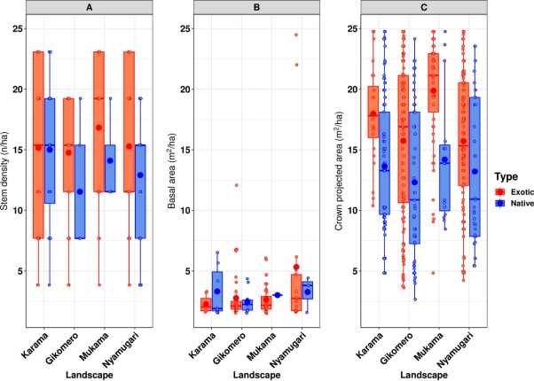

Supplement information Fig. 1 Boxplot showing the variation of the stem densities (number of individuals/ha), Crown projected area and Basal area within and across landscapes as a function of Landscapes. The two different colors represent types of tree species. The red area indicates Tree species_{Exotic} whereas blue area indicates Tree species_{Native} in the four different landscapes. Horizontal bar: Median value: Box: Interquartile Range; Whiskers: 1.5 time the interquartile range; Points: Data Points beyond the range of whiskers.

