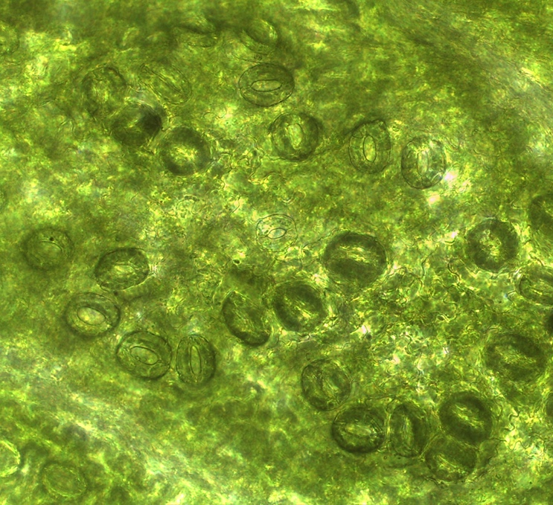
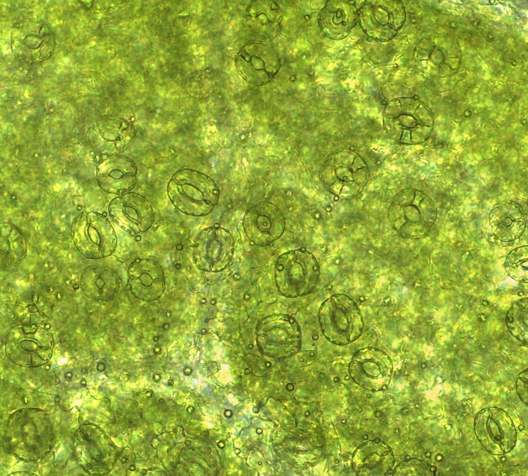
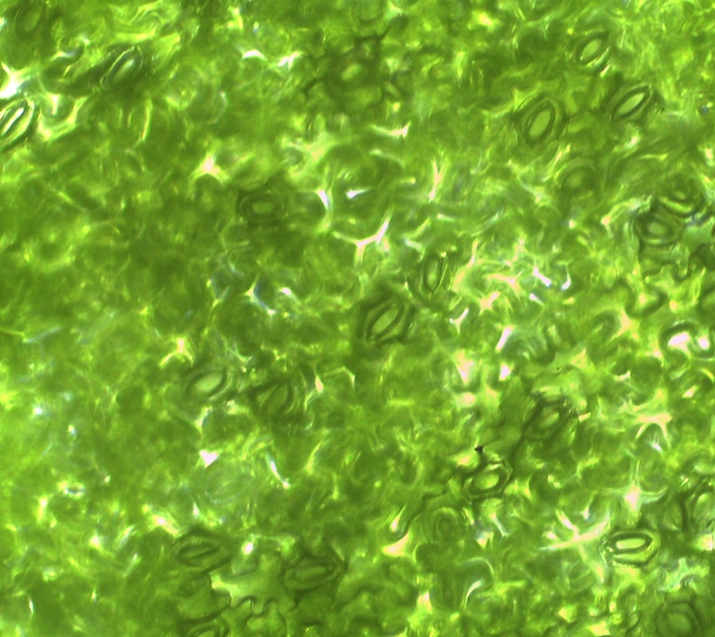
C
B
A

Supplementary Figure 1. Stoma cell on the lower epidermis of Aronia melanocarpa leaves under in vitro conditions. Recovered or healthy leaves (a), low vitrification, and high vitrification (c) on selected media. Bar size is 120 µm

