Large-scale genome-centric metagenomics reveals the prevalence of lysogenic virus-host interactions in activated sludge

Authors:
Jie Li, Depeng Wang, Xiwei He, Peng Liu*, Hongqiang Ren, Xu-Xiang Zhang*

Affiliations:
State Key Laboratory of Pollution Control and Resource Reuse, School of Environment, Nanjing University, Nanjing 210023, China

*Corresponding author:
Peng Liu: State Key Laboratory of Pollution Control and Resource Reuse, School of Environment, Nanjing University, Nanjing 210023, China
Email address: lp085853@163.com
Xu-Xiang Zhang: State Key Laboratory of Pollution Control and Resource Reuse, School of Environment, Nanjing University, Nanjing 210023, China
Email address: zhangxx@nju.edu.cn

Supplementary Information

8 pages including cover page
6 figures
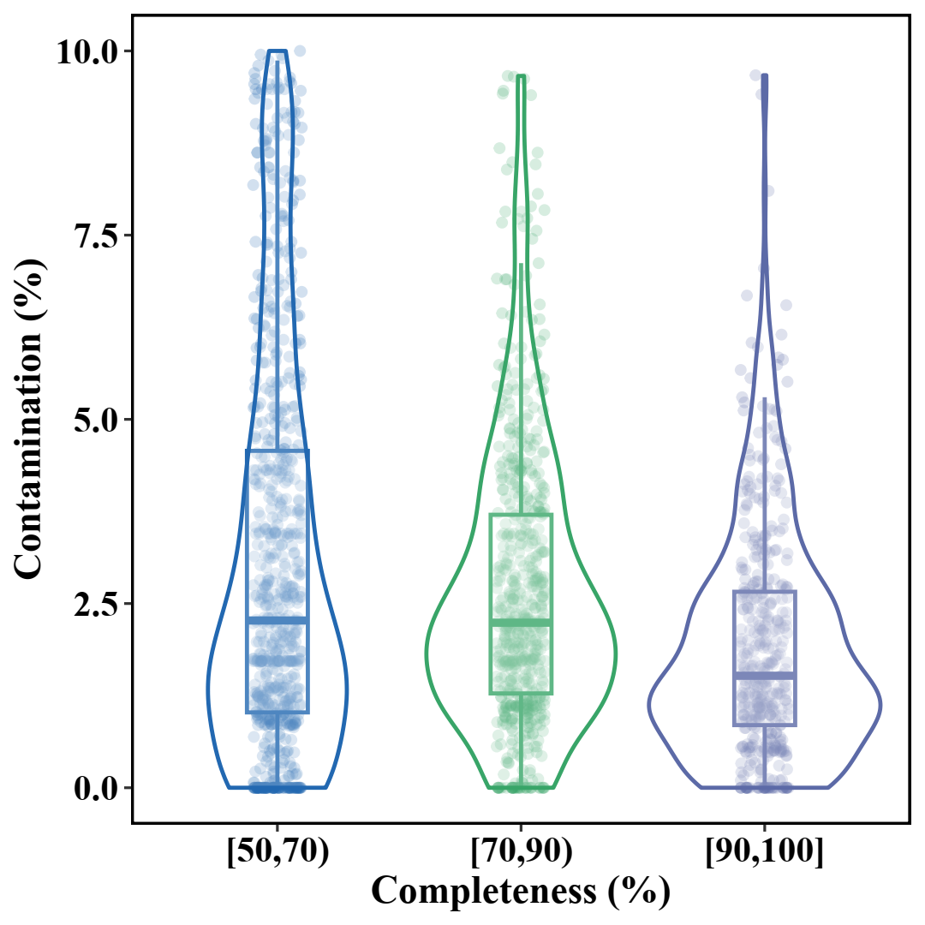
Fig. S1 Estimated completeness and contamination of the 1,826 non-redundant MAGs.

Fig. S2 The histogram displays the distribution of prophage genome size.

Fig. S3 The correlation analyses of the 1,826 MAGs genome size with (a) the number and (b) the length of prophages in the host genome.

Fig. S4 The interactions between prophages and hosts mediated by AMGs. The genes highlighted in red were encoded by prophage, suggesting that the prophage might be directly involved in the reaction, affecting host metabolism and shaping biogeochemical cycles.
Fig. S5 Geographic distribution of 211 samples from 44 full-scale municipal wastewater treatment plants where metagenomic data of activated sludge were collected from the NCBI Sequence Read Archive and European Nucleotide Archive.
Fig. S6 Workflow for the analyses of activated sludge metagenomic data.

